**Review on Dermatitis Herpetiformis : Gluten Free Diet and Dapsone Therapy**

**Mr. Dhiraj P. Bhoi*1, Mr. Shreyash J. Patil*2, Ms. Karuna Joshi*3**

**Department Of Phamaceutics, Sumantai Institute Of Pharmacy, Bambrud Kh. Pachora, Dist Jalgaon, Maharashtra, India.**

**Asst. Prof Department Of Pharmaceutics Sumantai Institute Of Pharmacy, Bambrud kh. Pachora, Dist. Jalgaon, Maharashtra, India.**

**Corresponding Author Email** Id : [dhirajbhoi344@gmail.com](mailto:dhirajbhoi344@gmail.com)

**ABSTRACT**

Dermatitis herpetiformis (DH) is a chronic, autoimmune blistering disorder of the skin, closely associated with celiac disease. It is characterized by intensely itchy, papulovesicular eruptions, typically on the elbows and knees.The primary feature of DH is intensely pruritic (itchy) lesions, which often appear as small, fluid-filled blisters or raised, red bumps, typically located on the extensor surfaces of the body. Diagnosis is confirmed by skin biopsy with direct immunofluorescence, revealing granular IgA deposits. The treatment of choice for DH includes a gluten-free diet, which addresses the underlying cause, and dapsone, a medication that effectively controls symptoms.DH results from an immune response to gluten, leading to the deposition of IgA antibodies in the skin's papillary dermis. The condition is genetically linked, with a higher prevalence in individuals carrying the HLA-DQ2 or HLA-DQ8 haplotypes.

1. **INTRODUCTION**

Dermatitis herpetiformis (DH) is a cutaneous manifestation of celiac disease, a gluten-sensitive enteropathy and an inflammatory immunobulous illness of the skin. Because blisters tend to grow in clusters, resenbling herpes simplex, the condition is known as herpetiformis. DH, however, is not brought on by a viral illness. Another name for DH is Duhring-Brocq disease. An extremely itchy eruption known as dermatitis herpetiformis is typically found on the extensor surfaces of the arms and legs as well as the buttocks. Larger surface areas may be involved in severe situations. An inflammatory subepidermal blistering condition called dermatitis herpetiformis is frequently linked to gluten-sensitive enteropathy (GSE). It is regarded as a form of celiac disease that affects the skin. Dr. Louis Duhring of the University of Pennsylvania described and named it in 1884. L! and is sometimes referred to as Duhring-Brocq disease or Duhring sickness. [2] The high incidence of autoimmune diseases and possible complications, such as the development of lymphoma, have been demonstrated in this dermatosis. DH is characterized by the presence of lgA deposits on top of the dermal papillae and primarily manifests on the extensor surface of the limbs, but also on the tocks and scapular area. Histocompatibility antigens (HLA), circulating IgA against transglutaminase autoantigens, and clinical remission on a gluten-free diet may be shared by patients with DH and CD. Costello used sulfonamides to treat dermatitis herpetiformis (DH) for the first time in recorded history in 1940.(1). He noted that after beginning sulfapyridine medication, the DH rash went away in a matter of days. It was later shown that the ratio nale for this—that bacterial allergies was the cause of DH—was incorrect. Although the exact mechanism of their therapeutic activity is still unknown, the observation nevertheless made it possible to empirically treat the rash with medications that are still in use today. Esteves and Brando were the first to report using dapsone (diaminodiphenyl sulfone) to treat DH (2). Since these first findings, the use of these medications to treat DH has gained widespread acceptance, and their efficacy is so high that the therapeutic response to dapsone was employed as a disease diagnostic tool until the early 1970s, when immunofluorescence was developed. When Marks and her colleagues demonstrated an enteropathy in 9 out of 12 DH patients in 1966, it marked the next significant advancement in the treatment and management of DH (3). Fry and associates noted the resemblance between celiac disease and the enteropathy observed in DH patients the following year (4). These authors' additional research revealed that the rash and enteropathy were both gluten-dependent, suggesting that DH was different from other bullous diseases and was brought on by an extrinsic antigen

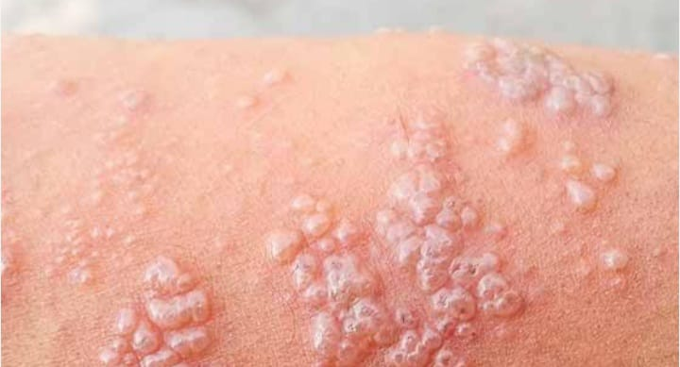

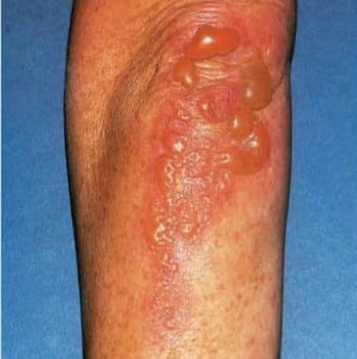

**PATHOPHYSIOLOGY :**

Cross-reactivity theory for cellac disease patients' dermatitis herpetiformis onset Pathologically speaking, the dermis may exhibit the condition's first symptoms. Edema, vascular dilatation, and cellular infiltration are some of the alterations that might occur at this stage. Eosinophils and lymphocytes are frequently seen. The subepidermal bullae with rounded lateral edges are seen in dermatitis herpetiformis-affected skin. The skin with dermatitis herpetiformis exhibits a collection of neutrophils when examined under a microscope. In regions where the dermis is closest to the epidermis, they are more common. Patchy granular IgA along the basement membrane and lgA in the dermal papillae are seen in direct IMF examinations of uninvolved skin. Partial villous atrophy of the jejunal mucosa is possible, but the alterations are usually less severe than in celiac disease.[l18] In terms of autoantigens, immunological research showed results comparable to those of celiac disease. Epidermal transglutaminase (eTG), a cytosolic enzyme involved in the creation of cell envelopes during keratinocyte differentiation, is the primary autoantigen of dermatitis herpetiformis.

Herpetiformis. It has been suggested that dermatitis herpetiformis may be brought on by a deposition of both lgA and eTG inside the dermis since eTG has been detected in precipitates of skin-bound lgA from skin afflicted by this illness. After 10 years of a gluten-free diet, these deposits are thought to have the potential to resorb. Furthermore, it is hypothesized that this illness has a strong hereditary component. This idea is predicated on the claims that those who continue to eat gluten-containing foods despite having a family history of gluten sensitivity are at an increased risk of developing the disorder due to the development of gluten antibodies. These antibodies and eTG have a cross-reaction.and lgA/eTG complexes accumulate in the papillary dermis to produce dermatitis herpetiformis lesions. After avoiding gluten in the diet for a long time (up to 10 years), these IgA deposits may go away.[7] Tissue transglutaminase (tTG) must deamidate the gliadin proteins in gluten once they are absorbed by the gut and reach the lamina propria. Gliadin is changed by tTG to become a peptide that is more immunogenic. The immunogenic peptide is endocytosed by classical dendritic cells (cDCs), and if their pattern recognition receptors (PRRs) are activated by pathogen-associated molecular patterns (PAMPs) or danger-associated Dermatitis herpetiformis, inflammation in the stomach and skin may be used to describe the condition. Gut inflammation is comparable to and associated with celiac disease.Particularly in those with certain HLA-DQ2 and HLA-DQ8 alleles and other gene variations that result in atopy, tTG is treated as an autoantigen. Following the absorption of gluten, tTG is up-regulated. cDCs only show gliadin to CD4+ T cells on pMHC-ll complexes, but they endocytose tTG modified gliadin complexes or modified gliadin alone.

After activation, these T cells polarize into type I helper T (Th1) cells. There are Th1 cells that are reactive to gliadin but notto tTG. Before the cDCs endocytose them, a naïve B cell removes tTG-modified gliadin complexes from their surface in the lymph nodes (LNs). The tTG component of the complex is the exclusive domain of the B cell receptor (membrane bound antibody, BCR). In a process called epitope spreading, the B cell endocytoses the complex and delivers the modified gliadin to the activated Th1 cell's T cell receptor (TCR) via pMHC-l.

As a result, the B cell creates antibodies that are specific to the self-antigen (tTG) but displays the foreign peptide (modified gliadin). Following activation, the B cell develops into plasma cells that release anti-tTG autoantibodies that may cross-react with epidermal In dermatitis herpetiformis, the allegedly cross-reactive autoantibodies may go to the skin. If the antibodies react with epidermal transglutanimase (eTG), lgA deposits might develop.It is unclear how dermatitis herpetiformis and celiac disease are related in certain people who have eTG-specific antibodies rather than tTG-specific cross-reactive antibodies. The same mechanism that stimulates macrophages to release IL-8 may also cause neutrophils to gather at regions of elevated eTG concentrations in the skin's dermal papillae. Blisters are characterized by the production of pus by neutrophils in the dermal papillae. The buildup of IL-31 near the blisters may make itching worse. When memory B and T cells are exposed to tTG-modified gliadin complexes or modified gliadin alone repeatedly, they may become activated without PAMPs and DAMPs. in turn. Avoiding a diet high in gluten helps individuals with dermatitis herpetiformis

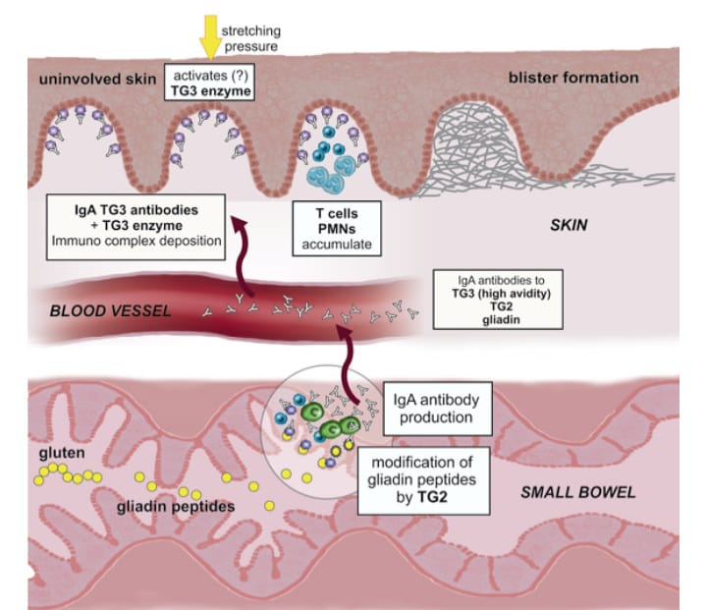

**SIGN AND SYMPTOMS:**

A rough skin rash with clusters of small blisters is the result of dermatitis herpetiformis. The rash may itch a lot. Prior to the rash developing, you may experience burning or itching.

Typically, the rash shows up on:

1. Elbows

2. The knees

3. The buttocks

4. Shoulder blades

Small, clustered papules and vesicles that appear symmetrically on the elbows, knees, buttocks, back, or scalp are the hallmark of DH. Additionally, the face and groin may be affected. Lesion formation may be preceded by a burning feeling. By the time a patient arrives for a physical examination, the lesions are typically scraped off, and the rash may manifest as erosions and excoriations.Over time, the rash may appear and go. It can occasionally leave darker or paler skin patches behind. You cannot catch it, hence it is not contagious.

Other signs that you might experience include

1. Sores filled with fluid

2. Rashes that resemble hives

3. Itching

4. Burning and redness

Another sign of celiac disease is dental enamel abnormalities in permanent teeth, which can occur in patients with DH. Celiac disease symptoms are seen in less than 20% of DH patients.

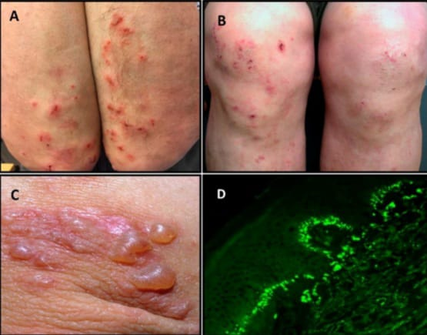

**CAUSES:**

1.The gliadin portion of gluten, which is present in wheat, rye, and barley, is the cause of dermatitis herpetiformis (DH) and celiac disease.

2. Gluten causes an immunological reaction that attacks the stomach and skin, as well as the development of IgA antibodies.

3. Gluten induces intestinal inflammation in celiac disease, which leads to weight loss, diarrhea, fatigue, discomfort in the abdomen, and metabolic effects of malabsorption.

4. Gluten-sensitive enteropathy is also seen in the majority of DH patients (> 90%). Most people have minimal gastrointestinal symptoms, but some don't have any at all.

5. Between 15 and 25 percent of those with celiac disease also have DH. Compared to people without DH, these patients typically have a more severe intestinal pathology in comparison to those without DH.

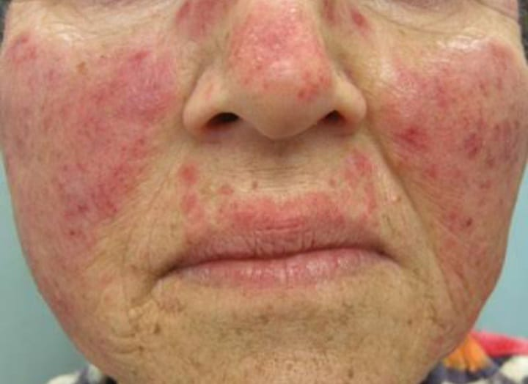

**TREATMENT :**

The gluten-free diet and medication therapy with sulfonamides or dapsone are the cornerstones of DH treatment.

**Gluten-free diet :**

The advantages of a gluten-free diet for DH patients were shown by Van der Meer et al. in 1981. Following the implementation of a gluten-free diet, two patients who had improvement in their cutaneous lesions were assessed. The patients were later able to lower the dapsenetim maintenance dosage. The same authors' 1985 study, which documented the remission of dermatological lesions in five individuals using the sarme diet, demonstrated the same nutritional effect."The diet typically offers gastrointestinal benefits much earlier than cutaneous ones, and improvement in DH can take up to two years if only this therapy is instituted." "Intestinal manifestations are gluten-dependent, especially in DH, due to the cumulative detrimental side effects of the drugs of choice." It could take a few years for lgA deposits to fully disappear from the dermoupidermal junction, but reintroducing gluten might cause new deposits and a rapid decline in clinical symptoms C3 deposits can also result from the consumption of gluten.Among the other advantages of this diet, we can mention the protective effect against the development of gastrointestinal tract iymphonas, which typically manifests five years afterdieting, and the intestinal mucosa's recovery, which improves malabsorption in patients who experience this symptom. To determine if nutrition reduces the occurrence of related auto-immune illnesses, further long-term studies are required.

After varied lengths of time, the majority of individuals receiving drug therapy usually see a steady decrease in their prescription, and some even discontinue their use entirely. The average time to discontinue taking dapsone is 25 months. Despite the importance of following the diet, patient compliance can be difficult, thus nutritional monitoring and, if possible, participation in support groups are recommended." Patients with CD/DH should be advised to carefully read food labels and avoid unknown ingredients, as many of them may be gluten derivatives.The triticeae family of cereals, which includes wheat, barley, and rye, has species that are hazardous to patients with CD and DH. Oats are members of the Avenae, a different family. Proteins called prolamins, which are high in proline and glutamine, are toxic to DH sufferers. Compared to wheat, barley, and rye, oat avenin, a prolamin produced from oats, has a lower proline level. Avenin level in oats ranges from 5 to 15%, while gliadin (wheat prolamin) content is around 40%. DH patients who were clinically treated with diets ingested 2.5 grams of avenin, which is comparable to 300 grams of oats, according to one research. had no negative effects on the gut or skin, and no anti-gliadin antibodies were formed. Nevertheless, During the milling process, wheat or the rotating technique used in agricultural crops can infect oats. Therefore, if patients can guarantee the purity of the source, they can be advised to consume oats. Putting the significance of gluten in context, Kadunce showed some clinical improvement with elemental diets, even when gluten was present.

**MEDICATION TREATMENT** :

**DAPSONE :**

The preferred therapy for DH is dapsone since it often lessens itching in three days.  
The dosage is 25–300 mg per day.  
Those who have been following a consistent gluten-free diet may be able to wean themselves off of it gradually.  
Dapsone's effects manifest quickly. Within a few hours, the itching symptoms go away, and within 24 to 36 hours, no new blisters form When starting a gluten-free diet, it is a good choice in the beginning.  
Dapsone had no effect on the risk of lymphoma, enteropathy, or IgA antibody deposition.  
Dapsone requires monitoring and may have adverse consequences.

Rare but dangerous side effects include methaemaglobinopathy, dapsone hypersensitivity, and agranulocytosis, which can happen 3–12 weeks after therapy begins. In these cases, dapsone must be discontinued right away.  
  
The following might be helpful if you have a dapsone allergy or intolerance:  
  
Extremely strong topical steroids  
  
Steroids in the system  
  
Colchicine  
  
Ciclosporin  
  
Azathioprine  
  
Sulfapyridine  
  
Rituximab.  
  
Patients who cannot handle higher doses of dapsone monotherapy may benefit from combination treatment that combines dapsone and sulfasalazine, according to some research.  
It has also been demonstrated that topical dapsone 5% gel works well as an adjuvant therapy for DH. Patients with glucose-6-phosphate dehydrogenase (G6PD) impairment can safely use topical dapsone, which has been linked to a reduced incidence of adverse effects than oral dapsone.

**Phamacological treatment :**

option for treating DH, with sulfapyridine serving as a substitute medication. Although dapsone's exact mode of action is unknown, it appears to inhibit chemotaxis, stimulate neutrophils, and decrease the generation of prostaglandins and leukotrienes. When it is administered, itchiness is quickly relieved, and cutaneous symptoms often return within a week. While it has little impact on intestinal diseases, it promotes improvement in skin lesions. With an average maintenance dose of 1 mg/kg/day, 100 mg per day is the most often utilized dosage. Smaller dosages are required for children. The objective is to maintain clinical control over the patient for a period of one to two years until the benefits of diet are realized. When feasible, the medication should be stopped and the lowest dose that can keep the patient in remission should be looked for. In the absence of diet, dapsone suspension will cause the lesions to return. The two most frequent, dose-dependent adverse effects associated with dapsone usage are methemoglobinemia and severe hemolytic anemia. Due to the decline in hemoglobin levels, elderly patients—particularly those with comorbidities—are susceptible to cardiac diseases like heart failure or coronary artery disease becoming unstable. Although the initial hemoglobin decrease (2–3g) is typical, reticuloytodid often makes up for it.

**DIAGNOSIS:**

**DIAGNOSIS OF DH:**

- DH is best diagnosed with a skin biopsy.

- A Direct Immunofluorescence Test is done which shows the presence of IgA antibody deposits.

- Blood test to check the presence of the antibodies.

- An Intestinal biopsy to check the presence of damage due to celiac disease.

**Specific autoantibody tests for DH are:**

IgA anti-endomysial antibodies (present in 80% of patients with DH)

* IgA tissue transglutaminase antibody (tTG)

* IgA epidermal transglutaminase antibodies (eTG), when available

* DH is associated with IgA eTG, which is not the case in coeliac disease

IgA and IgG deamidated gliadin peptide antibody (dGP)

* IgA and IgG gliadin assay

* Total IgA level.

The diagnosis of dermatitis herpetiformis (DH) is made on the basis of skin biopsy results. However, other tests can be performed depending on the presence of symptoms of associated syndromes. Serum markers, such as IgA endomysial antibodies, are negative in as many as 10-37% of patients with dermatitis herpetiformis. [5, 6] Arguments have been made in favor of testing for tissue transglutaminase for diagnosis, [7] but tissue transglutaminase enzyme-linked immunosorbent assay positivity can occur in many autoimmune diseases because of impurities and cross-reactivity.

**REFERENCES :**

1. Kárpáti S (2004) Dermatitis herpetiformis: close to unravelling a disease. J Dermatol Sci 34: 83-90.

2. Hervonen K, Hakanen M, Kaukinen K, Collin P, Reunala T (2002) First-degree relatives are frequently affected in coeliac disease and dermatitis herpetiformis. Scand J Gastroenterol 37: 51-55.

3. Marietta EV, Camilleri MJ, Castro LA, Krause PK, Pittelkow MR, et al. (2008) Transglutaminase autoantibodies in dermatitis herpetiformis and celiac sprue. J Invest Dermatol 128: 332-335.

4. Lorand L, Graham RM (2003) Transglutaminases: crosslinking enzymes with pleiotropic functions. Nat Rev Mol Cell Biol 4: 140-156.

5. Sárdy M, Kárpáti S, Merkl B, Paulsson M, Smyth N (2002) Epidermal transglutaminase (TGase 3) is the autoantigen of dermatitis herpetiformis. J Exp Med 195: 747-757.

6. Korponay-Szabó IR, Halttunen T, Szalai Z, Laurila K, Király R, et al. (2004) In vivo targeting of intestinal and extraintestinal transglutaminase 2 by coeliac autoantibodies. Gut 53: 641-648.

7. Troncone R, Jabri B (2011) Coeliac disease and gluten sensitivity. J Intern Med 269: 582-590.

8. Zone JJ, Egan CA, Taylor TB, Meyer LJ (2004) Iga autoimmune disorders: Development of a passive transfer mouse model. J Investig Dermatol Symp Proc 9: 47-51.

9. Hull CM, Liddle M, Hansen N, Meyer LJ, Schmidt L, et al. (2008) Elevation of iga anti-epidermal transglutaminase antibodies in dermatitis herpetiformis. Br J Dermatol 159: 120-124.

10. Zone JJ, Schmidt LA, Taylor TB, Hull CM, Sotiriou MC, et al. (2011) Dermatitis herpetiformis sera or goat anti-transglutaminase-3 transferred to human skin-grafted mice mimics dermatitis herpetiformis immunopathology. J Immunol 186: 4474-4480.

11. Antiga E, Quaglino P, Pierini I, Volpi W, Lami G, et al. (2015) Regulatory t cells as well as il-10 are reduced in the skin of patients with dermatitis herpetiformis. J Dermatol Sci 77: 54-62.

12. Caproni M, Feliciani C, Fuligni A, Salvatore E, Atani L, et al. (1998) Th2-like cytokine activity in dermatitis herpetiformis. Br J Dermatol 138: 242-247.

13. Airola K, Vaalamo M, Reunala T, Saarialho-Kere UK (1995) Enhanced expression of interstitial collagenase, stromelysin-1, and urokinase plasminogen activator in lesions of dermatitis herpetiformis. J Invest Dermatol 105: 184-189.

14. Salmela MT, Pender SL, Reunala T, MacDonald T, Saarialho-Kere U (2001) Parallel expression of macrophage metalloelastase (MMP-12) in duodenal and skin lesions of patients with dermatitis herpetiformis. Gut 48: 496-502.

15. Di Sabatino A, Corazza GR (2009) Coeliac disease. Lancet 373: 1480-1493.

16. Cummins AG, Roberts-Thomson IC (2009) Prevalence of celiac disease in the Asia-Pacific region. J Gastroenterol Hepatol 24: 1347-1351.

16. Lähteenoja H, Irjala K, Viander M, Vainio E, Toivanen A, et al. (1998) Oral mucosa is frequently affected in patients with dermatitis herpetiformis. Arch Dermatol 134: 756-758.

17. Ko CJ, Colegio OR, Moss JE, McNiff JM (2010) Fibrillar IgA deposition in dermatitis herpetiformis--an underreported pattern with potential clinical significance. J Cutan Pathol 37: 475-477.

18. Bonciolini V, Bianchi B, Del Bianco E, Verdelli A, Caproni M (2015) Cutaneous manifestations of non-celiac gluten sensitivity: Clinical histological and immunopathological features. Nutrients 7: 7798-7805.

19. Garioch JJ, Lewis HM, Sargent SA, Leonard JN, Fry L (1994) 25 years' experience of a gluten-free diet in the treatment of dermatitis herpetiformis. Br J Dermatol 131: 541-545.

20. Lewis HM, Renaula TL, Garioch JJ, Leonard JN, Fry JS, et al. (1996) Protective effect of gluten-free diet against development of lymphoma in dermatitis herpetiformis. Br J Dermatol 135: 363-367.

21. Turchin I, Barankin B (2005) Dermatitis herpetiformis and gluten-free diet. Dermatol Online J 11: 6.

22. Janatuinen EK, Pikkarainen PH, Kemppainen TA, Kosma VM, Järvinen RM, et al. (1995) A comparison of diets with and without oats in adults with celiac disease. N Engl J Med 333: 1033-1037.

23. Hardman CM, Garioch JJ, Leonard JN, Thomas HJ, Walker MM, et al. (1997) Absence of toxicity of oats in patients with dermatitis herpetiformis. N Engl J Med 337: 1884-1887.

24. Fry L (2002) Dermatitis herpetiformis: problems, progress and prospects. Eur J Dermatol 12: 523-531.

25. Tjon JM, van Bergen J, Koning F (2010) Celiac disease: how complicated can it get? Immunogenetics 62: 641-651.

26. Zhu YI, Stiller MJ (2001) Dapsone and sulfones in dermatology: overview and update. J Am Acad Dermatol 45: 420-434.

27. Booth SA, Moody CE, Dahl MV, Herron MJ, Nelson RD (1992) Dapsone suppresses integrin-mediated neutrophil adherence function. J Invest Dermatol 98: 135-140.

28. McFadden JP, Leonard JN, Powles AV, Rutman AJ, Fry L (1989) Sulphamethoxypyridazine for dermatitis herpetiformis, linear IgA disease and cicatricial pemphigoid. Br J Dermatol 121: 759-762.

29. Willsteed E, Lee M, Wong LC, Cooper A (2005) Sulfasalazine and dermatitis herpetiformis. Australas J Dermatol 46: 101-103.

30. Hervonen K, Alakoski A, Salmi TT, Helakorpi S, Kautiainen H, et al. (2012) Reduced mortality in dermatitis herpetiformis: a population-based study of 476 patients. Br J Dermatol 167: 1331-1337.