**THE ROLE OF ORGANIZATIONAL AND PERSONAL VALUES IN SHAPING WORKPLACE CULTURE: IMPLICATIONS FOR EMPLOYEE ENGAGEMENT AND PERFORMANCE**

Shree Vidya1 Dr. Divya Sahu2

1Research Scholar 2Research Guide

Department of Commerce

NIILM University, Kaithal (Haryana)

**Abstract**

This study explores the intricate relationship between personal and organizational values in shaping organizational culture and examines how this culture influences employee commitment and performance. Organizational culture, formed by shared values, norms, and practices, plays a critical role in determining employee behavior and engagement. By analyzing the alignment between employees' personal values and the organization's core values, this research seeks to understand how this congruence fosters a positive work environment, leading to higher levels of commitment and enhanced performance. The study also delves into how a strong organizational culture can cultivate loyalty, motivation, and job satisfaction, thereby improving overall productivity and organizational success. Through a comprehensive literature review and empirical investigation, the findings aim to provide insights for managers and leaders on cultivating a value-driven culture that supports employee well-being and organizational growth.

**Keywords:** Organizational Culture, Employee Commitment, Employee Motivation.

**Introduction**

**Research Rationale:** The majority of recent research in the field of management and organizational behavior has concentrated on the conceptual and empirical relationship between organizational culture and employee job commitment and performance. The majority of research on organizational culture and behavior is conducted within the context of Western culture and work environment. The argument that organizational culture has a direct and indirect impact on the job performance and commitment of employees has been established by these studies. The 1980s were the primary period in which the perception of the role of organizational culture in influencing employee behavior began to evolve, and researchers began to concentrate on the significance of organizational culture. Organizational culture is a critical concept that must be recognized in order to comprehend the productivity and performance of a company. This investigation would facilitate comprehension of the influence of organizational culture and individual values on employee commitment and performance.

**Research Question:** The primary research question that this research will answer is- “What is the role of personal and organizational values in forming organizational culture and its influence on employee’s performance and commitment?”

**Aims and Objectives:** Primary aim of this research is to understand the influence of organizational culture on individual values of employees and its impact on employee’s job performance and organizational commitment. The objectives of this research include:

* To understand the concept of organizational culture and individual values
* To understand relationship between organizational culture and individual values
* To understand impact of organizational culture and individual values on employee performance and commitment towards job.

**Research Methodology**

This study is aimed towards understanding different concepts of culture, values and performance in relation to organizational behavior of employees. Studies have identified that qualitative studies are the type of in-depth researches that adopt the range of techniques to understand individual behavior, perception, thinking and feelings. Although, a wide range of methods could be applied in qualitative studies, such as systematic reviews, questionnaire surveys, observation studies and interview methods. This research adopts the qualitative interview method, which is mainly used as the tool for uncovering the main theme of the study and understanding the study problem from the view point of participants. This research will conduct focus group interview of 5 professional managers from an IT company in India. This study will conduct a semi-structured interview of the participants and will focus on collecting the responses of interview participants towards the research topic.

**Understanding Organizational Culture**

Organizational culture has become an important concept in management and organizational behavior studies. Different scholars have defined and explained organizational culture in different ways and there is no single definition of this concept. Paschal et al. espoused in their research that organizational culture is the set of shared values and belief among the organizational members that influence their everyday work practices. Edgar H Schein has defined organizational culture as the pattern that encompass basic assumptions that are developed or discovered by the group of people and thus, help those people to cope with everyday problems. Some of the other researchers have espoused that organizational culture is multi-dimensional, dynamic and ever changing and could not fit in single definition. However in general terms organization culture can be defined as the shared values, belief, symbols, perception, experience and psychology of people that guide their behavior within organizations

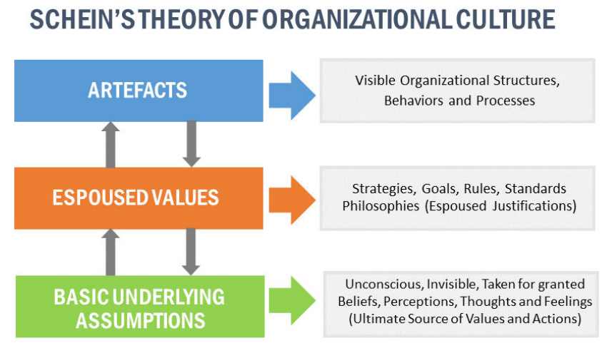

**Figure 1: Schein's theory of organizational culture**

**Understanding the Concept of Individual Values**

It has been identified that there is lack of evidences in literature towards understanding the concept of individual values and its interaction with organizational culture. Individual values logically can be associated with individual belief, cultural and religious influence, as well as basic assumptions and perceptions of individuals. Studies have also argued that values are more closely associated with personal philosophy and ideology rather than being considered as personal attitude. Evidences have also shown that understanding the individual values of the employees can help in developing a comprehensive framework through which organizations can understand the goals, attitude, self-concept, and behavior of employees. Literature associated with analyzing job performance and job satisfaction of employees, have placed some light over influence of individual values.

Some of the main individual values that influence employee behavior are, self-concept, security, power, achievement, benevolence, respect, acceptance and position. Individual values are identified as the motivating factors that are required to be supported through organizational culture in order to achieve high level of performance and productivity.

**Employee Performance and Commitment**

Employee performance and commitment towards organizations are directly influenced by the level of job satisfaction. According to Robert J. Ristino et al., positive or negative attitude of the employees towards organizational culture, values, rules and extent to fulfil their individual values influences their performance and their level of commitment. Organizational values that are aligned with individual values help in directing and influencing the employee behavior, and their performance. Employee’s perception of their work environment, organizational support, respect and autonomy that they receive within organization can have negative or positive influence over their performance and commitment. Social circumstances such as level of security, opportunity to maintain work-life balance, opportunities for growth and development and higher level of conformity within organizational culture are also identified as positive factors associated with better performance and higher level of job commitment.

**Interview Analysis**

**Understanding corporate culture:** Focus group members gave diverse replies. Most participants demonstrated a basic awareness of company culture. Respondent 1 said “Organizational culture can be associated with organizational values, norms, customs and belief, which influence our actions and decisions”. Respondent 3 stated “organizational culture could also be associated with said and unsaid rules, norms and symbols that could work as the informal guideline for us and influence our work behavior”. Three other respondents also understand company culture, indicating that workers comprehend it.

Respondent 1 stated that “organizational culture has set of pre-accepted belief and norms and we are required to wok according to those values and norms, and I don't believe that our personal or individual values could impact our behavior”. Respondent 3 said that “personal values influence our all actions, decisions and activities, thus I believe that our individual values can influence our behavior, as negative values can negatively impact my perception towards organization”. Respondent 4 added, “my values are developed from my culture and religious preferences and I believe that to some extent they can guide my behavior, but through my personal experience, I have found that organization that supports our personal goals, help in encouraging positive behavior.” All four respondents said individual values may affect corporate conduct, save one.

**Company Culture and Job Performance and Commitment:** Focus group participants said company culture affects employee performance and commitment. Respondent 2 said company culture may affect performance positively and negatively. For instance, if our company culture promotes our growth and development by offering prizes, promotions, and recognition, it will boost employee performance and dedication. Respondents 4 and 5 also said company culture that includes their beliefs and aspirations might affect their work performance. Respondents also thought their devotion to their company depended on their principles and aims.

Respondent 1 said, “my individual values towards my work are mainly associated with the level of security and growth opportunity and if organization fails to display such values then it might reduce my performance and commitment level”. Respondent 3 said, “I want organizations culture to support me in providing stability, autonomy, and respect towards my work and if my values are not being considered than it would defiantly reduce my work motivation and satisfaction levels and I might look for another job Focus group members said a culture that devalues employee values and goals may hurt performance and commitment.

**Results**

This article examines how company culture and employee values affect performance and commitment. This study used focus group analysis to bridge a literature gap by studying employee perception and thinking.

This study finds that employees' individual values of security, respect, power, autonomy, recognition, and growth interact with positive organizational culture to improve performance and commitment. This study supports literature that suggests a corporate culture that supports individual values might improve employee performance and commitment. Employee behavior includes perception, commitment, and drive to improve performance. This study also found that organizational culture, which combines employees' organizational and personal values, directly affects employee performance and commitment because it positively affects employee behavior.

This research shows that employee values and organizational culture shape organizational culture. Such mixture is necessary for a good corporate culture. A culture that blends individuals' own values of security, autonomy, respect, acknowledgment, and progress is more likely to improve performance and job commitment. This research confirms previous results. However, this study has helped integrate employee values and corporate culture to affect performance and commitment. This research opens the door to better understanding individual values in organizational behavior studies with bigger samples.

**Conclusion**

In conclusion, personal and organizational values play a pivotal role in shaping organizational culture, which in turn significantly impacts employee commitment and performance. When individual values align with organizational values, employees are more likely to feel a sense of belonging and purpose, leading to increased motivation, loyalty, and engagement. A strong organizational culture fosters a collaborative environment that supports personal growth and professional development, enhancing overall performance. Conversely, misalignment between personal and organizational values can lead to disengagement and reduced commitment. Therefore, cultivating a culture that reflects both shared values and organizational goals is essential for maximizing employee satisfaction and productivity.

**References**

1. Adhabi, Essa, and Christina Blash Anozie. "Literature review for the type of interview in qualitative research." International Journal of Education 9, no. 3 (2017): 86-97.
2. Cacciattolo, Karen. "Understanding organizational cultures." European scientific journal 2, no. 1 (2014): 1-7.
3. Chang, Christina Ling-hsing, and Tung-Ching Lin. "The role of organizational culture in the knowledge management process." Journal of Knowledge management 19, no. 3(2015): 433-455.
4. Cullen, Kristin L., Bryan D. Edwards, Wm Camron Casper, and Kevin R. Gue. "Employees’ adaptability and perceptions of change-related uncertainty: Implications for perceived organizational support, job satisfaction, and performance." Journal of Business and Psychology 29, no. 2 (2014): 269-280.
5. Elsmore, Peter. Organizational Culture: Organizational Change?: Organizational Change?. Routledge, 2017.
6. Habib, Salman, Saira Aslam, Amjad Hussain, Sana Yasmeen, and Muhammad Ibrahim. "The impact of organizational culture on job satisfaction, employees commitment and turn over intention." Advances in Economics and Business 2, no. 6 (2014): 215-222.
7. Hogan, Suellen J., and Leonard V. Coote. "Organizational culture, innovation, and performance: A test of Schein's model." Journal of Business Research 67, no. 8 (2014): 1609-1621.
8. Lune, Howard, and Bruce L. Berg. Qualitative research methods for the social sciences. Pearson Higher Ed, 2016.
9. Nair, Sreekumaran, Sree Lekshmi, and Steve Sommerville. "Impact of Organizational Culture on the Indian IT Workforce's Job Satisfaction and Stress: Qualitative Report from SMEs operating in Trivandruam." International Journal of Academic Research in Business and Social Sciences 7, no. 2 (2017): 237-246.
10. Ng, Jhony Choon Yeong, and Keith Yong Ngee Ng. "Culture, organizational culture and organizational climate: An integrative approach." Indian Journal of Commerce and Management Studies 5, no. 2 (2014): 18.
11. Padhi, Priyadarshini. "Organisational culture and employee performance." International Journal of Research in IT and Management (IJRIM, 7(5), 2017 pp 77-81.
12. Paschal, Anozie Obinna, and Ismail Nizam. "Effects of Organizational Culture on Employees Performance: Case of Singapore Telecommunication." International Journal of Accounting & Business Management 4, no. 1 (2016): 19-26.
13. Šahić, Elvir, and Savo Stupar. "Employee Perceptions of Organizational Culture and Individual Values Based on Examples of Companies in Bosnia and Herzegovina." International Journal of Business and Social Science 5, no. 7 (2014): 1.
14. Schein, Edgar H. "Organizational psychology then and now: Some observations." Annu. Rev. Organ. Psychol. Organ. Behav. 2, no. 1 (2015): 1-19.
15. Townsend, Keith, Rebecca Loudoun, and David Lewin, eds. Handbook of Qualitative Research Methods on Human Resource Management: Innovative Techniques. Edward Elgar Publishing, 2016.
16. Van Breda-Verduijn, Hester, and Marjoleine Heijboer. "Learning culture, continuous learning, organizational learning anthropologist." Industrial and Commercial Training (2016).
17. Zhang, Crystal, and Paul Iles. "Organizational Culture." Strategic Human Resource Management: An International Perspective (2014): 383.