**Residents’ Self-rated Effects of flood Incidence in Selected Neighbourhoods in an Urban Setting, North Central Nigeria**

**BAMIDELE, F. O.,**

**Department of Urban and Regional Planning,**

**Confluence University of Science and Technology,**

**Osara**

**EKE, E. E.,**

**Department of Urban and Regional Planning,**

**Federal University of Technology,**

**Akure**

**AFOLABI, O. S.   
Department of Environmental Modelling and Biometrics,**

**Forestry Research Institute of Nigeria**

**AFOLABI, H**

**Department of Urban and Regional Planning,**

**Obafemi Awolowo University, Ile Ife**

**Abstract**

Flood impacts are becoming more adverse in recent decades causing more damage to lives and livelihoods. The current study is an attempt to examine residents’ self-rated effects of flood incidence in the study area using a survey approach. A total of 257 respondents were selected. and administered questionnaire across six purposively sampled neighborhoods in the study area. Inerviews were also conducted on key informants comprising two residents in each sampled neighborhoods in the study area. Findings showed that flood effects as rated by residents were generally high. Findings also showed that flood impact was rated highest on displacements and infrastructure damage. Loss of lives was rated least across the six neighborhoods. Recommendations were made based on the findings.

Keyeords: Flood incidence; Disaster: Neighborhoods; Urban Setting

**Introduction**

The impact sustained from floods, especially in developing countries, Nigeria inclusive has become increasingly significant in the last centuries. The pattern of climatic change has aggravated the adverse effects of flooding in low-income communities (Odunsi, 2021; Bamidele, et al., 2024). Between 2010 and 2020, flood-related damages accounted for an average of 1.5 million dollar in property damage across developing counties (Buba et al., 2021; Odunsi, 2021). Sub-Saharan African countries are disproportionately affected by flood occurrences. More than 452 communities in this region experienced adverse flood effects, ravaging both lives and livelihoods between 2010 to 2023 (UN-Habitat, 2024).

The rapid population growth as experienced in flood prone areas in urban areas in the African subregion in recent times coupled with climatic changes have increased residents' exposure to flood impact. As the population continues to increase in these areas, there is in turn increase in built-up areas and encroachment into ecologically sensitive locations (Okunola & Bako, 2021; Falola, 2022). North Central Nigeria is particularly an extreme flood location in the country owing to its proximity to rivers Niger and Benue on one hand and its low terrain on the other hand. Due to its strategic location in the country. The North Central zone serves as the gateway to other parts of the country. The 2022 flood ravaged the area on an annual basis, affecting several communities and activities. Major nodal towns are being annually imparted by flood incidences.

However, flood occurrences hinder movements of traffic and therefore crippling human activities to a great extent, displacing human activities, posing damage on infrastructure and causing live loss. It is thus imperative to quantify the effects of flood incidence as reported by the affected residents in the study area.

**Literature Review**

Floods are disastrous events posing significant damage to lives and livelihoods. The effect of flood occurrences is becoming more devastating as climate condition is changing in the recent part. A number of studies both in developed and developing countries have acknowledged flood impact but only few within the global south have explored such impact quantitatively or rating it as reported by the affected groups

Mfon et al., 2022, Ugene & Oguike, 2020; meseka, 2024) Ugene and (2020) and Mfon et al, (2022) emphasized that main impacts of flooding in Nigeria were on livelihoods, lives and the equality of the environment. Emberga (2014) equality opined that the frequency of flood, magnitudes, affected area and the adverse socio-economic consequences in south western cities in Nigeria have been increasing over the years major impacts identified by the author are traffic jams, infrastructure damage, human displace, disruption of business activities and loss of lives. Meseka (2024) further added, while examining impact of flood disaster response on health outcomes, in western equatoraia, south Sudan, that panicking and fear, illness, trauma and loss of appetite are some of the behavior people experience after flood.

Recent Floods and their devastating effects especially in Sub-saharan Africa are becoming more frequency, intense and pose. Threats to sustainable development in human settlements. The nagging situation could be attributed to the living habits of the urban dwellers, top-down urban policies and programs adhoc government interventions have also been unsustainable. Thus the present study is an attempt to examine flood effects using. a resident-centred approach.

**Study Area**

The North central zone of Nigeria encompasses six states and the Federal Capital Territory. Owing to its strategic location contingent to the Niger and Benue Rivers, the zone experiences flooding on an annual basis (Itopa, 2019; Badmus et al, 2024). Low-lying areas along the river basin (comprising Kogi, Nasarawa and Benue) are at extreme flood risk. Economic and infrastructural losses resulting from flood incidence represent the most significant challenges confronting environmental sustainability in the study area (NEMA, 2020). As documented by the State Emergency Management Agency (2017) a total of property damage was recorded between 2012 and 2017, including displacement of over 3000 residents across 200 communities in the zone. This calls for an assessment of residents opinions on the effects of flood incidence with specific reference to the 2022 flood events in adversely affected neighbourhoods in North Central Nigeria.

Figure 1: Map of Extreme Flood zones in North Central Nigeria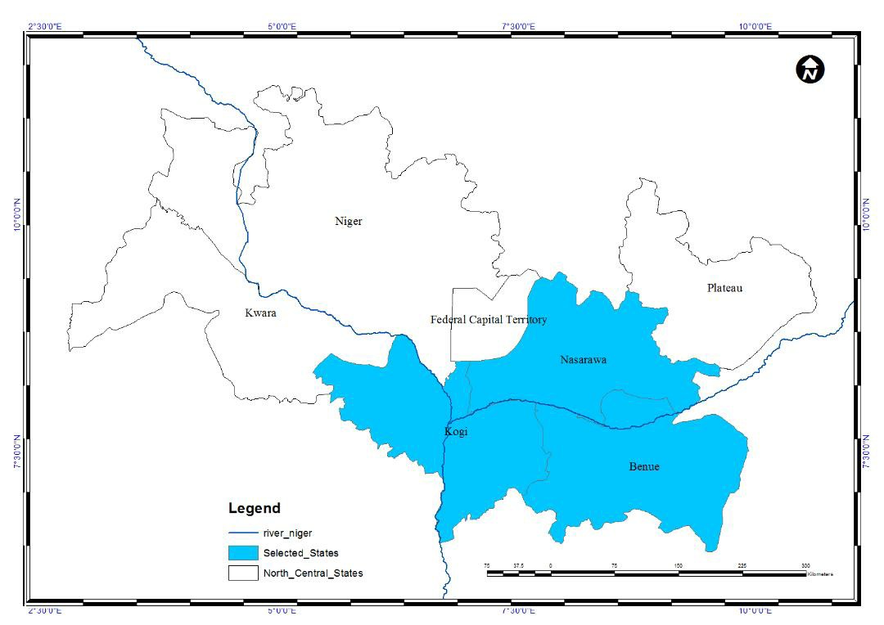

**Methodology**

Survey of the research involving data collection using structured questionnaires and interview guides were adopted. Six neighbourhoods in the flood-prone areas identified by earlier reports by SEMA (2022) as worse affected by floods were selected for the household survey. Houses along flood-prone streets were identified in each selected neighborhood through physical counts. Furthermore, a random start consisting of one out of the first five buildings along each flood-prone street was chosen. Subsequently, every fifth building was picked in sequential order for questionnaire administration. The total number of questionnaires summed up to 257 respondents. A household head or any other representative above the age of 18 years was selected to be administered the questionnaire. Interviews were conducted with three traders, and three farmers in the selected neighbourhoods are located. The interview was conducted to elicit information on their experiences of flood incidences in the areas and how they have coped with flood issues and their opinions on what institutions should do to reduce the impacts.

Selected Flood-prone Areas and Samples Picked

|  |  |  |
| --- | --- | --- |
| **Selected Flood-Picture Area** | **Number of Houses Across Selected Street** | **Samples Selected** |
| Vandekya | 205 | 41 |
| Kilema | 187 | 38 |
| Sabopegi | 195 | 39 |
| Ganaja | 181 | 37 |
| Marine | 225 | 43 |
| Adabkolo | 295 | 59 |
| Total | 1288 | 257 |

Author, 2024

Date collected were analysed using both descriptive and inferential statistics. Residents' responses on floods effects were rated on a 5-point Likert scale, raging from 1 to 5. Indicating low to high impact respectively.

**Results and Discussion**

The socio-economic and housing characteristics of the Neighbourhoods were analysed in percentages. It was shown through findings that 58.5% of the respondents were male while 41.5% were female. The results indicate that there was a bit higher proportion of male over female headed households in the study area.

All age categories were represented. There was dominance (59.5%) of those in the work force age bracket (21 to 45 years). About 21.5% were between 46 to 60 years. While 20.0% were above 60 years of age. While half (61.5%) of the respondents earned less than ~~N~~30,000. This implied that a greater proportion of the residents in the study area lived below the minimum wage stipulated by the federal government. Most of the respondents (51.1%) were actively engaged in farming while 15.7% represented civil servants and 33.3% were traders.

As regards educational background.

**Housing characteristics**

Most (66.3%) of the houses in the selected flood prone neighbourhoods under study were either along flood plains, on river courses or on river banks. It was observed that 71.5% of the buildings were located on sites less than the recommended set back (20m) to rivers while only 28.5% were 20m or more to rivers. Many (48.8%) of the buildings in the study area were not served with drainages while others (51.2%) had access to drainages blocked with refuses and silts which could prevent any flow of excess flood run offs. About 54.5% of yhe houses in the study area were built over 30 years ago while 27.5% were less than 30 years ago. A significantly high (84.2%) percentage of the buildings in the study area were erected with cement/concrete materials while 15.8% were not.tr

**Residents self-rated Flood Effects**

About (12.2%) rated flood effects livelihoods as very high, 10.3% rated it high, as much as 50.1% rated it moderate while 32.5% rated it1ow. implication of the result may be owing to the fact that most residents must have become resillient to flood after several experiences in the study area. It was also shown in findings that 21.5%, 51.3% and 41.17% effects high on traffic/movements, infrastructure damage/loss of lives, and displacement respectively. About 46.5%, 19.5% and 21.4% rated flood effects low on traffic/movements, infrastructural damage/loss of lives and displacements.

About one-third, representing 33.0%, 29.2% and 32.9% of the respondents reported low flood impacts on traffic/movements infrastructure damage and displacement/loss of lives. The results from the current study are in indication that flood adverse effects as reported by respondents were more significant on infrastructural damage displacement/loss of lives

This is in line with existing studies by Wahab and Ojolowo (2019) Okunola and Baka (2023) and Bamidele et al, (2024) that flood adversely displaced residents and disrupted infrastructure in 2023.

Results from interview guide showed that most flood incidence were as a result of release of dam when it has excess water and also as a consequence of residents non adherence to early warning by Emergency Management Agencies. Some residents suggested that sensitization needs to be intensified as regards flood occurrences and its adverse impacts, effective development control in flood prone areas and provided adequate support to flood affected victims during recovery and rehabilitation. Ost of the interviewer said they coped with floods by relocating temporarily to higher grounds, while some of them resort in using boots for movements when roads are submerged. Residents also provided self-constructed drains to allow easy flow of water.

**Mean Index of resident rated flood effects**

As reported by respondents, flood impact on infrastructure had the highest mean index (4.2), followed by displacement/loss of lives (3.8), and movements (3.0). the impact with the lowest mean index represented livelihood (2.3). The findings imply that infrastructural damage was the most severe adverse impact of flood in the study area.

The average mean index of flood impact obtained was 3.6, meaning that flood effects were rated high in the study area. Earlier studies by Buba et al (2022) and Chawdbury and Parida (2023) confirmed that floods in the North central, Lokokja in particular was significantly high as significant monetary loss and infrastructural damage were recorded.

An interview was conducted with Mrs Adeleye in one of the interviewed respondents in the flood-prone areas. She narrated her experience.

*‘I have been experiencing floods for the past ten years. But recently the impact has been more severe than ever. I lose property and I even have to relocate sometimes. I find it difficult. even cope with the situation. I feel the government or other relevant institutions should provide long-lasting solutions to these problems.’*

**Summary of Findings**

The effects of floods as rated by affected residents were examined in this study. It Is shown in the findings that residents rated the imparts of floods on infrastructure and displacement highest while others effects such as its effects on livelihoods and on movements moderate and low respectively. It was further shown in findings that residents developed self-designed measures for alleviating flooding effects on their lives and livelihoods.

**Conclusion and Recommendations**

From the results of findings in the study, it could be deduced that floods ha significant adverse infrastructural and displacement effects in study area. Based on findings in the study the following recommendations were made. Housing development along river courses should prohibited by enforcing land use control. Effective environmental laws prohibiting the dumping of waste into drains should be enforced. Institutions should provide adequate support for flood affected victims, especially during recovery and rehabilitation.

**References**

Fatemi, M. N. Okyere, S. A. Diko, S. K., f. Kita, M. Shimoda; M., and Metsubara, S. (2020) Physical Vulnerability and Local Responses to flood Damage in peri-urban Areas of Dhaka, Bangladesh sustainability, 12.

Chawdbury R., J & Oarida, Y (2023). Flood shocks and Post-disaster Recovery of Households: An Empirical Analysis from Rural Odisha, India, International Journal of Disaster Risk Reduction, 97. https/doi.org/10.1016/j.ldrr.2023.104070.

World Meteorological Organisation (2008). Urban flood Risk Management – A Tool for Integrated Flood Management, 2008 A joint Initiative of the WMO and Global water partnership Technical Document No. 1.

Okunola, H. O, & Bako, I.A. (2021). Exploring Residential Characteristic as Determinants of Households Adaptation to Climate Change in Lagos, Nigeria, International Journal of Disaster Resilience in the Built Environment, DOI 10. IJDRBE-05-2021-0060.

Bamidele Eke, E.E, Nwachi, C. C, Afolabi D.S & Fagbule, O.J. (2024).

An Evaluation of the Determinants Coping Behavious in Flood-affected Areas in Lokoja, Nigeria, Confluence Journal of Rnvironmental Studies 18 (3), 10-25.

Buba, F, N., Obaguo, S., Ogah, O. & Ajayi, F.O. (2021). A Participatory Assessment of the impact of Flooding in some Communities in Lokoja, Kogi State, Nigeria, American Journal of Climate change, 10 (i) 12-31.

Bamidele O.F, Adinoyi, U.S. Yisah, O.A, Sani, D; Damisa, E.S, Afolabi, O.S. & Fagbule, J. O (2024). Contributions of Voluntary Organisations to flood Disaster Reduction in Lokoja, North Central Nigeria. International Journal of Modern science and Research Technology. 8(2),

Odunsi F. (2021). Household Residence to flood disaster in Lagos metropolis, Nigeria Ph.D. Thesis, Urban and Regional Planning, Obafemi Awolowo University, Ileife. Nigeria.

Mfon, I., Oguike, O.M., Eteng S. & etim,N. (2022). Causes and effects of flood in Nigeria. A Review, East Asian Journal of multidisciplinary Research, 1 (a); 1777-1792.

Ugene, A.O. & Oguike, M.C. (2020)

Mitigating buildings flood hazards through environment sustainable Road design and construction. In Umoren V.and Atser, (eds). Land use management and environmental sustainability in Nigeria, Uyo parvenu Technologies.

Emberga, T. (2014). An Assessment of causes and effects of flood in Nigeria, scientific Research and Essays, 12 (7), 307-315.

Bamidele, O.F., Oyebanji.T.J & Badmus A.A (2023). Household perceived impact of Flooding on socio-economic Activities in Port-harcourt metropolis, Nigeria. Inernational Journal

Ojikpony B.E, Ekeng E.T, Obongha, U.E & Emiri, S.I (2016). Flood Risk Assessment of Residential Neighbourhood in Calabar metropolis, Cross River State, Nigeria, Environment and Natural Resources Research, 6(2), 115-127.

Meseka, T. (2024). The Impact of Flood Disaster Response Strategies on Health outcomes A study of western Equaloraia, International Journal of Dentistry Diabetes, Endxrinology and Oral Hygiene, 6(1), 40-56.

Umaru, J.U. and Saami, H.(2019). Perceived Effects of Flood on Residents’ Lives and Properties in Lokoja, Kogi State, Nigeria, Discovery Publications, 55 (284), 441-452.

Atufu, C.E. (2022). Evaluating the Impact of Flooding on the Residents of Lagos, Nigeria, Ph,D. Thesis Submitted for the Degree of Doctor of Phylosophy at the University of Northampton, England.