**ANALYZING THE INCOME AND EXPENDITURE PATTERNS OF LOCAL GOVERNMENT UNIT (LGU) OF PANABO CITY (2014-2020)**



Republic of the Philippines

UNIVERSITY OF SOUTHEASTERN PHILIPPINES

***College of Business Administration***

Davao City

In Partial Fulfillment of the Requirements for the Degree

Doctor of Philosophy Major in Organization Studies

**ROXANNE GUIA U. MALOLOY-ON**

DECEMBER 2024

**Introduction**

The Local Government Code (LCG) of 1991 gave the Local Government Units (LGUs) an increased spending and revenue generating responsibilities. This is to empower the LGUs to be a self-sufficient in their delivery of the devolved basic services like health, agriculture and social services. The LGUs now has the authority to impose and raise local taxes such as real property, local business and user fees to finance their spending. However, LGUs faced various challenges in performing the devolved functions, even National Government provides the LGUs with formulaic share of the country’s Internal Revenue Allotment[1] (IRA). Further, some LGUs that were endowed with a rich natural resources also receives a shares from the national wealth as well as excise taxes collected in their major sources of LGU income. Despite these diverse sources of funding, local governments continue to face various issues in delivering the basic services.

Aside from the regular sources of income of LGUs, the national government also provides supplementary assistance to LGUs through several programs which will be included in the national budget. Some of these programs are performance-based, while others are combination of both performance and equity based, as well as there are outright grants from specific programs of the National Government Agencies (NGAs).

Given the various sources if income that the LGUs get, it is crucial to determine how much LGUs receive from the national government and are these extra funds are used for, and carried out.

**Research Questions**

This study aims to analyze the income and expenditure pattern of Local Government Unit (LGU) of Panabo City (2014-2020). Specifically, the study also seeks to answer the following questions:

1. What are the key revenue sources of LGU Panabo City from 2014 to 2020?
2. To what extent does the LGU rely on internal versus external funding sources?
3. How are expenditures allocated among the development sectors?
4. What trends or changes in income and expenditure patterns can be observed during 2014-2020?

**Objectives of the study**

Based on the research questions detailed above, the overall objective of this study is to analyze the income and expenditure patterns of LGU Panabo City to identify the trends, challenges and opportunities to improve fiscal management. Specifically, the study aims:

1. Identify the primary revenue sources of the LGU from 2014-2020.
2. Examine the dependency of the LGU on various revenue streams (taxes, grants, and fees).
3. Categorize and analyze the major areas of LGU expenditure.
4. Assess how the LGU prioritizes spending across the development sectors: social, environmental, infrastructure, economic and institutional.

**Scope and Limitation**

This study will utilize a quantitative research methodology to analyze the income and expenditure patterns of LGU Panabo. The analysis will involve employing a systematic approach, which includes gathering comprehensive data such as income and expenditure statements from the City Treasury Office (CTO). This data will provide insights into the sources of income, including taxes, grants, fees, and other revenue streams. The expenditure statements provide comprehensive information, dividing expenses into administrative costs, public services, infrastructure, and other important sectors. Understanding the income and expenditure patterns allows LGUs to engage in a strategic financial planning. It facilitates the allocation of resources based on the priorities and goals, ensuring that financial decisions align with the city’s development needs.

This study will utilize secondary data from the City Treasury Office, City Budget Office, and City Planning and Development office to analyze the income and expenditure patterns of LGU Panabo over a 7-year period.

**Definition of Terms**

Words included in this section are adopted in the LGU Fiscal and Financial Profile Volume 1 of Department of Finance, 2004.

1. **Income Side**

**Business Tax.** The tax on business is an annual tax imposed on the act of doing business within the LGU.

**Extraordinary Receipts / Aids.** Foreign and domestic aid or grant provided for the LGU in the form of money and/or materials.

**Income.** Consists of monies and resources of the local government which are available for payment of expenditures, obligations or purposes not specifically declared by law as accruing and chargeable to, or payable from, any other fund.

**Loans / Borrowings.** Proceeds of loans from foreign and domestic sources and bond flotation; and transfer between funds and LGUs.

**Non-Tax Revenues.** Financial charges in the form of fees for the rent of Government property, and purchase of Government permits and forms.

**Other Receipts for Non-Tax Revenues.** Receipts not falling in any of the other non-tax revenues categories.

**Other Tax Revenues.** Financial charges in the form of taxation imposed on transaction related to transfer of property / ownership, practice of profession requiring Government exam, and all inhabitants of the Philippines 18 years old and above.

**Real Property Tax.** This account is used to record the ad valorem tax imposed on real properties and their improvements. Real Property includes land, buildings, machinery and other improvements affixed or attached to the real property.

**Receipts from Economic Enterprises.** Impositions for the operation of economic enterprises in connection with the government’s exercise of its proprietary functions.

**Regulatory fees.** Fees derived from the exercise of the regulatory powers of local governments (police power) such as Mayor’s Permit, Slaughter Permit Fees, etc.

**Service / User Charge.** Reasonable charges for services rendered

**Shares from National Tax Collection.** Monetary allotment coming from shares in various national level grants, aids and tax collection.

**Tax Revenue.** Are compulsory contributions to finance government operations. taxes are computed at the rate established by law to a defined base such as income, estate, imports, exports, foreign exchange, etc. without any direct relation to the services rendered to the individual assessed.

**Toll Fees.** Fees and charges for the use of any public road, pier, or wharf, waterways, bridge or telecommunications systems.

1. **Expenditure**

**Debt Service.** This sector covers expenditures for the repayment of loans, interest and other service charges for debts of the LGU.

**Economics.** This sector refers to activities directed to the promotion and enhancement and the attainment of desired economic growth.

**Education.** This sector covers expenditures for the support of schools and education facilities; planning and manpower development; sports and cultural preservation and enrichments.

**General Public Service.** This sector covers expenditures for services that are indispensable to the existence of an organized state. This includes executive and legislative services; overall financial and fiscal services; the civil service; planning and conduct of foreign affairs; general research; public order and safety and centralized services. This excludes general administration, regulation, research and other support services of departments that can be identified under a separate sector.

**Health.** This sector covers expenditure for the health program including medical dental, and health services, planning and administration of nutrition programs, population and family planning programs and administration of these programs.

**Housing.** This sector covers expenditures for the provision of housing and sanitary services, promotion of community development, slum clearance, zoning and control pollution.

**Labor.** This sector covers expenditures for the formulation, implementation and regulation of labor policies; promotion, placement, and regulation of domestic and overseas employment and the maintenance of industrial peace.

**Other Purposes.** This sector covers expenditures for all other services not falling under any of the other sectors.

**Social Service.** This sector covers expenditures for the upliftment of disadvantaged families and children, the rehabilitation of the physically and socially handicapped; assistance to distressed and displaced individuals and families; care of the aged and other welfare service and payments for retirement, pension and other social security benefits. Also included are expenditures for the provision of services and facilities for recreational, religious and other social activities not elsewhere classified.

**Chapter 2**

**Review of Related Literature**

The financial sustainability and effectiveness of Local Government Units (LGUs) are vital for delivering essential public services. The Local Government Code (LGC) of 1991, which granted increased fiscal autonomy to LGUs, allows them to raise revenues through local taxes, business fees, and share from the National Wealth. Despite this, LGUs continue to face challenges in efficiently managing their income and expenditures.

Several studies have examined the income-expenditure patterns of LGUs, highlighting the complexities of fiscal decentralization and the reliance on different revenue streams.

**Fiscal Decentralization of Local Government Units (LGUs)**

Fiscal decentralization is central to the autonomy granted to the LGUs. According the Faguet (2004), fiscal decentralization enhances the capacity of local governments to raise revenue and respond to the local needs. In the Philippine context, LGUs are empowered by the LGC to raise taxes such as real property taxes, business taxes, and other local fees (Manasan, 2011). LGUs are also entitled to a share of the national government’s Internal Revenue Allotment (IRA) and now presently called the National Tax Allotment (NTA), a crucial source of income for most local governments, especially those in less economically developed areas (Gonzales, 2006).

The study by Falangao and Javier (2015) found that the NTA is a substantial portion of the revenue of many LGUs in the Philippines, particularly in rural and less resource-endowed areas. However, studies suggest that a heavy reliance on NTA may reduce local governments’ incentives to improve their local revenue generation capacity. Thus, the analysis of how Panabo City generates its revenue from various sources, such as taxes, grants, and fees, will provide a more comprehensive understanding of its financial health.

**Expenditure Patterns of Local Government Units (LGUs)**

Expenditure patterns in LGUs are often determined by their fiscal responsibilities, including the provision of basic services in health, education, infrastructure, and social services (Marcos et al, 2013). According to Bordado (2016), a significant portion of LGU expenditure is typically directed towards infrastructure development, public safety, and welfare services. However, the challenge for many LGUs lies in ensuring that the available funds are used efficiently to meet their development goals, especially in rapidly urbanizing cities.

In Panabo City, the allocation of funds across different sectors such as agriculture, education, health and infrastructure must be strategically managed to align with the city’s development objectives. A study by Manasan (2005) revealed that while LGUs prioritize development expenditures, the effectiveness of such investments often depends on their ability to mobilize local resources and secure national funding assistance through grants and projects.

**The Role of National Government Assistance and Grants**

National government support, through performance-based grants and specific sectoral programs, plays a critical role in enhancing LGU’s revenue and development capacity. The study of Briones (2014) emphasized the need for an equitable distribution of national funds to LGUs, ensuring that both urban and rural local governments can effectively serve their populations, Moreover, some national programs such as Conditional Cash Transfer (CCT) and other targeted subsidies, supplement LGU efforts in delivering basic services (Dela Cruz, 2010).

The strategic use of national government assistance is particularly important in Panabo City, as the study intends to explore how supplementary grants have been utilized to supplements the city’s income. This is essential in understanding whether such grants contribute effectively to the city’s expenditure patterns and development priorities.

**Income – Expenditure Analysis as a Tool for Strategic Financial Planning**

Understanding income-expenditure patterns is crucial for strategic financial planning, as it allows LGUs to make informed decisions on resource allocation and project prioritization. According to Bacani (2017), analyzing historical trends in revenue generation helps local governments forecast future needs and identify potential revenue shortfalls. A study by Cruz and Ruiz (2018) on local government finance in the Philippines also underscores the importance of transparency and accountability in managing public funds, as this can significantly influence both the efficiency of expenditures and the public trust in the LGU.

In Panabo City, an analysis of income and expenditure patterns fropm 2018-2023 will help understand the challenges and successes in the financial management of LGU. This analysis will serve as a critical tool in developing strategies for future growth, aligning fiscal policies with the city’s broader development goals.

**Theoretical Framework**

This study draws upon several theories to examine the income and expenditure patterns of the Local Government Unit (LGU) of Panabo City. The theories of Fiscal Decentralization, Public Choice, Resource Dependence and Budgetary Prioritization and Sectoral Allocation, that will provide a comprehensive framework for analyzing LGU revenue generation, expenditure priorities, and the influences shaping these patterns.

Fiscal decentralization theory is the foundation of this study, which suggests that empowering local governments with fiscal responsibilities leads to more effective resource allocation tailored to local needs. In the Philippine context, the Local Government Code of 1991 embodies this theory, granting the LGUs the authority to raise revenues through local taxes, fees, and other means, aiming to decrease dependence on national resources. According to Capuno (2001), the intended outcome of fiscal decentralization in the Philippines has been a mixed, as many LGUs still depend on the Internal Revenue Allotment/National Tax Allotment (NTA) from the national government, impacting their fiscal independence.

The public choice theory offers an insights into the budgetary and expenditure decisions made by public officials, who balances public service demands with personal and political incentives. Tullock and Buchanan (1986), the pioneers of public choice theory, argued that government officials prioritize projects that enhance public visibility or political popularity, potentially influencing the allocation of funds within LGUs.

This theory is relevant in examining the Panabo LGUs expenditure patterns, specifically how funds are distributed across sectors like health, education, and infrastructure. Prioritization may reflect not only public demand but also the political benefits associated with highly visible projects. Bautista (2020) supports this, finding that LGUs often allocate funds in ways that maximize public and political approval. Particularly in development sectors with immediate impacts on its constituents.

This study is also based in the theory of Pfeffer and Salancik (1978), the resource dependence theory. The theory suggest that organizations, including the LGUs, are influenced by their reliance on external resources, shaping their strategies and actions to secure necessary funds. For LGUs dependence on external funding, such as grants and performance-based national assistance, impacts decision-making processes and potentially limits fiscal autonomy.

Soliman et al. (2022) highlighted how LGUs that rely heavily on national government grants face challenges in maintaining financial independence, which can influence long-term strategic planning. This theory is applied in this study to understand how Panabo City’s reliance on national grants affects its budgetary decisions and overall financial stability, examining the hypothesis that greater reliance on external funds may hinder LGU autonomy and skew priorities toward grant-specified projects.

Lastly, this study is also based on the theory of budgetary prioritization and sectoral allocation. That focuses on how the LGUs allocate resources across different sectors, including social services, infrastructure, economic services, environmental services and administration. It is based on prioritized goals like economic development, equity and public service efficiency. This theory highlights the need for an efficient distribution of resources to address diverse community needs and developmental objectives.

Manasan (2015) found that wealthier LGUs with higher income diversity can allocate more to development services, while smaller LGUs face limitations in meeting these needs. This study uses the budgetary prioritization framework to analyze how Panabo City allocates resources across sectors, assessing whether expenditure patterns align with the development priorities of the city. This analysis will help determine if Panabo City’s budgetary allocation are conducive to sustainable growth and responsive to the city’s long-term goals.

**Conceptual Framework**

**Revenue Sources of LGU Panabo**

**Development Outcomes**

* **Social Sector**
* **Environmental Sector**
* **Infrastructure Sector**
* **Economic Sector**
* **Institution Sector**

**Expenditure Patterns of LGU Panabo**

**Income level of LGU Panabo**

Figure no. 1 Conceptual Framework showing the LGU Panabo income and expenditure patterns as influence by multiple factors

**Revenue Sources of LGU Panabo City 2014-2020**

Panabo City is the third Component City of the Province of Davao del Norte, flourishing due to its rich resources and strategic location. The city is located between the two (2) bustling cities of Davao and Tagum City. The city envisioned to be the commercial and trading center of the northeast of the Davao Region. Also, the city is gifted with vibrant agriculture commerce, and trade which are being supported by infrastructure expansion and new projects from the National and international partners that will boost more the economy of Panabo.

In achieving such a boost, one should look into the trends that cause the movement of the economy of the city. Incomes of the city can be classified into two types, namely: the revenues and the receipts. Revenues are normally those that are related to taxation while receipts are non-tax related. The income can also categorized as regular income to include the Internal Revenue Allotment (IRA) or recently called the National Tax Allotment (NTA); taxes; fees; and charges which are regularly collected and accrued to the general fund of the LGUs while the sale of assets and one-time revenues are considered as non-regular income.

According to the source, incomes are either internally or externally obtained. As seen in the table no. 1, the locally and internally sourced income includes tax revenues from the real property, business and other local taxes, non-tax receipts from fees and charges, government business operations, and other miscellaneous income. Externally sources, on the other hand, include income from IRA, shares under special laws, grants and aids, and other transfers to the LGUs.

**Table No. 1**

**Income Structure of Local Government Unit (LGU)**

|  |  |
| --- | --- |
| **INTERNALLY SOURCED** | **EXTERNALLY SOURCED** |
| **Local Source**  Tax Revenues  Real Property Tax  Tax on Business  Other Taxes  Non-Tax Revenues  -Regulatory Fees  -Service/User Charges  -Receipts from Economic Enterprise  - Toll Fees  -Other Receipts | **Share from National Tax Collection**  Internal Revenue Allotment  Local Gov’t Stabilization & Equalization Fund  Local Affirmative Action Project  Priority Development Assistance Fund  Share in National Wealth  Share in Tabacco Excise Tax  Share in Expanded Value-Added Tax  Share from Economic Zone  Others  **Extraordinary Receipts/Grants/Aids**  **Grants (Foreign or Domestic)**  National Aids  Share from Lotto  Rebates from MMDA Contribution  Other Extraordinary Receipts  **Loans and Borrowings**  Foreign  Domestic  Bond Floatation  **Inter-Local Transfer** |

*Source: BLGF, 2007*

**Expenditure Patterns**

Analyzing the expenditure pattern of the Local Government Unit (LGU) of Pnabao City is crucial for understanding how public funds are allocated and utilized to support the city’s development goals. It provides insights into the LGUs priorities across the key sectors like health, education infrastructure, and agriculture revealing whether resources are directed toward addressing the community’s most pressing needs. This analysis promotes transparency and accountability in governance, ensuring funds are spent efficiently and equitable to reduce income inequality and uplift marginalized groups. Additionally, it helps evaluate the alignment of local expenditures with national policies and the city’s vision as an agri-industrial gateway. By examining expenditure patterns, policymakers and stakeholders can make evidence-based decisions, improve resource allocation, and plan for sustainable and inclusive growth.

In this study, the expenditure pattern will be analyzed using the budget allocation outlined in the Annual Investment Plan (2014-2020) of Panabo City as a proxy. This approach provides a framework for understanding how the LGU prioritized and planned resource distribution over the years, offering insights into the alignment between budgetary intentions and actual spending trends.

**Chapter 3**

**Methodology**

**Methods Used**

This study employs a quantitative research method to analyze the income and expenditure patterns of the Local Government Unit (LGU) of Panabo City from 2014 to 2020. A descriptive research design is utilized to systematically examine the financial data, identify trends, and assess the allocation of resources across major sectors. The study focuses on identifying income sources, including tax and non-tax revenues, and analyzing expenditure categories such as administrative costs, public services, infrastructure, and other development programs. The approach ensures a clear understanding of the LGUs financial priorities and trends over the seven-year period.

**Sources of Data**

The study relies on the secondary data obtained from the City Treasurers Office (CTO), City Budget Office (CBO), City Planning and Development Office (CPDO), Commission on Audit (COA) and other financial management policies from the Sanggunian Panlungsod (SP). These data sources ensures the reliability and validity as they are official records produced and maintained by government agencies. The study covers a seven-year period (2014-2020) to allow for an in-depth analysis of income and expenditure trends.

**Data Gathering Instrument**

In gathering the necessary data, the study uses the following tools: (1) income statements; (2) expenditure reports, and (3) other financial records from the CTO, CBO, and CPDO were collected and analyzed. These documents / reports provide a comprehensive view of the LGUs financial performance, including annual revenue sources and expenditure allocations. Additional information was also developed to systematically record and organize relevant financial data such as total income (tax and non-tax revenue); expenditure breakdown; and revenue and expenditure trends per year. Further, audited annual reports were also serve as supplementary instrument to validate the accuracy of the financial data from the LGU Offices.

**Statistical Treatment**

The study employs descriptive statistical techniques to analyze the income and expenditure patterns of LGU Panabo City. Techniques include summation and percentages, annual growth rate, trend analysis, and comparative analysis.

**Chapter 4**

**Presentation, Analysis and Interpretation of Data**

This chapter presents the findings of the study on the income and expenditure patterns of the Local Government Units (LGU) of Panabo City from 2014-2020. Data are presented through tables, graphs and textual analysis to identify the trends, relationships and variations in the financial performance of the LGU. The results are interpreted in the alignment with the research objectives.

1. **Income Performance of LGU Panabo City (2014-2020)**

***Local Source (Tax Revenue and Non-Tax Revenue)***

The income performance (Table no.2) of the LGU Panabo City from 2014 to 2020 demonstrates consistent growth, driven primarily by the tax revenue. The total local income increased from Php 223.6 million in 2014 to 347.6 million in 2020, reflecting a significant 55.5% growth over the seven-year period. This steady upward trend highlights the LGU’s positive fiscal management and its ability to generate revenue to support its operations and development priorities.

Tax revenue consistently served as the primary contributor to the LGUs income. Starting at Php119.8 million in 2014, it reached Php226.4 million in 2020, marking an impressive 89% growth. This steady increase indicates improved tax collection efficiency and possibly stronger economic activity within the city. Tax revenue’s share of the total local income grew over the years, rising from 53.6% in 2014 to 65% in 2020, reflecting the LGUs growing reliance on tax-based revenues. However, it is worth noting that a slight decline occurred in 2020 compared to 2019 (Php226.4 million vs. Php224.8 million) which may be attributed to the economic disruption of COVID 19 during the year.

**Table no. 2  
Income Performance of Panabo City**

**(Tax Revenue vis a vis Non-Tax Revenue) CY 2014-2020**

|  |  |  |  |
| --- | --- | --- | --- |
| **YEAR** | **Total Local Source** | **Tax Revenue** | **Non-Tax Receipts** |
| 2014 | 223,607,130.60 | 119,847,119.89 | 103,760,010.71 |
| 2015 | 239,859,068.85 | 136,756,313.74 | 103,102,755.11 |
| 2016 | 257,910,705.53 | 146,250,091.40 | 111,660,614.13 |
| 2017 | 274,645,026.13 | 156,289,219.77 | 118,355,806.36 |
| 2018 | 330,792,012.93 | 192,558,258.77 | 138,233,754.16 |
| 2019 | 373,418,350.30 | 224,813,049.69 | 148,605,300.61 |
| 2020 | 347,573,899.63 | 226,487,879.91 | 121,086,019.72 |

*Source: City Treasury Office, 2020*

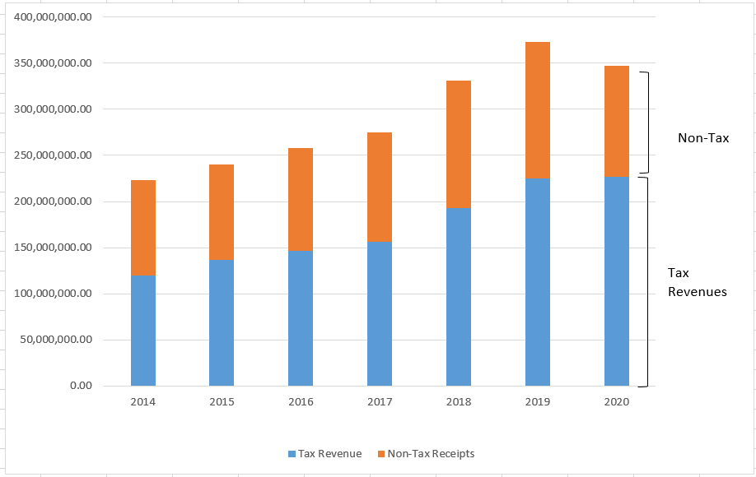

Figure 2. Income Performance of Panabo City 2014-2020

On the other hand, non-tax receipts exhibits a slower growth trajectory. Beginning at php103.7 million in 2014, non-tax revenues peaked at Php148.6 million in 2019 before declining to Php121.0 million in 2020. This overall increase of 16.6% is modest compared to the rapid growth in tax revenue. The decline in non-tac receipts in 2020 may indicate challenges in revenue collection from fees, charges and other non-tax sources, possibly influenced by external factors such as the economic slowdowns or reduced local activities.

Overall, Panabo City’s income performance shows a positive trend, underpinned by the significant growth of tax revenue, which has increasingly become the backbone of local income generation. However, the decline in non-tax receipts in 2020 highlights the need to diversify income sources to ensure sustainable revenue generation. Strengthening both tax and non-tax revenue streams will be crucial for the LGU to maintain fiscal stability and support its long-term development goals.

***External Source (Share from National Tax Collection)***

The table below provides an overview of the total external revenue sources for the Panabo City LGU from 2014 to 2020, categorized into the Internal Revenue Allotment (IRA)/ National Tax Allotment (NTA) and other shares. The data highlights a steady growth in external revenues over the seven-year period.

**Table no. 3  
External Source of Panabo City CY 2014-2020**

|  |  |  |  |
| --- | --- | --- | --- |
| **YEAR** | **Total External Source** | **IRA / NTA** | **Other Shares** |
| 2014 | 444,155,071.63 | 443,634,612.09 | 520,459.63 |
| 2015 | 507,418,257.99 | 507,038,096.00 | 380,161.99 |
| 2016 | 555,082,397.85 | 554,912,304.00 | 170,093.85 |
| 2017 | 621,403,086.73 | 620,981.496.00 | 421,590.73 |
| 2018 | 668,033,668.04 | 620,981,496.00 | 421,590.73 |
| 2019 | 739,982,666.40 | 739,212,762.00 | 769,904.40 |
| 2020 | 830,479,376.25 | 829,672,451.04 | 806,925.21 |

*Source: City Treasury Office, 2020*

The total external revenue grew from Php 444.16 million in 2014 to Php 830.48 million in 2020, reflecting an overall increase of 87% over the seven years. In average, the annual growth rate is at approximately 9.5%, indicating consistent increases in external revenue allocations.

**Comparative Analysis between Local and External Revenue Sources**

Panabo City’s external revenue is heavily dependent on IRA/NTA as shown in the table no 4. This dependence underscores the importance of the national government’s allocations to LGUs. Several implications could arise given that the LGU Panabo is heavily dependent with the external source from the national government – there is the limited fiscal autonomy. This can hinder the development of local economies and communities, as the LGU may not have the financial flexibility to implement a long-term, self-sustaining programs.

Since IRA/NTA is based in the national tax collections, any fluctuations in the country’s revenue or changes in the tax policies can directly impact the financial stability of the LGU. A decrease in national revenue or policy shifts could reduce the amount allotted to local governments.

**Table no. 3  
Comparative Analysis between Local and External Source**

|  |  |  |  |  |  |
| --- | --- | --- | --- | --- | --- |
| **YEAR** | **Total Local Source** | **Total External Source** | **% Local Source** | **% External Source** | **TOTAL** |
| 2014 | 223,607,130.60 | 444,155,071.63 | 33% | 67% | 100% |
| 2015 | 239,859,068.85 | 507,418,257.99 | 32% | 68% | 100% |
| 2016 | 257,910,705.53 | 555,082,397.85 | 32% | 68% | 100% |
| 2017 | 274,645,026.13 | 621,403,086.73 | 31% | 69% | 100% |
| 2018 | 330,792,012.93 | 668,033,668.04 | 33% | 67% | 100% |
| 2019 | 373,418,350.30 | 739,982,666.40 | 34% | 66% | 100% |
| 2020 | 347,573,899.63 | 830,479,376.25 | 30% | 70% | 100% |

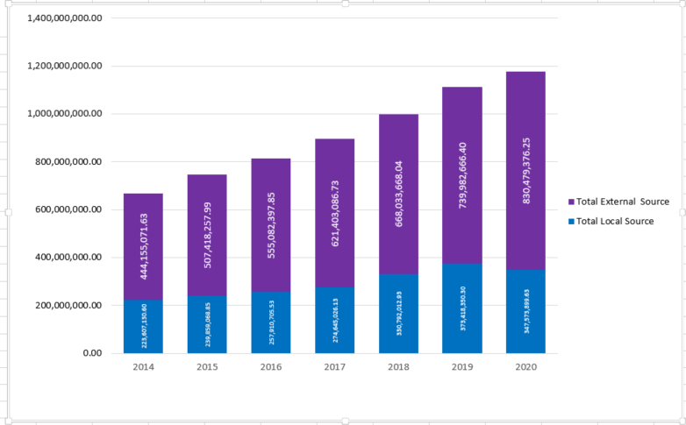Figure 3. Graph showing the distribution of local and external income Sources of Panabo City (2014-2020)

Given that Panabo City relies mainly on IRA/NTA, it may struggle to fund its own development initiatives, infrastructure projects, or public services without additional local income source in the taxes or business revenues. This could lead to underinvestment in critical areas like education, healthcare, or infrastructure. When an LGU receives a substantial IRA/NTA shares, there may be a less motivation to develop other revenue sources, such as local taxes or attracting private investments. This could stifle local economic growth and limit the opportunities for diversification and resilience in the long term.

1. **Annual Expenditure Trends of Panabo City (2014-2020)**

The figure below illustrates a general upward trend in the LGUs expenditures, nearly doubling over the six-year period. This growth likely reflects increasing investments or allocations driven by expanding programs, evolving development priorities, or the impact of inflation. The most significant growth is observed between 2016 and 2018, indicating a period of intensified spending. While the smallest changes are noted between 2018 and 2020, suggesting a stabilization or a plateau in expenditure levels.

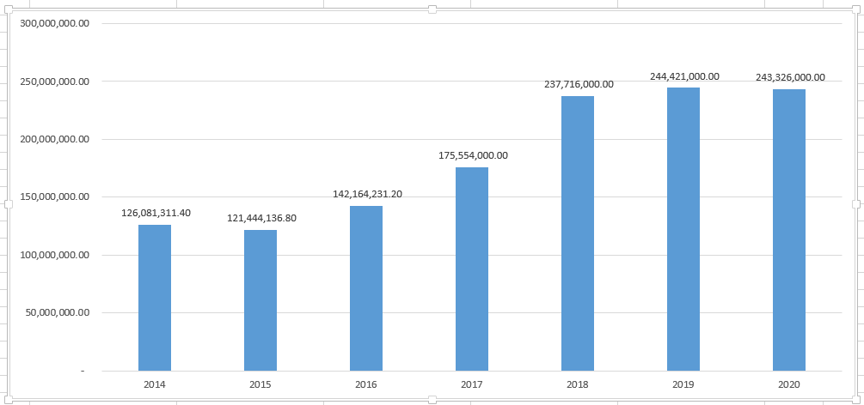

Figure 4. Annual Expenditure Trends of Panabo City (2014-2020) based in the Annual Investment Program (AIP) Budget Allocation.

The graph depicts the annual expenditure of LGU Panabo City from 2014-2020. In the year 2014-2015, there is a slight decrease in expenditures, from approximately Php126 million in 2014 to Php 121 million in 2015, indicating a reduction of around Php 5 million. At year 2015 to 2016, Expenditures increase to about Php 142 million, representing a significant growth of approximately Php 21 million. In 2016-2017, there was a sharper rise occurs, with expenditures reaching to Php 175 million, marking an increase of roughly Php 33 million. By 2017-2018, a notable jump in spending brings the total to Php 237 million, a substantial increase of about Php 62 million. In 2018-2019, the upward trend continues slightly, with expenditures rising to Php 244 million, reflecting a smaller increase of Php 7 million. By 2019-2020, there was a significant decline in expenditures, with the amount dropping to Php 243 million, a marginal reduction of Php 1 million.

1. **Development Sectors: social, environmental, infrastructure, economic and institutional**

***Under the 20% Development Fund***

The 20% Development Fund (DF) is a mandatory allocation by the Local Government Units (LGUs), requiring that 20% of their annual IRA/NTA be earmarked exclusively for development projects. This mandate is rooted in the Republic Act No. 7160, also known as the Local Government Code of 1991, which empowers LGUs to exercise autonomy in managing resources for local development. Section 287 of the ssaid law specifically states that LGUs should appropriate a portion of their IRA/NTA for development purposes. The primary goal of the 20% development fund is to foster socio-economic growth and improve the quality of life in local communities. It can be used to finance a wide range of projects, including economic development initiatives such as livelihood programs, social services like health and education facilities, infrastructure projects such as roads, public markets, and drainage systems and environmental management efforts like solid waste management and disaster risk reduction (DILG-DBMS JMC No. 2011-1).

The graph below illustrates the annual expenditures of Panabo City from 2014 to 2020 under the 20% Development Fund, categorized into five sectors: Social Development, Economic Development, Environmental Management, Infrastructure Development and General Services.

In general, the graph shows a prioritization of Economic development, with significant spikes in Infrastructure Development in 2018, suggesting targeted projects during that year. Other sectors like Environment Management and General Services receive relatively smaller shares of the budget.

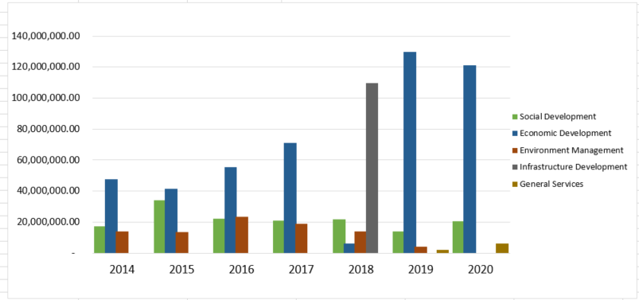

Figure 5. Annual allocation of 20% Development Fund (DF).

Figure 6A & 6b. 20% DF Budget allocation for years 2018 compared 2019.

Figures 6A and 6B compare the budget allocations of Panabo City for 2018 and 2019across various sectors. In 2018, Infrastructure development dominated the budget, accounting for 73% of the total allocation. This reflects a significant focus on infrastructure-related projects, which could have included road construction, public buildings, and other major capital investments. The remaining budget was divided among the social development (14%), environment management (9%), and economic development (4%), emphasizing a more balanced but infrastructure-heavy approach development.

In contrast, the 2019 budget reveals a shift in priorities, with economic development taking the largest share at 87%. This substantial increase in economic investment indicates a strong focus on initiatives aimed at promoting local economic growth, possibly through business support, job creation, and industry development. Allocations for social development decreased to 9%, while environment management accounted for 3%, the general services was introduced with a minimal allocation of 1%. Notably, infrastructure development, which dominated the 2018 budget, was entirely absent in 2019.

***Under the Locally Funded (LF) Projects***

Locally funded projects of Local Government Units (LGUs) refer to initiatives and programs that are financed primarily through the internal revenue and budget allocations of local governments. These projects are usually designed to address the specific needs and priorities of the local community, in contrast to nationally funded projects, which are typically supported by national government funds. Locally funded projects include the construction and maintenance of roads, bridges, and public markets, as well as the development of local health centers, schools, and public parks. These projects are often determined based on local needs assessments, which take into account factors such as population growth, 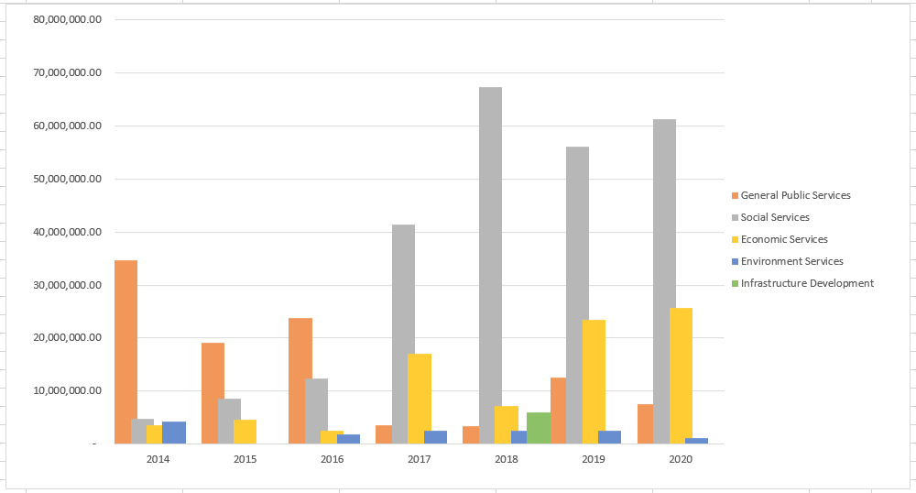economic activities, and social development priorities.

Figure 7. Budget allocation of LGU Panabo (2014-2020) under the Local Funds (LF)

The above figure illustrates the budget allocation of LGU Panabo under the Local Fund (LF) across the five (5) key development sectors. As shown, Social services consistently received the highest allocation, emphasizing the LGUs commitment to human development. General Public services showed fluctuations, with a notable increase by 2018, possibly reflecting efforts to improve administrative efficiency. Economic services receives the least allocation, indicating a potential need for increased attention, however it is also observed under the 20% DF – the economic development was being prioritized. The infrastructure development received moderate allocations, suggesting a focus on maintaining existing infrastructure. These trends imply a prioritization of social well-being, economic development, and administrative efficiency, while environmental concerns and infrastructure development might require further attention.

**Chapter 5**

**Summary, Conclusion and Recommendation**

Presented in this chapter are the summary and conclusion derived from the analysis and interpretation based on the comparative analysis from the previous chapter.

**Summary**

The study analyzed the income and expenditure patterns of Local Government Unit of Panabo City from 2014 to 2020, focusing on revenue source and expenditure allocations. Results indicate a steady growth in total income, with a significant reliance on external funding, particularly from the Internal Revenue Allotment (IRA) or the National Tax Allotment (NTA), Local income, primarily driven by tax revenues, increased by 55.5%, while non-tac revenues exhibited modest growth. Expenditures also trended upward, highlighting investments in development sectors such as infrastructure and economic growth. The 20% Development Fund revealed shifting priorities, from infrastructure projects in 2018 to economic initiatives in 2019. Locally funded projects prioritized social services and general administration but showed limited emphasis on economic and environmental sectors.

**Conclusion**

Panabo City’s fiscal management demonstrates a commendable ability to generate income and allocate resources effectively to meet its developmental objectives. From 2014 to 2020, the city’s local income experienced a steady upward trend, increasing by 55.5%, with tax revenues showing remarkable growth of 89% over the period. This growth highlights the city's improved efficiency in tax collection and its responsiveness to economic activities. Despite these achievements, non-tax revenue showed only modest growth, suggesting untapped potential in diversifying income sources.

However, a critical aspect of Panabo City’s fiscal profile is its significant dependence on external funding, particularly the Internal Revenue Allotment (IRA) or National Tax Allotment (NTA). External sources consistently accounted for approximately 67-70% of the city’s total income during the study period. This reliance limits the LGU’s fiscal autonomy and exposes it to vulnerabilities such as changes in national tax collection policies or revenue fluctuations at the national level. Such dependence may hinder the city’s ability to implement self-sustaining, long-term initiatives.

In terms of expenditure, Panabo City prioritized infrastructure and economic development, with infrastructure projects dominating the 20% Development Fund in 2018 and economic initiatives receiving the largest share in 2019. These investments reflect a strategic focus on fostering local economic growth and enhancing public infrastructure. However, other critical areas, such as environmental management and projects supporting long-term sustainability, received relatively minimal allocations. For instance, environmental initiatives accounted for less than 10% of the development fund in most years, indicating a gap in addressing ecological concerns and disaster resilience.

These findings highlight the importance of diversifying revenue streams to reduce dependency on external funding and rebalance budgetary allocations. Emphasizing sectors like environmental sustainability and social equity alongside continued economic and infrastructure development will help ensure the city’s fiscal resilience and promote inclusive growth.

**Recommendations**

To address the challenges identified in Panabo City’s fiscal management, several key recommendations are proposed. First, enhancing revenue diversification is critical. The LGU should strengthen efforts to improve local tax collection efficiency by adopting modernized systems and expanding the tax base. Further exploring non-tax revenue opportunities, such as forming public-private partnerships or developing enterprise-based income streams, can provide sustainable alternatives to traditional funding sources.

Reducing dependence on external funds is equally important. Strategies should be developed to gradually lessen reliance on the Internal Revenue Allotment (IRA)/National Tax Allotment (NTA). This can be achieved by fostering local economic growth through policies that encourage private investments, business development, and innovative financing mechanisms, which will, in turn, increase the city’s local income.

Expenditure priorities must also be rebalanced to address gaps in areas like environmental sustainability and long-term development. Allocating more resources to environmental management and disaster risk reduction will promote resilience, while equitable investment across sectors will ensure that the city’s growth benefits all constituents.

Transparent financial planning is essential for effective governance. The LGU should adopt data-driven and participatory budgeting processes to align resource allocation with community needs and the city’s broader development goals. By involving stakeholders in financial decision-making, the LGU can build public trust and ensure that funds are directed toward impactful projects.

Finally, strengthening monitoring and evaluation mechanisms is necessary to track the effectiveness of expenditures and measure their impact on development outcomes. Regular assessments will help identify inefficiencies, ensure accountability, and guide the LGU in optimizing its financial strategies for sustainable growth. By implementing these recommendations, Panabo City can improve its fiscal autonomy, resilience, and capacity to meet its developmental aspirations.



1. IRA - following the Mandanas-Garcia ruling, and the IRA was renamed as the National Tax Allotment (NTA).