**MODELLING THE NON-LINEAR BEHAVIOUR OF A 3D REINFORCED CONCRETE BEAM USING THE CONCRETE DAMAGE PLASTICITY MODEL.**

**Dr Okafor Chinedum Vincent1, Okeke Emmanuel Chukwuebuka2, Dr Ononye Roy3**

1Lecturer, Building, Nnamdi Azikiwe University, Awka, Anambra, Nigeria

2Scholar, Building, Nnamdi Azikiwe University, Awka, Anambra, Nigeria

3Lecturer, Department, Federal College of Education, Asaba, Delta, Nigeria

**ABSTRACT**

The aim of the study is to model the non-linear behavior of reinforced concrete beams using the concrete damage plasticity model. **The study also** investigated the compressive strain relation based on theoretical methods proposed by Carreira and Chu (1985), Hognestad et al (1989) and Kent and Park (1971). The concrete in tension was modelled as linear elastic brittle material with strain softening. The modified stress-strain relationship for linear elastic brittle material with strain softening was suggested by (Said and Mohie, 2012). With respect to the results obtained and summarized, it was observed that the stress-strain curve for the Hognestad model and the Kent and park model had a good agreement. However, at the descending branch, the Kent and park model showed greater softening behavior compared to the hognestad model. The difference in strain softening did not affect the post processing result of the compressive damage.

**Keywords:** Non-Linear Analysis, Stress-Strain Relationship, Concrete Damage Plasticity.

1. **INTRODUCTION**

Many researchers have made valuable contributions in understanding the behavior of concrete and has developed sophisticated methods of analysis (Chandhari and Chakrabar, 2012). Concrete is both homogeneous and isotropic. The physical behavior of concrete is complicated with very complicated stress-strain relationship. Therefore, modelling of concrete structure is very complicated due to the non-linear stress-strain relation in multi axial stress, tension softening behavior, pull out of reinforcement and aggregate interlocking. The compression response of concrete is highly non-linear and can be described numerically using several approaches (Chen, 2007). One approach of describing the compressive strength of concrete is by representing the stress-strain relation through curve fitting methods using standard codes or by elastic and plastic theories (Ortiz, 1985).

The uniaxial compressive behavior of concrete can be determined by either experimental tests or existing constitutive models such as does proposed by (Carreira and Chu, 1985), (Hognestad, 1989) and (Kent and Park, 1971). The authors made use of a wide range of experimental data with varied laboratory tests for fitting and other data to verify the model.

# **Concrete damage plasticity model**

The concrete damage plasticity material model was originally developed by (Lubliner, J.; Oliver, J.; Oller, S.; Oñate, E., 1989) and subsequently modified and improved by (Lee, J.; Fenves, G.L, 1998). As stated by (Lu, W.; Lubbad, R.; Løset, S.; Høyland, K, 2012), to model the damage process, it is necessary to define a constitutive law in order to determine the stress–strain law, a yield criterion, a hardening law, and a flow rule to describe the post-elastic response and, in the end, a damage initiation criterion and a damage evolution law.

* 1. **Damage parameters**

Lubliner et al, (1989). Proposed a material model based on a new yield criterion to account for both elastic and plastic loss of stiffness due to the occurrence of cracks which are associated with concrete damage. In general, the concrete damaging process can affect its material properties, such as its stiffness.

Lee and Fenves (1998) later pointed out that a single scalar damage variable was only useful for analyzing monotonic loading problems. For the uniaxial case, the scalar damage variable *d* reduces the elastic modulus as explained below:

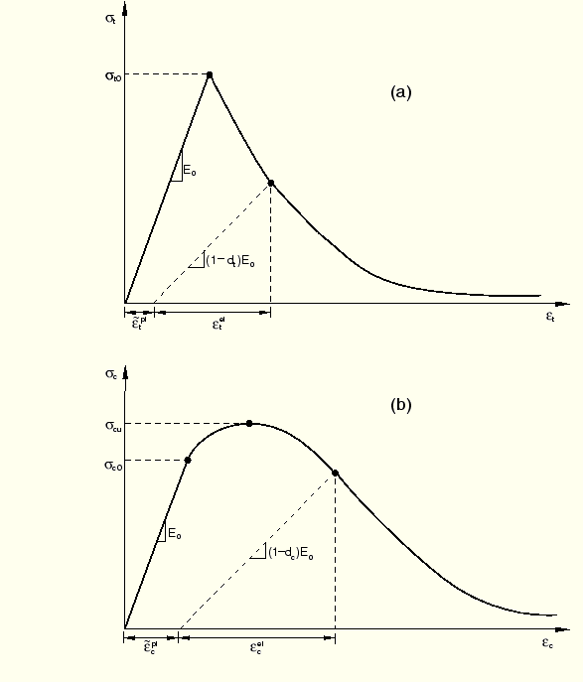

Figure 1: Response of concrete to uniaxial loading in tension (a) and compression (b).

As shown in figure 1B, Under uniaxial tension the stress-strain curve follows a linear elastic relationship until it reaches failure stress, . The failure stress signifies the beginning of micro-cracking in the concrete material. Beyond the failure stress the curve shows a downward branch called the softening branch, this branch signifies the formation of micro-cracks, which induces strain localization in the concrete structure.

As shown in figure 1A, Under uniaxial compression the stress-strain curve follows a linear elastic relationship until it reaches the initial yield,. In the plastic regime the response is typically characterized by stress hardening followed by strain softening beyond the ultimate stress,. This representation, although somewhat simplified, captures the main features of the response of concrete.

It is assumed that the uniaxial stress-strain curves can be converted into stress versus plastic-strain curves. (This conversion is performed automatically by ABAQUS from the user-provided stress versus “inelastic” strain data, as explained below.) Thus,

$σ_{t}=σ_{t}(ε_{t}^{pl}$, $ε_{t}^{pl},$ $θ,f_{i})$-----------1

$σ_{c}=σ_{c}(ε_{t}^{pl}$, $ε_{t}^{pl},$ $θ,f_{i})$-----------2

Where the subscripts *t* and *c* refer to tension and compression, respectively; $ε_{t}^{pl}$  and $ε_{c}^{pl}$  are the equivalent plastic strains, $ε_{t}^{pl}$  and $ε_{c}^{pl}$  are the equivalent plastic strain rates,  is the temperature, and  are other predefined field variables.

As shown in Figure 1, when the concrete specimen is unloaded from any point on the strain softening branch of the stress-strain curves, the unloading response is weakened: the elastic stiffness of the material appears to be damaged (or degraded). The degradation of the elastic stiffness is characterized by two damage variables, $d_{t}$  and $d_{c}$ , which are assumed to be functions of the plastic strains, temperature, and field variables:

$d_{t}=d_{t}\left(ε_{t}^{pl}, θ,f_{i}\right);0≤d_{t}≤1$------------------3

$d_{c}=d_{c}\left(ε_{c}^{pl}, θ,f_{i}\right);0≤d_{c}≤1$-----------------4

The damage variables can take values from zero, representing the undamaged material, to one, which represents total loss of strength.

If $E_{0}$ is the initial (undamaged) elastic stiffness of the material, the stress-strain relations under uniaxial tension and compression loading are, respectively:

$σ_{t}=(1-d_{t})E_{0}(ε_{t}-ε_{t}^{pl}$)----------------5

$σ_{c}=(1-d_{c})E_{0}(ε_{c}-ε_{c}^{pl}$)--------------6

We define the “effective” tensile and compressive cohesion stresses as

$∂_{t}=\frac{∂_{t}}{(1-d_{t})}=E_{0}(ε_{t}-ε_{t}^{pl}$)----------------7

$∂_{c}=\frac{∂_{c}}{(1-d_{c})}=E_{0}(ε_{c}-ε_{c}^{pl}$)----------------8

The effective cohesion stresses determine the size of the yield (or failure) surface. The relationships introduced above can be generalized for multi axial stress states. In this case, the stress–strain relationships are governed by the scalar damage elasticity equation (Smith, 2022):

***σ*** = (1 − *d*)***D****el* : ***ε*** − ***ε****pl* ----------------9

where *Del* is the elasticity matrix referred to as the initial condition, namely the undamaged one; ***ε***0 is the strain tensor and ***ε****pl* is the plastic part of the strain tensor, decomposing the strain tensor into elastic and plastic parts (Lee and Fenves, 1998)

* 1. **Concrete Modelling**

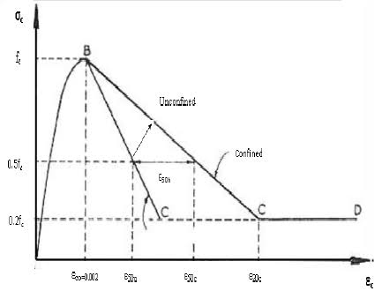

Figure 2: Uniaxial Compression curve for Kent and Park Model



Figure 3: Uniaxial Compression curve for the Hognestad et al Model

Under uniaxial compression, the ascending branch of the curve for both models (Figure 2 and 3) are linear until the value of the initial yield stress (бϲ₀). In the plastic region, the descending branch of the stress-strain curve is characterized with strain hardening (бϲ₀ to ƒ’ϲ). Beyond the ultimate compressive strength (ƒ'ϲ), strain softening begins to develop.

Carreira and Chu 1985, proposed a general equation to represent the complete stress-strain relationship of plain concrete as follows:

$\frac{ƒϲ}{ƒ’ϲ}=\frac{β({εc}/{ε^{'}ϲ})}{β-1+{({εc}/{ε^{'}ϲ})}^{β}}$-----------------------------10

Where, $β$ is a material parameter that depends on the shape of the stress-strain diagram. This parameter can be determined from compressive test in which the strain rate is controlled. In the absence of a compressive test, the parameter can be determined from equation 8

$β=\frac{1}{1-{ƒ’ϲ}/{ε^{'}ϲ*Ԑit} }$---------------------------------11

$ε_{it}$ = $\frac{ƒ’ϲ}{ε^{'}ϲ}(\frac{24.82}{ƒ’ϲ}+0.92)$------------------------12

$ε^{'}ϲ$ = (0.71* ƒ’ϲ + 168)*(0.00001)-----------13

$Ԑit$ = Initial Tangential Modulus which can be determined with equation 12

$ε^{'}ϲ$ = Strain corresponding to maximum stress which can be determined with 13

$Ԑϲ$ = Compressive strain,

$ƒ’ϲ$ = Concrete stress.

Unlike the carreira and Chu, 1985) that proposed only one equation for both the ascending and descending branches of the stress-strain relationship of concrete in compression, (Hognestad et al, 1989) proposed a numerical model that treats the ascending part of the stress-strain relation as a parabola and descending part as a straight line.

According to the (Hognestad et al, 1989),

$\frac{ƒϲ}{ƒ’ϲ}$ = $\frac{2Ԑϲ}{ε^{'}ϲ}(1-\frac{Ԑϲ}{2ε^{'}ϲ})$-----------------------------14 for 0 $<ε_{c}<ε^{'}ϲ$

$\frac{ƒϲ}{ƒ’ϲ}$ = $1-0.15(\frac{Ԑϲ}{Ԑu}-\frac{ε^{'}ϲ}{2ε^{'}ϲ})$---------------------15 for 0 $<ε_{c}< Ԑu$

Where, $Ԑu$ = ultimate compressive strain.

From figure 2 represents the stress-strain curve for Park and Kent, 1989, model. Figure 2 indicated a parabolic increasing branch (A-B) for the hardening stage while a linear behavior (B-C) was observed for the softening stages of the concrete.

The softening phase continued until 20% of the unconfined cylinder compressive strength (Point C) was reached and perfect plastic behavior was assumed following the softening branch(C-D).

$ƒϲ$ = $ƒ’ϲ$ (2 $\frac{Ԑϲ}{ε^{'}ϲ}-({\frac{Ԑϲ}{ε^{'}ϲ})}^{2}$-----------------------16

Park and kent, 1989. Reported that $ε^{'}ϲ$ equaled 0.002.

Table 1: Stress-Strain relation

|  |  |  |  |  |  |  |  |
| --- | --- | --- | --- | --- | --- | --- | --- |
| Ϭcu | ϭ | Hognestad Strain | Park and kent Strain | ϭ/ϭϹu | EQUATION 13 | EQUATION 14 | EQUATION 15 |
| 27 | 0 | 0 | 0 | 0 | 0.002 | 0 |  |
| 27 | 2 | 7.55E-05 | 7.55E-05 | 0.0741 | 0.002 | 0.074075 |  |
| 27 | 4 | 0.000154 | 0.000154 | 0.1482 | 0.002 | 0.148148 |  |
| 27 | 6 | 0.000236 | 0.000236 | 0.2222 | 0.002 | 0.222223 |  |
| 27 | 8 | 0.000322 | 0.000322 | 0.2963 | 0.002 | 0.296297 |  |
| 27 | 10 | 0.000413 | 0.000413 | 0.3704 | 0.002 | 0.370371 |  |
| 27 | 12 | 0.000509 | 0.000509 | 0.4444 | 0.002 | 0.444445 |  |
| 27 | 14 | 0.000612 | 0.000612 | 0.5185 | 0.002 | 0.51852 |  |
| 27 | 16 | 0.000723 | 0.000723 | 0.5926 | 0.002 | 0.592594 |  |
| 27 | 18 | 0.000845 | 0.000845 | 0.6667 | 0.002 | 0.666667 |  |
| 27 | 20 | 0.000982 | 0.000982 | 0.7407 | 0.002 | 0.740742 |  |
| 27 | 22 | 0.001139 | 0.001139 | 0.8148 | 0.002 | 0.814816 |  |
| 27 | 24 | 0.001333 | 0.001333 | 0.8888 | 0.002 | 0.88889 |  |
| 27 | 26 | 0.001615 | 0.001615 | 0.9630 | 0.002 | 0.962963 |  |
| 27 | 27 | 0.002 | 0.002 | 1 | 0.002 | 1 |  |
| 27 | 26 | 0.00237 | 0.00238 | 0.9630 | 0.002 |  | 0.9630 |
| 27 | 25 | 0.002741 | 0.00254 | 0.9259 | 0.002 |  | 0.9260 |
| 27 | 24 | 0.003111 | 0.0026 | 0.8889 | 0.002 |  | 0.8889 |
| 27 | 23 | 0.003481 | 0.00276 | 0.8519 | 0.002 |  | 0.8519 |

Figure 4: Stress-Strain curve. Kent and Park model

**Figure 5: Stress-Strain curve Hognestad et al model**

1. **METHODOLOGY**
   1. **Material Properties of Concrete**

The elastic behavior of the concrete was modelled considering simple linear elasticity with young modulus of elasticity and Poisson ration as the material constants. Young modulus of elasticity represents a stiffness parameter and is defined as the ratios of the stress over strain.

Therefore, ECM $=\frac{23045.92N}{{MM}^{2}}$

Poisson ratio is defined as the negative ratio of transversal rate of expansion of the strain over the axial contracting rate of strain when subjected to compression. The values for both parameters are presented in Table 2.

Table 2: Elastic Parameters for concrete.

|  |  |
| --- | --- |
| **Young’s Modulus** | $$\frac{23045.92N}{{MM}^{2}}$$ |
| **Poisson’s ratio** | **0.2** |

The simply supported beam is presented in figure 7, which is an RC beam with span of 1000mm and section height of 75mm and breadth of 230mm, 40mm concrete cover. In ABAQUS, the concrete adopted three dimensional hexahedral element, with 8 nodes (C3D8R element) and the reinforcement used Two-nodes, 3-dimensional truss element (T3D2 element). The reinforcement was embedded in the concrete element to simulate the bonding reinforcement between reinforcement and concrete.

Using the concrete damage plasticity in ABAQUS, to define the material, the stress- strain data of the concrete material under compression and tension should be provided beforehand. If the complete data is not available, available expression from relevant theories can be used to generate the stress strain curve of the concrete material. The constitutive model for the concrete axial compression as used in this research was based on formulae suggested by Hognested et al (1955) and Kent and Park (1971)

In ABAQUS, the user provides the data for compressive damage and inelastic compressive strain. In return, ABAQUS will internally compute the plastic strain as follows:

$ε_{c}^{pl}=ε_{c}^{in}-\frac{d_{c}}{(1-d_{c)}}×\frac{σ_{cu}}{ECM}$**----------------------16**

$ε_{c}^{in}= ε-ε_{c}^{el}$**----------------------------17**

$ε_{c}^{el}=\frac{σ_{cu}}{ECM}$**--------------------------------18**

$d_{c}=compressive damage parameter$, $ε_{c}^{in}=inelastic compressive strain$.

Ideally, the damage parameter is usually deduced from a material test with ramped loading/unloading cycles but according to (Lee and Fenves, 1998), in the absence of such data, the compressive damage parameter can be approximated as:

$d_{c}=1-\frac{σ}{σ_{cu}}$**,-------------------------------19**

The concrete in tension was modelled as linear elastic brittle material with strain softening. The modified stress-strain relationship for linear elastic brittle material with strain softening was suggested by (Said and Mohie, 2012) in figure 6. As shown in figure 6, the relationship assumed that the strain softening after cracking reduces the stress to zero at a total strain of about 16times the strain at first cracking.

Where $f_{ct max}$ is the maximum tensile stress of the concrete.

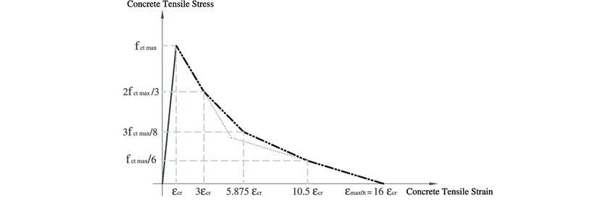

**Figure 6: Concrete tensile stress strain curve by Said and Mohie, 2012**

Table 3: stress strain data for compression in concrete

|  |  |
| --- | --- |
| **Stress** | **Strain** |
| **0** | **0** |
| **2** | **7.55E-05** |
| **4** | **0.000154** |
| **6** | **0.000236** |
| **8** | **0.000322** |
| **10** | **0.000413** |
| **12** | **0.000509** |
| **14** | **0.000612** |
| **16** | **0.000723** |
| **18** | **0.000845** |
| **20** | **0.000982** |
| **22** | **0.001139** |
| **24** | **0.001333** |
| **26** | **0.001615** |
| **27** | **0.002** |
| **26** | **0.00237** |
| **25** | **0.002741** |
| **24** | **0.003111** |
| **23** | **0.003481** |

**Source: Analytical calculation using formulas suggested by Hognested et al (1955)**

Table 4: stress strain data for compression in concrete

|  |  |
| --- | --- |
| **Stress** | **Strain** |
| **0** | **0** |
| **2** | **7.55E-05** |
| **4** | **0.000154** |
| **6** | **0.000236** |
| **8** | **0.000322** |
| **10** | **0.000413** |
| **12** | **0.000509** |
| **14** | **0.000612** |
| **16** | **0.000723** |
| **18** | **0.000845** |
| **20** | **0.000982** |
| **22** | **0.001139** |
| **24** | **0.001333** |
| **26** | **0.001615** |
| **27** | **0.002** |
| **26** | **0.00238** |
| **25** | **0.00254** |
| **24** | **0.0026** |
| **23** | **0.00276** |

**Source: Analytical calculation using formulas suggested by Kent and Park (1998)**

Table 5: Concrete Compression Damage

|  |  |
| --- | --- |
| **Compressive damage** | **Inelastic strain** |
| **0** | **0** |
| **0** | **2.62241E-05** |
| **0** | **0.000137433** |
| **0** | **0.0002593** |
| **0** | **0.000395652** |
| **0** | **0.000553339** |
| **0** | **0.000747335** |
| **0** | **0.001029101** |
| **0** | **0.001414** |
| **0.037037** | **0.00178437** |
| **0.074074** | **0.00215474** |
| **0.111111** | **0.00252511** |
| **0.148148** | **0.00289548** |

**Source: Analytical calculation using formulas suggested by Lee and Fenves (1998)**

Table 6: Concrete Compressive Behaviour

|  |  |
| --- | --- |
| **Yield Stress** | **Inelastic strain** |
| **13.5** | **0** |
| **14** | **2.62241E-05** |
| **16** | **0.000137433** |
| **18** | **0.0002593** |
| **20** | **0.000395652** |
| **22** | **0.000553339** |
| **24** | **0.000747335** |
| **26** | **0.001029101** |
| **27** | **0.001414** |
| **26** | **0.00178437** |
| **25** | **0.00215474** |
| **24** | **0.00252511** |
| **23** | **0.00289548** |

**Source: Analytical calculation using formulas suggested by Lee and Fenves (1998)**

Table 7: Concrete Tensile Behaviour

|  |  |
| --- | --- |
| Yield Stress | Cracking Strain |
| **3.637307** | **0** |
| **2.424871** | **0.000316** |
| **1.36399** | **0.000454** |
| **0.606218** | **0.00073** |

**Source: Analytical calculation using formulas suggested by Lee and Fenves (1998)**

Table 8: Concrete Tension Damage

|  |  |
| --- | --- |
| Damage Parameter | Cracking Strain |
| **0** | **0** |
| **0.333333389** | **0.000316** |
| **0.625000031** | **0.000454** |
| **0.833333347** | **0.00073** |

* 1. **Material property of steel**

For the analysis of steel the parameters are presented in Table 4.9

Table 9: Elastic and Plastic Parameters for steel

|  |  |
| --- | --- |
| **Young’s Modulus** | **2 x ${10}^{5}\frac{N}{{MM}^{2}}$** |
| **Poisson ratio** | 0.3 |
| **Yield Stress** | $460\frac{N}{{MM}^{2}}$ |
| **Plastic strain** | 0 |

**Source: BS8110-1-1997(Structural Use of Concrete)**

* 1. **Geometry**

The concrete part of the geometry and the reinforcement part were done separately as 3D deformable solid elements and merged together in an assembly module with the use of parallel face constrain (to align the reinforcement on the same direction with the concrete beam) and translating instance (to place the reinforcements on the corresponding location).

In order to get the stress and strains at the end of the analysis, a partition was defined on the full geometry beam by creating datum planes to place the supports(Pinned Supports) to serve as the end bearing of the beam(1/10th span of the beam).

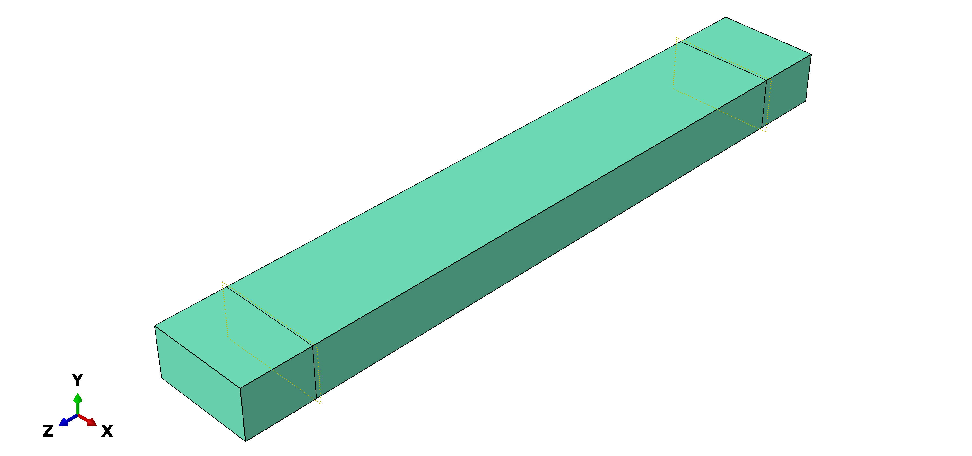

Figure 7: 150mm concrete Beam model

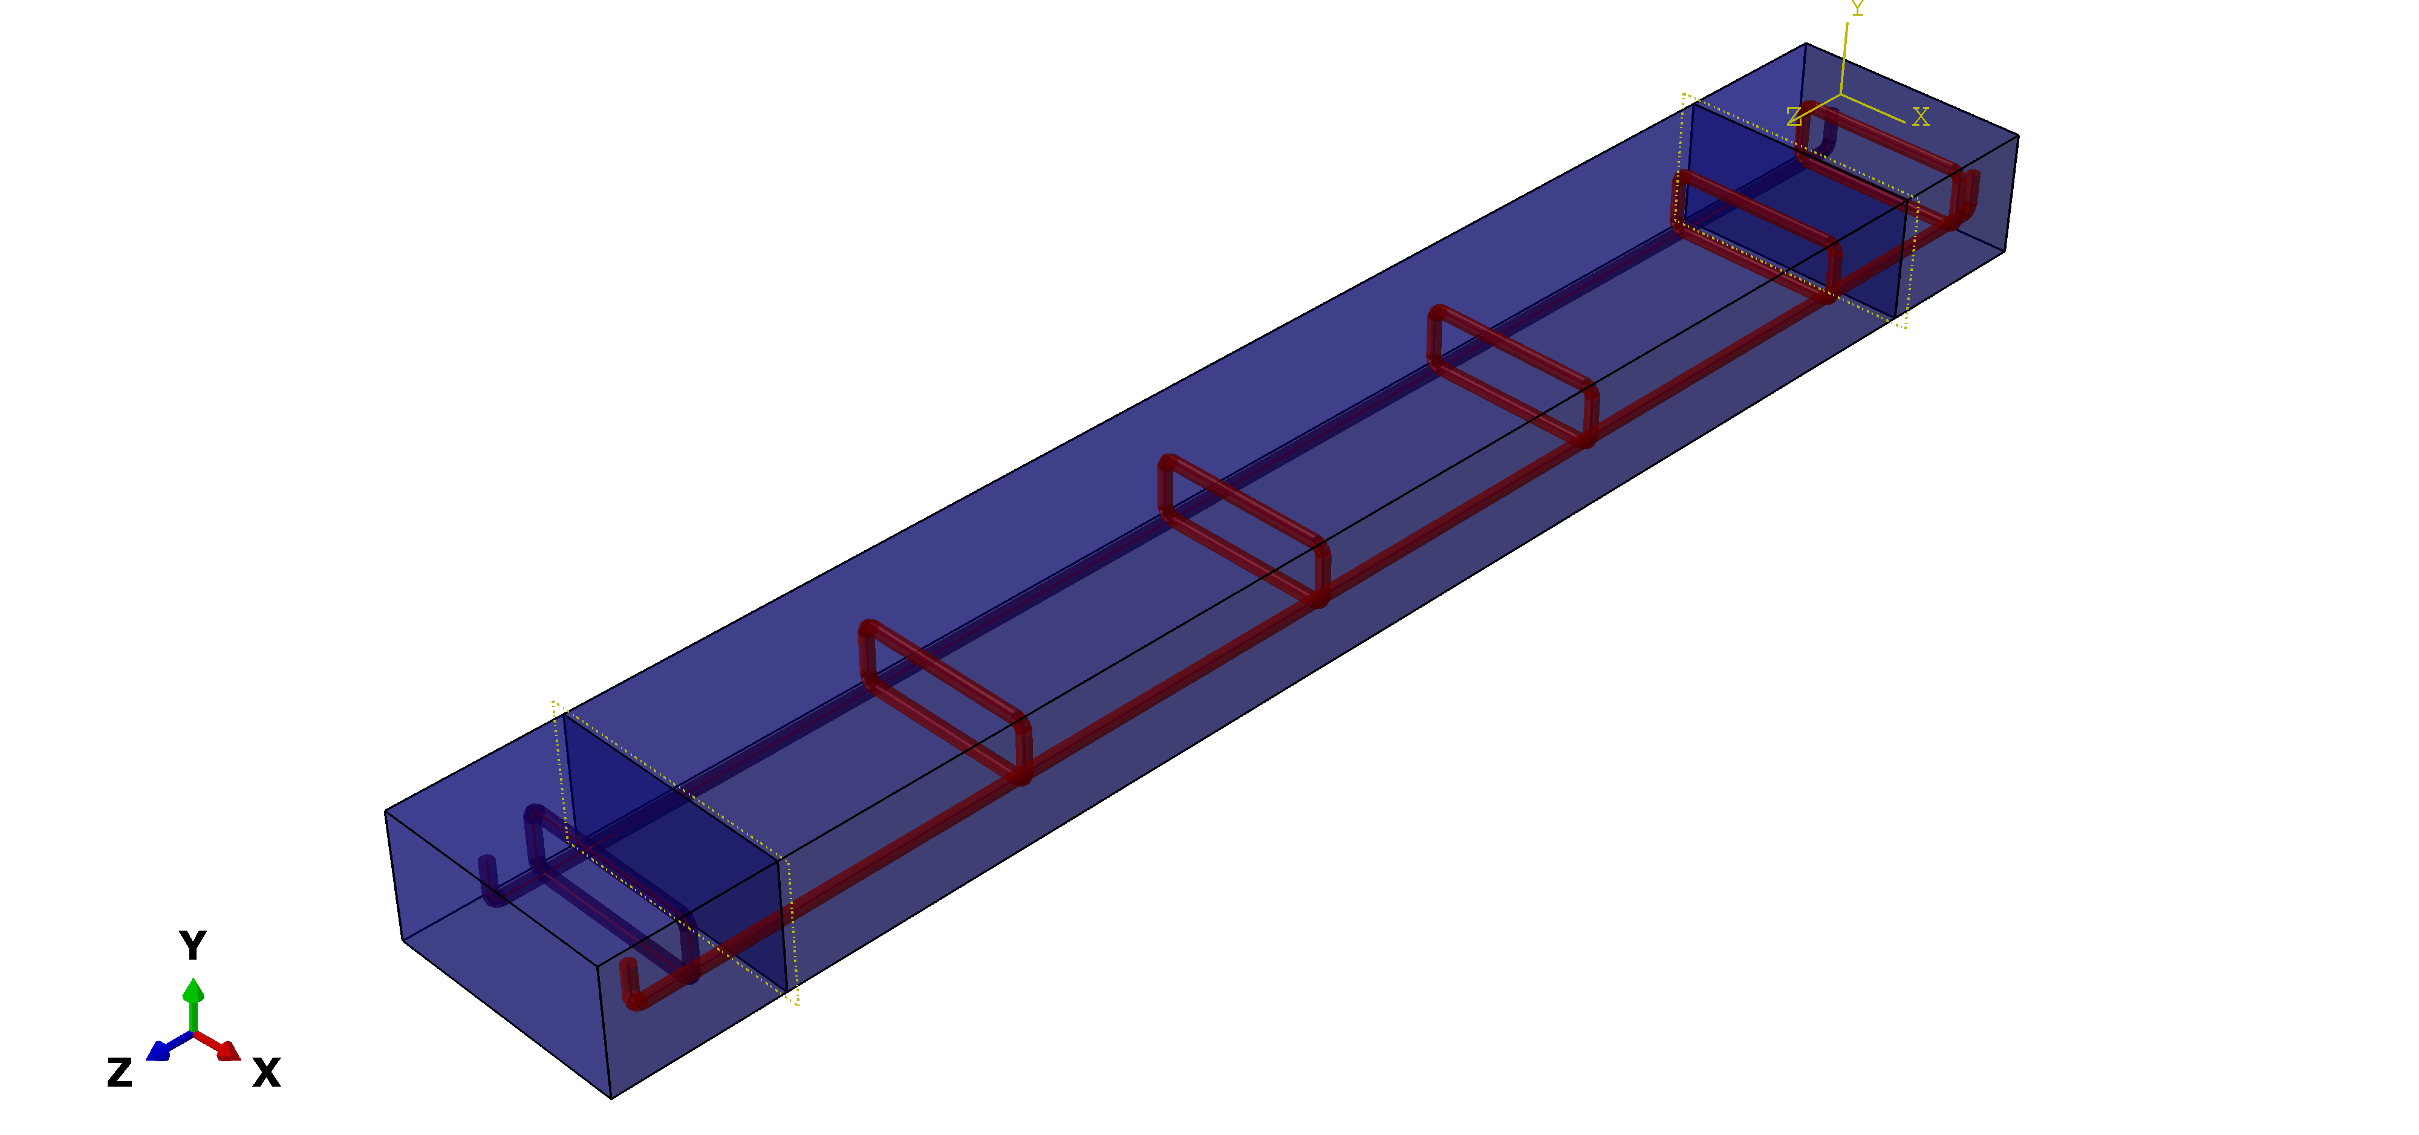

Figure 8: reinforcement bars embedded in the 150mm concrete Beam

* 1. Mesh system

One very important characteristic of finite element analysis is that the regions are divided into small part, so called finite element, and the software calculates a solution over each individual element. The first step in meshing the model is choosing the right type of element. There are severally types of element available in ABAQUS for the three dimensional analysis for the study, a three dimensional brick element with 8 nodes was used. In order to produce result in bending that are comparable to quadratic element but at a significant lower computational cost, Hexahedra incompatible mode with linear geometric order was adopted.

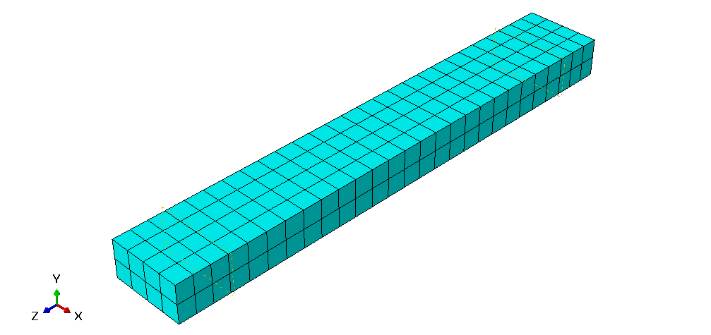

Figure 9: Mesh System with Hex element for the 150mm Beam model.

1. **RESULTS AND DISCUSSION**

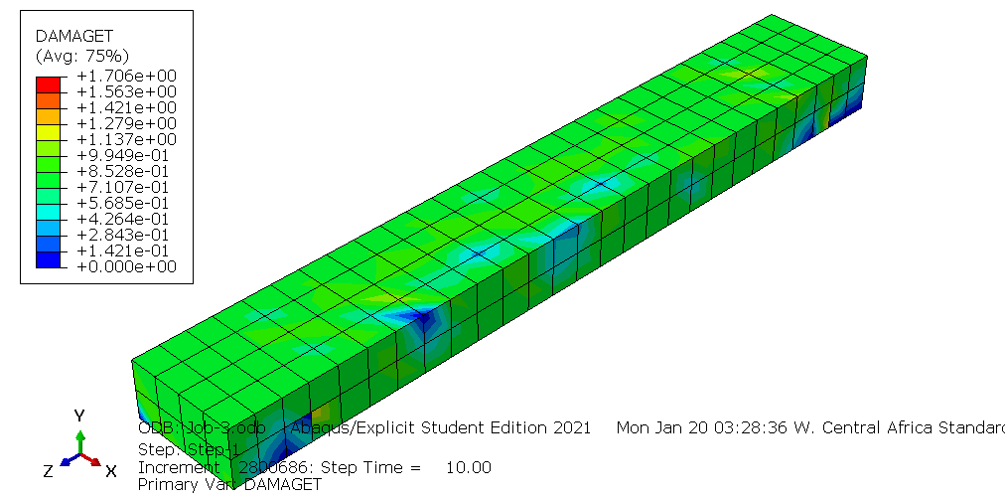

Figure 10: Post processing result for the tension damage using the Hognestad model

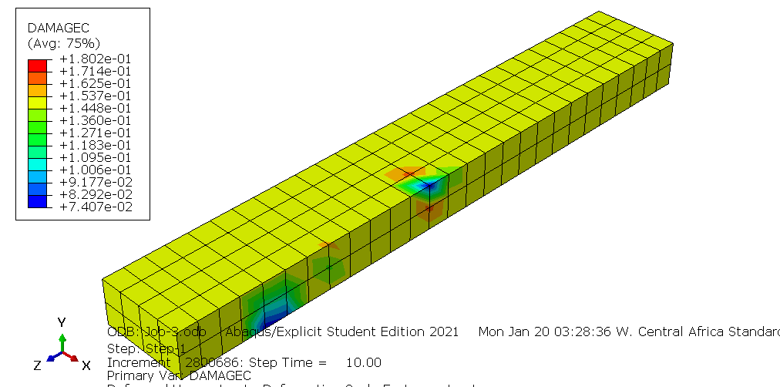

Figure 11: Post processing result for the compression damage using the Hognestad Model

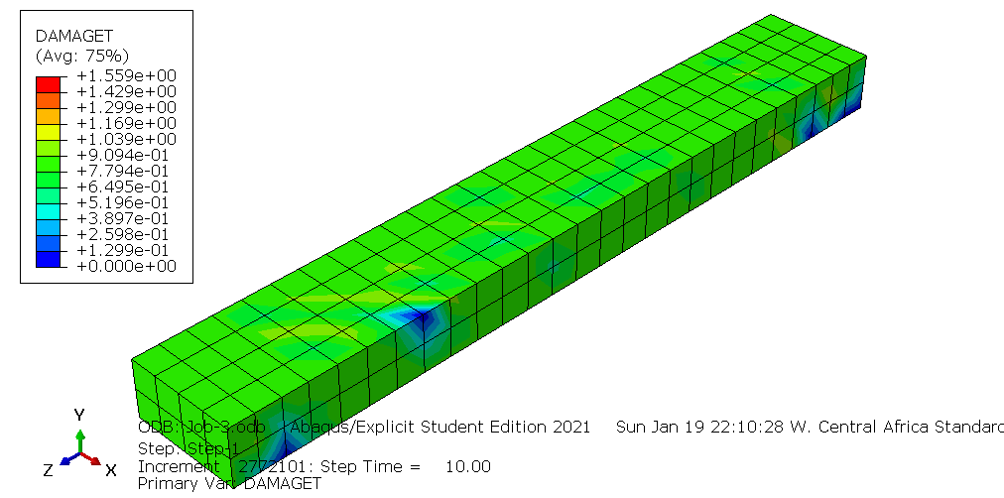

Figure 12: Post processing result for the tension damage using Kent and park model

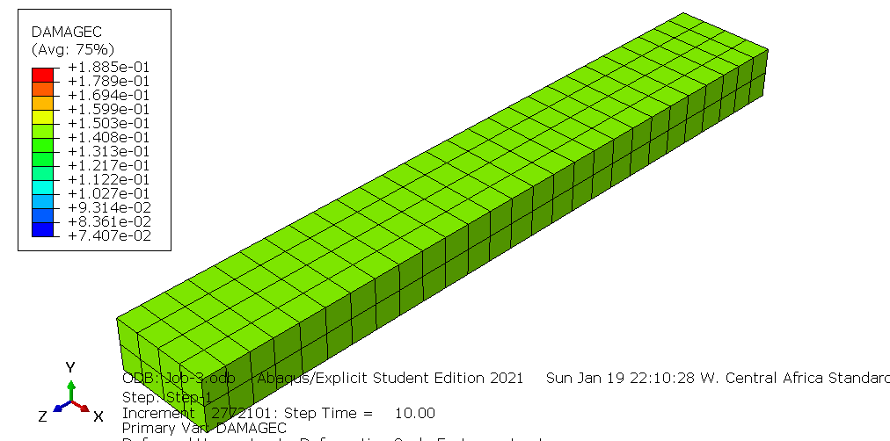

**Figure 13: Post processing result for the compression damage using the Kent and Park Model.**

The researcher was able to plot data of stress and strain relationship for both the hognestad model and the Kent and park model. With respect to the results obtained and summarized in table 2, it was observed that the stress-strain curve for the Hognestad model and the Kent and park model had a good agreement. The diagram clearly demonstrated a reasonable correlation between the stress-strain models at the ascending branch.

However, at the descending branch, the Kent and park model showed greater softening behavior compared to the hognestad model. The difference in strain softening did not entirely affect the post processing result of the compressive damage as seen in figure 11 and 13 with a value of 1802 ${mm}^{2}$ and 1885 ${mm}^{2}$ respectively. But the post processing result for the tension damage showed clear disagreement with a value of 1706N/ ${mm}^{2}$ and 1559 ${mm}^{2}$ for the Hognestad model and Kent and Park Model respectively.

1. **CONCLUSION**

The paper model the behavior of concrete for nonlinear analysis using concrete damage plasticity model in ABAQUS. The compressive stress strain relation for the study was derived using models developed by Hognestad et al (1989) and Kent and Park (1971). The study also compared the compressive stress strain behavior of the two models.

The tensile stress strain behavior of the concrete for the study was mode modelled as linear elastic brittle material with strain softening suggested by (Said and Mohie, 2012).

From the research findings, the post processing concrete damage results in tension were affected by the difference in softening behavior observed between the two compressive stress strain models.

1. **REFERENCES**
2. Abaqus Analysis User’s manual 6.10. Dassault Syste’mes Simulia Corp., Providence, RI USA.
3. Carreira D.J and Chu K.H (1985). Stress-strain relationship for plain concrete in compression. In Journal Proceedings, 1985.
4. Chaudhari S.V and Chakrabarti M.A (2012). Modelling opf concrete for nonlinear analysis using finite element code Abaqus. International Journal of computer application. Vol 44, No 7. PP: 14-18
5. Chen D (1995). Stress-strain behavior of high strength concrete cylinder.
6. Hognestad E, Hanson NW, McHenry D. Concrete Stress Distribution in Ultimate Strength Design, J ACI 1955; 27(24), 55-79.
7. Kent D.C and Park.R (1971). Flexural members with confined concrete. *J. struct. Division*, 97(7), 1969-1990.
8. Lee J and Fenves GL (1998). Plastic-Damage Model for Cyclic Loading of Concrete Structure, *Engineering Mechanics*. 124(8):892-900.
9. Lubliner, J.; Oliver, J.; Oller, S.; Oñate, E. A plastic-damage model for concrete. *Int. J. Solids Struct.* **1989**, *25*, 299–326.
10. Lu, W.; Lubbad, R; LØset, S.; HØyland, K. Cohesive Zone Method Based Simulations of Ice Wedge Bending: A Comparative Study of Element Erosion, CEM, DEM and XFEM. In Proceddings of the 21st IAHR International Symposium on Ice “Ice Research for a Sustainable Environment: Dalian, China, 11-15 June 2012; DSalian University of Tecgnology Press: Dalian, China, 2021. ISBN 978-7-89437-020-4.
11. Said M.A, Mohie S.S, Gehad E.R and Amal S.H (2012).Evaluation of tension stiffening effect on crack width calculation of flexural R.C Member Alexandria Engineering Journal, Vol 52, Issue 2, PP 163-173.