AUTOMATIC SUBSTATION CONTROL SYSTEM

# Ms. Mandlik Dipali.B 1, Mr.Avhad Deepak.R2 Mr. Dhomase Jaysing U3, Mr.Narode Devrndra S4, Mr. Shingade Ramdas S5, Mr. Gaikwad Rahul S6

1,2 Lecturer, Department of Electrical Engineering, Santosh N Darade Polytechnic, Yeola,Maharastra, India.

3,4,5,6 Students, Department of Electrical Engineering, Santosh N Darade Polytechnic, Yeola,Maharastra, India.

# ABSTRACT

The project is an automatic load operation system that controls load operation, multiple numbers of times according to programmed instruction. The project eliminates the manual ON/OFF switching of load. A real time clock (RTC) is used to track the time and automatically switch ON/OFF the load. This project is required for load shedding time management which is used when the electricity demand exceeds the supply and there comes a need for manually switching ON/OFF the electrical devices in time. Hence this system eliminates the manual operation by automatically switching the load ON/OFF. A matrix keypad is interfaced with the microcontroller from where the specified time is input to the microcontroller. When this input time equals to the real time, based on the commands the microcontroller initiates that particular relay to switch ON/OFF the load. The time is displayed on a seven segment display.

**Keywords:** Real time clock (RTC matrix keypad, microcontroller, seven segment display

# INTRODUCTION

In market several project is available which can be used to give Timing schedules. In market sequential timer circuit which is a CMOS timer. This timer can make ON one or more electronic or electric equipment in a specific sequence and turns them OFF after some particular time.

Another option a system is can be long duration timer which is available. Which uses timer MC IC. It is used along with ULN 2003 for giving time delay more than 30 min. it can give delay up to 24 hrs, 12 hrs, 6 hrs, 1.5 hrs, 45 hrs, 22.5 min. Another long duration timer uses MC IC which is counter, which uses only two ICs. It selects time which the help of switch. After complication of selected time period Relay becomes on and get connect with the circuit.

In requirement then do not requires large delay and system is not programmable. And again it cannot have password facility to avoid unauthorized access. The system will require less maintenance as compared to system discussed above and will have long life than above discussed above and will have long life then above discussed systems.

So there will not be any effect of power failure.

# METHODOLOGY

# PCB Making

Printed circuit boards (PCB) are metal foil conducting patterns usually copper, bounded to a support. The metal conducting patterns as a conducting medium for electronic components. PCB can be classified as follow.

# PCB Fabrication

1. **Single sided PCB: -**

The single sided PCB is used where the cost has to keep at a minimum. However, single sided PCB should be used wherever a particular circuit can be accommodated on such boards. If there is more jumper wires on the single sided then the use of the double sided PCB should be considered

1. **PCB Artwork: -**

The generation of PCB layout is the first step of the PCB manufacturing process. Event with most sophisticated PCB production Facilities, no PCB can be made better than quality of the artwork used. The various approaches use for making the artwork is discussed in the following paragraphs.

# Ink Drawing White Cardboard: -

The method is the earliest one used for PCB artwork design. The minimum requirement for the while cardboard sheet, ink and ink pen. The drawing procedure is very time consuming and requires good drawing skills. The precession obtained is slightly on the lower side.

# Black Tapping On Transport Base Foil: -

This method of artwork preparation is much faster and more precise with the availability of self adhesive or transfer pads and adhesive tapes in variety of size and widths. The artwork based foils mostly used today are polyester films which provides and excellent dimensional stability.

# Screen Printing Method:-

For the production of large number of identical commercial PCB screen printing methods is well suited. Screen printing is well known method a printing in industry; it has the capability of printing on any surface like glass, plastics, metals etc. Hence it is easily used on the fabrication of the artwork in the PCB designing.

In our project we have used this same technology. For the fabrication of our PCB’s. A screen fabric is stretched on the PCB and the image of the artwork is photographically transferred on to the board, using paint. The screen mesh is the made in such manner that the circuit paths can easily passed the paint but the other part is impermeable to the paint. Thus by this procedure we have the artwork on the PCB which can then processed for further processing.

# Etching:-

Etching is a process by which the unnecessary copper clad can be chemically washed out. A copper clad with screen printed artwork is ready for etching as the point used in screen printing acts as mask for the etching and when treated with the chemicals like ferric chloride the copper which is not covered by the point get washed away while the artwork remains on the PCB. The chemical reaction in the process is,

2FeCl3+Cu CuCl2+ 2FeCl2

Thus fabric chloride is a cheap chemical, least dangerous an easily available thus it is widely used for etching. For etching, the PCB is made to move freely in the solution of the fabric chloride for some time. After sometime the chemical reaction starts and the unmasked portion of the copper starts coming out. When the desired results have been achieved the PCB is washed with water.

# Drilling: -

The drilling can be done with the help of an electronic drilling machine or a manual one. We drilled the holes using the electronic drilling machines it was fast and more accurate than the manual one. The drilling has to be done very carefully because one error can be making the whole PCB useless.

# Iron Sholdering:-

In this shouldering technique each point is soldered one by taken while shouldering the component on to the PCB**.**

In market several project is available which can be used to give Timing schedules. In market sequential timer circuit which is a CMOS timer. This timer can make ON one or more electronic or electric equipment in a specific sequence and turns them OFF after some particular time.

Another option a system is can be long duration timer which is available. Which uses timer MC IC. It is used along with ULN 2003 for giving time delay more than 30 min. it can give delay up to 24 hrs, 12 hrs, 6 hrs, 1.5 hrs, 45 hrs, 22.5 min. Another long duration timer uses MC IC which is counter, which uses only two ICs. It

selects time which the help of switch. After complication of selected time period Relay becomes on and get connect with the circuit.

In requirement then do not requires large delay and system is not programmable. And again it cannot have password facility to avoid unauthorized access. The system will require less maintenance as compared to system discussed above and will have long life than above discussed above and will have long life then above discussed systems.

So there will not be any effect of power failure.

# CIRCUIT DIAGRAM

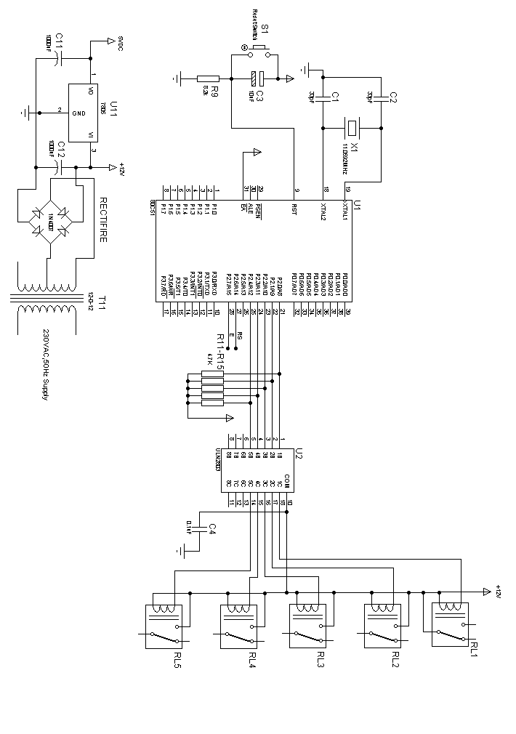

# WORKING PROCESS

1. **Power supply unit:-**

To provide regulated power supply to all blocks a special required power supply is designed for digital IC +5v is achieved for Op-Amp adder is +15V is generated as well as for ADC a signal +10Vis generated power supply. Block consists of transformer the sensor and switches.

1N4007Х4

+5V

**IC 7812**

**IC 7912**

**P**

**9**

**9**

**D4**

**D2**

**D3**

**25V**

**100 µf**

**25V**

**100 µf**

**10/25V**

**D1**

**10/25V**

- 5V

N

**POWER SUPPLY**

Power supply is the first and the most important part of our project.For our project we require +5v regulated power supply with maximum current rating 500 mA Following basic building blocks are required to generated power supply.

1. **Relay Board :-**

A relay is device that functions as an electrically operated switch. Most relay are electromagnetically operated. Current through a coil generates a magnetic field that attract and armature, which inter closes or opens the electrical contacts.

Step Down

Transformerr

Rectifier

Filter

3 Terminal

Vtg. Regulator

230vac

1. **Step Down Transformer :**

Step down transformer is the first part or regulated power supply . To step down the mains 230V A.C. we require step down transformer. Following are the main characteristic of electronic transformer.

1. Power transformer are usually designed to operate from source of low impedance at a single freq.
2. It is required to construct with sufficient insulation of necessary dielectric strength.
3. Transformer rating are expressed in volt-amp. The volt-amp of each secondary winding or windings is added for the total secondary VA. To this are added the load losses.
4. Temperature rise of a transformer is decided on two well known factors i.e. losses on transformer and heat dissipating or cooling facility provided unit.
5. **Rectifier Unit:**

Rectifier unit is a ckt. Which converts A.C. into pulsating D.C. Generally semi-conducting diode is used as rectifying element due to its property of conducting current in one direction only Generally there are two types of rectifier.

1. Half wave rectifier
2. Full wave rectifier.

In half wave rectifier only half cycle of mains A.C. rectified so its efficiency is very poor. So we use full wave bridge type rectifier, in which four diodes are used. In each half cycle, two diodes conduct at a time and we get maximum efficiency at o/p.

Following are the main advantages and is advantages of a full-wave bridge type rectifier ckt.

1. **Filter circuit :**

Generally a rectifier is required to produce pure D.C. supply for using at various places in the electronic circuit, However, the o/p of rectifier has pulsating character i.e. if such a D.C. is applied to electronic circuit it will produce a hum i.e. it will contain A.C. and D.C. components. The A.C. components are undesirable and must be kept away from the load. To do so a filter circuit is used which removes (or filter out) the A.C. components reaching the load. Obviously a filter circuit is installed between rectifier and voltage regulator. In our project we use capacitor filter because of his low cost, small size and litile weight and good characteristic. Capacitors are connected in parallel to the rectifier o/p because it passes A.C. but does not pass D.C. at all.

1. **Hardware part**

* Microcontroller Board.
* Status driver circuit.

Power supply.

1. **Software**

* Proteus circuit diagram.
* Proteus for PCB layout.
* Hex file controller.
* MPLAB IC burring Simulation software also use.

1. **Technical specifications**
2. Supply – 230V AC.
3. Logic – microcontroller system.
4. Output- AC.
5. Relay – 12V dc.

# ADVANTAGES

1. This control method uses commercial mobile communication networks as the path of data transmission.

2. Mobile communication network coverage is larger than that of LANs, thus user can take advantage of mobile phones to control the system.

# DISADVANTAGES

1) Electrical failure that time circuit in OFF condition.

2) Network problem.

# APPLICATION

# This project can be used as any substation control system.

1. For industrial automation.
2. Saving of time, saving of power consumption.

# FUTURE SCOPE

1. High accuracy.

2) High Substation auto control.

3) Simple in operation.

4) No skilled manpower required.

6) Very low maintenance cost.

7) Auto / Manual operation.

# RESULT

By making a demo of our project we came to a result that this project can also be applied for a substation distribution end in real-time by certain modifications. This can reduce the overall manpower and the risk of accidents at the substation. The mobile control of the distribution of power at substation can be easily achieved.

# CONCLUSION

After completion of the project unmanned substation condole system, we can come to conclusion than such Advance system are quite beneficial ,and saving time of operation and also MANUALLY type OPPRATION reduced ,improving the economy of the system the future such type of system will have more demanded.

# TRIAL & TESTING

To complete any project ,one has to go through many difficulty .during completion of this project we also have faced many problem beginning the project has been complicated in two different phase say electrical and mechanical one problem faced in electrical part are different and Problem encountered in mechanical part are different during PCB testing many point were short and many track were cut through proper chalking problem we over come the ICs required for our project not available n local market .

# REFERENCES

# “Controller relay system “by Kenneth Ayala

* design guides

“The Microcontroller system” by M.A.

Mazidi.

* curcuit system by – Narkhane G. B.

power suplay system – by web. Searching

& Guidance by …………………………..

Work shop technology by …………………………….

Industrial project working data book searching for Internet.

# 