**Central Bank Digital Currency(CBDC) and Its Impact on the Indian Economy**

Jaspreet Kaur Hunjan

Khalsa College for Women,Civil Lines,Ludhiana

*Abstract*

*India is a diverse country and a number of business transactions take place on a daily basis. A number of modes have been introduced to make the business payments easier like cards, Unified Payment System(UPI), cryptocurrency etc. Therefore the central bank of India, RBI has also introduced a new way of making the payments i.e. Central Bank Digital Currency(CBDC) on December 01,2022. It is also considered to be boosting confidence among the general public because it will be in the form of legal tender.It is now being issued in the same denominations as coins and paper money. It is being dispersed via financial intermediaries i.e. banks. So in this paper we are going to understand how the implementation of this currency will be done in a cash oriented economy where more preference is given to paper money and its potential benefits to the economy. It will also explain how it differs from the decentralized cryptocurrencies alongwith its role in creating a cash-lite, secure and efficient economy.*

***KEYWORDS-*** *Digital rupee, Central Bank Digital Currency (CBDC), Wholesale CBDC, Retail CBDC, Digital economy.*

**INTRODUCTION**

Central bank digital currency (CBDC) refers to digital currency that is issued and regulated by central banks. Unlike cryptocurrencies, CBDCs are generally more secure and stable by nature. Although some may consider CBDCs to be a new development, they have actually been around for three decades. The Avant smart card, an electronic currency introduced by the Bank of Finland in 1993, can be recognized as the earliest CBDC, despite its discontinuation in the early 2000s. Nevertheless, recent technological progress and a decline in cash transactions have led to a surge in global research on CBDCs. Currently, central banks are exploring the potential benefits of CBDCs, which include enhancing both efficiency and security.

Payments are the core of any financial institution, and in order to stay relevant, central banks need to create options that facilitate new global functions. One such solution aimed at helping central banks provide broad financial services is Central Bank Digital Currency (CBDC). The Reserve Bank of India (RBI) sees the e-Rupee, or Indian CBDC, as the next stage in payment solutions that are seamless, widely accepted, and offer user anonymity, delivering both value and a pleasant experience.

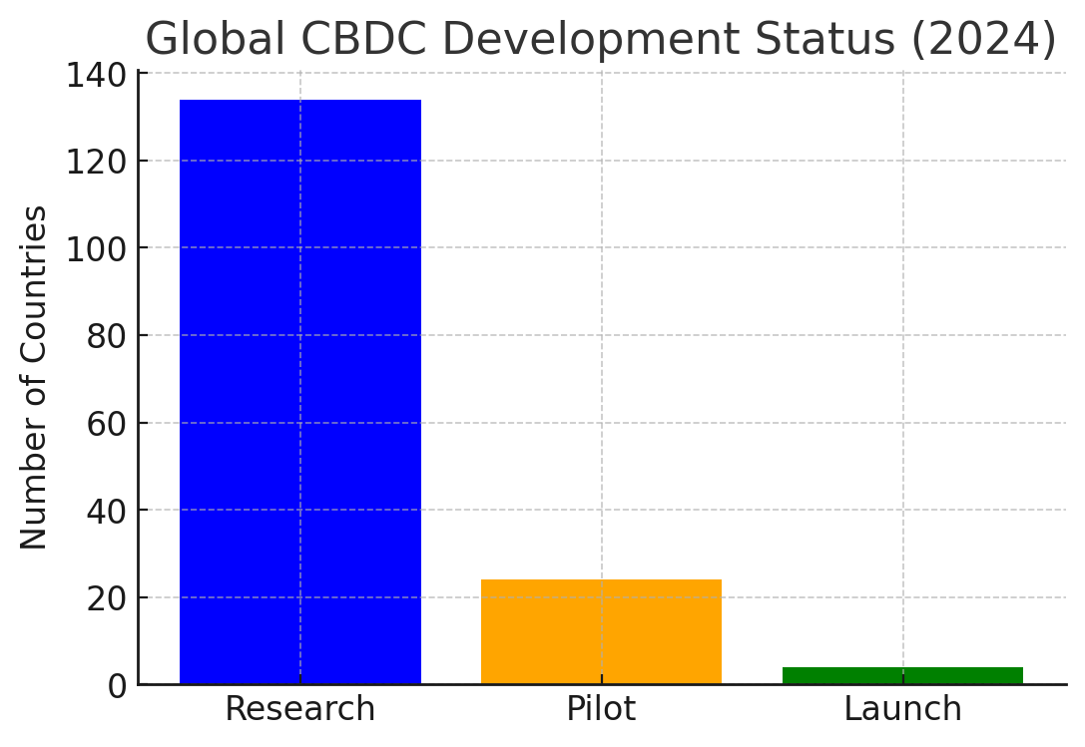

*Figure 1 Source-Bank for International Settlements(BIS)*

The Reserve Bank of India initiated its first pilot for the retail digital Rupee (e₹-R) on December 1, 2022, following the launch of its initial pilot project for the Digital Rupee in the wholesale sector (e₹-W) on November 1, 2022. With many leading global economies yet to embrace Central Bank Digital Currency (CBDC), India finds itself in a more advantageous position. This significant shift in payment preferences is largely due to the emergence of dependable, always-accessible electronic payment systems such as Real Time Gross Settlement.

Real Time Gross Settlement (RTGS) and National Electronic Funds Transfer (NEFT) have made it easier to transfer funds in real time or nearly so. Furthermore, the rise of mobile payment solutions like the Bharat Bill Payment System (BBPS), the National Electronic Toll Collection (NETC) for toll payments, as well as Immediate Payment Service (IMPS) and Unified Payments Interface (UPI) for swift payment processing have radically changed the payments environment in the country and earned worldwide acclaim. The pilot for the Digital Rupee-Wholesale segment (e₹-W) officially began on November 1, 2022. This pilot focuses on the settlement of transactions in the secondary market for government securities. The use of e₹-W is anticipated to improve interbank market efficiency. By removing the requirement for settlement guarantees or collateral that often increases settlement risk, conducting settlements in central bank currency could lower transaction costs. Subsequent pilots will leverage findings from this initiative, targeting other wholesale transactions and international payments. The Reserve Bank of India has chosen the following banks to take part in the initial phase of this initiative: State Bank of India, Bank of Baroda, Union Bank of India, HDFC Bank, ICICI Bank, Kotak Mahindra Bank, Yes Bank, and IDFC First Bank. Both "token-based" and "account-based" frameworks are feasible for Central Bank Digital Currency (CBDC). A token-based CBDC functions as a bearer instrument, similar to cash, with the tokens being assigned to whoever holds them at any moment. On the other hand, an account-based system would necessitate monitoring the transactions and balances of all CBDC holders and identifying the owners of these monetary assets. Given the advantages of both CBDC types, a token-based CBDC is regarded as the preferred option for CBDC-R because it mimics physical cash, whereas an account-based CBDC may be deemed appropriate for CBDC-W. This research paper aims to explore the effects of CBDC on the Indian economy.

**1. CBDC- Conceptual Framework**

Digital currency is created electronically by a central bank, making it a type of legal tender. It fulfills the same roles as traditional currency and can be converted on a 1:1 basis with fiat money. However, certain aspects of Central Bank Digital Currency (CBDC) differentiate it from physical cash. For instance, although digital money is prevalent in India, existing in bank accounts as entries in the ledgers of commercial banks, a CBDC would represent a liability of the Reserve Bank rather than a commercial bank. As an electronic form of sovereign currency, CBDCs should reflect all the qualities of physical cash. The functionalities of a CBDC dictate its design, which substantially affects payment systems. Moreover, it plays a role in shaping the structure and stability of monetary policies as well as the overall financial landscape. One key consideration is that the design features of CBDCs should ensure maximum discretion. The primary design decisions involved in the rollout of CBDCs include (i) whether to use token-based or account-based systems, (ii) choosing between Direct, Indirect, or Hybrid methods for their issuance and oversight, (iii) determining the type of CBDC to be introduced (Wholesale CBDC and/or Retail CBDC), (iv) selecting the design instrument (Remunerated or Non-remunerated), and (v) deciding the level of anonymity offered.

**2. Implementation of Digital Rupee**

When issuing CBDCs, the following important design decisions must be made: (i) the type of CBDC to be issued (retail or wholesale), (ii) the models for managing and issuing CBDCs (direct, indirect, or hybrid model), (iii) the form of CBDC (token-based or account-based), and (iv) instrument design. There are two main categories of CBDC: wholesale (CBDC-W) and general purpose or retail (CBDC-R). Retail CBDC may be used by everyone, including businesses, non-financial consumers, and members of the private sector, whereas wholesale CBDC is intended for limited access to specific financial institutions. Wholesale CBDC is designed to settle interbank transfers and associated wholesale transactions, whereas Retail CBDC is an electronic cash substitute mainly used for retail transactions. Due to its direct liability to the Central Bank, Retail CBDC is thought to be able to offer safe money for settlement and payment. The settlement systems for financial transactions could be completely changed by wholesale CBDC, making them safer and more effective. The Direct model (single tier model) and the Indirect model (two tier model) are the two models used for the issuance and administration of CBDCs. Under a direct model, the central bank would be in charge of overseeing every facet of the CBDC system, including issuance, accounting, and verification of transactions. The central bank and other intermediaries, such as banks and other service providers, each have a specific function in an indirect model. According to this model, the central bank only manages wholesale payments to intermediaries; any claims made by consumers are handled by the intermediary. 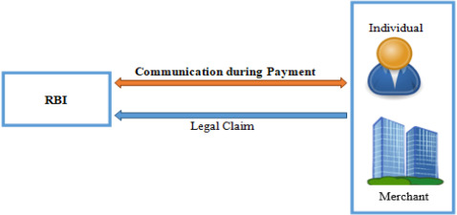

*(Figure 2,e₹—The digital currency in India: Challenges and prospects by Md. Asraful Haque , Md. Shoaib)*

The indirect model is comparable to the existing physical currency management system, in which banks oversee operations such as public note distribution, accounting, and compliance with.

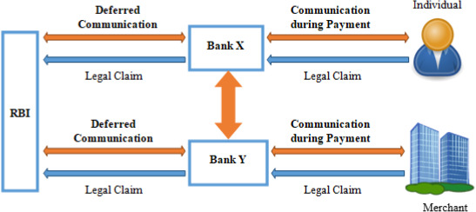

*(Figure 3,e₹—The digital currency in India: Challenges and prospects by Md. Asraful Haque , Md. Shoaib)*

**3. IMPACT OF CBDC ON INDIAN ECONOMY**

| **Impact** | **CBDC Contribution** |
| --- | --- |
| **Cash-Lite Economy** | Reduces reliance on physical cash, promoting digital payments, financial inclusion, and cost savings. |
| **Security** | Enhances transaction security, reduces fraud, ensures privacy through digital identity integration, and provides immutable records. |
| **Efficiency** | Enables instant settlements, lower transaction costs, streamlined government services, and more precise monetary policy. |
| **Innovation** | Fosters digital finance innovation, boosts e-commerce, and improves cross-border payment systems. |
| **Transparency & Accountability** | Increases transparency, reduces corruption, and improves government oversight and efficiency. |

3.1 Reduced transaction time: As we can understand from the following figure, the transaction time of CBDC is lowest as compared to other modes.

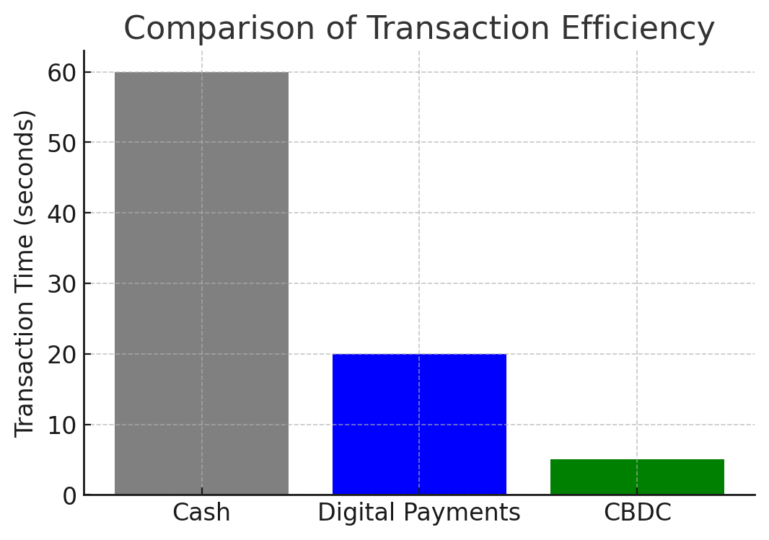

*Figure 5 Source-Bank for International Settlements(BIS)*

3.2.Efficiency in Payments

UPI Growth: In August 2023, UPI handled 10.5 billion transactions totaling ₹15.8 trillion. These platforms can be supplemented by a CBDC, which will increase speed and lessen dependency on middlemen.

Cross-Border Payments: The World Bank estimates that the typical cost of remittance in India is 5% of the total amount sent. By drastically lowering this expense, CBDC may help Indian expats send home ₹40,000 crore a year.

3.3. Effectiveness of Monetary Policy

In 2023, India processed ₹9.59 lakh crore in direct benefit transfers (DBTs) to recipients. By making these payments quicker, less expensive, and more secure, CBDC may be able to reduce transaction expenses by ₹1,000 crore a year.

3.4. Economical Effectiveness

Reduced Transaction Costs: Printing, storing, and distributing real currency might be made less expensive with the digital rupee. Additionally, it can lower the price of international settlement and payments.

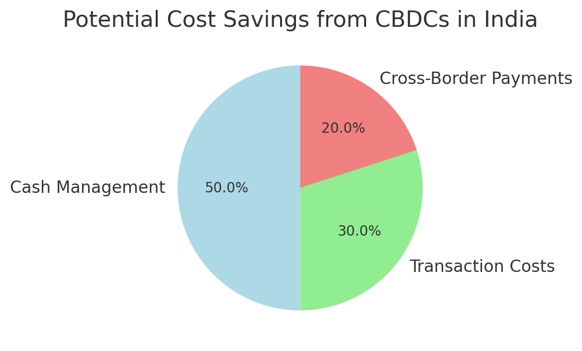

*Figure 4 SourceBank for International Settlements(BIS)*

Faster Settlements: Because digital payments may be processed instantly, clearing and settlement in traditional banking systems take less time and money.

3.5. Financial Inclusion

Present Financial Exclusion: The Global Findex Database estimates that 190 million Indian people were still unbanked as of 2021. With its convenient smartphone accessibility, CBDC can close this gap.

Digital Growth: In 2023, India had 700 million internet users and more than 1.2 billion mobile connections, suggesting that there is a great chance that CBDCs will be adopted in underbanked areas.

**4 Differences between CBDCs and decentralized cryptocurrencies**

4.1. Comparing centralization and decentralization

A central authority, often a government or central bank, is responsible for the issuance and regulation of CBDCs. Due to their centralized nature, the central bank has total control over how currency is issued, distributed, and regulated.

Decentralized cryptocurrencies, such as Ethereum and Bitcoin, operate without a single governing body or authority. Instead, they rely on a distributed network of nodes, or computers, to confirm and maintain transactions.

4.2. Issuance and Control of CBDCs

CBDCs are controlled and issued by a central authority, specifically central banks. Key aspects, including interest rates, monetary policy, and the overall money supply, fall under the central bank’s governance.

In contrast, decentralized cryptocurrencies are typically generated through mining or staking, with their issuance governed by predefined algorithms and consensus mechanisms (like Proof of Work and Proof of Stake). A single entity cannot directly oversee the creation and distribution of these coins.

4.3. Use cases and purpose

The primary goal of CBDCs is to deliver a digital form of government-backed currency. They aim to enhance the implementation of monetary policy, facilitate faster and more accessible payments, and strengthen the security and efficiency of financial systems. CBDCs are designed as a digital alternative to physical cash and are meant to maintain stability.

On the other hand, decentralized cryptocurrencies often emphasize disintermediation (removing intermediaries like banks), anonymity, and financial independence. They strive to provide individuals with full control over their funds and transactions without relying on governmental or financial institutions. Cryptocurrencies have various applications, including decentralized finance (DeFi), remittances, and investment opportunities.

4.4. Regulation

Since CBDCs are issued by central banks, they are subject to rigorous governmental oversight and regulation. They are designed to comply with existing financial laws and standards, such as those related to combating the financing of terrorism (CFT) and anti-money laundering (AML).

Decentralized cryptocurrencies, while potentially subject to regulations in some jurisdictions, remain largely unaffected by direct control from any government or regulatory body due to their decentralized nature. Although countries are still in the process of developing regulations to oversee cryptocurrency activities, this characteristic makes them more resistant to centralized limitations.

**5. Conclusion**

The introduction of a Central Bank Digital Currency (CBDC) could significantly transform India's financial landscape, bringing both opportunities and challenges. The Reserve Bank of India's (RBI) move towards a digital rupee marks a crucial advancement in enhancing the financial system's inclusivity and efficiency as the digital economy continues to grow. By addressing existing inefficiencies and fostering innovation, the rollout of a CBDC in India holds the potential to change the economic landscape. It offers an opportunity to improve financial inclusion by granting access to formal financial services for millions who are unbanked and underbanked. Utilizing the rapidly expanding digital infrastructure in the country, it ensures faster, more affordable, and secure transactions, including cross-border remittances, which are a significant source of foreign exchange for India.

CBDC's ability to complement existing digital payment mechanisms like UPI is one of the key advancements toward a cashless economy and can reduce reliance on physical currency. This transition can mitigate the risks associated with counterfeit money and unrecorded transactions while leading to considerable savings in cash management costs. Furthermore, the traceability of CBDC transactions enhances economic transparency and compliance, strengthening efforts to combat corruption, tax evasion, and financial crime.

By promoting the Indian rupee in global trade, CBDC also equips the Reserve Bank of India (RBI) with stronger monetary policy tools, such as direct benefit transfers and precise implementation of policy measures. Nonetheless, the successful rollout of CBDC must tackle issues like cybersecurity threats, privacy issues, and the challenge of technological adoption in rural regions. Strategic planning, strong infrastructure, and supportive policies will be essential to ensure the CBDC is integrated smoothly into India's financial landscape.

In summary, a thoughtfully designed CBDC can serve as a driving force for India's digital and economic evolution, enhancing financial resilience, fostering innovation, and improving global competitiveness. It marks a crucial step toward realizing a more inclusive, transparent, and efficient economic framework, aligning with India's aspiration to become a leading global economic power.

**REFERENCES-**

[1] Dash, B., Sharma, P., & Ali, A. (2022). Federated learning for privacy-preserving: A review of PII data analysis in Fintech. International Journal of Software Engineering & Applications, 13(4), 1–13. https://doi.org/10.5121/ijsea.2022.13401

[2] Aggarwal, K., Mijwil, M. M., Al-Mistarehi, A. H., Alomari, S., Gök, M., Alaabdin, A. M. Z., &Abdulrhman, S. H. (2022). Has the Future Started? The Current Growth of Artificial Intelligence, Machine Learning, and Deep Learning. Iraqi Journal for Computer Science and Mathematics, 3(1), 115-123.

[3] Sarkodie, S. A., Ahmed, M. Y., & Owusu, P. A. (2022). COVID-19 pandemic improves market signals of cryptocurrencies–evidence from Bitcoin, Bitcoin Cash, Ethereum, and Litecoin. Finance Research Letters, 44, 102049

[4] Alonso, S. L. N., Jorge-Vazquez, J., & Forradellas, R. F. R. (2021). Central Banks Digital Currency: Detection of Optimal Countries for the Implementation of a CBDC and the Implication for Payment Industry Open Innovation. *Journal of Open Innovation Technology Market and Complexity*, *7*(1), 72. <https://doi.org/10.3390/joitmc7010072>

[5] Alonso, S. L. N., Jorge-Vazquez, J., & Forradellas, R. F. R. (2021). Central Banks Digital Currency: Detection of Optimal Countries for the Implementation of a CBDC and the Implication for Payment Industry Open Innovation. *Journal of Open Innovation Technology Market and Complexity*, *7*(1), 72. <https://doi.org/10.3390/joitmc7010072>

[6] Burlon, L., Montes-Galdón, C., Muñoz, M., & Smets, F. (2022). The Optimal Quantity of CBDC in a Bank-Based Economy. *SSRN Electronic Journal*.

[7] Dash, B., Sharma, P., & Ali, A. (2022). Federated Learning for Privacy-Preserving: A Review of PII Data Analysis in Fintech. *International Journal of Software Engineering & Applications*, *13*(4), 1–13. <https://doi.org/10.5121/ijsea.2022.13401>

[8] Laboure, M., Müller, M. H., Heinz, G., Singh, S., & Köhling, S. (2021). Cryptocurrencies and CBDC: The Route Ahead. *Global Policy*, *12*(5), 663–676.

[9] Uknbn. (2017). CBDC: Cumbria Wildlife Trust: survey records from 1970 - 2007 of County Wildlife Sites. [Dataset]. In *Global Biodiversity Information Facility*. https://doi.org/10.15468/lwbbpg

[10] Dash, B., Ansari, M. F., Sharma, P., & Siddha, S. S. (2022). Future Ready Banking with Smart Contracts - CBDC and Impact on the Indian Economy. *International Journal of Network Security & Its Applications*, *14*(5), 39–49. https://doi.org/10.5121/ijnsa.2022.14504

[11] Bijlsma, M., Cruijsen, C. <. D., Jonker, N., & Reijerink, J. (2021). What triggers consumer adoption of CBDC? *SSRN Electronic Journal*. https://doi.org/10.2139/ssrn.3836440

[12] Morales-Resendiz, R., Ponce, J., Picardo, P., Velasco, A., Chen, B., Sanz, L., Guiborg, G., Segendorff, B., Vasquez, J. L., Arroyo, J., Aguirre, I., Haynes, N., Panton, N., Griffiths, M., Pieterz, C., & Hodge, A. (2021). Implementing a retail CBDC: Lessons learned and key insights. *Latin American Journal of Central Banking*, *2*(1), 100022. https://doi.org/10.1016/j.latcb.2021.100022

[13] Jabbar, A., Geebren, A., Hussain, Z., Dani, S., & Ul-Durar, S. (2022). Investigating individual privacy within CBDC: A privacy calculus perspective. *Research in International Business and Finance*, *64*, 101826. https://doi.org/10.1016/j.ribaf.2022.101826

[14] Jabbar, A., Geebren, A., Hussain, Z., Dani, S., & Ul-Durar, S. (2022b). Investigating individual privacy within CBDC: A privacy calculus perspective. *Research in International Business and Finance*, *64*, 101826. https://doi.org/10.1016/j.ribaf.2022.101826

[15] Niepelt, D. (2020). Monetary Policy with Reserves and CBDC: Optimality, Equivalence, and Politics. *SSRN Electronic Journal*. https://doi.org/10.2139/ssrn.3740324

[16] Tsai, W., Zhao, Z., Zhang, C., Yu, L., & Deng, E. (2018). A Multi-Chain Model for CBDC. *2021 8th International Conference on Dependable Systems and Their Applications (DSA)*. https://doi.org/10.1109/dsa.2018.00016

[17] Dabrowski, J., Chorzelski, T. P., Jablońska, S., Kraińska, T., & Jarzabek-Chorzelska, M. (1979). The Ultrastructural Localization of IgA Deposits in Chronic Bullous Disease of Childhood (CBDC). *Journal of Investigative Dermatology*, *72*(6), 291–295. https://doi.org/10.1111/1523-1747.ep12531739

[18] Sethaput, V., & Innet, S. (2023). Blockchain application for central bank digital currencies (CBDC). *Cluster Computing*, *26*(4), 2183–2197. https://doi.org/10.1007/s10586-022-03962-z

[19] Assenmacher, K., Berentsen, A., Brand, C., & Lamersdorf, N. (2021). A Unified Framework for CBDC Design: Remuneration, Collateral Haircuts and Quantity Constraints. *SSRN Electronic Journal*. https://doi.org/10.2139/ssrn.3896787

[20] Bilotta, N., & Botti, F. (2021). *The (near) Future of Central Bank Digital Currencies: Risks and Opportunities for the Global Economy and Society*. Peter Lang Gmbh, Internationaler Verlag Der Wissenschaften.

[21] Agur, M., Ari, M., & Dell’Ariccia, M. (2019). *Designing Central Bank Digital Currencies*. International Monetary Fund.

[22] Bouza, S., Hlayhel, B., Kroen, T., Miccoli, M., Mircheva, B., Polo, G., Sakha, S., & Yang, Y. (2024). *Central Bank Digital Currencies in the Middle East and Central Asia*. International Monetary Fund.

[23] Tan, B. (2023). *Central Bank Digital Currency and Financial Inclusion*. International Monetary Fund.

[24] Agur, M., Ari, M., & Dell’Ariccia, M. (2019b). *Designing Central Bank Digital Currencies*. International Monetary Fund.

[25] Bouis, R., Gelos, G., Nakamura, F., Miettinen, P. A., Nier, E., & Soderberg, G. (2024). *Central Bank Digital Currencies and Financial Stability: Balance Sheet Analysis and Policy Choices*. International Monetary Fund.

[26] Kunaratskul, T., Reslow, A., & Singh, M. (2024). *Implications of Central Bank Digital Currency for Monetary Operations*. International Monetary Fund.