**Quantification of gully erosion impact in Sudan Savannah areas of Kebbi State, Nigeria**

**Aminu A1, Usman S2 and Sakaba YB1**

1Department of Agricultural Education, School of Vocational and Technical Education, Adamu Augie College of Education, Argungu, Kebbi State, Nigeria.

2Department of Soil Science, Faculty of Agriculture, Federal University, Dutse, Nigeria

Corresponding Author: aaminu52@gmail.com

# Abstract

Gully erosion is a global threat to soil and food security. It is a serious problem to soil and land management in Africa. This study is aimed at measuring the quantitative impact of gully erosion and to evaluate the soil quality, soil fertility and land suitability around Argungu, Augie, Birnin Kebbi and Gwandu areas of Kebbi State, Nigeria. Sixty-four (64) soil samples were collected and assessed from the sixteen (16) different sites in the study areas. The results shows that of these 16 sites, more than half (13 sites) were critically damaged. The highest value of soil volume loss (796647.2 m3) was recorded at Gwandu whereas the lowest (241.60 m3) was recorded at Augie. The maximum width (49.56 m) was recorded at Tarasa and minimum (1.01 m) at Argungu 2. Likewise, maximum depth (8.666 m) was recorded at Badariyya and minimum (0.94 m) was recorded at Argungu1. Land and soil quality were characterized as bad and not suitable for agriculture. Significant portion of lands appeared to be vulnerable to landslides and further surface soil damage. Results also shows that the natural soil structural units, which were evaluated as granular, massive and single-grains appeared to have massive, small polyhedrals, very irregular, non-coherent, loose and poorly coordinated. It was observed that these characteristics of the study sites played a major role on the drainage pattern for gully erosion impact, and probably predicted high risk of soil quality deterioration and total surface soil damage in the near future. The study further suggested the use of technological and agronomic soil management options, which include the adoption of multiple scientific and cultural approaches such as planting of shelter belts across the affected sites, advanced drainage systems and provision of water ways, as well as inter- and mixed cropping systems among others.

**Keywords:** Soil erosion, Gully erosion, Land suitability, Soil depth, Soil width, Soil quality

# Introduction

Soil condition in the Sudan savannah of Kebbi State, around Augie, Argungu, Birnin Kebbi and Gwandu areas are physical affected by soil erosion (Usman, 2016). The physical impact of soil erosion in the region was considered nuisance to both soil resource and surface soil quality (Usman *et al.,* 2016). This soil erosion impact is a threat to food security and rural-urban economic development in sub-Saharan Africa (Usman *et al.,* 2017). Soil erosion impact placed a serious concern on the physical, biological and chemical components of soil and soil biodiversity (Al-Shoumik *et al.,* 2023). It has caused surface soil damage; decreased size of land for potential agriculture and economic growth and enhanced food security in sub-Saharan Africa (Ezeh *et al.,* 2024). Soil erosion forced the surface soil particles to detach and damaged soil structural quality and creates gully channels (Gebrie *et al.,* 2023). The detachment of soil particles was looked as one of the vicious environmental problems reducing the potential productivity and health condition of agricultural soils in sub-Saharan Africa (Andualem *et al.,* 2023). In Sudan savannah zone of Kebbi State, this detachment of soil particles by erosion, has been described as the removal of the soil materials from the top surface soil layer (sheet), extending to smaller channels (rills), and intensifying to larger channels (gullies) (Usman *et al.,* 2024a). Baade *et al.* (2024) described the initial rate of this removal of surface soil materials as a form of depression by rainfall impact (splash erosion) which can be extended to sheet, rill and gully erosion due to factors such as poor vegetation cover, climate change impact and poor soil management adaptation. The metaphors of how concentrated these types of erosion are, depends largely on the nature and condition of the soil properties, slope, vegetation cover and land use activities (Usman and Jayeoba, 2024). Land areas subjected to continuous cultivation without proper soil management, lack of tree plantation and mismanagement of vegetation (shrubs and plants), are considered as important factors leading to soil erosion in the Kebbi State (Usman, 2016). Evans (2013) noted that surface soil materials can be washed away easily by rains under poor vegetation cover and poor management practices. The problem in this situation has been described to affect soil quality and surface soil fertility at both on-site (detached site) and off-site (deposited site) areas (Lugato *et al.,* 2016). This problem of soil erosion remained a serious challenge to agricultural soils in Africa and the cost implication is significant to economic development of the region (FAO, 2023).

The process of soil erosion is generally caused by combination of natural erosive agents, which include rainfall, wind, waves and bioturbation including human-induced factors such as overploughing, overgrazing, building, deforestation, forest fires and off road vehicles (Pandey *et al.,* 2016). These combinations of erosive factors appeared to have physically caused serious surface soil damages and bigger gully channels to occur in many areas around Augie, Argungu, Birnin Kebbi and Gwandu areas of Kebbi State (Usman *et al.,* 2016). The impact of climate change especially in very poor vegetation areas is believed to have increased the width and depth of gully erosion in sub-Saharan Africa (Usman *et al.,* 2024b). This deepening of gullies in the affected areas, increase the cost of conservation application, reduce land quality, affect soil productivity, cause food insecurity, pressurize the soil biological biodiversity, and create hazards to human accommodation and wellbeing (Yang *et al.,* 2023). Reduction in agricultural land size and soil functional service to support the production of food crops, were noted to occurred as a result of soil erosion in dryland areas of Kebbi State (Usman *et al.,* 2016). This could also lead to rural-urban migration, increase hunger, malnutrition and land scarcity in the area (Usman, 2013). However, it is evident that gully erosion is deeper and cannot be managed by ploughing (Usman, 2024a). These problems caused by erosion, placed an urgent call for assessment and modelling of soil erosion in the affected areas (Borrelli *et al.,* 2021; Andualem *et al.,* 2023; Ezeh *et al.,* 2024). Therefore, assessment of soil erosion in the affected sites of Augie, Argungu, Birnin Kebbi and Gwandu areas of Kebbi State is important (Usman *et al.,* 2020). This will help to provide soil data required for the adaptation of appropriate soil conservation in the affected areas of the State (Jat *et al.,* 2023). This study aimed to assess and evaluate the impact of gully erosion in four local government areas of Kebbi State, Nigeria. The specific objectives are: (a) measure the quantitative impact of gully erosion, (b) evaluate the soil quality and land suitability and (c) evaluate the soil fertility status of the affected sites.

**Materials and Methods**

# Study area and sites characteristics

Kebbi State is geographically located in north-west Nigeria and dominated by Hausa-Fulani who are largely depended on farming and rearing of animals. The State has a total land area of 36,229 km2 of which 12,600 km2 is under cultivation (Usman, 2013). The two important agricultural lands in the State are dryland and Fadama. Significant parts of these two lands are located in the Sudan savannah zone of the State (Usman, 2016). The four local government areas of the Sudan savannah zone covered under this study are Augie, Argungu, Birnin Kebbi and Gwandu. The zone lies between latitude 11o and 13oN and longitudes 4o and 12oE, and bordered the Nigerian States of Sokoto to the north and Zamfara to the east (Figure 1).

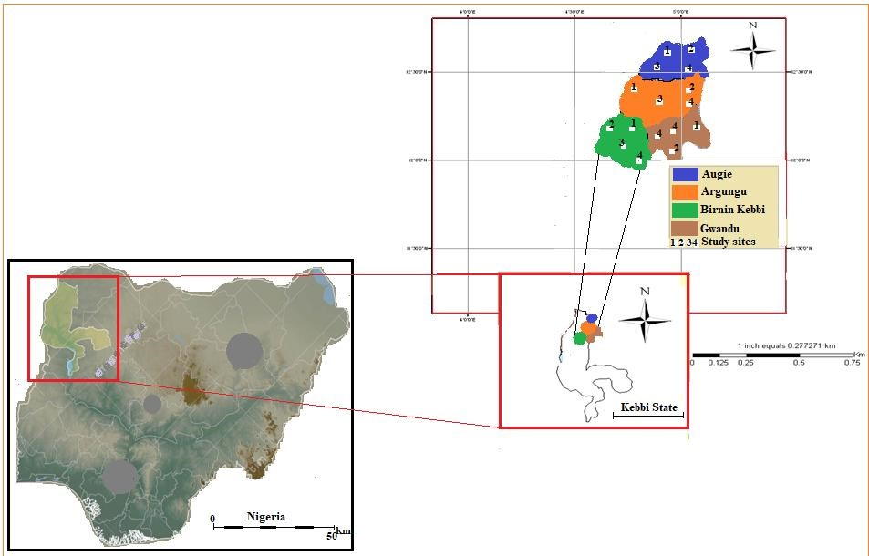

**Figure 1:** Map of study area and study sites

The zone has tropical weather conditions with three seasons: rainy, dry and hot (Usman *et al.,*

2016). The annual rainfall is between 650 mm to 875 mm and monthly temperature ranged from 28oC to 42oC (Local Meteorological Record). The soil and surface soil conditions are characterized by presence of parent materials, which are largely of sand and clay particles originated from Sahara desert (Usman, 2007). The common agricultural land use practices include mono-cropping, mixed-cropping, inter-cropping and nomadic herding. The common crops grown are millet, sorghum, maize, rice, cowpea, groundnut, wheat and wide range of horticultural crops such as onions, pepper, tomatoes, and carrots among others.

# Assessment of soil erosion based on physical impact

Gully erosion was assessed and classified in the field covering eighteen (18) different sites around Augie, Argungu, Birnin Kebbi and Gwandu (Figure 1). Field Book for Describing and Sampling Soils version 3.0 (Schoeneberger *et al.,* 2021), was used to classify the nature and condition of gully erosion in the study sites. The Visual Soil Erosion Approach (VSEA) which comprised of soil quality (P-Sq) and land suitability (P-Ls) classes as introduced by Usman *et al.* (2024) was adapted for the evaluation of soil quality and land suitability for agricultural potentials. Similarly, soil structure, soil consistency, slope, and surface drainage classes, were assessed and evaluated according to the general classes described by Schoeneberger *et al.* (2021).

# Soil sampling and laboratory analysis

Soil samples were collected using soil auger (0–20 cm depth) from all the 18 sites of the study area. At each site, four (4) different composite soil samples were collected; two of these samples were taken from the upper part of the gully section and the other two from the lower section. A total of seventy-two (72) different composite soil samples were collected for soil analysis in the laboratory. The analysis covered include; particle analysis for soil textural classes, analysis of organic matter, organic carbon, N, P, and K, pH, exchangeable Na, Mg, Ca and K. Particle analysis was determined using a Technico BS-604Bml C 20oC experimental cylinder that contains a scale of lines from 0 to 100%. The percentage sand, silt and clay were estimated based on guidelines in Schoeneberger *et al.* (2021) guideline for textural classification. Likewise, USDA-NRCS (Schoeneberger *et al.,* 2021) criteria were used to define the soil texture for management application. Soil pH was measured in a 1:1 soil-water ratio using a glass electrode (H19017 Microprocessor) pH meter (FAO, 2022). Soil organic carbon (%) was determined by the modified Walkley-Black method as described by Nelson and Sommers (1982). Total nitrogen (%) was determined by the Kjeldahl digestion and distillation procedure whereas available P and

K were determined according to Bray’s No. 1 extracts (Bray and Kurtz, 1945). Exchangeable Magnesium (Mg2+ cmolkg-1 soil), Sodium (Na2+ cmolkg-1 soil), Calcium (Ca2+ cmolkg-1 soil) and Potassium (K+ cmolkg-1 soil) were determined using ammonium acetate (NH4OAc) extract solution as described in Bray and Kurtz (1945).

# Measurement of the gully erosion

Study on gully erosion was conducted based on the concept of direct measurement of soil erosion in the field (USDA, 2012). The assessment employed the use of ranging poles, measuring tape, computer system and digital imagery. Ranging poles were used to allocate the affected areas and also to identify points for measurement of the gully channel in the field. These ranging poles were placed in the soil at the surface, with intervals of 5 m between them across the gully length. Ten (10) poles were used at each site during the measurement exercise in the field. These ranging poles were used as a reference point for the overall measurement, and covered 10 different measurements transects or points at each of study site. Selection of these measurement points was base on random sampling within the affected area. At each point, depth (d), width at top (W1), and width at bottom (W2), were recorded by measuring the distance between the edge of the gully width and benchmark pins established around the gully width. These parameters were measured including the length (L), by placing the measuring tape to the edge of the gully over the exposed section on each point. The volume of soil loss was calculated as follows (USDA, 2012):

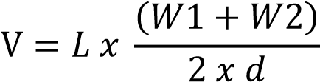

L was measured in the field from all the 3 sites as constant i.e. 12 m with an interval of 2 m extent from one point to another [2 m + 2 m + 2 m + 2 m + 2 m = 10 m] (see Figure 3).

Where: V = volume of soil loss

L = length

W1 = the average top width measured from the gully channel and W2 = the average bottom width measured in the gully channel

d = the average depth of gully erosion

# Statistical Analysis

All data were subjected to simple analysis using excel to compare the sum, average mean, minimum and maximum values of depth, width at top and width at bottom between the study sites.

# Results

## ***Length, width, depth and volume of soil loss***

The length, width (top and bottom), depth and volume of soil loss across the different sites are summarized in Table 1. The parameters reported were based on the measurement from the field assessment. The length described the distance end to end, and was considerably very high across the sites recorded around Birnin Kebbi (site 9 – 12) and Gwandu (site 13 – 16). Likewise, the distance across the gully channel and deepness, were found to be high in these sites compared to sites recorded around Augie (site 1 – 4) and Argungu (site 5 – 8). This could be the probable reasons for high soil loss recorded in the former sites compared to the lower volume recorded in the later sites. Of the 16 sites that were calculated as having a high volume of soil loss for gully erosion impact, more than half (13 sites) were actually measured as being critically damaged. The pattern for soil degradation and erosion impact predicted high risk of soil quality deterioration and possible landslides in future. The general trend was an increase of length, width and depth in the study sites for gully erosion and volume of soil loss, annually. Although, the combined factors, which could have contributed to both initial and existing trend of gully erosion across the study sites are unknown, however, the volume of soil loss reported (Table 1) revealed that the management application and vegetation are depressed as similarly noted by Usman *et al.* (2016).

### **Table 1:** Length, width, depth and soil loss across the study sites

|  |  |  |  |  |  |  |
| --- | --- | --- | --- | --- | --- | --- |
| **Site** | **Name of the study site** | **Length (m)** | **Width1 (m)** | **Width2 (m)** | **Depth (m)** | **Soil loss (m3)** |
| 1 | Kwararo | 11.9 | 36.2 | 20.7 | 11.8 | 3983.6 |
| 2 | Tungar Dangwari north | 9.87 | 39.2 | 19.5 | 11.3 | 3263.1 |
| 3 | Tungar Dangwari south | 15.6 | 45.6 | 20.7 | 12.7 | 6544.3 |
| 4 | Augie | 11.9 | 18.2 | 9.10 | 5.71 | 241.60 |
| 5 | Kewa | 15.8 | 18.5 | 10.9 | 7.65 | 1776.8 |
| 6 | Argungu 1 | 16.9 | 23.2 | 10.1 | 7.13 | 2010.4 |
| 7 | Argungu 2 | 8.38 | 11.4 | 11.4 | 6.69 | 638.54 |
| 8 | Helande | 13.9 | 37.4 | 12.9 | 12.4 | 4332.2 |
| 9 | Tarasa | 138.3 | 99.5 | 32.7 | 15.5 | 14153.6 |
| 10 | Badariyya | 1005.8 | 130.7 | 108.5 | 8.67 | 142637.2 |
| 11 | Kola | 411.8 | 126.7 | 76.8 | 26.4 | 3171.5 |
| 12 | Wuro Maliki | 364.9 | 91.6 | 43.9 | 10.2 | 253178.3 |
| 13 | Gwandu | 378.9 | 88.8 | 43.8 | 31.7 | 796647.2 |
| 14 | Lamude | 452.6 | 61.5 | 17.2 | 13.3 | 236587.8 |
| 15 | Garugga | 271.6 | 106.0 | 50.4 | 23.9 | 507757.5 |
| 16 | Tsohuwar Makaranta | 251.5 | 44.7 | 17.9 | 11.9 | 93769.9 |

## ***Comparison of width and depth***

Table 2 to 3 provided a summarized data on width and depths in the study sites. The analysis compared the maximum, minimum, average ad standard deviation, and shows that the differences are apparent. This comparison was made individually for each study area (Table 2), and also across all the sites (Table 3). On average, site 10 recorded the highest width and site 4 has the lowest (Figure 2). On the other hand, site 13 has the highest depth whereas site 4

recorded the lowest (Table 3). These variations were also noted for the overall widths and depths across the study sites around Augie, Argungu, Birnin Kebbi and Gwandu (Figure 3, 4, 5 and 6). These could probably be related to the overall soil condition and vegetation cover across the study sites, which is more or less loose and poor (Table 4).

**Table 2:** Comparison of width and depth across the study sites

|  |  |  |  |  |  |  |  |
| --- | --- | --- | --- | --- | --- | --- | --- |
| **S/N** | **Site** | **W1m** | | **W2m** | | **Dm** | |
|  |  | Maximum | Minimum | Maximum | Minimum | Maximum | Minimum |
|  | T/Dangwari north | 5.91 | 2.29 | 3.11 | 1.52 | 1.58 | 0.73 |
|  | Kwararo | 4.11 | 2.92 | 3.11 | 1.11 | 1.91 | 0.81 |
|  | T/Dangwari south | 6.13 | 2.81 | 2.4 | 1.05 | 1.77 | 0.58 |
|  | Augie | 2.81 | 1.12 | 1.1 | 0.52 | 1.01 | 0.23 |
|  | Kewa | 2.18 | 1.18 | 1.79 | 0.79 | 1.11 | 0.48 |
|  | Argungu 1 | 3.21 | 1.93 | 1.12 | 0.88 | 0.94 | 0.55 |
|  | Argungu 2 | 1.18 | 1.01 | 0.85 | 0.44 | 1.41 | 1.0 |
|  | Helande | 5.63 | 2.34 | 1.83 | 0.91 | 1.81 | 0.73 |
|  | Tarasa | 49.38 | 4.57 | 4.75 | 2.21 | 2.41 | 0.91 |
|  | Badariyya | 22.56 | 7.44 | 21.64 | 0.01 | 8.666 | 0.08 |
|  | Kola | 23.71 | 6.71 | 19.63 | 2.8 | 4.23 | 1.52 |
|  | Wuro Maliki | 13.41 | 6.09 | 7.96 | 0.01 | 1.52 | 0.49 |
|  | Gwandu | 12.5 | 3.78 | 43.83 | 1.68 | 4.79 | 1.68 |
|  | Lamude | 8.9 | 2.74 | 2.47 | 1.15 | 2.04 | 0.88 |
|  | Garugga | 14.63 | 7.34 | 7.62 | 3.05 | 3.98 | 1.85 |
|  | T/Makaranta | 9.75 | 1.84 | 8.23 | 0.01 | 1.83 | 0.63 |

**Table 3:** Comparison of average width and depth across the study sites

|  |  |  |  |  |  |  |  |
| --- | --- | --- | --- | --- | --- | --- | --- |
| **S/N** | **Site** | **Average** | | | **STDV** | | |
|  |  | W1 | W2 | d | W1 | W2 | d |
|  | Tungar Dangwari north | 3.919 | 2.136 | 1.127 | 1.318892 | 0.459376 | 0.277851 |
|  | Kwararo | 3.623 | 2.07 | 1.171 | 0.456437 | 0.663643 | 0.385067 |
|  | Tungar Dangwari south | 4.557 | 1.848 | 1.266 | 1.109705 | 0.678725 | 0.416232 |
|  | Augie | 1.815 | 0.91 | 0.571 | 0.526165 | 0.157762 | 0.275013 |
|  | Kewa | 1.845 | 1.093 | 0.846 | 0.351386 | 0.275118 | 0.429604 |
|  | Argungu 1 | 2.32 | 1.019 | 0.713 | 0.434792 | 0.086724 | 0.119912 |
|  | Argungu 2 | 1.139 | 0.669 | 1.143 | 0.048865 | 0.139718 | 0.134829 |
|  | Helande | 3.505 | 1.315 | 1.242 | 1.086414 | 0.297405 | 0.382297 |
|  | Tarasa | 9.953 | 3.27 | 1.548 | 13.87551 | 0.836687 | 0.552968 |
|  | Badariyya | 13.07 | 10.853 | 0.8666 | 6.38206 | 7.281433 | 0.560317 |
|  | Kola | 12.671 | 8.168 | 2.643 | 5.649176 | 5.813597 | 0.955743 |
|  | Wuro Maliki | 9.164 | 4.398 | 1.023 | 2.268946 | 2.535161 | 0.345159 |
|  | Gwandu | 8.879 | 4.383 | 3.17 | 2.820723 | 2.548577 | 8.658773 |
|  | Lamude | 6.145 | 1.721 | 1.329 | 1.930908 | 0.389 | 0.498987 |
|  | Garugga | 10.603 | 5.036 | 2.391 | 2.710927 | 1.439793 | 0.859709 |
|  | Tsohuwar Makaranta | 4.474 | 1.788 | 1.191 | 2.212491 | 2.401323 | 0.33818 |

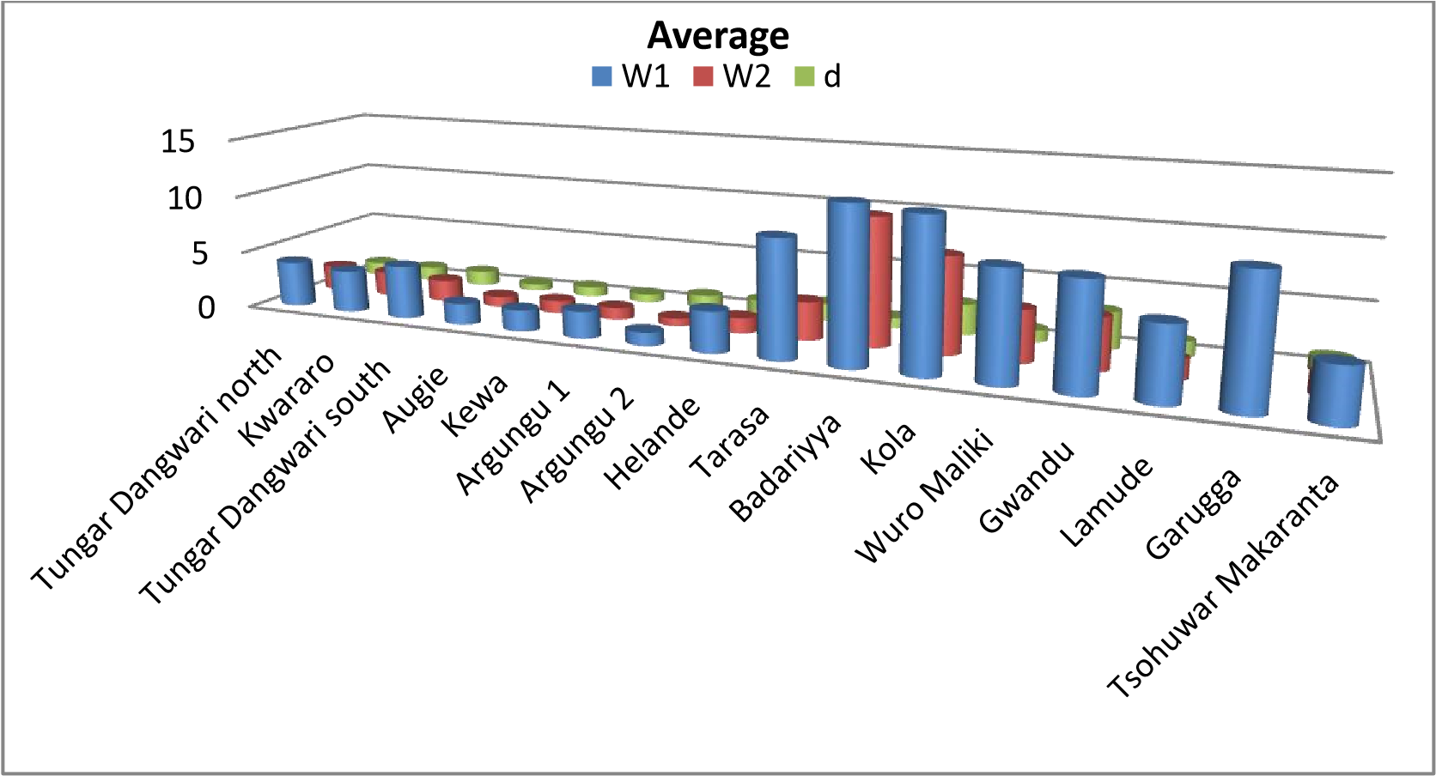

**Figure 2:** Average width across the study sites

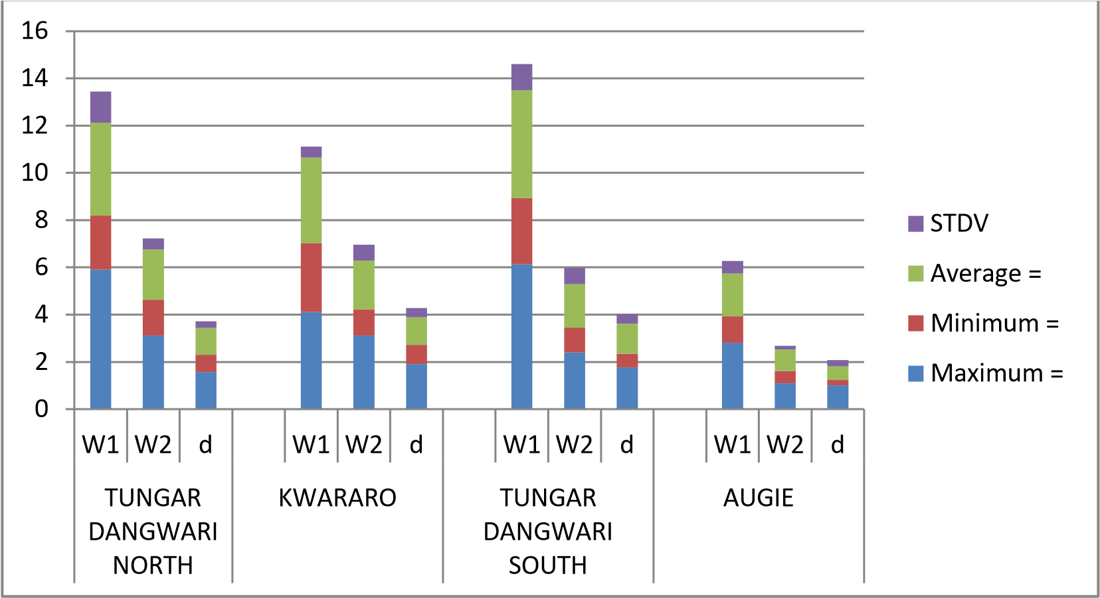

**Figure 3:** Gully erosion around Augie area Kebbi State

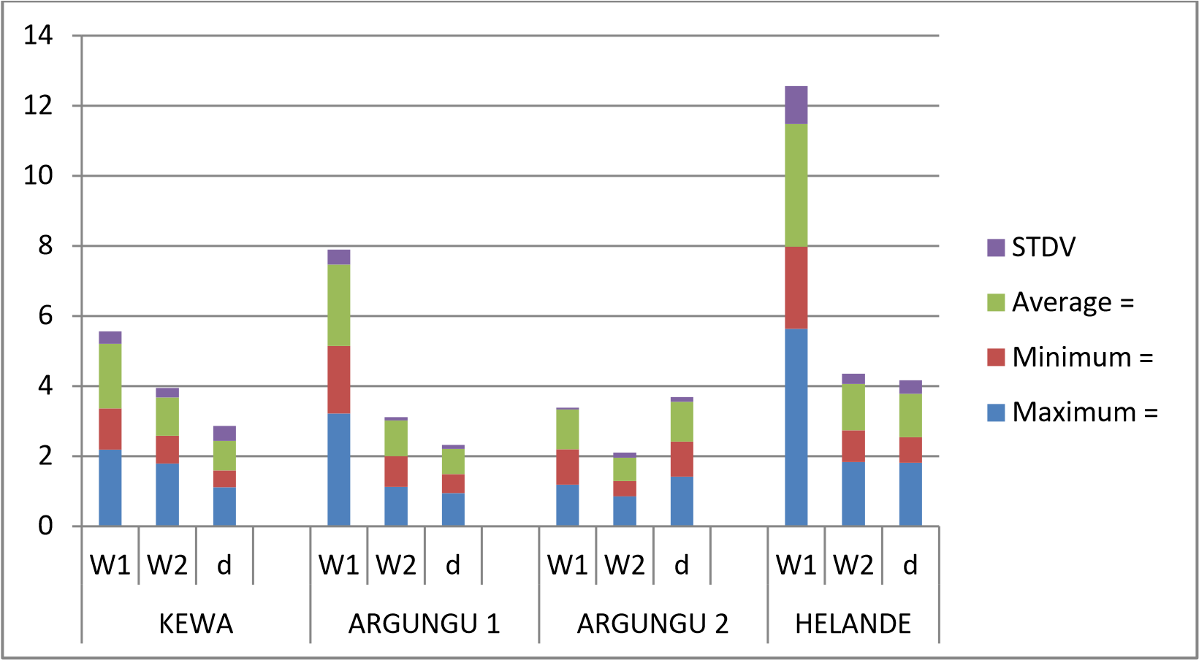

**Figure 4:** Gully erosion around Argungu area of Kebbi State

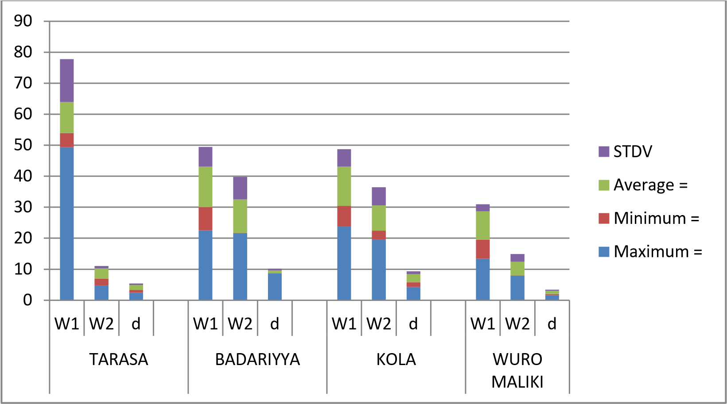

**Figure 5:** Gully erosion around Birnin Kebbi area of Kebbi State

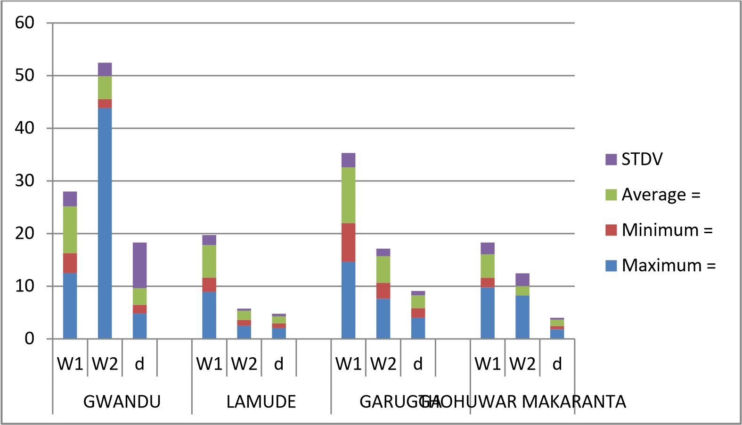

**Figure 6:** Gully erosion around Gwandu area of Kebbi State

**Table 4:** Soil loss, soil quality and land suitability classes in the study sites

|  |  |  |  |  |  |
| --- | --- | --- | --- | --- | --- |
| **Site Code** | **Study site** | **Soil loss (m3)** | **Soil quality class (P-Sq)** | **Land suitability class (P-Ls)** | **Surface condition** |
|  | Kwararo | 3983.6 | Sq4 | Ls4 | Notably damaged |
|  | T/Dangwari north | 3263.1 | Sq4 | Ls4 | Notably damaged |
|  | T/Dangwari south | 6544.3 | Sq5 | Ls5 | Bad land |
|  | Augie | 241.60 | Sq3 | Ls3 | Partly damaged |
|  | Kewa | 1776.8 | Sq3 | Ls3 | Partly damaged |
|  | Argungu1 | 2010.4 | Sq4 | Ls4 | Notably damaged |
|  | Argungu2 | 638.54 | Sq3 | Ls3 | Partly damaged |
|  | Helande | 4332.2 | Sq4 | Ls4 | Notably damaged |
|  | Tarasa | 14153.6 | Sq5 | Ls5 | Bad land |
|  | Badariyya | 142637.2 | Sq5 | Ls5 | Bad land |
|  | Kola | 3171.5 | Sq4 | Ls4 | Notably damaged |
|  | Wuro Maliki | 253178.3 | Sq5 | Ls5 | Bad land |
|  | Gwandu | 796647.2 | Sq5 | Ls5 | Bad land |
|  | Lamude | 236587.8 | Sq5 | Ls5 | Bad land |
|  | Garugga | 507757.5 | Sq5 | Ls5 | Bad land |
|  | Tsohuwar Makaranta | 93769.9 | Sq5 | Ls5 | Bad land |

Table 4 shows the status of the surface soil condition in term of soil quality and land suitability for agricultural and soil management application. Compared with the volume of soil loss across the study sites, three major classes of soil quality and land suitability were identified (Table 4). Except for Sq3 and Ls3 which can be managed under rigorous soil conservation application, all other sites appeared to be in bad condition. Significant portion of lands on Sq5 and Ls5 has been lost physically the lands are very exposed to landslides and further surface soil damage which may occur in future. Management of the soil for future agriculture required a very extensive conservation application that could demand heavy equipment which could be highly costly.

**Table 5:** Soil structure and soil consistency of the study sites

|  |  |  |  |  |  |
| --- | --- | --- | --- | --- | --- |
| **Site Code** | **Study site** | **Structure**  **type** | **Structure grade** | **Consistency wet** | **Consistency**  **dry** |
|  | Kwararo | Single-grain | Weak | Soft | Very-friable |
|  | T/Dangwari north | Single-grain | Structureless | Loose | Friable |
|  | T/Dangwari south | Single-grain | Weak | Soft | Very-friable |
|  | Augie | Single-grain | Weak | Soft | Very-friable |
|  | Kewa | Granular | Moderate | Soft | Friable |
|  | Argungu1 | Single-grain | Weak | Loose | Very-friable |
|  | Argungu2 | Single-grain | Structureless | Loose | Very-friable |
|  | Helande | Single-grain | Structureless | Slack | Loose |
|  | Tarasa | Massive | Structureless | Slack | Loose |
|  | Badariyya | Massive | Weak | Loose | Loose |
|  | Kola | Massive | Weak | Loose | Loose |
|  | Wuro Maliki | Granular | Moderate | Soft | Friable |
|  | Gwandu | Granular | Moderate | Soft | Friable |
|  | Lamude | Single-grain | Weak | Soft | Loose |
|  | Garugga | Single-grain | Weak | Slack | Loose |
|  | Tsohuwar Makaranta | Granular | Moderate | Soft | Friable |

The sites’ natural soil structural units known as pedogenic structure was described as granular, massive, and single-grain (Table 5). Sites characterized by granulated sorting appeared to have small polyhedrals and very irregular shapes, whereas sites dominated by massive arrangement naturally consist of soil particles, which are coherently mass with no structural units from the typical physical observation. Majority of the sites appeared to have single-grains arrangement that is non-coherent, loose and poorly coordinated (Table 5). Moderate soils in the study sites are well-formed, arranged from the typical observation in the field, whereas weak and structureless sites are fragile and poorly sorted. However, the degree and kind of cohesion and adhesion for these soils in the study sites were soft, loose, friable and very-friable at moist and dry condition (Table 5). This explained the nature and condition of the soil particles and how they were susceptible to erosion under a high rainfall intensity couple with poor vegetation cover across all the study sites many years ago.

**Table 6:** Slope and drainage characteristics of the study sites

|  |  |  |  |  |  |
| --- | --- | --- | --- | --- | --- |
| **Site Code** | **Study site** | **Slope comlexity**  **type** | **Slope shape** | **Drainage**  **pattern** | **Drainage**  **class** |
|  | Kwararo | Simple-complex | Linear-convex | Rectangular | Moderately  Well-drained |
|  | T/Dangwari north | Complex | Concave-convex | Parallel | Drained |
|  | T/Dangwari south | Complex | Concave-concave | Radial | Excessively  drained |
|  | Augie | Levelled | Linear | Deranged | Well-drained |
|  | Kewa | Levelled | Linear | Artificial | Drained |
|  | Argungu1 | Simple-complex | Linear-convex | Deranged | Excessively-drained |
|  | Argungu2 | Levelled | Linear | Annular | Moderately-well  drained |
|  | Helande | Simple | Linear | Deranged | Excessively-  drained |
|  | Tarasa | Complex | Convex-  concave | Parallel | Drained |
|  | Badariyya | Complex | Concave | Parallel | Moderately  well-drained |
|  | Kola | Simple-complex | Linear-  concave | Rectangular | Well-drained |
|  | Wuro Maliki | Complex | Convex | Rectangular | Drained |
|  | Gwandu | Simple | Linear | Deranged | Well-drained |
|  | Lamude | Complex | Convex-  convex | Parallel | Well-drained |
|  | Garugga | Simple | Linear | Deranged | Well-drained |
|  | Tsohuwar Makaranta | Complex | Concave-  convex | Karst | Excessively-  drained |

Table 6 describes the characteristics of the slope and nature of drainage across the study sites. Simple, complex and levelled, geographically conform very-well to surface geomorphology of the study sites. The basic drainage properties can be described as relative, although might have differed slightly due to nature of their surface geomorphic drainage patterns, which could be attributed to the typical slope complexity. Well-drained and excessively-drained sites experienced a rapid and very-rapid removal of water across the surface soil, living the soil particles loose and very loose (Table 6). These drainage conditions of study sites have caused many surface imbalances due to poor vegetation cover leading to expanding of gully erosion with different shapes and structures. Drained and moderately-well-drained soils experienced only wet condition in a very short time (typically within the root depth 0 – 20 cm) as observed around Argungu1, Tsohuwar Makabarta and Tarasa study sites. The soil textures in these two sites appeared to be the same and are closely related to soils of Wuro-Maliki, Gwandu, Badariya, Augie, Lamude and Kewa (Table 7). However, these sites differed from the soils of Garugga and T/Dangwari north which were described as loamy sand. Likewise, they differed from soils of Argungu2, Kwararo and Kola accordingly (Table 7). Soil bulk density was above 1 g/cm although diverge slightly across the sites probably due to the nature of particle size thickness, which also can be related to soil condition of the individual site (Table 4). Soil reaction was described by pH and appeared to be slightly acidic with the exception of Lamude which was found to be neutral, hence ideal for most crop production.

**Table 7:** Texture, Textural name, Bulk density (Bd), pH and EC

|  |  |  |  |  |  |  |
| --- | --- | --- | --- | --- | --- | --- |
| **Site** | **Texture** | **%** | **Texture Name** | **Bd g/cm3** | **pH** | **EC ds/m** |
| Argungu1 | Clay | 14 | Sandy loam | 1.65 | 6.65 | 0.07 |
|  | Silt | 10 |  |  |  |  |
| Wuro Maliki | Clay | 14 | Sandy loam | 1.7 | 6.8 | 0.06 |
|  | Silt | 8 |  |  |  |  |
|  | Sand | 78 |  |  |  |  |
| Tarasa | Clay | 18 | Sandy loam | 1.58 | 6.9 | 0.01 |
|  | Silt | 6 |  |  |  |  |
|  | Sand | 76 |  |  |  |  |
| Gwandu | Clay | 14 | Sandy loam | 1.58 | 6.9 | 0.01 |
|  | Silt | 8 |  |  |  |  |
|  | Sand | 78 |  |  |  |  |
| Garugga | Clay | 12 | Loamy sand | 1.52 | 6.7 | 0.05 |
|  | Silt | 2 |  |  |  |  |
|  | Sand | 86 |  |  |  |  |
| Argungu2 | Clay | 22 | Sandy clay loam | 1.54 | 7 | 0 |
|  | Silt | 6 |  |  |  |  |
|  | Sand | 72 |  |  |  |  |
| Badariyya | Clay | 16 | Sandy loam | 1.57 | 6.5 | 0.06 |
|  | Silt | 8 |  |  |  |  |
|  | Sand | 76 |  |  |  |  |
| Tsohuwar Makaranta | Clay | 14 | Sandy loam | 1.5 | 6.5 | 0.07 |
|  | Silt | 10 |  |  |  |  |
|  | Sand | 72 |  |  |  |  |
| Helande | Clay | 8 | Loamy sand | 1.49 | 6.68 | 0.02 |
|  | Silt | 6 |  |  |  |  |
| T/Dangwari north | Clay | 12 | Loamy sand | 1.58 | 6.68 | 0.08 |
|  | Silt | 2 |  |  |  |  |
|  | Sand | 86 |  |  |  |  |
| Kola | Clay | 26 | Sandy clay loam | 1.7 | 6.9 | 0.01 |
|  | Silt | 4 |  |  |  |  |
|  | Sand | 70 |  |  |  |  |
| Augie | Clay | 12 | Sandy loam | 1.21 | 6.68 | 0.01 |
|  | Silt | 8 |  |  |  |  |
|  | Sand | 80 |  |  |  |  |
| Kwararo | Clay | 22 | Sandy clay loam | 1.5 | 6.97 | 0 |
|  | Silt | 4 |  |  |  |  |
| T/Dangwari south | Clay | 12 |  | 1.53 | 6.65 | 0.05 |
|  | Silt | 8 |  |  |  |  |
|  | Sand | 70 |  |  |  |  |
| Kewa | Clay | 12 | Sandy loam | 1.49 | 6.8 | 0.01 |
|  | Silt | 18 |  |  |  |  |
|  | Sand | 70 |  |  |  |  |
| Lamude | Clay | 16 | Sandy loam | 1.52 | 7.1 | 0.03 |
|  | Silt | 8 |  |  |  |  |
|  | Sand | 76 |  |  |  |  |

**Table 8:** Organic Carbon (%), Organic Matter (%), Nitrogen (%), Available Phosphorus (mg/kg) and Potassium, Exchangeable Bases (Cmol(+)/kg), Total Exchangeable Bases (Cmol(+)/kg), and

## Effective Cation Exchange Capacity (Cmol(+)/kg)

|  |  |  |  |  |  |  |  |  |  |  |  |
| --- | --- | --- | --- | --- | --- | --- | --- | --- | --- | --- | --- |
|  | **OC** | **OM** | **N** | **P** | **Na** | **K** | **Ca** | **Mg** | **AI+H** | **TEB** | **ECEC** |
| Argungu 1 |  |  |  |  |  |  |  |  |  |  |  |
| 1 | 0.2 | 0.3 | 0.0093 | 3.4 | 0.16 | 0.081 | 0.65 | 0.31 | 0.59 | 1.201 | 1.79 |
| 2 | 0.1 | 0.2 | 0.0095 | 3.1 | 0.18 | 0.093 | 0.58 | 0.32 | 0.61 | 1.089 | 1.69 |
| 3 | 0.2 | 0.4 | 0.0097 | 3.1 | 0.16 | 0.067 | 0.66 | 0.29 | 0.63 | 1.177 | 1.81 |
| 4 | 0.3 | 0.3 | 0.0091 | 3.3 | 0.14 | 0.074 | 0.65 | 0.25 | 0.66 | 1.114 | 1.77 |
| Wuro Maliki |  |  |  |  |  |  |  |  |  |  |  |
| 1 | 0.8 | 1.37 | 0.00528 | 1.37 | 0.31 | 0.12 | 0.7 | 0.2 | 0.5 | 1.33 | 1.83 |
| 2 | 1.4 | 2.4 | 0.00258 | 2.4 | 0.23 | 0.099 | 1.9 | 0.44 | 0.73 | 2.669 | 3.39 |
| 3 | 0.2 | 0.3 | 0.0068 | 0.3 | 0.16 | 0.083 | .59 | 0.30 | 0.59 | 1.133 | 1.72 |
| 4 | 0.8 | 1.37 | 0.00528 | 1.37 | 0.31 | 0.11 | 0.7 | 0.2 | 0.5 | 1.23 | 1.73 |
| Tarasa |  |  |  |  |  |  |  |  |  |  |  |
| 1 | 0.76 | 1.31 | 0.00227 | 1.31 | 0.14 | 0.071 | 0.7 | 1.9 | 0.66 | 3.81 | 4.47 |
| 2 | 0.264 | 0.41 | 0.00212 | 0.44 | 0.32 | 0.082 | 0.05 | 1.85 | 1.16 | 2.3 | 3.45 |
| 3 | 0.42 | 0.724 | 0.00249 | 0.724 | 0.34 | 0.15 | 1.2 | 0.2 | 0.61 | 1.89 | 2.55 |
| 4 | 0.75 | 1.33 | 0.00326 | 1.33 | 0.13 | 0.051 | 0.9 | 1.8 | 0.57 | 2.88 | 3.45 |
| Gwandu |  |  |  |  |  |  |  |  | 0.66 |  |  |
| 1 | 0.2 | 0.34 | 0.00144 | 0.34 | 0.17 | 0.082 | 0.05 | 1.05 | 0.66 | 1.35 | 2.01 |
| 2 | 1 | 1.72 | 0.014 | 1.72 | 0.37 | 0.095 | 1.65 | 1.65 | 0.69 | 2.665 | 3.32 |
| 3 | 1 | 1.72 | 0.0014 | 1.72 | 0.33 | 0.088 | 1.58 | 1.58 | 0.56 | 2.608 | 3.29 |
| 4 | 0.2 | 0.34 | 0.00144 | 0.34 | 0.17 | 0.082 | 1.05 | 1.05 |  | 1.35 | 1.91 |
| Badariyya |  |  |  |  |  |  |  |  |  |  |  |
| 1 | 0.32 | 0.55 | 0.00315 | 0.55 | 0.21 | 0.11 | 0.5 | 0.5 | 0.5 | 2.72 | 3.22 |
| 2 | 0.9 | 1.55 | 0.00239 | 1.55 | 0.34 | 0.08 | 1.15 | 1.15 | 0.83 | 2.72 | 3.55 |
| 3 | 0.32 | 0.55 | 0.00315 | 0.55 | 0.21 | 0.11 | 0.5 | 1.9 | 0.5 | 2.72 | 3.22 |
| 4 | 0.8 | 1.65 | 0.00333 | 1.65 | 0.29 | 0.07 | 1.19 | 1.15 | 0.77 | 2.70 | 3.47 |
| Garugga |  |  |  |  |  |  |  |  |  |  |  |
| 1 | 0.42 | 0.724 | 0.00249 | 0.724 | 0.34 | 0.15 | 0.2 | 0.2 | 0.61 | 1.89 | 2.55 |
| 2 | 0.99 | 1.32 | 0.00315 | 1.32 | 0.32 | 0.3 | 0.05 | 0.05 | 0.66 | 1.65 | 2.31 |
| 3 | 1.08 | 1.77 | 0.00072 | 1.77 | 0.29 | 0.064 | 0.3 | 0.3 | 0.56 | 1.56 | 2.12 |
| 4 | 0.06 | 0.1 | 0.00204 | 0.1 | 0.1 | 0.086 | 0.4 | 0.4 | 0.56 | 1.246 | 1.81 |
| Helande |  |  |  |  |  |  |  |  |  |  |  |
| 1 | 0.58 | 1 | 0.008 | 3.89 | 0.37 | 0.1 | 1.1 | 0.5 | 0.33 | 2.07 | 2.40 |
| 2 | 0.32 | 0.55 | 0.00315 | 3.89 | 0.21 | 0.11 | 1.9 | 0.5 | 0.5 | 2.72 | 3.22 |
| 3 | 1.4 | 2.4 | 0.00258 | 2.1 | 0.23 | 0.099 | 1.9 | 0.55 | 0.83 | 2.779 | 3.61 |
| 4 | 0.42 | 0.724 | 0.00249 | 4.04 | 0.35 | 0.16 | 1.2 | 0.2 | 0.66 | 1.91 | 2.57 |
| Tsohuwar Makaranta |  |  |  |  |  |  |  |  |  |  |  |
| 1 | 1 | 1.72 | 0.0014 | 3.5 | 0.37 | 0.095 | 0.55 | 1.65 | 0.66 | 2.665 | 3.33 |
| 2 | 0.42 | 0.724 | 0.00249 | 4.04 | 0.35 | 0.16 | 1.2 | 0.2 | 0.66 | 1.91 | 2.57 |
| 3 | 1 | 1.72 | 0.0014 | 3.5 | 0.37 | 0.095 | 0.55 | 4.65 | 0.66 | 2.665 | 3.33 |
| 4 | 1 | 1.72 | 0.0014 | 3.5 | 0.33 | 0.088 | 0.61 | 1.58 | 0.69 | 2.608 | 3.29 |
| T/Dangwari South |  |  |  |  |  |  |  |  |  |  |  |
| 1 | 0.6 | 1.03 | 0.00154 | 2.93 | 0.34 | 0.02 | 1.3 | 0.2 | 0.66 | 1.86 | 2.52 |
| 2 | 0.1 | 0.2 | 0.0095 | 3.1 | 0.18 | 0.093 | 0.58 | 0.32 | 0.61 | 1.089 | 1.69 |
| 3 | 0.2 | 0.4 | 0.0097 | 3.1 | 0.16 | 0.067 | 0.66 | 0.29 | 0.63 | 1.177 | 1.81 |
| 4 | 0.6 | 1.01 | 0.00134 | 2.73 | 0.24 | 0.02 | 1.3 | 0.2 | 0.63 | 1.76 | 2.49 |
| Kola |  |  |  |  |  |  |  |  |  |  |  |
| 1 | 0.42 | 0.724 | 0.00249 | 4.04 | 0.35 | 0.16 | 1.2 | 0.2 | 0.66 | 1.91 | 2.57 |
| 2 | 0.6 | 1.03 | 0.0154 | 2.93 | 0.34 | 0.02 | 1.3 | 0.2 | 0.66 | 1.86 | 2.52 |
| 3 | 0.86 | 1.48 | 0.00311 | 2.57 | 0.29 | 0.1 | 0.8 | 0.5 | 0.66 | 1.69 | 2.35 |
| 4 | 0.4 | 0.68 | 0.0096 | 3.9 | 0.2 | 0.11 | 1.7 | 0.25 | 0.5 | 2.21 | 2.71 |
| Augie |  |  |  |  |  |  |  |  |  |  |  |
| 1 | 0.9 | 1.55 | 0.00239 | 18.8 | 0.34 | 0.8 | 1.15 | 1.15 | 0.83 | 2.72 | 3.55 |
| 2 | 0.4 | 0.68 | 0.0096 | 3.9 | 0.2 | 0.11 | 1.7 | 0.25 | 0.5 | 2.21 | 2.71 |
| 3 | 0.9 | 1.55 | 0.00239 | 18.8 | 0.34 | 0.8 | 1.15 | 1.15 | 0.83 | 2.72 | 3.55 |
| 4 | 0.6 | 1.3 | 0.00154 | 2.93 | 0.34 | 0.02 | 1.3 | 0.2 | 0.61 | 1.86 | 2.49 |
| Kwararo |  |  |  |  |  |  |  |  |  |  |  |
| 1 | 0.24 | 0.41 | 0.00212 | 4.54 | 0.32 | 0.082 | 0.05 | 1.85 | 1.16 | 2.3 | 3.45 |
| 2 | 1.34 | 2.31 | 0.00247 | 2.3 | 0.32 | 0.13 | 0.05 | 0.1 | 0.66 | 0.6 | 1.26 |
| 3 | 1.08 | 1.86 | 0.00072 | 4.1 | 0.34 | 0.086 | 1.25 | 0.5 | 0.66 | 2.17 | 2.83 |
| 4 | 0.3 | 0.3 | 0.0091 | 3.3 | 0.14 | 0.074 | 0.65 | 0.25 | 0.66 | 1.114 | 1.77 |
| T/Dangwari South |  |  |  |  |  |  |  |  |  |  |  |
| 1 | 1.34 | 2.31 | 0.00247 | 2.3 | 0.32 | 0.13 | 0.05 | 0.1 | 0.66 | 0.6 | 1.26 |
| 2 | 1.08 | 1.86 | 0.00072 | 4.1 | 0.34 | 0.086 | 1.25 | 0.5 | 0.66 | 2.17 | 2.83 |
| 3 | 0.24 | 0.41 | 0.00212 | 1.54 | 0.32 | 0.082 | 0.05 | 1.85 | 1.16 | 2.3 | 3.45 |
| 4 | 0.42 | 0.724 | 0.00249 | 4.04 | 0.34 | 0.15 | 1.2 | 0.2 | 0.61 | 1.89 | 2.55 |
| Kewa |  |  |  |  |  |  |  |  |  |  |  |
| 1 | 0.86 | 1.48 | 0.00311 | 2.57 | 0.29 | 0.41 | 0.8 | 0.5 | 0.66 | 1.69 | 2.35 |
| 2 | 0.88 | 1.51 | 0.00311 | 2.51 | 0.31 | 0.2 | 0.7 | 0.5 | 0.61 | 1.71 | 2.32 |
| 3 | 0.79 | 1.46 | 0.00301 | 2.54 | 0.28 | 0.1 | 0.8 | 0.6 | 0.59 | 1.78 | 2.37 |
| 4 | 0.90 | 1.48 | 0.00311 | 2.61 | 0.26 | 0.1 | 0.9 | 0.4 | 0.68 | 1.66 | 2.34 |
| Lamude |  |  |  |  |  |  |  |  |  |  |  |
| 1 | 1.8 | 1.77 | 0.00072 | 4.2 | 0.29 | 0.064 | 0.91 | 0.3 | 1.56 | 1.56 | 2.12 |
| 2 | 1.08 | 1.75 | 0.00062 | 4.1 | 0.39 | 0.071 | 0.87 | 0.4 | 1.7 | 1.71 | 2.2. |
| 3 | 0.86 | 1.48 | 0.00311 | 2.57 | 0.29 | 0.1 | 0.8 | 0.5 | 1.69 | 1.69 | 2.35 |
| 4 | 1.08 | 1.86 | 0.00081 | 4.2 | 0.33 | 0.044 | 0.9 | 0.6 | 0.66 | 1.87 | 2.53 |

Table 8 above presented a set of chemical data that described the fertility status of the study sites. Percentage OC, OM and N appeared to be between low and very low across the study sites. Exchangeable bases were recorded to have show different abilities to attract important compound for soil quality and soil fertility development. Sites such as Badariya, Kola, Augie, Helande Kewa and Lamude recorded the highest TEB and ECEC. These sites probably seem to benefit from soil managememt and conservation application compared to those of other study sites.

# Discussion

Surface soil is a shield layer that protects soils against soil erosion and runoff (Usman *et al.,* 2017)

Soil erosion was found to have affected this surface shield layer across the study sites (Table 1–5). The impact was noted to have caused serious damage to soil quality and soil fertility, and affected the overall physical, biological and chemical components of soil resources, biological life and biodiversity (Al-Shoumik *et al.,* 2023). The results from this study shows that some sites were severely damaged due to nature and condition of the gullies, which described the land as bad and damaged (Table 4). This is in agreement with other studies, which described the physical and quantitative impact of soil erosion as nuisance to agricultural soils in Africa (Usman *et al.,* 2017; Onyelowe, *et al.,* 2018; Ezeh *et al.,* 2024). The volume of soil loss across the study sites was noted to have affected the soil quality (Sq) land suitability (Ls) potentials for agricultural production in the study sites (Table 4). Although, this could be probably due to the nature of soil particles and drainage characteristics as described in Table 5 and 6, however, the overall land quality was believed to be at a very high risk of degradation (Evans, 2013) because significant part of the land has already been destroyed (Table 1 – 3). This could lead to a serious deterioration to biological organisms and major components of soil physical, biological and chemical properties across the study sites (Al-Shoumik *et al.,* 2023). Soil detachment across the study sites during the rainy season is likely to increase annually because of the damaged that had caused significant deterioration of the soil particles (Gebrie *et al.,* 2023). This will increasingly affect the potential of soil to support plant production for improved food security (Andualem *et al.,* 2023). Therefore, an increased of width, depth and length of gully erosion in the study sites is likely to cause more frequent landslides and advanced soil loss in the study area (Andualem *et al.,* 2023; Baade *et al.,* 2024). The consequence of this incident could lead to total decline in the overall soil quality and soil fertility status across the study sites (Usman *et al.,* 2024a). This was further explained from the overall chemical data reported in Table 8. Generally, soil erosion was considered one of the environmental factors deteriorating soil nutrient content, and may lead to decreased in soil fertility and food security (Valkanou *et al.,* 2022; Baade *et al.,* 2024; Wen *et al.,* 2024).

The physical damaged caused by the expanding width and depth of gully erosion from end to end parts of the affected area is an indication of poor soil quality and land productivity (Figure 3 – 5). This is a global threat to sustainable soils and food security (Li *et al.,* 2024). It is also a serious environmental hazard to sustainable economic growth in Africa (Salhi *et al.,* 2023). However, the significance of this impact in the study sites is believed to have been increased due to natural conditions of the drainage characteristics, which are also subject of consideration across the study sites (Table 2). Soil conditions with the drainage patterns reported in this study was considered vulnerable to soil erosion assault, and could lead to significant surface soil damage (Usman, 2024). Particle size characteristics revealed that soil texture was dominated by sand particles (Table 7). Obviously, the sites characterized by dominant sand particles could be the reason for its high rate of erosion and could also lead to unexpected landslides in the future (Baade *et al.,* 2024). The result shows that the impact of gully erosion is advancing, and can be quantified from the amount of soil loss from the various depths and widths recorded across the study sites (Table 2 – 5). Perhaps, this could be responsible for destroying the productive potential of soil and its major soil functional services, such as nutrient cycle (Usman *et al.,* 2016; Usman *et al.,* 2019). This shows importance of taking immediate action for the sustainable soil management and conservation of the affected sites, and is also equally useful for soil and water management in the region (Usman, 2024a; Usman, 2024c). However, one of the recent aspects of this management with regards to erosion impact is the use of technological and agronomic management options, which involved multiple scientific and traditional approaches (Srinivasarao *et al.,* 2023; Usman, 2024b; Usman, 2024c).

# Conclusion

This study has shown that the surface soil conditions of the study area were seriously affected by gully erosion across the study sites. The assessment observed that gully erosion has caused surface soil damage and has also caused threat to soil productivity. The volume of soil loss was described by the typical width and depth and provided a clear depiction of the physical and quantitative impact of gully erosion in the study sites. The study clearly highlighted the occurrence of gully erosion threatening agricultural lands and soil resources in the study sites. Gully erosion is expanding and the cost of management is also likely to increase on annual basis because of the increasing size of widths and depths across the study areas. Soil condition in terms of soil quality and fertility status appeared to have been affected, and the impact are physical, biological and chemical. This study demonstrated cleared evidence of the potential decrease of agricultural land and crop production in the study sites. This study suggests the need for appropriate conservation applications involving both the technical and traditionally based approaches. These sustainable conservation applications may include; planting of shelter belt across the affected sites, advanced drainage systems and provision of water ways, inter- and mixed cropping systems. Farmers need to be equipped technically with skills on how to manage their land sustainably to avoid degradation and improve their livelihood.

# Acknowledgement

The authors acknowledge Tertiary Education Trust Fund (TetFund), Nigeria, for funding this research, through the Institution Based Research (IBR) intervention grant.

# References

Al-Shoumik, B.A., Khan, Md, Z., Islam, Md, S. (2023). Soil erosion estimation by RUSLE model using GIS and remote sensing techniques: A case study of the tertiary hilly regions in Bangladesh from 2017 to 2021. *Environ Monit Assess.* **195**(9):1096.

Andualem T G, Hewa G A, Myers B R, Peters S, Boland J. 2023. Erosion and Sediment Transport Modeling: A Systematic Review. *Land.****12****, 1396*.

Baade, J. et al. (2024). Soil Erosion Research and Soil Conservation Policy in South Africa. In:

von Maltitz, G.P., et al. Sustainability of Southern African Ecosystems under Global Change. Ecological Studies, vol 248. Springer, Cham. *https://doi.org/10.1007/978-3-03110948-5_13*

Borrelli P, AlewellC, AlvarezP, AnacheJ A A, Baartman J, BallabioC, BezakN, BiddoccuM, CerdàA, ChaliseD, ChenS, ChenW,*et al*.2021. Soil erosion modeling: A global review and statistical analysis. *Science of The Total Environment.***780**, 146494.

Bray, R.H., Kurtz, L.T. 1945. Determination of Total Organic and Available Forms of Phosphorus in Soils. Soil Science, 59, 39-45. http://dx.doi.org/10.1097/00010694194501000-00006

Evans, R. (2013). Assessment and monitoring of accelerated water erosion of cultivated land – when will reality be acknowledged? *Soil Use and Management, 29, 105 – 118. https://doi.org/10.1111/sum.12010*

Ezeh, C.U., Igwe. O., Asare, M.Y., Ndulue, D.C., Ayadiuno, R.U., Preko, K. (2024). A review of soil erosion modeling in Nigeria using the Revised Universal Soil Loss Equation model. *Agrosystems, Geosciences & Environment*. **7**, e20471.

FAO. 2022. A primer on soil analysis using visible and near-infrared (vis-NIR) and mid-infrared (MIR) spectroscopy. Rome, FAO https://doi.org/10.4060/cb9005en.

FAO. (2023). Global Symposium on Soil Erosion. FAO, Rome Italy. Available at: https://www.fao.org/about/meetings/soil-erosion-symposium/key-messages/en/

Gebrie, A.T., Hewa, G.A., Myers, B.R., Peters, S., Boland, J. (2023). Erosion and Sediment Transport Modeling: A Systematic Review. *Land.***12**, 7: 1396.

Jat M L, Gathala M K, ChoudharyM, Gupta N, -Singh, Y. 2023. Conservation agriculture for regenerating soil health and climate change mitigation in smallholder systems of South Asia. *Advances in Agronomy*. 20:23.

Li R, Hu W, Jia Z, Liu H, Zhang C, Huang B, Yang S, Zhao Y, Zhao Y, Shukla MK, Taboada MA. 2024. Soil degradation: a global threat to sustainable use of black soils. *Pedosphere,* Available online 9 June 2024. https://doi.org/10.1016/j.pedsph.2024.06.011.

Lugato E, Paustian K, Panagos P, Jones A, Borrelli P. 2016. Quantifying the erosion effect on current carbon budget of European agricultural soils at high spatial resolution. *Glob. Chang. Biol.* **22**, 1976–1984.

Onyelowe, K.C, Bui, Van D., Ikpemo, O.C., Ubachukwu, O.A., Van Nguyen M. (2018). Assessment of rainstorm induced sediment deposition, gully development at Ikot Ekpene, Nigeria and the devastating effect on the environment. Environmental *Technology & Innovation, 10, 194-207*.

Pandey, A., Himanshu, S.K., Mishra, S.K., Singh, V.P. 2016. Physically based soil erosion and sediment yield models revisited. *CATENA, 147, Pages 595-620.*

Salhi A, El Hasnaoui Y, Pérez Cutillas P, Heggy E. 2023. Soil erosion and hydroclimatic hazards in major African port cities: the case study of Tangier. *Sci. Rep.,* **13**: *13158*.

10.1038/s41598-023-40135-3

Schoeneberger, P.J., D.A. Wysocki, E.C. Benham, and Soil Survey Staff. 2021. Field book for describing and sampling soils, Version 3.0. Natural Resources Conservation Service, National Soil Survey Center, Lincoln, NE.

Srinivasarao Ch, Kumar GR, Manasa R, Pilli K, Sahoo S, Rakesh S, Kundu S, Nataraj KC, Rao KV, Prasad JVNS, Malleswari S. 2023. Dryland farming: Technological and management options for sustainable agriculture and food systems. *Encyclopedia of Soils in the Environment (2nd Edn.)*, **3**: *113-124*. https://doi.org/10.1016/B978-0-12-8229743.00219-6.

USDA. (2012). Estimating soil loss from gully erosion. Jun 1, 2002 – Section I-D-3. FOTG Erosion Prediction. USDA, efotg.nrcs.usda.gov/references/public/MO/gullyephemeral_erosion.pdf

Usman S, Nabayi A, Hamisu I, Abdullahi A S. 2020. Chapter 34: *Digging the environmental resources with soil survey: Concept, Objectives, Types, Stages and Uses*. Our Changing Environment and Development ed. (Jacinta A.O.). Metropolitan International University Press. ISBN 978-9970-9670-0-1(print) 978-9970-9670-1-8 (online), 302–316pp.

Usman S. 2013. Understanding Soils: Environment and Properties under Agricultural Conditions. Publish America, Baltimore, USA. 151pp. ISBN: 9781627098533.

Usman, S. (2007). Sustainable Soil Management of the Dryland Soils of Northern Nigeria. GRIN Publishing GmbH, Munich, Germany. ISBN 978-3-640-92122-5. 155pp.

Usman, S. (2016). Surface soil factors and soil characteristics in geo-physical milieu of Kebbi

State Nigeria. *Eurasian J Soil Sci, 2016, 5 (3): 209–220. DOI: http://dx.doi.org/10.18393/ejss.2016.3.209-220*

Usman, S. (2024a). Advanced soil conservation for African drylands: from erosion models to management theories. *In Press: Pedosphere. pedos202405255.*

Usman, S. (2024b) Evaluation of local compost methods for soil management in northwestern Nigeria: An advanced scientific theories and economic values. Bulgarian Journal of Soil Science Agrochemisty and Ecology, 58(2), 46-60. DOI: https://doi.org/10.61308/RKVQ3583.

Usman, S. (2024c). . Soil and water management perspectives for tropical and dryland areas of Africa. *Soil Studies. 13(2):108 – 122*.

Usman, S., Garba, O., Onokebhagbe, V. (2017). Soil problems in dryland environment of subSaharan Africa: a review of the impact on soil erosion and desertification. *Biological and Environmental Sciences Journal for the Tropics.* ***14****(1): 91–105.*

Usman, S., Jayeoba, J.O. (2024). Evaluation of soil structural quality and soil fertility indicators of dryland and fadama milieus using soil profile pits*. Discover Soil, Springer Nature: Preprint: https://doi.org/10.21203/rs.3.rs-4731751/v1*

Usman, S., Jayeoba, J.O., Amana, S.M. (2024a). Evaluation of surface soil quality and land suitability for agricultural soils affected by soil erosion. *Preprint: https://doi.org/10.21203/rs.3.rs-4817075/v1 and Research Squire:*

*https://www.researchsquare.com/article/rs-4817075/v1*

Usman, S, Jayeoba, JO, Kundiri, AM (2024b). Climate Change at a Global Concept: Impacts and Adaptation Measures. International Journal of Environment and Climate Change, 14(6): 445-459. DOI: https://doi.org/10.9734/ijecc/2024/v14i64242.

Usman, S., Mahmud, A.T., Adinoyi, S. (2019). Evaluation of gully erosion impact on soil quality development in Fagoji, Kargo and Zai villages of Dutse, Jigawa State Nigeria. Nigerian *Journal of Soil and Environmental Research*. **17**, 89 – 99.

Usman, S., Noma, S.S., Kudiri, A.M. (2016). Dynamic surface soil components of land and vegetation types in Kebbi State Nigeria. *Eurasian J Soil Sci 2016, 5 (2): 113 - 120. DOI: http://dx.doi.org/10.18393/ejss.2016.2.113-120*

Valkanou K, Karymbalis E, Bathrellos G, Skilodimou H, Tsanakas K, Papanastassiou D, GakiPapanastassiou K. 2022. Soil Loss Potential Assessment for Natural and Post-Fire

Conditions in Evia Island, Greece. *Geosciences.* **12***(10): 367.* https://doi.org/10.3390/geosciences12100367

Wen H, Wang T, Zhang T, Xue Q. 2024. Footprint of soil erosion effects on pedodiversity at different hierarchical levels: A study across China's water erosion-prone areas. *Journal of*

*Environmental Management,* **372**: 123152. https://doi.org/10.1016/j.jenvman.2024.123152

Yang, J., Wei, H., Quan, Z., Xu, R., Wang, Z., He, H. (2023). A global meta-analysis of coal mining studies provides insights into the hydrologic cycle at watershed scale. *Journal of Hydrology, 617, Part B, 129023. https://doi.org/10.1016/j.jhydrol.2022.129023*