A review paper on

**IOT Enabled Hazardous Gas**

**Detection and Removal System in**

**Poultry Farm**

1. Sejal Shingane, 2.Swanandi Raut, 3.Gauri Kadam, 4. Trupti Bhagat, 5.Mitali Pawar, 6. Utkarsha Chuke,

7.Shri.R.M.Gharat

1,2,3,4,5,6Students, Electronics Engineering.

1. Lecturer/HOD, Electronics Engineering,

Dr. Panjabrao Deshmukh Polytechnic, Amravati, Maharashtra, India.

**Abstract :**

***The escalating demand for animal protein strains global poultry production, a cornerstone of agriculture. Intensive methods raise concerns about environmental stewardship, disease control, and animal welfare. Emissions of ammonia (NH3) and hydrogen sulfide (H2S), along with fly infestations and persistent odors, threaten both bird health and ecosystem integrity.Poultry houses contain hazardous gasses that pose a serious threat to the well being of the birds as well as the health of surrounding residents and farm laborers. Concentrations of harmful gases, such as carbon dioxide, hydrogen sulfate, ammonia, and others, can accumulate and result in respiratory issues, reduced revenue, and even death.***

**Keywords:**

***IoT, gas detection, gas removal, cryptogamic biofilter, poultry farming, sustainability.***

**Introduction:**

Poultry farming plays a vital role in meeting global food demands, but it is also accompanied by significant challenges, particularly the management of air quality .Hazardous gases such as ammonia (NH3), carbon dioxide (CO₂), methane (CH4), and hydrogen sulfide (H₂S) are commonly released in poultry farms due to bird waste decomposition, poor ventilation, and high humidity.These gases can accumulate to harmful levels, leading to the respiratory issues, reduced egg production, and even mortality in poultry. Traditional methods of gas management in poultry farms often involve ventilation systems and chemical treatments. [1]

Prolonged exposure to these gases adversely affects poultry health also leads to serious health issues for farm workers.

An IoT-enabled Hazardous Gas Detection and Removal system integrates advanced sensor technology, IoT communication, and gas removal mechanisms to monitor and control gas levels in real time. Using the Internet of Things (IoT), the system allows remote access to gas data, automated alerts, and active mitigation strategies, ensuring a safe and healthy environment for both poultry and workers.

The system's ability to continuously detect and remove harmful gases enhances productivity, prevents potential health hazards, and promotes sustainable farming practices. This innovative solution also helps farm owners comply with environmental regulations by maintaining proper air quality standards. This introduction outlines the significance and capabilities of such a system, emphasizing its importance in modern poultry farming. [2]

**Literature survey:**

According to the research Mohammed Al-Shuaili et al., has expressed that the category of birds, especially poultry, is one of the most important consuming and preferred organisms for humans because it is a rich source of protein and vitamins and low in fat and cholesterol In recent times, it has been observed that the level of consumer awareness and awareness of poultry food safety has increased and from this platform, chickens are in great demand, especially chickens that are healthy and of good quality. [1]

The investigation reveals Mahdi Salch Mohammad Al- Kerwi et al. has asserted that With the agricultural industry, the strategic importance of GHG [Greenhouse gas] emitted from animal houses in general and poultry houses, in particular, stems from the fact that they constitute worthwhile proportions concerning the quantities emitted from other sources such as laboratories and fuel In relation to other scientific branches in poultry disciplines, the emission of harmful gases is a pivotal issue interconnected with the rest of the disciplines to reach an optimally healthy environment compatible with higher levels of productivity. [2]

As indicated by the survey Mr. K. Santhosh Kumar et al. has claimed that The proposed system aims to improve the health and well-being of poultry by maintaining optimal air quality in the farm environment. By continuously monitoring gas levels and efficiently removing harmful gases, the system can help reduce the incidence of respiratory issues and improve overall production efficiency. An IoT-enabled system for detecting and removing hazardous gases in poultry farms, utilizing a non electronic cryptogamic biofilter, offers a sustainable and efficient solution. This innovative approach combines advanced sensing technology with natural biofiltration, enhancing poultry health and environmental sustainability.[3]

The result of the review suggests Anisha L.", Bala Devika B et al. has confirmed that Effectively managing hazardous gases such as Hydrogen Sulfide (H2S), Ammonia (NH3), and Carbon dioxide (CO2) has the added benefit of preserving avian health and ensuring that birds can fulfill their ecological duties One advantage of the IoT Systems goes beyond the increase productivity and efficiency, since it includes provision for improved animal welfare, diminished environmental impact and also compliance with regulatory laws. One advantage of the IoT Systems goes beyond the increase productivity and efficiency, since it includes provision for improved animal welfare, diminished environmental impact and also compliance with regulatory laws. [4]

From the collected information Dr.S. Subasree, Dr.N.K. Sakthivel et al.has mentioned that A complex combination of hardware and software modules, such as high sensitivity gas detection mechanisms, microcontrollers and information-processing techniques, graphical user interfaces, and alarm systems, make up the sensory detector for hazardous gasses in chicken farms. Together, these elements enable accurate gas concentration detection, data evaluation, and stakeholder sharing of useful information. Additionally, developments in technologies for wireless communication make it possible for farm managers to monitor and control operations remotely.[5]

Based on the study Jeevitha D, Aarthi K², Yashika T3, Pasavakeerth et al. has noted that Concentrations of harmful gases, such as carbon dioxide, hydrogen sulfate, ammonia, and others, can accumulate and result in respiratory issues, reduced revenue, and even death. These sensory detectors, which consist of an intricate combination of both software and hardware modules, such as microcontrollers, machine learning algorithms, user interfaces with graphics, alarm systems, and high-sensitivity detection of gases mechanisms, allow for accurate detection of gas concentrations, data analysis, and the communication of critical information to relevant parties.[6]

From the observation Namrata S. Chougale et al. has reported that An essential part of supplying the world's animal protein needs is the production of poultry. Gases like ammonia, hydrogen sulfide, and carbon dioxide can build up and cause respiratory problems, financial losses, and even death. this study investigates the creation and application of sensitive gas detection equipment designed especially for chicken farms, emphasizing the critical role that these systems play in protecting human health and animal welfare while also improving operational efficiency.[7]

Insights from the data indicate M. F. H. Hambali et al. has confirmed that IoT-based Gas Monitoring in Poultry Farms: Enhancing Odor and Fly Management: In poultry farming, maintaining optimal environmental conditions is crucial for the well-being and productivity of the birds. An intelligent poultry management system integrates IoT technologies to monitor and control various parameters within the farm, including gas levels such as NH3 (ammonia). [8]

Finding from the assessment T. S. Gunawan, M. F. Saba et al. has stated that By utilizing sensors connected to a NodeMCU, the system continuously assesses NH3 levels and other environmental. factors like temperature, humidity, and water levels. When NH3 levels exceed predefined thresholds, the system initiates corrective actions to mitigate the issue. These actions may include activating ventilation systems or implementing ammonia scrubbers to reduce the concentration of NH3 in the air. By addressing NH3 levels promptly, the system helps minimize odor and fly infestation, creating a healthier environment for the poultry.[9]

**Proposed Model**

This project aims to enhance poultry farm safety by implementing a gas detection using MQ series sensor (MQ-135) and notification system using an ESP32 microcontroller. This system monitor the hazardous gas like ammonia, methane, H2S and CO2, and when abnormal levels are detected, it trigger a notification to a ground station via Wi-Fi and store data in cloud storage. Additionally electronic filter and exhaust fan is activated to mitigate the impact by extracting harmful gases from the poultry farm to the external environment. The system focuses on detecting and mitigating hazardous gases like ammonia (NH₃), methane (CH₄), and carbon dioxide (CO₂) in poultry farms. This ensures a healthier environment for both poultry and workers while improving overall productivity.

1. IoT Sensor Deployment: Sensors are strategically installed across the poultry farm to detect hazardous gas concentrations.
2. Commonly used sensors:

* Ammonia sensors
* Carbon dioxide sensors
* Methane sensors

These sensors collect real-time data.

2. Data Transmission:Sensors transmit data wirelessly to a centralized processing unit using IoT protocols like Zigbee, LoRa, or Wi-Fi. Data can also be sent to a cloud server for advanced analysis and storage.

3. Data Processing and Analysis:The central processing unit analyzes sensor data to identify dangerous gas concentrations. Predefined thresholds are used to trigger alerts when gas levels exceed safety limits.

4. Automated Control Mechanisms: Ventilation systems (exhaust fans) activate automatically to remove hazardous gases. Air purification systems may also be used to neutralize harmful gases.

5. Real-Time Monitoring and Alerts: A dashboard provides real-time gas level monitoring. Alerts (SMS, app notifications, or emails) are sent to farm managers for immediate action if needed.

6. Remote Access and Control: Farm managers can remotely monitor and adjust the system via mobile apps or web interfaces. Historical data analysis aids in identifying patterns for preventive measures.

7. Energy Efficiency:The system optimizes power usage by activating ventilation or purification only when necessary.

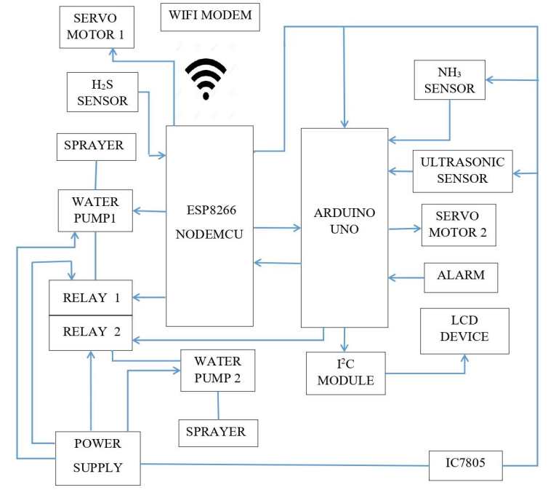

**Fig 1. Block Diagram**

**Buzzer:**

A buzzer is an audio device that produces sound from an electrical signal. They are also called sounders, audio indicators, or audio alarms An audio signaling device like a beeper or buzzer may be electromechanical or piezoelectric or mechanical type. The main function of this is to convert the signal from audio to sound.

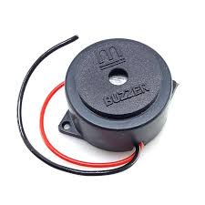

**Fig 2. Buzzer**

**ESP32 Microcontroller :**

The ESP32 is a follow-up to the ESP8266. This low-cost system on a chip (SoC) series was created by Espressif Systems. Based on its value for the price, small size, and relatively low power consumption, the ESP32 is well-suited to a number of different loT applications.ESP32 can perform as a complete standalone system or as a slave device to a host MCU, reducing communication stack overhead on the main application processor. ESP32 can interface with other systems to provide Wi-Fi and Bluetooth functionality through its SPI / SDIO or I2C/UART interfaces.

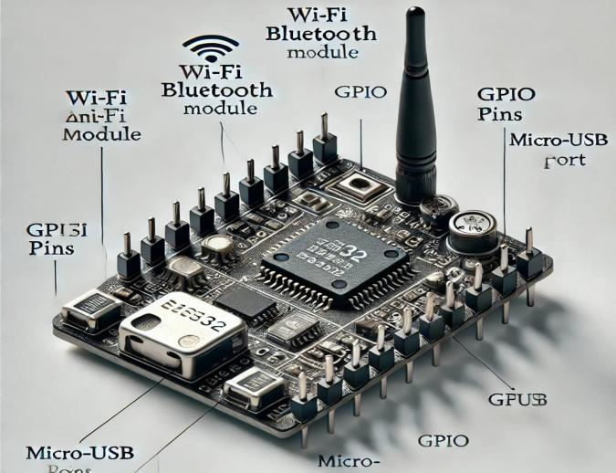

**Fig 3.ESP32 Microcontroller**

**Relay:**

A relay is an electromechanical or solid-state device that allows a low-power signal to control a high-power circuit. It acts as a switch, enabling isolation between different circuits.

**Exhaust Fan:**

It sounds like you're dealing with an exhausted fan—whether it's a ceiling fan, a computer fan, or something else. If the fan is making unusual noises, not spinning, or running inefficiently, it could be due to dust buildup, a faulty motor, or worn-out bearings.

**Cryptogamic Biofilter :**

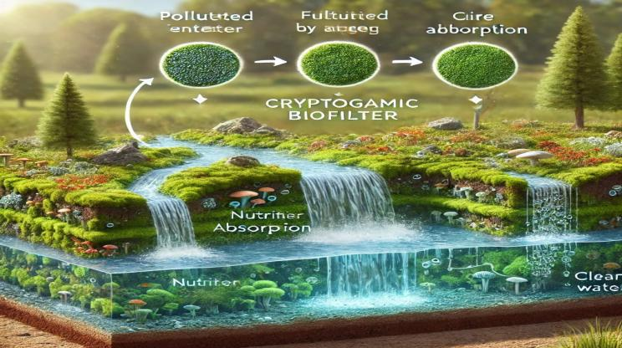

**Fig 4. Cryptogamic Biofilter**

The cryptogamic biofilter process involves using cryptogamic covers—composed of mosses, lichens, algae, and cyanobacteria—to filter and purify water. These organisms are known for their ability to absorb pollutants, stabilize ecosystems, and support sustainable water treatment. Below is the step-by-step process:

1. Initial Water Flow:

Contaminated water or runoff is directed over a surface covered with cryptogamic organisms.

This surface may include soil, rocks, or other substrates where the organisms thrive.

2. Filtration by Cryptogamic Layer:

The cryptogamic cover traps and absorbs impurities like sediments, heavy metals, and organic pollutants.

Microbial activity in the cryptogams helps break down harmful compounds into less toxic forms.

3. Absorption of Nutrients and Pollutants:

The organisms absorb nutrients such as nitrogen and phosphorus, which are common in agricultural runoff.

They also sequester carbon, helping in carbon dioxide reduction.

4. Water Purification:

The filtered water that emerges from the biofilter is cleaner and safer, suitable for environmental release or further use.

5. Maintenance and Regeneration:

Periodic maintenance may include allowing the cryptogamic organisms to regenerate naturally or replacing parts of the biofilter if necessary. This ensures the biofilter remains efficient over time.

Applications:

Wastewater Treatment: Natural filtration of municipal or industrial effluents. Stormwater Management: Filtering pollutants from urban runoff. Agriculture: Reducing nutrient pollution in farming runoff. Ecosystem Restoration: Stabilizing soil and improving water quality in degraded areas.

This sustainable, low-energy method makes cryptogamic biofilters an environmentally friendly solution for water purification.

**Conclusions**

In conclusion, IoT-enabled hazardous gas detection and removal systems offer a transformative solution for modern poultry farming. By providing real-time monitoring and automated responses to harmful gas levels, these systems ensure improved air quality, healthier poultry, and enhanced productivity. Additionally, the integration of sustainable technologies, such as natural filtration methods, reduces environmental impact and operational costs. This approach not only addresses the challenges of gas emissions but also sets a benchmark for smart, eco-friendly farming practices in the agricultural industry.

**References**

1. Mohammed Al-Shuaili, Aisha Al-Risi, Rahma Al-waili Low-Cost Smart Poultry Farming Based on IoT 2021 IJRAR December 2021, Volume 8, Issue 4
2. Mahdi Salch Mohammad Al- Kerwi', Omar Mardenli, Mohammed Rasoul Mahdi Jasim and Moustafa Abed Al-Majeed " *Effects of Harmful Gases Emitted from Poultry Houses and Health Performance" ISAESE - 2022
3. Mr. K. Santhosh Kumar "IOT Enabled Hazardous Gas Detection and Removal System in Poultry Farm" International Journal of Engineering Research & Technology (IJERT) ISSN : 2278-0181
4. Anisha L.", Bala Devika B., Sabitha S. & Mrs. M.L. Ashly Beby " Smart IoT System for Gas Monitoring and Environmental Control in Poultry Farms" Irish Interdisciplinary Journal of Science & Research (IIJSR) Volume 8, Issue 2, April-June 2024
5. Dr.S. Subasree, Dr.N.K. Sakthivel,M.Karthik "Sensory Detector of Hazardous Gases in Poultry Farms" International Journal of Engineering Research & Technology (IJERT)ISSN: 2278-018 Vol. 13 besine 4. April 2024
6. Jeevitha D, Aarthi K², Yashika T3, Pasavakeerthi T, Prof. C. Sathiyavel M.E.'5 " IOT -Based gas monitoring in poultry Farms Enhancing odor And File management( IRJMETS) Volume:06/Issue:05/May-2024
7. Namrata S. Chougale, Suraj K. Haragapure, 'Shubhangi B. Patil, Amarsinh B. Farakte " *Internet of Things (IoT) based smart poultry farming" JETIR June 2023, Volume 10, Issue 6
8. M. F. H. Hambali, R. K. Patchmuthu, and A. T. Wan, “IoT Based Smart Poultry Farm in Brunei,” IEEE Xplore, Jun. 01, 2020. https://ieeexplore.ieee.org/document/9166331.

[9] T. S. Gunawan, M. F. Sabar, H. Nasir, M. Kartiwi, and S. M. A. Motakabber, “Development of Smart Chicken Poultry Farm using RTOS on Arduino,” IEEE Xplore, Aug. 01, 2019. https://ieeexplore.ieee.org/document/9057310 (accessed Mar. 17, 2021)