**TITLE:**

**Spiritual Tourism: A New Dimension for Sustainable Development for Tourism Industry (Special emphasis on Madhya Pradesh Spiritual tourism)**

**Name of Author:**

**Dr. Varsha Patel**

**Affiliation:**

**Geography Department Barkatullaha University, Bhopal M.P**

**Email:**

**varsha4711@gmail.com**

**Spiritual Tourism: A New Dimension for Sustainable Development for Tourism Industry (Special emphasis on Madhya Pradesh Spiritual tourism)**

**Abstract:**

Spirituality, in general, has recently become an important subject of research in social and business areas. This has added a new dimension to the tourism industry, called spiritual tourism. and Consequently, there has been an increase in the awareness and research interest in the thematic field of spiritual tourism. Tourism is an age old activity associated with civilized nations. Thus, tourism literature too has a long history. However, there are few areas in tourism which have come to the domain of scientific investigation only recently. This paper emphasizes on the emergence of spiritual tourism oriented research activities and explores the potentials for future work in tourism research. Research publications on spiritual / pilgrimage tourism appeared in five different journals and a few major conference proceedings since the year 1992 have been analyzed. This paper presents an analysis of the available and relevant literatures in the field of spiritual tourism with special emphasis on the Madhya Pradesh state of India. Madhya Pradesh Well known as the heart of India and Madhya Pradesh is Very rich for its Hospitality, its Beauty and for its spiritual tourism Destinations.

**Keywords:** spiritual tourism, tourism research, classification of tourism literature, tourism marketing, tourism research.

**Introduction:** Tourism is playing a very vital for the economy of many countries, due to the revenue generated by the consumption of goods and services by tourists, the taxes levied on businesses in the tourism industry, and the opportunity for employment in the service industries associated with tourism. Tourism has its own direct and indirect effect on society which is regarded as an effective instrument of country‘s economic development. Tourism industry improves a country‘s economy, stimulates development process, restores cultural heritage, and helps in maintaining international peace and understanding. It has been observed that spirituality, in general, has recently become an important subject of research in social and business areas. This has added a new dimension to the tourism industry, called spiritual tourism. Spiritual tourism, also termed as religious heritage tourism, includes all the religions, religious places associated with, emotional attachment to these centers and infrastructure facilities for the tourists. This can also be referred to as pilgrimage tourism, as clients are not looking for luxury but arduous journeys to meet the divine goal or simple life. Spiritual tourism seems to be a newer academic concept, but it is certainly not a new phenomenon. The term spiritual tourism, attracted many researchers globally. This increasing interest is not because of its spiritual perspective, but for the potential it carries to become the largest segment within the industry. The present paper examines the emergence of spiritual tourism as a fertile research area in the context of available literature.

**Study area:**

Madhya Pradesh literally means "Central Province", and is located in the geographic heart of India, between latitude 21.2°N-26.87°N and longitude 74°02'-82°49' E. The state straddles the Narmada River, which runs east and west between the Vindhya and Satpura ranges; these ranges and the Narmada are the traditional boundary between the north and south of India. The state is bordered on the west by Gujarat, on the northwest by Rajasthan, on the northeast by Uttar Pradesh, on the east by Chhattisgarh, and on the south by Maharashtra.

Madhya Pradesh has a subtropical climate. Like most of north India, it has a hot dry summer (April–June), followed by monsoon rains (July–September) and a cool and relatively dry winter. The average rainfall is about 1,370 mm (53.9 in).

It decreases from west to east because monsoon wind moves from west to east and drained clouds in western part takes less quantity of water vapours with them to eastern part.

The south-western districts have the heaviest rainfall, some places receiving as much as 2,150 mm (84.6 in), while the western and north-western districts receive 1,000 mm (39.4 in) or less. Since the study area is not concentrated to any particular place or point but Madhya Pradesh as a whole. The current world tourism contribution to GDP is 11%., while, Indian tourism contribution to GDP is 1.8% and it is targeted to reach 6% in the next decade.

If this can be re-targeted to reach 10%, an additional 1.2 crore jobs can be created. A majority of the 2 crore NRIs, are central Indian who are prosperous as professionals and traders. This untapped resource can be motivated to become prospective tourists and investors in this sector and the GDP level can be improved considerably.

The state of Madhya Pradesh has been transformed into an industrial powerhouse during the last three decades reducing its dependence on agriculture and textiles. 2.1. Development of Madhya Pradesh t. Study area Madhya Pradesh literally means "Central Province", and is located in the geographic heart of India, between latitude 21.2°N-26.87°N and longitude 74°02'-82°49' E.

The state straddles the Narmada River, which runs east and west between the Vindhya and Satpura ranges; these ranges and the Narmada are the traditional boundary between the north and south of India.

The state is bordered on the west by Gujarat, on the northwest by Rajasthan, on the northeast by Uttar Pradesh, on the east by Chhattisgarh, and on the south by Maharashtra. Madhya Pradesh has a subtropical climate. Like most of north India, it has a hot dry summer (April–June), followed by monsoon rains (July–September) and a cool and relatively dry winter.

The average rainfall is about 1,370 mm (53.9 in). It decreases from west to east because monsoon wind moves from west to east and drained clouds in western part takes less quantity of water vapours with them to eastern part. The south-western districts have the heaviest rainfall, some places receiving as much as 2,150 mm (84.6 in), while the western and north-western districts receive 1,000 mm (39.4 in) or less. Since the study area is not concentrated to any particular place or point but Madhya Pradesh as a whole.

The current world tourism contribution to GDP is 11%., while, Indian tourism contribution to GDP is 1.8% and it is targeted to reach 6% in the next decade. If this can be re-targeted to reach 10%, an additional 1.2 crore jobs can be created. A majority of the 2 crore NRIs, are central Indian who are prosperous as professionals and traders.

This untapped resource can be motivated to become prospective tourists and investors in this sector and the GDP level can be improved considerably. The state of Madhya Pradesh has been transformed into an industrial powerhouse during the last three decades reducing its dependence on agriculture and textiles.

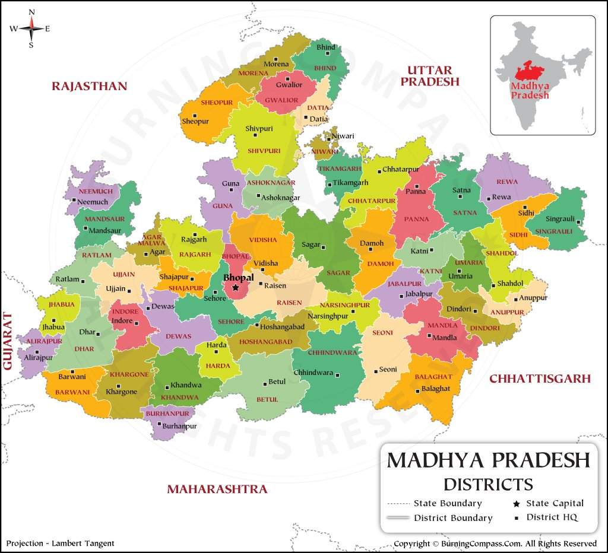**Location map of madhya pradesh**

**Development in the tourism sector of Madhya Pradesh :**

Madhya Pradesh has a long historical and cultural tradition dating back to the days of the Harappa civilization established by relics found at Lothal. Situated on the central part of the India. Tourism is one of the most important sectors in Madhya Pradesh, which is to be exploited in the coming years. The Madhya Pradesh tribal life is a celebration, of music, dance and multi-coloured traditions. Activities like religious and archeological tourism, heritage, coastal and beach tourism, adventure tourism, highway tourism etc are being encouraged.

The State thus offers scope for investment in tourism related activities in the form of accommodation projects, food oriented projects, amusement parks and water sports, handicraft village complexes, sea/river cruise, safari project, sports/health facility complexes, etc.

The Government would also like to encourage service-oriented projects like travel operation, tour operation, transport operation etc. Madhya Pradesh has a long varied history and a great number of interesting places to visit. Some of the most important sites in Madhya Pradesh are scenic beauty, national parks, wildlife sanctuaries as a Khajuraho temple, Panna Tiger Reserve, Khana National Park, Bandhav Garh, Sone crocodile sanctuary etc.

The tourism policy in India provides boost to the tourism industry in order to harvest the socio-economic benefits of this service providing sector. The ministry of tourism in the year 2004 has launched the “Atithi Dev Bhav”, “Guest is God” & is the latest key to the Indian tourism sector, in order to attract a fairly good chunk of tourists both local as well as international. Similar type of promotional movement can be seen in almost all the states as for example, “Madhya Pradesh, where life is celebration” is the new mantra of the Madhya Pradesh state tourism corporation & has declared the year 2006 as tourism year to promote tourism in Madhya Pradesh.

Tourism & resource development According to Prof. Zimmerman, Resource does not refer to a thing or substance but to a function which thing or substance may perform or to an operation in which it may take part‟. The significance of the term tourism & resource relationship can be understood by economic geographer as resource is neither a material nor substance but a positive interaction between man & nature, positive in terms of satisfying individual needs & social objectives that we may apply for tourism development.

Tourism and resource both are interrelated. Tourism helps in upgrading the quality of resources, which has not yet been fully utilized. Say for example most the hills & mountains are remain virgin i.e. not been touched by the human beings, because of prevailed inaccessibility, can be developed as a hill tourism or mountain tourism, such as adventure, climbing, tracking, hill station tourism etc. The plain has now become the hub of all cultural development; in fact we can say it possesses the world’s best-developed potential tourism environment in the world.

Now the new type of tourism is coming in view i.e. the forest & wildlife tourism, which has catered a huge number of tourists from all over the world, because of its natural environment. In M.P. such places are Khajuraho, Panna National Park. Khana National Park, Ken and Sone Crocodile sanctuary, Bandhav Garh National Park major national parks and sanctuary. Tourism has the potential to create beneficial effects on the resource development by contributing to environmental protection and conservation. It is a way to raise awareness of environmental values and it can serve as a tool to finance protection of natural areas and increase their economic importance.

The quality of the environment, both natural and man-made, is essential to tourism. The impact of tourism on the land environment can be seen in the form of sprouting hotels restaurants, & others kinds of related infrastructures, which fulfills the demand of the tourists. Rise of cultural landscape in the form of nature park natural reserves, parks, golf courses etc. transforms the natural landscape. In short complete land use pattern alter in the places of tourists interests. Typical services offered at ecotourism destinations might include local arts and crafts, guided hikes and wildlife viewing, publications, natural history lectures, photography, and local food. Revenues are generated from fees for these services, as well as natural area user fees and local expenditures for hotels, restaurants and bars, and transportation services (Seidl 1994).

Some writers qualify ecotourism even more specifically, suggesting that it also must provide direct revenue toward the conservation or protection of natural areas and educate tourists about related environmental issues. The Ecotourism Society defines ecotourism as “travel to natural areas to understand the cultural and natural history of the environment, taking care not to alter the integrity of the ecosystem, while producing opportunities that make the conservation of the natural resources beneficial to local citizens” (Wood 1993).

The qualification that ecotourism not harm the natural environment raises the issue of sustainability and the additional concept of sustainable tourism. Sustainability in tourism literature can be considered within political, social, economic, ecological, and cultural contexts (Henry and Jackson 1996) with sustainability of natural resources being the predominant view.

Ecotourism precludes more intensive exploitation of natural resources in rural areas or developing countries by providing economic returns that exist as positive incentives to local residents who are enlisted in natural resource protection. In this view, non-tourism industries generally are portrayed as exploitative and degrading to natural resources, whereas tourism generally, and ecotourism specifically, are advocated as ways to capture natural resource use and nonuse values. According to this view, non-tourism industries must be controlled and ecotourism promoted. Some researchers view the tourism industry itself as exploitative and degrading to natural resources as well as indigenous people and cultures. According to this view, the development of tourism is what must be controlled to sustain natural resources and cultural attributes on which tourism depends.

**Research on Spiritual Tourism:** Spiritual tourism has extended the conventional concept the harder the journey, the better the reward‘, to a wider concept of a desire for a change, relief from the dull daily life and enthusiasm and divine nature for a common man. Accordingly, academic interests in analysing different aspects of spiritual tourism as a new segment have been gaining momentum. Spirituality has become an increasingly significant area in social, health and business research (Haq et al., 2008). Travels to spiritual places have recorded a phenomenal increase in the recent years. Believe in spirituality has caused people to travel since long even with poor travelling and communication infrastructures. However, scientific study on marketing aspects of spiritual tourism is very limited. Most of the studies are case-based or demographic. A brief review of literatures appeared in five leading international journals (Annals of Tourism Research, Applied Geography, International Journal of Tourism Research, International Journal of Contemporary Hospitality Management, and Journal Management, Spirituality and Management) and few International Conference Proceedings since the year 1992 have been presented in the following subsection.

**Emergence of spiritual tourism in Madhya Pradesh:**

Madhya Pradesh is one the most beautiful Indian states dotted with some ancient temples and attractions perfect for spirituality seekers. The state, also known as the heart of India, MP is rich in cultural heritage and spiritual significance.If you're planning to explore the spiritual landmarks of Madhya Pradesh, here are five must-visit attractions that offer a glimpse into the region’s historical beauty:

***Bhojpur******Temple*:** Located in the town of Bhojpur, the Bhojpur Temple is dedicated to Lord Shiva. The site is revered for its massive but incomplete Shiva lingam, which is one of the largest in India. The temple, built during the reign of the Paramara king Bhoja, features impressive stone carvings and a grand architectural layout.

***Ujjain’s Mahakaleshwar Temple***: Another unmissable site is Mahakaleshwar Temple in Ujjain. It is one of the twelve Jyotirlingas, which are highly revered in Hinduism. The temple is noted for its Bhasma Aarti, a unique ritual where the Shiva lingam is offered ashes from a sacred fire. The temple’s spiritual atmosphere and architectural beauty make it a central pilgrimage site for devotees.

***Chausath Yogini Temple***: Perched on a hilltop in the village of Mitawali, the Chausath Yogini Temple is dedicated to the 64 Yoginis, a group of female deities. This ancient temple, built in the 9th century by the Kachchhapaghata dynasty, is notable for its circular design and the impressive sculptures of the Yoginis.

***Sanchi Stupa*:** Although primarily known for its stupas, the Sanchi site also includes several ancient temples that reflect the Buddhist influence on Madhya Pradesh. The Sanchi Stupa, built by Emperor Ashoka in the 3rd century BC, is one of the oldest and best-preserved stupas in India. The nearby temples, such as the Temple No. 17 and the Temple No. 18, offer insights into early Buddhist architecture and the religious practices of that era.

In the last few years, the major research focus was shifted towards development of marketing strategy, drivers of spiritual tourism, development of typology model and analysis of tourists‘perspectives and attitudes. It has been observed that both religious tourism‘and pilgrimage‘are often included within the broad umbrella of spiritual tourism. It is observed that the literatures analyzed in the present work (1992 – June 2009) can further be categorized into four groups based on the theme of the publications. These categories include literatures on themes like conceptual, marketing, destination of spiritual tourists, and socio-cultural issues.There has been a significant interest in marketing aspects of spiritual tourism. However, investigations into the socio-cultural aspects of the spiritual/pilgrimage tourism indicate diverse research interests, while destination related studies are relatively less.

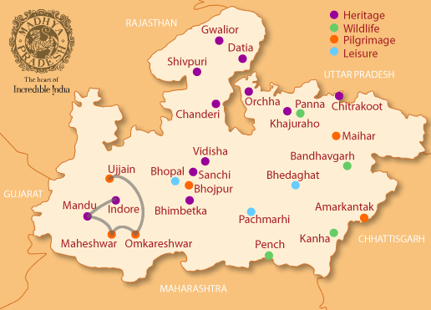

**Tourist map of Madhya pradesh**

**Future scope of research:**

Tourism has been recognized as one of the major industries of many countries. Spiritual tourism is also recognized as one of the major contributors in a state‘s revenue. Many countries are known for their spiritual heritages. However, organized research activities in the area are yet to be seen. Thus, although there has been an encouraging trend in the recent years, sufficient literature on spiritual tourism is yet to be generated. There are immense scopes of research in the area. Segmentation of inbound and outbound tourists needs to be studied well. Segmentation, as suggested by Tkaczynski et al. (2009), should be at the tourism stakeholder level rather than at the destination level. Destination marketing has been recognized worldwide as one of the important aspects in marketing of tourism.

**Conclusion:**

There has been a phenomenal increase in spiritual travelers in the recent years owing to generic changes in the people‘s attitude towards spirituality. Ripple effect of this change has also been observed in the academic research.

Literatures in the field of spiritual tourism, along with other sector-based tourisms (adventure tourism, eco tourism, medical tourism, wedding tourism etc.), have been on rise significantly. A higher trend in reporting case-based studies (geo-specific, shrine specific etc.), rather than on general approach, have been observed.

Current paper presents a brief review of literatures concerning tourism research, in general, and with a focus on spiritual tourism during the period 1992 – June 2009. Major thematic classifications in tourism research presented by different authors have been analysed. A new model depicting general classification of tourism literatures including spiritual tourism has been proposed.

Literatures on spiritual/ pilgrimage tourism could be further classified into four different major categories based on the issues discussed. Growth of spiritual tourism as a promising research domain has been discussed with the available literatures. Potentials for future research in the area have been indicated.

Major conclusions of the present study can be summarized as: Researches in the sector-based tourism are increasing significantly in the recent years. There has been a substantial increase in research interest in the area of spiritual/ pilgrimage tourism, especially, in the current decade. Increase in the published literature in the second half of the current decade is almost four times that of the first five years.

Literatures on spiritual/pilgrimage tourism can be further subdivided into four thematic areas – conceptual, marketing, destination, and socio-cultural. Spiritual tourism as a subject of scientific research is still in its infancy. Many aspects like infrastructural development and requirement, destination analysis, segmentation of destination, demographic segmentation of tourists are yet to be explored well.

**References:**

Aggarwal, A. K., Guglani, M. and Goel, R. K. (2008), Spiritual & Yoga Tourism: A case study on experience of Foreign Tourists visiting Rishikesh, India, Proceedings of the Conference on Tourism in India – Challenges Ahead, Kozhikode, May 15-17, 457–463.

Beerli, A. and Martı´n, J. D. (2004), Factors Influencing Destination Image, Annals of Tourism Research, 31(3), 657–681.

Buhalis, D. (2000), Marketing the competitive destination of the future, Tourism Management, 21(1), 97–116.

Calantone, R.J. and Mazanec, J.A. (1991), Marketing management and tourism, Annals of Tourism Research, 18, 101–119.

Chaudhary, M. (2000), India's image as a tourist destination - a perspective of foreign tourists, Tourism Management, 21, 293–297.

Cohen, E. (1979), Rethinking the Sociology of Tourism, Annals of Tourism Research, Jan/Mar, 18–35.

Connell, J. (2006), Medical tourism: Sea, sun, sand and …. Surgery, Tourism Management, 27, 1093–1100.

Costa, J. (1995), International perspectives on travel and tourism development, International Journal of Contemporary Hospitality Management, 7(7), 10–19.

Cracolici, M. F. and Nijkamp, P. (2008), The attractiveness and competitiveness of tourist destinations: A study of Southern Italian regions, Tourism Management, 30, 336–344.

Crouch, G. I. and Ritchie, J. R. B. (1999), Tourism, Competitiveness, and Societal Prosperity, Journal of Business Research, 44, 137–152.

Das, D., Mohapatra, P. K. J., Sharma, S. K. and Sarkar, A. (2007), Factors influencing the attractiveness of a tourist destination: A Case study, Journal of Services Research, 7(1), 103–131.

Eade J and Sallnow MJ (Eds.) (1991) Contesting the sacred. The anthropology of Christian pilgrimage. London: Routledge.

Fedele A (2014) Energy and transformation in alternative pilgrimages to Catholic shrines: deconstructing the tourist/ pilgrim divide. Journal of Tourism and Cultural Change 12(2):150-165.

Gesler W (1996) Lourdes: Healing in a place of pilgrimage. Health & Place 2:95–105.

Haq F and Medhekar A (2020) The Rise of Spiritual Tourism in South Asia. Journal of Management and Research 7(1): 52-78.

Heidari A, Yazdani RH, Saghafi F and Jalilvand RM (2018) The perspective of religious and spiritual tourism research: a systematic mapping study. Journal of Islamic Marketing 9(4):747-798.

Indian Panorama (2018) Why is India the Center of Spiritual Tourism? Available at: www.indianpanorama.in/blog/ why-is-India-the-centre-of-spiritual-tourism