ENHANCING OF COMMUNICATION SKILLS FOR THE PROFESSIONAL GROWTH OF ENGINEERING STUDENTS
¹Mrs. P. Alagumathi and ²Mr. S. Ramesh Raja
^{1,2}Assistant Professor, Department of English, Sri Bharathi Engineering College for Women, Kaikkurichi, Pudukkottai.

Abstract: Effective communication skills significantly enhance a student's chances of achieving success in life, while a lack of these skills can hinder their professional growth. For engineering students in India, strong English communication skills are essential to meet the recruitment demands of Information Technology (IT) companies and multinational corporations. Possessing technical expertise alone is insufficient; employability skills are crucial for securing positions in prestigious organizations or pursuing advanced educational opportunities. To thrive in their professional careers, students must focus on improving their communication abilities. Employers often prioritize a high level of English proficiency as one of the most desirable attributes in candidates. Communication skills are critical for engineering students preparing for on-campus interviews. This paper explores strategies to develop effective communication skills, highlights relevant courses and soft skill programs, and provides actionable insights to enhance employability.
Keywords: Communication skills, soft skills, employability, public speaking, interpersonal skills, personality development, confidence building, technical interviews.
- Introduction
The role of English in engineering institutions is vital due to the competitive edge enjoyed by English-speaking nations in terms of their economic influence, global trade, and technological advancements. English serves as a critical tool in engineering education, forming the foundation for effectively conveying knowledge acquired in core subjects, both orally and in writing. Alongside English, students receive instruction in fundamental areas with a focus on technical knowledge. An engineering degree can be broadly divided into two components: the technical aspect, which involves understanding physical and mathematical principles, analytical techniques, and models, and a set of general skills. At this stage, it is crucial to motivate students to develop a strong commitment to learning, refine their interpersonal abilities, efficiently manage time and resources, respond constructively to feedback, and enhance problem-solving, critical thinking, and stress management skills. With these attributes, students can confidently handle challenges in both their personal and professional lives. However, despite excelling academically, engineering students often struggle to express themselves effectively in interviews or group discussions, which may reduce their chances of securing opportunities for higher education abroad.
The success of an individual largely depends on their ability to communicate effectively. Strong communication skills are vital for achieving both personal and professional goals. In India, engineering courses, introduced during the 18th century, are renowned for their high standards. Each year, a significant number of students graduate with technical degrees, many of whom meet the necessary academic qualifications. However, a lack of practical communication skills often limits their chances of securing employment in Information Technology (IT) companies and multinational corporations. Technical knowledge alone is insufficient for obtaining suitable job opportunities; employability skills, particularly communication proficiency, are equally crucial. To excel in the workplace, students must enhance their English language skills, as it is a key factor in job acquisition. The teaching methodology plays a critical role in achieving this objective. In this context, educators need to adopt specific instructional approaches to help students meet the desired outcomes. On-campus interviews are a vital gateway for engineering students to secure their first professional role. While technical expertise is crucial, communication skills often serve as a differentiator, enabling candidates to present their knowledge confidently and connect effectively with interviewers. Employers look for individuals who can articulate their thoughts, collaborate in teams, and adapt to various professional scenarios. Unfortunately, many engineering students struggle with effective communication due to a lack of exposure and practice. This document discusses the importance of communication skills, the challenges faced by students, and the courses and programs available to bridge the skill gap.
In today’s globalized job market, engineering graduates face significant competition when seeking employment. Communication skills, particularly in professional English, have become a critical factor in securing employment, whether in India or abroad. As many companies and institutions require proficiency in English to conduct technical discussions, attend interviews, and collaborate with international teams, it is essential for engineering graduates to master both technical and professional English. This paper highlights the significance of English language skills during job searches and interviews, as well as the specific challenges and strategies for overcoming language barriers in an engineering context. The paper also discusses how improving English proficiency can make graduates more competitive in both domestic and global markets.
1.1 Necessary of English for Engineering Students:
The incorporation of English into the engineering curriculum serves to enhance students' technical and specialized communication skills, both oral and written, with an emphasis on logical and coherent explanation techniques. Without proper guidance, students may struggle to effectively convey their in-depth subject knowledge. Upon completing their academic degrees, students are expected to join professional organizations and adhere to appropriate conduct and etiquette to seamlessly integrate into organizational structures. Proficiency in language plays a significant role in developing the skills required for adapting to professional settings.
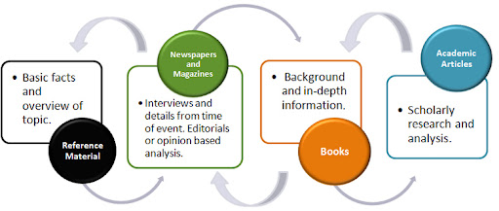
Fig. 1. Communication Research methods
At the undergraduate level, students acquire a basic understanding of the language, making it essential to teach them how to use appropriate structures and terminology to improve the impact of their presentations. It is important for students to understand the proper use of tenses and voice during oral presentations. Often, students fail to differentiate between spoken and written language, leading to a writing style that closely resembles speech. This lack of awareness regarding the distinctions and subtleties of written communication requires targeted instruction.
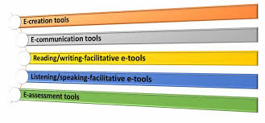
Fig. 2. ICT Tools for professional communication
Students must be taught to recognize the differences between written and spoken communication, which are sometimes mistakenly considered interchangeable or referred to as an "interactive mode." At this stage, learners should also develop strong listening skills, particularly in comprehending specialized terminology and grammatical structures. Additionally, proficiency in reading is a critical skill for success in the professional world. Reading involves cognitive abilities such as skimming, scanning, note-taking, and note-writing, all of which are essential for professional growth.
Engaging students actively in the teaching and learning process is vital for fostering the development of these essential skills. The ultimate goal is to cultivate effective communication abilities within a professional context, preparing students to compete for engineering and technical careers and to excel in their respective fields.
- Objectives for the Development of Communication:
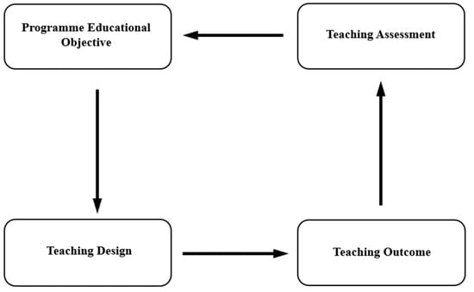
Fig. 3. Developing the communication skills
Achieving the outlined objectives requires the adoption of a practical teaching methodology. The teaching-learning process should center on fostering learning outcomes. If the defined goals are met, securing employment will become more accessible. However, many highly skilled engineers and software professionals struggle to make a significant impact in the global market, largely due to inadequate communication skills. It is crucial to acknowledge that engineers must possess not only technical expertise but also a strong command of the English language to effectively convey their abilities. A lack of proficiency in English and a tendency to undervalue its importance should be replaced with a focused effort to enhance language skills, ensuring academic and professional success.
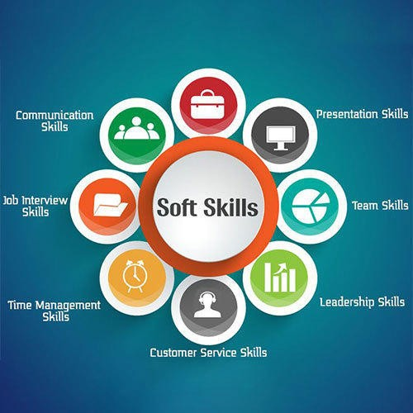
Fig. 4. Soft Skills
Mastery of English communication is vital for even basic survival in today's world. The defined goals must be thoughtfully evaluated, and a well-structured action plan should be implemented to bring about the desired behavioral changes in students. A well experienced communication expert has observed that an analysis of employable talent across various states reveals that, despite producing a high number of engineers, the overall employability rate remains significantly low. This underscores the importance of improving the quality of education rather than merely expanding its capacity.
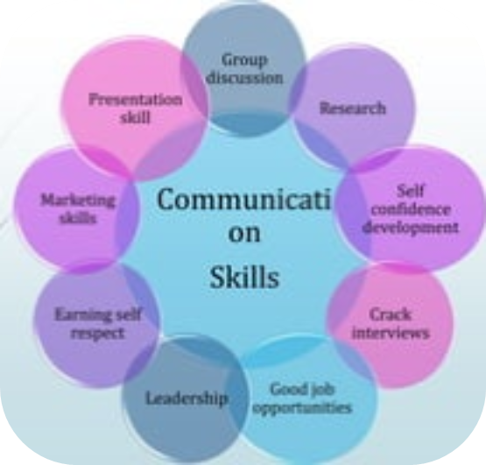
Fig. 5. Group of Skills
- Methodology:
This study employs a mixed-methods approach to gather data and assess the role of professional English in engineering graduates' employability:
- Survey and Interviews: A survey was conducted among engineering graduates and professionals who have recently gone through job application processes and interviews. The survey focused on their perceptions of English language skills and their challenges during interviews. In-depth interviews with recruiters from Indian and multinational companies provided insights into the importance of English in the hiring process.
- Language Proficiency Assessment: Graduates' language proficiency was assessed using standardized tests that evaluate professional English in areas such as technical communication, writing skills, and speaking fluency. This included an analysis of their ability to explain complex engineering concepts clearly and their effectiveness in negotiating job offers or discussing roles during interviews.
- Training Programs: The study also examined various English language training programs aimed at improving engineering graduates’ communication skills. Participants underwent a short-term English for Professional Communication course and were assessed before and after the training.
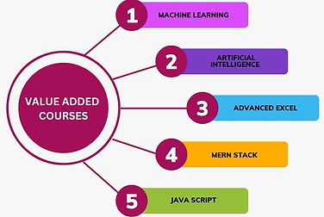
Fig. 6. Value Added Courses
- Comparative Analysis: A comparative analysis of job success rates was conducted between graduates with high professional English proficiency and those with lower levels. This analysis considered both Indian job markets and opportunities abroad.
- Understanding Key Communication Skills:
  - Verbal Communication: Clarity in expressing ideas during technical and HR interviews.
  - Non-verbal Communication: Body language, eye contact, and gestures that convey confidence and professionalism.
  - Listening Skills: Active listening to understand questions and respond appropriately.
- Challenges Faced by Engineering Students:
  - Limited opportunities for public speaking and group discussions.
  - Hesitation due to fear of judgment or lack of fluency in English.
  - Inadequate training in interpersonal and team collaboration skills.
- Improvement Strategies:
  - Enrolling in communication and soft skill programs tailored for engineering students.
  - Participating in group discussions, mock interviews, and presentation workshops.
  - Leveraging online platforms offering courses like Coursera, Udemy, and LinkedIn Learning.
  - Engaging in extracurricular activities like debates, seminars, and technical clubs to gain practical experience.
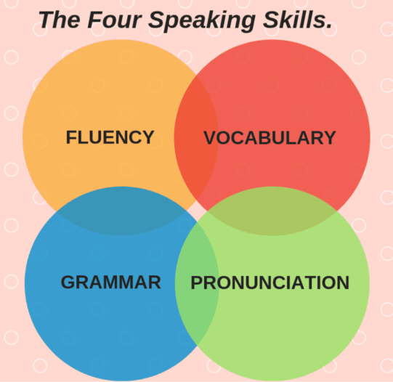
Fig. 7.Speaking Skills
- Popular Courses and Soft Skill Programs:
  - Public Speaking and Presentation Skills: Courses by Dale Carnegie, Toastmasters, or local public speaking groups.
  - Professional Writing and Email Etiquette: Workshops on drafting resumes, cover letters, and business emails.
  - Personality Development Programs: Focused on confidence building, grooming, and stress management.
  - Language Proficiency Programs: IELTS, PTE, and spoken English classes for non-native speakers.
- Application of Skills in On-Campus Interviews:
  - Structuring responses using frameworks like STAR (Situation, Task, Action, Result) for behavioral questions.
  - Demonstrating problem-solving capabilities and teamwork experiences through real-life examples.
  - Showcasing adaptability and eagerness to learn.
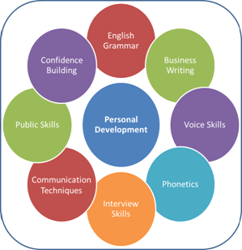
Fig. 8.Personal Development Methods
- Scope and Output of Communication Skills
Outputs: By adopting these strategies and enrolling in the recommended programs, engineering students can achieve:
- Improved clarity and confidence in communication.
- Enhanced ability to articulate technical knowledge effectively.
- Positive impressions during interviews through strong verbal and non-verbal cues.
- Higher success rates in on-campus recruitment processes.
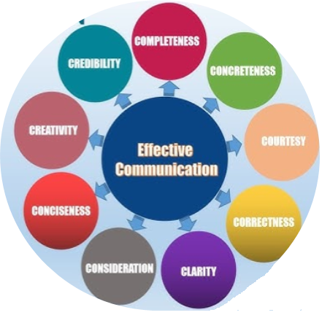
Fig. 9.Effective Communication
- Impact of English Proficiency: Graduates with a higher level of professional English proficiency showed significantly better success rates in securing job interviews and offers, particularly for positions in multinational companies. English fluency, especially in oral communication and technical writing, was identified as a crucial factor in differentiating successful candidates from those who struggled.
- Challenges in Language Use: Many engineering graduates faced challenges in presenting complex technical concepts clearly in English, especially when asked to explain their projects or work experiences during interviews. The lack of confidence in speaking English and the tendency to rely heavily on regional languages were found to hinder effective communication in global contexts.
- Training Program Effectiveness: Graduates who underwent focused training programs in English for professional purposes showed notable improvement in their language skills. This included enhanced clarity in their spoken English, better writing skills for emails and reports, and an increased ability to engage in technical discussions.
- International Job Market Preferences: The study also revealed that international employers prioritize not only technical expertise but also the ability to communicate effectively in English. In interviews for jobs abroad, candidates who demonstrated strong language proficiency were preferred, as it indicated their potential for successful integration into a global work environment.
- Conclusion
The challenge of students' learning is exacerbated by the lack of adequately trained English language teachers at all levels. Enhancing the English proficiency of teachers could significantly improve the situation, as students may struggle to learn effectively if their teachers are not truly competent. In many rural areas and certain English-medium schools, the English language skills of teachers remain less than satisfactory. In addition to academic qualifications, teachers should be required to pass standardized proficiency tests to be deemed qualified for teaching English. This is particularly important as the focus should be on teaching English as a global language for academic and professional communication. Communication skills are indispensable for engineering students aiming to excel in on-campus interviews. Alongside technical knowledge, these skills empower candidates to connect with recruiters, present themselves as competent professionals, and secure job opportunities. By enrolling in targeted courses, practicing regularly, and embracing feedback, students can transform their communication abilities, ultimately boosting their employability and career prospects.
References:
1. Prof. V. Chandra Sekhar Rao (2017), “A Model English Syllabus Design for the Students of Science and Technology”, Journal for research Scholars and Professors of English Language Teaching, Vol– 1, Issue–3.
2. K. Latha (2014), “Role of English Language for Engineering Students”, American International Journal of Research in Humanities,Arts and Social Sciences
3. Dr. Meenu Pandey & Dr. Prabhat Pandey (2014), “Better English for Better Employment Opportunities”, International Journal of Multidisciplinary Approach and Studies, Volume -01, No.4, July - Aug 2014, (pp.417-426).
4. Venkateswar Rao. D (2015), “Teaching English Communication Skills for Professional Students”, Indo – Asian Journal of Multidisciplinary Research (IAJMR), Vol-1, Issue-2, Year – 2015
5. Nagia, B. (2016), “Prominence of English Language for Career Development", Language in India, Vol-16, No. 4, April 2016
6. National Educational Policy – 2019 (p.90).
7. Mr.S.Ramesh Raja, Mrs.A.Alagumathi, Utilizing AI-based Technology for English Teaching and Learning, International Journal of Engineering Research & Technology, Volume-12, Issue-01, 2024.
8. B. Prakash Ayyappan, S. Ramesh Raja, P. Alagumathi, R. Saratha, R. Abirami (2024), Enhancement of Research Publication in Effective Manner. IJISRT24JUL1087, 704-707. DOI: 10.38124/ijisrt/IJISRT24JUL1087. https://www.ijisrt.com/enhancement-of-research-publication-in-effective-manner

