**A Review in Analytical Methods for Determination of Anti-inflammatory Agents**

1Tamil Selvan R, 2Senthil kumar S K, 3 Swetha R, Barath P, Sathiyan V, Shalini S, Surya prakash S

1 Associate Professor, Arunai College of Pharmacy, Tiruvannamalai, Tamil Nadu 606603

2principal cum Professor, Arunai College of Pharmacy, Tiruvannamalai, Tamil Nadu 606603

3Students, Arunai College of Pharmacy, Tiruvannamalai, Tamil Nadu 606603

Submitted: Accepted:

**ABSTRACT:**

Non-steroidal anti-inflammatory drugs (NSAIDs) are the most commonly used pharmaceuticals in both human and animal medicines for the treatment of certain conditions such as inflammation, fever, and pain. The role of validated analytical methods has become highly important in the quantification of drug substances from their pharmaceuticals as precise product [quality control](https://www.sciencedirect.com/topics/chemistry/quality-control) is required. In the present review, we have summarized various [sample preparation methods](https://www.sciencedirect.com/topics/chemistry/sample-preparation-method) and analytical methods developed for the quantification of NSAIDs during the past decade (2012-till date). Furthermore, an in-depth description of numerous techniques including [chromatography](https://www.sciencedirect.com/topics/chemical-engineering/chromatography), spectrometry (UV), high-performance liquid chromatography (HPLC), ultra-performance liquid chromatography (UPLC), thin-layer chromatography (TLC), High performance thin-layer chromatography (HPTLC), liquid chromatography-mass spectrometry (LCMS), and gas chromatography (GC) approaches used to determine and quantify NSAIDs are provided. Based on the matrix utilized, the following details were discussed: analytical conditions, detection limits, and solvent used in sample preparation. The present compilation provides valuable insights and crucial information on quantification methods for NSAIDs and would assist the scientific community to select the best and economical method for drug analysis in pharmaceuticals and biological samples. UV spectrometry and HPLC were the most commonly used.

**KEYWORDS:** Anti-inflammatory drugs, Analytical methods, validation parameters.

**I. INTRODUCTION:**

Non-steroidal anti-inflammatory drugs (NSAIDs) constitute some of the highly recognized categories of pharmaceutical agents having a variety of advantages. These agents are generally employed as therapeutics in humans and animals due to their ability to function as antipyretic, analgesic, and anti-inflammatory agents. Drugs included within this category differ in terms of their chemical properties and almost all agents possess varying amounts of therapeutic efficacy.  NSAIDs are widely employed to alleviate several debilitating conditions including fever, migraines, [menstrual irregularities](https://www.sciencedirect.com/topics/pharmacology-toxicology-and-pharmaceutical-science/menstrual-irregularity), [rheumatoid arthritis](https://www.sciencedirect.com/topics/pharmacology-toxicology-and-pharmaceutical-science/rheumatoid-arthritis), [osteoarthritis](https://www.sciencedirect.com/topics/pharmacology-toxicology-and-pharmaceutical-science/osteoarthritis), gout, and [postoperative complications](https://www.sciencedirect.com/topics/pharmacology-toxicology-and-pharmaceutical-science/postoperative-complication). Several reports in the literature have suggested that NSAIDs have certain functions in reducing the risk of acquiring malignancies such as colorectal, breast, ovarian, hepatocellular, prostate, pancreatic, and [head and neck cancers](https://www.sciencedirect.com/topics/pharmacology-toxicology-and-pharmaceutical-science/head-and-neck-cancer).

**SALICYATES:-**

1. **ASPIRIN**

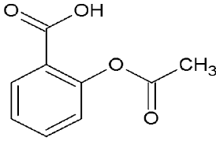

**IUPAC name :** 2-Acetyloxybenzoic acid

**Molecular formula:** C9H8O4

**Molecular weight:** 180.16g/mol

**Physical properties Appearance:** colourless to white crystalline powder

**Solubility:** Sparingly soluble in water; soluble in alcohol and organic solvents

**Boiling point:** 140 °C

**Melting point:** 135 °C

**Pharmacological action :** Aspirin's mechanism of action involves the inhibition of cyclooxygenase (COX) enzymes, primarily COX-1 and COX-2.

1. Inhibition of COX: By acetylating a serine residue in the COX enzymes, aspirin permanently inhibits their activity. This prevents the conversion of arachidonic acid into prostaglandins and thromboxanes.

2. Reduced Prostaglandin Production: Prostaglandins are mediators of inflammation, pain, and fever. By reducing their synthesis, aspirin alleviates these symptoms.

3. Antiplatelet Effect: In low doses, aspirin inhibits thromboxane A2 production in platelets, which reduces platelet aggregation and helps prevent blood clots.

This combination of actions makes aspirin effective for pain relief, inflammation reduction, and cardiovascular protection.

**ANALYTICAL METHODS :**

* 1. **UV-Visible spectrophotometers**

UV-Visible spectrophotometers provide quick and effective analysis in analytical chemistry. They require only little amounts of substances (at mg & µg levels), which are frequently recoverable after testing, and they provide permanent chartrecorded information. Because UV-visible spectrophotometry is so sensitive and selective, it is useful for identifying substances in complicated combinations and finding minute contaminants.

**1.2 Analytical method validation**

It is crucial for ensuring the efficacy and safety of medicinal products by assessing their overall purity during storage, distribution, and use. Validated procedures establish the quality relationship between the examined substance and the one initially evaluated pharmaceutically, toxicologically, and pharmacologically. Sound quality control relies on validated analytical methods, essential for manufacturing, government control laboratories, or pharmacopoeia inclusion. Key validation characteristics include specificity, linearity, range, accuracy, precision, detection limit, quantitation limit, and robustness. These parameters ensure that the analytical method produces reliable data fit for its intended purpose.

**1.3 HPLC ASSAY METHOD VALIDATION ASPIRIN**

A sensitive, specific, precise and cost effective High Performance Liquid Chromatographic method of analysis for aspirin in presence of its degradation products is developed and validated. The method employed Hypersil BDS C18 (100 x 4.6 mm 5μ) column as stationary phase.The mobile phase consisted of sodium perchlorate buffer (pH 2.5): acetonitrile: isopropyl alcohol (85:14:1 % v/v). It is pumped through the chromatographic system at a flow rate of 1.5 ml min−1.The UV detector is operated at 275 nm. This system was found to give good resolution between aspirin and its degradation products. Method was validated as per ICH guidelines.

**Table 1: Effect of pH**

| **Parameters** | **pH 2.3** | **pH 2.5** | **pH 2.7** |
| --- | --- | --- | --- |
| **Retention Time** | 5.2 | 4.6 | 4.7 |
| **Theoretical Plates** | 3686 | 2806 | 3461 |
| **Capacity Factors** | 6.42 | 4.8 | 4.2 |

**Table 2: Effect Of stationary Phases:**

| **Parameters** | **BDS Hypersil C18 column**  **(25 cm × 4. 6mm i.e., 5μm)** | **BDS Hypersil C18 column**  **(5 cm × 4. 6mm i.e., 5μm)** |
| --- | --- | --- |
| **Retention Time** | 9.4 | 3.8 |
| **Asymmetry Factors** | 1.2 | 1.0 |

**Table 3: Effect of Flow Rate**

| **Parameters** | **1.3 ml/min** | **1.5 ml/min** | **1.7 ml/min** |
| --- | --- | --- | --- |
| **Retention Time** | 5.3 | 4.6 | 4.1 |
| **Theoretical Plates** | NA | 2806 | 1246 |
| **Capacity Factors** | 5.6 | 4.8 | 4.8 |

**Table 4: validation Parameters:**

| **Parameters** | | | | | | **Obtained Results** |
| --- | --- | --- | --- | --- | --- | --- |
| **r2 (Representive linearity)** | | | | | | 0.997 |
| **Accuracy (% RSD)** | | | Recovery  levels | | 50% | 97.8 % |
| 75% | 98.0 % |
|  |  | | 100% | 99.8 % |
| 125% | 100.0 % |
|  | | | 150% | 100.0 % |
| Assay | | | 101.1 % w/w |
| **Precision (% RSD)** | | | System Precision | | | 0.6 % |
|  | | Intermediate  Precision | | | Analyst 1 | 0.48 % |
| Analyst 2 | 0.32 % |
| Method Precision | | | | 1.3 % |
| **Robustness (%**  **RSD)** | | Effect of  variation in  pH | | | pH 2.3 | 0.16 % |
| pH 2.5 | 0.10 % |
| pH 2.7 | 0.20 % |
| Effect of  variation in  flow rate | | | 1.3 ml/min | 0.52 % |
| 1.5 ml/min | 0.57 % |
| 1.7 ml/min | 0.65 % |
| **Ruggedness** | | System to  system  variability | | System 1 | | 0.10 % |
| System 2 | | 0.63 % |

**Table 5: Filter Description:**

| **Filter Description** | **Filters** | |
| --- | --- | --- |
| **NYLON66** | **PVDF** |
| **Manufacturers Name** | Micro Devices | Milex |
| **Size** | 0.45μm | 0.45μm |

**Table 6: Filter Validation:**

| **Centrifuged** | | | **PVDF** | | | **NYLON 66** | | |
| --- | --- | --- | --- | --- | --- | --- | --- | --- |
| **% Assay** | | | **% Assay** | | | **% Assay** | | |
| **1** | **2** | **3** | **1** | **2** | **3** | **1** | **2** | **3** |
| 100.8 | 100.8 | 101 | 101 | 101.7 | 100.7 | 101.5 | 100 | 99.17 |

**Table 7: System Suitability Parameters:**

| **Parameters** | **Aspirin** |
| --- | --- |
| **USP plate Count** | 3254 |
| **USP tailing** | 1.0 |
| **% RSD of six Replicate Injection** | 0.6 |

**ANTHRANILLIC ACID:-**

1. **MEFENAMIC ACID**

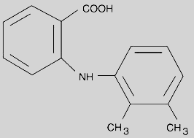

**IUPAC name :** 2-(2,3-dimethylanilino)benzoic acid

**Molecular formula:** C15H15NO2

**Molecular weight:** 241.28 g/mol

**Physical properties Appearance:** White to off-white, crystalline powder

**Solubility:** Slightly soluble in water; soluble in organic solvents like ethanol and acetone.

**Boiling point:** 364 °C

**Melting point:** 230-231 °C

**Pharmacological action :** Mefenamic acid is a non-steroidal anti-inflammatory drug (NSAID) that primarily works by inhibiting cyclooxygenase (COX) enzymes, leading to decreased synthesis of prostaglandins. This results in reduced pain, inflammation, and fever, making it effective for treating conditions like menstrual pain and arthritis.

**ANALYTICAL METHODS :**

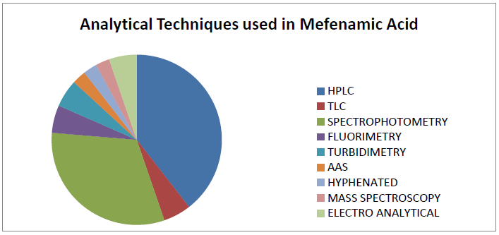

**Fig. Distribution of analytical method described in the literature for the determination of MFA**

**2.1 Thin layer chromatography (TLC)**

For the simultaneous determination of MFA (MFA) and its two toxic impurities, Martha M. Morcoss et al established and validated a process. The proposed TLC- densitometric system using a mobile phase consisted of of chloroform: acetone: acetic acid: ammonia (70:30:2:2, v/v/v/v) and TLC aluminum plates 60 F254 was used as a stationary phase and the separated bands were UV-scanned at 225 nm. Harrizul Rivai et al. studied and validated thin layer chromatography-densitometry method for analysis of MFA in tablet. The accuracy and reliability of the method was assessed by evaluation of linearity (50-300 µg/ml), precision intra-day and inter-day relative standard deviation values were always less than 2, accuracy (102.45 % ± 1.36% for Sample A and 100.28% ± 1.90% for Sample B) in accordance with ICH guidelines. The detailed information is depicted in Table 8.

**Table 8. TLC for analysis of MFA**

| **Title** | **Mobile phase** | **Stationary phase** | **λmax** | **LOD** |
| --- | --- | --- | --- | --- |
| Different chromatographic methods for simultaneous determination of MFA and two of its toxic impurities | Chloroform  :acetone: acetic  acid:  ammonia solution(70:30:2  :2)v/v/v/v | Aluminium plates 60  F254 | 225 nm | 0.3-2 μg/band |
| Development and validation of thin layer chromatography-densitometry method for analysis of MFA in tablet | Chloroform  :methanol  (9.0:0.1,v:v) | Silica gel 60  F254 | 320 nm | 50-300 μg/ml |

*ª λmax-maximum wave length; ᵇ LOD -linearity*

**2.2 Fluorimetric Method**

A simple spectro fluorimetric procedure for assessment of MFA in pharmaceutical preparation and urine was reported by Ahad Bavili Tabriz. The process includes oxidizing MFA using cerium (IV) to create cerium (III) and the fluorescence of cerium (III) after stimulation at 255 nm was measured at 354 nm. A sensitive and simple spectro fluorimetric approach was developed using terbium sensitized fluorescence. The process is based on the conversion of radiative energy from anthranilates to terbium ions in alkaline methanolic solutions, with detection limits 1.4x 10-8 reported by Pinelopi C. Ioannou at el. Studies are summarized in Table 9.

**Table 9. Fluorimetric method**

| **Title Objective Evaluation** |
| --- |
| A Simple Spectrofluorimetric The process includes oxidizing The fluorescence of cerium (III)  method for determination of MFA using cerium (IV) after stimulation at 255nm  MFA in pharmaceutical to create cerium (III), was measured at 354nm.  preparation and urine |
| Spectrofluorimetric The process is based on the The detection limit of MFA  determination of anthranilic conversion of radiative energy was1.4x10-8  acid derivatives based on from anthranilates to terbium  terbium sensitized ions in alkaline methanolic  fluorescence solutions. |

**2.3 Atomic Absorption Spectrometry (AAS)**

Atomic absorption spectrometry was used to measure MFA in tablet dosage type. Sunil Jawla et al explained the formation of metal complexes of Diclofenac sodium and MFA with cupric chloride and cobaltous chloride in these processes. The first approach involves reacting all drugs with cupric chloride to produce light blue metal complexes which are then separated with dichloromethane and digested with 0.1 M nitric acid. Both drugs are estimated indirectly using AAS to determine copper content in shaped complexes. The second approach is focused on the creation in pink-colored cobaltous chloride complexes of both drugs. In cupric chloride method, MFA can be determined in the concentration range 2.5-23.0 µg/ml with mean percentage recovery 100.31 ± 0.79%. In cobaltous chloride method MFA can be measured in the concentration range 3.0-24.5 µg/ml with mean percentage recovery was 100.26 ± 0.76%.

1. **FLUFENAMIC ACID**

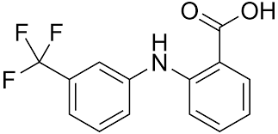

**IUPAC name :** 2-[3-(trifluoromethyl)anilino]benzoic acid

**Molecular formula:** C14H10F3NO2

**Molecular weight:** 281.23 g/mol

**Physical properties Appearance:** White to off-white crystalline powder

**Solubility:** Sparingly soluble in water; soluble in organic solvents like ethanol and acetone

**Boiling point:** Not well-defined due to decomposition

**Melting point:** 133.5°c

**Pharmacological action :** Flufenamic acid works by inhibiting the cyclooxygenase (COX) enzymes, specifically COX-1 and COX-2. These enzymes are involved in the conversion of arachidonic acid into prostaglandins, which play a key role in inflammation, pain, and fever.

**ANALYTICAL METHODS:-**

**3.1 Spectrofluorometric** **method**

Spectrofluorometric method for determination of flufenamic acid in bulk powder and capsule dosage forms was presented. The methods are based on the cyclization reaction of flufenamic acid with concentrated sulfuric acid to produce the corresponding acridone derivative and measurement of the fluorescence intensity at 450 nm (λex =400 nm) and peak-to-peak measurements of the first- (1D) and secondderivative (2D) curves, respectively. Beer’s law is obeyed over the concentration ranges of 2.0–20 ng mL-1.

**3.2 Visible spectrophotometric method**

A simple visible spectrophotometric method was described for the determination of enfenamic acid in bulk samples and pharmaceutical preparations. The method is based on the reaction of enfenamic acid with p-N,N-dimethylphenylenediamine in the presence of S2O82- or Cr(VI) whereby an intensely coloured product having maximum absorbance at 720 nm is developed. The reaction is sensitive enough to permit the determination of 0.125–2.0 lg mL-1.

**Table 10. Visible spectrophotometric method**

| Name of  drug | Method | λmax (nm) | Linear range(lg mL_1) |
| --- | --- | --- | --- |
| Flufenamic acid | Copper(II) ammine sulphate/  Diethyldithiocarbamate Spectrofluorometry with  concentrated sulfuric acid | 430 λem= 450  λex =400 | 6.0–60  2.0–20 ng mL-1 |

**INDOLE ACETIC ACID:-**

1. **INDOMETHACIN**

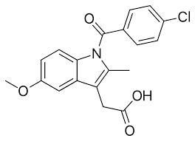

**IUPAC name :** 2-[1-(4-chlorobenzoyl)-5-methoxy-2-methylindol-3-yl]acetic acid

**Molecular formula:** C19H16ClNO4

**Molecular weight:** 357.80 g/mol

**Physical properties Appearance:** Pale-yellow to yellow-tan, crystalline powder

**Solubility:** Slightly soluble in water; soluble in organic solvents.

**Boiling point:** Decomposes before boiling.

**Melting point:** 160-162 °C

**Pharmacological action :** Indomethacin is a non-steroidal anti-inflammatory drug (NSAID) that primarily inhibits cyclooxygenase (COX) enzymes, leading to decreased synthesis of prostaglandins. This action results in reduced pain, inflammation, and fever, making it effective for treating conditions such as arthritis, bursitis, and tendinitis.

**ANALYTICAL METHODS:-**

**4.1 UV Spectroscopy:**

The method was validated through linearity, sensitivity, precision and accuracy, as shown in Table.10. The results were checked by UV-Vis. spectroscopy method measure the absorbance at (318.4 nm)of the solution IND diluting with(9:1) methanol: hydrochloric acid(0.1N) solvent[18] the results are in good agreement with this method.

**Table.11: Optical characteristics, parameters of the method**

| **No.** | **Parameters** | **Result** |
| --- | --- | --- |
| 1 | Absorption maxima(λmax) | 228 nm |
|  | Linear equation | Y = 0.1263 x – 0.002 |
|  | Regression co-efficient | 0.9947 |
|  | Linearity | 1-10 mg/L |
|  | LOD (mg/L) | 0.602- 0.129 |
| 6 | LOQ (mg/L) | 1.825 - 0.390 |

**4.2 UV-Spectrophotometer by mixed solvency concept**

The developed UV-spectrophotometric method was validated as per ICH guidelines in terms of linearity, and range, specificity, precision, sensitivity and accuracy. In order to determine linearity range of developed method, a series of solutions were prepared using Indomethacin stock solution at concentration range of 10-50µg/ml.The absorbances of the resultant solutions were measured at 320 nm against reagent blank.

**Table 12: Developed UV method specification**

| Instrument and specification | UV-Spectrophotometer Shimadzu 1800 |
| --- | --- |
| Scanning Range | 200 nm to 400 nm |
| Solvent Used | Hydrotropic solvent |
| Strength of Solvent | 10% Sodium caprylate, 10% Sodium Benzoate and 10% Niacinamide |
| Composition of Solvent | 10% Sodium caprylate, 10% Sodium Benzoate and 10% Niacinamide |
| Wavelength Maxima of Indomethacin | 320 nm |

**ARYL PROPIONIC ACIDS:-**

1. **IBUPROFEN**

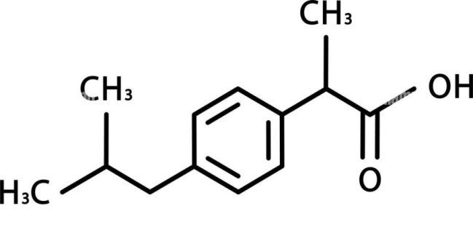

**IUPAC name :** 2-[4-(2-methylpropyl)phenyl]propanoic acid

**Molecular formula:** C13H18O2

**Molecular weight:** 206.28 g/ml

**Physical properties Appearance:** Colorless, crystalline stable solid

**Solubility:** Ibuprofen is slightly soluble in water, but soluble in organic solvents like ethanol and acetone.

**Boiling point:** 157ºC

**Melting point:** 75-77.5 ºC

**Pharmacological action :** Inhibition of COX Enzymes:Like sulindac, ibuprofen inhibits cyclooxygenase (COX-1 and COX-2), reducing the production of prostaglandins. Anti-inflammatory Effects: This leads to decreased inflammation and pain relief. Analgesic and Antipyretic Actions: Ibuprofen is effective for relieving mild to moderate pain and reducing fever.

**Chromatographic and ultraviolet (UV) spectrophotometric methods:**

In early ages, most of the analytical methods were done using thin-layer spectrophotometric, differential pulse polygraph, colorimetric, gas-liquid chromatography, paper chromatography, or direct liquid introduction mass spectrometry (MS). However, due to greater facilitate sample preparation, those early methods have largely been replaced by high-performance liquid chromatography (HPLC), gas chromatography (GC), and GC-MS, and a recent report describes the use of HPLC Table.

**Table 13: Chromatographic and UV spectrophotometric methods for various experiments**

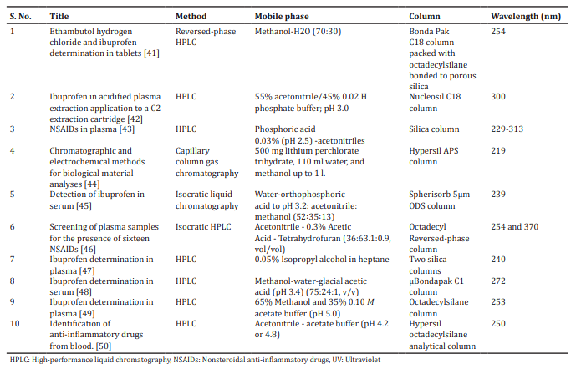

1. **NAPROXEN:-**

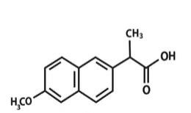

**IUPAC name :** (2*S*)-2-(6-methoxynaphthalen-2-yl)propanoic acid

**Molecular formula:** C14H14O3

**Molecular weight:** 230.26 g/mol

**Physical properties Appearance:** White to off-white crystalline powder

**Solubility:** Slightly soluble in water; soluble in alcohol and chloroform

**Boiling point:** 250 °C

**Melting point:** 154 °C

**Pharmacological action:** Naproxen primarily works by inhibiting the cyclooxygenase (COX) enzymes, specifically COX-1 and COX-2. These enzymes are responsible for converting arachidonic acid into prostaglandins, which are lipid compounds that mediate inflammation, pain, and fever. By inhibiting both COX-1 and COX-2, naproxen reduces the synthesis of prostaglandins, resulting in decreased inflammation, alleviation of pain, and reduction of fever. This mechanism makes it effective in treating various inflammatory conditions and pain syndromes.

**Spectrophotometric method:**

A second-derivative spectrophotometric method for the determination of naproxen in the absence or presence of its 6- desmethyl metabolite in human plasma is described. The method consists of direct extraction of the non-ionized form of the drug with pure diethyl ether and determination of the naproxen by measuring the peak amplitude (mm) in the second-order derivative spectrum at a wavelength of 328.2 nm. The efficiency of the extraction procedure expressed by the absolute recovery was 94.6 }0.7% (mean } SD) for the concentration range tested, and the LOQ attained according to the IUPAC definition was 2.42 lg mL_1.

**Table 14. Spectrophotometric method**

| Name of the drug | Method | λmax (nm) | Linear range  (lg mL_1) |
| --- | --- | --- | --- |
| Naproxen | Second-derivative  1-Naphthylarnine and sodium nitrite  MBTH with Ce(VI) or Fe(III)  2,6-Dichloro-p-benzoquinone-4-chlorimine (gibbs reagent)  TCNE, DDQ, p-CHL | 328.2  460–480 | 10–65 |

**HETERO ARYL ACETIC ACIDS:-**

1. **TOLMETIN:-**

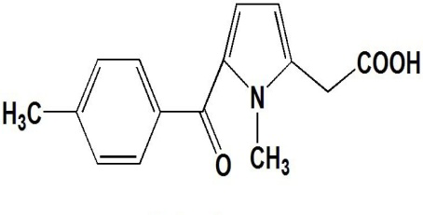

**IUPAC name :** 2-[1-methyl-5-(4-methylbenzoyl)pyrrol-2-yl]acetic acid

**Molecular formula:** C15H15NO3

**Molecular weight:** 257.28 g/mol

**Physical properties Appearance:** White to off-white crystalline powder

**Solubility:** Practically insoluble in water, ethanol, and acetone; sparingly soluble in chloroform

**Boiling point:** Not specifically reported (decomposes before boiling)

**Melting point:** 156 °C

**Pharmacological action :** Tolmetin’s mechanism of action (MOA) primarily involves the inhibition of cyclooxygenase (COX) enzymes, specifically COX-1 and COX-2. By blocking these enzymes, Tolmetin reduces the synthesis of prostaglandins, which are mediators of inflammation, pain, and fever.

**7.1 Spectrophotometric Determination Of Tolmetin Sodium**

The accuracy and reproducibility of both procedures have been assessed by adopting the standard additions technique, where different added amounts (20-80%) of claimed tolmetin sodium in Tolectin® were tried. The concomitant added percent recoveries obtained were 99.60 ± 0.22 (n = 6) and 100.16 ± (126 for the zero order and first derivative methods respectively. In conclusion it can be stated that the two proposed spectrophotometric methods are rapid, simple, precise and accurate; and any of them is suitable for quality control of totmain sodium. However, the first derivative method has the advantage of eliminating irrelevant absorption due to possible interfering co-existing substances.

**Table 15: Determination of Tolmetin Sodium by Zero-Order and First-Derivative Spectrophotometry.**

Zero-Order Method First-Derivative Method

|  |
| --- |

Pharmaceutical Nominal % Found % of Added % Found % of Added

Preparation concentration ± SD* recovery ± SD* ± SD* recovery ± SD*

μg/ml

|  |
| --- |

Tolectin® 1-15 100.42 ± 0.33 99.60 ± 0.22 100.28±0.26 100.16±0.26

capsules (n=6) (n=6) (n=6) (n=6)

(200 mg)

|  |
| --- |

SD* = Standard deviation.

**7.2 High-Performance Liquid Chromatography and Method Validation**

The intra- and interday (Table 17 ) standard deviations (SDs) of six replicate determinations for six consecutive days at the usual working concentrations of 5.0–100μM were between 0.087 and 0.518 with coefficients of variation (CVs) of between 0.20% and 1.77% for the former, and 0.129 to 0.293 with CVs of between 0.12% and 3.40% for the latter. The accuracies of the method, as referring to the recovery test at the 5 concentrations of 5, 10, 25, 50, and 100μM (expressed as the closeness of the observed mean to the true value), were determined to be 98.7%, 101.7%, 99.7%, 99.8%, and 100.0%, respectively. There was no significant difference in comparison with the results having 100% recovery (*p* > 0.05), which indicates good accuracy for the assay method. Clearly, the established assay method is reliable and applicable for stability assessment of TLM degraded under photoirradiated conditions.

| **Table 16. Intra- and Interday (*n* = 6) Analytical Precisions for TLM** | | |
| --- | --- | --- |
| **Concentration**  **(μM)** | **Intraday** | **Interday** |
| **Mean Rel.**  **(SD) CV (%) error (%)** | **Mean Rel.**  **(SD) CV (%) error(%)** |
| 5  10  25  50  100 | 4.909 (0.087) 1.77 –1.82  10.003 (0.157) 1.57 0.00  25.219 (0.255) 1.01 0.87  49.843 (0.518) 1.03 – 0.31  100.023 (0.201) 0.20 0.02 | 4.937 (0.168) 3.40 –1.26  10.173 (0.194) 1.91 1.73  24.928 (0.293) 1.17 –0.29  49.918 (0.273) 0.54 –0.16  100.041 (0.129) 0.12 0.04 |

1. **DICLOFENAC**

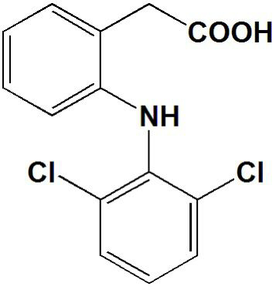

**IUPAC name :** 2-[2-(2,6-dichloroanilino)phenyl]acetic acid

**Molecular formula:** C14H11Cl2NO2

**Molecular weight:** 296.1 g/mol

**Physical properties Appearance:**  Usually appears as a white to pale yellow crystalline powder.

**Solubility:** Slightly soluble in water; more soluble in organic solvents like ethanol and dimethyl sulfoxide (DMSO).

**Boiling point:** 295 °C

**Melting point:** 283-285 °C

**Pharmacological action :** Diclofenac's mechanism of action (MOA) primarily involves the inhibition of cyclooxygenase (COX) enzymes, specifically COX-1 and COX-2. By blocking these enzymes, diclofenac reduces the synthesis of prostaglandins, which are mediators of inflammation, pain, and fever. This results in decreased inflammation and pain relief. Additionally, diclofenac may also have effects on other inflammatory pathways, contributing to its therapeutic effects.

**8.1 Validation of Simple UV-Spectrophotometric Method**

A simple, selective, accurate, precise spectroscopic method for the estimation of diclofenac sodium in bulk and pharmaceutical tablet dosage form has been developed and validated. The linearity range of the diclofenac is 10-30 μg/ml and all parameters shown in Table 9. The LOD and LOQ were found to be 1.03 μg/ml and 3.12 μg/ml respectively. The amount of diclofenac was calculated as 99.42%. Further the precision of the method was confirmed by the repeatable analysis of solution. The % RSD was found to be 1.370 it indicated that the method has good precision. The percentage recovery was found to be in the range of 98.72-99.15%. The % recovery was calculated for 80%, 100% and 120%. RSD value indicated that there is no interference due to excipients used in formulation. Hence, the accuracy of the method was confirmed. All the procedure followed in the present study as per the ICH guidelines.

**Table 17: Results of Validation Parameters**

| **S. No.** | **Parameter** | **Results** |
| --- | --- | --- |
| 1  2  3  4  5  6  7  8  9  10 | Absorption maxima (nm)  Beers range (μg/ml)  Standard Regression Equation  Correlation Coefficient (r2)  %Assay  Precision (%RSD)  Intraday Precision  Interday Precision  Accuracy  Robustness (%RSD)  LOD  LOQ | 276.20  10-30 μg/ml  Y= 0.0324x + 0.0021  0.9995  99.42 ± 0.084  0.622  0.724  99.72 ± 0.080  0.9204  1.03  3.12 |

1. **KETOROLAC**

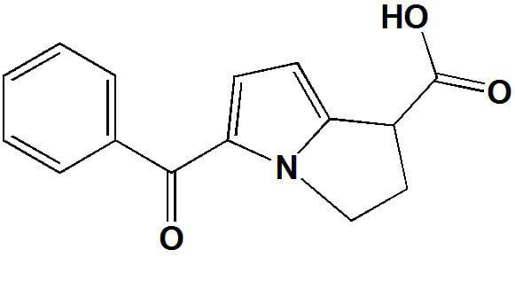

**IUPAC name :** 5-benzoyl-2,3-dihydro-1*H*-pyrrolizine-1-carboxylic acid

**Molecular formula:** C15H13NO3

**Molecular weight:** 255.27 g/mol

**Physical properties Appearance:**  white to off-white crystalline powder.

**Solubility:**  Soluble in water, methanol, and ethanol; slightly soluble in chloroform.

**Boiling point:**  Not typically specified, but it decomposes before boiling.

**Melting point:** 162-165 °C

**Pharmacological action :** Ketorolac inhibits both COX-1 and COX-2 enzymes. COX-1 is primarily involved in the production of prostaglandins that protect the stomach lining and support kidney function, while COX-2 is induced during inflammation and is responsible for pain and swelling.

**9.1 Determination Of Ketorolac In Plasma By HPLC**

A simple and sensitive method for the determination of ketorolac in plasma by HPLC was developed and validated. Adequate specificity, precision and accuracy of the proposed method were demonstrated over the concentration range of 10.0e125.0 ng/ml. The method was accurate, reproducible, specific and applicable to the evaluation of pharmacokinetic study of ketorolac.

**Table 18 : Intraday and interday accuracy and precision of ketorolac.**

| Standard concentration  (ng/mL) | Average calculated  concentration (ng/mL) Mean ± SD |
| --- | --- |
| Interday (n ₌ 3)  10  80  125  Intraday (n ₌ 3)  10  80  125  SD = Standard deviation | 9.87 ± 0.07  79.47 ± 0.46  124.54 ± 0.52  9.79 ± 0.08  79.87 ± 0.71  124.49 ± 0.60 |

**OXICAMS :-**

1. **PIROXICAM**

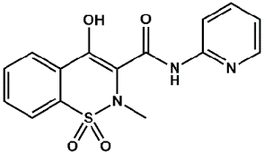

**IUPAC name :** 4-hydroxy-2-methyl-1,1-dioxo-*N*-pyridin-2-yl-1λ6,2-benzothiazine-3-carboxamide

**Molecular formula:** C15H13N3O4S

**Molecular weight:** 331.3 g/mol

**Physical properties Appearance:**  yellow to orange crystalline powder.

**Solubility:** Not typically specified; tends to decompose before boiling.

**Boiling point:**  Not typically specified; tends to decompose before boiling.

**Melting point:** 198-200 °C

**Pharmacological action :** COX Inhibition: It inhibits both COX-1 and COX-2 enzymes, leading to decreased synthesis of prostaglandins. This results in reduced inflammation, pain, and fever. Analgesic and Anti-inflammatory Effects: Piroxicam is effective in managing pain and inflammation in conditions such as arthritis and other inflammatory disorders. Long Half-Life: It has a relatively long half-life (around 50 hours), allowing for once-daily dosing.

**10.1 HPLC:**

HPLC is at present one of the most sophisticated tools of analysis. The estimation of Piroxicam is done by RP-HPLC. The mobile phase consists of buffer (volumes of phosphate buffer, 55 volumes of Methanol and 45 volumes of buffer. The ratio pH was found to be 3.0. Then finally filtered using 0.45μ nylon membrane filter and degassed in sonicator for 10 minutes). The detection is carried out using PDA detector set at 240nm. The solutions are chromatographer at the constant flow rate of 0.8 ml/min. The Retention time for Piroxicam was around 7.0 minutes. Linearity range for Piroxicam is 50 to 150μg/ml. The quantitative estimation was carried out on the tablet by RP-HPLC taking a concentration of 50μg/ml. the quantitative results obtained is subjected to the statistical validation. The values of RSD are less than 2.0% indicating the accuracy and precision of the method. The % recovery 98.0% to 99.80% for Piroxicam. The results obtained on the validation parameter met the requirements. It inferred that the method was found to be Simple, Specific, Precision, and Linearity, Proportional i.e. it follows Lambert-Beer’s law. The method was found to have a suitable application in routine laboratory analysis with a high degree of Accuracy and Precision.

**Table 19. Results of HPLC system suitability parameters for Piroxicam**

| S.NO | Parameter | Calibration range (mg/ml) | Theoretical plates | Tailing factor | Correlation Coefficient(r2) | % Recovery | System Suitability %RSD | Method Repeatability %RSD |
| --- | --- | --- | --- | --- | --- | --- | --- | --- |
| Drug name |
| 1. | Piroxicam | 5-150 | 8881.6 | 1.20 | 0.9991 | 98.0% - 99.8% | 0.4% | 1.9% |

**10.2 HPLC with UV detection:**

The present study describe the development and validation of a novel fast and accurate HPLC method with UV detection for the quantitative determination of Piroxicam in bulk and pharmaceutical formulations.In the study, the recovery percentage of piroxicam were higher than those obtained using othermethods.The newly developed method has a much faster analysis time.It is a simple method that eliminates the need for mass spectrometryand large volumes of organic solvents. The proposed method can be used to for the analysis of piroxicam in pharmaceuticals formulations used for the treatment of artrithis. These studies also provide information about the degradation pathways and degradation products that could form during storage.

**Table 20. Stress testing results of piroxicam**

| **Nature of stress** | **Storage conditions** | **Time (h)** | **Amount of piroxicam remaining (%)** |
| --- | --- | --- | --- |
| 2M HCl | 40°C | 5.00 | 95.56 |
| 2M NaOH | 40°C | 10.0 | 90.25 |
| 3% H2O2 | ambient | 0.30 | 80.25 |
| Photolytic | sunlight | 0.30 | 91.25 |
| UV | UV lamp | 0.30 | 79.56 |
| Thermal | 105°C | 2.00 | 60.25 |

**PYRAZOLONE AND PYRAZOLIDINEDIONE :-**

1. **PHENYLBUTAZONE**

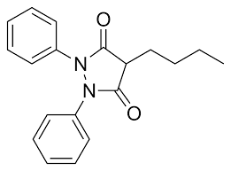

**IUPAC name :** 4-butyl-1,2-diphenylpyrazolidine-3,5-dione

**Molecular formula:** C19H20N2O2

**Molecular weight:** 308.4 g/mol

**Physical properties Appearance:** White to off-white crystalline powder.

**Solubility:** Slightly soluble in water; soluble in organic solvents like ethanol and acetone.

**Boiling point:** 438 °C

**Melting point:** 105°C

**Pharmacological action :** Phenylbutazone acts as a nonsteroidal anti-inflammatory drug (NSAID). It reduces inflammation and pain by inhibiting cyclooxygenase (COX) enzymes, which play a key role in the production of prostaglandins—compounds involved in inflammation and pain signaling.

**11.1 Using TLC:**

In analysis using TLC, There is one sample of tested herbal medicine that is suspected to contain BKO phenylbutazone, namely 0.3%. There was one sample containing BKO phenylbutazone with an Rf value in three consecutive mobile phases of 0.5, 0.7, and 0.6. Meanwhile, in the analysis using UV-Vis’s spectrophotometry, data was obtained in the form of maximum wavelength, absorbance, calibration curve equation, concentration for calculating precision tests, accuracy, and sample levels. In the quantitative analysis of phenylbutazone, it was found that the limit of detection (LOD) was 0.09 μg⁄mL and the limit of quantitation (LOQ) was 0.3 μg⁄m.

**Table 21: Phenylbutazone Mobile Phase Optimization Results.**

| | Movement Phase |  | Rf Score | | --- | --- | --- | | Ethyl Acetate: N-hexane (1:4) |  | 0.6 | | Chloroform: Ethanol (9:1) |  | 0.9 | | N-hexane: Chloroform: Methanol (6:3:1) |  | 0.8 | | Ethyl Acetate: Chloroform (2:1) |  | 0.87 | | Ethyl Acetate: Methanol: Ammonia (7:2:1) |  | 0.95 | |
| --- | --- | --- | --- | --- | --- | --- | --- | --- | --- | --- | --- | --- | --- | --- | --- | --- | --- | --- |

**11.2 HPLC:**

The procedure described allows the quantitative and qualitative detection of phenylbutazone in plas- ma samples from fighting bulls. The sensitivity of the method, with a detection limit at 0.016 μg/ml and a quantification limit of 0.029 μg/ml (λ= 240 nm), is better than that of Salvadori et al. The presence of phenylbutazone was checked and quantified in unknown samples of plasma from bulls killed in 2nd and 3rd category bullrings in the province of Salamanca (Spain), and it is possible to use the method for the simultaneous analysis of dexamethasone, betamethasone, phenylbutazone and flunixin in plasma from fighting bulls.

**Table 22. Results of HPLC system suitability parameters for phenylbutazone**

| S.NO | Parameter  Drug name | λ | Sensitivity (mg/ml) | | Intra-assay C.V. (%) | | Inter-assay C.V. (%) | | Recovery (%) |
| --- | --- | --- | --- | --- | --- | --- | --- | --- | --- |
| Detection limit | Quantitation limit | Plasmaa | Methanolb | Plasmaa | Methanolb |
| 1. | Phenylbutazone | 240 nm | 0.016 | 0.029 | 2.04 | 1.73 | 1.72 | 1.83 | 83 |
| 254 nm | 0.027 | 0.061 | 1.69 | 1.87 | 1.69 | 1.69 | 84 |

1. **ANTIPYRINE**

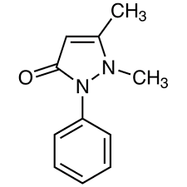

**IUPAC name :** 1,5-dimethyl-2-phenylpyrazol-3-one

**Molecular formula:** C11H12N2O

**Molecular weight:** 188.23 g/mol

**Physical properties Appearance:** White to light yellow crystalline powder

**Solubility:** Soluble in alcohol and chloroform; slightly soluble in water

**Boiling point:** 319°C

**Melting point:** 114°C

**Pharmacological action :** Antipyrine is an analgesic (pain reliever) and antipyretic (fever reducer) agent. It is used to relieve pain and reduce fever, often in combination with other medications. Antipyrine has anti-inflammatory properties and can also be used as a diagnostic tool in ear examinations.

**ANALYTICAL METHODS:-**

**12.1 TLC-densitometric method:**

In this work, two stability-indicating methods were developed for the simultaneous determination of antipyrine in the presence of the reported BEN degradation product (PABA). The advantage of the TLC-densitometric method is that several samples can be run simultaneously using a small quantity of the mobile phase, thus lowering the analysis time and cost per analysis, as well as providing high sensitivity and selectivity.

**Table 23. Results of TLC system suitability parameters for Antipyrine**

| S.NO | Parameters  Drug name | Mean | S.D | *n* | Variance | Student’s  *t*-test | *F*-test |
| --- | --- | --- | --- | --- | --- | --- | --- |
| 1. | Antipyrine | 100.22 | 1.375 | 6 | 1.89 | 0.222 (2.262) | 3.88 (6.26) |

**12.2 HPLC:**

In this work, two stability-indicating methods were developed for the simultaneous determination of antipyrine in the presence of the reported BEN degradation product (PABA). HPLC has the advantage of being highly selective compared with other published HPLC methods, which cannot separate ANT and BEN in the presence of PABA.

**Table 24. Results of HPLC system suitability parameters for Antipyrine**

| S.NO | Parameters  Drug name | Mean | S.D | *n* | Variance | Student’s  *t*-test | *F*-test |
| --- | --- | --- | --- | --- | --- | --- | --- |
| 1. | Antipyrine | 99.93 | 0.985 | 7 | 0.985 | 0.271 (2.228) | 1.99 (6.16) |

**PYRROLE-ACETIC ACID :-**

1. **ZOMEPIRAC**

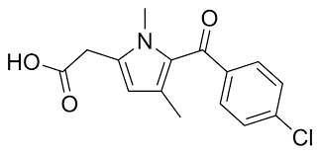

**IUPAC name :** 2-[5-(4-chlorobenzoyl)-1,4-dimethylpyrrol-2-yl]acetic acid

**Molecular formula:** C15H14ClNO3

**Molecular weight:** 291.73 g/mol

**Physical properties Appearance:** White to off-white crystalline powder

**Solubility:** Soluble in water and organic solvents

**Boiling point:** Not readily available, as it's typically not reported

**Melting point:** 178.5°C

**Pharmacological action :** Zomepirac acts primarily as a nonsteroidal anti-inflammatory drug (NSAID). Its mechanism of action involves: Inhibition of Cyclooxygenase (COX) Enzymes: Zomepirac inhibits COX-1 and COX-2 enzymes, which play a key role in the conversion of arachidonic acid to prostaglandins. Prostaglandins are mediators of inflammation, pain, and fever. Reduction of Prostaglandin Synthesis: By inhibiting COX enzymes, zomepirac decreases the synthesis of prostaglandins, leading to reduced inflammation, pain relief, and a decrease in fever. Overall, its analgesic and anti-inflammatory effects stem from the reduction of prostaglandin levels in the body.

**HPLC:**

The lowest concentration of zomepirac that can be measured accurately and precisely (coefficient of variation <20%) in a z-ml plasma sample is 10 ng/ml. The standard curve is linear in the concentration range of 10 to 5000 n_g/ml. To date, this procedure has been employed successfully in analysin g over 10,000 clinical plasma samples.

**Table 25. Results of HPLC system suitability parameters for Zomepirac**

| S.NO | Parameters  Drug name | Plasma conc.  ng/ml | Mean peak height ratio | Standard deviation | Co-efficient of variation (%) |
| --- | --- | --- | --- | --- | --- |
| 1. | Zomepirac | 10-5000 | 0.10-57.96 | 0.01-3.25 | 9.7-5.6 |

**PARA-AMINO PHENOL:-**

1. **PHENACITIN**

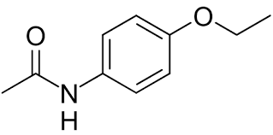

**IUPAC name :** *N*-(4-ethoxyphenyl)acetamide

**Molecular formula:** C10H13NO2

**Molecular weight:** 179.22 g/mol

**Physical properties Appearance:** White crystalline powder

**Solubility:** Soluble in alcohol, ether, and chloroform; slightly soluble in water

**Boiling point:** 242-245 °C

**Melting point:** 134-135 °C

**Pharmacological action :** Phenacetin is an analgesic and antipyretic agent, primarily used for pain relief and to reduce fever. It works by inhibiting the synthesis of prostaglandins, similar to other NSAIDs. However, phenacetin has been largely withdrawn from the market in many countries due to safety concerns, including potential links to kidney damage and cancer.

**14.1 HPLC:**

The proposed method is simple, accurate, reproducible and fast. It can determine the phenacetin, the adulterants/ diluents including saccharin simultaneously. The present method can be routinely used for the analysis of these components in illicit phenacetin samples and it will be a valuable method for drug profiling.

**Table 26. Results of HPLC system suitability parameters for Phenacetin**

| S.NO | Parameters  Drug name | Limit of  detection  (LOD) | Limit of  quantification  (LOQ) | Linearity  range | %  Recovery | Intraday recovery ± S.D | Interday recovery ± S.D |
| --- | --- | --- | --- | --- | --- | --- | --- |
| 1. | Phenacetin | 10 ng | 33 ng | 200ng – 2000ng | 101.53 | 1.47 | 1.92 |

**14.2 LC-MS-MS method:**

A stable, high throughout, and sensitive LC-MS-MS method has been developed for the simultaneous extraction and determination of phenacetin in rabbit plasma. Acceptable precision and accuracy were obtained for concentrations within the standard curve range of 4–1,600 ng mL-1 for phenacetin. The method is flexible and requires only 200 lL of plasma, making it suitable for pharmacokinetics studies of phenacetin. The method should also be applicable to clinical concentration monitoring of phenacetin poisoning or overdose.

1. **ACETAMINOPHEN**

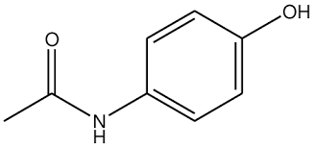

**IUPAC name :** *N*-(4-hydroxyphenyl)acetamide

**Molecular formula:** C8H9NO2

**Molecular weight:** 151.16 g/mol

**Physical properties Appearance:** White crystalline powder

**Solubility:** Soluble in water, alcohol, and ether

**Boiling point:** >500 °C

**Melting point:** 169-170.5 °C

**Pharmacological action :** Acetaminophen is an analgesic and antipyretic medication used to relieve pain and reduce fever. Acetaminophen primarily inhibits the cyclooxygenase (COX) enzymes, particularly in the brain, leading to decreased production of prostaglandins, which are mediators of pain and fever.

Acetaminophen is widely used for its effectiveness and safety when taken at recommended doses.

**15.1 RP-HPLC**:

The developed method was validated in terms of specificity, system suitability, linearity, accuracy, precision, limit of detection, limit of quantification and robustness.

To develop a precise, linear, specific & suitable stability indicating RP-HPLC method for the simultaneous estimation of Acetaminophen in tablet dosage form, different chromatographic conditions for its validation were applied & the results observed are presented (Shown in table). The results of Correlation coefficient (r) LOD, LOQ, Accuracy, Precision, Robustness and Ruggedness Shown in table.

**Table 27: Results from Analysis and Calibration Curves.**

| S.NO | Parameters  Drug name | Correlation coefficient (r) | LOD (μg/mL) | LOQ (μg/mL) | Accuracy (%) ± % RSD | Precision ( % RSD) | Robustness | Ruggedness |
| --- | --- | --- | --- | --- | --- | --- | --- | --- |
| 1. | Acetaminophen | 0.99 | 0.05 | 0.12 | 99.96% | 1.33 | 0.62 | 0.81% |

**15.2 HPLC:**

A new HPLC method for the determination of acetaminophen was developed using a mixed-mode Hypersil Duet C18/SCX stationary phase. The separation was achieved using a mixture of phosphate buffer (pH ¼ 4.88)–methanol (80:20 v/v) as mobile phase. Both elution and flow rate gradients contribute to the total time of analysis lower than 15 minutes. The selectivity and the efficiency of the separation are very good. The chromatographic method was validated in the laboratory. A fluorescence program for detection in HPLC was also developed, with the aim of analyzing samples with low concentrations of acetaminophen impurities. The influence of the temperature on the separation of the analyte was also studied; the linearity of the van’t Hoff plots indicates that the retention mechanism of each compound does not change when temperature increases. The method was applied with good results on commercially available acetaminophen tablets.

**Table 28. Results of HPLC system suitability parameters for acetaminophen**

| S.NO | Parameters  Drug name | Concentration | Recovery [%+s.d.] | Precission (% R.S.D.) | |
| --- | --- | --- | --- | --- | --- |
| Intra-day | Inter-day |
| 1. | Acetaminophen | 40 mg/mL | 100.7+ 0.42 | 1.29 | 1.45 |

**II. CONCLUSION:**

In this literature study, the most popular Spectrophotometric and Chromatographic analytical procedures has been listed. The development of these methods involved the use of analytical equipment such as UV-Visible Spectrophotometers, High-Performance Liquid Chromatography, Reverse-Phase High-Performance Liquid Chromatography and Thin Layer Chromatography. It was developed to describe particular anti-inflammatory drugs. Salicylates, anthranillic acids, indole acetic acids, aryl propionic acids, oxicams in their pure form, human plasma, and other biological fluids.

**REFERENCES:**

[1]. Latif D.Jamadar et al. described Analytical Method Development And Validation For Aspirin Jan-Mar 2010:389-399.  
[2]. Ashira et al. described Review For Analytical Methods For The Determination Of Mefenamic Acid 426-437, 2021.

[3]. Karima Fadhil Ali et al. New assay method UV spectroscopy for determination of Indomethacin in pharmaceutical formulation *2015, 7(4):1591-1596*.

[4]. Sanjay Jain et al. Development and validation of simple UVSpectrophotometric method of quantization of indomethacin in solid dosage formulation using mixed solvency concept TPI 2017; 6(12): 453-456.

[5]. Sagar Bashyal Ibuprofen And Its Different Analytical And Manufacturing Methods: A Review *2018, 25-29.*

[6]. A.A. Gouda et al. Spectrophotometric and spectrofluorometric methods for the determination of non-steroidal anti-inflammatory drugs: A review (2013) 6, 145–163.

[7]. K.A. Al-Rashood *Et Al.* Spectrophotometric Determination Of Tolmetin Sodium In Capsule Dosage Form 97-101, 1988.

[8]. Fu-An Chen et al. Quantitation Of Tolmetin By High-Performance Liquid Chromatography And Method Validation August 2003.

[9]. Dinesh K Sawant1*, P P Ige1 Development and Validation of Simple UV-Spectrophotometric Method for Estimation Diclofenac Sodium in Bulk and Tablet Dosage Form January 2016.

[10]. S. Muralidharan et al. Simple and sensitive method for the analysis of ketorolac in human plasma using high-performance liquid chromatography (2013) 98e101.

[11]. Vijay Kumar. R *et al* Analytical method development and validation of Piroxicam by RP-HPLC *2010, 2(2): 217-22.*

[12]. Alina-Diana Panainte et al. Fast HPLC Method for the Determination of Piroxicam and its Application toStability Study.

[13]. Abdullah et al. The Application of UV-VIS Spectrophotometry Method to Identify Phenylbutazone in Herbal Packages Circulating in Big Cities in Indonesia (2023): 961-967.

[14]. M.I. Gonza´lez Mart´ın et al. Determination by high-performance liquid chromatography of phenylbutazone in samples of plasma from fighting bulls (2002) 119–126.

[15]. Hanan A. Merey at el. Validated simultaneous determination of antipyrine and benzocaine HCl in the presence of benzocaine

HCl degradation product2014, 6, 6044.

[16]. K.--T-. Ng, T. Snyderman Determinatlon Of Zomepirac In Plasma By High-Pressure Liquid Chromatography May 30th, 1979.

[17]. Idris et al. Simultaneous determination of methaqaulone, saccharin, paracetamol, and phenacetin in illicit drug samples by hplc 2013, 4:4.

[18]. Lufeng Hu et al. Rapid LC-APCI-MS-MS Method for Simultaneous Determination of Phenacetin and Its Metabolite Paracetamol in Rabbit Plasma 2009, 70, August.

[19]. *Ms Fayeza Batool et al.* An Assay Method For The Simultaneous Estimation Of Acetaminophen And Tramadol Using Rp-Hplc Technology 07, 2015*.*

[20]. Ca˘linescu et al. HPLC Separation of Acetaminophen and its Impurities Using A Mixed-mode Reversed-Phase/Cation Exchange Stationary Phase 2012;50:335–342.