**Optimization of Public Transport Demand**

**A CASE STUDY OF BHOPAL**

**Kapil Kashyap1, Ar. Shefali Soni2, Ar. Shivani Paliwal3**

1U.G. Student, School of Architecture, Rajiv Gandhi Proudyogiki Vishwavidyalaya, Bhopal MP, India

2.3Associate Professor, School Of Architecture, Rajiv Gandhi Proudyogiki Vishwavidyalaya, Bhopal MP, India.

***Abstract*-** Rapid growth in vehicles population has put enormous strains in all urban roads in all million plus cities in India, due to high vehicle ownership and poor supporting public transport facilities specially in the cities where the population is between 1 to 2 million. The major factor is very low ridership in public transport due to poor service quality and more traveling time. This study is concerned of assessment of public transport demand for Bhopal and identifies the major factors for poor ridership with estimation of the probable shift of personal vehicle users to bus due to the increase in its level of service also identifies ways to account for qualitative factors in the public transport project evaluation by adjusting travel time values to reflect comfort and convenience. This can help to find innovative solutions to the current problems such as increasing traffic congestion, energy-consumption etc. and can increase the efficiencies as well as support for alternative modes of public transport, making them more acceptable by the people & achieving their equity objectives and increased economic efficiency both also a new approach is required to estimate the actual public transport demand so that most feasible and suitable system can be selected to optimise the public transport demand.

***Index Terms***- Public transport, Optimisation Demand, Bhopal, transit demand factors

1. Introduction

A

ll the million plus cities in India facing a serious urban transport problems, due to the increases in population in urban areas as a result of both - the natural increase and migration from rural areas and smaller towns. The increase in the number of motorized vehicles and in the commercial and industrial activities has further added to transport demand in urban areas, as evident from ***Table 1*** & the corresponding ***Figure***

***1***. In many cases, this demand has outstripped the existing road capacity. This is becoming more & more evident in the form of greater congestion and delays, which are widespread in Indian cities and indicate the seriousness of transport problems. A high level of pollution is another undesirable feature of these overloaded streets. The transport crisis also takes a human toll. Statistics indicate that traffic accidents are a primary cause of accidental deaths in Indian cities.

# Table 1: Forecast of Vehicle Populations in India (in million vehicles)

|  |  |  |  |  |  |
| --- | --- | --- | --- | --- | --- |
| Population | **2005** | **2008** | **2015** | **2025** | **2035** |
| 2-W | 35.8 | 46.1 | 87.7 | 174.1 | 236.4 |
| 3-W | 2.3 | 3.0 | 5.3 | 8.8 | 13.1 |
| HCV | 2.4 | 2.9 | 4.6 | 9.1 | 16.2 |
| LCV | 2.4 | 3.2 | 5.7 | 12.5 | 26.9 |
| Car, SUV | 6.2 | 8.8 | 18.0 | 41.6 | 80.1 |
| Grand Total | 49.1 | 63.9 | 121.3 | 246.1 | 372.7 |

Source: Ministry of Urban Development, Government of India, New Delhi (2006)

# Fig. 1: Forecast of Vehicle Populations in India

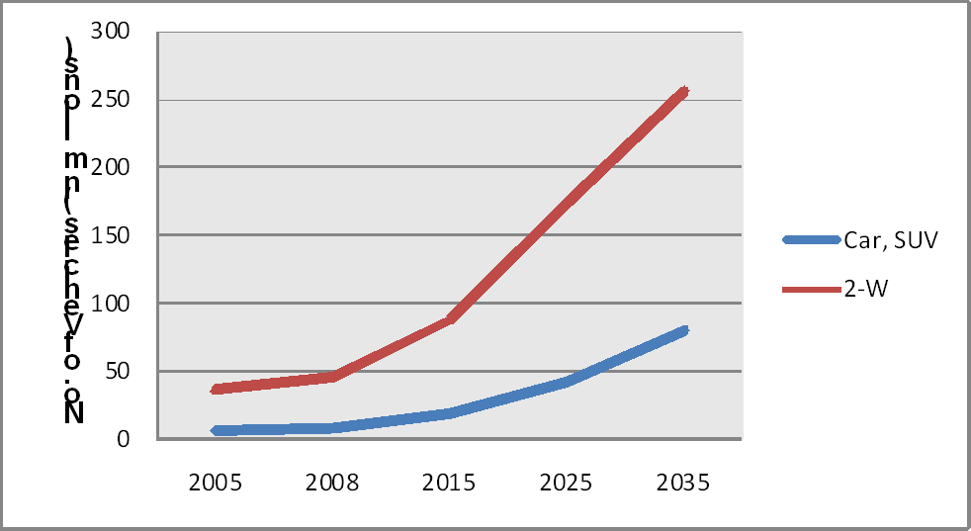

**Source: ministry of urban transport 2010**

demand over the past few decades. Particularly the bus services

The main reasons behind these problems are (i) Prevailing imbalance in modal split, (ii) Inadequate transport infrastructure, and (iii) Sub-optimal use of existing transport infrastructure.

The existing public transport systems in the Indian cities have not been able to keep pace with the rapid and substantial increases in

have much deteriorated, and their relative output is further getting reduced as passengers are continuously switching to personalized modes and intermediate public transport (Pucher J 2004).

# Fig.2: Improving Urban Transport Problems by Public Transport

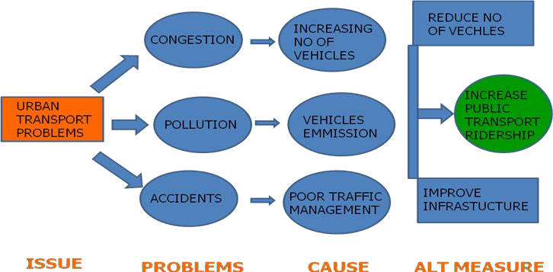

The above figure mention the major issue, problems cause and best alternative measure related to urban transport and shows that how public transport can reduce urban transport problem in Indian cities. These cities cannot afford to cater only to private cars and two-wheelers. There must be a general recognition that without public transport cities would be even less viable. There is a need to encourage public transport instead of personal vehicles. This requires both an increase in quantity as well as quality of

public transport and effective use of demand as well as supply- side management measures.

Hence, it is incumbent on the government to institute appropriate policy initiatives to increase the share of public transport by improving the service quality and comfort. Such interventions should identify & consider factors influencing the demand for public transport and should also quantify the impact of environmental and policy variables. Presently the public transport systems are either under crowed or overcrowded. That

means the demand measures which are used to project the actual demand are not appropriate.

In the Indian cities, the most serious traffic & transportation problems are encountered where the higher public transport facilities are found but the demand and the existing route cannot satisfy the requirements. In addition, many such available transport facilities are worn out and therefore do not satisfy the demand of passengers. There are many external and internal factors that affect the public transport demand. Whereas the external factors are associated with socio-economic development & are not subject to control (e.g. income, car ownership, population, employment, other household characteristics), the internal factors are characteristics of the public transport system and are subject to policy decisions (e.g. public transport fares, trip length, travel time and service levels).

The overall purpose of this study is to contribute to the understanding of how local public transport demand is affected by different factors. It will also identify the effect of parameters like land use, travel-time, travel-cost, accessibility, comfortability, density of study area, per capita trip-rate, affordability and flexibility onto the public transport demand. The key issues in the research will be the identification of factors influencing public transport demand and assessment of their impact on trip generation and modal split. Also, the role of these factors, i.e., how they can increase and stimulate the public transport demand so that most efficient and feasible public transport system can be introduced for the particular city, will also be looked upon so as to come up with innovative solutions for increasing the efficiencies as well as support for alternative modes of public transport.

1. PUBLIC TRANSPORT SCENARIO IN INDIAN

CONTEXT

In the Indian context, the larger is the city size, the higher is the percentage of urban trips served by public transport. Thus according to this, 30 percent of urban trips are served by the public transport in cities with population between 1 and 2 million, whereas it’s 42 percent for cities with populations between 2 and 5 million, and 63 percent for cities with populations over 5 million (Source: Census 2011). Thus, the especially rapid growth of large cities suggests a further rise in future demands for public transport in India.

Apart from the dependence of the urban trips on public transport based on the city size as shown in ***Figure 3***, there is also a substantial variation in the public transport led urban trips among cities of the same size category. Almost 80 percent of all trips in Kolkata are by some form of public transport, compared to about 60 percent in Mumbai, and 42 percent in both Chennai and Delhi, as shown in ***Figure 4***. Differences in land use and roadway supply explain some of the variation. Delhi and Chennai are lower density, more polycentric, and more spread out than Mumbai and Kolkata. Kolkata also have more restricted geographies, since both are situated on peninsulas that channel travel and land-use development in only a few directions. Such focused travel corridors especially encourage suburban rail use, as in Mumbai. Delhi has no such geographic restrictions and sprawls out in all directions. Thus, Delhi currently relies primarily on auto rickshaws, motorcycles, taxis, and private cars to serve the multi-destinational, less focused travel patterns of its residents (Pucher, J & Korattywaroopam, N 2005). Thus, apart from the city size, the demand for the public transport also depends substantially upon various geographical, transport supply & land use patterns of the city.

# Fig. 3: Details of Urban Trips in Indian Cities (Based on City Size)

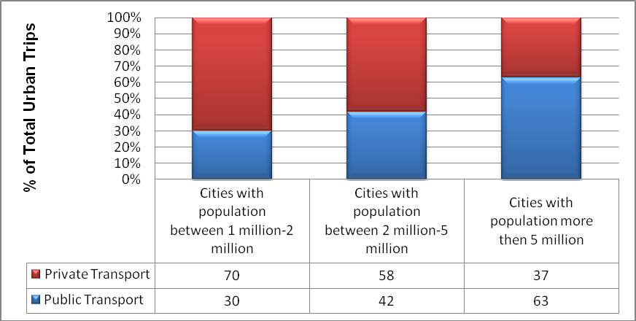

Source: Census 2011

In India most of transportation studies have been conducted only for metro cities in last few decades as these cities in priority in political and administrative point of view. Very few studies were conducted for small and medium towns due to their least priority

in transport sectors & the extensive transport planning was generally neglected while planning such cities.

# Table 2: category wise existing Modal Split in Indian Cities (as a % of Total Trips)

|  |  |  |  |  |  |  |  |
| --- | --- | --- | --- | --- | --- | --- | --- |
| City Population | **Walk** | **Cycle** | **Two Wheelers** | **Car** | **Public Transport** | **IPT** | **Total** |
| < 5 lakhs | 34 | 3 | 26 | 27 | 5 | 5 | 100 |
| 5 – 10 lakhs | 32 | 20 | 24 | 12 | 9 | 3 | 100 |
| 10 – 20 lakhs | 24 | 19 | 24 | 12 | 13 | 8 | 100 |
| 20 – 40 lakhs | 25 | 18 | 29 | 12 | 10 | 6 | 100 |
| 40 – 80 lakhs | 25 | 11 | 26 | 10 | 21 | 7 | 100 |
| > 80 lakhs | 22 | 8 | 9 | 10 | 44 | 7 | 100 |

**Source: W. Smith Association, Ministry of Urban Development, GOI, New Delhi (2008)**

The Indian cities were classified in six categories for transport studies by ministry of urban development. Our study is more concern with category 3 cities of population of 10 – 20 lakhs.

Since in category 3 town rail transport is not feasible so more emphasis is given to bus transport as a public transport system.

# Table 3: Classification the cities in following six categories

|  |  |  |  |  |
| --- | --- | --- | --- | --- |
| **City Category** | **Population** | **Avg Trip Length (km)** | **Per Capita Trip Rate (PCTR)** | **No of** |
| **cities** |
| Category 1 | < 5 lakhs | 2.4 | 0.8 | - |
| Category 2 | 5-10 lakhs | 3.5 | 1 | 47 |
| Category 3 | 10-20 lakhs | 4.7 | 1.2 | 30 |
| Category 4 | 20-40 lakhs | 5.7 | 1.3 | 7 |
| Category 5 | 40-80 lakhs | 7.2 | 1.5 | 4 |
| Category 6 | >80 lakhs | 10.4 | 1.6 | 2 |

Source: W Smith Association, Ministry of Urban Development, GOI, New Delhi.2008, census 2011

# Table: 4 category wise daily trips of cities

|  |  |  |  |  |  |
| --- | --- | --- | --- | --- | --- |
| City Category | Population | Passenger trips/day (in lakhs) | | | |
| 2007 | 2011 | 2021 | 2031 |
| Category 1 | < 5 lakhs | 8.5 | 10 | 13.4 | 17.2 |
| Category 2 | 5-10 lakhs | 263.1 | 308.3 | 423 | 558.3 |
| Category 3 | 10-20 lakhs | 427.7 | 498.2 | 675.6 | 871.9 |
| Category 4 | 20-40 lakhs | 183.6 | 210.4 | 309.6 | 433.5 |
| Category 5 | 40-80 lakhs | 403.6 | 469.8 | 675.2 | 868 |
| Category 6 | >80 lakhs | 992.1 | 1124.9 | 1552.4 | 2054.7 |
| Total |  | 2286 | 2630.4 | 3661.2 | 4819.2 |

Due to the urbanization and modernisation there are several cities of category 2 those will become in category 3 in near future. In those cities the best mode of public transport will be the bus transport only as they cannot meet the passenger demand of the

rail transport. So by doing the study of category 3 cities we can do the projection of demand assessment for category 2 cities in near future (Wilbur Smith Associates, 2008).

# Fig. 4: Existing Model Split in Indian Cities (as a % of Total Trips)

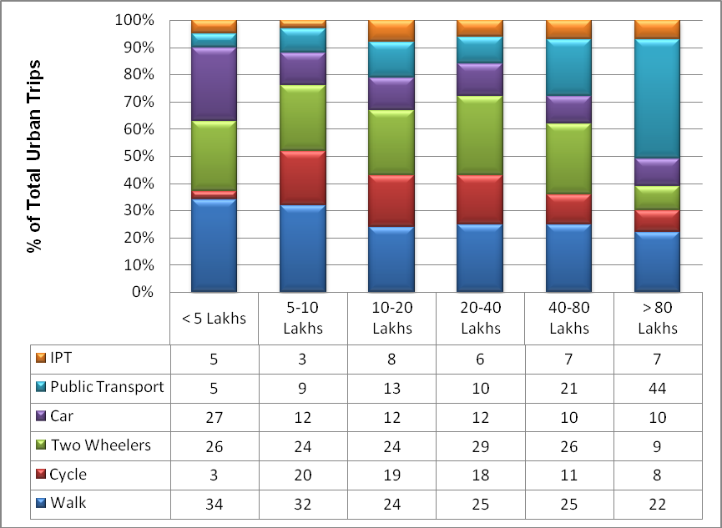

Source: Ministry of Urban transport, GOI, New Delhi 2010

These two tables, i.e., ***Table 2*** & ***Table 5*** shows that there was a huge gap of public transport share, especially in small and medium cities. So there is an urgent need to balance the desire model split. It occurred only after the introduction of JNNURM and National Urban Transport Policy (NUTP) that the emphasis was also given to small and medium towns also specially in

public transport sector. The basic emphasis was to increase the public transport share and change in ridership so that the various problems like congestion, pollution and accidents can be minimized in such cities as they have rapid growth due to urbanization and industrialization.

# Table 5: Desirable Modal Split in Indian Cities (as a % of Total Trips)

|  |  |  |  |
| --- | --- | --- | --- |
| City Population (in millions) | **Mass Transport** | **Bicycle** | **Other Modes** |
| < 5 lakhs | 30-40 | 30-40 | 25-35 |
| 5-10 lakhs | 40-50 | 25-35 | 20-30 |
| 10-20 lakhs | 50-60 | 20-30 | 15-25 |
| 20-50 lakhs | 60-70 | 15-25 | 10-20 |
| 50 lakhs + | 70-85 | 15-20 | 10-15 |

Source: Ministry of Urban Development, Government of India, New Delhi (1998)

1. PUBLIC TRANSPORT SCENERIO IN BHOPAL: AN

OVERVIEW

Bhopal is the capital of the Indian state of Madhya Pradesh and the administrative headquarters of Bhopal District and

Bhopal Division. Bhopal is also known as the Lake City for its various natural as well as artificial lakes and is one of the greenest cities in India.

References

1. , A. K 2004, ‘Urban Transport Issues and strategies’, Proceeding IUT, India.
2. Akshima, T and Sunder, S 2010, A Focus on the Passenger Transport Sector in Million-Plus Cities, India Infrastructure Report
3. Balcombe, R and Paulley, N 2004, ‘Demand of Public Transport: A Practical Guide’ TRL Report 2004, TRL Limited, Great Britain
4. Berechman, J (1993). Public Transit Economics and Deregulation Policy. Amsterdam, North Holland.
5. Dissanayake, D and Morikawa T (1999) ‘ Analysis Of Urban Travel Demand For Development Country By Integrating RP And SP Data’ Proceedings of

Infrastructure Planning **Vol** 22, pp. 381-384

1. Deb, K and Philippini, M 2010, Public bus transport demand elasticities in India” 2010
2. Holmgren, J 2007, ‘Meta-analysis of public transport demand’ , Science Direct, Transport Research, part A 41, pp. 1021-41
3. Holmgren, J 2008 ‘Study in local public transport demand for Sweden’ Linköping Studies in Arts and Science No. 460,
4. Irena,S and Zura,M, ‘EVA Mode Choice Model Parameters estimation’, Mathematical model for engineering Science, ISBN 978-960-474-252-3,

pp. 232-237.

1. Kittelson & Associates 2003, Transit Capacity and Quality of Service Manual, Report 100, Transit Cooperative Research Program, Transportation Research Board.
2. Khalid, A and sadeq, H 2003, ‘Ridership Demand Analysis for Palestinian Intercity Public transport, Journal•of•Public•Transportation,

Vol.•6,•No. 2, pp. 20-35

1. Litman, T 2010, Evaluating Public Transit Benefits and Costs: best practices Guide book, Victoria Transport Policy Institute
2. Muthukannan, M and Thirumurthy A (April 2008) ‘modelling for Optimization of Urban Transit System Utility’, ARPN Journal of Engineering and Applied Sciences, vol.3, no.2, pp. 71-74
3. Nijkamp, P, Pepping, G., 1998. ‘Meta-analysis for explaining the variance in public transport demand elasticities in Europe’. Journal of Transportation and Statistics, vol 1 no. 1, pp.1–14.
4. Pucher, J & Ittyerah, N 2004, ‘The crises of public transport in India: Overwhelming needs but limited resources’, Journal of Public Transportation, vol. 7, no. 4, pp 1-20
5. Pangotra, P and Sharma, S 2006, Modeling travel demand in Metropolitan cities case study of Bangalore, IIM Ahmadabad research publication.
6. Pucher, J & Korattywaroopam, N 2005 ‘Urban transport crisis in India’

Transport policy 12, Elsevier , pp.185-198

1. Sing, S K 2005 ‘Review of Urban Transport in India”, Journal of Public Transport, Vol 8, pp. 67-88
2. Sharifi, M & Shamsudi, K B 2006 ‘Spatial criteria Decision Analysis in Integrated planning in Public transport Malaysia’ , ISPRS, July 2006
3. Sreedharan, E., 2003, Need for Urban Mass Transport System for Our Cities. Press Information Bureau, Government of India, New Delhi, India.
4. Sobota, A & Zochowska, R May 2008 ‘Model of urban public transport network for the analysis of punctuality’, Journal of achievements in materials and manufacturing Engineering, vol.28,issue 1, pp. 63-66
5. Waterson, J & Hounsell, N 2003, ‘Simulating the Impact of Strong Bus Priority Measures, Transport Engineering’, ASCE, November 2003
6. Wilbur Smith Associates 2008, Study on traffic and Transportation Policies and Strategies in Urban Areas in India final report, Ministry of Urban Development, India
7. [Zargari](http://scialert.net/asci/author.php?author=Shahriar%20A.&last=Zargari)s, A and [Morteza A 2008, ‘](http://scialert.net/asci/author.php?author=Morteza%20Araghi&last)**An Integrated Urban Land Use and Transportation Demand Model Based on Lowry Linage’,** Journal of Applied Sciences, Volume 8, Number 7.