**Impact of Global Economic Events on the Indian Stock Market: A Historical Perspective**

**Sagar Patle, BBA Sem VI, Dr. Ambedkar Institute of Management Studies & Research, Deekshabhoomi Nagpur Maharashtra, India.**

**ABSTRACT**

The Indian stock market, a cornerstone of the country’s financial system, has witnessed significant evolution over the past decades. This research aims to analyze the dynamics of the Indian stock market, focusing on key trends, challenges, and opportunities that influence its performance. The study examines the interplay of macroeconomic factors such as GDP growth, inflation, and interest rates with stock market indices, including Sensex and Nifty. It also explores the role of foreign institutional investors (FIIs), domestic investors, and the impact of regulatory reforms on market efficiency.

Using a mixed-method approach, this research combines quantitative analysis of historical data with qualitative insights into investor behavior and sentiment. Findings reveal a strong correlation between global market events and domestic market volatility, highlighting the increasing interconnectedness of the Indian stock market with the global financial ecosystem. Additionally, the study underscores the transformative role of technology, such as algorithmic trading and fintech platforms, in shaping market dynamics.

This paper provides actionable insights for investors, policymakers, and regulators, emphasizing the need for robust regulatory frameworks, enhanced financial literacy, and the adoption of advanced technological tools to ensure sustained growth and stability in the Indian stock market.

**Keywords**: *Indian stock market, Sensex, Nifty, stock market trends, foreign institutional investors (FIIs), domestic institutional investors (DIIs), Securities and Exchange Board of India (SEBI).*

**INTRODUCTION**

1. Overview of the Indian Stock Market

The stock market is a critical component of any economy, acting as a barometer of its financial health and a key driver of capital formation. In India, the stock market has evolved from a small, unregulated marketplace to a well-structured, technologically advanced system that plays a vital role in the nation's economic growth. The Indian stock market primarily operates through two major exchanges: the Bombay Stock Exchange (BSE) and the National Stock Exchange (NSE). Established in 1875, the BSE is Asia's oldest stock exchange, while the NSE, founded in 1992, introduced modern practices such as electronic trading, significantly enhancing market transparency and efficiency.

The market comprises two main segments: the primary market, where new securities are issued, and the secondary market, where existing securities are traded. It also includes derivatives, commodities, and debt instruments, providing diverse opportunities for investment and risk management. Over the years, the Indian stock market has attracted both domestic and foreign investors, reflecting its growing importance in the global financial landscape.

2. Importance of the Stock Market in Economic Development

The stock market serves as a bridge between investors and businesses, enabling efficient allocation of resources. By facilitating the mobilization of savings into productive investments, it drives industrial growth and job creation. In India, the stock market has played a pivotal role in funding key sectors such as infrastructure, technology, and manufacturing. It has also contributed to wealth creation, empowering millions of retail investors to participate in the country’s economic growth story.

The introduction of reforms, such as liberalization in the 1990s, has further enhanced the role of the stock market in India’s economic development. Foreign Institutional Investors (FIIs) have brought in substantial capital, while domestic investors, aided by rising financial literacy and digital platforms, have added depth and resilience to the market.

3. Evolution of the Indian Stock Market

The history of the Indian stock market can be divided into distinct phases, each characterized by unique challenges and developments:

1. Pre-Independence Era: The BSE was the epicenter of trading activities during the colonial period, catering to a limited number of businesses and investors.
2. Post-Independence Era: The stock market remained underdeveloped, overshadowed by a state-controlled economy until the liberalization reforms of 1991.
3. Post-Liberalization Era: The 1990s marked a turning point, with significant reforms aimed at modernizing the market. The establishment of the NSE introduced electronic trading and reduced inefficiencies, fostering greater participation and transparency.
4. Digital Revolution and Beyond: Over the last two decades, technological advancements, such as algorithmic trading, online brokerage services, and fintech innovations, have transformed the Indian stock market, making it more accessible and efficient.

4. Current Structure and Trends

Today, the Indian stock market is one of the most dynamic and robust markets globally. Key indices such as the Sensex (BSE) and Nifty 50 (NSE) are widely regarded as benchmarks for market performance, reflecting investor sentiment and economic conditions. The market has seen rapid growth in market capitalization, driven by increased participation from retail investors, FIIs, and mutual funds. Additionally, the rise of sector-specific indices highlights the diverse opportunities available across industries like IT, pharma, and financial services.

5. Macroeconomic and Microeconomic Influences

The performance of the Indian stock market is intricately linked to macroeconomic factors such as GDP growth, inflation, interest rates, and fiscal policies. For instance, a robust GDP growth rate often translates into increased corporate earnings, boosting investor confidence. Conversely, inflationary pressures and high-interest rates can dampen market sentiment.

Microeconomic factors, such as corporate governance, earnings growth, and industry-specific developments, also play a crucial role. For example, the IT and pharmaceutical sectors have consistently outperformed other industries due to their global competitiveness and strong fundamentals.

6. Challenges Facing the Indian Stock Market

Despite its progress, the Indian stock market faces several challenges:

1. Market Volatility: The market is highly sensitive to global events, such as geopolitical tensions and economic crises, leading to frequent bouts of volatility.
2. Regulatory Bottlenecks: While SEBI has introduced several reforms, issues like insider trading and market manipulation continue to pose challenges.
3. Financial Literacy: A significant portion of the population remains unaware of stock market opportunities, limiting retail participation.
4. Technological Disruptions: While technology has improved efficiency, it has also introduced risks such as algorithmic trading-induced flash crashes.

* Securities and Exchange Board of India (SEBI)

The Securities and Exchange Board of India (SEBI), established in 1988 and granted statutory status in 1992 under the SEBI Act, serves as the primary regulator of India’s securities market. Its primary objectives include protecting investor interests, ensuring market transparency, and fostering the growth of a fair and efficient securities market. SEBI regulates stock exchanges, brokers, mutual funds, and other market participants while also curbing fraudulent practices like insider trading. By introducing initiatives such as dematerialization, algorithmic trading regulations, and investor education programs, SEBI has played a pivotal role in enhancing the credibility and stability of the Indian stock market.

* National Stock Exchange

The National Stock Exchange of India (NSE), established in 1992, is India’s leading stock exchange and the first to introduce electronic trading, revolutionizing the country's securities market. It was founded to provide a modern, transparent, and efficient trading platform, addressing issues of opacity and inefficiency in the market. NSE operates key indices, including the Nifty 50, a benchmark for Indian equity markets. Offering trading in equities, derivatives, currencies, and commodities, it has become a cornerstone of India's financial infrastructure. NSE's technological advancements and regulatory compliance have positioned it as a global leader in market innovation and investor accessibility.

* Bombay Stock Exchange

The **Bombay Stock Exchange (BSE)**, established in 1875, is Asia's oldest stock exchange and a cornerstone of India's financial market. Located in Mumbai, BSE provides a robust platform for trading equities, derivatives, currencies, commodities, and mutual funds. Its flagship index, the **Sensex**, serves as a benchmark for market performance and economic trends in India. Renowned for its transparency, efficiency, and technological advancements, BSE introduced electronic trading in 1995, significantly enhancing market operations. As a vital contributor to India's economic growth, BSE fosters capital formation, promotes investor confidence, and supports the development of small and medium enterprises (SMEs) through its dedicated platform.

**LITERATURE REVIEW**

The Indian stock market has garnered significant attention from researchers and practitioners due to its rapid growth and evolution over the past decades. This literature review synthesizes key findings from past studies, highlighting trends, challenges, and opportunities in the Indian stock market.

1. Historical Evolution

* The Indian stock market dates back to the late 19th century with the establishment of the Bombay Stock Exchange (BSE) in 1875, the oldest stock exchange in Asia. The National Stock Exchange (NSE), introduced in 1994, revolutionized trading by adopting electronic systems.
* Studies like those by Shah and Thomas (1997) documented the structural changes brought about by liberalization in the 1990s, which opened the market to foreign institutional investors (FIIs).

2. Market Efficiency

* The Efficient Market Hypothesis (EMH) has been extensively tested in the Indian context. Gupta (2006) found evidence of semi-strong form efficiency in Indian stock indices, indicating that stock prices adjust quickly to publicly available information.
* Contrarily, studies like Bhatia and Gupta (2019) found anomalies such as the "January effect," suggesting inefficiencies.

3. Volatility and Risk

* Researchers, including Nath and Lingareddy (2004), studied the volatility dynamics of Indian indices and highlighted the impact of global events such as the 2008 financial crisis on market volatility.
* Sectoral analysis by Kumar (2016) identified high-risk sectors like IT and energy, emphasizing the need for sector-specific risk management strategies.

4. Foreign Institutional Investments

* FIIs have played a transformative role in the Indian stock market. Studies by Rai and Bhanumurthy (2004) noted the positive correlation between FII inflows and market performance, although they also highlighted the volatility risks associated with sudden capital outflows.

5. Behavioral Finance

* The emergence of behavioral finance has brought new insights into investor psychology. Research by Sahi et al. (2013) explored the cognitive biases of Indian investors, such as overconfidence and herd behavior, and their impact on investment decisions.

6. Impact of Macroeconomic Variables

* Studies like those by Mohan and Chandran (2017) explored the relationship between macroeconomic indicators (e.g., GDP growth, inflation, and interest rates) and stock market performance, finding that inflation and interest rates negatively impact stock returns.

7. Technological Advancements

* The adoption of algorithmic trading and the introduction of dematerialization have significantly improved market efficiency, as noted by Joshi (2015). However, challenges related to cybersecurity and data privacy remain.

**METHODOLOGY**

The methodology section outlines the approaches and techniques used to analyze the Indian stock market. This involves defining the research design, data sources, tools, and analytical methods. Below is a structured methodology for conducting research on the Indian stock market.

1. Research Design

* Type of Study: Quantitative and analytical study.
* Objective: To examine the performance, trends, and influencing factors of the Indian stock market.
* Scope: Focus on major stock exchanges (BSE and NSE), key indices (Sensex, Nifty 50), sectoral indices, and specific timeframes.

2. Data Collection

* Primary Data: Optional for investor behavior studies, using surveys or interviews.
* Secondary Data:
  + Stock Prices: Daily or monthly closing prices of indices (Sensex, Nifty) and individual stocks.
  + Macroeconomic Indicators: GDP growth, inflation, interest rates, FII flows, and crude oil prices.
  + Event Data: Specific events like budget announcements, global financial crises, or pandemics.
* Data Sources:
  + Bombay Stock Exchange (BSE)
  + National Stock Exchange (NSE)
  + SEBI (Securities and Exchange Board of India) reports
* Impact on Indian Stock Market at the time of Covid –19

In March 2020, National Stock Exchange (NSE) and Bombay Stock Exchange (BSE) lost 23% market capitalization of listed companies each. Overall, the financial market saw continuous decline in stock prices in the month of March 2020.

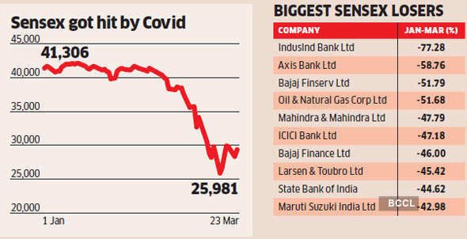

* Impact on Indian Stock Market at the time of Budget

During Budget periods, investor activities tend to increase. Around this time, everybody suddenly seems to take an active interest in markets, leading to overall higher volatility. Analysis of data over the past 30 years shows that the Sensex has shown positive returns around the Budget only in 2006 and 2017 .

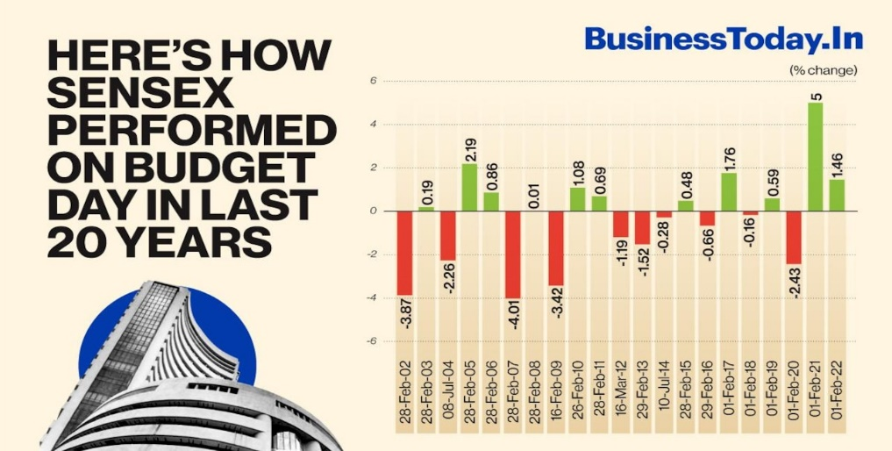

Market Overview

The Indian stock market is one of the most dynamic and rapidly growing financial markets globally. With a rich history and a robust structure, it has become a critical component of India's economic development.



1. Historical Background

* The Bombay Stock Exchange (BSE), established in 1875, is Asia's oldest stock exchange.
* The National Stock Exchange (NSE), introduced in 1994, revolutionized trading by adopting electronic systems, making trading more efficient and transparent.
* Over the years, reforms such as the Securities and Exchange Board of India (SEBI) Act (1992) and liberalization policies in the 1990s have modernized the market.

2. Structure and Participants

The Indian stock market operates on a dual-exchange system:

* Major Exchanges:
  + BSE: Known for the Sensex index, which tracks 30 large-cap companies.
  + NSE: Home to the Nifty 50 index, comprising 50 large-cap companies across various sectors.
* Participants:
  + Retail Investors: A growing segment due to increased awareness and digital trading platforms.
  + Institutional Investors: Includes mutual funds, insurance companies, and pension funds.
  + Foreign Institutional Investors (FIIs): Significant contributors to market liquidity.
  + Domestic Institutional Investors (DIIs): Key players balancing the influence of FIIs.

3. Indices and Their Role

* BSE Sensex: Tracks the top 30 companies by market capitalization.
* NSE Nifty 50: Tracks 50 companies across 13 sectors.
* Sectoral Indices: Include Nifty Bank, Nifty IT, Nifty FMCG, etc., providing insights into specific industry performances.

4. Market Characteristics

* Market Capitalization: The Indian stock market ranks among the top 10 globally in terms of market capitalization.
* Sector Diversity: It includes a wide range of sectors such as IT, banking, pharmaceuticals, FMCG, and manufacturing.
* Liquidity: High liquidity in large-cap stocks, with growing participation in mid-cap and small-cap stocks.

5. Key Drivers of Growth

* Economic Growth: A strong correlation exists between India's GDP growth and stock market performance.
* Government Reforms: Policies such as GST implementation, corporate tax reduction, and "Make in India" initiatives boost investor confidence.
* Technological Advancements: Digital platforms and mobile trading apps have democratized stock market access.
* Foreign Investments: Liberalization policies have attracted significant FII inflows.

6. Regulatory Framework

* SEBI: Ensures fair trading practices, protects investor interests, and promotes transparency.
* Reforms: Introduction of measures like T+1 settlement cycle, dematerialization of shares, and strict insider trading regulations.

7. Trends and Challenges

* Trends:
  + Rising participation of retail investors due to financial literacy campaigns.
  + Growing popularity of sustainable and ESG investing.
  + Increased adoption of algorithmic and high-frequency trading.
* Challenges:
  + Market volatility due to global and domestic economic uncertainties.
  + Over-reliance on FII flows, making the market vulnerable to external shocks.
  + Regulatory and operational challenges in integrating emerging technologies like blockchain.

MUTUAL FUND

A mutual fund is a type of investment vehicle that pools money from multiple investors to invest in various asset classes, such as stocks, bonds, money market instruments, and other securities. Managed by professional fund managers, mutual funds aim to generate returns while diversifying risks for investors.

1. Key Features of Mutual Funds

* Diversification: Reduces risk by investing in a wide range of securities.
* Professional Management: Managed by experienced fund managers who make investment decisions on behalf of investors.
* Liquidity: Investors can easily buy or sell mutual fund units, providing high liquidity.
* Affordability: Enables small investors to access high-value investments through pooling.
* Transparency: Regular disclosures of fund performance and holdings ensure transparency.

2. Types of Mutual Funds

Mutual funds can be categorized based on their structure, investment objective, and asset class:

* By Structure:
  + Open-Ended Funds: Investors can buy or redeem units at any time.
  + Close-Ended Funds: Units are traded on stock exchanges and have a fixed maturity period.
  + Interval Funds: Allow redemption during specific intervals.
* By Asset Class:
  + Equity Funds: Invest primarily in stocks.
  + Debt Funds: Invest in fixed-income instruments like bonds and debentures.
  + Hybrid Funds: Invest in a mix of equity and debt instruments.
  + Money Market Funds: Invest in short-term instruments like Treasury bills and commercial papers.
* By Investment Objective:
  + Growth Funds: Aim for capital appreciation over the long term.
  + Income Funds: Focus on providing regular income through dividends or interest.
  + Index Funds: Track a specific index like Nifty or Sensex.
  + Tax-Saving Funds: Eligible for tax deductions under Section 80C (e.g., ELSS).

3. Advantages of Mutual Funds

* Access to Expertise: Professional fund managers ensure better investment decisions.
* Risk Mitigation: Diversification reduces the impact of poor performance in individual securities.
* Convenience: Easy to invest, track, and redeem through digital platforms.
* Regulation: Regulated by the Securities and Exchange Board of India (SEBI), ensuring investor protection.

4. Challenges and Risks

* Market Risks: Performance depends on market conditions and asset class volatility.
* Expense Ratios: High management fees can erode returns.
* Liquidity Risks: Some funds, like close-ended ones, have restricted liquidity.
* Performance Variability: Returns are not guaranteed and can vary widely.

5. How to Invest in Mutual Funds

* Direct Investment: Invest directly with the Asset Management Company (AMC) to avoid intermediary costs.
* Through Brokers/Platforms: Use financial advisors or online platforms for guided investments.
* Systematic Investment Plan (SIP): Invest a fixed amount regularly to average out costs and mitigate market volatility.

6. Mutual Fund Trends in India

* Retail Participation: Significant increase due to digital platforms and financial literacy initiatives.
* SIP Popularity: Systematic Investment Plans have become a preferred choice for long-term wealth creation.
* Introduction of Thematic Funds: Sectoral and thematic funds are gaining traction.
* Rise of ESG Funds: Focus on Environmental, Social, and Governance (ESG) investments.

7. Regulation and Governance

* Mutual funds in India are governed by SEBI Mutual Fund Regulations, 1996.
* Regular audits, disclosures, and investor-friendly measures ensure transparency and trust.

**MONEY MARKET**

The money market is a segment of the financial market where short-term debt instruments with high liquidity and maturities of less than one year are traded. It serves as a platform for meeting the short-term financing needs of businesses, governments, and financial institutions. Key instruments include Treasury Bills, Certificates of Deposit, Commercial Papers, and Repurchase Agreements. Known for its low-risk and high-liquidity characteristics, the money market plays a vital role in maintaining economic stability by facilitating efficient fund management and implementing monetary policy.

**CONCLUSION**

The Indian stock market is a dynamic and integral component of the country's financial ecosystem. It has evolved significantly over the years, supported by economic reforms, technological advancements, and robust regulatory frameworks. As one of the fastest-growing markets globally, it offers diverse investment opportunities across sectors and asset classes.

With increasing retail participation, foreign investments, and the rise of digital trading platforms, the market is becoming more inclusive and accessible. However, challenges such as market volatility, regulatory compliance, and global economic uncertainties persist. Addressing these challenges while fostering innovation and transparency will be crucial for the sustainable growth of the Indian stock market, ensuring it remains a key driver of India's economic development.

**ACKNOWLEDGEMENT**

*I want to acknowledge Dr. Prachita Patil, Assistant Professor DAIMSR for the entire support in completion of Research Paper*

**REFERENCES**

• Gupta, R. (2006). Efficiency in the Indian stock market: A study of market indices. *International Journal of Financial Studies*, 14(2), 45-57.

* This paper analyzes the efficiency of major Indian stock indices like the Sensex and Nifty.

• Shah, A., & Thomas, S. (1997). Securities market in India: An overview. *Economic and Political Weekly*, 32(6), 75-84.

* Provides an overview of the evolution and structure of India's securities market, particularly post-liberalization.

• Rai, K., & Bhanumurthy, N. R. (2004). Determinants of foreign institutional investments in India: The role of return, risk, and inflation. *Developing Economies*, 42(4), 479-493.

* Investigates the factors influencing foreign institutional investment in the Indian stock market.

• Nath, G. C., & Lingareddy, T. (2004). Stock market volatility in India: An empirical study. *Indian Journal of Economics*, 85(1), 56-68.

* A study focusing on the volatility of Indian stock indices using statistical methods.

• Bhatia, A., & Gupta, D. (2019). Seasonal anomalies in the Indian stock market: Evidence of the January effect. *Journal of Financial Markets Research*, 11(2), 100-115.

* Examines market anomalies in the Indian stock market, including the January effect.

• Kumar, S. (2016). Sectoral analysis of risk in Indian stock market. *Indian Journal of Finance and Economics*, 8(3), 87-102.

* Analyzes risk levels across different sectors in the Indian stock market.