**STUDY OF FORMULATION AND EVALUATION OF IBUPROFEN GEL BY USING CHICLE**

Kusum Gurjar*, Mrs.AjraShaikh, Dr.Revathi A Gupta,

Institute of Pharmacy, Dr. APJ Abdul Kalam University, Indore (Mp)

**ABTRACT**

The Ibuprofen gel exhibited a well-defined homogeneous structure, demonstrating proficient drug loading capabilities. The pH of the gel formulations was measured and found to fall within the neutral range, signifying their compatibility with human skin. Furthermore, the viscosity assessments revealed that the formulation is appropriate for effective topical drug delivery. The drug content analysis yielded a concentration of 87.56, indicating a high efficiency in drug loading. This specific ibuprofen formulation was engineered as a prolonged-release gel for dermatological purposes, utilizing the natural polymer guar gum. The resultant gels displayed adequate homogeneity and texture. Notably, these formulated gels outperform commercially available alternatives, thereby establishing them as a viable option for the management of both localized and systemic inflammatory conditions.

## KEYWORDS : Gel, Ibuprofen, Formulation, Topical and homogeneous.

**INTRODUCTION**

Topical or transdermal drug delivery refers to the method of administering medications through the skin, offering a noteworthy alternative to conventional delivery systems such as oral and parenteral routes. The advantages of employing topical or transdermal delivery systems include non-invasive administration, circumvention of first-pass metabolism, prolonged therapeutic effects, reduced dosing frequency, stabilization of plasma drug concentrations, diminished drug toxicity and associated adverse effects, as well as improved patient adherence, among various other benefits.

GEL:Gels represent a consistent category of semisolid formulations, generally composed of solutions or dispersions that incorporate one or more active pharmaceutical ingredients within suitable hydrophilic or hydrophobic matrices.

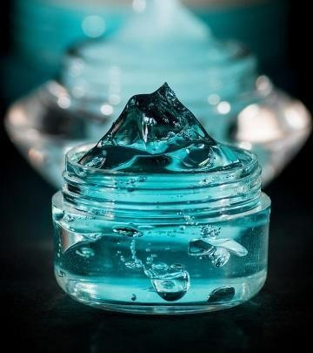

Figure 1 – Gel

STRUCTURE OF GELSThe rigidity of a gel is primarily dependent on a network formed by the interlinking of gelling agent particles. The properties of these particles, alongside the specific forces that enable their connections, are vital in determining the architectural framework of the network as well as the properties exhibited by the gel.

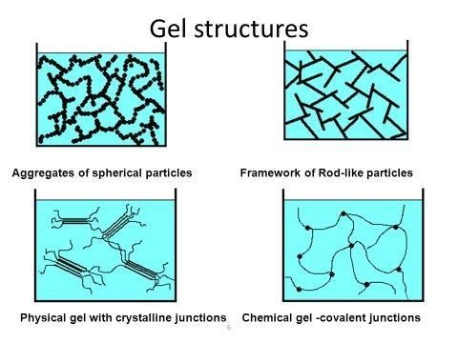

Figure 2 – Gel structure

CLASSIFICATION OF GELS

Gels can be categorized according to various criteria, including colloidal phases, the nature of the solvent employed, physical characteristics, and rheological properties, among others.

1) Based on colloidal phases They are classified into:

a) Inorganic (Two phase system)

b) Organic (Single phase system)

## 2) Based on nature of solvent used

## a) Hydro gels (water based)

## b) Organic Gels (with a non - aqueous solvent)

3) Based on rheological propertiesusually gels exhibit non-Newtonian flow. They are classified into:

## a) Plastic gel

## b) Pseudo plastic gel

## c) Thixotropic gels

4) Based on physical nature

## a) Elastic gels

## b) Rigid gels

5) Bases or gel forming polymers:- It can be classified as follows:

## a) Natural polymers

## b) Semi synthetic polymers

## c) Synthetic polymers

USES OF GELS

a) Delivery systems designed for the administration of pharmaceuticals via oral routes encompass various mechanisms that ensure optimal therapeutic effectiveness.

b) Topical medications are formulated for direct application to dermal layers, mucous membranes, or ocular surfaces, facilitating localized treatment.

c) Long-acting formulations of medications may be introduced into the body through intramuscular injections or via implantation, ensuring sustained therapeutic intervention.

d) The use of binders in tablet granulation, protective colloids in suspension formulations, and thickeners in oral liquids and suppository products is crucial for achieving desired physicochemical properties and enhancing product stability.

**DRUG PROFILE**

IBUPROFENIbuprofen is categorized as a nonsteroidal anti-inflammatory drug (NSAID) and is widely used for the treatment of pain, fever, and various related ailments. It demonstrates efficacy in mitigating mild to moderate pain, decreasing inflammation, and alleviating fever associated with numerous medical conditions. Specifically, its application is indicated for the management of dysmenorrhea, osteoarthritis, rheumatoid arthritis, and juvenile idiopathic arthritis. Furthermore, ibuprofen is recognized on the World Health Organization’s List of Essential Medicines, which delineates the most effective and safely utilized medications that are critical to a functional healthcare system.

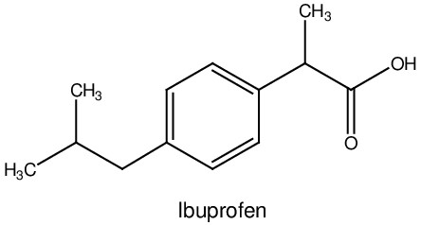

USES

Ibuprofen is primarily employed in the management of a range of pain conditions, including, but not limited to, headaches, back pain, dysmenorrhea, dental pain, generalized body aches, and myalgia.

### CHICLE GUM

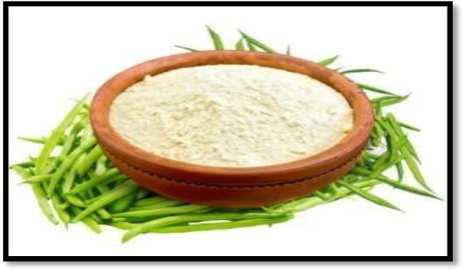

Figure 3 – Chicle Gum

Chicle gum is a naturally occurring polymer extracted from the endosperm of specific seeds. Historically, guar has primarily been employed as a protein-rich feed source for livestock. Furthermore, it plays a role as a green vegetable within Indian culinary practices.

### FORMULATION OF TRANSDERMAL IBUPROFEN GEL

### METHOD OF PREPARATION

Approximately 1.5grams of ibuprofen were incorporated into 5 milliliters of propylene glycol, and the mixture was heated to 65°C for a duration of 10 minutes to achieve a solution. A gel was formulated by dissolving 2 grams of guar gum in 4 milliliters of glycerin, creating a slurry, followed by the gradual addition of 15 milliliters of distilled water while continuously mixing with a magnetic stirrer until a homogeneous gel was obtained. The ibuprofen solution was subsequently combined with the gel, to which methyl paraben and peppermint oil were added, along with distilled water to reach the desired final weight, all while maintaining vigorous stirring. The ibuprofen-infused gel was stirred continuously using a magnetic stirrer for approximately 10 minutes. Finally, the gel was neutralized and its viscosity was enhanced through the incorporation of triethanolamine.

Table No. 1 : - Gel Formulation

| **S. NO.** | **INGREDIENTS** | **QUANTITY**  **(30G)** |
| --- | --- | --- |
| 1 | Ibuprofen | 1.50g |
| 2 | Guar gum | 2.0g |
| 3 | Propylene glycol | 5.0ml |
| 4 | Glycerine | 4.0ml |
| 5 | Methyl paraben | 400mg |
| 6 | Tri - ethanol amine | 0.1ml |
| 7 | Peppermint oil | 0.3ml |
| 8 | Distilled Water | Up to 30ml |

**RESULT & DISCUSSION**

STANDARD CALIBRATION CURVE OF IBUPROFEN

The calibration curve for Ibuprofen was constructed using a phosphate buffer at pH 7.4. The analysis of the standard solution indicated a maximum absorption peak at a wavelength of 267 nm. It was observed that Beer-Lambert's law was upheld within the concentration range of 2.0 μg/ml to 50.0 μg/ml in the phosphate buffer at pH 7.4, as depicted in Fig. .

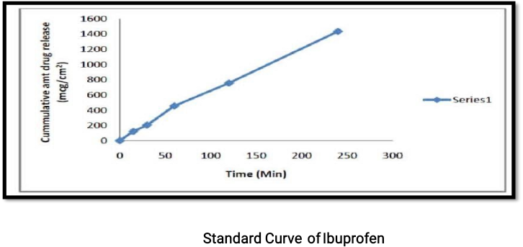

Figure 4 – Standard Curve of Ibuprofen

## pH OF IBUPROFEN GEL

The pH of the gel formulations was determined to be 6.3, and a comparative analysis was conducted with a standard gel

Table No. 2 : - pH of formulation

| Formulation | pH |
| --- | --- |
| Formulated Gel | 6.3 |
| Marketed Gel (Nurofen) | 7.4 |

The pH of the developed gel is measured at 6.3, which is lower than that of the commercially available gel, recorded at 7.4. Nevertheless, this lower pH is deemed acceptable, as both ibuprofen and guar gum exhibit stability within this pH range. Furthermore, the pH of the formulated gels is more aligned with the natural pH of the skin, approximately 5.5, thereby minimizing the risk of skin irritation.

## GEL SPREADABILITY STUDY

The spreadability of the gel formulations was evaluated after 1 minute and subsequently compared to a standard gel, as detailed in Table

Table No. 2 : - Spread ability of Gel Formulation

| Formulation | Spread ability |
| --- | --- |
| Formulated Gel | 19.79 |
| Marketed Gel (Nurofen) | 21 |

### VISCOSITY

The viscosity of the gel formulations was found between 19100 cps. Viscosity of Gel Formulation (20 rpm)

DRUG CONTENT

The drug content of the gel formulations was determined to be 87.56%, indicating effective drug loading capabilities. The Ibuprofen gel exhibited homogeneity and satisfactory drug incorporation. Additionally, the pH of the gel formulations was measured to fall within the neutral range, rendering it compatible with skin application. The viscosity of the formulation was also found to be suitable for topical drug delivery. Overall, the drug content of 87.56% further underscores the formulation's efficient loading properties.

**CONCLUSION**

## This study presents a comprehensive examination of the development of ibuprofen in a prolonged-release gel formulation designed for dermatological applications, with natural guar gum incorporated as a pivotal component. The resultant gels demonstrated notable homogeneity and an enhanced texture. The superior efficacy of these formulated gels, in comparison to existing commercial products, suggests their potential as viable alternatives for the management of both localized and systemic inflammatory conditions.

## REFERENCE

1. A.M. Avachat, R. R. Dash, and S. N. Shrotriya, Ind. J. Pharm. Edu. Res. 45, 86 (2011).
2. Available from[https://www.sciencedirect.com](https://www.sciencedirect.com/)
3. AukunuruJithan, Chinnala Krishna Mohan and GuduriViswanath. Development of a Novel Transdermal Ibuprofen ointmen,Current Trends in Biotechnology and Pharmacy · January 2009
4. Barry B W. Novel mechanisms and devices to enable successful transdermal drug delivery. Eur. J. Pharm. Sci. (2001) 14: 101-114.
5. BalajiMaddiboyina, ArthapuHari Krishna, MakkenaRamya Sri, PasupuletiBhuvanaKalyani, ShaikJabeena, ShaikSharmila, VankudavatuLakshmibai. Preparation and evaluation of ibuprofen in-situ periodontal gel. IJMSCR, volume 4 Issue1 March, 2020.
6. BashyalSagar Ibuprofen and its differently analytical and manufacturing methods .Asian Journal of Pharmaceutical and Clinical Research Vol 11, Issue July,2018. 8) Cotton S.D.andClaridge E. Do all human skin colours lie on a defined surface within lms space? Technical Report CSR-96-1, School of Computer Science, The Univeristy of Birmingham, 1996.
7. GaireArjun ,MaharjanSangit , ShresthaSumitra. Formulation & Evaluation of Fluconazole Gel for Topical Drug Delivery System January, 2021 ISSN 2313-4410, Global Society of Scientific Research and Researchers.
8. Herskovitz I, Macquhae F, Fox JD, Kirsner RS. Skin movement, wound repair and development of engineered skin. Exp. Dermatol. 2016 Feb;25(2):99-100. [PubMed: 26660718]
9. Igarashi Takanori, Nishino Ko , and Nayar Shree K. The Appearance of Human

Skin Department of Computer Science Columbia University,New York,NY10027, USA July, 2007.

1. Iyaz BB., “Formulation and evaluation of Gel containing Fluconazole-Antifungal agent”.

International Journal of Drug Devlopment and Research 3.4 (2011): 109-128.

1. Khan Barkat Ali Human skin, aging and antioxidants .Journal of Medicinal Plants Research Vol. 6(1), pp. 1-6, ISSN 1996-0875 ©2012 .
2. KashyapAnkita, Das Asha , Ahmed Abdul Baquee. Formulation and Evaluation of Transdermal Topical Gel of Ibuprofen. Open Access to Pharmaceutical and Medical Research 2011-18, publisher and licensee JDDT, This is an Open Access article.
3. Loyd VA., “Ansel’s pharmaceutical dosage forms and drug delivery systems. 9th ed. Philadelphia: Lippincott Williams & Will dns; (2011).
4. Maru S, Okaru A.O., Kamau F.N., Kuria K.A.M., Nganga B.N., Gathu L. And Mathenge

A. Formulation and Evaluation of Ibuprofen Gel using a Natural Polymer. East and Central

African Journal of Pharmaceutical Sciences Vol. 18 (2015) 18-22

1. ParhiaRabinarayan, GoutambSahukaraVenkataSai, MondalcSumanta.

Formulation and Evaluation of Transdermal Gel of Ibuprofen: Use of Penetration Enhancer and Microneedle. Iranian Journal of Pharmaceutical Sciences October, 2020.

1. Prajapati D., Jani G.K.,Moradiya N. G., and Randeria N.P., Carbohydr. Polym. 92, 1685 (2013).
2. RasoolBazigha K Abdul, Abu-GharbiehEman , Sahar A Development and

Evaluation of Ibuprofen Transdermal Gel Formulations Tropical Journal of

Pharmaceutical Research August 2010; 9 (4): 355-363

1. RathodHemendrasingh and Mehta Dhruti. A Review on Pharmaceutical Gel. International Journal of Pharmaceutical Sciences · October 2015.

Srivastava M. Manjunath, GowdaDV,Anjali , Kumar Praveen, SrivastavaAtul.Guar Gum and Its Pharmaceutical and Biomedical Applications. Srivastava A., Gowda D.V. ,Hani U., Shinde C.G., and Osmani R., RSC Adv. 5, 44652 (2015).

1. SayedManar, Raouf Abdel, SayedAsmaa, and Mostafa Mai .Application of Guar Gum and Its Derivatives in Agriculture (January,2022).<https://www.researchgate.net/publication/356783134>
2. Soni A, Chaudhary A, Singla S, Goyal S. Review on: Novel Approach in Pharmaceutical Gel. Current Pharma Research. 2018;9(1):2576-88.
3. YousefHani,SharmaSandeep Regional Medical Center. Skin (Integument),

Epidermis, Baptist Regional Medical CenterStatPearls Publishing; 30 Dec,2017.