Response of Indian Stock Market During Covid-19 Pandemic
– An Impact Analysis

Dr Abhijit Chakraborty*, Ms. Manisha Goswami**,
Ms. Gowri Hebbar***, Mr. Kiran Suraj S****

* Associate Professor, School of Commerce and Management Studies, Dayanand Sagar University, Bangalore, Email: abhijitchakraborty-scms@dsu.edu.in | Mobile: +91-9706027177

**Research Scholar, Department of Management Studies, National Institute of Technology Silchar, Email: piya_manisha@yahoo.com | Mobile: +91-7086619146

*** Research Scholar, School of Commerce and Management Studies, Dayanand Sagar University, Bangalore, Email: gowrihebbar-rs-mgt@dsu.edu.in | Mobile: +91- 9480521578

**** Research Scholar, School of Commerce and Management Studies, Dayanand Sagar University, Bangalore, Email: Kiran.suraj-rs-mgt@dsu.edu.in | Mobile: +91-80883 32281

Abstract:
The Covid-19 Pandemic has made the entire world to suffer a lot. In a very short span of time, the pandemic has affected almost all the nations. It had direct impact on the manufacturing sector of economies and indirect impact on the spending and investment behaviour of the public in general. The stock market across the world fluctuated abnormally during the first wave of Covid Pandemic. This study intends to investigate the existence of any cointegration and causality between Covid-19 Pandemic and stock market behaviour in India. Johansen Cointegration test was applied to check for cointegration. Engle Granger Causality test was adopted to check for causality. The analysis revealed that there is long-run negative relationship between Covid-19 pandemic and Indian stock market behaviour, but there exists no causality between them. The results may help the policy makers to take appropriate steps to regulate the stock market and ensure growth of investments.
Keywords: Causality, Cointegration, Covid-19 Pandemic, Covid crisis, Indian Stock Market.

Introduction:
The world has witnessed many challenges after the outbreak of COVID-19 which was declared as Pandemic by WHO on 11th March 2020. Originating from China’s Wuhan province, Covid-19 rapidly engulfed most of the nations within months. Globalization has not only opened access to the market but also provided wings to pandemics like COVID 19 and allowed it to spread like wildfire from China’s Wuhan to New York, London, and Milan, which are the nerve centres of global trade, commerce and tourism. The geographical scope of earlier pandemics were restricted to a limited area/zone, whereas COVID 19 has already affected people in more than 200 countries of the world. (Açikgoz & Günay, 2020; Chakraborty & Maity, 2020; Iqbal, et al., 2020; Sharma, et al.,2020; Laing, 2020). The spread of this rapidly mutating virus demanded preparation to deal with this sudden health shock, and in response, most of the affected countries adopted several measures, including restricting the domestic and international movement of people and goods. This affected the entire global economy.

In this critical situation, an extraordinary approach from the policy makers is required to bring the country’s economy back in to track (Sai Ganesh & Parameswaran, 2013). Therefore, almost all the affected countries have announced a range of fiscal and monetary stimulus packages with an aim of transferring income to people having higher marginal propensity to spend to boost the sagging demand, following the Keynesian principle of “pump-priming. The major challenge faced by the Multi National Companies (MNCs) is to optimise the economic gain of globalisation while minimising the risk of adverse effect arising from COVID-19 pandemic on its value chain (Duffin, 2020). The Pandemic impacted the stock markets of nations across the globe (Baker, et. al., 2020; Parth, 2020), and India is not an exception.

The worldwide adopted lockdown and containment measures acted against the economic logic of globalisation which is based on concentration of production in low cost countries in order to benefit from economies of scale. Lockdown affected the livelihood of millions of people, specially in developing & emerging economies (Kazmi, et al., 2020). These nations have already been reeling under economic turbulences, unstable external demand, capital flow reversals, break in production process and a sharp fall in commodity prices. As a result of the current crisis, which resulted from a highly contagious health shock accompanied by an unfolding economic collapse, the condition of unemployment, domestic demand, informal sector, micro small and medium enterprises (MSMEs), trade and investment, industrial output were deteriorating very fast (Kirubadevi & Sai Ganesh, 2016). Post Great Depression of 1930 which brought great miseries to the global economy, the Covid Pandemic is the one which has affected the global economy in a similar intensity. In India, the impact on the economy is worse than that was witnessed in 2008 crisis. The country faced multiple challenges in terms of financial crisis, health crisis, collapse in commodity prices and much more (Fernandes, 2020). The global pandemic has hit Indian economy which challenged the target to reach USD $5 Trillion mark with 7 percent of GDP by the year 2024. Expected growth rate for Indian economy, as per World Bank assessment, will be contracted by 8.5% in FY 2021 (www.worldbank.org). The Indian economy needs to grow at a speed of 9% every year for next 5 years to reach the USD 5 trillion mark.

The slowing down and stoppage of production process pulled down the GDP of the Indian economy from 3 percent in March, 2020 to -24.3 percent , -7.3 percent and .4 percent in June, 2020, September, 2020 and December, 2020 respectively. But the GDP is recovering at a faster rate than what was expected.

The Stock Market (NSE) trend in India from June 2020 to May, 2021, is depicted in Chart 1. The trend of Covid cases for the same period is depicted in Chart 2.
Chart 1. Movement in Stock Market
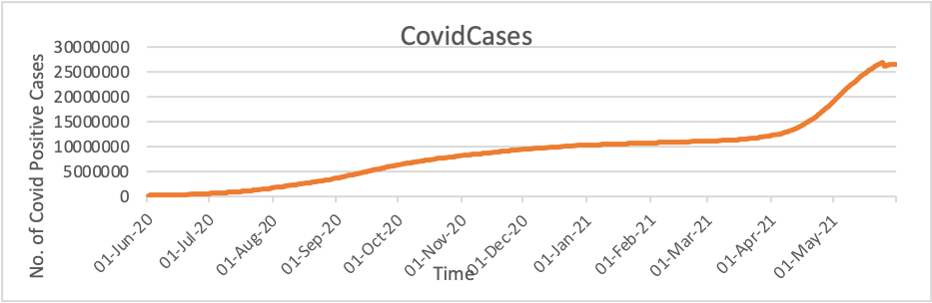

Source: Authors’ compilation (data from www.nseindia.com)

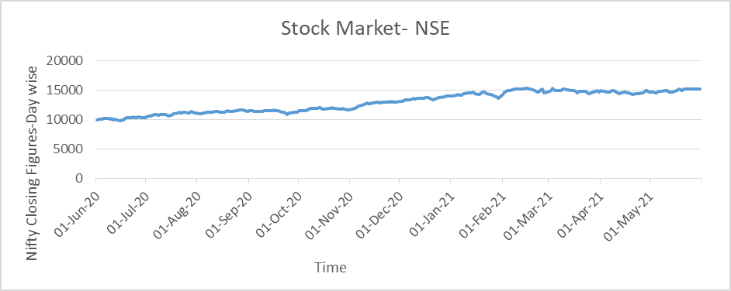
Chart 2. Number of Covid Positive Cases

Source: Authors’ compilation (data from www.indiastat.com)

The trend in covid cases is more volatile than the movement in stock market as can be seen from the above charts 1 and 2. The stock market maintained a upward trend during the period of study. Whereas, the Covid cases show a rise in the first phase, than a period of stagnancy and again a rise in the second phase. The Stock market performance was not at par the investors’ expectation. This calls for the need to investigate impact of Covid cases on Indian stock market.

Literature Review:

Many empirical studies are carried out worldwide relating to impact of “Covid-19 Pandemic” on global economy with specific reference to stock market movements in both developed and developing country including India. After analysing the history of all unexpected events, Covid 19 pandemic is termed as ‘Black Swan’ event (Das & Panja, 2024; Rajaram, 2020). ‘Black swan’ is an unforeseen event beyond expectation and has severe consequences on happening. It is also mentioned that recovery from Covid crisis cannot be assured until public health system is stabilized (Rajaram, 2020).

Spread of contagious disease negatively affects investors’ sentiment which leads to wrong investment decision and that impact the stock market (Liu, et al., 2020). US stock market behaved abnormally in March 2020, and hit the “circuit breaker mechanism” for four times within ten days. Leading index of UK, FTSE dropped exceeding 10 percent on March 2020 (Zhang, et al., 2020). US treasury market showed liquidity crunches in the month of March, 2020, and this affected the credit market which made borrowing of funds difficult for any duration (Roy, 2020). General pattern of “Country-Specific risk” & “systematic risk” in world financial market was studied during Covid 19 outbreak and it was found that global market has become volatile and it has also increased the financial risk caused due to rising uncertainty related to quick recovery (Das & Panja, 2020; Panja & Das, 2020).

People restricted themselves to necessities only, therefore, FMCG (Fast Moving Consumer Goods) companies showed positive returns, whereas, all other companies showed negative return during pandemic period (Das & Panja, 2022; Rakshit & Basistha, 2020). Considering the daily closing price of indices of Sensex and Nifty during September 2019 to July 2020, it was found that Indian stock market had volatility during pandemic period. Comparative study of pre-covid 19 periods & pandemic period showed that in the pre-covid 19 period, return on the indices were higher. The returns were least during the first lockdown period that was from 24th March 2020 to 6th April 2020 (Rakshit & Basistha, 2020). Another study was undertaken taking eight sectoral indices of BSE (Capital goods, Consumer Durables, Auto, Banks, FMCG, Heath care, IT and Reality) and two composite indices (BSE Sensex & BSE 500), and it also compared the composite indices of India with global indexes FTSE 100, Nikkei 225 & S&P 500. The daily record from January, 2019 to May, 2020 was taken in consideration and all indices’ key findings which showed lower mean daily return rather showed negative return during pandemic period than pre-pandemic period( Maji,2024 ). GLS Regression results of the study showed Indian stock market became more volatile during pandemic period & skewness became negative. The crisis phase exhibited fluctuations in kurtosis of return for the indices which indicates future risk (Choudhury, et al., 2020). An event study was conducted from 22nd January to 8th June, 2020 on the impact of pandemic on sensex indices where all the constituents of BSE Sensex 30 had very large CAR (Cumulative Abnormal Return) for the entire period which shows that Indian stock market was negatively affected by pandemic caused by Covid 19 (Singh, et al., 2020).

To Investigate abnormal returns (AR) & Panel Data Regression in order to explore the reasons behind abnormal return, similar event study methodology was adopted considering the indices of G-20 countries (Sai Ganesh & Parameswaran, 2024). The observed window was 58 days post the Covid 19 news release in the international media and estimation window was 150 days before the event data. Results showed negative AR (Abnormal Returns) is substantial for both developed & developing nations. However, in the later stages of event window, it was seen that stock market was gradually improving as indicated by positive CAR (Cumulative Abnormal Return) value. Study concluded that uncertainty due to pandemic outbreak resulted panic selling of shares but later with the infusion of capital, recovery is facilitated (Singh, et al., 2020).

With an emphasis on Bajaj Finance, Shriram Finance, Cholamandalam Finance, and Bajaj Holdings, Jayashree and Vijay (2024) study examines the risk-return characteristics of financial firms included in the BSE Finance Index. The article demonstrates substantial differences across the equities by employing statistical metrics, including standard deviation for volatility and correlation coefficients for market alignment. Bajaj Holdings is recognised as the least volatile and most closely correlated with the BSE Finance Index, rendering it a stable investment choice. Conversely, Cholamandalam Finance demonstrates the greatest volatility, signifying a more precarious profile. Bajaj Finance and Shriram Finance exhibit high correlations with the index while maintaining moderate risk levels. This analysis offers essential information for portfolio managers and investors aiming to equilibrate risk and return in the Indian financial sector, particularly during economic swings such as the COVID-19 epidemic.

From the above review of literatures, it was seen that the existing literature mainly focussed on the impact of Covid 19 pandemic on stock market through “event study” & “panel data analysis”. A symmetric power GARCH model is used to measure stock returns and its causes. GLS regression technique is used to examine the impact of COVID-19 on the multiple measures of volatility, namely standard deviation, skewness, and kurtosis of all indices. The CAAR model observed that indices of selected countries positively responded more in “post-pandemic period” compared with the “pre-pandemic period”. Even CGE (Computable General Equilibrium) model is used to examine the macroeconomic impact of three Covid 19 scenarios that ranges from relatively moderate pandemic to extensive pandemic

The studies so far mostly concentrated on investigating the impact of covid on various economic activities including stock market movements, but the causality aspects were rarely considered. It is important to investigate whether Covid crisis and stock market has any causal relationship to confirm whether the movements in stock market are caused by numbers of Covid cases in an economy. The present work intends to fill this gap by investigating the existence of any causal relationship between stock market movements & Covid 19 pandemic in India using time series data. The hypotheses of the study are:

H₁: Covid 19 Pandemic has long-run association with Stock Market Movement.
H_{2 :} Covid 19 pandemic causes stock market movement.

Research Methodology and Data Analysis:

Dataset and Research Methodology

Time series data relating to nifty index were sourced from www.nseindia.com and the covid data were collected from www.indiastat.com. Data were considered for a period of 365 days ( 01-06-2020 to 31-05-2021). Only those days were considered in which Stock Market (National Stock Exchange) was operative. Correlation test was conducted to see strength & direction of relationship between the variables under study. As a basic requirement for time series data analysis (Debnath, et al., 2014), Stationarity test was done using Augmented Dickey Fuller (ADF) unit root test.

For investigating long-run association between the variables, “Johansen Cointegration test” was applied. To determine number of cointegrating equations, maximum eigenvalue and the trace statistics were employed. The test originates from a p-order vector autoregressive model (VAR) as expressed in equation 1:

X_{t} = A₁ x _{t-1} + A₂ x _{t-2} + A3 x _{t-3} +……….. + A_{p} x _{t-p} + e _{t} (1)

Where, xt is (n × 1) vector. (x1t, x2t, x3t, ... ., xnt), e_{t} are independently and identically distributed n-dimensional vector with zero mean and a constant variance. A reduced form of Equation (1) is expressed in equation 2:

Δx_{t-I +} μ+ βt + e (2)
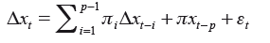
The linear combination of more than one time series “integrated of order I (1)” is a stationary process but the same may not be true for all situations. The Johansen Test identifies the number of cointegrating vectors between two or more I(1) time series variables that results in a stationary process, which can be symbolised as follows:
Where,

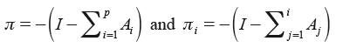
(3)

This study intends to identify the coefficient matrix that holds the long-run association between the variables. The rank of the matrix represents the “number of cointegrating vectors” that is needed to ensure xt is a stationary process
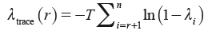

To test the hypothesis of the reduced-order matrix, Johansen has provided two likelihood based measures, as follows:
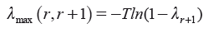
(4)

Where, T = number of observations
l = number of non-zero eigenvector.
The trace test value is used to test the null hypothesis of “r cointegrating vector(s)” against the alternative “more than r cointegrating vector(s)”. On the contrary, the maximum eigenvalue test helps in testing the null hypothesis of “r cointegrating vector” against the “alternative ‘r + 1’ cointegrating vectors”.

The presence of causal relationship between the variables were checked using Engle-Granger Causality test. One way causality running form CovidCases to StockMarket was considered, as it is assumed that number of Covid Cases causes fluctuations in the Stock Market, and not vice versa.

Empirical Findings and Discussion:

The correlation test results indicate existence of strong correlation between stock market & covid cases as evident from correlation coefficient of 84.44 percent with a p-value of 0.00.

Test for Stationarity

Table 1 represents the test results of ADF unit test. The ADF test holds the Null hypothesis that “time series variables are not stationary”. The null hypothesis can be rejected if the absolute critical values are lower than the ADF Test Statistics.

Table 1. Augmented Dickey Fuller Test
Variables | OD | Critical value | ADF Test Statistic
StMarket | 1 | -3.46 (c) *** | -10.82
CovidCases | 0 | -3.99 (b) *** | - 4.64

Notes: 1. Within parentheses ‘b’ represents ‘with drift and trend’, and ‘c’ represents ‘none’.
Optimal lag length is determined by AIC (not shown).
2. *** indicates 99 percent level of significance
3. OD represents ‘order of difference’; 0 represents ‘stationary at level’, 1 represents
‘stationary at first difference’.

The test result indicates that for CovidCases variable, the ‘ADF test statistic’ is greater than the ‘absolute critical value’ at level. This allows to reject the null hypothesis of non-stationarity, establishing that the variable is stationary at level and integrated of order I (0). But, For StMarket variable, the ‘ADF test statistic’ is greater than the ‘absolute critical value’ only when first difference is taken. It confirms that the StMarket variable is stationary at first difference only and integrated of order I (1).

Cointegration Test

The cointegration test measures long-run associationship between the variables. The Johansen Cointegration test is applied to check for the existence of cointegration. The null hypotheses of the cointegration test holds the number of cointegrating equation between the variables, starting from zero or none. The Johansen test results into Trace Statistic & Max-Eigen Statistic. The results of the test as shown in Table 2, revealed that the p-value for both the tests against the hypothesis of ‘no cointegrating equation’ is 0.00, which allows to reject the null hypothesis “no cointegration” and establishes “existence of cointegration” in both Trace Statistic & Max-Eigen Statistic. Both these statistics reveal that there is one cointegrating equation between the variables under study. This confirms existence of a long-run associationship between the variables StMarket and Covidcases,

Table 2. Johansen Co-Integration Test

Hypothesized no. of CE(s) | Eigenvalue (λ) | Trace Test |  | Max-Eigenvalue test
Hypothesized no. of CE(s) | Eigenvalue (λ) | Null | Λ- Trace | Null | λ -max
None | 0.11 | r= 0 | 31.56 (0.00) | r=0 | 27.97 (0.00)
At most 1 | 0.01 | r≤1 | 3.59 (0.06) | r=1 | 3.59 (0.06]
Note: 1. Trace test & Max-eigenvalue test represents 1 cointegrating equations at 0.05 level.
2. Figures within ( ), indicates p-value.
*Mackinnon-Haug-Michels (1999) p-values

The long run relationship suggests that covid cases have a “long-run impact” on the movement of Indian stock market. This finding matches with the hypothesis of the study. This finding is also supported by Saptoka (2020). The covid crisis and resultant pandemic jeopardised the entire global economy as the countries were left with no clue about how to deal with this unforeseen uncertainty, and India was not an exception. The fear of liquidity and absolute uncertainty about any possible solution to fight back the pandemic discouraged investors to keep invested. The decision to liquidate existing investment was much preferred and stock markets began to be volatile. The month-long lock-down in states and the return of migrant labourers to their home location stopped the continuous flow of production almost in every sector. With the fall of production, employment, income and demand, there arises a situation of panic among all, which adversely impacted almost all economic activities across the nation. The situation became graver by third quarter of 2020, as no medicine or vaccine was discovered till then. Though by the end of third quarter the number of Covid positive cases declined and the panic was diminishing, there was an upward rise in the stock market during that phase. The second wave of covid-19 hit India by April & the situation became more grave with rising number of fatalities. The stock market again got a break and severe fluctuations in the market were witnessed. The covid-19 had a negative impact on the stock market. With every rising trend in covid-positive cases, the stock market responded negatively.

Engle Granger Causality Test

The impact of Covid 19 Pandemic on Stock Market was expected and the empirical tests also confirmed that. This study intends to go further to investigate whether there exists any “cause-effect relationship” between Covid Cases and Stock market fluctuations. The “Engle Granger causality test” is popularly used to check for existence of causality among variables. The null hypothesis of the test holds that “there exists no causality between the variables”. The null hypothesis can be rejected if the P-value is below 5 percent. The result of Engle Granger causality test is represented in Table 3.

Table 3. PAIRWISE GRANGER CAUSALITY TEST
Lags: 2 (automatic selection)
Null Hypothesis | F-Statistic | Prob. | Outcome
CovidCases does not granger cause d(StMarket) | 0.11 | 0.90 | No causality

The test result revealed that null hypothesis cannot be rejected as P-value is above 5 percent, which indicates that there is no causality between Covidcases and StMarket. The finding does not match with the hypothesis of the study. This finding matches with the findings of Gherghina et al., (2020) who investigated the impact of Covid-19 pandemic on Romanian stock market. Though long-run association exists between covid cases & stock market, but covid cases was not found to be the cause for fluctuations in stock market. This finding may be reconfirmed from the spikes in stock market which was seen on 28th July, 16th Sep, 11th Nov, 18th Dec, 14th Jan, 8th Feb, 4th March, 7th April, 28th April, 11th May and 21st May in the study period from 1st June, 2020 to 31st May, 2021, when covid crisis was continuing and India experiencing a second wave which is more fatal than the first wave. This spikes were witnessed when the covid crisis was existing in the economy indicating that Covid cases are not the cause of fluctuations in the stock market.

Conclusion

The present work intended to empirically investigate the existence of co-integration and causality between covid cases and stock market movements using co-integration and causality tools. It was observed that there exists a long-run association between positive cases of covid and movements in the stock market. The commercial activities of the Indian Economy was severely affected. The Govt. of India is striving hard to fight with this global pandemic and the slowing down of covid positive cases in some big states is a positive indication. The Covid pandemic was not found to be a cause for fluctuations in Stock Market (NSE), but it shows a “long-run negative impact” on Indian Stock Market as was evident from the existence of co-integration. The findings of the study suggests adoption of proper lock-down and unlocking procedure to meet both the ends which includes controlling further spread of covid in one hand and simultaneously, restoration of the economic activities as and when possible. The regulators should work hard to regulate and monitor any abnormality in the stock market which includes appropriate information simulation among the investors and avoidance of panic-situation in the stock market.

References:

Tewari, S., Gujarathi, R., & Maduletty, K. (2019). Leadership styles and productivity. Asian Social Science, 15(4), 115.

Tewari, S. (2015). Effect of social media on employer branding. International Journal of Scientific and Engineering Research, 6(1), 53-63.

Sanjay, K., & Tewari, S. (2024). Determinants of Life Insurance Purchase Intention using Structured Equation Modelling with Focus on Saving Motive and Financial Literacy. International Journal of Banking Risk and Insurance, 12(2), 102-113.

Tewari, S. (2023). The Effect of Telecommuting on Productivity: A Meta-Analysis. Academy of Marketing Studies Journal, 27(4).

Maji P. (2024). Sustainable Innovations in Textiles and Fashions, Asian Textile Journal, Vol 33 (1-2), 47-51.

Web sources:
https://www.irdai.gov.in
https://www.nseindia.com
https://www.indiastat.com.

