**GAUSSIAN ANTI-MAGIC LABELING FOR A GRAPH AND DIGRAPH**

*1S. Bala, 2T. Vijay, 3K. Thirusangu,*

*Department of Mathematics,*

*S.I.V.E.T College, Gowrivakkam, Chennai-73.*

*E-Mail:* [*1yesbala75@gmail.com*](mailto:1yesbala75@gmail.com) *,* [*2vijivijay31897@gmail.com*](mailto:2vijivijay31897@gmail.com)

***ABSTRACT***

*Graph labeling is one of the important research areas in graph theory. In this paper, we prove the existence of Gaussian anti-magic labeling for 4- regular $(n,2n)$ graph of girth $j≥3$ and Cayley digraph associated with 2- generator 2- group graph. Also we investigate the existence of and Fibonacci cordial labeling for the Cayley digraph associated with 2- generator 2- group graph.*

***Keywords:*** *Regular graph, Cayley digraph, 2-generator 2-group, Gaussian anti-magic labeling, Fibonacci Cordial labeling*

1. **INTRODUCTION AND DEFINITION**

The concept of graph labeling was introduced by Rosa [5] in 1967. Graph labeling is an assignment of integers to the vertices or edges or both subject to certain conditions. After the introduction of graph labeling, various labeling of graphs such as graceful labeling, magic labeling, anti-magic labeling, cordial labeling etc., have been studied in over 2500 papers [3]. In 1878, Cayley constructed a graph for a given group with a generating set which is now popularly known as Cayley graphs. A directed graph or digraph $G(V,E)$ consists of a finite set of points called vertices and a set of directed arrows between the vertices.

Let $G$ be a finite group and $S$ be a generating subset of $G$. The Cayley digraph denoted by $Cay(G,S)$, is the digraph whose vertices are the elements of $G$, and there is an arc from $g to gs$ whenever $g ∈ G$ and $s ∈ S$. If $S = S^{-1}$ then there is an arc from $g to gs$ if and only if there is an arc from $gs to g$. The Cayley graphs and Cayley digraphs are excellent models for interconnection networks [4]. For example, hypercube, butterfly, and cube-connected cycle’s networks are Cayley graphs [1].

In 2018, a new type of graph labeling called Gaussian Anti-magic labeling has been introduced by K. Thirusangu and A. Selvaganapathy [8], Gaussian anti-magic labeling in a $G(p,q)$ graph is a function $f:V→\left\{a+{ib}/{a,b∈N , 1≤a,b≤q}\right\}$ such that the induced function $f^{'}:E→N$ defined by $f^{'}\left(e=uv\right)={\left|f\left(u\right)\right|}^{2}+{\left|f\left(v\right)\right|}^{2} where {\left|f\left(u\right)\right|}^{2}=a^{2}+b^{2} if f\left(u\right)=a+ib,$ for all $u,v∈V ;e∈E$, which results all the edge labels are distinct. A graph which admits Gaussian anti-magic labeling is called Gaussian anti-magic graph. Rokad and Ghodasara introduced a new labeling called Finonacci cordial labeling in 2016 [6], An Injective function $η:T\left(G\right)⟶\left\{F_{0},F_{1},F_{2},…,F_{j}\right\}$, where $F_{j}$ is the $j^{th}$ Fibonacci number $(j=0,1,…,l)$, is said to be Fibonacci cordial labeling if the induced function $η^{*}:W\left(G\right)→\left\{0,1\right\}$ defined by $η^{*}\left(t_{i}t_{j}\right)=\left(η\left(t_{i}\right)+η\left(t_{j}\right)\right) \left(mod 2\right)$ satisfies the condition $\left|w_{η^{*}}\left(0\right)-w_{η^{*}}(1)\right|≤1.$ A graph which admits Fibonacci cordial labeling is called Fibonacci cordial graph.

A group $G$ is said to be a $p$-group if $o(G) = p^{m}, m ≥ 1$. It is said to be   
2-generated if the minimal generating set of $G$ has exactly two elements. It is said to be a 2-group if $p = 2.$ Cayley digraph for the 2-generated 2-group $Cay(G, (α,β))$ has $n$ vertices and $2n$ arcs with the vertex set of $Cay(G, (α,β))$ as $V=\left\{v_{1},v_{2},v_{3},{…,v}_{n-1},v_{n}\right\}$ and the arc set of $Cay(G, (α,β))$ as $E(E_{α},E_{β})$ where $E_{α}= \{(v, αv)|v ∈V\}$ and $E_{β}=\{(v, βv) | v ∈ V\}$ or $E(E_{α}',E_{β}’)$ where $E_{α}'= \{(αv, v) | v ∈V\}$ and $E_{β}' =\{(βv, v) | v ∈ V\}$. Denote the arcs in $E_{α}$ as $\{g_{α}(v_{i}) | v_{i} ∈V \}$ and $E_{β}$ as $\{g_{β}(v_{i}) | v_{i} ∈V \}$ or $E_{α}'$ as $\{g_{α}'(v_{i}) | v_{i} ∈V \}$ and $E_{β}’$ as $\{g_{β}’(v_{i}) | v_{i} ∈V \}$. Clearly each vertex in $Cay(G, (α, β))$ has exactly two outgoing arcs out of which one arc is from the set $E_{α}$ $(E_{α} ’)$ and another is from the set $E_{β} (E_{β}’)$.

A graph $G$ is said to be regular graph if degree of each vertex is equal. A graph is called $k$-regular if degree of each vertex in the graph $G$ is $k$. It is said to be 4-regular graph if degree of each vertex in the graph $G$ is 4. Girth of a graph G is defined as the length of smallest cycle. It is denoted by $j$. The possible girth $j$ $=\left\{\begin{aligned}3≤j≤\frac{n}{2} if n≡0 (mod2) \\ 3≤j≤ \frac{n+1}{2} otherwise\end{aligned}\right.$

4-regular graph with girth $j$ has the vertex set and edge set as $V=\left\{v_{1},v_{2},v_{3},…,v_{n}\right\}$ and $E=\left\{\begin{aligned}\left\{{(v}_{k}v_{k+1}) , 1≤k≤n-1\right\}∪\left\{{(v}_{k}v_{k+\left(j-1\right)}) , 1≤k≤n-(j-1)\right\}∪ \\ \left\{{(v}_{n}v_{1})\right\}∪\left\{{(v}_{n-l}v_{j-(l+1)}) , 1≤l≤j-2\right\}∪\left\{{(v}_{n}v_{j-1})\right\}\end{aligned}\right\}$. It is denoted by (4- ${RG)}_{n,j}$.

1. **MAIN RESULTS**

In this section, we prove the existence of the gaussian anti-magic labeling for 4-regular graph with girth $j$ and Cayley digraph associated with 2- generated 2- group. Also, we prove the existence of the Fibonacci cordial labeling for Cayley digraph associated with 2- generated 2- group.

**THEOREM 2.1:**

The graph (4- ${RG)}_{n,j}$ admits Gaussian anti-magic labeling.

**Proof:**

From the construction, we have a 4-regular graph with girth $j$ has $n$ vertices and $2n$ edges.

Define the vertex set $f:V→\{a+ib∕ a,b∈N, 1≤a,b≤2n\}$ by

$$f\left(v_{r}\right)=r+i(2r+1) ;1≤r≤n$$

Vertex labelings are show in the table given below:

|  |  |  |  |  |  |
| --- | --- | --- | --- | --- | --- |
| **Vertex $V$** | $$v_{1}$$ | $$v_{2}$$ | **…** | $$v_{n-1}$$ | $$v_{n}$$ |
| $$1+i3$$ | $$2+i5$$ | … | $$\left(n-1\right)+i (2n-1)$$ | $$n+i(2n+1)$$ |

Define an induced function $f^{'}:E→N$ by

$f^{'}\left(e=v_{r}v_{s}\right)={\left|f(v_{r})\right|}^{2}+{\left|f(v_{s})\right|}^{2}$ for all $v_{r},v_{s}∈V, e∈E.$

Edge labelings obtained are shown in the table given below:

|  |  |  |  |  |
| --- | --- | --- | --- | --- |
| **Edge E** | $$v_{1}v_{2}$$ | $$v_{2}v_{3}$$ | **…** | $$v_{n-1}v_{n}$$ |
| 39 | 87 | … | $$10n^{2}-2n+3$$ |
| $$v_{1}v_{j}$$ | $$v_{2}v_{j+1}$$ | **…** | $$v_{n-j+1}v_{n}$$ |
| $$5j^{2}+4j+11$$ | $$5j^{2}+14j+39$$ | … | $$5\left(2n^{2}+j^{2}\right)+$$ $$2n\left(9-5j\right)-14j+11$$ |
| $$v_{n}v_{1}$$ | $$v_{n-l}v_{j-(l+1)}$$ | | $$v_{n}v_{j-1}$$ |
| $$5n^{2}+4n+11$$ | $$5{[(n-l)}^{2}+{\left(j-l\right)}^{2}]+$$ $$2[2\left(n-l\right)-3\left(j-l\right)]+3$$ | | $$5\left(n^{2}+j^{2}\right)+2\left(2n-3j\right)+3$$ |

Thus, all the edge labels are distinct.

Therefore, the graph (4- ${RG)}_{n,j}$ admits Gaussian anti-magic labeling.

**EXAMPLE 2.1:**

Gaussian anti-magic labeling for graph (4- ${RG)}_{9,3}$, graph (4- ${RG)}_{9,4}$, graph (4- ${RG)}_{9,5}$ is given in Figure 2.1, Figure 2.2, Figure 2.3, respectively.

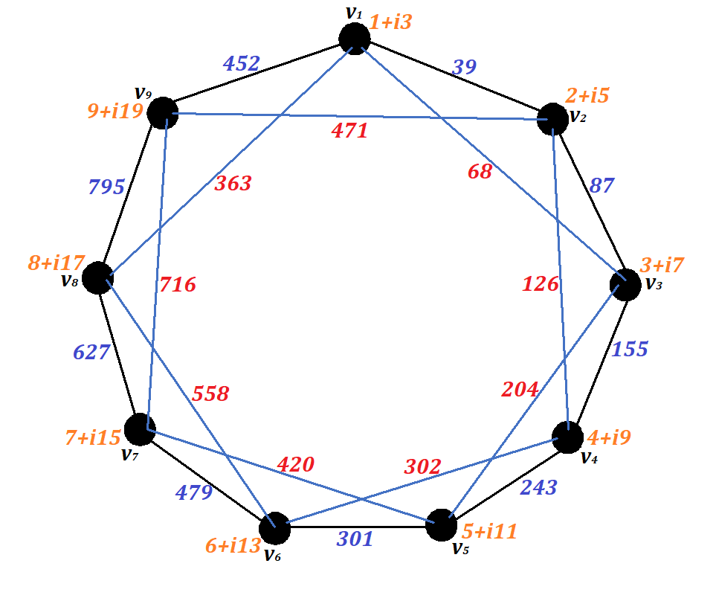

**Figure 2.1: Gaussian anti-magic labeling for graph (4- ${RG)}_{9,3}$**

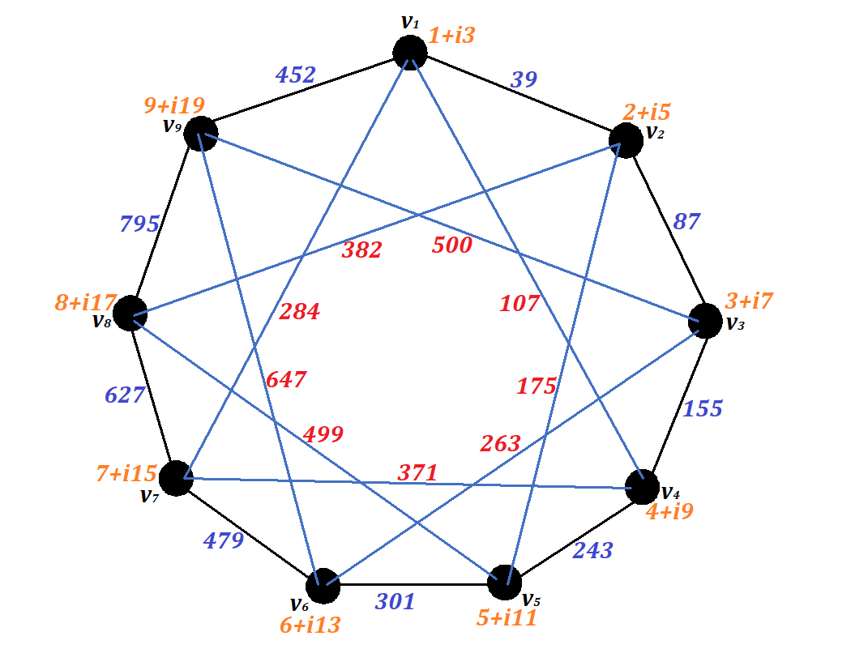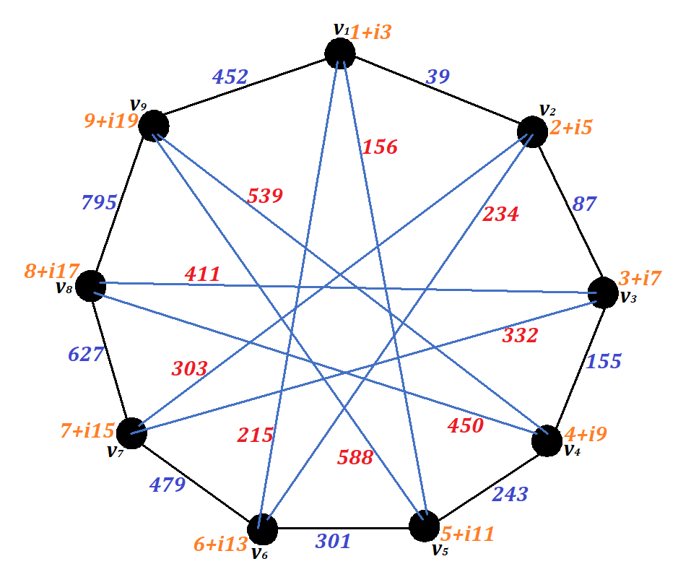

**Figure 2.2: Gaussian anti-magic Figure 2.3: Gaussian anti-magic**

**labeling for graph (4- ${RG)}_{9,4}$. labeling for graph (4- ${RG)}_{9,5}$.**

**THEOREM 2.2:**

The Cayley digraph associated with 2- generated 2- group admits Gaussian anti-magic labeling.

**Proof:**

From the structure of 2-generated 2-group $G=\left\{1,-1,p,-p,q,-q,r,-r\right\}$ with the generating set $S=\left\{p,q\right\}$ such that $p^{2}=q^{2}=r^{2}=-1, pq=r,qr=p, rp=q, rp=-q, rq=-p, pr=-q$.

Let vertex set $V\left(G\right)=\left\{v_{1},v_{2},v_{3},v_{4},v_{5},v_{6},v_{7},v_{8}\right\}$ be represented as $\left\{1,-1,p,-p,q,-q,r,-r\right\}$ respectively. Clearly, Cayley digraph associated with 2-generated 2-group $G$ has 8 vertices and 16 edges.

Define a vertex set $f:V(G)→\{a+ib∕ a,b∈N, 1≤a,b≤16\}$ by

$$f\left(v_{k}\right)=k+i \left(k+1\right), 1≤k≤8.$$

Vertex labelings are show in the table given below:

|  |  |  |  |  |  |  |  |  |
| --- | --- | --- | --- | --- | --- | --- | --- | --- |
| **Vertex V** | $$v_{1}$$ | $$v_{2}$$ | $$v_{3}$$ | $$v_{4}$$ | $$v_{5}$$ | $$v_{6}$$ | $$v_{7}$$ | $$v_{8}$$ |
| $$1+i2$$ | $$2+i3$$ | $$3+i4$$ | $$4+i5$$ | $$5+i6$$ | $$6+i7$$ | $$7+i8$$ | $$8+i9$$ |

Define an induced function $f^{'}:E(G)→N$ by

$f^{'}\left(e=v_{k}v_{j}\right)={\left|f(v_{k})\right|}^{2}+{\left|f(v_{j})\right|}^{2}$ for all $v_{k},v_{j}∈V, e∈E.$

Edge labelings obtained are shown in the table given below:

|  |  |  |  |  |
| --- | --- | --- | --- | --- |
| **Edge E** | $$v_{1}v_{3}$$ | $$v_{1}v_{4}$$ | $$v_{1}v_{5}$$ | $$v_{1}v_{6}$$ |
| 30 | 46 | 66 | 90 |
| $$v_{2}v_{3}$$ | $$v_{2}v_{4}$$ | $$v_{2}v_{5}$$ | $$v_{2}v_{6}$$ |
| 38 | 54 | 74 | 98 |
| $$v_{3}v_{7}$$ | $$v_{3}v_{8}$$ | $$v_{4}v_{7}$$ | $$v_{4}v_{8}$$ |
| 138 | 170 | 154 | 186 |
| $$v_{5}v_{7}$$ | $$v_{5}v_{8}$$ | $$v_{6}v_{7}$$ | $$v_{6}v_{8}$$ |
| 174 | 206 | 198 | 230 |

Thus, all the edge labels are distinct.

Therefore, Cayley digraph associated with 2- generated 2- group admits Gaussian anti-magic labeling.

**EXAMPLE 2.2:**

Gaussian anti-magic labeling for Cayley digraph associated with 2-generated 2-group is given in Figure 2.4.

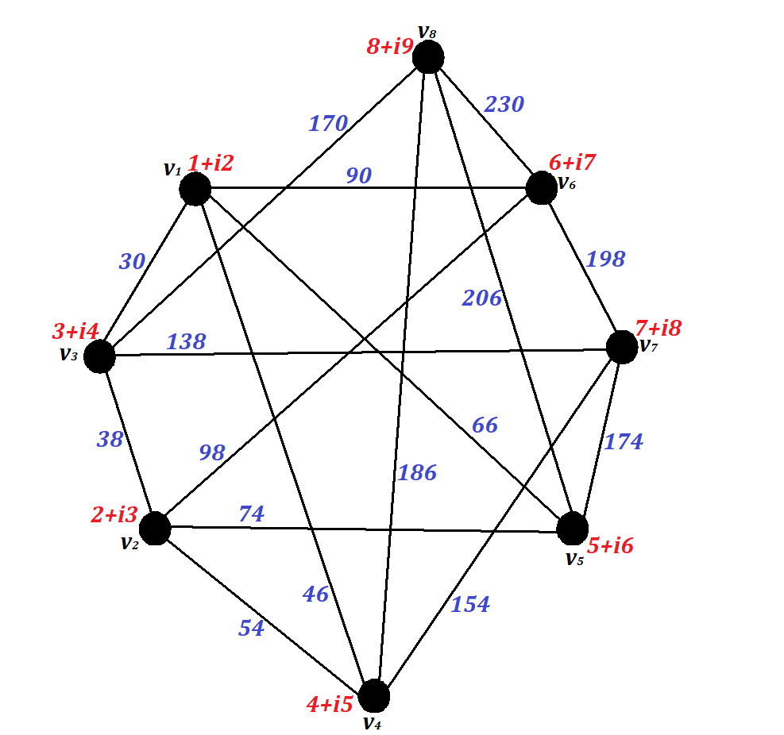

**Figure 2.4: Gaussian anti-magic labeling for**

**Cayley digraph associated with 2-generated 2-group.**

**THEOREM 2.3:**

The Cayley digraph associated with 2- generated 2- group admits Fibonacci cordial labeling.

**Proof:**

We know that, Cayley digraph associated with 2-generated 2-group $G$ has 8 vertices and 16 edges.

Define a vertex set $f:V(G)→\left\{F_{0},F_{1},F_{2},F_{4},F_{5},F_{6},F_{7},F_{8}\right\}$ by

$$f\left(t_{i}\right)=F_{i-1}, 1≤i≤2$$

$f\left(t_{i}\right)=F_{i}, 3≤i≤8$.

Define an induced function $f^{*}:W\left(G\right)→\left\{0,1\right\}$ by

$$f^{'}\left(t_{i}t_{j}\right)=\left(f\left(t_{i}\right)+f\left(t_{j}\right)\right) \left(mod 2\right)$$

Thus, $E_{f^{'}}\left(0\right)=8;E_{f^{'}}\left(1\right)=8, \left|E_{f^{'}}\left(0\right)-E_{f^{'}}(1)\right|=\left|8-8\right|=0$.

Clearly, the condition $\left|E_{f^{'}}\left(0\right)-E_{f^{'}}(1)\right|≤1$ is satisfied.

Therefore, Cayley digraph associated with 2- generated 2- group admits Fibonacci cordial labeling.

**EXAMPLE 2.3:**

Fibonacci cordial labeling for Cayley digraph associated with 2-generated 2-group is given in Figure 2.5.

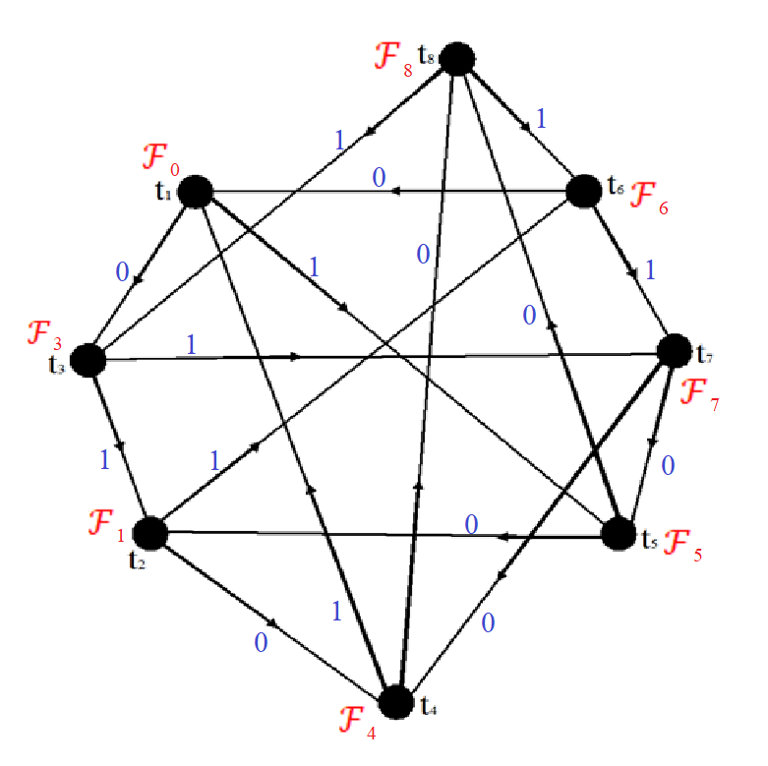

**Figure 2.5: Fibonacci cordial labeling for**

**Cayley digraph associated with 2-generated 2-group.**

**Conclusion:**

In this paper we have proved the existence of Gaussian anti-magic labeling for 4- regular $(n,2n)$ graph of girth $j≥3$ where $n≥5$ and Cayley digraph associated with 2- generator 2- group graph. Also, we investigated the existence of Fibonacci cordial labeling for the Cayley digraph associated with 2- generator 2- group graph.

**References:**

1. Annexstein.F, Baumslag.M, Rosenberg.A.L, *Group action graphs and Parallel architectures*. SIAM J. Comput.19, (1990), 544-569.
2. Bala.E, Thirusangu.K, *On Bi-magic labeling of 4-regular graphs*, Indian Journal of Science and Technology, Vol 4, No.4 (2011), 414-416. 10
3. J.A.Gallian, A dynamic survey of graph labeling, *The Electronic Journal of Combinatorics,* 24th edition (2021), DS6
4. Heydemann.M, *Cayley graphs and interconnection networks* in Hahn.G and Sabidussi.G (Eds), *Graph symmetry: Algebraic methods and Applications*, (1997), 167-224.
5. Rosa.A, On certain valuations of the vertices of a graph, Theory of graphs *(International Symposium, Rome)*, July 1996, Gordon and Breach, N.Y. and Dunod Paris (1967),349-355.
6. Rokad A.H., Ghodasara G.V, Fibonacci cordial labeling of some special graphs, Annalus of pure and applied mathematics, Vol.11, N0.1, 2016, 133-144. ISSN: 22279-087X(P), 2279-0888(online).
7. Thirusangu.K, Bala.E, *Magic and antimagic labelings in Cayley digraphs of 2-generated p-groups,* International Journal of Mathematics Research Vol 3. No.3 (2011), 221-229.
8. Thirusangu.K, Selvaganapathy.A, Gaussian anti-magic labeling in some graphs, *International Journal of Mathematics Trends and Technology* (IJMTT), May 2018.