**Some Divisor Cordial Labelings of star related graph**

S.Bala(1), S. Saraswathy(2), K.Thirusangu(3)

1,2,3Department of Mathematics,

S.I.V.E.T. College, Gowrivakkam, Chennai-73.

e-mail: [ssaraswathy4@gmail.com](mailto:ssaraswathy4@gmail.com)

**ABSTRACT**

In this paper, we investigate the existence of some divisor cordial labeling for star graph.

**keywords:** Graph labeling, Star graph, Triplicate graph, Divisor cordial labeling.

1. **INTRODUCTION**

In 1967, the concept of graph labeling was introduced by Rosa[8] . A graph labeling is an assignment of integers to the edges or vertices or both to the certain conditions. In 2011[1], the concept of the extended triplicate graph of a path Pp was introduced by Bala and Thirusangu. In 2023[2], the concept of Extended triplicate graph of star ETG(k1,p ) was introduced by Bala .et.al.,. The concept of Square divisor cordial labeling was introduced by Murugesan[9]. Let G be a simple graph with p vertices and q edges. A bijective function S: δ(G) $→\{1, 2, 3, …..,p\}$ is said to be a square divisor cordial labeling if an induced function $S^{*}:$ $β$ (G) $→\{0,1\}$ defined by $S^{*}:$ $β$ (G) $→\{0,1\}$ by $S^{*}\left(bc\right)= \left\{\begin{aligned}1 ;if \left({(s\left(c\right))}^{2} | s(b)\right) or\left(s(c) | {(s\left(b\right))}^{2}\right) \\ 0 ; otherwise\end{aligned}\right.$, $∀ bc ∈β(G)$ satisfies $\left|β_{S^{*}}\left(0\right)-β_{S^{*}}\left(1\right)\right|$ $≤1$. A graph which admits a square divisor cordial labeling is called as square divisor cordial graph. The concept of Sum divisor cordial labeling was introduced by Lourdusamy.et.al.,[7]. Let G be a simple graph with p vertices and q edges. A bijective function S: δ(G) $→\{1, 2, 3, …..,p\}$ is said to be a sum divisor cordial labeling if an induced function $S^{*}:$ $β$ (G) $→\{0,1\}$ defined by $S^{*}\left(bc\right)= \left\{\begin{aligned}1 ; if\left(2 | (s(b\right)+s(c))) \\ 0 ; otherwise\end{aligned}\right.$, $∀ bc ∈β(G)$ satisfies $\left|β_{S^{*}}\left(0\right)-β_{S^{*}}\left(1\right)\right|$ $≤1$. A graph which admits a Sum divisor cordial labeling is called as sum divisor cordial graph. The concept of Subtract divisor cordial labeling and multiply divisor cordial labeling was introduced by Gondalia.et.al.,[5,6]. Let G be a simple graph with p vertices and q edges. A bijective function S: δ(G) $→\{1, 2, 3, …..,p\}$ is said to be a subtract divisor cordial labeling if an induced function $S^{*}:$ $β$ (G) $→\{0,1\}$ defined by $S^{*}\left(bc\right)= \left\{\begin{aligned}1 ; if\left(2 | (s(b\right)-s(c))) \\ 0 ; otherwise\end{aligned}\right.$, $∀ bc ∈β(G)$ satisfies $\left|β_{S^{*}}\left(0\right)-β_{S^{*}}\left(1\right)\right|$ $≤1$. A graph which admits a Subtract divisor cordial labeling is called as subtract divisor cordial graph. Let G be a simple graph with p vertices and q edges. A bijective function S: δ(G) $→\{1, 2, 3, …..,p\}$ is said to be a multiply divisor cordial labeling. if an induced function $S^{*}:$ $β$ (G) $→\{0,1\}$ defined by $S^{*}\left(bc\right)= \left\{\begin{aligned}1 ; if\left(2 | (s(b\right).s(c))) \\ 0 ; otherwise\end{aligned}\right.$, $∀ bc ∈β(G)$ satisfies the condition $\left|β_{S^{*}}\left(0\right)-β_{S^{*}}\left(1\right)\right|$ $≤1$. A graph which admits a Multiply divisor cordial labeling is called as Multiply divisor cordial graph.

By stimulation of the above studies, In this paper we investigate the existence of Square divisor cordial labeling, Sum divisor cordial labeling, Subtract divisor cordial labeling, and Multiply divisor cordial labeling in the context of Extended Triplicate graph of star.

**2. MAIN RESULT**

In this section, we investigate the existence of Square divisor cordial labeling, Sum divisor cordial labeling, Subtract divisor cordial labeling and Multiply divisor cordial labeling for the Extended Triplicate graph of star.

**2.1 STRUCTURE OF EXTENDED TRIPLICATE OF STAR GRAPH**

Let G be a star graph (K1,p).The triplicate graph of star with vertex set $δ^{'}$ (G) and edge set $β^{'}$ (G) is given by: $δ^{'}$ (G) $=\left\{b∪b^{'}∪b^{''}∪c_{i}∪c_{i}^{'}∪c_{i}^{''}/1 ≤ i≤ p \right\}$ and $β^{'}$ (G) $=\left\{bc_{i}^{'}∪b^{'}c_{i}∪b^{'}c_{i}^{''}∪b^{''}c_{i}^{'}/1≤i≤p\right\}$. Clearly, Triplicate graph of star TG(K1,p) with this vertex set and edge set is disconnected. To make this a connected graph, include a new edge b $c_{1}$ to the edge set $β^{'}$ (G) . Thus, we get an **Extended Triplicate of star graph** with vertex $set = ^{'}$ and edge set $β\left(G\right)=β^{'}(G) ∪ bc_{1}$. Clearly, ETG(K1,p) has $3(p+1)$ vertices and $(4p + 1)$ edges and is denoted by ETG(K1,p).[2].

**Theorem 2.1:** Extended triplicate of star graph is a Sum divisor cordial graph.

**Proof:** Extended Triplicate of star graph ETG(K1,p) has vertex set (G) $=\left\{b∪b^{'}∪b^{''}∪c_{i}∪c_{i}^{'}∪c_{i}^{''}/1 ≤ i≤ p \right\}$ and edge set $β$ G) $=\left\{bc_{i}^{'}∪b^{'}c_{i}∪b^{'}c_{i}^{''}∪b^{''}c_{i}^{'}∪bc_{1}/1≤i≤p\right\}$

Clearly, it has $3(p+1)$ vertices and $(4p+1)$ edges.

To show that ETG(K1,p) is a Sum divisor cordial graph.

Define the bijective function S: δ(G) $→\{1, 2, 3, …..,3(p+1)\}$ to label the vertices as follows.

|  |  |  |  |
| --- | --- | --- | --- |
| $$if,p=3$$ | $$S(b) = 2$$ | $${S(b}^{'})=1$$ | $${S(b}^{''})=3$$ |
| For, $1≤i≤p$ | $${S(c}_{i})=2i+p$$ | $$S(c_{i}^{'})=2(i+1)$$ |
| For, $2≤i≤p$ | ${S(c}_{1}^{'}'$) = $2\left(p+1\right)+3$ | $S(c_{i}^{'}'$) = $2(p+i)$ |
| $$if,p>3$$ | $$S(b ) = 3$$ | $${S(b}^{'})=1$$ | $${S(b}^{''})=2$$ |
| For, $1≤i≤p$ | $${S(c}_{i})=2i+3$$ | $$S(c_{i}^{''})=2\left(i+1\right)$$ |
| To find $S(c_{i}^{'})$ | | |
| $$p≡0 mod2$$ | $S(c_{i}^{'})$ = $\left\{\begin{aligned}2\left(p+i\right)+3 ;1≤i≤\frac{p}{2} \\ p+2\left(i+1\right) ; \frac{p+2}{2} ≤i≤p\end{aligned}\right.$ | |
| $$p≡1 mod2$$ | S( $c_{i}^{'})$ = $\left\{\begin{aligned}2\left(p+i\right)+3 ;1≤i≤\frac{p-1}{2} \\ p+2i+3 ; \frac{p+1}{2} ≤i≤p\end{aligned}\right.$ | |

Define an induced function $S^{*}:$ $β$ (G) $→\{0,1\}$ by $S^{*}\left(bc\right)= \left\{\begin{aligned}1 ; if\left(2 | (s(b\right)+s(c))) \\ 0 ; otherwise\end{aligned}\right.$,

$∀ bc ∈β(G)$ to obtain the edge labels as follows.

|  |  |  |  |
| --- | --- | --- | --- |
| $$if,$$ $$p=3$$ | For, 2 $≤$ $i ≤p$ | $$S^{*}({ b}^{'}c_{i}^{''})=0$$ | $$S^{*}({bc}_{1})=0$$ |
| For, 1 $≤i≤p$ | $$S^{*}(b^{''}c_{i}^{'})=0$$ | $$S^{*}(b^{'}c_{i})=S^{*}(bc_{i}^{'})=1$$ |
| $$if,$$ $$p >3$$ | $${S^{*}(bc}_{1})=1$$ | | |
| For, 1 $≤i≤p$ | $$S^{*}(b^{'}c_{i})=1$$ | $$S^{*}({ b}^{'}c_{i}^{''})=0$$ |
| To find $S^{*}($ $bc_{i }^{'})and S^{*}($ $b^{''}c_{i}^{'})$ | | |
| $$p≡0 mod2$$ | $S^{*}\left(bc_{i }^{'}\right)$ = $\left\{\begin{aligned}1 ; 1≤i≤\frac{p}{2} \\ 0 ;\frac{p+2}{2} ≤i≤p\end{aligned}\right.$ | $S^{*}($ $b^{''}c_{i }^{'})$ = $\left\{\begin{aligned}0 ; 1≤i≤\frac{p}{2} \\ 1 ; \frac{p+2}{2} ≤i≤p\end{aligned}\right.$ |
| $$p≡1 mod2$$ | $S^{*}\left(bc_{i }^{'}\right)$ = $\left\{\begin{aligned}1 ; 1≤i≤\frac{p-1}{2} \\ 0 ;\frac{p+1}{2} ≤i≤p\end{aligned}\right.$ | $S^{*}(b^{''}c_{i }^{'})$ = $\left\{\begin{aligned}0 ; 1≤i≤\frac{p-1}{2} \\ 1 ;\frac{ p+1}{2} ≤i≤p\end{aligned}\right.$ |

Thus, we get

|  |  |  |  |
| --- | --- | --- | --- |
| For, |  |  | = |
| For, $$p >3$$ | $$β_{S^{*}}\left(0\right)=2p$$ | $β_{S^{*}}\left(1\right)=2p$ +1 | = |

From both the cases, it is clear that $\left|β_{S^{*}}\left(0\right)-β_{S^{*}}\left(1\right)\right|≤1$ is satisfied.

Hence, the Extended triplicate of star graph is a sum divisor cordial graph.

**EXAMPLE 2.1:** ETG(K1,3) ,ETG(K1,5) and its Sum divisor cordial labelling is shown in

figure 1 and figure 2.

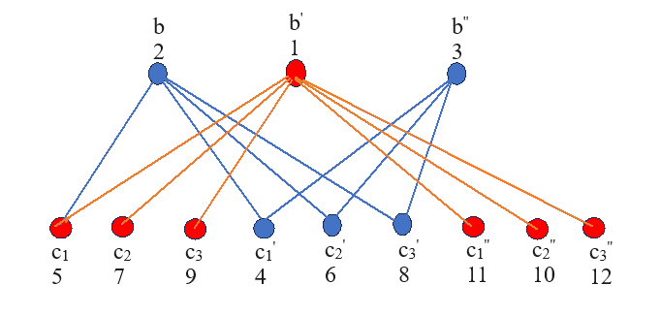

**FIGURE – 1**

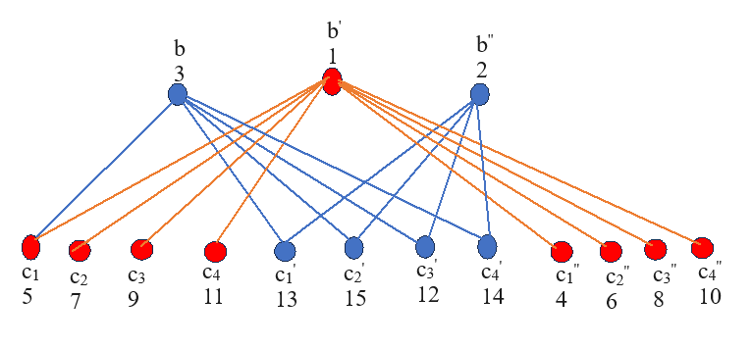

**FIGURE – 2**

**Theorem 2.2:** Extended triplicate of star graph is a Subtract divisor cordial graph.

**Proof:**  Extended Triplicate of star graph ETG(K1,p) has $3(p+1)$ vertices and $(4p+1)$ edges.

To show that ETG(K1,p) is a Subtract divisor cordial graph.

Define the bijective function $S:δ(G)$ $→\{1, 2, 3, …..,3(p+1)\}$ to label the vertices as follows.

|  |  |  |  |
| --- | --- | --- | --- |
| $$if,p=3$$ | $$S(b)=3p$$ | $$S(b^{'})=3p+2$$ | S( $b^{''})=3(p+1)$ |
| For, $1≤i≤p$ | $$S(c_{i})=2i$$ | $$S(c_{i}^{''})=p+2(i-1)$$ |
| S( $c_{i}^{'})=\left\{\begin{aligned}2\left(p+i\right) ; 1≤i≤\frac{p+1}{2} \\ 1 ; i=\frac{p+3}{2}\end{aligned}\right.$ | | |
| $$if,$$ $$p≡1 mod 2$$ ( $p≠3)$ | $$S(b)=3p$$ | $$S(b^{'})=3p+2$$ | S( $b^{''})=3(p+1)$ |
| For, $1≤i≤p$ | $$S(c_{i})=2i$$ | $$S(c_{i}^{''})=p+2(i-1)$$ |
| $S$ ( $c_{i}^{'})=\left\{\begin{aligned}2\left(p+i\right) ; 1≤i≤\frac{p+1}{2} \\ 1 ; i=\frac{p+3}{2} \\ {s(c}_{\frac{p+3}{2}}^{'})+2j ; \frac{p+2j+3}{2}≤i≤p ;jϵ N\end{aligned}\right.$ | | |
| $$if,$$ $$p≡0 mod 2$$ | $$S(b)=3p+1$$ | $S$ ( $b^{'})=3(p+1)$ | $S$ ( $b^{''})=3p+2$ |
| For, $1≤i≤p$ | $S$ ( $c_{i})=2i$ | $$S(c_{i}^{''})=p+2i-1$$ |
| $S$ ( $c_{i}^{'})=\left\{\begin{aligned}2\left(p+i\right) ; 1≤i≤\frac{p}{2} \\ 1 ; i=\frac{p+2}{2} \\ {s(c}_{\frac{p+2}{2}}^{'})+2j ; \frac{p+2(j+1)}{2}≤i≤p ;jϵ N\end{aligned}\right.$ | | |

Define an induced function as $S^{*}:$ $β$ (G) $→\left\{0,1\right\}$ by $S^{*}\left(bc\right)= \left\{\begin{aligned}1; if \left(2 | (s(b\right)-s(c))) \\ 0 ; otherwise\end{aligned},\right.∀ bc ∈β(G)$ to obtain the edge labels as follows.

|  |  |  |  |
| --- | --- | --- | --- |
| $$S^{*}({bc}_{1})=0$$ | | | |
| For, 1 $≤$ $i≤p$ | $$S^{*}(b^{'}c_{i})=0$$ | $$S^{*}{( b}^{'}c_{i}^{''})=1$$ | |
| To find $S^{*}($ $bc_{i }^{'})and$ $S^{*}(b^{''}c_{i}^{'})$ | | | |
| $$if,$$ $$p≡0 mod 2$$ | $S^{*}$ ($bc_{i }^{'})$ = $\left\{\begin{aligned}0 ; 1≤i≤\frac{p}{2} \\ 1 ; \frac{p+2}{2} ≤i≤p\end{aligned}\right.$ | | $S^{*}$ ( $b^{''}c_{i }^{'})$ = $\left\{\begin{aligned}1; 1≤i≤\frac{p}{2} \\ 0 ;\frac{p+2}{2} ≤i≤p\end{aligned}\right.$ |
| $$if,$$ $$p≡1 mod 2$$ | $S^{*}bc_{i }^{'})$ = $\left\{\begin{aligned}0 ;1≤i≤\frac{p+1}{2} \\ 1 ;\frac{p+3}{2} ≤i≤p\end{aligned}\right.$ | | $S^{*}(b^{''}c_{i }^{'})$ = $\left\{\begin{aligned}1 ; 1≤i≤\frac{p+1}{2} \\ 0 ;\frac{p+3}{2} ≤i≤p\end{aligned}\right.$ |

From the above labeling, we get $β_{S^{*}}\left(0\right)=2p+1$ and $β_{S^{*}}\left(1\right)=2p$

Thus $\left|β_{S^{*}}\left(0\right)-β_{S^{*}}\left(1\right)\right|$ = $\left|(2p+1)-2p\right|≤1$. It is clear that $\left|β_{S^{*}}\left(0\right)-β_{S^{*}}\left(1\right)\right|≤1$ is satisfied.

Hence, Extended Triplicate of star graph is a Subtract divisor cordial graph.

**EXAMPLE 2.2:**  ETG(K1,3), ETG(K1,4) and ETG(K1,5) and its Subtract divisor cordial labelling is shown in figure 3, figure 4 and figure 5.

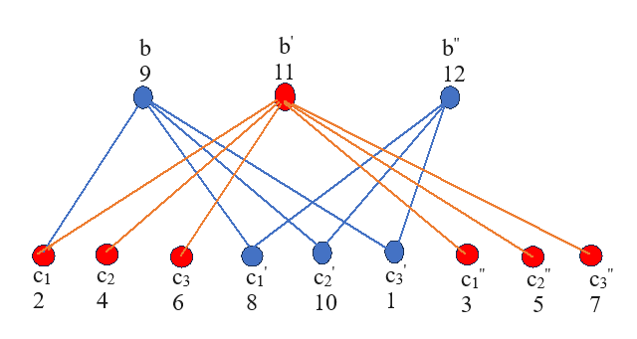

**FIGURE – 3**

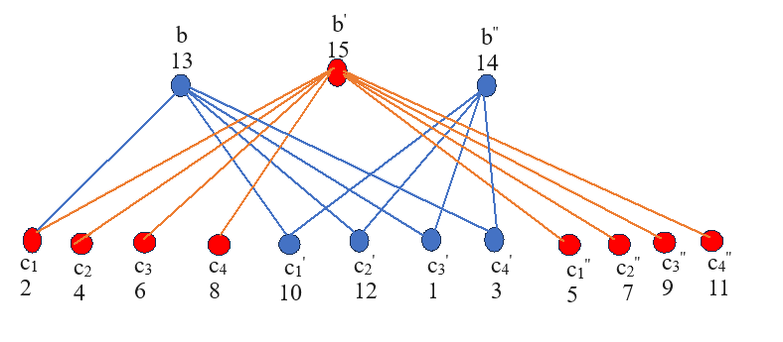

**FIGURE – 4**

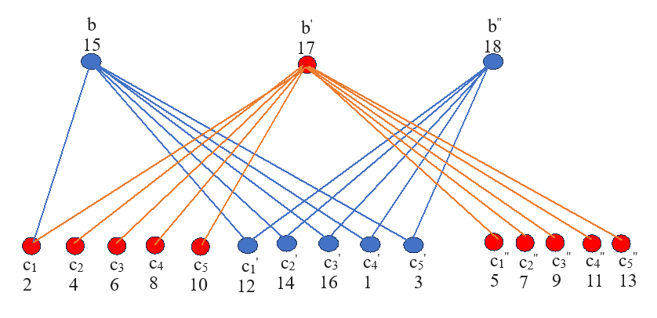

**FIGURE – 5**

**Theorem 2.3:** Extended triplicate of star graph is a Multiply divisor cordial graph.

**Proof:** Extended Triplicate of star graph ETG(K1,p) has $3(p+1)$ vertices and $(4p+1)$ edges.

To show that ETG(K1,p) is a Multiply divisor cordial graph.

Define the bijective function S: δ(G) $→\{1, 2, 3, …..,3(p+1)\}$ to label the vertices as follows.

|  |  |  |
| --- | --- | --- |
| $S(b)$ = 1 | $${S(b}^{'})=2$$ | $$S(b^{''})=3$$ |
| For, $1≤i≤p$ | $${S(c}_{i})=2\left(i+1\right)$$ | $$S(c_{i}^{'})=2i+3$$ |
| To find $S(c_{i}^{''})$ | | |
| $$if,p≡1 mod 2$$ | $${S(c}_{i}^{''})=\left\{\begin{aligned}2\left(p+i+1\right) ;1≤i≤\frac{p+1}{2} \\ p+2\left(i+1\right) ; \frac{p+3}{2}≤i≤p\end{aligned}\right.$$ | |
| $$if,p≡0 mod 2$$ | $${S(c}_{i}^{''})=\left\{\begin{aligned}2\left(p+i+1\right) ; 1≤i≤\frac{p}{2} \\ p+2i+3 ; \frac{p+2}{2}≤i≤p\end{aligned}\right.$$ | |

Define an induced function $S^{*}:$ $β$ (G) $→\{0,1\}$ by $S^{*}\left(bc\right)= \left\{\begin{aligned}1 ; if\left(2 | (s(b\right).s(c))) \\ 0 ; otherwise\end{aligned}\right.$, $∀ bc ∈β(G)$ to obtain the edge labels as follows.

|  |  |  |  |
| --- | --- | --- | --- |
| For, 1 $≤$ $i≤p$ | $$S^{*}({bc}_{1})=1$$ | $$S^{*}(b^{'}c_{i})=1$$ | $$S^{*}({ b}^{'}c_{i}^{''})=1$$ |
| $S^{*}($ $bc_{i }^{'})=0$ | $$S^{*}(b^{''}c_{i}^{'})=0$$ |

We get $β_{S^{*}}\left(0\right)=2p$ and $β_{S^{*}}\left(1\right)=2p+1$

Thus, $\left|β_{S^{*}}\left(0\right)-β_{S^{*}}\left(1\right)\right|$ = $\left|2p-(2p+1)\right|≤1$

Here, it is clear that $\left|β_{S^{*}}\left(0\right)-β_{S^{*}}\left(1\right)\right|≤1$ is satisfied.

Hence, the Extended Triplicate of star graph is a Multiply divisor cordial graph.

**EXAMPLE 2.3:**  ETG(K1,4), ETG(K1,5) and its Multiply divisor cordial labelling is shown in figure 6 and figure 7.

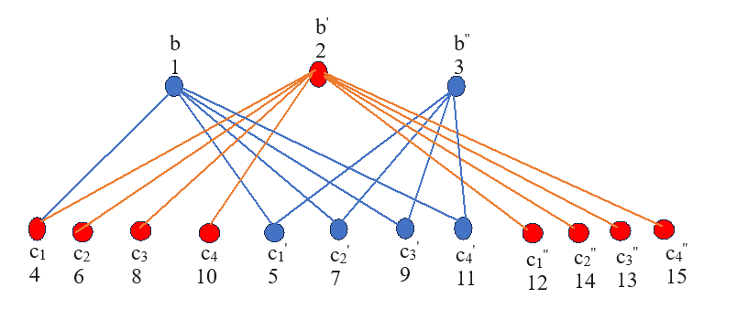

**FIGURE – 7**

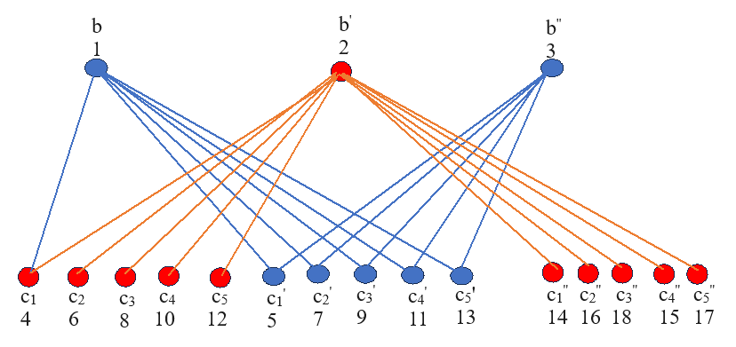

**FIGURE – 8**

**Theorem 2.4:** Extended triplicate of star graph is a square divisor cordial graph.

**Proof:** Extended Triplicate of star graph ETG(K1,p) has $3(p+1)$ vertices and $(4p+1)$ edges.

To show that ETG(K1,p) is a Square divisor cordial graph.

Define the bijective function $S:δ(G)→\left\{1, 2, 3, …..,3(p+1)\right\}$ to label the vertices as follows.

|  |  |  |  |
| --- | --- | --- | --- |
| $$if,$$ $$p=3$$ | $$S(b) = 2$$ | $S$ ( $b^{'})=3$ | $$S(b^{''})=1$$ |
| For, $1≤i≤p$ | $S$ ( $c_{i})=2(i+1)$ | $$S(c_{i}^{'})=2i+3$$ |
| For, $1≤i≤p-1$ | $S(c_{i}^{'}'$) = $2\left(p+i+1\right)$ | $S(c_{p}^{''}$) = $4p-1$ |
| $$if,$$ $$p>3$$ | $$S(b ) = 2$$ | $${S(b}^{'})=1$$ | $$Sb^{''})=3$$ |
| For, $2≤i≤p$ | $$S(c_{i})=2\left(i+1\right)$$ | $$S(c_{1})=5$$ |
| $$S(c_{1}^{'})=7$$ | $$S(c_{i}^{'})=\left\{\begin{aligned}2i+7 ; 2≤i≤6 \\ 2\left(i+j\right)+7 ;2j+5≤i≤2j+6 ;j ϵ N\end{aligned}\right.$$ | |
| To find $S(c_{i}^{'}'$) | | |
| $$for,p≡0 mod 2$$ | $S$ ($c_{i}^{'}'$)= $\left\{\begin{aligned}2\left(p+i+1\right) ; 1≤i≤\frac{p}{2} \\ 21 ; i=\frac{p+2}{2}, for p>4 \\ c_{\frac{p+2(j-1)}{2}}^{''}+6 ; \frac{p+2j}{2}≤i≤p-2 ;jϵ N-\left\{1\right\}, for p>6\end{aligned}\right.$ | |
| $S$ ($c_{p-1}^{''}$) = $9$ | $$S(c_{p}^{''})={S(c}_{p-1}^{''})-5$$ |
| $$for,p≡1 mod 2$$ | $S(c_{i}^{'}')$ = $\left\{\begin{aligned}2\left(p+i+1\right) ; 1≤i≤\frac{(p+1)}{2} \\ 21 ; i=\frac{p+3}{2}, for p>5 \\ c_{\frac{p+2j-1}{2}+6}^{''} ; \frac{p+1+2j}{2}≤i≤p-2 ;jϵ N-\left\{1\right\},for p>7\end{aligned}\right.$ | |
| $S(c_{p-1}^{''})$ = $9$ | $$S\left(c_{p}^{''}\right)=S\left(c_{p-1}^{''}\right)-5$$ |

Define an induced function as $S^{*}:$ $β$ (G) $→\{0,1\}$ by $S^{*}\left(bc\right)= \left\{\begin{aligned}1 ;if \left({(s\left(c\right))}^{2} | s(b)\right) or\left(s(c) | {(s\left(b\right))}^{2}\right) \\ 0 ; otherwise\end{aligned}\right.$, $∀ bc ∈β(G)$ to get the edge labels.

We get

|  |  |  |  |
| --- | --- | --- | --- |
|  |  |  | = |
|  |  | +1 | = |

From both the cases, it is clear that $\left|β_{S^{*}}\left(0\right)-β_{S^{*}}\left(1\right)\right|≤1$ is satisfied.

Hence, Extended triplicate of star graph is a square divisor cordial graph.

**EXAMPLE 2.4:** ETG(K1,3), ETG(K1,4) and its square divisor cordial labelling is shown in figure 9 and figure 10.

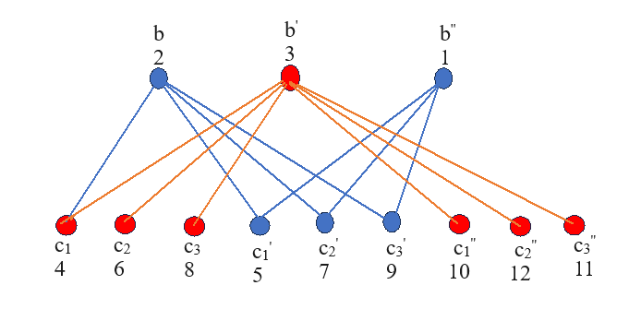

**FIGURE – 9**

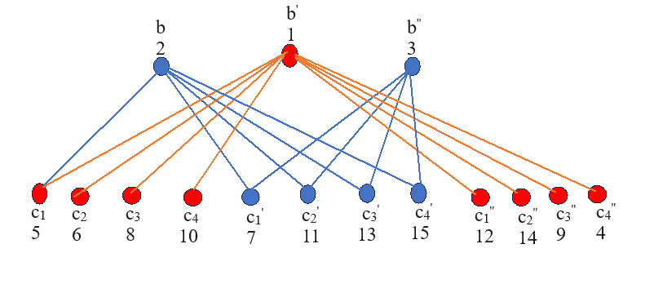

**FIGURE – 10**

**CONCLUSION**

In this paper, we have proved that extended triplicate of star graph admits the Square divisor cordial labeling, Sum divisor cordial labeling, Subtract divisor cordial labeling, and Multiply divisor cordial labeling.

**REFERENCE**

1. Bala. E, Thirusangu. K, Some graph labelings in Extended triplicate graph of a path pn , International review in Applied Engineering research,vol.1.No.1(2011),pp.81-92.
2. Bala .S, Saraswathy. S, Thirusangu .K, Some labelings on extended triplicate graph of star, Proceedings of the international conference on recent innovations in application of mathematics 2023, pp 302-305.
3. Cahit.I, Cordial graphs: A weaker version of graceful and harmonious graph, ARS combinatorial, 1987, volume 78, pp 179-199.
4. Gallian.J.A, A Dynamic survey of Graph labeling, The Electronics Journal of Cobinatories,vol.19,(2012),No,DS61- 260.
5. Gondalia.J.T and Rokad.A.H, Subtract Divisor cordial labeling, International Journal of innovative technology and exploring Engineering, Volume 8,Issue 684,Apl 2019,Page 541-545.
6. Gondalia.J.T and Rokad.A.H, Multiply Divisor cordial labeling, International Journal of Engineering and Advanced technology, Vol9,Issue 2,2019,pp.1901-1904.
7. Lourdusamy.A and Patrick.F, Sum divisor cordial graphs, Proyecciones Journal of math,Vol.35,Issue 1, March2 2016.
8. Rosa . A, On certain valuation of the vertices of graph.Theory of graphs(international symposium, Rome),July 1996,Gordan and Breach,N.Y. and Dunod paris(1967),pp.349-355.
9. Shankar. R and Uma.R Square Divisor cordial labeling for some graph ,International Journal of engineering science research technology, Oct.2016,pp.726-730.