**Project Title : A Study on Consumer Behavior in the Magazine Industry with Special Reference to the Outlook Group**

**ABSTRACT**  
The magazine industry faces transformative changes due to the digital revolution, evolving consumer preferences, and competitive dynamics. This study focuses on understanding the factors driving consumer behavior in the magazine industry, with a specific emphasis on the Outlook Group, a prominent publisher in India. Through a combination of surveys, interviews, and secondary data analysis, this research explores readership demographics, content preferences, and the impact of digital media on traditional print formats. The findings indicate a shift towards digital consumption while revealing a niche audience that values print media’s tactile experience. Recommendations include adopting innovative digital strategies, enhancing content quality, and leveraging personalized marketing to remain competitive.

**Keywords:** Consumer behavior, Magazine industry, Digital transformation, Print media, Outlook Group, Content personalization.

**INTRODUCTION**  
The magazine industry has been undergoing significant changes due to technological advancements, shifting consumer preferences, and the rise of digital platforms. Understanding consumer behavior within this dynamic landscape is critical for publishers aiming to retain relevance and achieve market leadership. The Outlook Group, established in 1995, is a key player in India’s magazine sector, offering diverse publications such as Outlook English, Outlook Traveller, and Outlook Money. This study aims to examine the drivers of consumer behavior in this industry, focusing on readership demographics, preferences, and the ongoing transition from print to digital formats.

**Objectives of the Study:**

1. Identify key factors influencing magazine readership and subscription choices
2. Analyze the impact of digital transformation on consumer behavior in the magazine industry
3. Evaluate the effectiveness of the Outlook Group's strategies in engaging readers across print and digital platforms
4. Assess the role of data analytics in understanding and predicting consumer behavior in the magazine industry
5. Explore opportunities for growth and innovation within the magazine market
6. Develop recommendations for magazine publishers to adapt to changingconsumer preferences and market dynamics

**RESEARCH METHODOLOGY**  
This research adopts a mixed-method approach, combining quantitative surveys with qualitative interviews to provide a holistic understanding of consumer behavior. The methodology is outlined as follows:

**Research Design:** A descriptive research design was chosen to systematically study consumer preferences and market trends.

**Data Collection Methods:**

1. **Primary Data:**
   * Online surveys were conducted with 300 respondents, focusing on demographics, content preferences, and format preferences (print vs. digital).
   * In-depth interviews with 20 regular readers of Outlook publications provided qualitative insights.
2. **Secondary Data:**
   * Analysis of industry reports and academic literature on consumer behavior in the publishing sector.

**Sampling:** A stratified sampling method ensured representation across age groups, genders, and geographic locations, with a focus on urban and semi-urban readers.

**Data Analysis Techniques:** Quantitative data were analyzed using descriptive statistics, while qualitative data were examined through thematic analysis.

**FINDINGS AND DISCUSSION**

**1. Demographic Insights:**

* The primary readership comprises educated professionals aged 25-45, with an equal gender distribution.
* Urban readers showed a higher inclination towards digital magazines, while semi-urban readers displayed a preference for print formats.

**2. Content Preferences:**

* Readers prioritized content on current affairs (42%), lifestyle (30%), and entertainment (20%).
* Specialized topics such as technology and health are gaining traction, particularly among younger audiences.

**3. Print vs. Digital Consumption:**

* While 65% of respondents preferred digital formats for convenience, 35% expressed loyalty to print magazines due to their tactile and distraction-free experience.
* Digital magazines were favored for features such as multimedia content and real-time updates.

**4. Brand Loyalty and Purchasing Patterns:**

* Outlook Group enjoys strong brand loyalty, attributed to its reputation for quality content and credibility.
* Monthly subscriptions were the most popular purchasing model, with 60% of subscribers opting for this format.

**5. Impact of Social Media:**

* 58% of respondents indicated that the magazine’s social media presence influenced their purchasing decisions.
* Interactive posts, polls, and exclusive online content were effective in engaging readers.

**KEY FINDINGS ON CONSUMER PREFERENCES**

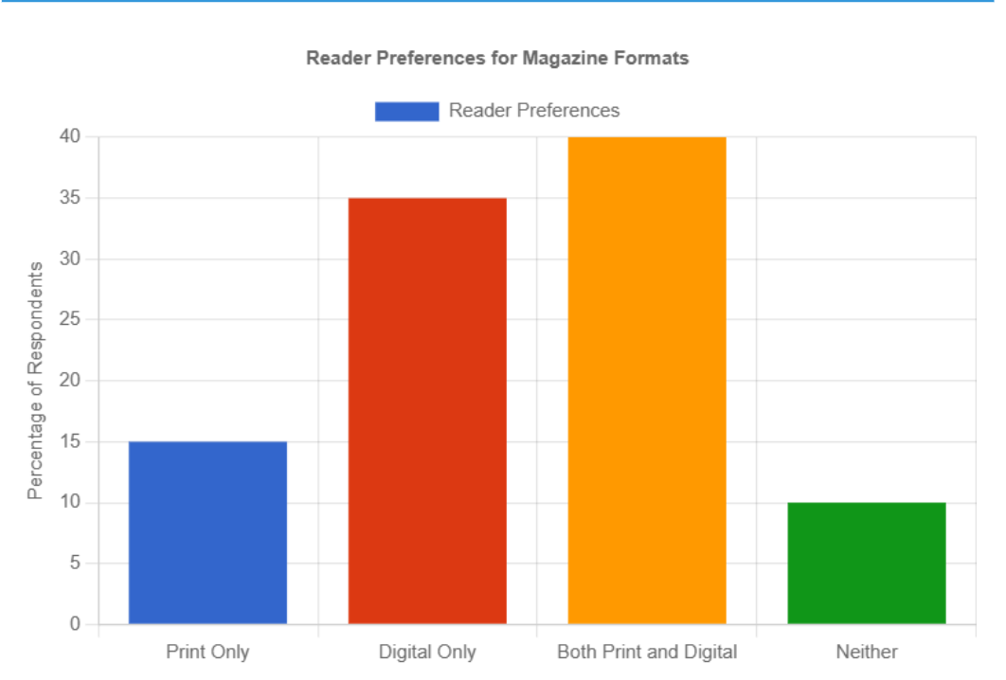

* 40% of readers prefer a combination of print and digital formats
* Content quality and relevance are the primary drivers of subscription decisions
* Younger demographics show a stronger preference for digital-only content
* Print magazines are still valued for their tactile experience and perceived credibility

**CONCLUSION**  
Consumer behavior in the magazine industry reflects a complex interplay of preferences for content quality, format, and accessibility. The findings underscore the need for publishers like the Outlook Group to adapt to digital trends while maintaining the unique appeal of print media. Emphasizing high-quality, niche content and leveraging digital platforms for personalized marketing can ensure sustained relevance and growth in a competitive landscape.

**RECOMMENDATIONS**

1. **Enhance Digital Presence:**
   * Develop mobile-friendly apps and interactive features such as multimedia content and personalized recommendations.
   * Invest in social media marketing to attract younger audiences.
2. **Innovate Content Delivery:**
   * Introduce podcasts, video articles, and other digital formats to complement traditional content.
   * Provide hybrid subscription models offering both print and digital access.
3. **Focus on Niche Topics:**
   * Expand coverage on emerging topics such as sustainability, wellness, and technology to capture niche audiences.
4. **Strengthen Brand Loyalty:**
   * Use data analytics to understand reader preferences and deliver personalized content.
   * Implement loyalty programs offering exclusive content and early access to premium articles.

**REFERENCES**

* **Chahal & Bala (2020)**: Discusses the significant components of brand loyalty in digital media, relevant for understanding how magazines can maintain loyal readership.
* **Han, Kim, & Lee (2019)**: Examines factors influencing the adoption of digital magazines, highlighting the shift from print to digital.
* **Hennig-Thurau (2020)**: Explores content strategies for digital magazine publishers, emphasizing consumer preferences for specialized content.
* **Keller (2019)**: Focuses on building strong brands, relevant for understanding how the Outlook Group can retain its readers.
* **Li & Guo (2021)**: Investigates the impact of interactive and multimedia content on reader engagement, critical for digital magazine strategies.
* **McQuail (2017)**: Provides foundational theories in mass communication, useful for contextualizing consumer behavior in the magazine industry.
* **Park (2020)**: Reviews the role of social media in the magazine industry, highlighting its importance as a distribution channel.
* **Steinbock (2018)**: Discusses the challenges and opportunities of digital transformation in the magazine industry, providing a broad overview of industry trends.
* **Kotler, P., & Keller, K. L. (2016). *Marketing Management* (15th ed.). Pearson Education.**

Provides foundational knowledge on consumer behavior, marketing strategies, and the shifting dynamics in media consumption.

* **Solomon, M. R. (2018). *Consumer Behavior: Buying, Having, and Being* (12th ed.). Pearson.**

Offers insights into consumer behavior, particularly in the context of digital media and changing consumption patterns.

* **Belch, G. E., & Belch, M. A. (2021). *Advertising and Promotion: An Integrated Marketing Communications Perspective* (12th ed.). McGraw-Hill Education.**

Explores the role of advertising and promotion in influencing consumer behavior in the magazine industry.

* **McDonald, M., & Dunbar, I. (2013). *Market Segmentation: How to Do It, How to Profit from It.* John Wiley & Sons.**

Discusses market segmentation strategies that can be applied to niche magazines and digital platforms

**APPENDIX**  
Sample Survey Questions:

1. What factors influence your decision to subscribe to a magazine?
2. Do you prefer print or digital formats? Why?
3. How important is social media in shaping your perception of a magazine?
4. What type of content do you value the most (e.g., current affairs, lifestyle, entertainment)?
5. What improvements would you suggest for the Outlook Group’s publications?