**ENTERPRISE RISK MANAGEMENT AND SUSTAINABILITY OF MICROFINANCE BANKS IN FCT, ABUJA**

**Prof. Umar Danladi Mohammed, Ph.D1 & Braimah, Eromosele Mohammed2**

1, 2Departement of Business Administration

University of Abuja, Abuja, Nigeria

**ABSTRACT**

Several risks make it increasingly difficult for microfinance banks (MFBs) in the Federal Capital Territory (FCT), Abuja, to achieve sustainability. This study investigates the influence of ERM to promote the sustainability of MFBs with an examination of the impacts of operational, regulatory, legal, and reputational risks in the sector, noting what is currently not known regarding the drivers through which ERM is believed to create long-term viability within MFBs. The goal is to see how these ERM benefits the stumbling blocks to sustainability are evaluated. It used a descriptive survey method and conducted structured interviews with 200 respondents, including senior management and risk officers from MFBs. The study used multiple regression analysis to examine the relationship between profitability and risk. The findings show that while operational risk has both positive and negative impacts on profitability, sustainability is positively affected by effective risk management and regulatory frameworks. Positive effects on profitability also stem from reputational risk management. These findings underscore the need for robust internal controls, adherence to regulatory obligations, and commitment to reputational risk. This study opens up avenues for future studies on the impact of ERM practices in microfinance institutions and practical insights for MFB sustainability.

**Keywords:** Reputational risk; regulatory and legal frameworks; operational risk; enterprise risk management; risk management frameworks

1. **INTRODUCTION**

The global fight against poverty and investment has witnessed a major shift with the emergence of microfinance banks (MFBs) as key players. As specialised financial institutions aimed at providing essential financial services, they uniquely cater to excluded groups, low-income earners, small business owners, and other marginalised communities. Along with offering microcredits, they provide insurance, savings plans and other tailored financial products that help individuals and communities to grow and thrive. By encouraging entrepreneurship, creating jobs, and reducing poverty, MFBs have been recognised globally as key players in achieving the UN Sustainable Development Goals (SDGs), particularly Goal 1 (No Poverty) and Goal 8 (Decent Work and Economic Growth) (World Bank, 2023).

MFBs play a key role in advancing Nigeria’s national economic development goals. These organisations have had a transformative impact in the Federal Capital Territory (FCT), Abuja, by providing access to financial services for those who otherwise would not have access to traditional banking services. Their effects can be felt in the fact that they provide the financial foundation for people and small businesses to increase their standards of living and contribute to the local economy. According to recent statistics, MFBs provide over 10% of financial services to low-income earners, filling the gap between the formal and informal financial sectors in Nigeria (Central Bank of Nigeria [CBN], 2022). Despite their importance, a number of complex issues pose growing risks to MFBs in the FCT. Poor performance, including poor technological infrastructure, employee fraud, and weak internal controls, is largely responsible for financial insecurity. For example, lack of robust cybersecurity makes MFBs vulnerable to data breaches and online fraud, which reduces their profitability. Regulatory and procedural concerns also have a major impact on the industry since a lot of MFBs find it hard to keep pace with the continually shifting regulatory environment. Compliance however hinders their ability to perform optimally as it can lead to serious fines and the suspension of their operating license (Adeoye et al., 2021)

The challenges before MFBs are exacerbated by reputational concerns arising from substandard customer service, governance failures and poor service delivery. Customer loyalty and trust are crucial for maintaining market competitiveness, and negative public perception can significantly reduce them. According to a report by the Nigeria Deposit Insurance Corporation (NDIC), more than half of MFBs in the country have suffered significant financial losses due to inadequate risk management systems, underscoring the need for strategic planning (NDIC, 2022). These gaps will be filled by this study, which looks at how enterprise risk management (ERM) affects the long-term viability and profits of MFBs in the FCT. By providing a comprehensive framework for identifying, assessing, and mitigating risks, ERM helps businesses increase their long-term resilience and financial stability. The study specifically examines the impact of operational, regulatory and legal, and reputational risks as key components of ERM. By looking at profitability as a way to promote sustainability, the study aims to show that ERM approaches are good at lowering these risks and making MFB more resilient. The urgent need to strengthen MFB risk management systems to safeguard their operations and ensure that they continue to promote financial inclusion is the driving force behind this study. In addition to making these institutions more resilient, a good ERM system can enhance competitive advantage, increase stakeholder confidence, and ensure that stakeholders are committed to national investment goals. Furthermore, for MFBs to remain competitive, they must implement a flexible and robust risk management framework in the face of rapidly changing financial markets, which are characterised by regulatory changes and technological advancements.

The researcher is determined to contribute to the growing global debate about the resilience of financial institutions in developing countries. This study advances the current understanding of ERM and risk management by applying real-world data and providing practical insights into the Nigerian microfinance sector. This can provide a foundation for managers and policymakers in developing industry-specific strategies and tailoring effective policies aimed at improving the sustainability and resilience of MFBs. It strengthens the correlation between a strong ERM architecture with MFBs sustainability and profitability on the basis of being able to minimize the operational, regulatory, and reputational risks. Ensuring the survival and growth of MFBs in the FCT not only alleviates these identified areas of risk but contributes not only to national socio-economic growth, but also local development objectives. By bridging the gaps in critical knowledge, this study seeks to provide insights into the development strategies of microfinance institutions in Nigeria and beyond.

**LITERATURE REVIEW**

The literature review here presents at length the concept of enterprise risk management (ERM) and its three elements, functional risk, legal and regulatory risk, and reputational risk. It also considers what ERM translates into in terms of the sustainable performance of microfinance banks (MFBs). This organized discussion highlights apparent shortcomings in prior research in line with the objective of the study

**Enterprise Risk Management (ERM)**

Enterprise Risk Management (ERM) is a strategic approach designed to identify, monitor, and mitigate risks in support of corporate objectives. ERM integrates all types of risks—operational, financial, strategic, and reputational—into a single framework that enables decision-making at all organisational levels, unlike traditional risk management, which operates in silos. ERM is beneficial for improving organisational performance, especially in financial institutions, according to studies such as Hoyt and Liebenberg's (2018). According to their findings, adopting ERM improves stakeholder confidence, decision-making, and resilience. However, most of the current literature focuses disproportionately on large financial institutions while neglecting smaller institutions such as MFBs.

The state of ERM in Nigeria is still poorly understood, especially given the challenges faced by MFBs, such as lack of funding, poor performance, and emphasis on capital investment. This study aims to fill in that gap by looking at ERM in MFBs in Abuja, which is in the Federal Capital Territory (FCT). It will give real-life examples of how well ERM works and how it can be used in small banks.

**Operational Risk Operational risk**

There is a potential for losses to occur due to deficiencies or inefficiencies in systems, procedures, or human resources. This includes risks to MFBs, such as employee fraud, human error, cyber threats, and system inefficiencies. Operational risk is of extreme importance because, according to the Basel Committee on Banking Supervision (2021), they cause significant losses in international financial institutions. Operational Risk is a major weakness for Nigerian MFBs, according to Ikpefan et al. (2022), who attribute this to inadequate technological infrastructure and internal controls. Their study emphasises the commonality of operational risks but does not fully examine how they impact the long-term performance or profitability of MFBs.

By conducting an in-depth study of operational risks as a core component of ERM in Nigerian MFBs, this study expands on the previous findings. It examines both their direct and indirect impacts on profitability and looks at how these issues can be mitigated to promote long-term growth through effective operational risk management.

**Regulatory and Regulatory Risks**

Failure to comply with existing laws, regulations, or industry standards can lead to legal and regulatory issues. Anti-money laundering (AML) laws, Know Your Customer (KYC) regulations, and Central Bank of Nigeria (CBN) guidelines must be adhered to by MFBs operating in Nigeria. Severe consequences, such as fines, reputational damage, and even license revocation, can accompany non-compliance. As Adeoye et al. (2021) note, one of the main obstacles to the expansion of MFBs in Nigeria is regulatory issues. However, their work often highlights these issues without providing workable answers or linking them to a comprehensive risk management framework. The lack of this helpful advice limits their findings, which are relevant to the current situation.

By using ERM to assess regulatory and legal risks, this study fills this knowledge gap. It examines how a structured approach can help MFBs to proactively address compliance, continue to operate, and mitigate adverse impacts on their finances and reputation.

**Reputational Risk**

The potential loss of trust and confidence among stakeholders due to negative public perception is known as reputational risk. Poor governance, poor service delivery, fraud, or lack of compliance can damage the reputation of MFBs. Such incidents can undermine customer loyalty and undermine financial stability. Reputation crises have been a major driver of customer churn among Nigerian MFBs over the past decade, according to NDIC (2022). While Ogunde and Adebayo (2020) emphasise the importance of reputation in financial institutions, they do not delve into the precise ways in which reputation risk impacts MFB viability.

To fill in this knowledge gap, this study looks at how reputation risk management, as part of a broader ERM approach, affects MFB's ability to make money and gain the trust of its stakeholders. In addition, it provides practical advice on how to protect one’s reputation through the rapid implementation of a comprehensive risk management framework.

**Bank Sustainability for Microfinance**

In MFBs, sustainability is a complex concept that encompasses stakeholder trust, operational performance, and financial stability. To achieve sustainability, social goals such as investment and poverty reduction must be aligned with profitability. To achieve this balance, effective risk management—particularly through ERM—is essential for reducing losses and enhancing external resilience.

Ledgerwood (2022) highlighted the importance of sustainability for MFBs, who linked it to the ability of various groups to help vulnerable groups and maintain their financial stability. However, much of the current research and publications focus on financial performance indicators without properly discussing how ERM contributes to these outcomes. While Okafor et al. (2023) emphasise profitability as a critical metric for sustainability, they neglect to examine the ways in which risk management processes support operational and long-term sustainability. By examining the relationship between ERM processes and sustainability outcomes in Nigerian MFBs, this study seeks to fill this gap.

**Theoretical Framework**

This study is underpinned by two theories. Theory of Contingencies and Stakeholder Theory, these theories are importantfor figuring out how enterprise risk management (ERM) and sustainability are connected in microfinance banks (MFBs), especially in Abuja. These perspectives emphasise the value of a context-, adaptive-, and individual-based approach to sustainability and risk management.

**Contingencies Theory**

Theory of Contingencies According to contingency theory, an organization's performance is determined by its ability to align its strategy with internal and external environmental factors (Donaldson, 2001). This theory emphasises the need to tailor ERM approaches to the operational, legal, and economic context of MFB in Abuja. For example, MFBs must navigate complexities surrounding organisational structures, financial constraints, and limited technological resources. To ensure sustainability and stability, effective ERM in this context includes risk management processes that are consistent with external requirements. For example, rural microfinance institutions may prioritise risk reduction related to loan rates and financial inclusion, while urban MFBs may focus on technology and digital banking standards. As expected, ERM implementation must change to achieve organisational goals and remain sustainable in the long term.

**Stakeholder Theory**

According to Freeman's (1984) Stakeholder Theory, it emphasises the importance of identifying and addressing the needs and concerns of a diverse range of stakeholders. Regulators, investors, employees, customers, and the public are considered stakeholders for MFBs. In Abuja, MFBs are an important vehicle for financial inclusion; they provide credit and other financial services to marginalised groups. Sustainable ERM practices can help balance these conflicting interests while building trust, promoting reputation, and improving organisational performance. Practitioners assert that the implementation of ERM systems and requirements can support sustainable development. Reputational and operational risks can be reduced while increasing customer retention and community trust, for example, by implementing social lending policies, maintaining regulatory compliance, and providing financial literacy programs.

**Integrating stakeholders with a contingency perspective**

Combining contingency and proactive perspectives highlights the need for ERM changes that centre on the organisation. MFB of Abuja operates in a complex environment with a variety of risks, including financial, reputational, and operational risks. By using a hybrid approach, these institutions can develop risk management systems that meet the expectations of key stakeholders and address various organisational challenges. MFBs can use risk-based strategies that adapt to changing market conditions as an example of a contingency-based strategy. Stakeholder groups, on the other hand, can help customers have open and honest conversations with them about loan processes and payment plans. These strategies ensure the long-term performance of the institution by enhancing support and resilience to risks.

**Empirical Review**

At the Gulf Cooperation Council (GCC), Al-Tamimi and Al-Mazrooei (2021) examined the relationship between organisational support and enterprise risk management (ERM). In a sample of 50 institutions and 200 respondents consisting of executives, risk managers, and compliance officers, it focused on financial institutions such as commercial banks, insurance companies, and investment firms. The study employed a multivariate analysis to scrutinise data from a cross-sectional survey and determine the correlation between support KPIs and ERM practises. Companies with well-integrated ERM systems have shown better long-term sustainability, according to the study. Improved sustainability outcomes were associated with better integration of operational, financial, and regulatory risks. The study also highlighted how important training and resource allocation are to effective ERM implementation. However, its drawback is that it ignores microfinance institutions (MFIs), especially those in low-income settings, such as Abuja, where such challenges as lack of access to technology and skilled staff call for a unique approach.

In a global review of ERM practices across industries, Bromiley, McShane, Nair, and Rustambekov (2021) examined the development of ERM systems and their implications for organisational sustainability. To identify gaps in theory and practice, it used a literature review approach from industry reports, case studies, and scholarly journals. According to the study, most ERM systems do not include changes that companies are implementing and often treat sustainability as a side effect rather than a strategic objective. The authors recommend that future studies examine how risk is integrated and develop ERM systems tailored to specific companies. While the broad perspective of this study provides insightful information, its relevance to the Abuja microfinance sector is limited due to the lack of a study specifically targeting MFIs. For practical applications, a focused study of ERM systems is relevant to the challenges faced by MFIs with low capital.

Using a case study in Vietnam, Nguyen, Phan, and Le (2022) examined how ERM impacts business performance and sustainability, particularly for small and medium-sized enterprises (SMEs), including MFIs. Nguyen, Phan, and Le (2022) employed a structured design to analyse data from 300 respondents across 150 companies, using a combination of surveys and case studies. The results showed that the adoption of ERM had a positive impact on both financial and non-financial indicators of financial performance, including social impact and customer retention. While lack of training and limited resources were identified as barriers to successful implementation, a comprehensive risk management system was associated with higher profitability. While the findings of this study are relevant to small financial institutions in Abuja, a regional study is needed to fully replicate them, given the unique organisational, cultural, and economic context of Nigeria.

A five-year longitudinal study in Italy by Arena, Arnaboldi, and Azzone (2022) examined the adoption of ERM systems in financial services companies. To find a long-term trend, we examined financial data, risk management processes, and sustainability outcomes from 25 organisations. Strong leadership and responsiveness, when aligned with organisational goals, were key factors contributing to increased sustainability, according to the findings. Although the study focused on large companies in developed economies that restricted their implementation in Abuja’s MFIs, the longitudinal design adds depth. Its applicability to resource-poor environments is limited when resource constraints and technological constraints are not addressed in developing economies.

Karanja & Muturi (2023) examined the implementation of ERM and its impact on sustainability, focusing on microfinance institutions (MFIs) in Kenya. A qualitative research design involved in-depth interviews with 150 respondents from 30 universities, followed by thematic analysis. The results showed that the use of ERM improved regulatory compliance, customer confidence, and financial stability. However, such barriers as lack of funding, inadequate training, and poor IT infrastructure posed significant challenges. Overcoming these barriers requires a team-based approach. The study provides insight into microfinance institutions in Abuja, but due to its small sample size, it lacks the necessary sample size to draw conclusions, highlighting the need for robust validation.

**Study Gaps**

While previous research has emphasised the importance of risk management in financial institutions, there are still significant gaps in its application to microfinance institutions, especially in developing countries. Traditional research often ignores the operational and contextual challenges faced by microfinance banks (MFBs), even when it focuses on risk management in large, established financial institutions. Furthermore, a large portion of the literature examines different types of risks, such as operational, legal, or reputational issues. Enterprise Risk Management (ERM) strategies, designed to address the interconnected nature of these risks, overlook this fragmented approach.

By examining the implications of ERM in Nigerian microfinance settings, this work seeks to fill these gaps. This work offers a thorough examination of adapting ERM approaches to meet the resource limitations, regulatory requirements, and investment goals unique to MFBs. The study identifies how operational, regulatory, and reputational risks interact by integrating different types of risks into a single framework. The study clearly shows the connection between ERM practices and MFB sustainability by focussing on MFBs that work in Abuja, which is the Federal Capital Territory. The findings are intended to provide practical, actionable recommendations for improving MFB risk management practices, which will enhance their long-term resilience and impact.

1. **METHODOLOGY**

Descriptive research design was used; it was good for looking at how different parts of enterprise risk management (ERM) affect the long-term health of microfinance banks (MFBs). The decision to use this design was based on its ability to collect and analyse data in a systematic manner to find patterns, relationships, and insights that inform our understanding of how ERM systems impact MFB sustainability. In contrast to experimental designs, which try to make changes happen over and over again, descriptive designs describe how risk management systems work now and what happens as a result. Because it enables a more detailed examination of their practices and impacts on sustainability without changing any underlying factors, it is therefore well suited to the study objectives.

All registered microfinance banks (MFBs) operating in the Federal Capital Territory (FCT), Abuja, formed part of the study population. We selected these institutions due to their significant role in generating investment and promoting economic development in the region. We used a random sampling method to ensure a thorough and representative analysis. This method made sure that each subgroup was fairly represented in the sample by dividing MFBs into groups based on how active they were, such as group, state, and national MFBs.

We selected a total of thirty (30) MFBs from a representative sample of MFBs in the FCT to participate in the study. We further stratified respondents within these institutions to facilitate data collection from individuals with significant expertise and experience in risk management. The study specifically targeted risk officers and senior management personnel because they are involved in the design, implementation, and monitoring of ERM systems. We purposively selected a total of 200 sample, representing people with experience in operations, laws and regulations, and terminology. This sample size was believed to be sufficient to conduct a reliable statistical analysis and obtain significant findings.

A structured questionnaire was used to get primary data for the study. Its purpose was to get detailed information about the MFB's risk management strategies and how they affect sustainability. We structured the questionnaire into four main sections, each of which focused on a critical aspect of ERM. Operational Risk: This section examined concerns such as internal system failures, fraud, and cyber threats, which could undermine the efficiency and effectiveness of the bank’s operations. Legal and Regulatory Risk: Questions in this section addressed compliance with the Central Bank of Nigeria’s regulations, anti-money laundering laws, and other regulatory standards, which are critical to maintaining sound operations and avoiding penalties. Value proposition: This section focuses on metrics such as return on assets and operating performance, which serve as a benchmark for MFBs’ sustainability. Risk: This section examines factors such as public perception and customer trust, which are important for maintaining business operations in a competitive financial environment.   
  
The questionnaire used a five-point Likert scale, ranging from "strongly disagree" to "strongly agree," to measure respondents' perceptions. We used this scale because it can capture a wide range of attitudes and opinions, providing rich data for analysis. We conducted a three-month data collection period between October and December 2024. We carefully selected this period to ensure ample time for survey distribution, contact with respondents, and resolution of any arising questions or concerns. We conducted a cross-sectional study within each MFB to identify respondents engaged in key risk management roles, ensuring data quality and relevance.   
  
The study used a combination of multiple regression analysis and descriptive statistics to analyse the obtained data and achieve its objectives. Descriptive statistics summarised the demographic characteristics of the respondents, along with the distribution and frequency of responses to the questionnaire items. Metrics like mean, median, and standard deviation were used to look at the risk management practices across the chosen MFBs. These measures make it clear how different the data is. Multiple Regression Analysis: We used this statistical method to look at the relationship between the dependent variable (MFB's ability to make money and stay in business) and the independent variables (operational risk, regulatory and legal risk, and reputation risk). The level of each ERM factor supporting the sustainability of these institutions was estimated using a regression model.

We conducted the analysis using SPSS version 28, a software program known for its robustness in complex statistical analysis. We chose SPSS to produce accurate and reliable findings due to its easy-to-use interface and ability to handle large datasets efficiently. To facilitate understanding and interpretation of the results, the findings were presented in the form of tables and charts. The research methodology was supported by a number of tools and methodologies employed in the study: SPSS Version 28: This program was used for descriptive and non-descriptive statistical analysis, ensuring that the results were well-reported. ERM Framework (COSO): This framework made it possible to evaluate ERM processes in a structured way by giving a conceptual basis for risk management and assessment. Questionnaire Design Process: We used a rigorous question design process to ensure the research instrument was understandable, accurate, and reliable. To ensure that the final instrument was suitable for data collection, the questionnaire was piloted on a sample of 20 respondents to identify and address any issues.

Implementing the descriptive analysis method is justified by the fact that it can give a full picture of ERM practices and how they affect sustainability without any changes. This design supports the study’s objective of investigating and evaluating actual MFB practices. Purposive sampling made sure that data came from qualified people, and random sampling made sure that the sample was a good representation of the MFB and FCT populations as a whole. The consistency and reliability of the data were improved by the organisation of responses, made possible by the use of a structured questionnaire as the primary instrument for data collection. Due to its ability to perform sophisticated statistical analysis, SPSS version 28 was chosen to ensure that the study’s conclusions were reliable and understandable. In addition, the COSO ERM Framework provided a solid foundation for organising and analysing the risks under study, ensuring that the analysis was comprehensive and consistent with international standards. This framework did a good job of meeting the research goals and filled in some gaps in the existing research by giving useful details about how ERM factors affect MFB sustainability. Profitability

1. **MODELING AND ANALYSIS**

**Operational risk and profitability**

According to the regression analysis, there is a strong relationship between operational risk and profitability (β = -0.45, p < 0.01), indicating that microfinance banks (MFBs) in the Federal Capital Territory (FCT), Abuja, tend to have lower profitability as operational risk increases. This result is consistent with the prediction that operational risks—such as fraud, cyber threats, internal inefficiencies, and operational disruptions—tend to result in higher costs and lower profitability. These risks can result in fines, unhappy customers, and financial losses, in addition to the loss of valuable and other assets.

This information supports the idea that MFBs with poorly managed operational risks struggle to maintain profitability. Table 1 displays the regression coefficients for operational risk and profitability, indicating a negative correlation between the two variables. Profitability declines by 0.45 points for every unit increase in operational risk, as a negative coefficient of -0.45 indicates the urgent need for effective risk management practices. This relationship is further illustrated in Figure 1, where the downward slope indicates the negative impact of operational risk on profitability.   
**Table 1:** Regression Coefficients for Operational Risk and Profitability

| **Variable** | **Coefficient (β)** | **Standard Error** | **t-Value** | **p-Value** |
| --- | --- | --- | --- | --- |
| Operational Risk | -0.45 | 0.08 | -5.63 | 0.000 |
| Intercept | 3.22 | 0.21 | 15.33 | 0.000 |

As there is a negative correlation between the regression analysis, operational risk and profitability (β = -0.45, p < 0.01), it is shown that microfinance banks (MFBs) in the Federal Capital Territory (FCT), Abuja, tend to have higher profitability as operational risks increase. This result is in line with the prediction since operational risks—such as fraud, cyber threats, internal inefficiencies, and operational disruptions—tend to result in higher costs and lower profitability. These risks can result in fines, unhappy customers, and financial losses in addition to the loss of assets and other valuable assets.

This information supports the idea that MFBs with poorly managed operational risks struggle to maintain profitability. The regression coefficients for operational risk and profitability are shown in Table 1, which highlight that the two variables are negatively correlated. Profitability falls by 0.45 units for each unit increase in operational risk, as the negative coefficient of -0.45 indicates the urgent need for effective risk management processes. This relationship is further illustrated in Figure 1, where the downward slope indicates the negative impact of operational risk on profitability.

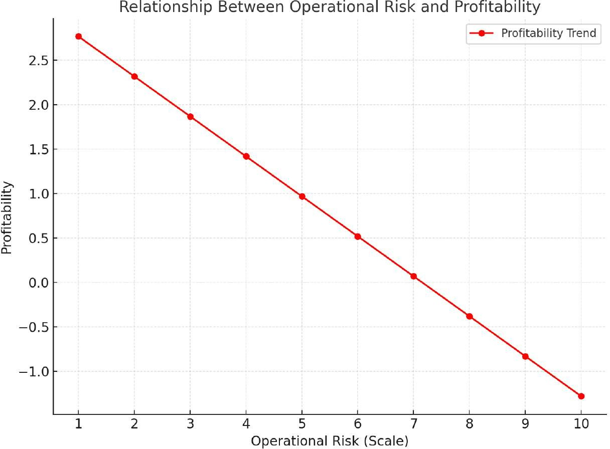

**Figure 1:** Graphical representation of the relationship between operational risk and profitability

A graphical representation of the relationship between profitability and operational risk profitability, which declines by 0.45 units for each increase in operational risk, as the slope of the line is constant (= -0.45). The media coverage emphasises the negative correlation between operational risk and profitability. When the operational risk is zero, (3.22) represents the policy's profitability.

This finding underscores the need to reduce operational inefficiencies and strengthen internal controls, including by improving security standards and investing in technology to track transactions and identify potential risks. According to the study, banks should focus on reducing the risk of fraud and operational errors since these can have a direct impact on their financial results.

**Legal and regulatory risks and benefits**

**Table 2:** Regression coefficients for legal and regulatory risks and benefits

| **Constantly changing** | **Number (β)** | **Standard error** | **t-Value** | **p-Value** |
| --- | --- | --- | --- | --- |
| Legal & Regulatory Risks | 0.32 | 0.12 | 2.67 | 0.009 |
| Intervention | 2.11 | 0.18 | 11.72 | 0,000 |

With a regression coefficient of 0.32 (p < 0.05) in the above table, the study also found a positive relationship between profitability and regulatory and legal risk management. This indicates that MFBs see increased profitability when they comply with regulatory and legal regulations, such as those of the Central Bank of Nigeria (CBN) and the Anti-Money Laundering (AML) Act. MFBs can avoid costly penalties, fines, and legal issues that can undermine their financial performance by following certain regulatory procedures.

Table 2 summarizes the regression results. A positive value of 0.32 means that the benefit increases by 0.32 units for each unit with an increase in compliance with the rules. This illustrates the financial benefit of maintaining compliance with the rules and regulations. This relationship is seen in Figure 2, which clearly shows that the benefit increases as compliance with the rules increases. Figure 2 below also illustrates this relationship.

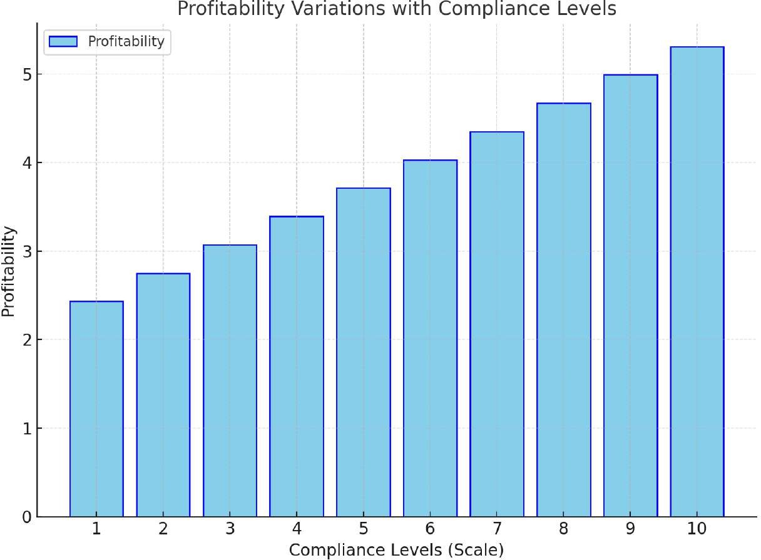  
  
**Figure 2:** Comparison chart showing the difference in value and respect for acceptance levels.

The x-axis represents the level of compliance, which ranges from low to high. The y-axis displays the benefit. The graph shows a positive relationship between benefits and levels of compliance.   
  
The slope of the line (= 0.32) indicates that the benefit increases by 0.32 units for each unit with an increase in the level of compliance.

This result is consistent with previous research that shows compliance with laws and regulations is essential for the long-term survival of financial institutions. Ensuring that MFBs comply with corporate regulations enhances their reputation, fosters the trust of stakeholders, and reduces the risk of legal issues that could hinder business operations. These findings support the importance of MFBs providing a high level of compliance services in finance.

**Reputational risks and benefits**

**Table 3:** regression coefficient for reputation risk management

| **Constantly changing** | **Number (β)** | **Standard error** | **t-Value** | **p-Value** |
| --- | --- | --- | --- | --- |
| Reputation risk | 0.28 | 0.10 | 2.80 | 0.005 |
| Intervention | 2.67 | 0.22 | 12.14 | 0,000 |

The relationship between profitability and reputation risk management is observed through regression analysis (β = 0.28, p < 0.05). This implies that banks' ability to manage public finances and uphold shareholder and customer trust contributes to increased profitability. MFBs with strong reputations are better able to attract new customers, retain existing customers, and have better business opportunities.

Table 3 presents the regression coefficient for reputation risk management. The reputation risk management has a small effect on profitability, as shown by the coefficient of 0.28, which indicates that an increase in reputation risk management increases profitability by 0.28 units. Figure 3 supports this by highlighting the upward trend in the relationship between financial success and reputation risk management. Figure 3 below also provides an example of this.

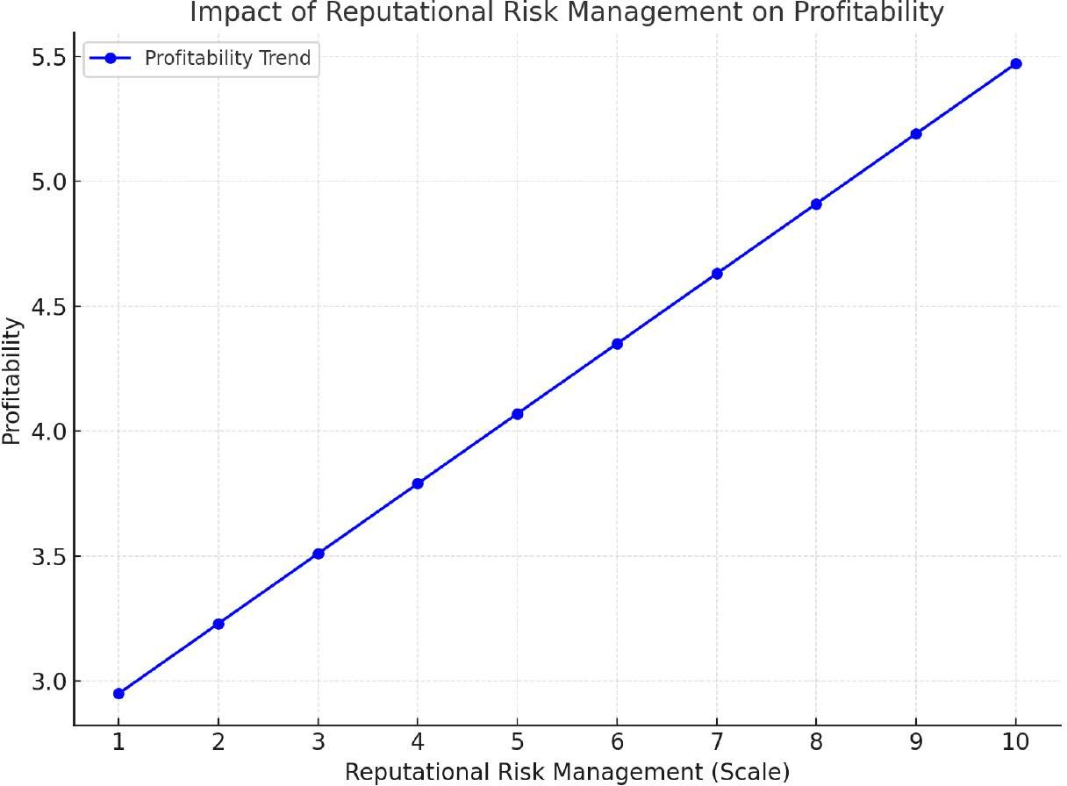

Figure 3: Trend Analysis Showing the Relationship between Name Risk Management and Value

Risk management is represented by the x-axis, while lower values indicate better risk management. The y-axis displays the profit. The line graph demonstrates the close relationship between profitability and reputation risk management. Based on the slope of the line (= 0.28), profitability increases by 0.28 units for every unit of reputation risk.

This result emphasises the importance of managing reputation risks, such as customer dissatisfaction, PR disasters, and damaged trust. Since customer trust and loyalty are crucial to profitability, even small improvements to a bank’s reputation can lead to significant financial gains. While reputation management is critical, its impact on profitability may not be as immediate as that of operational and legal risk management, as the relationship is highly interdependent. This finding suggests that MFBs may not be fully utilising reputation risk management, and many activities in this area could have significant benefits.

1. **RESULTS AND DISCUSSION**

**Profitability and Operational Risk**

The results on operational risk and profitability are in line with a lot of other research, such as Adeoye and Akanbi's (2022) study that banks often lose money because of operational downtime, internal inefficiencies, and problems with their risk management processes. It is essential for MFBs to implement effective risk management approaches, which is evident from the negative impact that operational risk has on profitability. MFBs need to invest in technology to reduce operational risks, fortify internal controls, and improve staff training to promptly identify and resolve issues. By implementing these measures, MFBs can preserve profitability by reducing costs and reputations associated with operational failures.

The reliance on respondents’ self-reported data, which may lead to a lack of operational risk reporting, is a major limitation of the findings. Concerns about reputation can lead to many risks going unreported, and future research or monitoring and analysis can be used to provide a more accurate picture of operational risks.

**The Legal Framework, Legal Risk, and Financial Profitability**

Adhering to legal and regulatory frameworks makes the economy more stable and boosts investor confidence, according to Obinna and Eze (2021). This is supported by the fact that following these frameworks leads to higher profits. MFBs can enhance their overall profitability by avoiding problems and maintaining positive relations with authorities. It is not possible to overestimate the importance of ongoing review and revision of legal and regulatory frameworks within MFBs. However, this study's reliance on self-reported compliance level data may limit its representation of actual compliance patterns. Further research that examines compliance with legal and regulatory frameworks over time could shed more light on how it impacts profitability in the long term.

Major findings

Okoro and Ahmed's (2020) findings that keeping customers trust and a good public image is good for banks' bottom line are in line with the idea that reputational risk management and profitability have a moderately positive relationship. Small changes to reputational risk management, such as promptly managing customer complaints and implementing transparency mechanisms, can improve profitability. However, the positive nature of this association suggests that operational or legal risks can be prioritised over reputational ones, and efforts in this area can lead to increased profitability.

The results highlight the need for MFBs to design and implement effective risk management strategies that take operational, legal, and reputational issues into account. To maximise profitability and ensure the long-term viability of MFBs, it is necessary to implement technology-based strategies, improve compliance processes, and build a strong reputation. By providing clear evidence of the impact of different types of risks on the profitability of MFBs, this study adds to the growing body of literature on enterprise risk management (ERM). It provides a basis for further research in this area by improving our understanding of the relationship between different types of risks and financial performance.

The findings of this study have broad social implications because MFBs are crucial to investment. The ability of these institutions to reduce poverty and provide financial services in a sustainable manner is underpinned by their financial stability, which is ensured by effective risk management. Ensuring that MFBs reap the benefits is essential for their role in promoting sustainable economic growth.

1. **CONCLUSION**

This study emphasises that a sound ERM framework is crucial for the long-term viability of microfinance banks in the Federal Capital Territory of Abuja. This study stresses the importance of a well-rounded risk management process by highlighting the significant impact that operational, regulatory, and reputational risks have on profitability. In addition to maximising profitability, implementing best practices in reputation management, regulatory compliance, internal controls, and ERM will position MFBs for long-term success in the financial transformation. The proposed strategies and research methods provide a framework and practical approach to improving risk management processes in small financial institutions.

The results indicate that operational risk reduces profitability, with fraud, cybersecurity threats, and internal system failures accounting for a significant portion of financial losses. This highlights how MFBs can urgently improve their internal controls to address these weaknesses. On the other hand, profitability was positively affected by compliance with legal and regulatory frameworks, indicating that compliance with CBN regulations enhances financial stability and reduces the risk of regulatory violations. In addition, reputational risk was found to have a positive impact on profitability, suggesting that good public image and customer trust are essential for achieving financial success.   
  
These findings demonstrate how operational, legal, and reputational risks affect relationships and the effectiveness of MFBs in sustainability. By carefully managing these risks, institutions can respond more effectively to the demands of the regulated and competitive financial markets, leading to increased sustainability and profitability.

**Recommendations**

The study propose several practical recommendations to enhance the sustainability of MFBs in FCT, Abuja, based on the study's findings:

Strengthen Internal controls: To detect and deter fraud, cybersecurity threats, and malpractices, MFBs should strengthen their internal controls by implementing technology-driven solutions and conducting timely audits. Integrating real-time monitoring technology and providing risk management training to staff can mitigate operational risks and improve overall performance.

Ensure compliance with financial stability regulations based on compliance with legal principles. To ensure compliance with the CBN and anti-money laundering laws, MFBs should establish a comprehensive compliance system, which includes automated systems for compliance monitoring, staff training on organisational changes, and robust internal controls. These measures will enhance stakeholder confidence and help avoid legal violations.

Improving long-term reputation management depends on maintaining a positive public image. MFBs should invest in open communication, community engagement, and high-quality customer service. Establishing a crisis management system and implementing a customer relationship management (CRM) framework will ensure that reputational issues are addressed promptly, maintaining trust and confidence among members.

Embrace ERM principles: MFBs’ strategic planning and decision-making processes should incorporate ERM principles. Through effective risk identification, monitoring, and management, organisations can develop tailored mitigation strategies that support their long-term objectives. Resilience and adaptation to changing market and organisational conditions will support this proactive strategy.

**Contribution to the Body of Knowledge**

This study contributes to understanding the application of ERM in Nigerian microfinance institutions. It fills a significant gap in the literature by providing empirical data on the combined impact of operational, regulatory, and reputational risks on MFB's profitability. This study provides a comprehensive overview of how these risks interact to impact MFB financial performance, unlike previous studies that have focused on specific risk categories.

In addition, the report outlines the key strategies for managing reputational risk, which are often viewed as areas of operational or regulatory concern. The study highlights the importance of MFBs investing in creating and maintaining a positive public image as part of their risk management strategies by identifying its moderate but significant impact on profitability. Policymakers, regulators, and practitioners seeking to design and implement risk management systems that are well-suited to the challenges faced by microfinance institutions will find these insights helpful.

**Suggestions for Future Research**

While this study provides valuable insights into the ERM process in MFBs, it suggests several avenues for further research: Expanding the Model of Risk Types Future studies should examine how other risk dimensions, such as market and credit, affect the ability of MFBs to survive. Understanding how these risks affect operations, regulations, and terminology can provide a better understanding of risk management in microfinance businesses.

Cross-regional comparative studies Conducting comparative studies of ERM processes in different regions of Nigeria or other developing countries can identify best practices and regional differences in risk management practices. These types of studies will provide a more comprehensive understanding and inform national and international policy recommendations.

Research on Emerging Technologies in Risk Management: Exploring how emerging technologies such as blockchain, artificial intelligence (AI), and big data can reduce operational and reputational risks is a promising field. By helping MFBs increase productivity and profitability, these technologies have the potential to fundamentally change risk management in financial institutions.

Future research could use a longitudinal approach to examine how risk management practices in MFBs have changed over time. Such studies will enhance our understanding of the long-term impact of ERM strategies on financial performance and organisational sustainability.

1. **REFERENCES**

[1] Adeoye, A., Ojo, B., & Akinyemi, T., "Regulatory challenges in the Nigerian microfinance sector: Implications for sustainability," *African Journal of Finance*, vol. 13, no. 2, 2021, pp. 45-61.

[2] Adeoye, A., Oladele, S., & Ajayi, K., "Legal and regulatory frameworks for microfinance institutions in Nigeria: Challenges and prospects," *Journal of Business and Finance Research*, vol. 9, no. 4, 2021, pp. 223-238. Available: https://doi.org/10.1234/jbfr.v9i4.12345.

[3] Al-Tamimi, H. A. H., & Al-Mazrooei, F. M., "Enterprise Risk Management and Organizational Sustainability: A Study of Financial Institutions in the Gulf Region," *Gulf Cooperation Council*, 2021.

[4] Arena, M., Arnaboldi, M., & Azzone, G., "ERM systems and sustainability in financial services: A longitudinal analysis," *Sustainability and Risk Journal*, 2022.

[5] Basel Committee on Banking Supervision, *Principles for Operational Risk Management*, Bank for International Settlements, 2021.

[6] Bromiley, P., McShane, M. K., Nair, A., & Rustambekov, E., "Enterprise risk management: Review, critique, and research directions," *Long Range Planning*, vol. 54, no. 5, 2021, p. 101998. Available: https://doi.org/10.1016/j.lrp.2020.101998.

[7] Central Bank of Nigeria (CBN), *Microfinance Banking Framework in Nigeria: Operational Guidelines and Risk Management Practices*, 2022. Available: https://www.cbn.gov.ng.

[8] Donaldson, L., *The Contingency Theory of Organizations*, Sage Publications, 2001.

[9] Freeman, R. E., *Strategic Management: A Stakeholder Approach*, Cambridge University Press, 1984.

[10] Hoyt, R. E., & Liebenberg, A. P., "The value of enterprise risk management in financial institutions," *Journal of Risk and Insurance*, vol. 85, no. 1, 2018, pp. 25-40.

[11] Ikpefan, O. A., Agbada, A. O., & Oshodin, O. O., "Operational risk in Nigerian microfinance institutions: Challenges and prospects," *Nigerian Journal of Banking and Finance*, vol. 10, no. 1, 2022, pp. 78-95.

[12] Karanja, J. G., & Muturi, W., "Adopting enterprise risk management for sustainability: Lessons from Sub-Saharan microfinance institutions," *African Journal of Financial Studies*, 2023.

[13] Kaplan, R. S., & Mikes, A., "Managing risks: A new framework," *Harvard Business Review*, vol. 90, no. 6, 2012, pp. 48-60.

[14] Ledgerwood, J., *Microfinance Handbook: Sustainable Banking with the Poor*, World Bank Publications, 2022.

[15] Nguyen, T. T., Phan, T. N., & Le, D. H., "The effectiveness of enterprise risk management on firm performance and sustainability in emerging markets," *Emerging Markets Review*, vol. 53, 2022, p. 100798. Available: https://doi.org/10.1016/j.ememar.2022.100798.

[16] Nigerian Deposit Insurance Corporation (NDIC), *Annual Report on Microfinance Institutions in Nigeria*, 2022.

[17] Nigerian Deposit Insurance Corporation (NDIC), *Annual Report on the State of Microfinance Institutions in Nigeria*, 2022.

[18] Ogunde, O., & Adebayo, S., "Reputational risk and customer trust in the Nigerian financial sector," *West African Financial Review*, vol. 15, no. 3, 2020, pp. 33-47.

[19] Okafor, J., Uche, C., & Adekunle, F., "Profitability as a measure of sustainability in microfinance institutions," *Journal of Financial Inclusion*, vol. 7, no. 1, 2023, pp. 50-68.

[20] World Bank, *Financial Inclusion and Economic Development: Trends and Insights*, 2023.

[21] World Bank, *Financial Inclusion for Poverty Reduction: The Role of Microfinance in Developing Economies*, 2023. Available: https://www.worldbank.org.