**SMART STREET LIGHTS CONTROL SYSTEM**

**Suganya M1, Shaiyad Khan2, Charvi Sinha3, Akshata Patil4, Tanuja B5**

1Assistant professor, Computer Science and Engineering, T. john Institute of Technology, Bengaluru, Karnataka, India.

2,3,4,5Student, Computer science and Engineering, T. john Institute of Technology, Bengaluru, Karnataka, India.

**ABSTRACT**

By dynamically modifying illumination in response to current conditions, the Smart Street Light Control System improves energy efficiency. Because they run at maximum intensity, traditional street lights waste energy. With the help of ESP32 microcontrollers, IR sensors, LDRs, and LEDs, this system only turns on lights when necessary.   
LDR sensors switch off lights during daylight, further saving energy. IR sensors maintain smooth illumination along a vehicle's route, preventing wasteful lighting. IR sensors detect vehicles or pedestrians, illuminating lights ahead and dimming those behind. The following are important features: dynamic brightness control, ambient light sensor, vehicle detection, and IoT-based remote monitoring. By lowering energy consumption, carbon footprint, and operating costs and enhancing visibility, safety, and sustainability, this scalable, reasonably priced solution supports smart city objectives.

**Keywords:** ESP32, Motion-Activated, IoT-based, Smart Street Lighting, Energy Efficiency

1. **INTRODUCTION**

Public safety, visibility, and security all depend on street lighting, but conventional systems are ineffective since they use a lot of energy and have significant operating expenses because they are always fully lit. This is especially problematic in places with little traffic where it is not required to provide constant lighting. Due to extended use, the traditional method of street lighting wastes electricity and raises maintenance costs. By incorporating sensors and Internet of Things technologies into the architecture of urban lighting, the Smart Street Light Controller System solves these inefficiencies. In order to detect incoming cars or pedestrians and modify the lights appropriately, the system makes use of motion detection sensors (such as infrared or ultrasonic sensors). To ensure energy savings without sacrificing safety, lights in front of you shine while those behind you dim. Vehicle identification, dynamic brightness control, automated dimming, and Internet of Things-based monitoring for real-time fault detection are some of the key features. Through lower energy usage, lower operating costs, and support for smart city programs, this scalable and affordable technology improves urban sustainability.

1. **METHODOLOGY**

The Smart Street Light Control System uses sensor-based automation and the Internet of Things to optimize street lighting operations and increase energy efficiency. This includes several steps, like software development, system testing, and hardware implementation.  
**System Design and Architecture**: ESP32 microcontrollers, LEDs, LDR sensors, and infrared sensors are used in the system's construction. To identify traffic in real time, a decentralized sensor network is employed.   
**Hardware Implementation**: Vehicle and pedestrian activity is detected via infrared sensors. To automate day-night transitions, LDR sensors track the amount of ambient light. The ESP32 microcontroller manages LED brightness and interprets sensor inputs. When motion is detected, LED streetlights dynamically change their brightness.

**Software Development**: Microcontroller programming is done via embedded C programming. To cut down on energy waste, PWM (Pulse Width Modulation) regulates LED brightness. System diagnostics and remote monitoring via IoT integration.  
**Operation Mechanism**: The closest LEDs brighten and the lights behind dim when a car is spotted. In order to save energy, the system is turned off throughout the day. The lights stay at their lowest brightness when there is no motion detected.  
**Validation and Testing:** The system's energy economy, response time, and sensor accuracy are evaluated. Several test cases verify real-time flexibility in various traffic scenarios. By ensuring an automated, economical, and scalable smart lighting solution, this methodology lowers energy consumption and supports sustainable urban infrastructure.

1. **MODELING AND ANALYSIS**

The Smart Street Light Control System uses sensor-based automation and Internet of Things technology to improve energy efficiency. Designing the system architecture, putting hardware and software into place, and assessing performance through simulations and actual testing are all part of the modelling and analysis process.

**1. System Architecture and Design**

The system follows a modular approach, integrating ESP32 microcontrollers, IR sensors, LDR sensors, and LEDs. The architecture ensures seamless operation with the following components:

**High-Level Design**

* **Sensor Module**: Detects vehicles using IR sensors and adjusts light intensity accordingly.
* **Lighting Control Module**: Manages LED brightness based on sensor input.
* **Microcontroller Module**: Processes sensor data and executes control logic.
* **Power Management Module**: Ensures efficient energy distribution and conservation.

**Low-Level Design**

* **IR Sensors** are placed at intervals to detect vehicles and pedestrians.
* **LDR Sensors** monitor ambient light, ensuring lights remain off during daylight.
* **PWM (Pulse Width Modulation)** is used to adjust LED brightness dynamically.

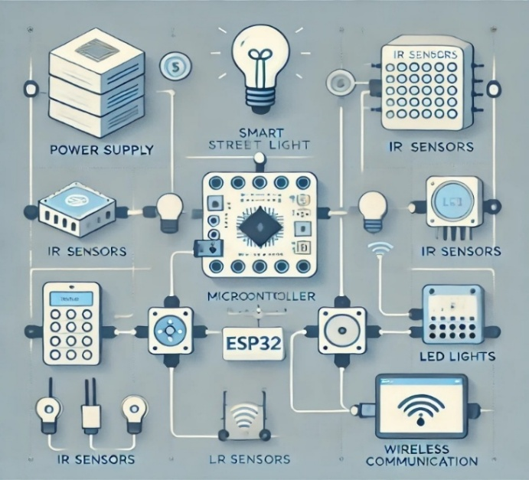

**Figure 1:** System Architecture

**2. Circuit and Flow Diagrams**

**Circuit Diagram**

The circuit diagram consists of a NodeMCU (ESP8266), IR sensors, and LEDs.

* **IR sensors** detect vehicle presence and send signals to the microcontroller.
* **LDR sensors** monitor ambient light to ensure operation only at night.
* The **microcontroller** processes inputs and adjusts LED brightness accordingly.

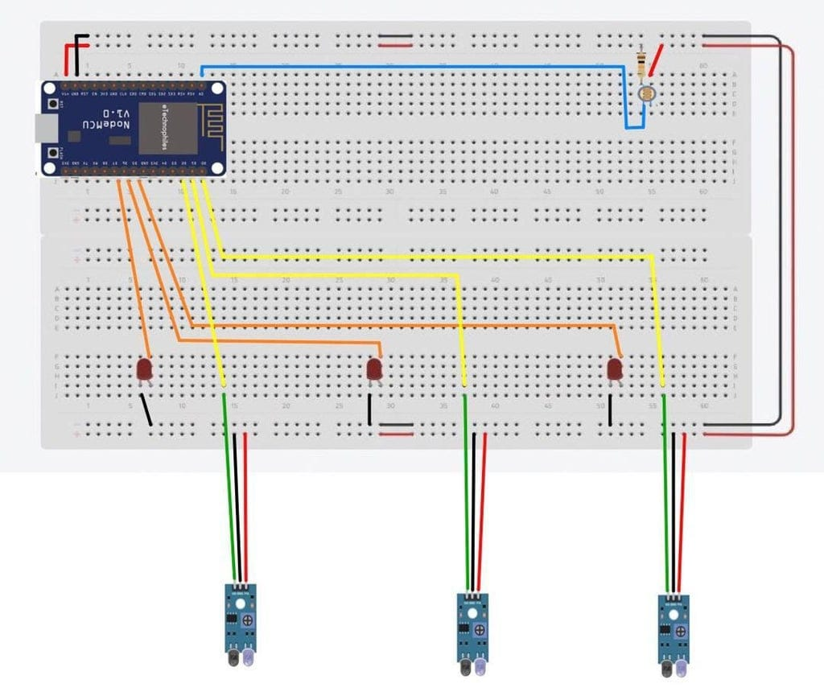

**Figure 2:** Circuit Diagram

**Block Diagram**

This block diagram represents the interaction between system components:

1. **Power Supply** energizes the microcontroller and sensors.
2. **IR Sensors** detect motion and transmit data.
3. **LDR Sensors** ensure lights remain off in daylight.
4. **Microcontroller (ESP32)** processes inputs and controls LEDs.
5. **LED Lights** illuminate or dim based on sensor readings.

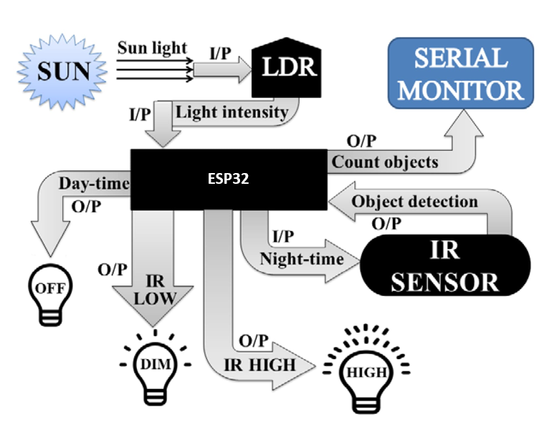

**Figure 3:** Data Flow Diagram

**Figure 4:** Block Diagram

**3. System Working and Analysis**

**Working Process:**

* **Motion Detection**: IR sensors detect vehicles and activate nearby streetlights.
* **Light Adjustment**: LEDs ahead of the vehicle brighten, while lights behind dim.
* **Energy Optimization**: When no motion is detected, lights remain at minimum brightness.
* **Daylight Monitoring**: LDR sensors switch off lights during daylight hours.

**Performance Analysis**

The system was analyzed based on energy consumption, response time, and fault detection. Key results:

* **Energy Efficiency**: Reduces power consumption by 40-50% compared to traditional streetlights.
* **Real-Time Adaptability**: Immediate response to vehicle movement within milliseconds.
* **Reliability**: Works efficiently under different environmental conditions.

**Comparative Analysis**

|  |  |  |
| --- | --- | --- |
| **Parameter** | **Traditional Street Lights** | **Smart Street Light Control System** |
| Energy Consumption | High | Low (Adaptive Control) |
| Operation | Fixed (On/Off) | Sensor-Based Automation |
| Cost Efficiency | High Maintenance | Reduced Costs |

**Table 1**: Comparative Analysis

1. **RESULTS AND DISCUSSION**

Reliability, response time, and energy efficiency were evaluated for the Smart Street Light Control System. Owing to the findings, the system successfully reduces energy usage by 40–50% when compared to conventional street lighting. The dynamic brightness modification minimizes power waste while guaranteeing ideal illumination. The system demonstrated real-time willingness by operating effectively under a variety of environmental instances, including low light intensity. Vehicles were precisely identified by the motion detection sensors, which only turned on lights when necessary. By detecting non-functional lights, the defect detection technology also increased the effectiveness of maintenance.



**Figure 5:** IR Sensor-Based LED Activation in Low-Light Conditions

During nighttime or low-light conditions, the IR sensors continuously monitor the presence of objects. When an object is detected, all four IR sensors activate the corresponding LEDs, illuminating them at full brightness to ensure optimal visibility and safety.

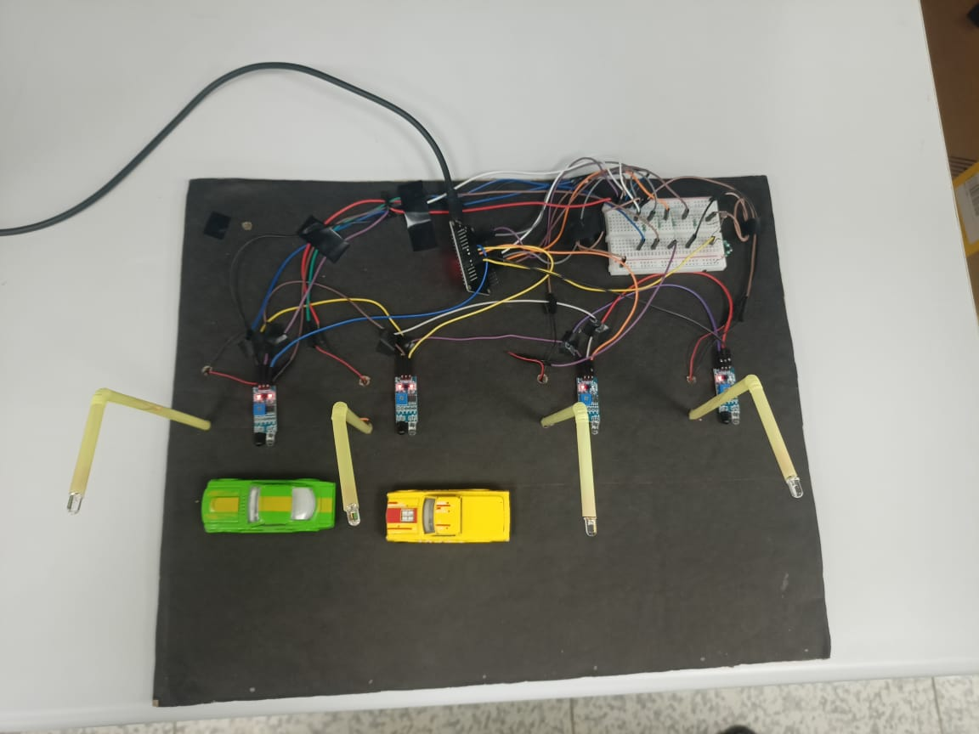

**Figure 6:** Smart Street Light Control System- Prototype, during daytime

LDR sensors are used to measure ambient light levels in the Smart Street Light Control System prototype during the day. The LDR sensors save energy by automatically turning off the streetlights during the day when there is enough natural light. The system maintains energy efficiency while guaranteeing no needless power consumption. The streetlights are reactivated by the system when darkness falls or the amount of ambient light drops. By using natural light for street lighting during the day, this system contributes to lower energy waste and operational expenses, which is in line with smart city sustainability objectives.

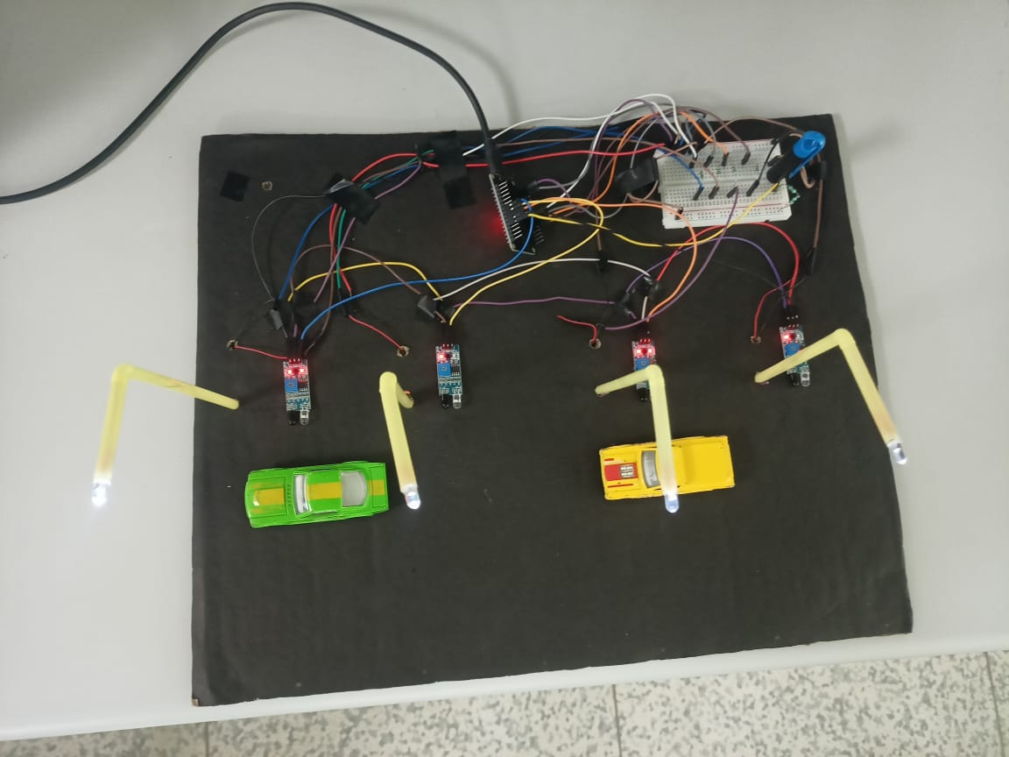

**Figure 7:** Smart Street Lights Control System- Prototype, during nighttime

Infrared sensors are used by the Smart Street Light Control System to identify pedestrian or vehicle activity at night. The system modifies the LED brightness in response to motion detection, making the lights in front of the moving object brighter and the ones behind it dim. To save energy, the lights stay at a low brightness if there is no motion detected. This dynamic control minimizes energy waste while preserving safety and visibility by ensuring ideal lighting based on current conditions. The solution supports sustainable smart city infrastructure by improving nighttime energy efficiency and operational cost reductions.

**Comparison of Traditional vs. Smart Street Lighting**

|  |  |  |
| --- | --- | --- |
| **Feature** | **Traditional Street Lights** | **Smart Street Light Control System** |
| **Energy Consumption** | High | Low (Adaptive Control) |
| **Operational Mode** | Fixed (On/Off) | Sensor-Based Automation |
| **Response Time** | Manual Delay | Instantaneous |
| **Maintenance Cost** | High | Reduced (Self-Diagnostic) |
| **Environmental Impact** | High Carbon Footprint | Eco-Friendly |

**Table 2:** Traditional vs Smart Street Lights

The discussion confirms that IoT-enabled lighting control provides a cost-effective, scalable, and sustainable solution for urban street lighting. The project aligns with smart city initiatives, promoting energy conservation and environmental sustainability.

1. **CONCLUSION**

The Smart Street Light Control System successfully enhances energy efficiency by integrating IoT and sensor-based automation. The system dynamically adjusts streetlight brightness based on motion detection and ambient light levels, ensuring minimal power wastage and lower maintenance costs. It improves road safety by providing illumination only when necessary. The fault detection mechanism further enhances system reliability. Unlike conventional lighting, this approach promotes sustainability and smart city development. Future enhancements, such as solar power integration and AI-driven traffic analysis, can further improve performance, making it a scalable and eco-friendly solution for modern urban infrastructure.

1. **REFERENCES**
2. S. R. Joshi, A. Sharma, and P. Kumar, “IoT-Based Smart Street Lighting System for Energy Efficiency,” International Journal of Computer Applications, Vol. 179, Issue 3, pp. 56-60, 2020.
3. R. K. Verma, D. S. Yadav, and M. Gupta, “Smart Street Lighting System with Motion Detection and Adaptive Control,” International Journal of Engineering Research and Technology, Vol. 8, Issue 12, pp. 230-235, 2019.
4. P. Choudhury, S. Agarwal, and V. Kumar, “Energy-Efficient Street Lighting System Using IoT and Smart Sensors,” International Journal of Electronics and Communication Engineering, Vol. 12, Issue 5, pp. 340-347, 2021.
5. J. Sharma, N. S. Mehta, and S. Gupta, “An Intelligent Street Light Control System for Smart Cities,” International Journal of Research in Electronics and Communication Technology, Vol. 7, Issue 6, pp. 78-83, 2018.
6. M. Singh, P. Sharma, and K. R. Gupta, “Smart Street Light Control System Using IoT and Sensors for Energy Optimization,” Journal of Automation and Control Engineering, Vol. 10, Issue 4, pp. 123-128, 2020.