Temperature Controller for Continuous Stirred Tank Reactor using Adaptive PSO Based PID Controller

**1J.Jeevanantham,2R.Vijayarajan,3K.Goutham,4S.Dharan,5R.Abishek,6R.Jeganathan**

1,2Assistant Professor,Department of Instrumentation and Control Engineering,Sri Manakula Vinayagar Engineering College,Puducherry,India

3,4,5,6Student, Instrumentation and Control Engineering,Sri Manakula Vinayagar Engineering College,Puducherry,India

[1jeevag2020@gmail.com,2vgrvy@gmail.com,3goutham27404@gmail.com,4dharan2817@gmail.com](mailto:1jeevag2020@gmail.com,2vgrvy@gmail.com,3goutham27404@gmail.com,4dharan2817@gmail.com),

5abishekrangasamy12@gmail.com, 6jeganathan3152004@gmail.com

**Abstract :**

The objective of the project is to control the reactant temperature of a Continuous Stirred Tank Reactor (CSTR) by manipulating the coolant temperature. The plant is modeled mathematically for the normal operating condition of CSTR. Then the transfer function model is obtained from the process. The various different kinds of controller is designed and implemented to control the temperature of the CSTR system, such as conventional method (Trial and Error method), Ziegler- Nichols method, Fuzzy logic method, PSO tuned PID controller method and Adaptive PSO tuned PID controller method. The servo response is obtained for the different operating condition of temperatures. From the servo response, Adaptive PSO algorithm based PID tuning method has given better setpoint tracking capability than the Ziegler-Nichols method, Conventional PID method, Fuzzy logic method, Particle swarm optimization (PSO) algorithm based PID tuning method.

***Keywords*—Conventional PID Controller, Z-N PID Controller, Fuzzy PID Controller, APSO and CSTR.**

.

1. Introduction

In chemical industries one of the complex dynamics system is Continuous Stirred Tank Reactor (CSTR). The temperature controlling of the complex CSTR is very difficult by using linear controller. In a Continuous Stirred Tank Reactor (CSTR), reactants and products are continuously added and continuous collected in the outlet. An electrical motor is used to mixer the content and it is required to achieve uniform composition and temperature of the mixer. The continuous stirred-tank reactor (CSTR), also known as vat reactor, it is a general reactor type in chemical industries. Chemical kinetics and reactor design are at the heart of producing almost all industrial chemicals. The reaction occurred in a reactor is exothermic or endothermi

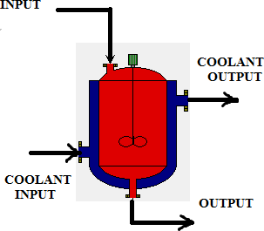

Fig 1.CSTR

The reactor is having a jacket or coil in order to maintain the reaction temperature in the reactor. While chemical reaction takes place inside the reactor, there is a chance to producing heat or chance to getting cold. If endothermic reaction takes place in the CSTR, a process or reaction in which the system absorbs energy from its surroundings in the form of heat, so the flow of heating medium is passing through jacket or coil for maintain the reaction temperature in the CSTR.

A reactor operates at a constant temperature, then

that is called as the isothermal reactor. The temperature of the reactions varies with time and we need to control temperature of the CSTR reactor in order to produce good quality product because of endothermic and exothermic reactions. In chemical industries the temperature control.

II. CALCULATING TRANSFER FUNCTION MODEL FOR DIFFERENT OPERATING CONDITIONS OF CSTR

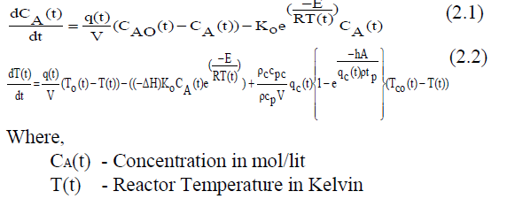Mass and energy balance equation of CSTR is following

## TABLE I. NORMAL OPERATING CONDITION OF CSTR

|  |  |  |
| --- | --- | --- |
| **Sl. No.** | **Process variable** | **Normal operating condition** |
| 1. | Concentration(CA) | 0.0885 mol/lit |
| 2. | Reactor Temperature(T) | 441.1475 K |
| 3. | Volumetric Flow Rate(q) | 100 L/min |
| 4. | Reactor Volume(V) | 100l |
| 5. | Feed Concentration(CAf) | 1 mol/Lit |
| 6. | Feed Temperature(Tf) | 350 K |
| 7. | Coolant Temperature(Tcf) | 350 K |
| 8. | Coolant Flow Rate(qc) | 97 L/min |
| 9. | Heat of Reaction(∆H) | 2e5 cal/mol |
| 10. | Reaction Rate Constant(Ko) | 7.2e10 /min |
| 11. | Activation Energy term(E/R) | 9980 K |
| 12. | Heat Transfer term(hA) | 7e5 cal/(min*K) |

Finding Transfer function

For qc = 97 L/min.

CA = 0.08235mol/Lit.

T = 443.4566 K

The system transfer function,

G(s)  s2  21.53s 9.403

## TABLE II. TRANSFER FUNCTION FOR DIFFERENT OPERATING POINTS

|  |  |  |  |  |
| --- | --- | --- | --- | --- |
| **Sl.**  **No.** | **Qc**  **(lit/m)** | **CA**  **(mol/lit)** | **Temper ature**  **(K)** | **Transfer function** |
| 1 | 97 | 0.0795 | 443.456 | 1.414s  System1 18.51  s2  22.87s  9.497 |
| 2 | 100 | 0.0885 | 441.147 | 1.492s  System2 17.57  s2  21.55s 9.782 |
| 3 | 103 | 0.0989 | 438.776 | 1.582s  System3 16.71  s2  20.34s 10.22 |
| 4 | 106 | 0.1110 | 436.309 | 1.681s  System4 15.87  s2 19.2s 10.36 |
| 5 | 109 | 0.1254 | 433.692 | 1.788s  System5 15  s2 18.11s10.62 |

## III.DESIGN OF CONTROLLERS

## A. Design of Conventional Controller

Conventional controller is controller where the controller parameters like kp, ki, kd are all tuned by guess and check method i.e. called “Trial and error “method. Because of random choices trial and error method will take large time to tuning the controller parameters of the controller. The following tuning rule present in book titled “The Michigan chemical process dynamics and controls open text book” by prof. Peter Woolf, 2007**.**

TABLE III. TRIAL AND ERROR METHOD TUNING RULE

|  |  |  |
| --- | --- | --- |
| **Sl. No.** | **Gains** | **Temperature process** |
| 1. | Kp | 2-10 |
| 2. | ki | 2-10 |
| 3. | kd | 0-5 |

For the temperature process the controller parameters are taken from the Table III. Let the controller parameters are,

Kp=8; Ki=3; kd=1

## B. Ziegler-Nichols PID-Controller

A proportional-integral-derivative controller (PID controller) is a popular controller, which is widely used in all industrial because of its advantages in control systems. PID controller- proportional-integral-derivative controller.

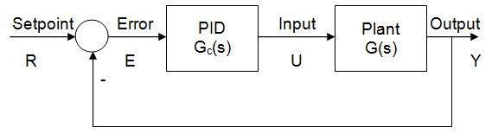

### Fig. 2. Block diagram of PID controller with G(S) Plant

Thus the above diagram shows the general Ziegler-Nichols PID controller with plant G(s) which is shown by figure.

u(t) KPe(t) Ki0te(t)dt  Kd dtd e(t) (3.2)

Where,

Kp = Proportional gain

Ti = 1**/**Ki = Integral gain

Td = 1**/**Kd = Derivative gain

E = error = Set point-process variable

It was developed by John G. Ziegler and Nathaniel B. Nichols. Ziegler-Nichols tuning rule was the first such effort to provide a practical approach to tune a PID controller.

TABLE IV. ZIEGLER NICHOLS TUNING RULE

|  |  |  |  |  |
| --- | --- | --- | --- | --- |
| **Sl. No.** | **Controller** | **Kc** | **Ti** | **Td** |
| 1. | P | Ku/2 | - | - |
| 2. | PI | Ku/2.2 | Pu/1.2 | - |
| 3. | PID | Ku/1.7 | Pu/2 | Pu/8 |

Ziegler-Nichols tuning rule gives sometime better results but not suitable for all process. Because of the improper tuned controller parameters. This is one of the major disadvantage in Ziegler-Nichols controller.

TABLE V. CONTROLLER PARAMETERS FOR DIFFERENT OPERATING TEMPERATURES

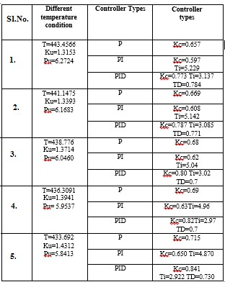

### TABLE VI. TIME DOMAIN PARAMETERS FOR DIFFERENT CONTROLLERS

|  |  |  |  |  |  |  |
| --- | --- | --- | --- | --- | --- | --- |
| **Sl.**  **No** | **Time domain**  **characteristics** | **Trial and**  **Error method** | **Z-N method** | **Fuzzy logic**  **method** | **PSO-**  **PID method** | **APSO-**  **PID method** |
| 1 | Settling time (sec) | 4.5 | 9.2 | 8.52 | 4.7 | **4.12** |
| 2 | Rise time (sec) | 1.3 | 2.64 | 2.23 | 1.98 | **1.87** |
| 3 | Overshoot (%) | 0 | 23.6 | 22.42 | 0 | **0** |

## C. Fuzzy PID-Controller

Fuzzy logic control is an efficient control for problems which are nonlinear and has scarce knowledge regarding them. Fuzzy inference system is a popular computing technique. Fuzzy is basically rule base methodology for computing different tasks. Here fuzzy is used to compute the gain values of the PID controller. The input to the fuzzy tuned controller is the error and change in error and the outputs are the PID gain values. The membership function used is a triangular membership function and defuzzification method used is centroid.

Advantages of Fuzzy Logic Controller over Ziegler

Nichols Controller,

* Fuzzy PID Controller used for Non-Linear process.
* Here dynamic behaviour of the process can be captured.
* Process output meet the desired set point quickly.

## D. Design Procedure of Fuzzy Logic PID Controller

* Build and tune a conventional PID controller first.
* Replace it with an equivalent linear fuzzy controller.
* Make the fuzzy controller nonlinear.
* Fine-tune the fuzzy controller.

TABLE VII. FUZZY LOGIC CONTROLLER TUNING RULE

|  |  |  |  |  |
| --- | --- | --- | --- | --- |
| **Sl.No** | **Controller** | **Kp** | **1/Ti** | **Td** |
| 1. | Fuzzy P | GE*GU | _ | _ |
| 2. | Fuzzy PI | GCE*GU | _ | GCE/GE |
| 3. | Fuzzy PID | GE*GU | GIE/GE | GCE/GE |

The controller parameters are tuned by fuzzy logic technique as in ([1],[3],[8]).

TABLE VIII. FUZZY LOGIC RULES

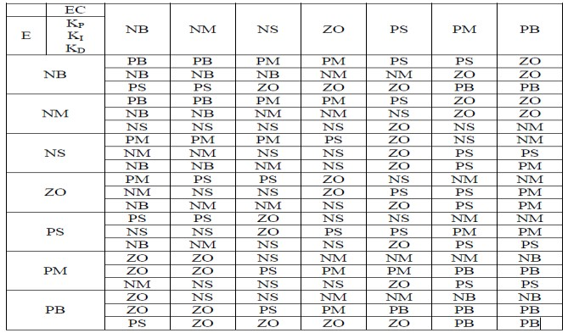

## IV. SIMULATION AND RESULTS

By using Matlab the system was modelled and simulated. The simulated results of the system control with closed loop method and Conventional Controller and Z-N PID-Controller and Fuzzy PID-Controller were analysed.

Figure 3, shows the Simulink block diagram of the closed loop systems.

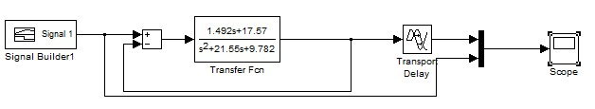

Fig. 3. Simulink Block Diagram for Closed loop systems

Figure 4, shows the Simulink block diagram of ZieglerNichols PID-Controller.

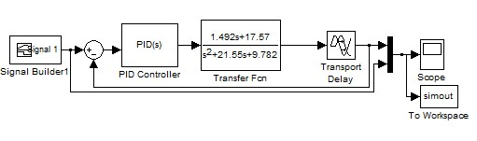

Fig. 4. Simulink Block Diagram for PID-Controller

Figure 5, shows the Simulink block diagram of fuzzy PIDController

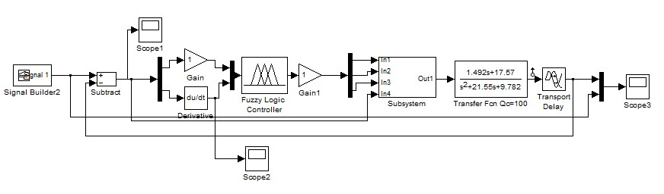

Fig. 5. Simulink Block Diagram for Fuzzy PID-Controller

Figure 6, shows the servo response of closed loop system, the process output doesn’t meet the desired set point.

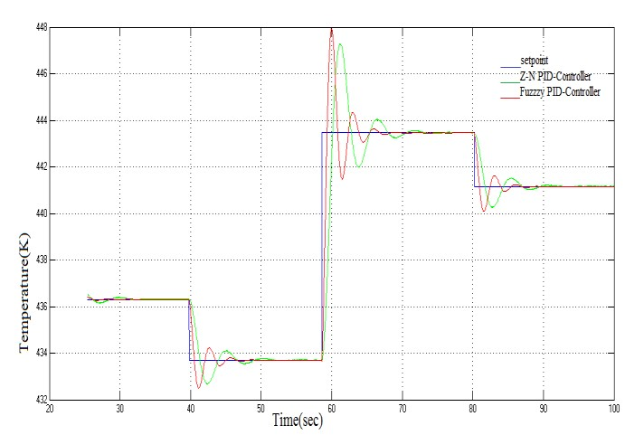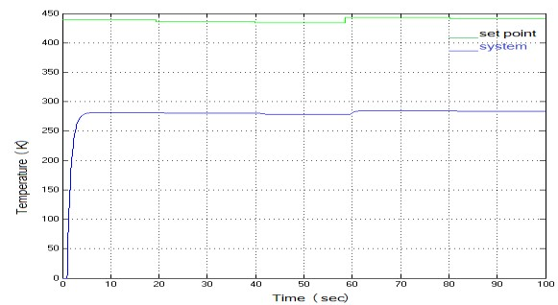

Fig. 6. Servo Response of Closed loop Systems

Figure 7, shows the servo response of Trial and Error

Method, the process output meet the desired set point quickly. The Controller parameters are Kp=8; Ki=3; kd=1 as in TABLE III. For simulation purpose equation (3.1) was used.

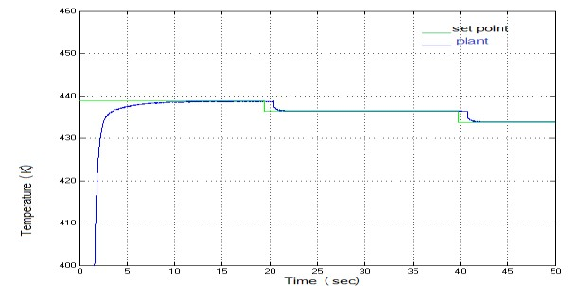

Fig. 7. Servo Response of Trial and Error Method

Figure 8, shows the servo response of Ziegler-Nichols

PID-Controller and Fuzzy PID-Controller, In the Fuzzy PIDController, The process output meet the desired set point quickly with less oscillation than the Ziegler-Nichols PIDController. The Controller parameters are Kp=0.7878; Ki=3.0857; Kd=0.7714 as in TABLE V. For simulation purpose equation (3.1) was used.



Fig. 8. Servo Response Comparison of Ziegler-Nichols PID-Controller and Fuzzy PID-Controller

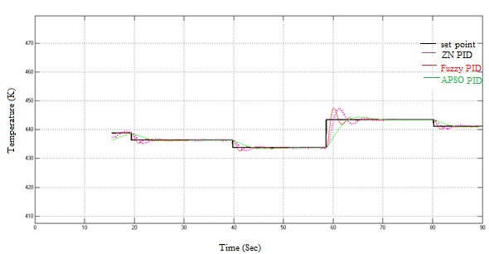

Fig. 10. Servo Response

for APSO PID

-

Controller

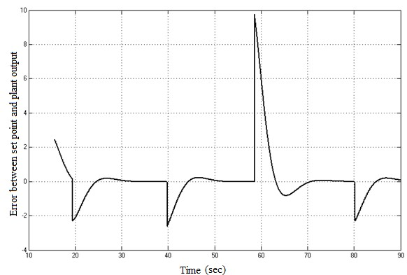

Fig. 11. Error Response for APSO PID-Controller

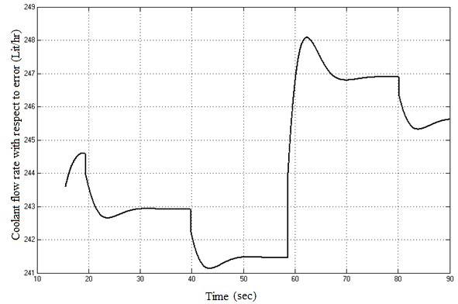

Fig. 12. Coolant Flow Rate with respect to Error for APSO PID-Controller

The following table shows the analysis between the error and coolant flow rate for APSO-PID controller method.

TABLE IX ERROR VS. COOLANT FLOW RATE (LIT/HR) FOR APSO PID-CONTROLLER

|  |  |  |
| --- | --- | --- |
| **Sl. No** | **Error** | **Coolant flow rate (lit/hr)** |
| 1 | -2 | 243.5 |
| 2 | 0 | 243 |
| 3 | -2 | 242 |
| 4 | 0 | 241.5 |
| 5 | 10 | 248 |
| 6 | 0 | 247 |
| 7 | -2 | 246.3 |
| 8 | 0 | 245.5 |

TABLE X PID PARAMETERS VALUES FOR DIFFERENT CONTROLLERS

|  |  |  |  |  |  |  |
| --- | --- | --- | --- | --- | --- | --- |
| **Sl.**  **No** | **PID parameters** | **Trial and**  **Error method** | **Z-N metho d** | **Fuzzy logic**  **method** | **PSO**  **-PID** | **APSO-**  **PID method** |
| 1 | Kp | 8 | 0.7878 | 0-1.5 | 0.12 96 | 0.1196 |
| 2 | Ki | 3 | 3.0585 7 | 0-1.5 | 0.13 67 | 0.2264 |
| 3 | Kd | 1 | 0.7714 | 0-0.5 | 0.09 56 | 0.0811 |

## V. CONCLUSION

The mathematical modelling of the process is done for all five operating conditions. The ZN-PID controller, Fuzzy based PID and PSO-PID controller are able to maintain the set point at the desired value. However, the performances of APSO based PID controller at all operating points are found to be better than ZN-PID ,Fuzzy based PID and PSO-PID controller, as there is less overshoot and settles to the set point faster. The APSO based PID controller provides a better performance compared to ZN-PID controller. The PID controller gains were tuned and the proposed methodology is shown better performance when compared with the traditional methodology, fuzzy logic controller and standard PSO tuned PID controller for the CSTR process.

## **REFERENCES**

1. Chuen Chien LEE, “Fuzzy Logic in Control Systems: Fuzzy Logic Controller,” in IEEE Transactions on Systems, Man and Cybernetics, vol. 20, 1990.
2. Conradie, R. Miikkulainen, and C. Aldrich, “Adaptive Control Utilizing Neural Swarming,” In Proceedings of the Genetic and Evolutionary Computation Conference, USA, 2002.
3. J. Prakash, “Design of observer based nonlinear model predictive Controller for a continuous stirred tank reactor,” in Journal of Process control vol. 18 (2008) pp.504-514, 2008.
4. M. Thangaraj, R. Abraham, “Particle swarm optimization using adaptive mutation,” in Proc. 19th International Conference on Database and Expert Systems Application, pp. 519-523, 2008
5. J. Prakash, “Design of nonlinear PID controller and non-linear model predictive controller for a continuous stirred tank reactor,” in proceedings ISA Transactions 48, pp.273-282, 2009.
6. M. Santos, S, Dormido, “Fuzzy-PID controllers vs. Fuzzy-PI controllers,” in IEEE Transactions Systems, Man and Cybernetics, vol. 20, no. 2, pp.404-418, 2009.0
7. Essam Nathen and Khalid, A. Buragga, “Comparison between Conventional and Fuzzy Logic PID Controller for controlling DC motors,” in International Journal of Computer science, vol. 7, Issue 5, September 2010.
8. Krishnaa, K. Suryanarayanab, G.R. Aparnab, “Tuning of PID Controllers for Unstable Continuous Stirred Tank Reactors,” proceedings in International Journal of Applied Science and Engineering. 10, pp.1-18, 2012.
9. S. Morkos, H. Kamal, “Optimal Tuning of PID Controller using Adaptive Hybrid Particle Swarm Optimization Algorithm,” by, International Journal of Computers, Communications & Control, ISSN 1841-9836, vol. 7, no. 1, pp. 101-114, 2012.