***Image Classification***

|  |  |  |
| --- | --- | --- |
| Author 1: Snehal Shah  *Asst. Faculty Electronics And telecommunication*  *Shree L.R Tiwari College Of Engineering*  Mumbai, India  Snehal.shah@slrtce.in  Author 3: Aditya Ashok Pandey  *SE Electronics And Telecommunication*  *Shree L.R Tiwari College Of Engineering*  Mumbai, India  adityapandey20043@gmail.com |  | Author 2: Sahil Haresh Bhasin  *TE Electronics And Computer Science*  *Shree L.R Tiwari College Of Engineering*  Mumbai, India  [Sahil.bhasin897@gmail.com](mailto:Sahil.bhasin897@gmail.com)  Author 4: Iqra Abid Patel  *TE Electronics And Computer Science*  *Shree L.R Tiwari College Of Engineering*  Mumbai, India  iqrapatel2004@gmail.com |

***Abstract*—Image classification is a fundamental problem in computer vision with broad applications in fields ranging from**

**medical imaging to the entertainment industry. In this study, we explore and compare the use of TensorFlow for**

**constructing Convolutional Neural Network (CNN)-based models to classify images of cats and dogs. TensorFlow's**

**versatility and accessibility via Google Colab allow for scalable deep learning applications to tackle binary classification**

**challenges effectively. This case study provides a systematic**

**review of methods, procedures, and challenges associated with building an image classification model using deep learning**

**techniques. We also discuss the limitations of current models and provide insights into future improvements that can**

**enhance accuracy and robustness (TensorFlow Documentation, 2025).**

**Keywords—Image Classification, Deep Learning,**

**TensorFlow, Cats vs Dogs, Convolutional Neural Networks (CNN), Google Colab, Artificial Intelligence (AI) Techniques, and Model Optimization.**

*I. INTRODUCTION*

The emergence of deep learning has significantly advanced computer vision, enabling improved automation in image

classification, object detection, and image segmentation.

Among common computer vision tasks, binary classification—such as distinguishing between cats and dogs—has served as a benchmark for deep learning

research. The primary challenge arises due to intra-class variations such as differences in fur texture, color, facial features, lighting conditions, and background clutter *(Kaggle Dataset, 2025).*

This study explores the role of TensorFlow in enabling efficient deep learning-based classification. With its Keras

API, TensorFlow simplifies CNN model construction while Google Colab offers cloud-based computational resources, enabling large-scale training without the need for dedicated hardware. The objective of this study is to highlight

TensorFlow's ability to facilitate efficient CNN-based binary classification, analyze its performance, and discuss

its broader implications and future directions *(TensorFlow Documentation, 2025).*

# II. LITERATURE REVIEW

## A. Traditional Approaches to Image Classification

Historically, image classification relied on feature extraction techniques such as Histogram of Oriented Gradients (HOG), Scale-Invariant Feature Transform (SIFT), and Support Vector Machines (SVMs). While these approaches provided reasonable accuracy in specific scenarios, they were limited by the need for extensive feature engineering and lacked scalability (He et al., 2016).

## B. Deep Learning and CNN Architectures

The introduction of Convolutional Neural Networks (CNNs) revolutionized image classification by automating feature extraction and hierarchical learning. Notable CNN architectures include AlexNet, VGGNet, ResNet, and Inception. TensorFlow provides an open-source deep learning framework with tools and pre-built architectures to develop these models. Its integration with Keras streamlines model construction, training, and evaluation (TensorFlow Documentation, 2025).

In this study, we focus on using TensorFlow to build a CNN model for the classification of cats and dogs.

# III. TENSORFLOW FOR IMAGE CLASSIFICATION

TensorFlow offers a complete pipeline for machine learning tasks, from data preprocessing to model deployment. To implement the cats vs dogs classification, we followed a structured approach

## A. Data Preprocessing

Preprocessing is a crucial step in deep learning as it directly influences model performance. Using TensorFlow's ImageDataGenerator, we apply techniques such as:

* **Image normalization**: Scaling pixel values to a 01 range to improve model convergence.
* **Data augmentation**: Introducing transformations such as rotation, flipping, zooming, and brightness adjustment to enhance generalization and prevent overfitting.
* **Resizing**: Standardizing image dimensions to match model input requirements (TensorFlow Documentation, 2025).

## B. Model Architecture

The CNN model consists of multiple convolutional layers for feature extraction, max pooling layers for dimensionality reduction, fully connected layers for classification, and dropout layers to prevent overfitting. The architecture follows a progressive feature extraction approach, capturing low-level and high-level image patterns (Krizhevsky et al., 2012).

## C. Training and Optimization

The model was trained using the Adam optimizer and binary cross-entropy loss function. Mini-batch gradient descent was applied to accelerate learning, while training and validation accuracy were monitored throughout the process (TensorFlow Documentation, 2025).

*D. Flow Chart*

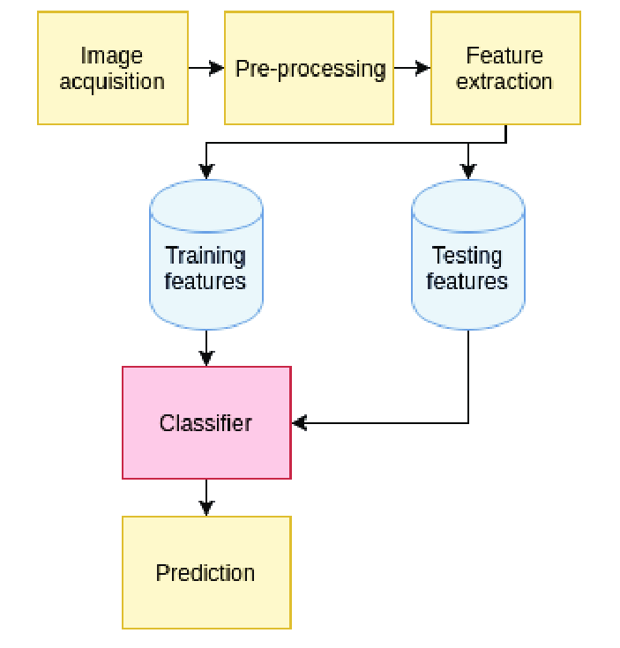

## E. Key Features Of TensorFlow

* **Ease of Use**: High-level APIs streamline CNN model implementation.
* **GPU Acceleration**: Cloud-based TPU/GPU execution speeds up training.
* **Scalability**: TensorFlow’s modularity enables deployment at both research and production levels.

# IV. CHALLENGES IN BINARY CLASSIFICATION

Despite the advantages of TensorFlow and CNNs, several challenges persist:

1. **Data Imbalance**: Unequal class representation can bias model predictions.
2. **Overfitting**: Complex models may memorize patterns rather than generalize.
3. **Computational Costs**: Even with cloud GPUs, training deep models demands significant resources (He et al., 2016; Kaggle Dataset, 2025).

# V. APPLICATION OF CATS VS DOGS CLASSIFICATION

Binary image classification has practical applications across multiple domains. One of the most notable uses is in **pet identification systems**, where AI-powered classification can assist animal shelters and veterinary clinics in recognizing and tracking pets. This can help with reuniting lost pets with their owners and managing pet adoption databases efficiently. AI-based systems can accurately differentiate between breeds and identify individual pets based on their unique features, improving the effectiveness of pet management (Kaggle Dataset, 2025).

Another significant application is in **content management and automated image categorization**. AI-powered classification models can be integrated into photo organization applications, automatically sorting images into respective categories. This feature is particularly beneficial for personal digital archives, cloud storage platforms, and social media applications, where users can efficiently search and manage large volumes of pet images without manual intervention (TensorFlow Documentation, 2025).

Beyond static image classification, there is a growing demand for AI-based **real-time pet monitoring systems**. Smart surveillance cameras equipped with CNN models can distinguish pets from other objects, enabling smart home security systems to notify owners about pet activities. This advancement is useful for pet owners who need remote access to monitor their pets while away from home. Additionally, AI-driven surveillance systems can integrate with health monitoring applications to detect abnormal pet behavior, providing insights into an animal's well-being (He et al., 2016).

## VI. FUTURE SCOPE

The future of AI-based image classification extends beyond binary distinctions. A significant advancement would be in **multi-class classification models**, expanding the current

two-category system to include multiple animal species. By incorporating a broader range of species, AI applications can become more versatile, enabling comprehensive pet classification and breed detection (Kaggle Dataset, 2025).

Explainable AI (XAI) techniques present another future opportunity. While deep learning models offer impressive accuracy, they often function as black-box systems, making it difficult to interpret model decisions. Developing XAI frameworks will improve transparency, helping researchers and developers understand why a model classifies an image as a cat or dog. Explainability will also be critical in building trust among users, particularly in applications where misclassification could have significant consequences (TensorFlow Documentation, 2025).

Another critical area of future research involves edge computing and model optimization for deployment on mobile and IoT devices. Current deep-learning models are computationally expensive and require substantial resources for training and inference. Optimizing CNN architectures for mobile processors and lightweight edge devices will make real-time pet classification more accessible, particularly in applications such as home security systems, interactive pet toys, and veterinary diagnostic tools. The integration of TensorFlow Lite can play a significant role in scaling down models for real-time inference on devices with limited computational power (He et al., 2016).

To further improve classification accuracy, researchers can focus on augmented datasets and transfer learning approaches. Traditional models are limited by the diversity of training datasets. By integrating more diverse and

VII. OUTPUT

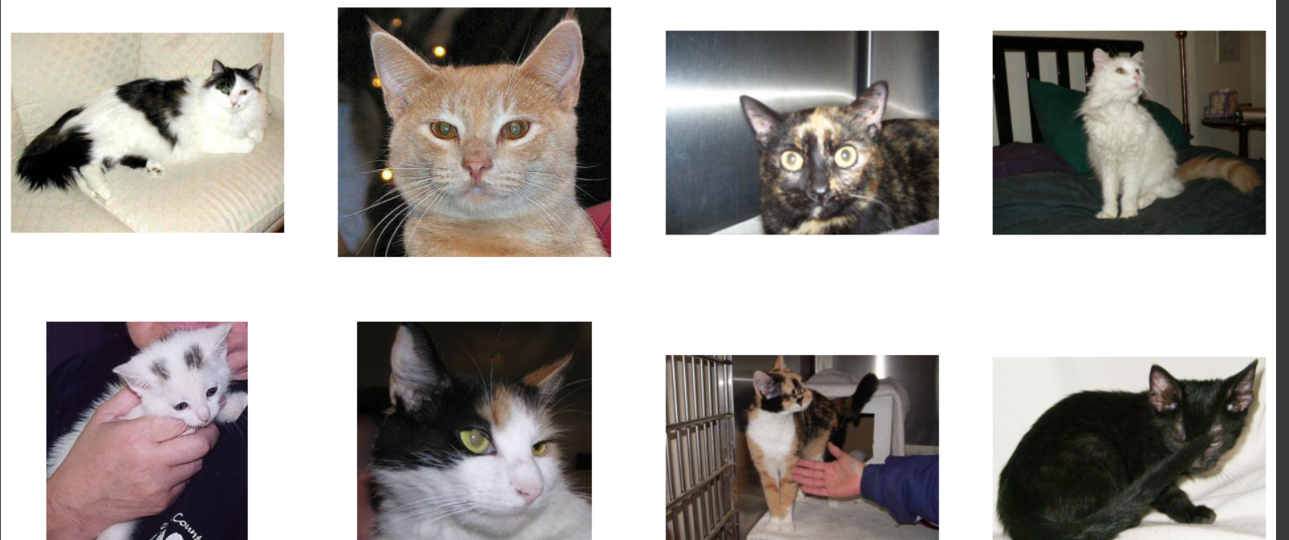

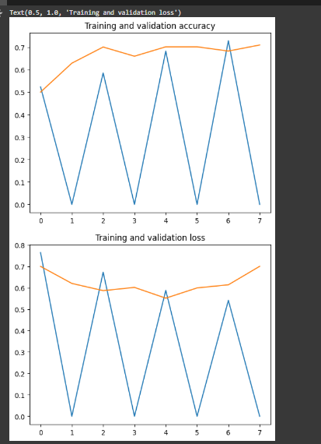

VIII. CONCLUSION

This study highlights the effectiveness of TensorFlow in implementing CNN-based image classification models for distinguishing between cats and dogs. The ease of use provided by TensorFlow’s Keras API, combined with the computational efficiency of Google Colab’s cloud GPU infrastructure, has significantly facilitated deep learning model development for this task. The classification of cats and dogs, while seemingly straightforward, presents challenges such as data imbalance, model overfitting, and high computational resource requirements (TensorFlow Documentation, 2025).

Despite these challenges, this research demonstrates that deep learning-based classification models are highly adaptable and offer numerous real-world applications in pet identification, content management, and smart home monitoring. With further advancements in multi-class classification, explainable AI, and model optimization for edge computing, AI-driven image classification will continue to improve, making it more accurate, scalable, and practical in real-world applications (He et al., 2016). Future research directions include refining model architectures to achieve higher accuracy with minimal computational overhead, integrating transfer learning approaches, and expanding dataset diversity to improve robustness. The continued development of TensorFlow’s deep learning ecosystem will undoubtedly enhance its capabilities in image classification, paving the way for more sophisticated and intelligent AI-powered solutions in the field of computer vision (Kaggle Dataset, 2025).

REFERENCES

[1] TensorFlow Documentation: "Building Image Classification Models with Keras." Available at: https://www.tensorflow.org/tutorials. Accessed January 2025.

[2] Kaggle Dataset: "Cats and Dogs Image Classification." Available at: https://www.kaggle.com/datasets. Accessed January 2025.

[3] He, K., Zhang, X., Ren, S., & Sun, J. (2016). "Deep Residual Learning for Image Recognition." IEEE Conference on Computer Vision and Pattern Recognition (CVPR), 770–778. doi:10.1109/CVPR.2016.308.

[4] LeCun, Y., Bottou, L., Bengio, Y., & Haffner, P. (1998). "Gradient-Based Learning Applied to Document Recognition." Proceedings of the IEEE, 86(11), 2278-2324.

doi:10.1109/5.726791.

[5] Krizhevsky, A., Sutskever, I., & Hinton, G.E. (2012). "ImageNet Classification with Deep Convolutional Neural

Networks." Advances in Neural Information Processing

Systems (NeurIPS), 25, 1097–1105