**ROBOTIC OIL SKIMMER**

**Prof. Hema S**¹**, Arunima B², Meera S³ , Megha Murali⁴, Naila Nahvi⁵**

¹Assistant Professor, Dept. of Electronics and Communication Engineering

²Dept. of Electronics and Communication Engineering

³Dept. of Electronics and Communication Engineering

⁴Dept. of Electronics and Communication Engineering

⁵Dept. of Electronics and Communication Engineering

**ABSTRACT**

The project is essentially done by creating an oil spillage cleanup vessel that would perform the removal of oil on water surfaces. Here, not only are the conventional procedures with pumps involved but instead, a specialized skimming system, fed by the IOT system, will oversee enhanced control and performance monitoring. The Inventive design of this system integrates a belt-driven skimming method to bring the oil up mechanically from water surface, thereby minimizing environmental turbulence. In contrast, Blynk IoT commands aid in driving the flipping flapper blades of the system, providing the possibility for remote and cruise navigation of the vessel. A turbidity sensor is installed into the apparatus to test the quality of water before and after skimming operations. This is important to assess how successful the skimming mechanism has been performed. The above-discussed approach is certainly beneficial in terms of practicality, cost-effectiveness, and environmental friendliness. By virtue of IoT power, this will allow users access to real-time data for ensuring operational adjustments, thus maximizing output at all times. Some experimental results demonstrate the effectiveness of this system in responding to small scale oil spills, even though some problems such as decline in skimmer capacity in slightly turbulent waters, occasionally requiring sensor recalibration, have been encountered. In spite of these limitations, the project reflects upon a huge potential alliance between electromechanical science and IoT technologies to resolve issues tied to accidental spillages of oil. Some work still needs to be done to beef up the robustness of the system, facilitate adaptability under varying conditions, and sustain the device in the long term.

**Keywords**: oil skimmer boat, oil spills, water surfaces, skimming mechanism, IoT technology, motor-driven skimming blades, Blynk IoT application, remote operation, real-time monitoring, turbidity sensor, water quality, environmental disruption, performance parameters.

**1.Introduction**

One of the major environmental catastrophes caused that need to be minimized are oil spills, which causes harm to marine ecosystems and coastal ammunitions around the world. Therefore, traditional oil spill cleanup practices are costly and labor-intensive. This project intends to develop an alternative source-a boat-based oil skimmer network embedded with IoT along with sensor technologies-for effective oil recovery operations, with more focus on a lightweight construction design for easy transport and suitability to diverse deployment conditions. The system should be inexpensive, employing cost-effective components while still being highly efficient. In addition, real-time monitoring, enabled by modern IoT technology giving users a means for remote tracking, may detect problems and continuously optimize system performance in the field.

**2.Problem Statement**

Oil spill represents one of the profound environmental disasters hereby causing detrimental effects to marine ecology, biodiversity, and coastal economies. Conventional oil spilling cleanup methods like chemical dispersants and pump-based recovery systems are highly expensive, inefficient, and labor-intensive. Besides, many of these methods create harmful residues or extremely disturb aquatic habitats, making them not environmentally friendly as such. Consequently, there arises the necessity of a cost-effective, portable, and environment-friendly solution to stop the happening. This project meets this gap by proposing an optimized- performance-monitoring and real-time monitoring IoT oil skimmer boat. The objective of this research is to create a light-effective, mobile, adaptable system so that undesirable externalities of oil spillwell, could be managed, while ensuring easy, without hitches, deployment and system operation for various water conditions.

**3. Methodology**

The methodology for the project contains various essential steps to make sure the system operates efficiently and functions well. Primarily, the design phase with component selection from a motorized system is done for motion, a turbidity sensor for real-time water quality control, and integration to the Blynk IoT platform for hands-free control is done. The motor system would allow this skimmer to traverse the surface of the water, while an oil collection device would be developed to recover the spilled oil effectively. The turbidity sensor will allow continual monitoring of water quality by regulation of the operational speed according to the oil contamination level. The Blynk IoT app is an interface for remote on-off and monitoring to allow users to keep track of parameters such as motor speed and oil collection efficiency. After the assembly of the system, testing and calibration in controlled environments are expected to be insightful, with field examinations in a real-life situation to optimize performance and scalability in a practical solution.

**4.Block Diagram**

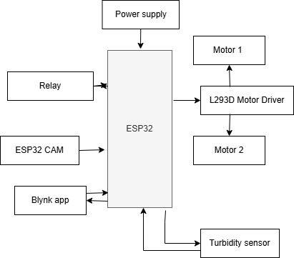

Fig 4.1 block diagram

**5.System Overview:**

**Requirements Analysis**: this phase involves stating the requirements for the operation of the robotic oil skimmer, which includes the oil type, environmental conditions, and recovery capacity.

**Component analysis:** aftercareful analysis, the components so selected are as follows.

**ESP32**

Any project aimed at using the potential of a microcontroller usually gravitates towards Arduino as a natural first choice hence, for our oil-skimmer project, we are opting to using an ESP32 microcontroller primarily due to its advanced nature and suitability to serve our needs. The ESP32 is an easy microcontroller to use with relevant digital and analog I/O pins to integrate sensors and motors into the system. It comes with built-in Wi-Fi and Bluetooth modules, hence suitable for IoT applications like remote control and monitoring of the skimmer through the Blynk app. It has a dual-core processor with a high clock speed supporting multi-threading to ensure that real-time data from turbidity or water level indicators and any individual task of real-time monitoring or making adjustments are executed. Besides, the low power consumption of the ESP32 makes it suitable for any project with long-term deployment in the field and very much needed in a remote area.

\On a flip side, the ESP32 has some limitations in terms of oil skimming. One of them is its sensitivity to various environmental factors, such as humidity, moisture, and others, which, if overexposed, can adversely affect the ordinarily expected throughput in the sketch unless waterproofing has been done. The strong learning curve, enshrouding the less knowledge of beginners in comparison with simpler microcontrollers such as Arduino, might require some extra effort in programming and debugging. Great as it is, developing solutions based on wireless devices raises issues of the reliability of the signals for users, where they may be used within poorly Wi-Fi-covered areas or those that experience interference. Finally, the limited libraries specifically focusing on operations related to oil skimming imply that a whole lot of custom coding may likely be needed, which often tends to delay the operation. Still, the ESP32 remains a highly versatile one and quite powerful, which can prove to be beneficial in making our project highly functional.

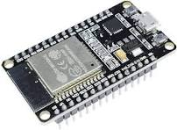

Fig 5.1 an esp32 module

**Motor System**: Here, we designed and assembled a mechanism driven by a motor for the moving oil skimmer in water. For smooth and precise operation, stepper motor or DC Motors were used along with an L293D motor driver.

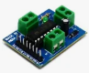

Fig 5.2 an L293D motor driver

The L293D motor driver is an IC that is used to control the speed and the direction of DC motors. It acts as an H-bridge driver, hence allowing a microcontroller to separately control two DC motors to go forward or backward. Its SWI and high versatility make it the best choice in robotics and automation projects. The allowable motor voltage for the L293D animated ranges from 4.5 to 36V and currents up to 600mA per channel, correspondingly. The inbuilt diodes are to be provided with the IC so that it protects the circuits from the back EMF, assuring it is long-lasting and reliable in operation when the motor is running. The enable pins from the IC allow easy control on/off for the motors; this gives far more flexibility into designs.

Here in this project, the L293D is used to drive the motor of the oil skimmer for good control of the motor speed and direction. This is very essential in various tasks, like changing the direction of the skimmer or moving it in such a way that oil is collected in a more efficient way. The L293D is good for controlling 2 motors simultaneously, which fits in very nicely for the skimmer, which could use any number of motors for tasks such as operating collection mechanisms or moving the device forward. It is economical and paired with the ESP32 microcontroller, easy to integrate, enabling easy communication and operation in this IoT-enabled application.

**Oil Collection System**: the oil collection system procedure is done by adding a skimmer belt that is activated from the data received from the turbidity sensor via the blynk app.

The conveyor belts continuously sweep through water and stick to oil due to their material properties. During the upward belt movement, the oil is collected into specific whale tusks, where it is either scraped off or deposited into a tank. This design is optimally conducive to a continuous and automatic oil recovery system, thus keeping operator's involvement to a minimum in order to maintain high efficiency. The unit is driven by a motor, which receives a command from the ESP32 microcontroller through the L293D motor driver. Sensors and IoT integration can provide real-time monitoring of the oil-skimming process in order to reap the required in-process arrangements for optimization.

At the moment, we shall be using an oleophilic belt with a belt mechanism to attract and contain oil while repelling water. The stickers used shall comprise certain oleophilic and hydrophobic materials that accomplish the process of sticking with oil but not withwater. With such a provision in place, oil will stick more effectively as no water will be picked up with it during the oil-skimming process. The surface texture of the belt is designed to allow for consistent oil pick-up, coupled with enough resilience to carry out continuous operations. The choice of this belt is essential as the recovery rates must be consistently high.

**Turbidity Sensor:**

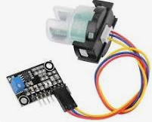

Fig 5.3 turbidity sensor

Turbidity sensors are used to measure a liquid's cloudiness or haziness due to the suspended particles that are present in a liquid. It utilizes the principle of light scattering that is, a light source inside the sensor which emits a beam of light into the liquid and a photodetector which measures the intensity of the transmitted and scattered light. The higher the turbidity of the medium, the greater will be the number of particles and light scattering being done by these particles. The turbidity sensors are used in water quality monitoring, environmental studies, and industrial applications for assessing the liquids. Most incorporate either analog or digital type outputs that can be interfaced with microcontrollers such as the ESP32 for real-time monitoring.

In this project, we are using a Turbidity Sensor Module TSD-10. The above sensors are often used to measure water quality and can be used to measure turbidity levels of a wide range of liquids. The sensor is compact and gives reliable and accurate measurements for suspended particle concentration in water. The turbidity sensor is an important tool meant to monitor the clarity of water during oil skimming. By monitoring turbidity changes, it can provide information on the operational efficiency of the skimmer in removing oil from water and feedback in improving system operation.

**ESP 32 CAM module**This is placed on the robotic oil skimmer to control the boat even if the oil skimmer goes far off sight. It aids in better control of the boat.

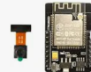

Fig 5.4 esp32 cam module

**Data Processing**: upon connecting the turbidity sensor into a microcontroller (like an Arduino) for data processing, the data will be used by the system to, in turn, trigger an action like possibly thereby increasing the speed or adjusting the skimmer settings.

**6. IoT Integration:**

**Blynk App** : The Blynk IoT platform is used for the to control and monitor the robotic oil skimmer. The app would assist the user in monitoring a few real-time parameters, such as motor control and turbidity of water. when the presence of oil is detected, the blynk app grants a notification based permission setting by which we can initiate the process of oil skimming and a live video of the esp32 cam is also displayed in the blynk app when the skimmer is at a far offsight, thus offering the user to access the boat smoothly

**Microcontroller Programming**: Codes will be written to enable connecting the turbidity sensor and motors, so that they would be informed about directly reporting contacts with the Blynk IoT platform for skimmer and app control.

**7. Testing and Calibration:**

Prototype Testing: The verification of the operability of the oil skimmer, accuracy of the turbidity sensor, and effectiveness of the Blynk IoT will first be tested under controlled conditions.

**Calibration**: The rigorous calibration of the turbidity sensor must be done, so that by motor regulation, the skimmer can adjust based on the different turbidity levels of water to allow the collection of maximum oil so spilled.

**8. Optimization and Final Deployment:**

**System Optimization**: Optimization and the performance of the skimmer is done by refining its movement patterns, improving the oil collection mechanism, and ensuring the robustness of the IoT interface.

**Field Trials:** Field tests in open water were conducted to prove the effectiveness and scalability of the robotic oil skimmer within the different environmental settings.

in accordance with this methodology, the autonomous operation of the robotic oil skimmer enabled efficient oil recovery, sensing its environment, and Blynk IoT control and monitoring from the cloud.

**9. Result**

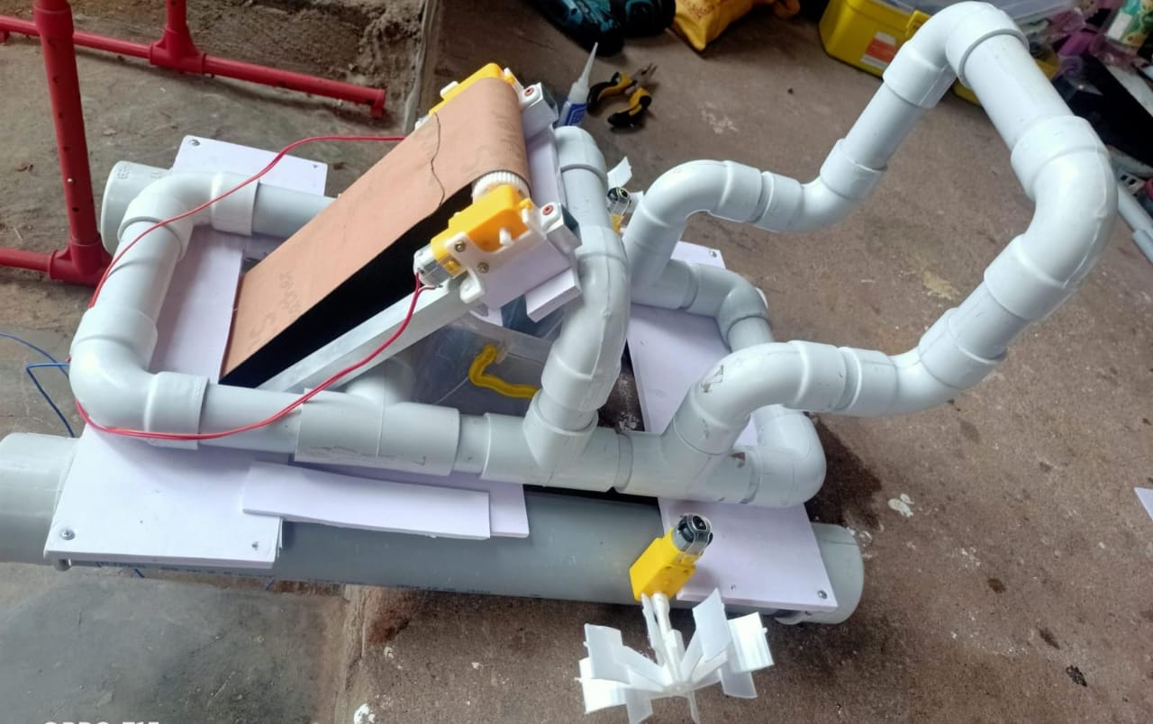

Fig 9.1 the robotic oil skimmer setup

Devised a robotic oil skimmer that not only runs on water but also skims the oil from the water surfaces upon proper usage. With the help of multiple robotic oil skimmers and if done on a larger scale, the oil can be more effectively and efficiently collected from the water in events of oil spillages.

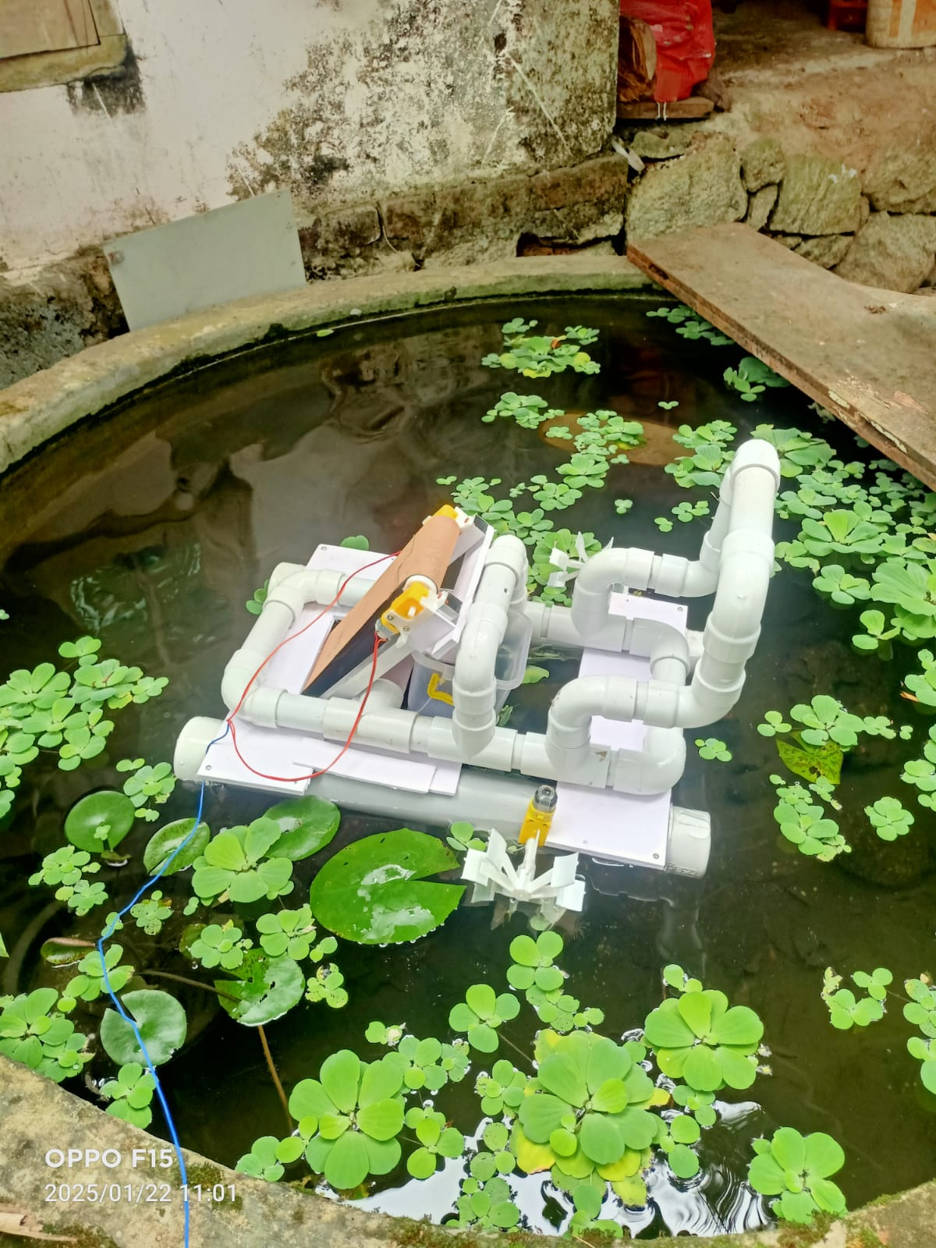

Fig 9.2 the testing of oil skimmer

**10. Conclusion**

The robotic oil skimmer project is the most innovative and practical way to deal with environmental issues that arose from oil spills in aquatic bodies. In fact, it combines motorized movement, a turbidity sensor for real-time monitoring of water quality, and the Blynk IoT platform for remote control; hence, it offers an automated and scalable method of oil recovery. This initiative offers an economically better option keeping the traditional manual approaches in mind, thus increasing the efficiency of oil spill management while also reducing the environmental impact. This effective design and application of the robotic oil skimmer could enhance oil spills and turn the affected water bodies safer and cleaner thus granting a boon to both corporates and the marine ecosystem.

**10.References**

[1] Eugene, C. Z., Lim, J. J., Nirmal, U., & Lau, S. T. (2019). Battery powered RC boats: a review of its developments for various applications. Current Journal of Applied Science and Technology, 33(5), 1-29.

[2] Sabari, M., Aswinth, P., Karthik, T., & Kumar, C. B. (2020). Water quality monitoring system based on IoT (2020).

[3]Đorđević, M., Šabalja, Đ., Mohović, Đ., & Brčić, D. (2022). Optimisation methodology for skimmer device selection for removal of the marine oil pollution. Journal of marine science and engineering, 10(7), 925.

[4]Salleh, A., Hashim, N. M. Z., & Mohamad, N. (2022). Realization of IoT Water Monitoring System using Node MCU ESP8266 Microcontroller and Blynk Application. vol. X, 209-213.

[5]Maier, A., Sharp, A., & Vagapov, Y. (2017, September). Comparative analysis and practical implementation of the ESP32 microcontroller module for the internet of things. In 2017 Internet Technologies and Applications (ITA) (pp. 143-148). IEEE.

[6]Alani, S., Mahmood, S. N., Attaallah, S. Z., Mhmood, H. S., Khudhur, Z. A., & Dhannoon, A. A. (2021). IoT based implemented comparison analysis of two well-known network platforms . Int. J. Electr. Comput.

[7]Godawarikar, S. S., & Gavhane, A. T. (2020). Literature review on oil recovering skimmer from the surface of water. Int J Eng Res Technol, 7, 3956.