|  |  |  |
| --- | --- | --- |
| P.B. Naveen *Department of CT-UG Kongu Engineering College* Erode, Tamilnadu [naveen200412.p@gmail.com](mailto:naveen200412.p@gmail.com)  Ms.N. Kaya *Department of CT-UG Kongu Engineering College* Erode, Tamilnadu ` | R. Ponkavin  *Department of CT-UG Kongu Engineering College* Erode, Tamilnadu [ponkavin051004@gmail.com](mailto:ponkavin051004@gmail.com) | Dr.S. Gandhimathi  *Department of CT-UG Kongu Engineering College* Erode, Tamilnadu |

BRAILLENET : AN OPTIMIZED DEEP LEARNING BASED FRAMEWORK

FOR BRAILLE TEXT-TO-AUDIO CONVERSION

**Abstract---** Braille is a very important source of literacy and communication for the blind; however, current methods in Braille recognition and conversion often lack either efficiency, scalability, or accuracy. In order to cope with such a challenge, we introduce BrailleNet, a custom deep-learning model for Braille image recognition and audio generation. The dataset of Braille characters used in this study was taken from Kaggle; it contains more than 1650 images for each of the 26 alphabets, making up diverse Braille patterns. BrailleNet is also extensively benchmarked against the standard machine learning and deep learning models, including SVM, ResNet, and EfficientNet. All experiments consistently show that BrailleNet has the highest accuracy, less computational overhead, and strong generalizability over diverse Braille datasets to establish itself as the state-of-the-art solution in this area.

The developed system integrates BrailleNet with a web application supporting image uploads containing Braille sentences. The proposed framework is scalable and deployable for real-world use, showing great strides in trying to bring inclusive technologies to the doorsteps of visually impaired individuals.

**Keywords: BrailleNet, Resnet, Prediction, Image Classification.**

**I.INTRODUCTION**

The Braille system, invented by Louis Braille in the early 19th century, has been a cornerstone of literacy and independence for the blind. It is a tactile writing system; users can read and write using raised dots arranged in specific patterns. Over the years, Braille has become one of the important tools in education, communication, and day-to-day tasks for millions around the world. But bringing Braille into the modern digital ecosystem has remained a challenge despite its importance. Most sharing of information in this digital age occurs through screens and audio; visually impaired persons, therefore, face immense barriers to access to written material in Braille. This process has made Braille very expensive and hard to update or reproduce, thereby limiting access to physically available Braille books and other resources. While technological strides have indeed been made in converting printed text into digital formats, the same progress has not been made in converting Braille text into readable and audible formats. Many of the existing Braille recognition systems are based on traditional techniques that are either inaccurate, or not scalable, or do not handle real-world challenges such as Braille quality variation, noise in scanned images, and non-standard formatting.

Such limitations bring out the need to find innovative solutions to bridge the gap between this tactile Braille medium and digital communication. Modern machine learning allows creating systems with realistic goals not only in high-accuracy Braille text recognition but also in translating Braille texts into easily consumable formats, like text and audio. This would greatly improve the accessibility and usability of Braille in a digital context, enabling visually impaired users to interact with technology and access information much more effectively.

**II. LITERATURE SURVEY**

Only a few researches have been done ………… Nagwa Elaraby et al. [1] presented a generalized ensemble approach for Braille Character Recognition (BCR) by using transfer learning models to improve the accuracy on datasets. The research evaluated 17 transfer learning models on three datasets: handwritten Braille - Omniglot (HBO), Braille Character (BC), and a newly developed Arabic Braille (AB) dataset. The authors suggested three ensemble techniques by majority voting of the top performing models. The combination of DarkNet-53, GoogleNet, SqueezeNet, and DenseNet-201 showed the best performance with F1 score of 89.42% on HBO, 99.58% on BC, and 97.11% on AB dataset respectively, and also showed lower generalization error than solo models.

Vishnu Preetham Revelli et al. [2] proposed a system to automate Braille text-to-speech conversion using a customized CNN model. The research focused on extracting Braille text from images, translating it into English, and providing an audio output. The CNN model was designed to classify 26 Braille alphabet classes with an accuracy of 96.15%. The system proved robust against challenges like low-light conditions and hence is suitable for real-time applications.

Tasleem Kausar et al. [3] developed a Braille character recognition approach based on deep learning using lightweight CNNs. This paper was carried out in two steps: image preprocessing to align and enhance the image and a character recognition step based on CNNs with integrated inverted residual block (IRB) to lower the computational cost. This method is tested on the English Braille and Chinese double-sided Braille image datasets and obtains prediction accuracies of 95.2% and 98.3%, respectively. The lightweight model achieved efficient processing times, and it demonstrates to be a viable solution for practical Braille recognition.

Tasleem Kausar et al. [4] further explored Braille character recognition by designing a new CNN-based method: The combination of image preprocessing techniques, including principal component analysis and Wiener filtering, was integrated into a novel Inverted Residual Block to further improve the efficiency of recognition. The model reached 95.2% and 98.3% on English and Chinese Braille dataset with test times 0.01s and 0.03s respectively. The research has shown the model to be robust, computationally efficient, and potentially integrable in accessible users' interfaces.

I. R. Bothaa et al. [5] developed a new portable tactile Braille reading device based on Dielectric Elastomer Actuators (DEAs) and optical character recognition (OCR) software. The focus of the project was to bridge the gap in the availability of quality Braille reading material in South African schools for the visually impaired. Low-cost, miniaturized designs were emphasized, and the performance assessment of DEAs fabricated from VHB4910 acrylic film and MG Chemicals 846 carbon grease was conducted. The OCR software showed improved accuracy in the recognition of multiple characters, hence great potential for implementation in low-cost Braille assistive technologies.

Made Ayu Dusea Widyadara et al. [6] proposed an advanced Braille character recognition approach using the Mask Region-Convolutional Neural Network (MRCNN), where high-speed image processing and robust object detection ability significantly improve the precision and efficiency of Braille recognition. The study, therefore, emphasizes how MRCNN can be an avenue for improving communication and information exchange between visually impaired and sighted people for facilitating better accessibility and independence.

Filiz Dalip et al. [7] Introduced Raspbraille: a new system to translate text and audio into Braille by using Optical Character Recognition (OCR) and speech recognition algorithms. It photographed the text documents, processed them via OCR, and changed them into Braille characters. Similarly, the audio inputs were converted into text and then into Braille. A physical device using servo motors was developed in order to display the Braille letters thus fastening the way for visually impaired people to access written information.

Abdulmalik AlSalman et al. [8] tackled the issues in Optical Braille Recognition for multilingual Braille documents; they, therefore, proposed a deep learning-based model for the high-precision recognition of Braille image to translate into multilingual text through DCNN. There has been an effective progress in using classification accuracies up to 99.28% and 98.99%, respectively, when tested using different datasets. Hence, DCNNs will minimize the gap between visually impaired people and sighted persons.

Byeong-Sun Park et al. [9] developed a two-fold approach toward Braille recognition with the use of visual and tactile perception techniques: In the visual perception part, a Faster R-CNN–FPN–ResNet-50 model was applied to achieve an mAP50 of 94.8 and mAP75 of 70.4 on our own Braille dataset. For tactile perception, a flexible capacitive pressure sensor array detects Braille characters. The combination of visual and tactile methods provided a holistic solution, creating the way for innovative assistive technologies for the blind.

A.Mousa et al. [10] proposed a system using the most updated image acquisition, noise removal, and segmentation techniques in order to increase efficiency in the Braille recognition process. This flexible system supports Grade 1 and Grade 2 Braille, thus it is easily adaptable to different users' needs and can contribute toward better literacy among the blind or visually impaired persons.

Liqiong Lu et al. [11] proposed an anchor-free Braille character detection method for natural scene images based on the edge feature. Introduced a new dataset called NSBD, designed to detect small-size Braille characters that are composed of Braille dots located at the edge region of the character. Their method used CNN to improve pattern recognition in Braille detection.

Dong-Hun Yoo and Soo-Whang Baek [12] developed a portable device that translates text into Braille using a Raspberry Pi camera module and the pytesseract OCR library. The system captures the images, extracts the text, and converts it to Braille, outputting the information through a 20-cell Braille module. The device was designed with efficiency and portability in mind, using 3D printing and ABS resin for better tactile recognition.

R. Sathish Kumar et al. [13] developed a system that extracts text from images and converts it into speech. The method used OCR for text extraction and applied text-to-speech conversion to make information accessible to the visually impaired and illiterate users. The study emphasized the application of image processing and digital technologies for accessibility.

Ilya G. Ovodov [14] proposed a semantic-based annotation enhancement algorithm to improve machine learning efficiency in optical Braille recognition. This approach took pseudo-labeling with semantic enhancement, and the optimizations are done by the domain-specific knowledge on machine-generated annotations to ensure better performances.

Vishwanath Venkatesh Murthy et al. [15] presented a system to translate Braille Grade-1 and Grade-2 words to English. The preprocessing of the Braille image is done using MATLAB, and the system further performs noise reduction and feature extraction by adaptive histogram equalization and CNN. The recognition accuracy of this system is very high: 97%~100% on different datasets.

**III. PROPOSED SYSTEM**

**3.1. System Architecture:**

The system architecture for the proposed BrailleNet model is designed in such a way that it effectively handles Braille image recognition and conversion into audio output. The system architecture is modular, with three main components: image preprocessing, model development, and output generations, as indicated in Figure 3.1. It would begin with the uploading of a Braille sentence image by the user. These frames are then passed through the BrailleNet model in order to recognize each character in Braille. After recognition, the characters are combined to form a complete sentence that is then converted to audio using text-to-speech synthesis.

The architecture also includes a web application, which provides user interaction capabilities—uploading of Braille images, showing the recognized text, and the output. The system guarantees accessibility for visually impaired users, as this efficient and automated way of translating Braille images into spoken language is very user-friendly.

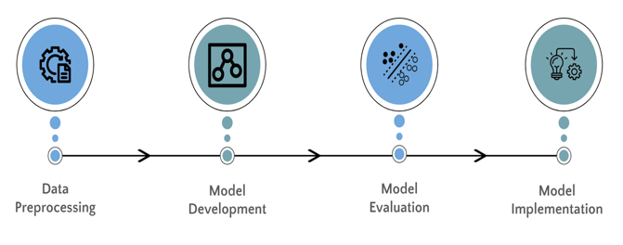

Fig.3.1 Proposed model workflow

**3.2. BrailleNet:**

BrailleNet: A custom-built deep-learning model for the recognition of Braille characters from images, where the model has been developed with multiple layers optimized for efficient feature extraction and classification of Braille characters. The input image is passed through quite a few convolutional and separable convolutional layers, which helps the model learn spatial hierarchies and recognize relevant features in an image. The architecture includes the following layers:

* **Input Layer**: The input layer accepts images of size 28×28×3 pixels.
* **Convolutional Layers**: The BrailleNet model uses standard, separable convolutional layers with ReLU activation, batch normalization, and regularization to avoid over-fitting and improve feature learning.
* **Pooling Layers**: Max-pooling layers are designed to decrease the dimensionality of the feature maps so that the model can focus on important patterns.
* **Fully Connected Layers**: This is followed by dense layers with ReLU activations, which process the features to make the final predictions. Dropout layers are added on top to prevent overfitting by randomly deactivating a fraction of the neurons during training.
* **Output Layer**: The last layer is the output layer, which has 26 neurons corresponding to the 26 letters of the English alphabet and uses a softmax activation function, hence outputting the probability distribution over each possible character.

BrailleNet is trained and evaluated over a Braille dataset with high accuracy in the recognition of Braille characters. Compared to traditional models like SVM, ResNet, and EfficientNet, it shows better performance on the recognition task for Braille images. The trained model is deployed on a web application that will allow real-time image-to-text and text-to-audio conversions for Braille sentences.

**IV. MODULE DESCRIPTION**

The architecture of this system will hold various modules performing image preprocessing, Braille image recognition training and testing, and efficient generation of corresponding audio output, taking care that every module provides services in favor of the optimization of BrailleNet modeling and increasing its performance, implying that higher overall accuracy is realized through such specialization from Braille image acquisition and preprocessing up to sentence mapping with the equivalent Braille notation, leading into a proper, valid text-to-audio conversion system.

#### 4.1 Data Handling

The Data Handling module takes care of the input and output through the system in terms of data. This consists of various steps: it loads Braille image data and pre-processes them. The images are resized and normalized to let the system work efficiently in a coherent way. It also contains data splitting for training and test sets, ensuring that there is a trained dataset representative of diversity. Along with image data handling, this module is responsible for converting images into frames so that individual characters can be recognized. A few data augmentation techniques like rotation and flipping are also performed so as to introduce diversity in the dataset, making the model more robust.

#### 4.2 Model Training

The Model Training module is in charge of the training of the BrailleNet deep learning model with the pre-processed dataset. During training, the model learns Braille characters by changing the weights of the layers with respect to the input data. The main steps in this module include:

* **Hyperparameter Tuning**: Choosing the optimal parameters, such as learning rate, batch size, and epochs, to improve model performance.
* **Loss Function**: The module is using categorical cross-entropy as the loss function, which is right for multi-class classification tasks.
* **Optimizer**: The Adam optimizer is utilized for updating the model weights during training, and this achieves fast convergence with better accuracy.
* **Validation**: A separate validation set is also used to evaluate the model's performance during training, so early stopping can be implemented to prevent overfitting. Once a threshold accuracy is reached, the trained model is saved for future use and deployment.

#### 4.3 Evaluation

The Evaluation module is used to test the trained model with several major metrics in order to identify how effective it is in recognizing Braille characters. Some of the components of this module are:

* **Accuracy**: Accuracy refers to the estimation of the general performance of the model: the percentage of correct predictions made by the model on the test dataset. High accuracy means that the model has learned how to recognize Braille characters correctly.
* **Classification Report**: It generates a classification report that provides a detailed breakdown of the model's performance for each class, or Braille character. This will also include the precision, recall, and F1-score of each class in the sense of understanding how the model can correctly classify characters and handle imbalanced classes.
* **Confusion Matrix**: The Confusion Matrix allows the model's performance to be visualized across all classes, showing the number of true positives, true negatives, false positives, and false negatives for each Braille character. It is actually a matrix that helps to spot any misclassifications and areas where the model may struggle.

#### 4.4 Visualization

The Visualization module is actually used to graphically present the model's performance during training and evaluation; this will really help in showing the learning procedure of the model and in identifying possible problems.

* **Accuracy Graph**: Figure 4.1: How the accuracy of the model changes during training; this plot includes the training and validation accuracy at each epoch, so it is actually a visual presentation of how the model generalizes on unseen data. The steadily rising accuracy curve gives proof that learning has taken place.

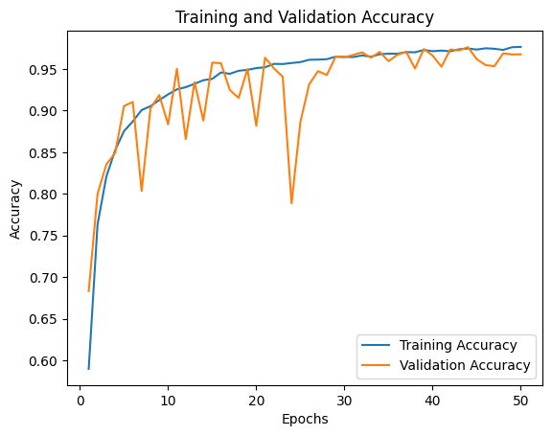

Fig 4.1 Training and Validation Accuracy of the BrailleNet model

* **Loss Graph**: Figure 4.2: Loss value at each epoch during training. It will be easier to keep an eye on whether the model, while training, is converging because a drop in loss proves that the model is learning—diminishing error. It might signal that the model needs to be either regularized by some hyperparameter adjustments or maybe it has become overfitted.

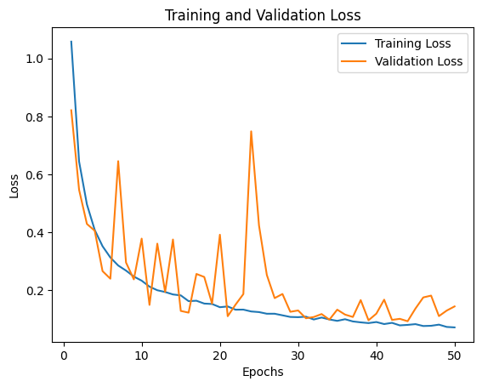

Fig 4.2 Training and Validation Loss of the BrailleNet model

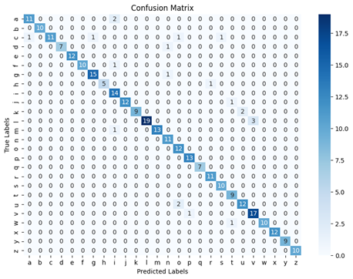

Fig 6.1 Confusion matrix of the BrailleNet

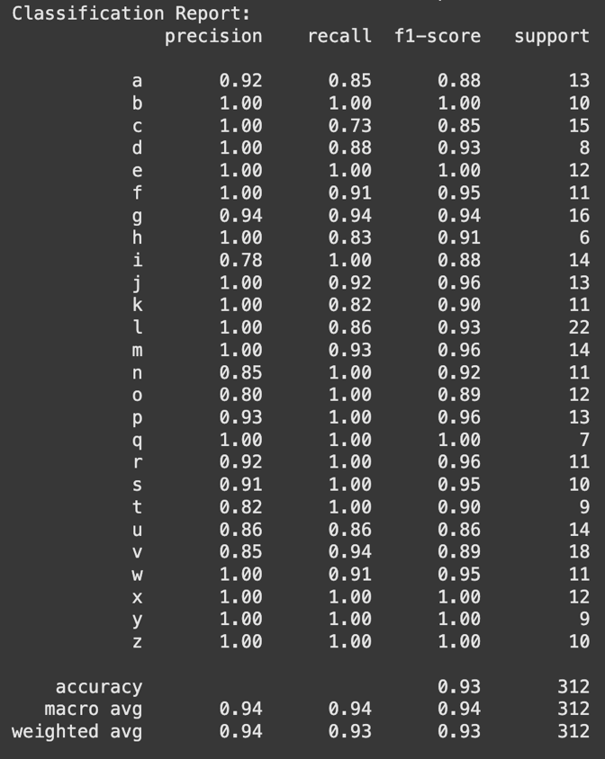

Fig 6.2 Classification report of the BrailleNet

**V. IMPLEMENTATION**

We compare the performance of the proposed Braillenet with three state-of-the-art deep learning models: SVM, EfficientNet, and ResNet. Each of these models has its unique advantages, and the goal is to assess their effectiveness.

#### 5.1 BrailleNet

The Braillenet model will be a Braille character-recognizing, custom CNN-architecture model working with images. The proposed model takes an input image (28x28 pixels) that passes through a sequence of convolutional layers followed by batch normalization, max pooling, and separable convolutions, which help the model in the better extraction of features from input images. Then, the Dense Layers help the model in recognizing characters. The last output layer uses a softmax activation function to predict one of the 26 Braille characters. The model is trained using L2 regularization technique and dropout to prevent overfitting. Braillenet is trained on large datasets of images in Braille with high accuracy, outperforming the traditional models like SVM, ResNet, and EfficientNet for the Braille character recognition task.

#### 5.2 EfficientNet

EfficientNet is the state-of-the-art CNN architecture, known for its efficiency in model size and performance. The architecture classifies Braille characters from the input images. It exploits a compound scaling method by balancing the depth, width, and resolution of the network for optimal performance. EfficientNet makes a strong claim for Braille character recognition due to having very few parameters yet maintaining high accuracy. Still, while Figure 5.1 shows EfficientNet to have very promising results, it falls short of Braillenet, mainly due to the specialized nature of the recognition tasks for which Braillenet's custom layers and architecture make more sense.

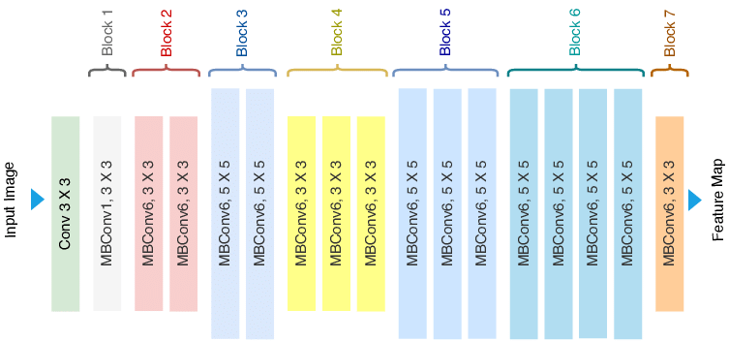

Fig 5.1 Efficient Net Architecture

#### 5.3 ResNet

ResNet: Figure 5.2 represents a very famous CNN architecture with residual connections, which is also tested for Braille character recognition. In this way, the residual connections allowed the model to train a very deep network by overcoming the vanishing gradient problem. ResNet was trained using the same dataset of the Braille images and evaluated in terms of accuracy and efficiency. While ResNet performs well and shows improvements over SVM, it does not match the accuracy and precision of Braillenet, which is designed specifically for the task of Braille image recognition. However, the ability of ResNet to train deeper models without losing information makes it a good alternative for more complex tasks in image classification.

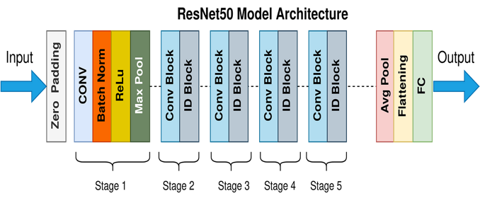

Fig 5.2 Architecture of ResNet

#### 5.4 SVM

### SVM is a classical machine-learning technique, which is applied to the classification of Braille characters. For this implementation, first, pre-processing of the Braille images is performed by converting them into feature vectors and normalizing them for the SVM. In this case, the RBF kernel is used to map the input into a higher-dimensional space, helping SVM handle the non-linearly separable data more fittingly. After training the SVM on the dataset, the model is tested on unseen images in order to classify Braille characters. Although SVM does a decent job, it still lags behind BrailleNet in terms of accuracy and speed, mainly for complex image patterns.

### 

### VII. PERFORMANCE ANALYSIS

Validating the effectiveness of the proposed BrailleNet model, performance comparisons are given with the three widely recognized deep learning models: SVM, EfficientNet, and ResNet. Each has unique characteristics, and the comparison shows how BrailleNet will turn out relative to other approaches in terms of recognizing Braille characters.

#### 7.1 Accuracy:

From Table 7.1, it can be viewed that BrailleNet has better accuracy than SVM and the traditional deep learning models: EfficientNet and ResNet. While SVM is a very strong model in machine learning, it clearly suffers from the complexity in image-based recognition tasks, especially in the high-dimensional data of Braille character images. BrailleNet has custom architecture and hence a higher accuracy rate, which actually denotes that this network is much stronger in the classification of Braille characters. Although EfficientNet and ResNet are powerful in many image classification tasks, they also show competitive accuracy scores but slightly lower than BrailleNet because of their complex architecture, which needs huge amounts of training data to perform at their best.

**Table 7.1**: Comparison of the accuracy of the models

|  |  |
| --- | --- |
| Model | Accuracy (%) |
| Braillenet | 93.27 |
| SVM | 80.77 |
| EfficientNet | 69.87 |
| ResNet | 88.14 |

**VIII. RESULTS AND DISCUSSION**

The performance of the proposed BrailleNet model is evaluated alongside three other models— SVM, EfficientNet, and ResNet—using accuracy as the primary metric. Results demonstrate that BrailleNet achieves the highest accuracy among the four models, with a significant lead over SVM (80.77%), EfficientNet (69.87%), and ResNet (88.14%). This indicates that BrailleNet is highly effective in the recognition of Braille characters, outperforming the other models by a considerable margin. The model's superior accuracy can be attributed to its specialized architecture, which is designed to optimize the recognition of Braille patterns. BrailleNet's custom layers and regularization techniques allow it to extract more relevant features from the input images, resulting in improved classification accuracy. In comparison, SVM, though a strong machine learning model, struggles with the complexity of image based classification, particularly with Braille images that require the model to capture subtle variations in character structure. This limitation is reflected in its accuracy of 80.77%, which, while respectable, is considerably lower than that of BrailleNet.

EfficientNet, while generally efficient in image classification tasks, posts a relatively lower accuracy score of 69.87%. This model, designed for general image recognition tasks, seems to struggle with the specific requirements of Braille image recognition, probably due to its generalization to a wider range of features, which may not be as relevant for Braille-specific patterns. ResNet: The deep learning model based on residual networks exhibits better performance, with an accuracy of 88.14%. It, however, still lags behind BrailleNet in the actual scores. The model does a very good job in capturing difficult patterns but falls short in delivering the same precision and recall values for Braille character recognition like BrailleNet. The accuracy comparison among all four models is provided in Figure 8.1, which obviously indicates the superiority of BrailleNet in performance. This comparison underlines the effectiveness of the proposed BrailleNet model for the recognition of Braille characters, as it outperforms all traditional machine learning models and other deep learning models by a large margin.

In other words, results prove that BrailleNet is the most appropriate model for Braille character recognition and can, therefore, be applied in many applications such as Braille-to-text and Braille-to-audio conversion. The findings show the importance of using a model tailored to the peculiarities of Braille images.

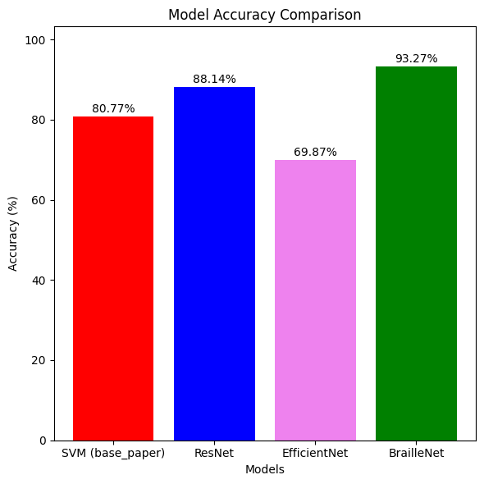

Fig 8.1 Comparison of the performance of Deep Learning models

**IX.CONCLUSION**

This manuscript presents a new deep learning-based system, BrailleNet, developed for the identification of Braille characters from pictures. The envisioned system exploits CNN most recent techniques and technologies to accurately classify the Braille characters in an efficient way and translates into textual and auditory forms for blind users. A comparison of BrailleNet's performance is given on three state-of-the-art: SVM, ResNet, and EfficientNet architectures. Experiments and results showed that BrailleNet had an accuracy of 93.27%, way above SVM, EfficientNet, and ResNet in the task of Braille character recognition. In a comparison to explain the improved performance of BrailleNet, the custom architecture of BrailleNet was far superior in its optimization for these character patterns' detection within Braille images. In conclusion, it turns out very effective for BrailleNet application purposes in sight-related accessibility improvements for visually impaired individuals. This Braille translation system guarantees not only a high level of accuracy but also continuity for better user experience, as it accommodates a Web application that accepts uploading Braille sentence images from a user and converts these to text in real time to provide audio. That makes the proposed system robust in terms of Braille sentence real-time translations into an audio form. In other words, the BrailleNet model marks a great stride in the development of Braille recognition, hence offering a reliable, efficient, and accurate solution for the task of translating braille images into text and audio. This will empower visually impaired people with better tools to communicate and access information in a more thorough way.

In such a way, further enhancements and work in the future might lead to make this model even stronger against different kinds of variations in Braille image quality and real-world testing under a variety of evaluating conditions of system performance. That gives the possibilities to add features to support multilanguage and multicategory grades in Braille that will also greatly increase usefulness for visually impaired persons around the whole world.

**REFERENCES**

[1] Elaraby, N., Barakat, S., & Rezk, A. (2024). A generalized ensemble approach based on transfer learning for braille character recognition. Information Processing & Management, 61(1), 103545.

[2] Revelli, V. P., & Sharma, G. (2022). Automate extraction of braille text to speech from an image. Advances in Engineering Software, 172, 103180.

[3] Kausar, T., Manzoor, S., Kausar, A., Lu, Y., Wasif, M., & Ashraf, M. A. (2021). Deep learning strategy for braille character recognition. IEEE Access, 9, 169357-169371.

[4] Tasleem Kausar, M. S., Kausar, A., Lu, Y., Wasif, M., & Ashraf, M. A. Deep Learning Strategy for Braille Character Recognition.

[5] Botha, I. R., Bright, G., & Collins, J. E. T. (2022). Dielectric Elastomer Actuators and Optical Character Recognition in a Braille Display. R&D Journal, 38, 31-42.

[6] Wibawa, A. P., & Handayani, A. N. Enhanced Braille Character Recognition Using Mask Region-Convolutional Neural Network (MRCNN).

[7] Dalıp, F., Yıldız, K., Ülkü, E. E., & Büyüktanır, B. (2022). Raspbraille: Conversion to Braille Alphabet with Optical Character Recognition and Voice Recognition Algorithm. Hittite Journal of Science and Engineering, 9(4), 253-261.

[8] AlSalman, A., Gumaei, A., AlSalman, A., & Al-Hadhrami, S. (2021). A Deep Learning-Based Recognition Approach for the Conversion of Multilingual Braille Images. Computers, Materials & Continua, 67(3).

[9] Park, B. S., Im, S. M., Lee, H., Lee, Y. T., Nam, C., Hong, S., & Kim, M. G. (2023). Visual and tactile perception techniques for braille recognition. Micro and Nano Systems Letters, 11(1), 23.

[10] Mousa, A., Hiary, H., Alomari, R., & Alnemer, L. (2023). Smart braille system recognizer. *International Journal of Computer Science Issues (IJCSI)*, *10*(6), 52.

[11] Lu, L., Wu, D., Xiong, J., Liang, Z., & Huang, F. (2022). Anchor‐Free Braille Character Detection Based on Edge Feature in Natural Scene Images. Computational Intelligence and Neuroscience, 2022(1), 7201775.

[12] Yoo, D. H., & Baek, S. W. (2022). Developing of Text Translation and Display Devices via Braille Module. Mathematical Statistician and Engineering Applications, 71(3), 537-547.

[13] Kumar, R. S., Sujai, K., Ajay, R., & Vishva, S. EXTRACTING TEXT FROM IMAGE AND BRAILLE TO SPEECH CONVERSION.

[14] Ovodov, I. G. (2021, January). Semantic-based annotation enhancement algorithm for semi-supervised machine learning efficiency improvement applied to optical Braille recognition. In 2021 IEEE Conference of Russian Young Researchers in Electrical and Electronic Engineering (ElConRus) (pp. 2190-2194). IEEE.

[15] Hanumanthappa, M & Murthy, Vishwanath. (2024). Translating Braille Grade-1 and Grade-2 word to. International Journal for Research in Engineering Application & Management. 7. 2454-9150. 10.35291/2454-9150.2021.0608.