AI and IoT-Powered Irrigation System for Turmeric Farming Efficiency

Dharanishsriram L
Department of CT-UG
Kongu Engineering college
Erode,India
dharanishsriraml.22bir@kongu.edu

Nanthiya D
Department of CT-UG
Kongu Engineering college
Erode,India
nanthiya.ctug@kongu.edu

Jegan T
Department of CT-UG
Kongu Engineering college
Erode,India
jegant.22bir@kongu.edu
Gowshicksriraja S
Department of CT-UG
Kongu Engineering college
Erode,India
gowshicksrirajas.22bir@kongu.edu

Abstract—The backbone of India is Agriculture. We have to save the water for irrigation and water requirements. Agriculture has made significant advancements, but water scarcity remains a critical challenge, especially for small-scale farmers. IoT empowered smart irrigation system equipped with a lot of sensors like soil moisture, humidity, pH, temperature sensors and so on offer a solution. However, the high cost of such systems limits their accessibility for small farmers. This paper proposes the idea of smart irrigation system for small scale farmers. In Erode district of Tamil Nadu, turmeric cultivation often suffers from low yields due to limited awareness of soil pH, mineral content and water scarcity. To address this, the system incorporates pH sensors to provide insights into soil conditions, enabling farmers to improve soil composition for better crop growth. By combining soil moisture, humidity, and pH sensors, this affordable solution aims to conserve water, improve soil quality, and boost crop yields, offering practical support to farmers facing water and soil management challenges.
Keywords— Smart Irrigation, IoT, Water Management, Soil Moisture, Humidity, pH Monitoring, Turmeric Cultivation, Precision Agriculture, Sustainable Farming, Affordable Sensors, Crop Yield Optimization, Erode District.

Introduction
Agriculture has advanced significantly with technological innovations, yet challenges like water scarcity, soil degradation, and pest control persist, particularly in regions like Erode district in Tamil Nadu, known for its turmeric cultivation. Erode’s semi-arid tropical climate and diverse soils, including red loamy, black, and alluvial types, support crops like turmeric, sugarcane, and coconut, but limited water management and insufficient real-time soil health data affect productivity. Turmeric (Curcuma longa L.), a culturally and economically significant crop, is valued for its medicinal properties, with high-curcumin varieties like Lakadong gaining global recognition. This project addresses these challenges by utilizing Internet of Things (IoT) technology to implement smart farming practices .A Group of sensors like pH ,humidity ,soil moisture will collects data of the farmer’s farm .Enabling optimized irrigation, fertilization, pest control and farm security. By tailoring interventions for specific farmland sections, this precision agriculture approach improves resource efficiency, boosts crop yields, and reduces environmental impact. The system, designed to be affordable and accessible, empowers small-scale farmers in Erode to adopt sustainable practices, enhance productivity, and overcome agricultural challenges effectively.

Literature Survey
The paper on "IoT-based Smart Irrigation Management Using Machine Learning" [1]. They integrated sensors for UV light, SM- (soil moisture), air temperature monitoring, transmitting data via wireless networks. MLA were used to predict water requirements, optimizing water usage and enhancing crop yields through efficient resource management.
The paper on "Fuzzy Logic-Based Smart Irrigation System" [2]. Their system used air and soil moisture sensors with fuzzy logic for automated water pump control. The system turned off pumps during rain, saving water and energy, thereby promoting sustainable agriculture.
The paper on "Smart Irrigation Using IoT" [3]. Their system measured humidity, soil moisture, pH, and NPK levels, storing data in the cloud for analysis. Farmers received real-time updates for remote monitoring and improved irrigation strategies using historical data trends.
Munir et al presented a paper on "IoT for Smart Energy and Irrigation in Tunnel Farming" [4] .They used mainly IOT sensors to monitor the farm.by using tunnel farming we can reduce the labour cost easily.
Kanade & Prasad proposed a paper on "Arduino-based Smart Irrigation with Machine Learning and IoT" [5] ..The soil moisture sensor gives the data of soil levels .This paper gives the smart irrigation technique and water consumption idea.
Kumar et al. proposed a paper on "IoT-Based Automatic Irrigation System" [6].They are using the soil moisture sensor and ATMEGA32 processor to make automation. The Data was collected and stored in the cloud for future purposes.
The paper on "Smart Irrigation Using Machine Learning and IoT" [7].Environmental condition is monitored by Romyan’s method. Finally AIML model is used to prediction of making irrigation to the farm land .
Aggarwal & Kumar presented a paper on "IoT and Artificial Neural Network for Smart Irrigation" [8].Data of weather and soil is used to prediction and automation using ANN .This Model will predict the weather and may used to reduce loss.
The paper topic is "Smart Agriculture for Limited Space Farming" [9].They used to predict the nutrients values of plants in hydroponics system. In urban areas this model is very helpful to them to cultivate more crops.
Sakthi Sharan et al. (2024) proposed a paper on KNN based IoT system on irrigation .[10] This approach enhances water efficiency, sustainability, and crop yields.
Belkher et al. (2025) explored IoT-enabled precision irrigation for winter wheat in Tunisia, showing that 75% ETc deficit irrigation improves water efficiency without major yield loss.[11] This highlights IoT's role in sustainable water management.
The paper on “Cloud-based IoT smart irrigation” using LoRa networks and cost-effective moisture sensors, achieving 91.4% water efficiency on a strawberry farm in Paraguay.[12] This highlights the system's robustness and water-saving potential.
The paper on “IoT-based smart system for apple orchards, reducing pesticide and fungicide” use by up to 50% and 33%, respectively, while optimizing irrigation and fertilization for better yield and sustainability[13].
Saravanan et al. (2024) developed an Internet of things automatic plant irrigation system using machine learning models (SVM, RF, CNN, ANN) to optimize irrigation and predict agricultural yield[14]. Their system achieved high accuracy, promoting sustainable farming practices.

PROPOSED METHODOLOGY

Blynk IOT Platform:
The Blynk IoT platform allows remote monitoring and control of IoT devices through a user-friendly interface. It integrates with hardware like Arduino and Raspberry Pi for real-time data collection. Key features include user interface creation, cloud-based data storage, and customizable alerts for events like threshold breaches. Blynk IoT platform is used to convert the raw input into easily readable format. It gives the free data storage space in cloud .They also provides web application to control the water pump motors through online. This technique reduces the manual interventions and reduces the labour costs.
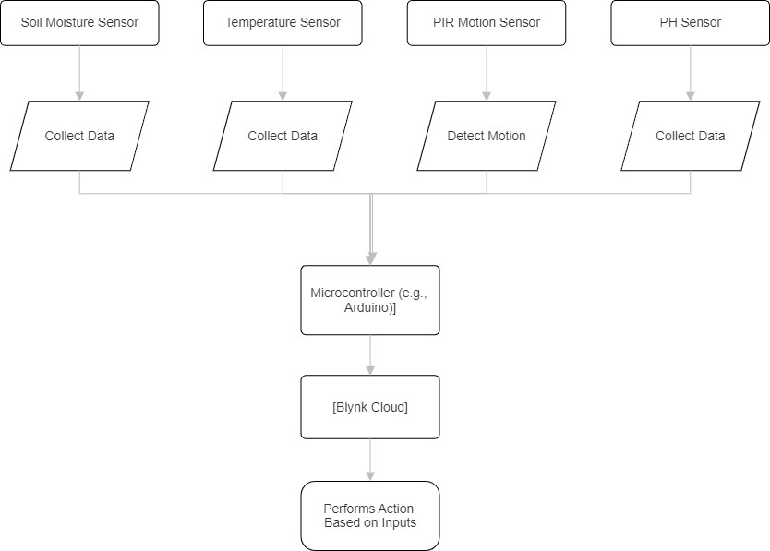
Figure1. Flow Chart

Arduino IDE
Arduino IDE is mainly used for coding uploading process. And then ESP8266 is a wireless module for communication. Sensors is used to collect the data. The ESP8266 get the sensor inputs, such as humidity ,soil moisture and temperature . Then they converts them to analog values into digital form for wireless transmission and analysis. This integration may allows to make the sensor data collection and mainly used to reduce the labour cost.

Workflow Description
- Install the Blynk library in Arduino IDE, then account creation is finished, and make authentication tokens. Using ESP8266, we can create the wireless network connection to make enabling to automation of sensor controls and reduce workers.
- Sensors like pH, soil, humidity data is collected by ESP8266 module. This data is wirelessly transmitted to IoT platforms for real-time monitoring, alerts, and actionable insights.
- The pH sensor, integrated with hardware and IoT platforms, helps monitor soil pH levels. Farmers receive suggestions and control irrigation pumps based on sensor data to maintain optimal crop conditions.

Results and Discussion
The pH measurement system is playing an important role in evaluating soil conditions for turmeric cultivation. The system employs a pH electrode to sense the soil's pH level .Then pH meter is used to gives reading. Calibration with high-quality buffer solutions ensures measurement accuracy, which is vital for maintaining optimal crop health.
The relationship between the pH sensor reading and voltage can be expressed as:
Voltage=pH Reading×1023.05.0 (1)
This equation converts the analog sensor data into a digital voltage output, enabling precise monitoring of soil pH. Proper calibration of the system enhances the reliability of these readings.
For the turmeric plant we have to maintain the soil pH range within 6.5 to 7.5 . The system provides recommendations for correcting deviations, such as adding gypsum for acidic soil or organic matter for alkaline soil. These actions ensure better crop yield and sustainability.
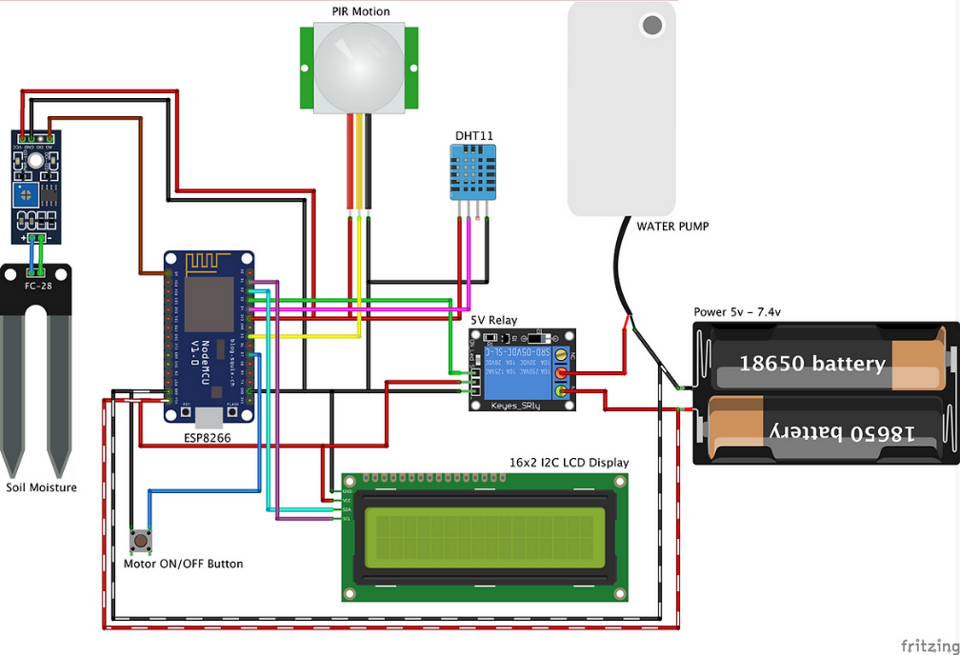
Figure2. Circuit Daigram

- We give suggestions like: Use gypsum to reduce soil acidity and achieve a pH of 6.5 for turmeric.
- Add limestone or organic matter to lower alkalinity and enhance soil quality.
- Maintain balanced soil pH for healthier turmeric growth.
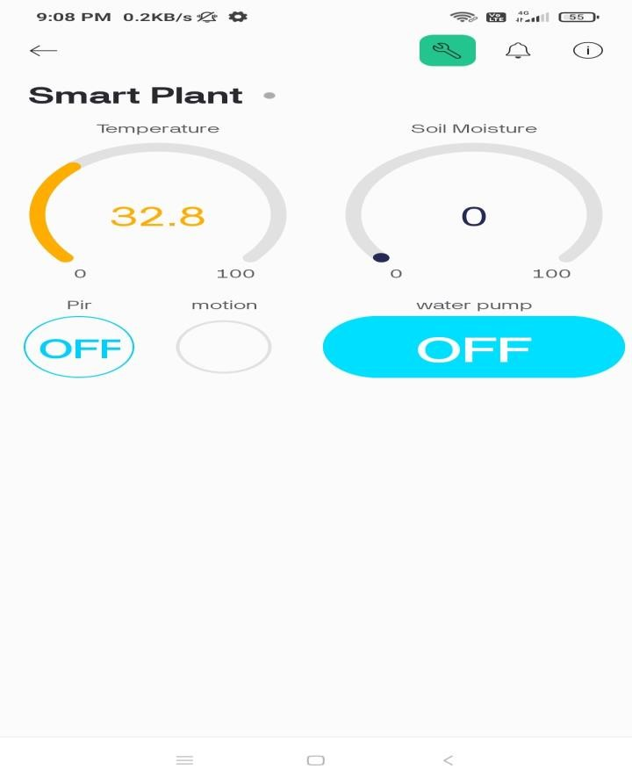Figure3. Blynk IOT platform

Conclusion
The smart farming is a transformative toolkit for future agriculture, offering real-time monitoring system of soil and climatic conditions through advanced sensors and IoT integration. By enabling farmers to remotely manage irrigation and soil health, the system supports efficient farm management and enhances crop yields, particularly for turmeric cultivation. However, incorporating weather forecasting capabilities, such as an evapotranspiration sensor linked to a weather app, would significantly enhance its functionality. This improvement would prevent water wastage during unexpected rainfall and optimize resource use. With such advancements, the system can become an even more effective and adaptive solution for sustainable farming practices.

References
- Goap, A., Sharma, D., Shukla, A.K. and Krishna, C.R., 2018. An IoT based smart irrigation management system using Machine learning and open source technologies. Computers and electronics in agriculture, 155, pp.41-49.
- Krishnan, R.S., Julie, E.G., Robinson, Y.H., Raja, S., Kumar, R. and Thong, P.H., 2020. Fuzzy logic based smart irrigation system using internet of things. Journal of Cleaner Production, 252, p.119902.
- Singh, H.P., Gupta, K., Verma, M. and Singh, J.B., 2022. Solar Based Smart Irrigation System Using NodeMCU and IoT. International Journal of Microelectronics and Digital Integrated Circuits, 8(2), pp.1-8.
- Munir, M.S., Bajwa, I.S., Naeem, M.A. and Ramzan, B., 2018. Design and implementation of an IoT system for smart energy consumption and smart irrigation in tunnel farming. Energies, 11(12), p.3427.
- Kanade, P. and Prasad, J.P., 2021. Arduino based machine learning and IOT Smart Irrigation System. International Journal of Soft Computing and Engineering (IJSCE), 10(4), pp.1-5.
- Kumar, D.S., Haritha, V., Pravalika, C., Kumar, V.U. and Vijay, P., 2018. Automatic Irrigation System Using IOT.
- Anagha, C.S., Pawar, P.M. and Tamizharasan, P.S., 2023. Cost-effective IoT-based intelligent irrigation system. International Journal of System Assurance Engineering and Management, 14(Suppl 1), pp.263-274.
- Aggarwal, S. and Kumar, A., 2019, March. A smart irrigation system to automate irrigation process using IOT and artificial neural network. In 2019 2nd International Conference on Signal Processing and Communication (ICSPC) (pp. 310-314). IEEE.
- Lakshmiprabha, K.E. and Govindaraju, C., 2023. Hydroponic‐based smart irrigation system using Internet of Things. International Journal of Communication Systems, 36(12), p.e4071.
- Sharan, M.S., Shivani, D. and Ramprasath, M., 2025. Enhancing crop prediction and resource management: A KNN-based approach coupled with IoT-driven smart irrigation for rice, wheat, and corn cultivation. In Challenges in Information, Communication and Computing Technology (pp. 238-242). CRC Press..
- Belkher, S., Latrech, B., Bekri, W., Markwordt, F., Rahim, M.A., Dupont, C., Ben Abdallah, M.A., Daghari, H. and Rezig, M., 2025. Deficit Irrigation and an IoT-Based System for Improving Yield and Water Use Efficiency of Winter Wheat Grown Under Semi-Arid Conditions. Agronomy, 15(1), p.157.
- Orihuela, L., Pacheco, E., Bareiro, J., Tapia, A. and Manzano, J.M., 2025. Deployment of a Smart Irrigation Control System with Capacity-Based Moisture Sensors on a Production Farm. Journal of Irrigation and Drainage Engineering, 151(1), p.04024039.
- Jamshidi, B., Jolfaee, H.K., Mohammadpour, K., Seilsepour, M., Dehghanisanij, H., Hajnajari, H., Farazmand, H. and Atri, A., 2025. Internet of things-based smart system for apple orchards monitoring and management. Smart Agricultural Technology, 10, p.100715.
- ] Saravanan, M., Jangirala, S., Sahib, D.F., Chaudhary, P., Santiago, J.J. and Naidu, B.V.V., 2025. Exploring advanced learning capabilities in an Internet of Things (IoT) based smart plant irrigation system. In Challenges in Information, Communication and Computing Technology (pp. 94-99). CRC Press.

