**INDEX**

|  |  |  |
| --- | --- | --- |
| Sr. No. | Content | Page No. |
| 1 | Abstract | 1 |
| 2 | Introduction | 2 |
| 3 | Defination , Merits Of Natural Lipsticks Over Synthetic Ones | 3 |
| 4 | Anatomy Of Lips | 4 |
| 5 | Types Of Lipstick | 5 |
| 6 | Ingredients . Uses Of Ingredients | 7 |
| 7 | Conclusion | 12 |
| 8 | Refrences | 13 |

**ABSTRACT :-**

Cosmetics have become essential in daily life for people of all ages, with new products introduced each year to keep up with the latest trends. However, many harmful cosmetic products are now available in the market. To address these concerns, the present research explores the benefits of herbal lipsticks. Lipstick, a popular beauty product, is used to enhance appearance, make lips look attractive, and protect them from UV rays and environmental damage. Traditional lipsticks often contain synthetic colors and harmful chemicals that can be damaging to the skin. In contrast, herbal lipsticks are gaining popularity due to their natural ingredients, which are safer and less likely to cause harm. They are easy to use, come in a wide range of shades and textures, and cater to diverse preferences. Herbal lipsticks generally have fewer side effects and are considered more skin-friendly. This review focuses on the natural ingredients used, formulations, extraction methods, and potential defects in lipstick. Additionally, it examines key parameters such as melting point, breaking point, smoothness, and pH levels.

**KEY WORD :-**

Cosmetics, Herbal lipstick, Formulation, Evaluation, Colour, Ingredients, side effect, safe.

**INTRODUCTION :- A. According to the Drugs & Cosmetics Act of 1940:**

The Act defines any article intended to be applied to any part of the human body for purposes such as cleansing, beautifying, promoting attractiveness, or altering appearance as a cosmetic. This includes products like skin moisturizers, perfumes, lipsticks, fingernail polishes, eye and facial makeup, shampoos, permanent waves, hair colors, toothpastes, deodorants, and any components used in cosmetic products.

**B. Characteristics of Herbal Lipstick:**

1. Long-lasting effect
2. Physically and chemically stable
3. Shiny and smooth appearance
4. Softens the lips

**C. Lipstick as a Cosmetic:**

Lipstick formulations are designed to protect the lips from sun damage and pollution, while enhancing their appearance. They are easy to use, especially for modern women. The use of botanicals in cosmetics has risen due to their mild action and non-toxic nature. Cosmetics often include both natural and phytochemical ingredients. Natural products may consist of oils, extracts, and secretions, while phytochemical ingredients are pure constituents obtained through various processes.

Herbal cosmetics play an essential role in enhancing beauty, with products like lipstick, talcum powder, kajal, and eyeliners becoming increasingly popular. Herbal lipsticks, in particular, are in high demand in the beauty and fashion industries due to their pharmacological effects, including antimicrobial, anti-inflammatory, and moisturizing properties. These herbal formulations not only improve the appearance of lips but also help address common issues such as dryness and darkening, especially in winter.

Herbal products are generally considered safer with minimal side effects. This review focuses on the evaluation of natural lipstick, highlighting its evolutionary properties and significant demand in the cosmetics market.

**Definition:**

Lipstick is a cosmetic product composed of pigments, oils, waxes, and emollients that adds color and texture to the lips. It is one of the most widely used cosmetic items by women to enhance the appearance and provide an attractive color to the lips. Lipstick comes in various forms and shades, offering a wide range of options for different preferences. In British English, the term "lippy" is commonly used as a colloquial reference to lipstick. These are typically produced as molded sticks, consisting of coloring pigments dissolved in a fatty base that contains wax.

**Merits of Natural Lipsticks over Synthetic Ones**

* Herbal dyes used in natural lipsticks are non-toxic, highly lipophilic, and possess antioxidant, antimicrobial, and anti-inflammatory properties, making them especially beneficial for treating conditions like leukoderma on the lips.
* These colorants offer a wide range of original colors, including purplish red, ruby red, beetroot purple, dark violet, pastel red, pale red, rose red, deep magenta, dark purple, orange, and deep violet.
* By combining different colorants, various shades can be created to suit individual preferences.
* The color of natural lipsticks can be modified by adjusting the pH with organic and inorganic acids and bases.

**ANATOMY OF LIPS :-**

Waves, colored contact lenses, hair dyes, hair sprays and gels, antiperspirants, baby products, shower oils, bubble baths, shower salts, moisturizers, and a wide range of other products are highly popular in both developing and developed countries. Lipsticks, for example, contain waxes, oils, antioxidants, and emollients. The waxes, such as beeswax, ozokerite, and candelilla wax, provide structure to the solid lipstick. In the cosmaceutical sector, lipsticks are formulated to be safe, eco-friendly, health-promoting, and incorporate herbal colors and fragrances. Natural ingredients are increasingly considered effective agents for promoting physical well-being, as shown in recent studies. Beauty products also include skincare creams, moisturizers, powders, perfumes, nail polishes, makeup for eyes and face, colored contact lenses, hair care products, antiperspirants, baby care items, and bath products like bubble baths and shower salts, which are all in high demand in both developed and developing nations. The demand for herbal remedies is also rapidly increasing due to their minimal side effects.

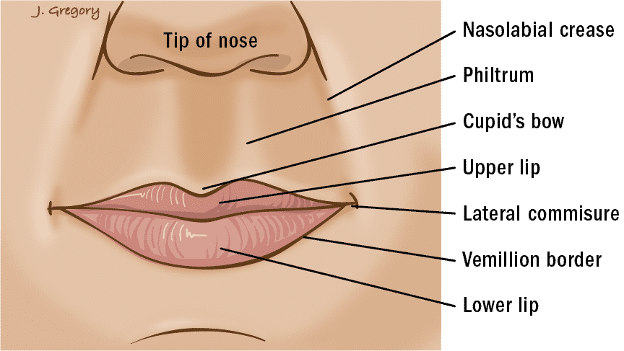

Fig.1 Anatomy Lips

**Types of Lipstick :-**

Lipsticks come in various forms, including lipstick sticks, pencils, creams, and liquid versions, depending on their consistency. They can also be categorized based on their functional properties:

1. **Moisturizing Lipstick**: Contains moisturizing ingredients and often includes SPF to protect against ultraviolet radiation.
2. **Nutritive Lipstick**: Ideal for winter, this type protects the lips from harsh weather conditions.
3. **Treatment Lipstick**: Designed to soothe delicate lips, heal cracks, prevent herpes, and provide softness and natural shine.

Lipsticks also vary in terms of finish and texture:

* **Matte Lipstick**: Offers a smooth, non-glossy finish with a thick, dry consistency.
* **Satin Lipstick**: Has a soft, slightly glossy finish with a hint of sheen and is well-pigmented with a smooth texture.
* **Cream Lipstick**: Creamy in texture, providing a slight sheen, good pigmentation, and a rich feel.
* **Cremesheen Lipstick**: A hydrating, cream-based formula with medium to high pigmentation and a luxurious, smooth texture.
* **Frost Lipstick**: Features a sparkling, shimmery finish with reflective particles.
* **Glaze Lipstick**: Semi-glossy with light pigmentation and a wet, shiny texture, offering a softer shine than glitter.
* **Shimmer Lipstick**: Offers a glossy, glittery finish with a thicker consistency.
* **Sheer Lipstick**: Light and transparent, offering a subtle color with low pigmentation.

Lipsticks can also be categorized based on their durability:

* **Long-lasting Lipstick**: Stays in place for 8 to 24 hours.
* **Enhanced Lipstick**: Offers added benefits like additional shine or subtle color shifts.
* **Waterproof Lipstick**: Resistant to water, ensuring the lipstick stays intact even in humid or wet conditions.

Lipsticks can also differ by color intensity:

* **Clear Lipstick**: No color, providing a simple gloss or sheen.
* **Neutral Lipstick**: Shades that complement natural lip tones for a subtle look.
* **Vibrant Lipstick**: Bold, vivid colors that make a statement.

**Ingredients**

**General requirements**

|  |  |  |  |
| --- | --- | --- | --- |
| S.no | Ingredients | Quantity | Roles |
| 1 | Bees Wax | 14g | Thickening Agents |
| 2 | White soft paraffin | 6g | Base |
| 3 | Olive Oil | 5ml | Moisturizing Agent |
| 4 | Pigment | 1g | Binder |
| 5 | Acacia | 1g | Additive |
| 6 | Orange Juice | 1ml | Antioxidant |
| 7 | Vitamin E | 1ml | Antioxidant |
| 8 | Papaya essence | 1ml | Colouring Agent |
| 9 | Perfume | q. s. | Flavouring Agent |

**Table. (1)**

**Uses of Ingredients**

1. **Beeswax:**

* Beeswax acts as a thickening agent in cosmetic formulations.
* It is commonly used in products like lip balms, lip glosses, and hand creams.
* Beeswax helps to nourish and protect the lips.
* It aids in retaining moisture, keeping the skin hydrated.
* 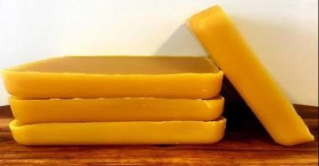Due to its beneficial properties, beeswax is widely used in a variety of cosmetic products.

**Figure (A) .Bees wax**

**2) White Soft Paraffin:**

* White soft paraffin is used in many cosmetic and personal care products, such as lipsticks, lotions, and creams.
* It helps reduce friction on the skin, providing a smooth application.
* As an emollient, it softens and moisturizes the skin.
* 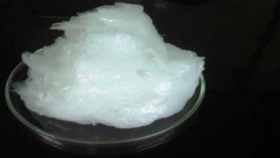It aids in restoring the skin's smoothness, softness, and flexibility.

**Figure(B). White soft paraf**

**3) Olive Oil:**

* Olive oil helps to keep lips soft and supple.
* It provides superior hydration, nourishing the lips.
* It offers relief from cracked and chapped lips.
* 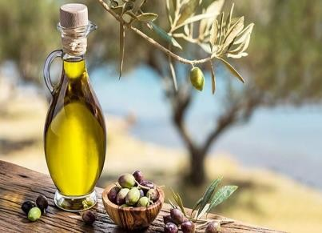Olive oil also provides natural SPF protection for the lips.

**Figure(c). Olive Oil**

**4) Pigment:**

* Inorganic pigments are commonly used in lipsticks to provide color.
* They act as binders, helping to hold the formulation together.
* Pigments also give a clear gloss and vibrant color to the lips.

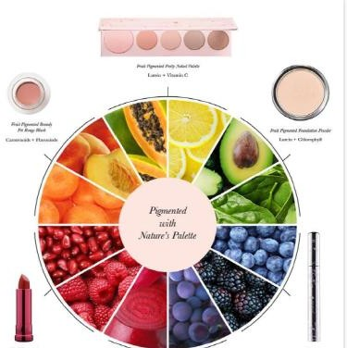

**Figure D). Pigment**

**5) Acacia:**

* Acacia acts as an emulsifying and suspending agent in cosmetics.
* It helps increase the viscosity of lipstick, giving it a thicker texture.
* It prevents the color from lightening, maintaining the lipstick's intensity.
* Acacia is also used as a demulcent, soothing and protecting the lips.
* It helps maintain the desired thickness and consistency of the lipstick.

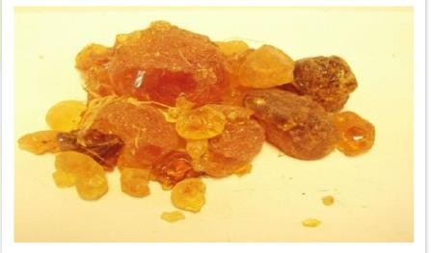

**Figure (E). Acacia**

**6) Orange Juice:**

* Orange juice is ideal for dry lips and provides a universal shade.
* It helps promote healthy lips and prevents cell damage.
* It reduces inflammation, soothing irritated lips.
* Orange juice can help curb the urge to smear lipstick.
* It is also used to prevent colds, thanks to its vitamin C content.
* 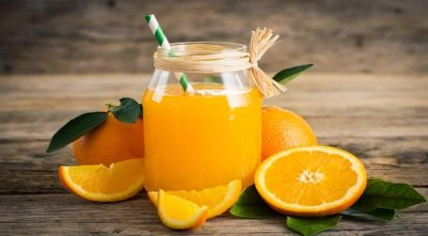Additionally, it contributes to the smoothness and softness of the lips.

# Figure (F). Orange Juice

# 7) Vitamin E:

* Vitamin E can be incorporated into various cosmetic products, including lipsticks and mascaras.
* As a universally beneficial ingredient, it is commonly found in most skincare and cosmetic products.
* Vitamin E is a key ingredient in herbal lipsticks, known for its nourishing properties.
* It helps prevent and treat fine lines and wrinkles, keeping the skin smooth
* 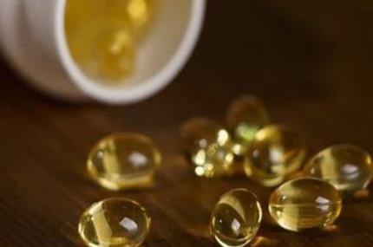Vitamin E also makes the lips softer and more hydrated.

**Figure(G). Vitamin E**

**8) Papaya Essence:**

* Papaya essence is an essential ingredient in herbal lipstick formulations.
* It acts as a natural flavoring agent, enhancing the lipstick's scent.
* Being a natural component, it adds to the overall purity of the lipstick.
* Papaya essence provides unique colors and flavors to herbal lipsticks.
* It softens, nourishes, and protects the lips from environmental damage.

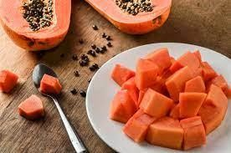

**Figure(H). Papaya Essence**

**9) Perfume:**

* Perfume is used to add fragrance to the lipstick.
* It helps create a more natural and appealing aroma.
* 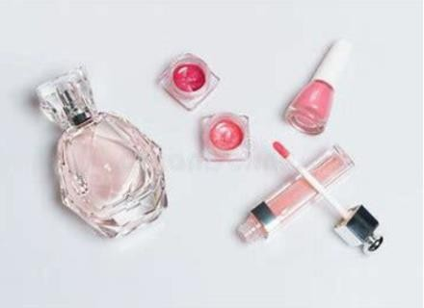It provides a pleasant scent, enhancing the overall user experience.

**. Figure(I). Perfume**

**CONCLUSION**

The study concludes that herbal lipstick can be successfully formulated using various natural ingredients such as white beeswax, butter, castor oil, coconut oil, olive oil, vanilla and rose essences, papaya extract, and lemon. The research also suggests that the use of natural colorants in lipstick formulation results in minimal or no side effects. Therefore, the prepared lipstick can be considered safe and effective, pending further clinical trials.

Herbal lipstick not only enhances the appearance of the lips but also offers several benefits, including rejuvenating lip muscles, maintaining skin elasticity, removing dirt particles, and improving blood circulation. One of the key advantages of herbal-based cosmetics is their nontoxic nature, making them a safer choice. This herbal lipstick nourishes the skin, helping to eliminate wrinkles, cracking, dryness, and folds on the lips. It provides exfoliation, a soothing, calming, and cooling effect, and restores the natural shine of the lips within a short Frequent use of herbal lipsticks improves lip texture and imparts an attractive color. In addition, herbal lipsticks protect against the adverse effects of pollution and harsh climates, helping to retain the elasticity of lip cells and preventing premature aging. Fine lines and wrinkles can be effectively controlled with regular use of herbal lipstick.

This study has highlighted the excellent properties of herbal lipsticks, and further research is needed to explore additional benefits. As consumers increasingly embrace natural remedies due to their safer profiles and fewer side effects compared to chemical-based products, the demand for herbal formulations continues to grow. Herbal lipsticks, with their various natural nutrients, offer an effective and sustainable solution to the evolving cosmetics market.

**REFERENCE :-**

1. Dwivedi S, Dwivedi SN, Patel PC. Formulation evaluation and antimicrobial activity of herbal lipstick. Recent Adv in Prosp and Potent of Medi Plants 2009; 39 -43
2. Mittal B.M. and Saha R.N. Handbook of Cosmetics 1st ed. A Vallabh Prakashan. 2003 Page no: 132- 156.
3. Acharya Deepak,Shrivastava Anshu Indigenous Herbal Medicine, Tribal Formulation and Traditional Herbal Practices, Avishkar Publisher Distributor, Jaipur, India, 2008: 421
4. Benett, W. et.al, Cosmetic formulary, Edn-II, Chemical publishing company, New York, 1983: 90-100.
5. Nadkarni A.K. Indian Materica Medica, 3rd ed, vol. II. Popular Prakashan, Mumbai.1975

6.P.P.sharma,Cosmetics- Formulation, Manufacturing and quality control, fourth ed.vandana Publication Pvt.Ltd., India, 2008.

1. Cosmetics –formulation, manufacturing and QC by P.P.Sharma, 5thedition, Vandana publication Delhi,(297).
2. The Chemistry and Manufacture of Cosmetics Volume II Formulating-Edited by Mitchell L. Schlossman, Chapter 22 by Geoffrey Finkenaur(629-657) ,Allured Publishing Corporation.
3. Azwanida N, Hui MS, Afandi A,Mohamed S, Zulhisyam AK, Ayob A, Rusli N, Rasat MSM, Color stability evaluation of pigment extracted from Hylocereus polyrhizus, Clitorea ternatae and Pandanus amaryllfolius as cosmetic colorants and premarket survey on customer acceptance on natural cosmetic product, Journal of Tropical Resources and Sustainable Sciences, 3, 2015, 61-67
4. Malviya N, Isolation and Quantification of Lycopene from Watermelon, Tomato and Papaya, Research Journal of Recent Sciences, 3, 2014, 68-70
5. Lilwani S and Nair V, Extraction and Isolation of Lycopene Form Various Natural Sources, Journal of Biotechnology and Biochemistry, 1(5), 2015, 49-51.
6. Chaudhari Nileshwari P, Chaudhari Namarata U, Chaudhari Harshada A, Premchandani Laxmi A, R Amit kumar, Dhankani, Pawar Dr. Sunil P, A Review on herbal lipstick from different natural colouring pigment, Indian Journal of Drugs, 6(3), 2018, 174-179.
7. Kadu M, Dr Vishwasrao S, Dr Singh S, Review on natural lip balm, International Journal of Research in cosmetic Science, 5(1), 2015,1-7.
8. Korac RR, Khambholja KM. Potential of herbs inskin protection from Ultraviolet radiation. Pharmacogn Rev, 2011; 7: 164-173.
9. Shivanand P, Nilam M, Viral D. Herbs play an important role in the field of cosmetics. Int J Pharm

Tech Red, 2010; 2: 632-639

1. Navarre MG, editor. The chemistry and Manufacturer of Cosmetics. 2nd ed. Vol.1. New York: Wiley- Inter science; 1974.
2. Hart RG, editor. Harry’s Cosmeticology. 6th ed. London: Leonard Hil! Books; 1973. pp. 140- 156.
3. Nema RK, Rathore KS, Dubey BK. Text of cosmetics. 1st ed. New Delhi (India): CBS Publishers and Distributors; 2009. pp. 69-81
4. Katiyar SK, Elmets CA. Green tea polyphenols skin protection and antioxidant (Review). Int J Oncol,

2001; 18: 1307-1313.

1. M D Avinash, A M Hari, N S Pradeep, Herbal lipstick formulation: A new approach, International Journal of Research in Ayurveda & Pharmacy, 2(6), 2011, 1795-97.
2. Deshmukh S, Chavan M, Sutar M, Singh S, Preparation and Evaluation of Natural Lipsticks from Bixa Orellana Seeds, International Journal of Pharma and Bio Sciences, 4(3), 2013, 139– 144.
3. Sainath M, Formulation and Evaluation of Herbal Lipstick, International Journal of AdvancedResearch in Medical & Pharmaceutical Sciences, 1(1), 2016, 14-19.
4. Mishra P, Dwivedi S, Formulation and evaluation of lipstick containing herbal ingredients, Asian J Med Pharm, 2, 2012, 58-60.
5. HANDBOOK OF COSMETICS by B.M.Mitthal and R.N.Saha, (39-50), by Vallabh Prakashan.