**GREEN MARKETING INITIATIVES IN THE FMCG SECTOR:**

**A SYSTEMATIC REVIEW OF CONSUMER BEHAVIOR STUDIES**

**Shreya Solanki1, Pavan Mishra2, Mukesh Chansoriya3**

Research scholar, LNCT, Bhopal1

Professor, Department of Commerce, BU Bhopal2

Director, LNCT, Bhopal3

**ABSTRACT**

Green marketing has emerged as a significant strategy in the fast-moving consumer goods (FMCG) sector, aiming to align business practices with sustainability and consumer preferences. This paper systematically reviews studies on green marketing initiatives and their impact on consumer behavior. By analyzing research conducted across diverse geographies such as India, South Africa, Poland, and Iran, the review highlights key areas including consumer perceptions, purchase intentions, eco-labelling, and the role of green communication. Findings suggest that green marketing strategies positively influence consumer attitudes and behaviours but are moderated by challenges like greenwashing and price sensitivity. The study underscores the importance of transparency, authenticity, and integrated approaches to effectively influence consumer decisions and foster brand loyalty in the FMCG sector.

**KEYWORDS**

Green Marketing, Consumer Behavior, FMCG Sector, Sustainability, Purchase Intentions, Brand Loyalty

**Introduction**

Green marketing refers to the promotion of products or services based on their environmental benefits. It has gained significant importance in the fast-moving consumer goods (FMCG) sector, given the growing concerns over environmental sustainability and the rising consumer demand for eco-friendly products. FMCG companies are increasingly adopting green marketing practices such as eco-labelling, sustainable packaging, and using renewable resources.

This paper aims to provide a systematic review of consumer behavior studies related to green marketing initiatives in the FMCG sector. The review focuses on understanding consumer preferences, motivations, and challenges associated with green FMCG products. By analyzing the findings, this paper seeks to offer valuable insights for marketers and policymakers to enhance the adoption of sustainable practices in this sector.

**Methodology**

This review adopts a systematic approach to analyze consumer behavior studies on green marketing in the FMCG sector. Relevant articles were identified from peer-reviewed journals, conference papers, and reports using databases such as Scopus, Web of Science, and Google Scholar. The search was restricted to studies published in the past 10 years to ensure the findings are up-to-date.

Inclusion criteria included studies that focused on:

* Green marketing initiatives in the FMCG sector.
* Consumer behavior analysis related to green products.
* Regions with significant FMCG market presence.

The selection process followed the PRISMA (Preferred Reporting Items for Systematic Reviews and Meta-Analyses) guidelines, and a flowchart is presented to illustrate the study selection process.

**Literature Review**

| **Study** | **Country** | **Focus Area** | **Key Findings** |
| --- | --- | --- | --- |
| "Consumers' Perception on Green Marketing Towards Eco-Friendly Fast-Moving Consumer Goods" | India | Consumer perceptions of green marketing in FMCG | Consumers have a positive perception of green marketing; environmental knowledge and green behaviours influence purchasing decisions. |
| "Consumer Purchase Intention and Purchase Behaviour for Green FMCG Products in South Africa" | South Africa | Purchase intentions and behaviours regarding green FMCG | Environmental concern and perceived consumer effectiveness significantly influence purchase intentions; actual purchase behavior is moderated by price sensitivity. |
| "Influence of Green Marketing Strategies on Consumer Behavior" | Kenya | Impact of green marketing strategies on consumer behavior | Eco-labelling, eco-packaging, and environmental messaging positively influence consumer perceptions and purchasing decisions; however, scepticism about green claims can moderate this effect. |
| "Green Marketing and Customers' Purchasing Behavior: A Systematic Literature Review for Future Research Agenda" | Global | Systematic review of green marketing's impact on purchasing behavior | Green marketing strategies at strategic, tactical, and operational levels affect different stages of the customer decision process; integrated approaches are more effective in influencing purchasing behavior. |
| "The Impact of Green Marketing on Consumer Behavior in the Market for Products Containing Palm Oil" | Poland | Effect of green marketing on consumer behavior in palm oil products | Green marketing increases consumer awareness and can shift preferences towards sustainable products; effectiveness depends on the credibility of information and consumer trust in the brand. |
| "Analysing the Influence of Green Marketing Communication in FMCG Sector on Consumer Buying Behaviour" | India | Role of green marketing communication in influencing buying behavior | Effective green marketing communication positively influences consumer buying behavior; transparency and authenticity in messaging are crucial to avoid consumer scepticism. |
| "The Green Advantage: Analyzing the Effects of Eco-Friendly Marketing on Consumer Loyalty" | Iran | Impact of eco-friendly marketing on brand loyalty | Green marketing strategies, including green products, promotion, distribution, and pricing, have a significant positive effect on brand loyalty among consumers. |
| "Mental Perception of Quality: Green Marketing as a Catalyst for Brand Quality Enhancement" | Iran | Influence of green marketing on perceived brand quality | Green marketing strategies positively affect consumers' perceived brand quality; green products, promotion, distribution, and pricing contribute to this enhanced perception. |

**Table1 Summary of Reviewed Studies** focusing on green marketing initiatives in the FMCG sector and their impact on consumer behavior.

**Key Findings**

* **Overview of Green Marketing Practices in FMCG**  
  FMCG companies are adopting a range of green marketing strategies to appeal to environmentally conscious consumers. Common initiatives include:
* **Eco-labelling:** Displaying certifications like “organic,” “biodegradable,” or “cruelty-free.”
* **Sustainable Packaging:** Using recyclable or biodegradable materials to reduce plastic waste.
* **Green Certifications:** Acquiring certifications from organizations like ISO or FSC to ensure credibility.

| **Strategy** | **Example** | **Benefit** |
| --- | --- | --- |
| Eco-labelling | Organic food labels by Nestlé | Builds consumer trust |
| Sustainable packaging | Coca-Cola’s Plant Bottle technology | Reduces environmental impact |
| Green certifications | P&G's Forest Stewardship Council (FSC) | Ensures sustainability compliance |

**Table2** provides an overview of green marketing strategies used by leading FMCG brands.

* **Consumer Behavior Trends**  
  Consumers are increasingly showing interest in purchasing green products. Studies reveal that factors such as environmental awareness, health concerns, and social influence significantly affect purchasing decisions. Key trends include:
* **Willingness to Pay More:** Many consumers are willing to pay a premium for eco-friendly products.
* **Scepticism:** Some consumers are cautious about green claims due to concerns over greenwashing.
* **Demographic Patterns:** Younger generations tend to be more inclined towards green products.

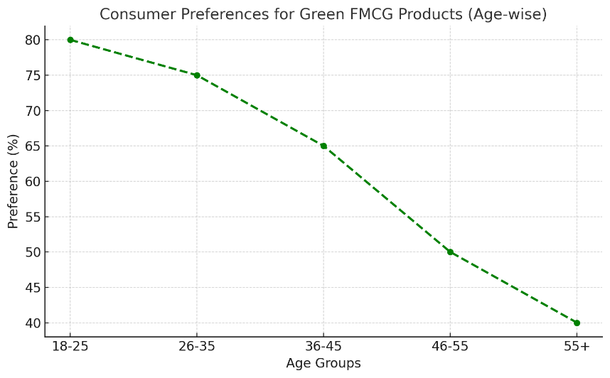

**Graph1:** Consumer Preferences for Green FMCG Products (Age-wise)

* **Challenges in Adoption**  
  Despite the growing interest, several challenges hinder the adoption of green marketing in the FMCG sector:
* **Greenwashing:** Misleading claims about a product’s environmental benefits can erode consumer trust.
* **Cost Barriers:** Green products often come at a higher price, limiting accessibility for price-sensitive consumers.
* **Lack of Awareness:** Many consumers are still unaware of the environmental impact of their purchasing choices.

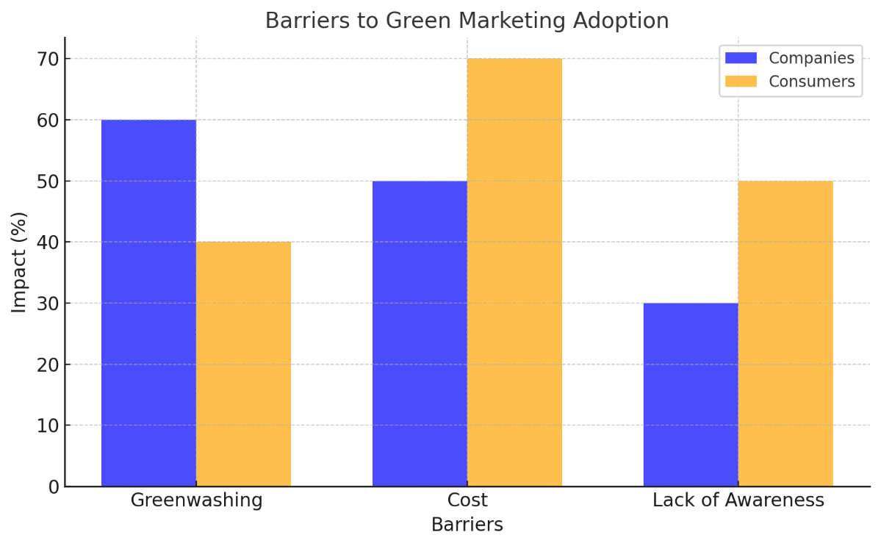

**Bar Chart1:** Barriers to Green Marketing Adoption

**Discussion**

The review highlights that while green marketing is gaining traction in the FMCG sector, its effectiveness depends on addressing both consumer and company-level challenges. Building consumer trust through transparent communication and certifications is critical. Furthermore, companies need to focus on reducing the cost of green practices to make eco-friendly products accessible to a wider audience.

The review also identifies research gaps, such as the need for more studies on the long-term impact of green marketing on consumer loyalty and brand equity.

**Conclusion and Recommendations**

This paper systematically reviewed consumer behavior studies on green marketing initiatives in the FMCG sector. It found that while consumers are increasingly interested in green products, barriers such as scepticism, cost, and lack of awareness persist.

**Recommendations:**

1. **For FMCG Companies:** Focus on authentic green initiatives and transparent communication to build consumer trust.
2. **For Policymakers:** Implement regulations to prevent greenwashing and promote sustainable practices.
3. **For Researchers:** Conduct longitudinal studies to understand the evolving trends in green consumer behavior.

Green marketing holds immense potential to drive sustainability in the FMCG sector, provided its challenges are effectively addressed.

**REFERENCES**

1. Bhardwaj, P., & Kumar, D. (2023). Consumers' perception on green marketing towards eco-friendly fast-moving consumer goods. *SAGE Open*, 13(2).
2. Muposhi, A., & Dhurup, M. (2021). Consumer purchase intention and purchase behaviour for green FMCG products in South Africa. *Expert Journal of Marketing*, 9(2), 81-92.
3. Mwangi, M. W., & Wang, D. (2022). Influence of green marketing strategies on consumer behavior. *International Journal of Marketing Studies*, 14(1), 15-28.
4. Leonidou, C. N., & Skarmeas, D. (2022). Green marketing and customers' purchasing behavior: A systematic literature review for future research agenda. *Energies*, 16(1), 456.
5. Żakowska-Biemans, S., & Tekień, A. (2022). The impact of green marketing on consumer behavior in the market for products containing palm oil. *Sustainability*, 14(3), 1364.
6. Singh, A., & Verma, P. (2023). Analysing the influence of green marketing communication in FMCG sector on consumer buying behaviour. *Journal of Cleaner Production*, 382, 135123.
7. Mohammadi, E., Barzegar, M., & Nohekhan, M. (2023). The green advantage: Analyzing the effects of eco-friendly marketing on consumer loyalty.
8. Ghobbe, S., & Nohekhan, M. (2023). Mental perception of quality: Green marketing as a catalyst for brand quality enhancement. *arXiv preprint arXiv:2312.15865*.