[Harnessing Sustainable Energy: EV Charging Stations Integrated with Renewable Energy Sources in India](https://docs.google.com/document/d/19iWrM_eMEjySgUo2FnBhiArruVse19Bpy38Cnqw-QZ8/edit" \l "heading=h.gjdgxs)

-Anuj Shah (anujshah7203@gmail.com), Devang Desai, Ramesh Guduru

School of Technology, Pandit Deendayal Energy University, Gujarat

# Abstract

Governments all around the world have started taking initiatives to take steps towards green mobility. Every country has announced its deadline to go 100% electric mobility as the existing fossil fuel resources get exhausted and leave our planet dry and void of traditional petrol and diesel. Manufacturers have started bringing out newer electric vehicles, with many of them having set long term goal to go 100% carbon neutral. The efforts towards these desired results will not come easy, as many factors must be considered. Every goal has its own set of obstacles that need to be addressed and, in this case, we really need to address the current capacity of our existing grids. Several parts of the world still do not receive 24-hour electricity, let alone meeting the demands of upcoming EVs. Alternate energy sources must be recognized to supplement the excess energy requirement imposed by the newer EVs. However, no such single source of energy can be implemented to all regions of the world, as some parts of the world receive no sun fall to the contrary some parts receive abundant sun fall, while some regions may receive a high wind speed whereas some do not receive a good wind speed. Hence, we need to account for every condition to select the optimum technology for a particular location.

This paper focuses on real-life analytics and suggests which sources of energy make sense economically, environmentally, socially, and feasibly in which part of India. Factors like capital expenditure, operational expenditure, social factors, grid penetration, EV Density, and environmental factors and use Multi Criteria Decision Making to ease the process of comparing multiple variables at the same time and obtain the optimum result for the given condition. This study includes thorough research, planning and modelling of charging stations integrated with Renewable Energy Sources (RES) while optimizing their location for maximum efficacy and environmental impact reduction. The research provides a comprehensive framework for deploying charging stations with alternate fuels. It delves into the implementation challenges, regulatory frameworks, and economic considerations for widespread adoption. We conclude by presenting case studies of successfully implemented RES-integrated EV charging stations and outlining future research directions for optimization and scalability. The study also provides details about various types of chargers available and the data about Electric Vehicles

Table of Contents

Abstract i

Chapter 1. Introduction 1

Chapter 2. Literature Review: 3

1) Information of Electric Vehicles: 3

2) Information of Energy Sources: 4

3) Information of EV Charging infrastructure 5

Chapter 3. Proposed Methodology: 7

Stage 1: Realizing the potential of alternate sources of energy 7

1.1 Solar Energy Technology: 7

1.2 Wind Energy Technology: 10

1.3 Hydrogen Fuel Cell Energy Technology: 13

Stage 2: A comparison of diverse sources 16

Stage 3: Site Selection Criteria 17

3.1 Environmental Factor 19

3.2 Technical Factor 20

3.3 Economic Factor 21

3.4 Social Factor 21

3.5 Engineering Feasibility Factor 22

Stage 4: Understanding geographical situation 22

Stage 5: Site Selection Process 23

Stage 6: Rules for EVCS 25

Stage 7: Example of the procedure 27

Chapter 4. Results and Discussion: 29

Chapter 5. Conclusion: 33

Chapter 6. Future Scope: 35

References 37

List of Figures

Figure 1.1 Percentage Of Cars Registered Iin Europe 1

Figure 1.2 Number Of Registrations Of Electric Vehicles Statewise 2

Figure 3.1 Type Of Solar Power Plants And Panels 8

Figure 3.2 Types Of Wind Turbines 11

Figure 3.3 Site Selection Procedure 24

Figure 3.4 India's Charging Network (Agarwal) 25

List of Tables

Table 1.1 Energy Consumption Per Day Of Different Types Of EVs 3

Table 1.2 Types Of Chargers 1

Table 1.3 Types Of Losses Due To Transmission 1

Table 2.1 Input And Output Parameters For Different Types Of Chargers 6

Table 3.1 Efficiency Of Solar Power 8

Table 3.2 CapEx For Solar Power 9

Table 3.3 Opex Of Solar 10

Table 3.4 Efficiency Of Wind Power 11

Table 3.5 Capex of Wind power 12

Table 3.6 Opex of Wind power 12

Table 3.7 Types of Hydrogen Fuel Cell 13

Table 3.8 Efficiency Of Hydrogen Fuel Cell 14

Table 3.9 CapEx Of Hydrogen Fuel Cell 14

Table 3.10 OpEx Of Hydrogen Fuel Cell 15

Table 3.11 Comparison Of Solar, Wind And Hydrogen Energy 16

Table 3.12.Criteria Specification For Site Selection 18

Table 3.13 General Scale 27

Table 3.14 Example Of Different Criterion And MCDM For The California State 28

Table 4.1 MCDM For The State Of Gujarat State 29

Table 4.2 Scaling For a Few States In India 29

Table 4.3 Weightage for different criterion and MCDM for California 30

Table 4.4 MCDM For Uttar Pradesh State 31

Table 5.1 Best Sources For Some Of The States Of India 34

# Introduction

In the coming years, our fossil fuels' existing reserves will be depleted, and many efforts have been put down to relax the usage of natural resources. A major innovation that aids this effort is the advent of electric vehicles. Electric vehicle has been around since 1832, but that was merely any good, however EVs became good in the recent years, but the question is the source of energy on which they run is electricity and do we enough of it to support the rising demands due to the shift from ICEs to EVs? Even if there is enough electricity, we would be getting it from coal. Which is again increasing our reliance on fossil fuels. Here we will discuss and suggest various sources of energy to complement the rising demands of electricity due to the increase in EVs. The European Union has set a goal of reducing emissions by 55% from 2021 levels. Such a feat will be accomplished by switching from standard ICE-powered automobiles to electric ones. It is estimated that over 220 million EVs (Electric Vehicles) will be on the road by the end of this decade. By 2030, it will be 10 times as many as the 26 million EVs sold in 2022. (Agency)

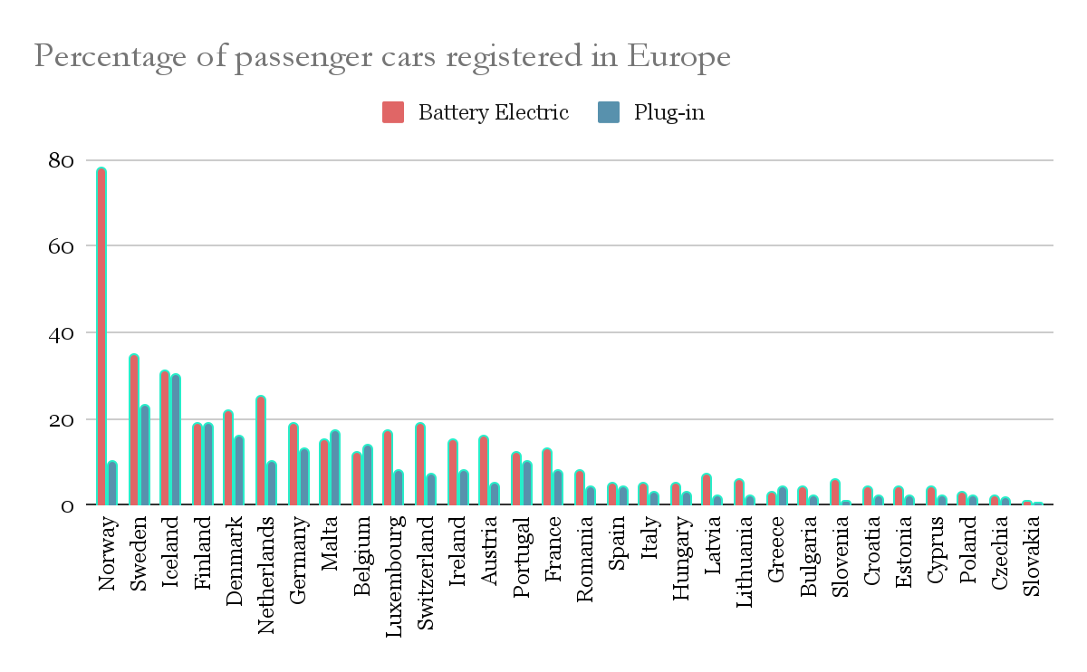

Figure 1.1 Percentage Of Cars Registered Iin Europe

In 2022, the proportion of electric vehicles in new car registrations increased in all countries (EU-27, Iceland, and Norway) compared to 2021. The highest percentages were observed in Norway (89%), Sweden (58%), and Iceland (56%). Germany, France, and Norway accounted for around 64% of new BEV (Battery Electric Vehicle) registrations in the EU-27 and non-EU EEA countries. Norway had the newest BEV registrations in 2022, accounting for 79% of total new car sales. The highest percentage of PHEV sales happened in Iceland, Sweden (both 23%), and Finland (20%). In four European countries (Cyprus, Poland, Czechia, and Slovakia), EV registrations accounted for less than 5% of the total fleet (Agency)

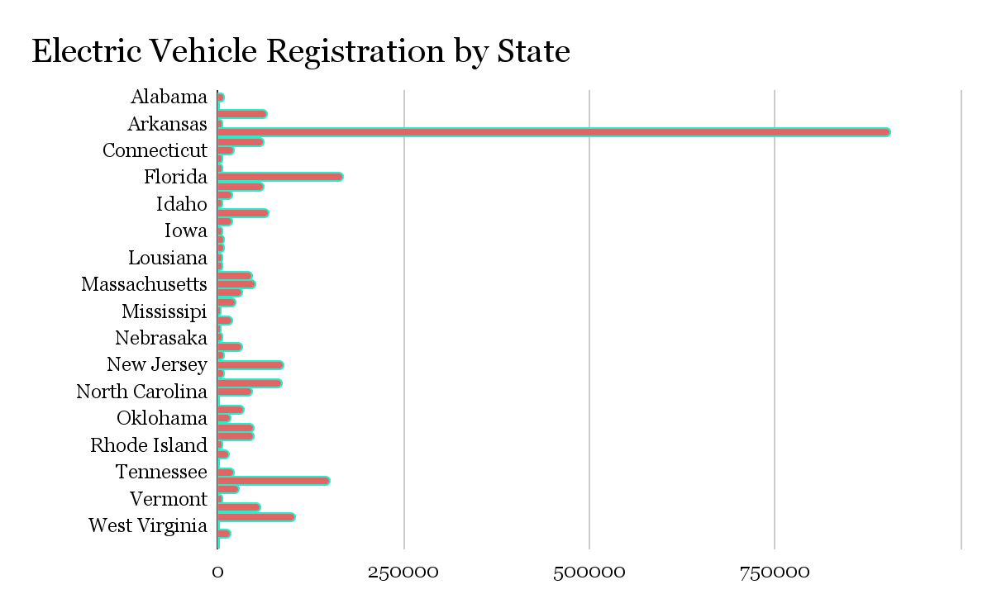

Figure 1.2 Number Of Registrations Of Electric Vehicles Statewise

America’s Federal government has set a goal to make half of the new vehicle sales in 2030 to have zero emissions vehicles. The American government also aims to develop a simple and fair network of 500,000 chargers to make EVs more accessible to Americans for both local and long-distance travel. (NREL)

When we talk about shifting towards Electric Vehicles, we must consider a case study to understand the trend in depth. For it we take India, an exponentially fast-growing country as our subject.

India aims to transition to electric vehicles such as buses to 40%, private automobiles to 30%, commercial vehicles to 70%, and two-wheelers to 80% by 2030, or 30% of the country's fleet to be electric (NITI Aayog). The targets, however, may appear to be highly environmentally beneficial, but they may be overly ambitious, because we do not know whether India's existing electrical infrastructure can satisfy the increased demand caused by newer EVs. This is especially true given that certain parts of the country still lack 24-hour access to energy. However, other fuel sources appear to help with such a situation. India, as a tropical nation, receives around 250-300 days of sunshine each year and has immense potential for solar power. Along with that, India's limits are surrounded by water on three sides, giving it a lot of wind power. Integrating these renewable sources of energy can serve as a support framework for our current thermal power plants, allowing them to fulfil increased energy demands in the next year. This article is to provide a clear picture in terms of Capex and OpEx of the suggested alternative energy sources, dispatchability, Levelized cost of energy (LCOE), efficiency, and viability of various proposals for integrating renewable energy sources.

A new analysis from Vahan Dashboard provides a quick comparison of several types of electric cars. These figures are the total number of electric cars on Indian roads, the amount of km they drive every day, and the consumption of each of these vehicles in terms of KWh/day.

Table 1 shows the data from the (Sheeshan V), displaying the number of Electric powered vehicles of all categories on Indian roads as of December 2023.

Table 1.1 Energy Consumption Per Day Of Different Types Of EVs

|  |  |  |  |  |
| --- | --- | --- | --- | --- |
| **Type of Vehicle (EV’s)** | **Number of Units in market** | **Energy consumption (kWh/km)** | **Average usage of Vehicles** | **Energy consumed per day (kWh/day)** |
| 2-Wheeler | 16,51,268 | 0.03-0.07 | 27-33 kms/day | 1651268x0.03x30 = **14,86,141.2** |
| 3-Wheeler | 15,09,879 | 0.059 – 0.089 | 105 kms/day | 1509879x0.07x105 = **1,10,97,610.65** |
| 4-Wheeler | 1,34,616 | 0.19 - 0.3 | 35 kms/day | 134616x0.2x35 = **9,42,312** |
| Buses | 5,926 | 1.15-1.66 | 160 kms/day | 5926x1.45x160 = **13,74,832** |

Total energy consumed by Electric Vehicles every day is **1,49,00,895.85** kWh. This energy is provided using charging stations. Each vehicle utilizes distinct types of chargers and the efficiency of it varies accordingly. Below provided table helps in identifying which type of electric vehicle uses which charger.

Table 1.2 Types Of Chargers

|  |  |  |
| --- | --- | --- |
| **Type of Vehicle** | **Type of Chargers used** | **Efficiency of Chargers** |
| 2-Wheeler | Level 2 AC | 83-91% |
| 3-Wheeler | Level 2 AC | 83-91% |
| 4-Wheeler | Level 2 AC/ Level 3 DC | 83-91% / 86-92.6% |
| Buses | Level 3 DC | 86-92.6% |

So, since practically every car uses either a Level 2 AC charger or a Level 3 DC charger, charger efficiency may be 89%. To provide 14.9 GWh of electricity, the chargers must require 16.74 GWh from the grid.

From the data obtained on The India Climate and Energy Dashboard (ICED), we obtain that the below provided losses takes place while transmitting power from the source to demand.

Table 1.3 Types Of Losses Due To Transmission

|  |  |
| --- | --- |
| **Type of Losses** | **Amount (in%)** |
| 1. DC to AC Conversion | 5 |
| 1. Step Up transformer for easy transmission | 1-2 |
| 1. Transmission line | 2-2.8 |
| 1. Step down transformer for distribution | 1-2 |
| 1. Distribution line | 2.5-5 |

Hence to obtain 16.74GWh of energy we will need to consider the above-mentioned losses, to obtain energy generation requirement using Solar or Wind.

So, 16.74/ (0.95*0.98*0.98*0.97*0.95) = 19.91GWh

After accounting for these losses, we arrive at a total energy need of 19.91GWh from the source. That indicates that charging 3.3 million automobiles per day would take around 19.91GWh of energy from any source.

# Literature Review:

For this research we have majorly scoured the government websites for the data. It is believed that the data available on these websites are not just random information but a comprehensive evaluated and authorized one, and hence being the most accurate that can be available to the general population.

The Literature survey is divided into 4 parts – 1) Information of Electric Vehicles, 2) Information of Energy Sources, 3) Information of EV Charging infrastructure, and 4) Site Selection Criteria

## 1) Information of Electric Vehicles:

Initially we began reviewing information regarding the sales and registration of Electric Vehicles across the USA and various countries in Europe. We observed that most countries across the globe have embarked on following the trend to shift towards a more sustainable future. This means the people of these countries opt for more electric vehicles instead of its counterpart IC Engine.

(Agency) The EU saw a notable surge in the use of electric vehicles in 2022, particularly vans. Electric vehicles accounted for an astounding 21.6% of newly registered cars, over two million more than the 1.74 million registered the year before. Another notable increase in popularity was seen in electric vans, which made up 5.5% of all new registrations in 2022. In addition, the number of newly registered battery electric cars increased by 25%, while the number of plug-in hybrid vehicles stayed the same. It is interesting to note that in 2022, the bulk of electric van registrations were battery electric cars. Yet, notwithstanding the remarkable strides witnessed in recent years, BEVs (Battery Electric Vehicles) constitute a mere 1.2% slice of the European automotive fleet. Thus, a concerted impetus toward further expansion of Europe's electric vehicle contingent stands imperative, not only to align with the EU's emissions reduction objectives but also to advance steadily toward the overarching aspiration of attaining climate neutrality by the year 2050.

The vehicle registration counts of all-electric vehicles by states are provided in a chart form, which clearly indicates that California has the greatest number of vehicles, approximately 37% of vehicles nationwide. Florida has the second highest count, followed by Texas. The federal government of the United States of America has set a lofty goal: by 2030, half of all new car sales must be zero-emission automobiles. To further improve American residents' access to electric vehicles and ease long-distance and local commutes, the government is working to develop a fair and simple infrastructure consisting of 500,000 chargers. (NREL)

In recent years, India has witnessed a notable surge in electric vehicle (EV) adoption, driven by increasing environmental awareness and rapid technological advancements. Government policies have also played a crucial role in facilitating this transition. With 2023 marking the second consecutive year of surpassing one million units sold, EV penetration has risen from 4.75% to 6.34% in just one year, with three-wheelers leading the segment at 53.75% penetration. Uttar Pradesh saw remarkable growth in EV sales, while Chandigarh emerged as a leader in penetration. Looking forward, forecasts indicate exponential growth in electric two-wheelers, but challenges remain for three and four-wheelers due to high upfront costs and inadequate charging infrastructure. Targeted interventions are essential to address these barriers and further accelerate EV adoption nationwide

## 2) Information of Energy Sources:

For this topic, we reviewed literature as well as websites for collecting information regarding energy sources like thermal, solar, wind and hydrogen fuel-cells. The information regarding efficiency, losses, classifications, economics, etc. was collected using websites and pre-existing literature.

Thermal power plants are vital for India's electricity generation, primarily using coal, natural gas, or oil as fuel to produce steam for turbines. Despite increasing focus on renewables, they remain essential for meeting energy demands. Concerns persist over environmental impact and air pollution, driving efforts to adopt cleaner technologies. Advancements like supercritical boilers enhance efficiency and reduce emissions. Government policies, such as the National Action Plan on Climate Change, promote sustainable practices (Government of India). Challenges remain in environmental compliance and transitioning to cleaner fuels.

The Indian solar power business has grown significantly in recent years, thanks to good geographic circumstances and government incentives. With plentiful sunshine around the year, India has the world's fifth largest solar deployment, with over 40 solar energy projects totaling at least 10 megawatts. In 2023 alone, the sector installed more than 10 GW of solar power, with 40 GW bids planned for the following year. Government incentives for solar rooftops have boosted adoption, with around 8877 MW of solar rooftops deployed across the nation. However, problems like PV conversion losses and soiling limits reduce total efficiency, which is currently approximately 20%. (NREL)

India's wind energy sector has developed as a viable renewable energy source, owing to its extensive coastline and ideal wind conditions. By the end of 2023, the country's wind power capacity had reached 71.84 TWH, with substantial installations in Gujarat and Karnataka. Government efforts like the National Solar Mission and subsidies have boosted the industry's competitiveness and economic viability. However, aerodynamic losses and wake effects provide problems to increasing efficiency, affecting overall system efficiency, which ranges between 24.1% and 54%.

Hydrogen fuel cell technology became known as a cleaner and more efficient alternative to existing energy sources in India. Fuel cell power plants use hydrogen as their major fuel source, producing water as a byproduct, making them ecologically beneficial. Despite its benefits, activation losses and hydrogen crossing have a 60% to 82% influence on total efficiency. A thorough cost study demonstrates that, while hydrogen fuel cells need more initial capital expenditure than solar and wind energy systems, operational expense stays comparatively cheap, making it a feasible long-term investment alternative. India's shift to renewable energy sources holds enormous promise for ensuring energy security and combating climate change, but overcoming technical obstacles is critical to realize the full potential of these technologies.

## 3) Information of EV Charging infrastructure

Charging infrastructure is the centroid of this research and hence it becomes more important to understand the basics of EV Charging Infrastructure. For this, we surveyed websites of organizations that work in setting up these systems. Also, we reviewed Government guidelines to plan and propose potential locations for EV Charging Stations in Indian states.

Types and levels of EV Chargers can be classified into 3 types: (EVESCO)

Table 2.1 Input And Output Parameters For Different Types Of Chargers

|  |  |  |  |  |  |  |
| --- | --- | --- | --- | --- | --- | --- |
|  | Input Parameters | | | Output Parameters | | |
| Charger Type | Voltage | Current | Power | Voltage | Current | Power |
| Level 2 (J1772) | 220-240 V | 80-100 Amps | 2.4 kW | 240 V | 10-30 amps | 3-22 kW |
| Level 1 (J1772) | 110-120 V | 8-10 Amps | 1.2 kW | 100 V | 10-30 Amps | 1-1.8 kW |
| DC Charger (CCS) | 480 - 1000 | 100-500 Amps | 48 - 100 kW | 110–900V | 32-40 Amps | 30-360kW |

- The Indian government regulates the EV industry through initiatives like the National Electric Mobility Mission Plan (NEMMP) and FAME India scheme. Bharat EV Standards set technical specifications for EVs and Charging infrastructure development is crucial for EV adoption in India, with public and private companies investing in it. Key players in the EV charging infrastructure market include Energy Efficiency Services Limited (EESL), Tata Power, and Bharat Heavy Electricals Limited (BHEL). Interoperability of public charging stations are mandated in India for seamless EV operation. (Team Acko Drive)

The agreement includes terms related to the installation work, operating costs, system components, and the agreement's duration. The agreement emphasizes safety measures, compliance with laws, and customization options for EVSEs. It also mentions the projected adoption of EVs in the country and the need for urban development guidelines to align with the increasing EV market share. By emphasizing safety measures and compliance with laws, the agreement ensures a secure and regulated environment for the installation and operation of charging stations. Customization options for EVSEs, such as authentication and integrated payment gateways, enhance user experience and technological advancements in the charging infrastructure. (Ministry of Power, Government of India)

# Proposed Methodology:

For this research we have employed a sequential method in which we proceeded with the research by laying out various stages. The crucial element that needs more research and experimentation is the final site selection simulation and energy technology optimization. As for data, most of it which was required was either available on the government websites or pre-existing research. The stages are mentioned below, with brief literature to help understand the situation and the suggestion.

## Stage 1: Realizing the potential of alternate sources of energy

When we perform research, we try to prepare models that would last at minimum 20 years, which means we need to look for a more sustainable future. This implies that we must consider alternative sources of energy that can be fruitful in the longer run.

There are several types of alternate energy sources like biomass, solar, wind, nuclear, hydro, etc. As for this research we have opted for 3 sources – solar, wind and hydrogen fuel-cell. We have briefly explained these sources and the reason for their selection.

### Solar Energy Technology:

India Being a tropical country receives 250-300 days of sunlight, with each day receiving 8-11 hours of sunlight. India stands 5th in solar deployment. Until 2023 India has more than 40 solar power plants installed in India which can produce at least 10 MW. The sector has witnessed phenomenal growth in recent years, adding over 10 GW in 2023 alone (Gupta). This momentum is expected to continue with ambitious targets of 40 GW tenders planned for 2023-24. (Ministry of New and Renewable Energy). Several government schemes have allowed citizens to install solar rooftops. According to the ministry, India has about 8877 MW of solar rooftops. India's solar power journey is far from over. With its ambitious targets, supportive policies, and a thriving ecosystem of stakeholders, the future looks bright. The sector is expected to play a crucial role in achieving India's energy security goals, mitigating climate change, and powering a sustainable future.

This being the reason, makes it crucial to select Solar as a major competitor among energy sources.

First of all, now we need to understand what type of solar technology is available in the market. Only after that can we know the best technology that can be selected for optimized output. For this, we believe a flowchart would be a great way. Hence the below provided image is the flowchart of the same.

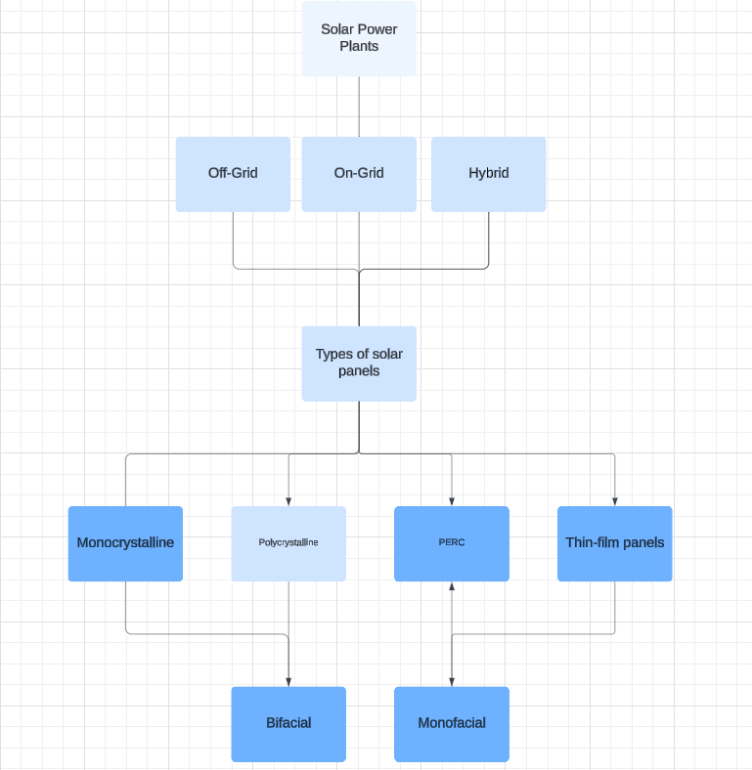

Figure 3.1 Type Of Solar Power Plants And Panels

For this research we have proposed the following data for monocrystalline bi-facial technology. This technology is the most efficient one that is available in Indian market for commercial as well as consumer applications.

The performance, however, is quite low for this system because it faces a certain number of losses. To apprehend the situation of these losses, the table below represents the data. These losses are approximated; they vary according to site locations

Table 3.1 Efficiency Of Solar Power

|  |  |
| --- | --- |
| **Losses to consider** | **Values (in%)** |
| PV Conversion | 70 |
| Soiling loss | 3 |
| Thermal Loss | 0.5 for every 1°C above 25°C |
| Solar Inverter Losses | 3 |
| Solar Panel Mismatch Losses | 1~2.5 |
| Wiring Losses | 1.52 |
| Low radiation loss | 0.59 |
| Overall, Losses | >80 |
| **Overall efficiency of solar power:** | ~20 |

To understand the economical factor of this technology, comprehensive data of Capex and OpEx (per installed kW capacity installed per year) is provided in the below Table. (Vignesh Ramasamy) (LUBI)

Table 3.2 CapEx For Solar Power

|  |  |
| --- | --- |
| **Capex** | |
| **Factors** | **Cost** |
| Infrastructure Related (Module, Inverter, SBOS, EBOS, Site prep) | $753 |
| Field Work (Labor, Equipment Rental, Inspection) | $295 |
| Office Work (Warehousing, Logistics, interconnect, Engineering, and outreach) | $66 |
| Energy Storage System (Battery) | $764 |
| Other Cost | $228 |
| **Total** | **$2106/kW** |

Table 3.3 Opex Of Solar

|  |  |
| --- | --- |
| **OpEx** | |
| **Factor** | **Costs** |
| Energy storage system | $30 |
| Land (Lease & Property Tax) | $5 |
| Insurance | $5.1 |
| Fixed cost (inspection, cleaning, Replacement components) | $10.9 |
| Fuel Cost | $0 |
| **Total** | **$51/kW/year** |

### Wind Energy Technology:

India having its boundary covered by three sides from water has rich potential in wind power. By the end of 2023 India has registered a wind power capacity of 71.84 TWH. The major wind farms are in Gujarat and Karnataka. A 252 MW wind power plant in Dwarka is planned along with a (Global Data) 2 GW Wind power plant has been proposed in Gujarat’s Khambhat (Dave). India is ranked 4thlargest in wind power installed capacity. The Indian government has been instrumental in driving the industry forward by implementing programs like as the National Solar Mission, offering subsidies, and simplifying laws. Wind power has become a more competitive and economical energy source due to the recent technical developments and economies of scale that have resulted in a considerable drop in wind turbine costs. India needs a consistent and sustainable energy source to meet the country's growing population and economic expansion. An abundant and clean substitute for conventional fossil fuels is wind power. India is extremely concerned about climate change and air pollution. By reducing its influence on the climate and promoting a better environment, wind energy provides a greener option.

Now we need to understand what type of wind technology is available in the market. Only after that can we know the best technology that can be selected for optimized output. For this, we believe a flowchart would be a great way. Hence the below provided image is the flowchart of the same.

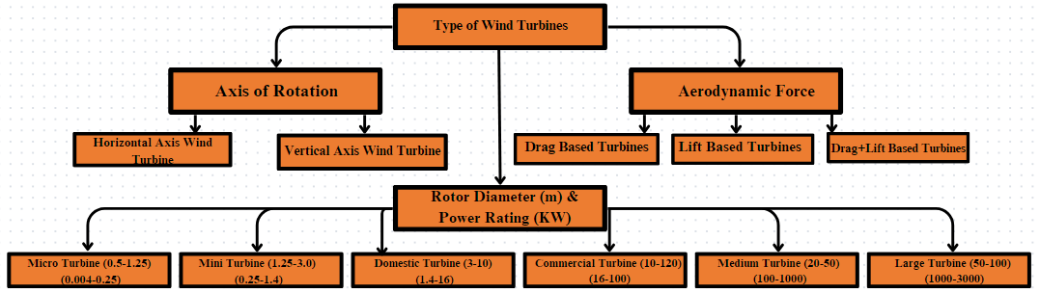

Figure 3.2 Types Of Wind Turbines

However, Horizontal axis wind turbines are more efficient than vertical wind turbines, therefore all utility scale wind power plants have horizontal axis wind turbines. Vertical wind turbines are also useful in some scenarios. (Zinat Tasneem)

The performance, however, is a bit higher as compared to solar system, yet in the same range of thermal power plant. To apprehend the situation of these losses, the table below represents the data. These losses are approximated; they vary according to site locations

Table 3.4 Efficiency Of Wind Power

|  |  |
| --- | --- |
| **Losses to consider** | **Values (in%)** |
| Aerodynamic Losses | 20-30 |
| Wake Effect | 10-20 |
| Electrical Transmission Efficiency | 8-15 |
| Turbine Performance | 1.8- 1.32 |
| Environmental | 1-2.2 |
| Gear mesh loss | 1.7 |
| Core, Copper and Additional Losses | 3.5-5.7 |
| = Total Losses | 46 – 75.9 |
| **Overall Efficiency of Wind Turbine** | **24.1 - 54** |

To understand the economical factor of this technology, comprehensive data of Capex and OpEx (per installed kW capacity installed per year) is provided in the below Table. (Wind Energy Technologies Office), (Duffy).

Table 3.5 Capex of Wind power

|  |  |
| --- | --- |
| **Capex** | |
| **Factors** | **Cost** |
| Wind Turbine (Rotor, Nacelle, Tower) | $1030 ($313, $512, $204 respectively) |
| BOS (Engineering, Project management, Foundation, Site access, staging, and facilities, Assembly and installation, Electrical infrastructure) | $322 ($23, $10, $75, $40, $41, $132 respectively) |
| Financial (Contingency, Construction) | $113 ($90, $23 respectively) |
| **Total** | **$1501/kW** |

Table 3.6 Opex of Wind power

|  |  |
| --- | --- |
| **OpEx** | |
| **Factor** | **Cost** |
| Fixed Cost (inspection, cleaning, Replacement components) | $15 |
| Insurance | $5 |
| Energy Storage system | $15 |
| Land (Lease and Tax) | $5.1 |
| Fuel | $0 |
| **Total** | **$40.1/kW/year** |

### Hydrogen Fuel Cell Energy Technology:

Hydrogen fuel cell power plants are a fantastic example of clean energy. These fuel cells are an emerging revolutionary source in the energy landscape, giving a clean and efficient option to traditional sources. The source of such a proposition is hydrogen, available in abundance, but its storage must be taken care of in the utmost manner as hydrogen is an extremely combustible substance. The emissions of this source in water which is not harmful to the environment we live in. The benefits of hydrogen fuel cells are that it has a high efficiency, about 70% of the input fed into the plant gets converted into useful energy, the operation unlike traditional thermal powerplants is very quiet reducing noise pollution and discomfort to nearby residents, flexibility of fluctuation load demand and zero emissions of harmful pollutants like nitrogen oxides and particulate matter, thus improving environmental conditions

Table 3.7 Types of Hydrogen Fuel Cell

|  |  |  |  |
| --- | --- | --- | --- |
| **Fuel cell type** | **Temperature** | **Electrolyte** | **Efficiency (%)** |
| PEMFC | 60-140 | Polymer | 55 |
| DMFC | 30-80 | Polymer | 30 |
| AFC | 150-200 | Potassium hydroxide | 60 |
| PAFC | 150-200 | Phosphoric acid | >40 |
| MCFC | 600-700 | Li/K/Na carbonate | 45 |
| SOFC (+) | 200-700 | Barium cerate | 40 |
| Direct ammonia | 400-700 | Barium cerate | 40 |

A hydrogen fuel cell plant has water as its major by product, which can be used by nearby civilians for household or even industrial purposes. The world’s largest Hydrogen fuel cell plant located in South Korea touts a similar setup, where in, about 44,000 households use the hot water produced by the plant. (Fuel Cell Works)

The performance is the highest of all other systems. To apprehend the situation of these losses, the table below represents the data. These losses are approximated; they vary according to site locations.

Table 3.8 Efficiency Of Hydrogen Fuel Cell

|  |  |
| --- | --- |
| **Losses to consider** | **Values (in %)** |
| Activation Loss | 10-15 (especially at low power) |
| Ohmic Loss | 2-10 |
| Concentration Loss | 5-20 (especially at high power) |
| Hydrogen Crossover | 1-5 |
| Internal Current Leakage | Negligible compared to crossover |
| Overall, Losses | 18-40 |
| **Overall Efficiency** | **60-82** |

To understand the economical factor of this technology, comprehensive data of Capex and OpEx (per installed kW capacity installed per year) is provided in the below Table. (Chung)

Table 3.9 CapEx Of Hydrogen Fuel Cell

|  |  |  |
| --- | --- | --- |
| **Capex** | | |
| **Factors** | **Cost** | |
| Fuel Cell | $1500 | |
| BOS (Engineering, Project management, Foundation, Site access, staging, and facilities, Assembly and installation, Electrical infrastructure) | | $1350 ($230, $250, $144, $105, $324, $297 respectively) |
| Field Work (Labor, Equipment Rental, Inspection) | $205 | |
| Office Work (Warehousing, Logistics, interconnect, Engineering, and outreach) | $167 | |
| Financial (Contingency, Construction) | $147 ($90, $57 respectively) | |
| **Total** | **$3369/kW** | |

Table 3.10 OpEx Of Hydrogen Fuel Cell

|  |  |
| --- | --- |
| **OpEx** | |
| **Factor** | **Cost** |
| Fixed Cost (inspection, cleaning, Replacement components) | $81.96 |
| Insurance | $5 |
| Fuel Cost (LH2) | $707.6 |
| Land (Lease and Tax) | $5.1 |
| Licensing | $0.13 |
| Electricity | $3.29 |
| Administration | $9.12 |
| **Total** | **$812.2/kW/year** |

## Stage 2: A comparison of diverse sources

Table 3.11 Comparison Of Solar, Wind And Hydrogen Energy

|  |  |  |  |  |  |  |
| --- | --- | --- | --- | --- | --- | --- |
|  | **Criteria** | | | | |  |
| **Sources** | **Efficiency (%)** | **Total Space Required to generate 19.91 GWh (in km2)** | **Generation (MWh/MW/year)** | **Capex**  **(initial investment) ($)** | **OpEx (operations) ($)** | **Amortization of OpEx ($)** |
| Wind (3MW on land *644 turbines) | 24.1-54 | 4366.23 | 3775 | 3 Bil | 81 Mil | 200 Mil |
| Solar (100MW*40 plants) | 15-20 | 238.92 | 1460 | 8.4 Bil | 204 Mil | 506 Mil |
| Fuel-Cell (78MW*11) | 75 | 4.5 | 8757.2 | 2.9 Bil | 688 Mil | 1.7 Bil |

The above table is derived using data from (Chung), (Duffy), (Vignesh Ramasamy). It is then changed according to Indian Standards for better understanding and ease of application.

As our planet strives for a sustainable future, the significance of renewable energy sources continues to grow. The leading contenders in this endeavor are hydrogen fuel cells, solar power, and wind energy, each boasting distinct advantages and disadvantages. Yet, how do they measure up in terms of performance and functionality when compared to one another?

Footprints and Amicability:

Land Utilization: Solar energy necessitates moderate spatial requirements, while wind farms encompass extensive regions. Hydrogen fuel cells manifest a comparably diminutive footprint when juxtaposed with the expanse of large-scale renewable installations.

Emissions: The triumvirate champions of clean energy all share the attribute of yielding zero emissions at the juncture of utilization. Nevertheless, the environmental ramifications of hydrogen hinge upon the specific method employed for its production. (Chengkang Gao)

Within the Domain of Option:

The choice of the best technology depends on certain requirements. Solar shines when considering dispersed power generation and smooth grid integration. In the meanwhile, wind continues to reign supreme in the vast generation of power in windy locations. On a variety of dimensions, hydrogen fuel cells advertise themselves as suppliers of clean, flexible energy; but, to achieve wider adoption, infrastructural development and the relentless quest of cost reduction are crucial.

## Stage 3: Site Selection Criteria

India being a country with diverse geographic conditions, it becomes concerningto select a particular source of energy generation. Hence, we need to plan dissimilar sources for different geographical conditions. For example, regions of country receiving a higher sun fall over the year suits solar power more while coastal regions favor wind power more, regions with limited space availability cater hydrogen fuel cell plants.

We can plan to develop power plants in metropolitan cities due to higher population density and increased energy demand for EVs (Electric Vehicles) or we can incur some transmission losses by developing energy power plants in regions found at a farther distance from urban regions.

By combining renewable energy sources and strategically placing charging stations, researchers have made tremendous progress in improving the infrastructure for EVCS by methodically selecting the best sites and station sizes to integrate a particular non-conventional energy to it. This strategy paves the path for environmentally friendly and self-sufficient EV (Electric Vehicles) infrastructure while also improving the grid's sustainability and reducing its environmental effect.Selecting criteria for an EVCS site is crucial for an effective decision-making process. Criteria give an objective basis, assist the project continue track with its objectives, and ease effective resource allocation. Assuring adaptation to changing conditions and recognising obstacles, they play a crucial role in risk mitigation. The criteria and sub criteria can be processed according to the needs and models of the analysts for optimum results desired and scalability to ensure the long-term success of the EVCS. A good site selection procedure depends on the careful selection and weightage of criteria. The criteria and sub criteria are stated below in Table 1 and then the individual importance of each has been explained.

Table 3.12.Criteria Specification For Site Selection

|  |  |
| --- | --- |
| Criteria | Sub Criteria |
| Environmental Factors | Air Quality: (Seyedmohsen Hosseini)  Compliance with Air Quality Standards  Waste Discharge:  Proper Drainage Systems  Waste Water Treatment Facilities  Compliance with Environmental Regulations (Sinem Hisoglu)  Fine particles emission reduction  Destruction Degree on Water Resources: (M. Y. Yunna Wu)  Impact on Aquatic Ecosystems  Groundwater Contamination Risk  Water Resource Sustainability |
| Technical Factors | Reliability and Redundancy of Power Supply: (Sinem Hisoglu)  Frequency of Power Outages  Availability of Backup Power Sources  Infrastructure Compatibility: (Huiru Zhao)  Compatibility with Smart Grid Systems  Grid Capacity for EV Load  Charging Technology: (Mohammad Hasan Ghodusinejad)  Battery capacity and range of current EV Models  Charging Speeds (Fast, Standard, Slow) |
| Economic Factors | Return on Investment (ROI):  Construction cost  Operation and maintenance cost  Investment payoff period  Operational Efficiency:  Remote Monitoring and Maintenance (Seyedmohsen Hosseini)  Financial Incentives and Subsidies:  Availability of Government Subsidies (Jun He)  Tax Benefits for EV charging Infrastructure |
| Social Factors | Public Perception and Acceptance  Measurement of population density  Traffic convenience  Service level (Seyedmohsen Hosseini) in future  Attitude of residents  Local authorities support |
| Engineering Feasibility | Distance from the Substation  Influence on the Power System of surrounding areas (M. Y. Yunna Wu)  Availability of Resources  Grid connection feasibility (Mohammad Hasan Ghodusinejad)  Topography |

### Environmental Factor

(Seyedmohsen Hosseini) argue that adhering to environmental regulations, minimizing air pollution, enhancing waste disposal systems, and preserving water sources are crucial for reducing environmental harm. These practices not only safeguard aquatic ecosystems and water availability but also improve air quality and lessen overall pollution. Wu et al. stress the significance of considering local air quality when installing electric vehicle charging stations (EVCS). Positioning EVCS in areas with poor air quality can help decrease pollution levels and encourage the use of electric vehicles. This strategic placement results in reduced emissions in polluted regions, thereby promoting cleaner air. However, obstacles such as limited availability of suitable locations remain.

(Sinem Hisoglu), (C. X. Yunna Wu) highlight the considerable direct and indirect effects of EV charging stations on water resources. Indirectly, these facilities may necessitate water for cooling, albeit in small quantities. Furthermore, the construction of charging stations often involves the development of impervious surfaces, such as pavements, which can intensify stormwater runoff and require effective stormwater management strategies. The urban growth associated with the establishment of these stations can affect groundwater flows, potentially impacting nearby aquatic systems and water quality. Despite these challenges, the adoption of measures such as water conservation initiatives and the integration of renewable energy sources can significantly reduce these impacts.

By prioritizing environmental sustainability, these facilities can foster trust among stakeholders and the public in the planning process.

### Technical Factor

(Sinem Hisoglu) emphasize the importance of conducting a thorough technical examination to ensure the successful implementation and operation of EV charging stations. By examining electrical interruptions and setting up backup power systems, companies can reduce customer complaints and operational difficulties. Smart networks can enhance communication between charging infrastructure and the electrical grid, leading to more efficient energy allocation based on consumption demands. This alignment not only improves energy distribution stability in communities but also increases the efficiency of operational procedures. It is also essential to consider the grid's capacity to accommodate EV demands, preventing excessive strain on nearby power systems and enabling a smooth integration of charging stations into the existing grid framework.

Examining charging alternatives, battery capabilities, vehicle range, and charging speed is crucial. Providing various charging speeds can enhance user flexibility. While slower charging options allow for longer parking durations and are cost-effective, faster charging alternatives cater to clients with time constraints, as noted by (Mohammad Hasan Ghodusinejad), (Huiru Zhao) stress that a careful evaluation of technical parameters is necessary to ensure that EV charging facilities operate at maximum efficiency, meet user satisfaction, and remain adaptable for future needs. By focusing on power supply reliability, compatibility with smart grid technologies, and versatility in charging options, businesses can provide uninterrupted services, strengthen reliable energy networks, and promote the widespread adoption of electric vehicles.

### Economic Factor

(Sen Guo). suggest that evaluating construction costs, such as those associated with setting up infrastructure, is the initial step in assessing the Return on Investment (ROI). To ensure long-term profitability through effective operations, financial planning must also consider operating and maintenance expenses. Determining the investment payback period provides insight into how quickly the initial investment can be recovered. Investors are more likely to be attracted to projects with shorter payback periods on stations, as they offer quicker financial returns. The financial success of charging stations depends on operational efficiency, which also impacts consumer satisfaction by ensuring uninterrupted service, maximizing station uptime, and increasing total revenue, as highlighted by (Seyedmohsen Hosseini).

The economic viability of charging stations is largely influenced by government subsidies and incentives. Evaluating the availability of subsidies is crucial, as they make charging station installations financially viable by offsetting the initial expense. Additionally, assessing tax benefits specific to EV charging infrastructure can reduce total tax loads and operating expenses, improving long-term sustainability and financial health. However, government regulations determine which incentives are available, so financial planning solutions must be flexible and adaptable to accommodate changing policies, as noted by (Seyedmohsen Hosseini)

### Social Factor

(Sen Guo) mention about the importance for comprehensive evaluation of social factors is necessary to identify the most appropriate sites for EV charging stations. According to (Seyedmohsen Hosseini) community participation plays a critical role in determining public perception and acceptance. The selection procedure is influenced by population density analysis, which focuses on heavily inhabited locations to provide a stable and varied user base. Convenience and accessibility increase station visibility and promote frequent use, particularly in crowded places like retail malls or transit hubs (Sujit Kumar Sikder). It makes strategic sense to include capacity expansion into consideration, because this will allow stations to adjust to the rising demand for EVs. It is critical to understand the local views on EVs as doing so will force aggressive measures to ease concerns and influence the community. (Golam Kabir)

In short, the integration of the charging station into the community is affected by these social elements, which promotes user acceptability, sustainable expansion, and beneficial connections with local stakeholders. By assessing these elements, strategic decision-making is ensured, improving the effectiveness and long-term sustainability of the station. (Sinem Hisoglu)

### Engineering Feasibility Factor

Being close to substations is crucial for maintaining a steady power supply with little energy loss. Assessing the impact of charging stations on the electrical grid prevents overload and preserves the stability of the present infrastructure. The availability of resources, including land, water, and building supplies, must also be considered for effective construction, cost reduction, and timely setup. (C. X. Yunna Wu)

To easily integrate the station into the local power grid, compatibility tests must be performed due to the critical nature of grid connection feasibility. For structural stability, an understanding of the topography, geology, and soil type is essential. Thorough examination enables suitable foundation plans, guaranteeing the station's long-term stability. The benefits of optimised power supply, effective resource utilisation, and structural stability highlight the significance of engineering feasibility for the careful positioning of EVCS. Infrastructure for charging that is dependable, effective, and sustainable is made possible by these factors. (M. Y. Yunna Wu) (Mohammad Hasan Ghodusinejad) (Golam Kabir)

## Stage 4: Understanding geographical situation

The classification of cities must be done to understand the power needs and set up the stations accordingly. The classification will be based on the population density so the power requirement could be carefully assessed, the cities are classified into three categories as described: (UP Government)

Tier 1 city (Metropolitan cities): These are cities with a population of 1,000,000. These cities also have a higher income rate, due to which more people prefer to commute with private vehicles which tend to have higher congestion on roads. So, a plan that encompasses building parking spaces integrated with charging stations and solar or hydrogen fuel cell-based infrastructure may prove to be an especially useful prospect for the future.

Tier 2 city (Urban centers): Tier 2 cities have less population than tier 1 cities, typically less than 1,000,000. These cities have fewer high-rise buildings due to which the dispatchability of wind turbine proposition might be higher as fewer buildings would be slowing down winds. Solar and hydrogen fuel cell propositions can also be considered as larger areas of land would be available since population density in such cities is lower.

Tier 3 city (Semi urban and rural centers): These cities are known for the least population density when compared to others, this is due to lack of opportunities. This results in the availability of large land areas particularly used for agricultural purposes. These land patches can be used in multiple ways (either by placing solar farms or wind farms or even by building hydrogen fuel cell plants) to provide energy to the cities as well as the charging stations to other nearby areas.

## Stage 5: Site Selection Process

In this stage, the methods that can be used for best site determination are considered. Many studies have shown the use of Multiple Criteria Determination Method (MCDM) with either Hexagonal Fuzzy or use of Geographical Information System (GIS) and Analytical Hierarchy Process (AHP). For this study, we have opted to use GIS, MCDM and Stochastic Multi-Criteria Acceptability Analysis (SMAA). This will provide a detailed study as well as a robust MCDM model. The steps to achieve this is given below:

1. Criteria Selection
   1. Population Density
   2. Geographical Situation
2. Method Selection
   1. MCDM, GIS
3. Tier Division
   1. Using GIS and data from Geographical situation
4. Data Collection
   1. Data of solar irradiance, wind potential and fuel cell availability
5. Data Normalization
6. Pairwise Comparison
   1. Use of weighted scoring to compare data
7. Data Aggregation
8. Robustness check
   1. Use of SMAA to check the robustness and ensure the sensitivity
9. Communication and Implementation
   1. Communicate the results to relevant stakeholders, such as local governments, utilities, and EV manufacturers.
   2. Implement the site selection recommendations to improve the EV charging infrastructure in India.

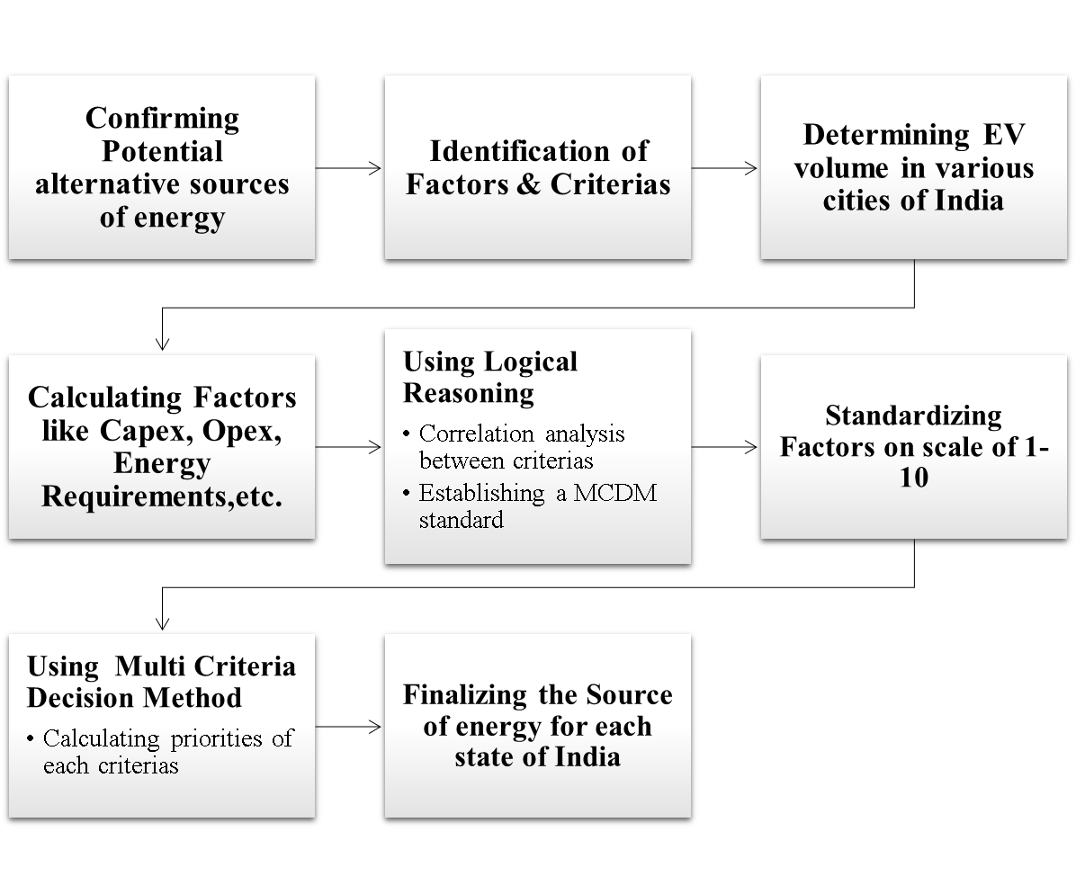

Figure 3.3 Site Selection Procedure

## 

## Stage 6: Rules for EVCS

When we talk about planning and selecting sites for Electric Vehicle Charging stations, we need to first prepare some rules and regulation guidelines, which need to be followed by anyone interested in setting up one.

Now, as for India, the Ministry of Power (a government body) through Bureau of Energy Efficiency (BEE), has initiated a few energy efficiency initiatives and acts to regulate the EVCS demand. A specific document consisting of guidelines and specifications for charging station infrastructure, helps us lay the foundation work for optimistically selecting sites for charging stations.

For basic Public Charging Stations (PCS) the guidelines that are supposed to be complied with are:

* At least one charging station shall be available in a grid of 3 kms x 3 kms.
* At least one charging station on each side of highways/roads at a distance of 25 kms.
* At least two charging stations (Fast/ Super-Fast) for heavy duty EV’s on each side of highways at a distance of 100 kms.

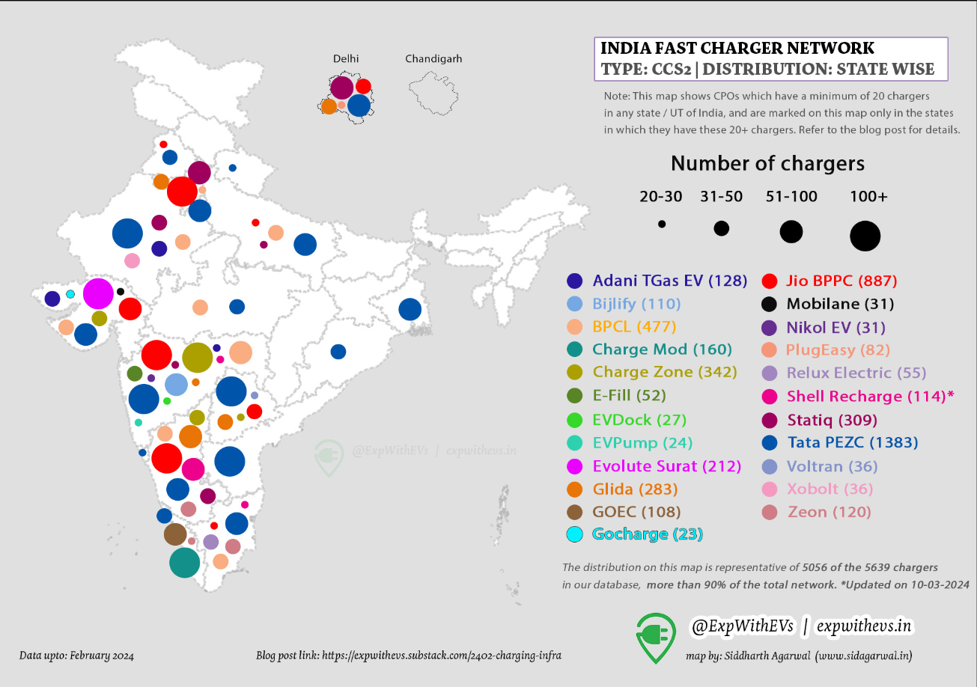

Figure 3.4 India's Charging Network (Agarwal)

The above image represents the EV Charging stations across India. It typically represents the volume, or the number of charging stations (inform of distinct size circles) provided by various companies across India.

Now, once we know the guidelines by the government and major charging station providers, we must select locations for the placement of new ones. As the data related to cities is not available, hence we must layout general idea for the location of the stations. The objective entails establishing a comprehensive network of EV charging stations that provides convenient and dependable access for electric vehicle proprietors, thus fostering the embrace and utilization of electric vehicles. Here are some key considerations:

* Accessibility and Visibility
* Proximity to High-Traffic Areas
* Parking Convenience
* Safety and Security
* Amenities and Services
* Strategic Infrastructure
* Collaboration with Local Stakeholders

Now as for location, keeping the above-mentioned considerations in mind and suggesting some open for all easily accessible location, these below mentioned ones can be considered:

* Shopping Malls
* Grocery shops and Marketplaces
* Airports
* Hotels and Restaurant Parking
* Public Parks and Gardens
* Parking Garages and parking lots
* Gaps under Flyovers
* Vacant Government lands

Incorporating readily accessible charging hubs, individuals owning electric vehicles (EVs) can confidently navigate through their daily routines, embark on extensive voyages, or luxuriate in recreational pursuits, all while being assured of dependable charging amenities.

The accessibility and availability of such charging infrastructure assume a pivotal role in the burgeoning acceptance of electric vehicles, emblematic of a change in basic assumptions towards eco-conscious transportation alternatives. Enlarging the grid of EV charging hubs in these strategic locales empowers us to fortify and incentivize the transition towards sustainable mobility, concurrently addressing the evolving needs of EV operators.

## Stage 7: Example of the procedure

Multi Criteria Decision Making (MCDM) has been applied to determine the best alternate source of energy in this study. As considering charging station in Indian cities becomes impossible due to lack of information regarding geographical data. Hence a general standardization and scaling based on factors like Capex, OpEx, Environmental, Efficiency, etc. is provided below.

Table 3.13 General Scale

|  |  |  |  |  |
| --- | --- | --- | --- | --- |
| Factors | Wind | Solar | Fuel Cell | Hybrid |
|  |  |  |  |  |
| Capex | 7 | 2 | 7 | 5 |
| OpEx | 9 | 6 | 2 | 6 |
| Efficiency | 5 | 3 | 10 | 6 |
| Losses | 4 | 2 | 8 | 5 |
| Environmental | 8 | 9 | 7 | 8 |
| Social | 9 | 9 | 6 | 8 |

There are several other factors required to conduct MCDM, these factors are harnessed by processing data related to land requirement, land availability, grid penetration factors etc. These data are more reliable in case of a county in United States like San Francisco, California. California shares, a lot of cultural diversity and environmental resemblance, with India. Hence, we will provide an MCDM example focusing on the above-mentioned location.

Table 3.14 Example Of Different Criterion And MCDM For The California State



# Results and Discussion:

The MCDM approach has yielded a set of results that suggest specific alternate sources of energy for specific states of India. We considered numerous factors as a part of analyzing the prospect and compiled them in an excel sheet as shown in the figure below.

Table 4.1 MCDM For The State Of Gujarat State

|  |  |  |  |
| --- | --- | --- | --- |
| State: - | **Gujarat** | | |
|  | Wind | Solar | Hydrogen |
| Capex | 3 | 2 | 3 |
| Opex | 4 | 4 | 2 |
| Area required | 3 | 3 | 2 |
| Ev Density | 9 | 9 | 9 |
| Environmental | 8 | 9 | 6 |
| Social | 7 | 9 | 6 |
| Grid Penetration | 8 | 8 | 1 |
|  |  |  |  |
| Output | 6 | 6.285714286 | 4.142857143 |

These factors have been analyzed for every state of India, and for California. The output is basically the average of all values that has been allotted to each factor for every source of energy. The values have been allotted such that if a certain source of energy involves an extremely high capital expenditure, then the value allotted to it will be 1 and if it is extremely low it will be allotted 10. These values are allotted according to the scale that we created which compares all the states for the sources of energy and each factor associated.

Table 4.2 Scaling For a Few States In India

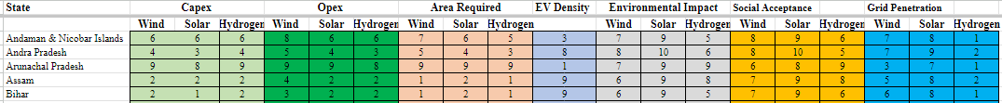

The scaling has been done based on detailed data of how many EVs have been registered, how much it would cost to run, and set up the plants, what would be the environmental impacts, how well it will be received among the civilians and grid penetration. All these factors do not hold equal weightage so a brief sheet displaying the weights was created.

Table 4.3 Weightage for different criterion and MCDM for California

|  |  |  |  |  |  |  |  |  |  |  |
| --- | --- | --- | --- | --- | --- | --- | --- | --- | --- | --- |
| State: - |  | **California** | | | | | | | | |
|  | **Weights** | **Wind** | **Solar** | **Hydrogen** | **Hybrid (35% Solar, 45% Wind and 20% Fuel Cell)** |  | **Weighted Wind** | **Weighted Solar** | **Weighted FuelCell** | **Weighted Hybrid** |
| Capex | 0.15 | 1 | 1 | 1 | 1 |  | 0.15 | 0.15 | 0.15 | 0.15 |
| Opex | 0.15 | 1 | 1 | 1 | 1 |  | 0.15 | 0.15 | 0.15 | 0.15 |
| Area required | 0.05 | 1 | 1 | 1 | 2 |  | 0.05 | 0.05 | 0.05 | 0.1 |
| Ev Density | 0.1 | 10 | 10 | 10 | 10 |  | 1 | 1 | 1 | 1 |
| Environmental | 0.3 | 8 | 9 | 7 | 10 |  | 2.4 | 2.7 | 2.1 | 3 |
| Social | 0.05 | 9 | 9 | 6 | 9 |  | 0.45 | 0.45 | 0.3 | 0.45 |
| Grid Penetration | 0.1 | 8 | 6 | 2 | 7 |  | 0.8 | 0.6 | 0.2 | 0.7 |
| Land Available | 0.1 | 8 | 8 | 8 | 8 |  | 0.8 | 0.8 | 0.8 | 0.8 |
|  |  |  |  |  |  |  |  |  |  |  |
| Output | 1 | 5.428571429 | 5.285714286 | 4 | 5.714285714 |  | 0.7142857143 | 0.7285714286 | 0.5642857143 | **0.7928571429** |

As far as the weights that have been allotted are concerned, these are purely personal interpretations of the necessity according to the region. This may vary from country to country, state to state. For this example, we chose the weights as Capital Expenditure and Operational Expenses as 15% each. While we chose Environmental factor holding 30% weightage because these technologies have high impact on environment in the above-mentioned location.

For California, capital expenditure and operational expenditure are the highest. Hence, they are allotted the value of ‘1‘. The EV density is lower; hence a number 10 is allotted. The amount of land needed to set up such power plants is massive because the electricity demand is high, as a result a higher capacity plant will be needed. On the opposite side the area available to set up plants is ample in the Saint Bruno region.

The results can be shown by the last row, in which the energy source with the highest value is considered the most optimum solution. From the above table, hybrid technology is better in terms of all factors combined. Therefore, for the state of California hybrid technology with 35% solar supply, 45% wind supply and 20% hydrogen fuel cell supply is suggested.

Similarly, a state of India is considered, for example Uttar Pradesh,

Table 4.4 MCDM For Uttar Pradesh State

|  |  |  |  |
| --- | --- | --- | --- |
| State: - | **Uttar Pradesh** | | |
|  | Wind | Solar | Hydrogen |
| Capex | 1 | 1 | 1 |
| Opex | 2 | 1 | 1 |
| Area required | 1 | 1 | 1 |
| Ev Density | 10 | 10 | 10 |
| Environmental | 7 | 9 | 6 |
| Social | 8 | 9 | 6 |
| Grid Penetration | 6 | 7 | 1 |
|  |  |  |  |
| Output | 5 | 5.428571429 | 3.714285714 |

Since, some data for hybrid technologies have not been available, it is not possible to conduct a study in that area for Indian states, however three main energy sources wind, solar and hydrogen are considered. Data for land available in the most recent year is not available and hence, it has not been considered.

Uttar Pradesh shows similar characteristics to California, but if we do not consider hybrid technology as a choice for California, we have wind energy as the next best solution, while for Uttar Pradesh it tends to be Solar energy. The major reason for this difference is because of the higher values for environmental, social, and most importantly grid penetration factors.

# Conclusion:

The study focuses on real-life analytics to determine economically, environmentally, socially, and feasibly suitable energy sources for EV charging stations in India. It emphasizes the importance of considering factors like capital expenditure, operational expenditure, social factors, grid penetration, EV Density, and environmental factors in decision-making. The research provides a comprehensive framework for deploying charging stations integrated with Renewable Energy Sources (RES) while optimizing their location for maximum efficacy and environmental impact reduction. The paper discusses the challenges, regulatory frameworks, and economic considerations for the widespread adoption of RES-integrated EV charging stations. Case studies of successfully implemented RES-integrated EV charging stations are presented, along with future research directions for optimization and scalability.

Different geographical conditions in India require planning for various sources of energy generation, such as solar power, wind power, and hydrogen fuel cell plants. Power plants can be developed in metropolitan cities to cater to the higher population density and increased energy demand for EVs. Transmission losses may occur when developing energy power plants in regions farther from urban regions. Stage-1 discusses dissimilar sources of energy that can be utilized to meet the rising demands of energy due to EVs. Solar, wind, and hydrogen fuel cells are the propositions that can be followed to avoid higher loads on our existing power supply grids. The current potential of all such sources is different, along with varying qualities like efficiency, output, and cost derivatives like Capex and OpEx. Based on these factors, a detailed comparison is provided in Stage-2 which helped determine the best alternate energy source. These sources of energy can be installed anywhere across the country and the energy can transmitted to any corner of the country, however careful considerations in stage-3 determine the factors like social, economic, environmental, technical, & engineering feasibility that will aid to fix the locations. Along with these factors come several geographical considerations that need to be addressed. The government of India has classified the cities into 3 categories: Tier-1, Tier-2, and Tier-3. These cities are classified by population and thus would help us determine the frequency of charging stations to be planted in a certain region. The certain locations on which these charging stations need to be planted must be determined by incorporating the use of certain methods and algorithms, after gathering data related to the source of energy. These methods, algorithms and models are very crucial for the project, which have been noted down under Stage-5. With the basic rules and guidelines from the government of India, the general location for Public EV Charging Stations is proposed under Stage-6. The final stage of MCDM/MCDA to select the best energy source for each state of India and an example of California, US to provide fundamental knowledge of the functioning of the method is bestowed in Stage-7. The list of best sources for each state is provided below.

Table 5.1 Best Sources For Some Of The States Of India

|  |  |  |  |  |  |  |  |
| --- | --- | --- | --- | --- | --- | --- | --- |
| State | Source | State | Source | State | Source | State | Source |
| 1. Andaman & Nicobar Islands | Solar | 10. Goa | Solar | 19. Madhya Pradesh | Solar | 28. Punjab | Solar |
| 2.Andra Pradesh | Solar | 11. Gujarat | Solar | 20. Maharashtra | Solar | 29. Rajasthan | Solar |
| 3.Arunachal Pradesh | Solar | 12. Haryana | Solar | 21. Manipur | Solar | 30.Sikkim | Solar |
| 4.Assam | Solar | 13. Himachal Pradesh | Solar | 22. Meghalaya | Solar | 31. Tamil Nadu | Solar |
| 5.Bihar | Solar | 14. Jammu & Kashmir | Solar | 23. Mizoram | Solar | 32. Telangana |  |
| 6.Chandigarh | Solar | 15. Jharkhand | Solar | 24. Nagaland | Solar | 33. Tripura | Solar |
| 7.Chhatisgarh | Solar | 16. Karnataka | Solar | 25. NCT of Delhi | Solar | 34. Uttar Pradesh | Solar |
| 8.Dadra & Nagar Haveli | Solar | 17.Kerala | Solar | 26. Odisha | Solar | 35. Uttarakhand | Solar |
| 9.Daman & Diu | Solar | 18. Lakshadweep |  | 27. Puducherry | Solar | 36. West Bengal | Solar |

# Future Scope:

Even after concluding this research, we still believe that there is a scope for more research on this topic. The future in respect to the site selection of EV Charging Stations in India holds a vast pool of relatable research. The following list provides options for future research.

* **Optimizing the “Energy Efficiency” of the energy generating technologies as well as energy consuming technologies.** - There are several technologies involved in the energy sector which may need more research to be optimized for higher efficiency and lesser losses. Like preparing new types of solar panels or even highly efficient wind turbines. Energy efficiency can help to reduce greenhouse gas emissions and promote the transition to a low-carbon economy, while also providing economic benefits such as cost savings, etc.
* **Capacity determination of Charging Stations considering dynamic nature as well as uncertainty of consumer usage**. - This could involve developing models that incorporate road network topology, actual traffic conditions, and capacity constraints of the distribution network, as well as simulating users' travel processes to obtain the spatiotemporal distribution of EV charging load. This could involve using techniques such as adaptive simulated annealing particle swarm optimization algorithms to solve complex optimization problems.
* **Development of data and analytics tools to support EV charging stations. -** This could involve developing models and algorithms that analyze large datasets to identify trends, patterns, and opportunities for optimization, as well as developing visualization tools that help stakeholders understand and interpret the data.
* **Technological Integration and System Inter-Operability. -** This could involve analyzing existing policies and regulations, identifying gaps and challenges, and proposing new policy and regulatory measures to support the integration of renewable energy sources into the EV charging station infrastructure as well as exploring ways to ensure compatibility and interoperability across different systems and technologies.
* **Financial Model and Investment Analysis. -** Investigating various income sources, such as pay-per-use, subscription-based, and advertising-based models, as well as the possibility of indirect revenue generating, might be part of this.It can also include analyzing the initial capital costs, operating costs, and potential revenue streams, as well as the potential savings in energy costs and grid reinforcement costs.
* **Site Selection for EV charging stations in cities, villages, and towns with less or no grid connection using GIS. -** This could include more comprehensive research and model formation for the deployment of EV charging stations in small cities, villages, and towns. This might involve selecting stand-alone energy generation systems with proper infrastructure for regular operations.
* **Customizable and Sustainable Charging Solutions -** Future research can explore the development of customizable and sustainable EV charging solutions like Tata Steel Nest-In's Charge Nest, which offers robust, durable, and environmentally friendly charging stations that can integrate renewable energy sources like solar panels. This aligns with the growing need for sustainable infrastructure in Indian cities

# References

1. Abdolvahhab Fetanat, Ehsan Khorasaninejad. "A novel hybrid MCDM approach for offshore wind farm site selection: A case study of Iran." *Ocean & Coastal Management* (2015): 17-28. Elsevier.
2. Agarwal, Siddharth. *India Fast Charger Network*. Delhi, 28 March 2024. Blog Post.
3. Agency, European Environment. *New Registration of electric cars EU-27*. 30 January 2024. <https://www.eea.europa.eu/en/analysis/indicators/new-registrations-of-electric-vehicles?activeAccordion=>.
4. California Energy Commision. *EV Charging Basics*. 3 January 2024. <https://calevip.org/electric-vehicle-charging-101>.
5. Chengkang Gao, Nan An, Sulong Zhu, Huan Yu, Chengbo Gao, Hongming Na. "Comprehensive comparison of multiple renewable power generation methods: A combination analysis of life cycle assessment and ecological footprint ." *Renewable and Sustainable Energy Reviews* (2021).
6. Chung, Mark. *Hydrogen Financial Analysis Scenario Tool*. 19 January 2024. <https://www.nrel.gov/hydrogen/h2fast.html>.
7. Dave, Kapil. *20000 MW offshore Wind Power Project in Gujarat gets nod*. 5 January 2024. <https://timesofindia.indiatimes.com/city/ahmedabad/20000-mw-offshore-wind-power-project-in-gujarat-gets-nod/articleshow/97672027.cms>.
8. Duffy, Tyler Stehly and Patrick. *2021 Cost of Wind Energy Review*. 21 January 2024. <https://www.nrel.gov/wind/offshore-market-assessment.html>.
9. EV Reporter. *Top Electric 3W- cargo Vehicles*. 3 January 2024. <https://evreporter.com/top-electric-3w-cargo-vehicles-l5/>.
10. EVESCO. *The Different Levels of EV Charging Explained*. 3 January 2024. <https://calevip.org/electric-vehicle-charging-101>.
11. Fuel Cell Works. *South Korea: worlds largest hydrogen fuel cell power plant opened by korean southern power kospo*. 10 February 2024. <https://fuelcellsworks.com/news/south-korea-worlds-largest-hydrogen-fuel-cell-power-plant-opened-by-korean-southern-power-kospo/>.
12. Global Data. *Power plant profile: Gujarat 252 MW Wind Farm, India*. 5 january 2024. <https://www.power-technology.com/data-insights/power-plant-profile-gujarat-252-mw-wind-farm-india/>.
13. Golam Kabir, Razia Sultana Sumi. "Power substation location selection using fuzzy analytic hierarchy process and PROMETHEE: A case study from Bangladesh." *Energy* (2014): 717-730. Elsevier.
14. Government of India. *Overview - Power Distribution in India*. 5 January 2024. <https://iced.niti.gov.in/energy/electricity/distribution>.
15. —. "Zero Emission Vehicle(ZEV): Towards a policy Framework." 15 February 2024. *Niti Aayog.* <https://e-amrit.niti.gov.in/reports-and-articles>.
16. Gupta, Kamini. *Top Five states for solar generation across India*. 5 January 2024. <https://ornatesolar.com/blog/top-five-states-for-solar-power-generation#:~:text=Rajasthan%20has%20the%20highest%20solar,17.8%20GW%20of%20solar%20energy>.
17. Huiru Zhao, Nana Li. "Optimal Siting of Charging Stations for Electric Vehicles Based on Fuzzy Delphi and Hybrid Multi-Criteria Decision Making Approaches from an Extended Sustainability Perspective." *Energies (MDPI)* (2016): 270.
18. Jun He, Xiao Ling Yang, ChangHong Deng, GuoGang Liu, WenTao Huang, LiWen Zhu. "Expansion planning of electric vehicle charging stations considering the benefits of peak-regulation frequency modulation." *Institute of Engineering and Technology* (2022).
19. Just We. *Electric Car Mileage Rates – How Efficient Are Modern EVs Really?* 3 January 2024. <https://justwe-gpi.com/ev-charging/electric-car-mileage/#:~:text=Average%20Modern%20EVs%20can%20go,(4%20kilometers)%20per%20kWh.>.
20. LUBI. *OpEx vs CapEx Models of Investment in Solar Power Plants: Know what is Best for your Company*. 13 January 2024. <https://solar.lubielectronics.com/opex-vs-capex-solar-power-plane-benefits/#:~:text=Capital%20Expenditure%20or%20CapEx%20refers,electrical%20infrastructure%2C%20and%20other%20components>.
21. Ministry of New and Renewable Energy. *Solar Overview*. 22 April 2024. 9 February 2024.
22. Ministry of Power, Government of India. "Powermin.gov.in." 14 January 2022. 3 April 2024. <https://powermin.gov.in/sites/default/files/Final_Consolidated_EVCI_Guidelines_January_2022_with_ANNEXURES.pdf>.
23. Mohammad Hasan Ghodusinejad, Younes Noorollahi, Rahim Zahedi. "Optimal site selection and sizing of solar EV charge stations." *Journal of Energy Storage* (2022).
24. NITI Aayog. *India's Energy Mix & Power Sector Overview*. 5 January 2024. <https://iced.niti.gov.in/energy/>.
25. NREL, Experian Information Solution. *Maps and Data - Electric Vehicle registration by state*. 30 January 2024. <https://afdc.energy.gov/data/10962>.
26. Sen Guo, Huiru Zhao. "Optimal Site Selection of Electric Vehicle Charging Station by Using FUZZY TOPSIS based on sustainability perspective." *Applied Energy* (2015): 390-402. Elsevier.
27. Seyedmohsen Hosseini, MD Sarder. "Development of a Bayesian network model for optimal site selection of electric vehicle charging station." *International Journal of Electrical Power & Energy Systems* (2019): 110-122.
28. Sheeshan V, Mitt Siddhpura, Ankit Bhatt. *EV Vahan Dashboard*. 8 January 2024. <https://cleanmobilityshift.com/ev-dashboard/>.
29. Sinem Hisoglu, Anu Tuominen, Aapo Huovila. "An approach for selecting optimal locations for electric vehicle solar charging stations." *The Institue of Engineering and Technology* (2023): 123-134.
30. Souvik Banerjee, Dr. Bishaljit Paul, Sumanta Kundu, Sudhangshu Sarkar. "Determination of Appropriate Site Selection of Electrical Vehicles Charging Station ." *International Journal of Engineering Research & Technology Vol. 9 - 11* (2021).
31. Sujit Kumar Sikder, Magesh Nagarjan, Navo Nil Mustafee. "Augmenting EV Charging Infrastructure Towards Transformative Sustainable Cities : An Equity Based Apporach." *Technological Forecasting and Social Change* (2023). Elsevier.
32. Team Acko Drive. *EV Charging standards and specifications in India*. 22 February 2024. <https://ackodrive.com/ev-guide/ev-charging-standards/>.
33. UP Government. "Decoding Indian Cities Classification in Tier I, II, III, IV." 20 February 2024. *Invest UP.* <https://invest.up.gov.in/wp-content/uploads/2023/06/decoding_270623.pdf>.
34. Vignesh Ramasamy, Jarett Zuboy, Michael Woodhouse, Eric O’Shaughnessy, David Feldman, Jal Desai, Andy Walker, Robert Margolis, and Paul Basore. *Solar Market and Research Analysis*. 19 January 2024. <https://www.nrel.gov/solar/market-research-analysis/index.html>.
35. Wind Energy Technologies Office. *Wind Energy Market Report*. 19 January 2024. <https://www.energy.gov/eere/wind/wind-energy-market-reports>.
36. Yunna Wu, Chao Xie, Chuanbo Xu, Fang Li. "A Decision Framework for Electric Vehicle Charging Station Site Selection for Residential Communities Under Intuitionistic Fuzzy Environment: A Case of Beijing." *Energies* (2017). MDPI.
37. Yunna Wu, Meng Yang, Haobo Zhang, Kaifeng Chen and Yang Wang. "Optimal Site Selection of Electric Vehicle Charging Stations Based on a Cloud Model and the PROMETHEE Method." *Energies (MDPI)* (2016): 157.
38. Zinat Tasneem, Abdullah Al Noman, Sajal K. Das, Dip K. Saha, Md. Robiul Islam, Md. Firoj Ali, Md. Faisal R Badal, Md. Hafiz Ahamed, Sumaya I. Moyeen, Firoz Alam. "An analytical review on the evaluation of wind resource and wind turbine for urban application: Prospect and challenges." *Developments in the Built Environment* (2020).