**Emotional Abuse and Stimulating Malpractices of Emotions: Exploring the causes and preventions of the malignant Activity and Malevolent Practice in Learning Science and Education.**

**Kinjal Chakraborty1 & Dr. Abhijit Halder2**

**Student, Department of Education, University of Kalyani, Kalyani, Nadia, W.B, 741235**

**State Aided College Teacher, Dept. of Education, Plassey College, Plassey, Nadia, W.B, 741156**

**Abstract**

Emotional abuse in educational settings is a growing concern that negatively impacts the mental health and academic performance of students. This paper examines the various forms of emotional abuse in schools, such as invalidation, passive aggression, silent treatment, derogatory nicknames, Gaslighting, projection, boundary violations, and body shaming, and explores their detrimental effects on students' emotional and psychological well-being. Emotional abuse often leads to increased levels of anxiety, depression, and suicidal ideation, with long-term consequences on students' self-esteem and academic success. The paper highlights the need for educators to develop emotional intelligence and adopt inclusive, supportive teaching practices to prevent emotional harm. It also emphasizes the importance of creating a positive and empathetic classroom environment, fostering intrinsic motivation in students, and providing accessible counseling and therapeutic services. By addressing emotional abuse through systemic changes, teacher training, and community collaboration, educational systems can work toward ensuring a safe, nurturing space where students can thrive emotionally and academically. Among the burning issues in the educational field today, one significant problem is emotional abuse. At various times and under different circumstances, students are affected by this issue. There has been much discussion about this in educational psychology. It is not only students who are affected; teachers too, at times, are emotionally abused by students in different ways, which is another separate issue. However, when students face such problems during their developmental phase, their overall mental health is negatively impacted. Stress, anxiety, depression, and various types of phobias invade their minds to such an extent that they sometimes choose the path of suicide. According to the NCRB report, in India, a student commits suicide every 42 minutes. When we examine the reasons, it might be found that many of them choose suicide because they have been emotionally abused. Some teachers are involved in such behavior, whether due to personal reasons or other factors, by treating students in an unbearable manner. Some may argue that these teachers are merely disciplining the students. Here, a crucial distinction must be made: the main purpose of punishment, according to behavioral psychology, is to reduce the frequency or magnitude of undesirable behavior so that the student refrains from repeating the action. In contrast, emotional abuse aims to intentionally destabilize the emotional balance of the student, directly attacking their emotions, provoking them, suppressing them, and creating a situation where they cannot set clear goals or adapt successfully. In such cases, students lose their rational stability and become distanced from practical thinking. Some teachers do this intentionally, others unknowingly, and some may do this due to inherent behavioral traits.

**Keywords:** Emotional abuse, Malpractices, Emotional manipulation, Educational environment, Psychological well-being, Academic performance

### Introduction

Emotional abuse in educational environments is a deeply concerning issue that has significant implications for the mental health and academic success of students. While much focus has traditionally been placed on physical abuse, emotional abuse—whether intentional or unintentional—can have profound and lasting effects on a student’s well-being. This paper aims to explore the concept of emotional abuse in schools, its impact on students, and the need for comprehensive strategies to address and prevent it. The paper will also consider the role of teachers in either contributing to or alleviating emotional abuse, and offer suggestions for creating a more supportive, emotionally safe environment in educational settings. Students come from various socio-economic backgrounds, which means their experiences, cognitive structures, and needs vary. The goal of modern inclusive education is to prioritize these needs and help meet them. Therefore, it is essential to develop the educational and developmental background of each student, considering their diversity. However, some teachers fail to do this, emotionally abusing students instead. For example, if a student comes from a disadvantaged background and a teacher suddenly tells them, “You will never succeed!” it will immediately reduce their motivation and goal-directed behavior. Similarly, if a wealthy student is taunted by the teacher with remarks like “You will never achieve anything, you’ll always rely on your father’s money,” it will have the same negative effect. Thus, some teachers lack the necessary emotional intelligence, destabilizing students' emotional stability through negative emotions.

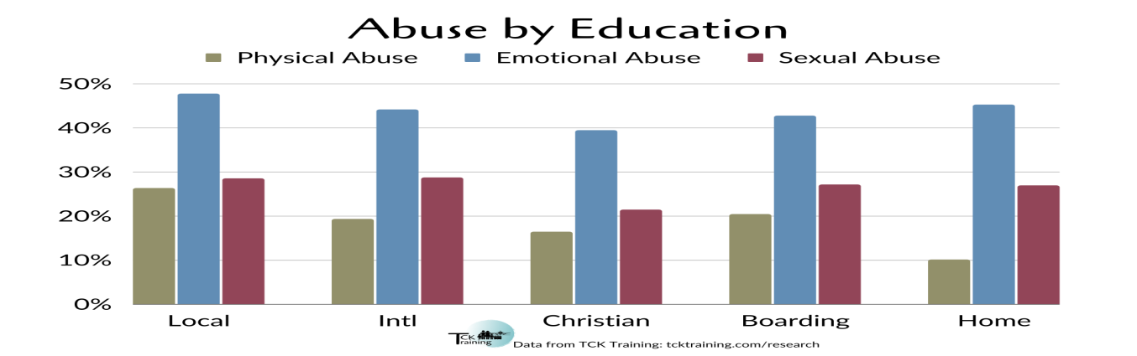

**Fig1: International scenario of Emotional abuse among school students compared than abuses.**

Source: https://www.tcktraining.com/blog/20230616mitigating-risk-factors-for-international-school-students

**Understanding Emotional Abuse in Educational Settings**

Emotional abuse in education is often more insidious than physical abuse, as it can be less visible and harder to detect. It involves actions that harm or destabilize a student’s emotional and psychological well-being. In the educational context, this abuse can come in various forms, including but not limited to verbal harassment, humiliation, neglect, and psychological manipulation. Though the intent behind such behaviors may vary—some teachers may engage in these practices knowingly, while others do so inadvertently due to a lack of awareness—emotional abuse nonetheless has a deleterious effect on students' mental health.

The purpose of discipline in education, as outlined by behavioral psychology, is to correct undesirable behavior in a manner that promotes learning and growth. However, when discipline turns into emotional abuse, it ceases to serve its constructive purpose and instead exacerbates the problem by undermining the student’s sense of self-worth. Emotional abuse is characterized by its focus on devaluing, belittling, or dismissing the student's emotional state, creating an environment of fear, anxiety, and insecurity (Kassinove & Schaefer, 2007).

**Forms of Emotional Abuse in Education**

Emotional abuse in schools can take many different forms, each having a distinct yet harmful impact on the student's emotional health. These include:

1. **Invalidation**: Invalidation occurs when teachers dismiss, ignore, or belittle a student’s feelings, ideas, or contributions. This consistent disregard of a student’s emotional state or thoughts can lead to feelings of inadequacy, self-doubt, and depression (Gonzalez, 2013).
2. **Passive Aggression**: This involves indirect, subtle actions or remarks designed to hurt or undermine a student. A teacher may make backhanded comments that the student may not immediately recognize as harmful but which build up over time, affecting their self-esteem and emotional well-being (Simon, 2010).
3. **Silent Treatment**: The silent treatment involves a teacher ignoring a student altogether, either through refusal to engage with them or by excluding them from classroom activities. This creates a sense of isolation and non-recognition for the student (Gross, 2014).
4. **Derogatory Nicknames**: Teachers may refer to students using insulting or belittling nicknames, often based on their appearance, socioeconomic status, or other personal characteristics. This form of emotional abuse can deeply affect the student’s self-esteem and sense of belonging (Garner, 2012).
5. **Gaslighting**: Gaslighting is a severe form of emotional abuse where a teacher manipulates a student into questioning their own perception of reality. This can lead to confusion, self-doubt, and a distorted sense of self-worth (Dorpat, 2010).
6. **Projection**: Teachers may project their own negative traits, insecurities, or frustrations onto students, making them feel unjustly blamed for problems or failures. This not only damages the student’s self-esteem but also affects their ability to form healthy relationships (Freud, 1916). This concept comes from
7. **Boundary Violations**: Teachers sometimes overstep their professional boundaries by engaging in inappropriate discussions or making personal comments about a student's life, family, or circumstances. These violations of privacy can create feelings of discomfort and vulnerability (Taylor & Wood, 2017).
8. **Body Shaming**: Teachers who make negative remarks about a student’s physical appearance, body type, or health contribute to body image issues and can trigger long-term emotional harm, such as eating disorders or low self-esteem (Rodin, 2014).

**The Impact of Emotional Abuse on Students**

The emotional abuse a student experiences can have a significant impact on their psychological and emotional development. Students who are subjected to emotional abuse are at a higher risk of developing mental health disorders such as depression, anxiety, and suicidal ideation (Briere & Elliott, 2019). Moreover, prolonged exposure to such abuse can impair their ability to form healthy relationships, engage in academic tasks, and achieve their personal potential.

The National Crime Records Bureau (NCRB) reports alarming statistics about student suicides in India, with one student reportedly taking their own life every 42 minutes. Though academic pressure is often highlighted as a primary cause, emotional abuse—whether in the form of bullying, humiliation, or neglect—contributes significantly to these tragic outcomes (NCRB, 2020). Furthermore, emotional abuse can lead to academic underachievement, behavioral problems, and a pervasive sense of hopelessness, which ultimately hinders the student’s ability to adapt and succeed in school.

**Remedies for Emotional Abuse in Education**

Addressing emotional abuse in schools requires a multi-pronged approach, focusing on teacher education, supportive classroom environments, and student well-being. Below are several strategies that can help mitigate the effects of emotional abuse and create a healthier educational environment.

**1. Developing Emotional Intelligence (EQ) in Teachers**

One of the most effective ways to combat emotional abuse is through the development of emotional intelligence among educators. Emotional intelligence refers to the ability to recognize, understand, and manage one’s own emotions as well as the emotions of others. Teachers with high EQ can more effectively navigate the emotional dynamics in their classrooms, recognizing when their actions may harm a student’s emotional well-being. By promoting empathy, self-awareness, and emotional regulation, teachers can create a more supportive and emotionally safe classroom (Goleman, 1995).

**2. Creating an Inclusive and Supportive Classroom Environment**

An inclusive classroom that respects and values the diversity of students’ backgrounds, abilities, and emotional needs is essential for preventing emotional abuse. Teachers should make conscious efforts to create an atmosphere where all students feel valued and supported, regardless of their socio-economic background, race, or personal challenges. By adapting teaching strategies to meet the needs of individual students and fostering a sense of belonging, teachers can minimize feelings of exclusion and helplessness (Tomlinson, 2001).

**3. Promoting Intrinsic Motivation Among Students**

Intrinsic motivation, the drive to engage in an activity for its inherent satisfaction, is crucial for fostering a positive learning environment. Teachers should encourage students to develop their own interests and passions, which will motivate them to take ownership of their learning. When students feel empowered and intrinsically motivated, they are less likely to be discouraged by external pressures, such as grades or fear of failure.Developing a practice of self determination theory. The components of self determination theory are autonomy , relatedness, and competence. (Deci & Ryan, 2000).

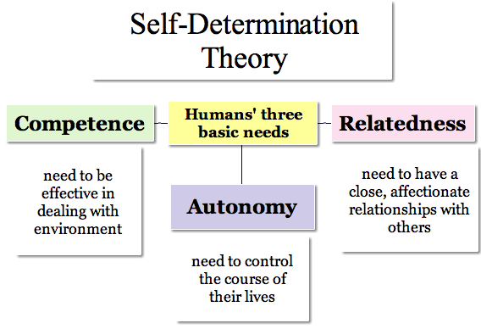 **Fig.1 Diagrammatic representation of self-determination theory**

**4. Providing Counseling and Psychological Support**

Schools should ensure that students have access to professional psychological support services, such as counseling and therapy. These services are essential for helping students navigate emotional challenges and build coping mechanisms. By providing access to resources such as cognitive-behavioral therapy (CBT), group therapy, and other mental health support systems, schools can address emotional distress and prevent more severe consequences, such as depression or suicidal behavior (Weissman et al., 2006).

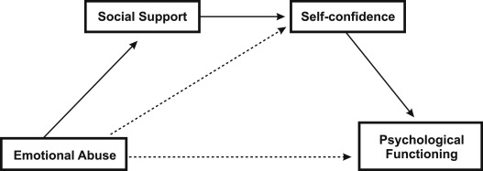

Fig:2 Relationship between the psychological support and Emotional abuse.

**5. Implementing Anti-Bullying Programs**

To prevent emotional abuse in the classroom, schools should implement comprehensive anti-bullying programs. These programs should raise awareness about the different forms of bullying, including emotional abuse, and provide strategies for students and teachers to respond effectively. Peer support networks and peer mentoring programs can also create a positive culture of empathy and understanding, reducing the likelihood of emotional abuse and bullying.

**6. Training Teachers and Educators**

Ongoing professional development for teachers is essential to ensure they are equipped with the skills and knowledge to prevent emotional abuse. Training should focus on recognizing the signs of emotional abuse, managing classroom dynamics effectively, and fostering emotional well-being among students. Teachers should also be educated about the ethical responsibilities they hold as role models and mentors, which include creating a safe and supportive environment for all students.

**Conclusion**

Emotional abuse in educational settings is a severe and often overlooked issue that can have lasting effects on students’ emotional and academic development. Teachers play a critical role in either contributing to or mitigating the impact of emotional abuse. By fostering emotional intelligence, creating inclusive classroom environments, promoting intrinsic motivation, and providing counseling services, schools can significantly reduce the incidence of emotional abuse and create a nurturing space where students can thrive. Through collective efforts from educators, administrators, and the community, it is possible to transform educational environments into emotionally safe spaces where all students can succeed and reach their full potential.

**References**

Briere, J., & Elliott, D. M. (2019). *Child abuse trauma: Theory and treatment of the lasting effects*. Sage Publications.

Deci, E. L., & Ryan, R. M. (2000). The "what" and "why" of goal pursuits: Human needs and the self-determination of behavior. *Psychological Inquiry, 11*(4), 227-268.

Dorpat, T. L. (2010). *Gaslighting: A modern day form of psychological abuse*. Journal of Clinical Psychology, 66(6), 607-611.

Freud, S. (1916). *The Standard Edition of the Complete Psychological Works of Sigmund Freud* (Vol. 13). Hogarth Press.

Garner, J. (2012). *The emotional toll of school bullying: Understanding the harm and the remedies*. Social Work Education, 31(7), 848-859.

Goleman, D. (1995). *Emotional intelligence: Why it can matter more than IQ*. Bantam Books.

Gonzalez, M. (2013). *Understanding the effects of invalidation in the classroom: Strategies for emotional and psychological support*. Journal of Educational Psychology, 105(1), 145-157.

Gross, M. (2014). *The silent treatment in classrooms: An analysis of teacher-student dynamics*. Educational Review, 66(4), 434-448.

Kassinove, H., & Schaefer, C. (2007). *Anger disorders: Definition, diagnosis, and treatment*. Oxford University Press.

NCRB. (2020). *National Crime Records Bureau Report 2020*. Ministry of Home Affairs, Government of India.

Rodin, J. (2014). *Body image and self-esteem in adolescence*. Psychology Press.

Simon, H. (2010). *The effects of passive aggression on student performance and teacher relationships*. International Journal of Educational Psychology, 20(3), 211-224.

Taylor, S., & Wood, C. (2017). *The impact of boundary violations in teacher-student relationships*. Journal of School Psychology, 55(6), 499-507.

Tomlinson, C. A. (2001). *How to differentiate instruction in mixed-ability classrooms*. Association for Supervision and Curriculum Development.

Weissman, M. M., et al. (2006). *Cognitive-behavioral therapy for adolescents with emotional problems*. Psychiatric Clinics of North America, 29(2), 229-243.