**Advanced Gas Leakage Detection System**

**Manjusha N Mahamune1, Harshini P 2, Harsha R3, Deepthi R4, Vijay Kumar5**

1Assistant Professor, Department of Computer Science and Engineering, T. John Institute of Technology, Bengaluru-560083, Karnataka, India

2,3,4,5Student, Department of Computer Science and Engineering, T. John Institute of Technology, Bengaluru560083, Karnataka, India

**ABSTRACT**

This paper presents the design and implementation of an advanced gas leakage detection system that leverages IoT technologies and precise sensors for enhanced safety in industrial and residential applications. The system integrates an ESP32 microcontroller, MQ2 gas sensors, and the Blynk IoT platform for real-time monitoring, automated alerts, and safety measures. Key features include continuous gas concentration monitoring, immediate notifications, and remote accessibility. Testing results demonstrate the system’s efficiency, scalability, and robustness, offering a cost-effective and reliable solution to prevent gas-related hazards.

**Keywords:** Gas leakage detection, IoT, MQ2 sensors, ESP32, real-time monitoring, automated alerts, safety systems.

1. **INTRODUCTION**

Gas leakage incidents pose severe safety risks in industrial and residential environments, often leading to catastrophic consequences. Traditional detection systems relying on manual intervention or wired sensors are limited by their lack of flexibility and delayed responsiveness. Leveraging advancements in IoT, this project introduces a wireless gas leakage detection system that enhances safety through automated alerts and real-time data visualization.

This study emphasizes the need for robust, scalable, and cost-effective systems capable of addressing limitations in existing setups. Our proposed system demonstrates significant improvements in monitoring and hazard prevention, with applications ranging from homes to large industrial facilities.

**METHODOLOGY**

The system employs MQ2 sensors and an ESP32 microcontroller to detect gas levels and trigger threshold-based alerts. Data is transmitted to the Blynk IoT platform for real-time monitoring and remote control. Implementation involves sensor calibration, integration with IoT dashboards, and testing under varying conditions.

**2.1 System Architecture**

The system integrates hardware components, including MQ2 gas sensors, an ESP32 microcontroller, a relay module, and a servo motor, with IoT-based monitoring via the Blynk platform. The architecture ensures:

* Real-time data acquisition from sensors.
* Threshold-based alerts to notify users.
* Activation of safety mechanisms such as alarms and ventilation systems.

**2.2 Data Flow**

Data from MQ2 sensors is processed by the ESP32 microcontroller, which triggers alarms when gas concentrations exceed predefined thresholds. Simultaneously, the system transmits data to the Blynk platform for remote monitoring and control.

**2.3** **Implementation**

The system employs the Arduino IDE for programming and integrates various libraries, including Blynk and ESP32 Servo. Key implementation steps include:

* Sensor calibration to ensure accuracy.
* Integration with the Blynk IoT platform for real-time visualization.
* Testing under various environmental conditions to validate reliability.
  1. **Data Flow Diagram**

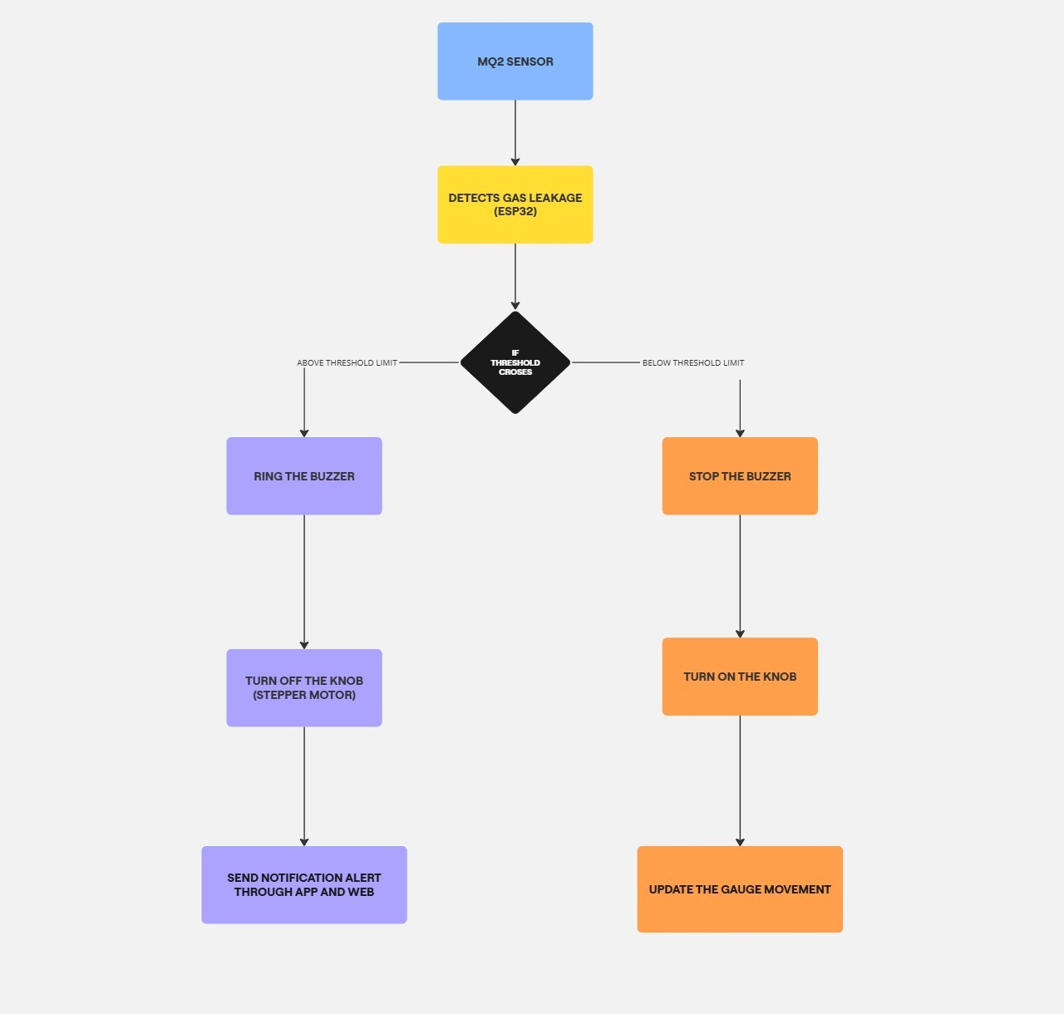

**Figure 1:** Dataflow diagram.

1. **RESULTS AND DISCUSSION**

**3.1** **System Performance**

The system was tested under controlled conditions to evaluate its sensitivity and responsiveness. Key findings include:

* Real-time alerts triggered within 1 second of threshold breaches.
* Accurate detection of LPG and methane gases.
* Reliable remote monitoring via the Blynk app.

**3.2** **Comparative Analysis**

Compared to traditional systems, the proposed model exhibits:

* Enhanced scalability for industrial and residential applications.
* Reduced false alarm rates due to precise sensor calibration.
* Lower installation and maintenance costs.

**3.3** **Limitations**

While the system demonstrates robust performance, it is reliant on stable internet connectivity and periodic sensor maintenance to sustain accuracy.

**3.4** **Future Scope**

Future enhancements include:

* Support for multi-sensor arrays to detect a broader range of gases.
* Cloud-based data analytics for predictive maintenance.
* Integration with smart assistants for voice alerts and advanced user interaction.
* Expanded applications in automotive safety and environmental monitoring.

1. **CONCLUSION**

This study presents a cost-effective and reliable gas leakage detection system with IoT integration for real-time monitoring and hazard prevention. By addressing limitations in traditional systems, our approach enhances safety standards in various settings. Future work will focus on expanding system capabilities and refining user interaction.

1. **REFERENCES**
2. T. Kumar, G.A. et al., "Implementation of real-time detection of gas leakage in industries using ARM7 and ZigBee," 2022.
3. Anusha, Dr. S. Meeravali, "Detection of Gas Leak and Its Location Using Wireless Sensors," 2022.
4. Sathyabama University, "Gas Leakage Detection System Using IoT," 2022.
5. Kodali, R.K. et al., "IoT-Based Industrial Plant Safety Gas Leakage Detection System," 2021.
6. Ahmad, S.; Ullah, T.; Ahmad, I.; ALSharabi, A.; Ullah, K.; Khan, R.A.; Ali, M. A Novel Hybrid Deep Learning Model for Metastatic Cancer Detection. Comput. Intell. Neurosci. 2022, 2022, 8141530
7. Diro, Abebe, et al.2021 "A comprehensive study of anomaly detection schemes in IoT networks using machine learning algorithms." Sensors 21.24 (2021): 8320.
8. Ravi Kishore Kodali, Greeshma, R.N.V, Kusuma Priya Nimmanapalli, Yatish Krishna Yogi Borra, “IOT Based Industrial Plant Safety Gas Leakage Detection System”, International Conference on Computing Communication and Automation (ICCCA), pp.no, 1-5, published in 2021.
9. M Athish Subramanian, Naveen Selvam, Rajkumar S, R Mahalakshmi, J Ram Prabhakar , “Gas Leakage Detection System using IoT with integrated notifications using Push bullet-A Review”, Proceedings of the Fourth International Conference on Inventive Systems and Control (ICISC 2020) IEEE Xplore Part Number:CFP20J06- ARTI; pp.no 359 – 363.