**FLOOD DETECTION & HUMAN IDENTIFICATION SYSTEM UTILISING FASTER RCNN ALGORITHM AND UNET MODEL**

**Prof Anusree L 1, Akshaya Sanil 2, Gayathri S 3**

**1 Assistant Professor, Dept. of ECE, LBSITW (Affiliated to APJ KTU)**

**2 B-Tech Student , Dept. of ECE,LBSITW(Affiliated to APJ KTU)**

**3 B-Tech Student , Dept. of ECE,LBSITW(Affiliated to APJ KTU)**

**ABSTRACT**

This project focuses on developing an advanced flood delineation and human detection system using aerial imagery and machine learning models to address critical gaps in disaster response and management. The traditional flood monitoring techniques often lack precision and efficiency in identifying flood affected areas and locating individuals in need of assistance. To overcome these, our system proposes the U-Net model to accurately segment and classify flood-affected and non-flood-affected regions and enabling the creation of precise flood maps. Additionally, the Faster R-CNN algorithm is employed to detect the presence of humans in these flood-affected zones through it which ensures timely precise rescue operations. By combining aerial imagery with these powerful machine learning techniques, the system achieves high accuracy in both flood delineation and human detection. Hence the system is designed to provide actionable insights for disaster management authorities and it can facilitate quicker decision-making and efficient allocation of resources during flood emergencies. The integration of automated alert mechanisms further enhances the system’s utility by enabling immediate communication with rescue teams. By addressing the critical challenges of accurate flood mapping and human detection, this project offers a robust, scalable, and cost-effective solution for disaster mitigation. This innovative approach not only enhances the efficiency of rescue operations but also has the potential to minimise the impact of floods on affected populations. This initiative approach represents a significant advancement in disaster management technology as well as it ensures more effective and timely response during natural calamities.

**Keywords:** Flood delineation, Faster R-CNN, UNET model, Human detection.

**INTRODUCTION**

Floods are one of the most dangerous natural disasters world-wide, it has the capability to cause serious damage to property, the environment, and human lives. For managing floods effectively, it requires accurate identification of flood-affected areas and locating people who need help in a timely manner. However, traditional methods for flood monitoring often lack of speed and accuracy, that it will makes the rescue operations to become more difficult and delayed. For mitigates these issues our project proposed a solution by using aerial images combined with machine learning models to improve flood monitoring and rescue operations. The U-Net model is used to segment the flood-affected and non-flood-affected areas through which generate the precise flood map. At the same time, the Faster R-CNN model is applied to detect people who are stranded in the flood zones. This combination helps to ensure high accuracy and reliability in identifying both affected regions and stranded individuals in need. And additionally we will combine an alert system for sending the critical information to nearby authorities with no of individuals and locations detected when humans are identified in flood affected areas. So we can say that our system will assigned for helping the disaster management teams to respond faster and they can use their resources more efficiently, ensuring better rescue operations. When we considered to aerial images it will allows for high resolution mapping and also provides the clear and detailed visuals of food conditions. By integrating these technologies, the project makes smarter and more effective, ultimately helping to save lives and reduce the impact of floods on communities.

**2. PROBLEM STATEMENT**

Floods are one of the most destructive natural disasters, affecting millions of people around the world. A major challenge during such disasters is the inability to quickly and accurately identify flood-affected areas and locate people in need of rescue. Current technologies often lack the speed and precision required to provide real-time data, which can delay rescue operations and lead to unnecessary loss of life. There is a need for an automated, real-time solution that can detect flood-affected areas and locate people in those regions efficiently.

This project addresses that need by developing an intelligent system using aerial imagery and machine learning models. It accurately identifies flood zones and detects people in need of help, helping rescue teams respond faster and more effectively. By improving the speed and accuracy of flood detection and human identification, our system enhances the overall rescue operation, ensuring more lives are saved during critical flood situations.

**3.SCOPE AND RELEVANCE**

Flooding is a major natural disaster that poses significant challenges to rescue operations, particularly in ensuring timely and accurate identification of affected areas and individuals in need of help. The scope of our work focuses on developing an advanced flood delineation human detection system using aerial imagery and deep learning models to assist in disaster management. By integrating the U-Net model for flood-affected area segmentation and Faster R-CNN for detecting human presence in these areas, our system aims to enhance flood monitoring and rescue operations.

The relevance of our project lies in its potential to significantly improve the speed and accuracy of flood response efforts. With high-resolution aerial imagery, our system provides more precise flood mapping, enabling disaster management teams to act quickly and effectively. By automating the detection of flood-affected regions and locating individuals in need of assistance, we can reduce response times and improve the efficiency of rescue operations. And also through which the integration of an alert system increases the effectiveness of a system, can save time as well as we can to reduce the unnecessary loss of lives. This approach addresses critical gaps in current technologies and offers a more reliable solution for real-time flood detection and human identification, ultimately saving lives during disaster events.

Through the use of advanced machine learning techniques, our project is relevant not only to flood management but also to broader applications in disaster response, where quick and accurate information is crucial.

**4.OBJECTIVES**

Broad objective

The primary objective of this project is to develop a real-time, automated system for flood detection and rescue operations using aerial imagery and advanced deep learning models. Employing technologies like U-Net for flood area segmentation and Faster R-CNN for human detection, the system aims to accurately identify flood-affected regions and locate individuals stranded in these areas. By introducing the integration of an alert mechanism the system will changes into real-time solution during the food emergency, it enhances efficiency and changes into more powerful in critical situations.

This project helps to improve the efficiency of disaster response by providing timely and precise data to rescue teams, enabling faster and more targeted operations. It also aims to minimize delays that often result in loss of life during flood emergencies.

Additionally, the system focuses on enhancing accuracy and reliability by evaluating its performance using metrics such as Intersection over Union (IOU), mean Average Precision (MAP), and overall accuracy, loss. It is designed to be adaptable, ensuring that it can handle diverse scenarios and integrate with existing disaster management frameworks.

By addressing these objectives, the project seeks to provide a robust and scalable solution that significantly improves the speed and effectiveness of flood rescue efforts, ultimately helping to save lives and reduce the unnecessary loss of life.

SPECIFIC OBJECTIVES

The proposed project focuses on developing a system for flood detection and rescue operations using advanced technologies. The specific objectives are:

1. Precise Flood Area Segmentation: It utilize the U-Net model to accurately segment aerial images into flooded and non-flooded areas. This ensures high precision in mapping affected zones, enabling effective disaster management,

2. Human Detection in Flood Zones: Implement the Faster R-CNN model to identify human presence within flood-affected regions. This feature ensures timely recognition of stranded individuals in need of rescue.

3. Automated Alert System: Integrate a GSM module to send automatic alerts to local rescue teams whenever human presence is detected in flood-affected zones. This ensures a faster response to critical situations.

4. Performance Evaluation: Assess the system's accuracy and reliability by evaluating key performance metrics, including Intersection over Union (IOU), Mean Areal Pressure ( MAP), and overall accuracy and also loss. This ensures that the system meets the required standards for effective disaster response.

5. Real-Time Efficiency: Develop the system to process aerial imagery and generate results in real-time, minimizing delays in rescue operations and improving response times during emergencies.

**5.METHODOLOGY**

**Flood Delineation Using U- Net Model**

1. Image Acquisition:

High-resolution aerial images are collected from reliable sources like kaggle, which offers diverse datasets of flood-affected areas. These images focus on pre-flood and flood-affected regions, forming the base data for flood analysis.

2.Preprocessing: Next we perform preproces6 to enhance image quality. In this step involves brightness adjustment, rotation of images Horizontal flip movement, noise reduction which means it ensuring the data is suitable for model input. By using open cv tool, done pre-processing. This step ensures the creation of a high-quality annotated dataset, enabling the U-Net model to learn flood segmentation effectively and can creates the map accurately.

3. U-Net Model: The annotated dataset is input into the U-Net model. It is a powerful deep learning technique designed for image segmentation tasks. The model identifies and segments flooded areas from the collected images with pixel-level accuracy

4. Segmentation Output: The output, where the flooded regions are highlighted and this visual representation is crucial for analysing the precise identification of flood extent. 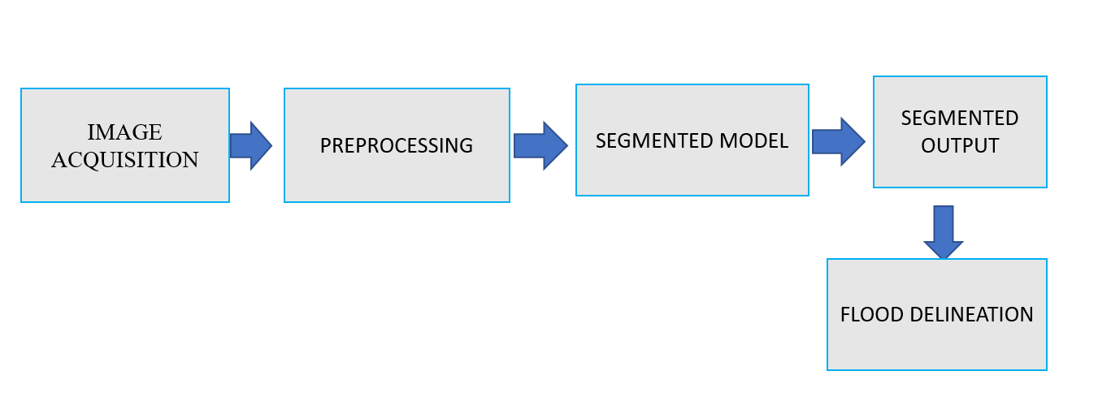

Fig.1: Flood delineation

**Human Detection Using Faster R-CNN**

1. Image Acquisition: collects the images targeting flood zones with potential human presences from Kaggle datasets. These datasets include diverse scenarios and varying conditions to train the detection model effectively.

2. Annotation of Data: Images are annotated manually to label human presence and rescue boats using bounding boxes around individuals and boats. Annotation tool such as ROBOFLOW used to mark precise bounding boxes, assigned the label for human 0.0 and for boat 1.0. This step ensures the creation of high quality labelled dataset .These annotations and input images provide the necessary training data for the Faster R-CNN model to identify humans and boats effectively

3. Faster R-CNN Model: The Region Proposal Network (RPN) generates regions of interest (ROIs) from the annotated images. And A classifier then assigns labels (E.g. Human ) and refines bounding box coordinates for precise detection.

4. Detection Output: The output includes detected humans or rescue boats marked with bounding boxes and confidence scores. These results are overlaid on the images for easy interpretation.

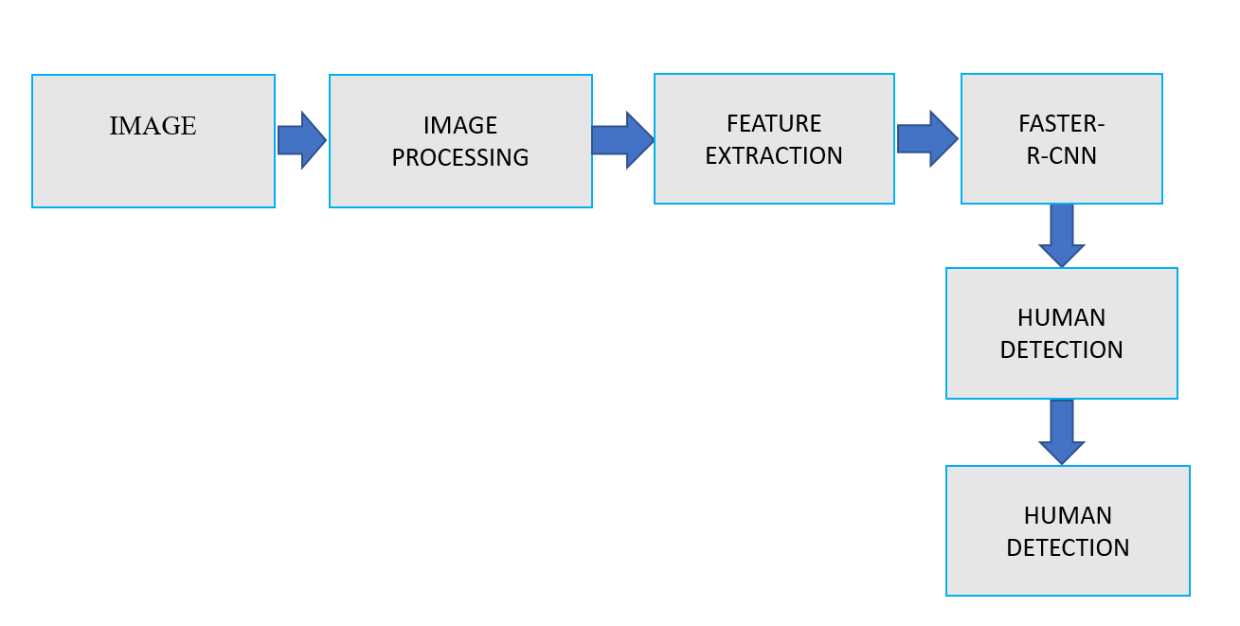

Fig.2: Human detection

**6.SOFTWARE REQUIREMENTS**

This project is developed using Python and operates on Windows OS, though it is compatible with any modern operating system that supports Python and its required libraries. The project integrates several essential Python libraries and tools to fulfilled its objectives effectively. For object detection, Faster R-CNN is implemented using PyTorch, a deep learning framework known for its flexibility and performance in building advanced neural networks. Image segmentation of flood-affected areas is performed using U-Net, trained with Tensor Flow. These frameworks ensure efficient model training and testing for accurate results. Image preprocessing is handled using Open CV, an open-source computer vision library used for enhancing image quality and extracting significant features. Num Py is utilized for numerical computations and data transformations, while Matplotlib is employed to visualize data, including detection outputs and model performance.. The project uses Flask, a lightweight web framework, to develop a user interface for displaying results and generating flood alerts. Data pre-processing is supported by Pandas, which is used to manage structured datasets and organize input or output flows. The library is utilized for accessing and downloading datasets from external sources. The development environment relies on Anaconda, which ensures compatibility of libraries and simplifies package management, and Jupyter Notebook is an interactive platform used for prototyping and testing code. These tools collectively provide a robust framework for real-time flood prediction, human detection, and alert systems, ensuring high efficiency and scalability.

**7.RESULTS**

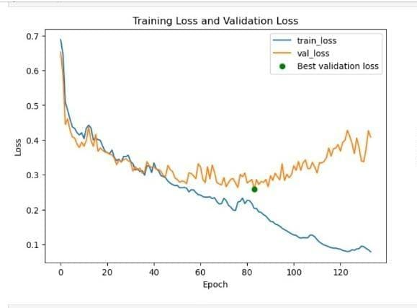

Fig.3:Training loss and Validation loss

The training loss (blue line) and validation loss (orange line) demonstrate the model’s learning progress over the epochs. Initially, both losses decrease, indicating effective learning. However, the validation loss reaches its minimum at a specific epoch (marked as the "Best validation loss") and starts to increase afterward, it shows the onset of overfitting. To address this, early stopping is applied, stops the training process at the point of minimal validation loss and saving the best-performing model.

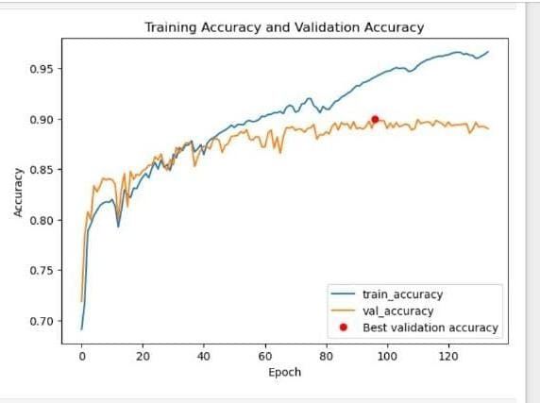

Fig.4: Training Accuracy and Validation Accuracy

The training accuracy (blue line) and validation accuracy (orange line) improve steadily over the epochs. The validation accuracy saturated after a certain number of epochs, showing that the model has reached its optimal performance on the validation data. The "Best validation accuracy" is marked with a red dot, indicating the peak validation accuracy achieved before stabilization.

FLOOD DELENATION

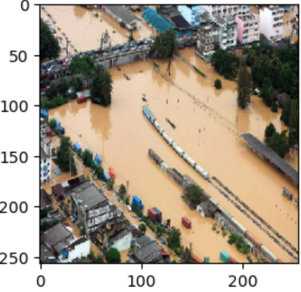 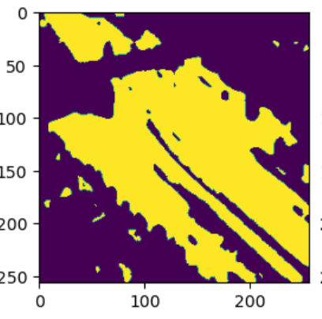

Fig.5: Input image Fig.6: Masked image (Actual image)

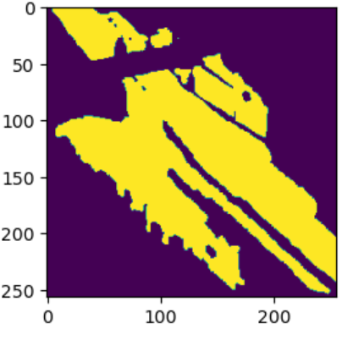

Fig.7: Predicted image

Figure 7.3 and Figure 7.4 and figure 7.5 illustrate the key stages of the flood delineation process using the U-Net model. Fig; 1 depicts the input image, which is aerial view of the flood-affected area, and fig:2 represents the corresponding ground truth mask, representing the actual flooded regions used during training. Fig:3 showcases the predicted output, which is the segmented image generated by the model to identify the flooded areas. These outputs validate the model's performance and form the basis for generating a comprehensive segmentation map. The map highlights the extent of flooding in the geographical area and integrates with the human detection module to support automated rescue operations.

**8.CONCLUSION**

This flood detection and human identification system by utilizing the Faster R-CNN algorithm and U-Net model for flood delineation it offers an innovative solution to enhance flood surveillance and rescue operations. By processing aerial imagery, the U-Net model effectively identifies and delineates flood-affected areas, while the Faster R-CNN algorithm detects the presence of humans within these regions. This combined approach ensures accurate flood mapping and quick identification of individuals in need of assistance through which enabl timely alerts to local rescue teams .The introduction of an automated alert system further improves the efficiency of the project by notifying rescue teams promptly and ensuring a swift and coordinated response to emergencies. This tool addresses critical challenges in flood disaster management, particularly in regions where traditional methods may be limited due to accessibility or visibility issues. Ultimately, this project aims to contribute to more effective disaster response by providing a reliable, scalable and accurate solution for flood delineation, human identification, and alert notification. By integrating advanced machine learning techniques with practical disaster management tools, the project generates a safer and more responsive environment for flood-affected communities.

**9.REFERENCES**

[1] Pathan, Ajim I., et al. "An IoT and AI based flood monitoring and rescue system." *Int. J. Eng. Tech. Res* 9.9 (2020): 564-567.

[2]Muhadi, Nur Atirah, et al. "Deep learning and LiDAR integration for surveillance camera-based river water level monitoring in flood applications." *Natural Hazards* (2024): 1-24.

[3] Song, Jiayi, et al. "State-of-the-Art Techniques for Real-Time Monitoring of Urban Flooding: A Review." *Water* 16.17 (2024): 2476.

[4] B Nair, Bhavana, Shivsubramani Krishnamoorthy, and Sethuraman N Rao. "Machine vision based flood monitoring system using deep learning techniques and fuzzy logic on crowdsourced image data." *Intelligent Decision Technologies* 15.3 (2021): 357-37

[5] Iqbal, Umair, et al. "Drones for flood monitoring, mapping and detection: A bibliometric review." *Drones* 7.1 (2023): 32., Bhavana B., et

[6] Nair al. "Enhanced Urban Flood Monitoring: Integrating Advanced Semantic Segmentation and Human Facial Feature and Posture Analysis." *IEEE Access* (2024).

[7] Van Ackere, Samuel, et al. "A review of the internet of floods: Near real-time detection of Benkraouda, Hadjer, Ezedin Barka, and Khaled Shuaib.

[8] Hong, Jung-Hong, and Yi-Tin Shi. "Integration of Heterogeneous Sensor Systems for Disaster Responses in Smart Cities: Flooding as an Example." *ISPRS International Journal of Geo-Information* 12.7 (2023): 279.

[9] Cyber-attacks on the data communication of drones monitoring critical infrastructure." *Comput. Sci. Inf. Technol* 8.17 (2018): 83-93.a flood event and its impact." *Water* 11.11 (2019): 2275.

[10] Visu, P., et al. "Software-defined forensic framework for malware disaster management in Internet of Thing devices for extreme surveillance." *Computer communications* 147 (2019): 14-20.