**ANALYSIS OF GROUNDWATER QUALITY IN UYO CAPITAL CITY:**

**A COMPARATIVE STUDY OF COMMERCIAL AND PRIVATE BOREHOLES**

**Abraham, C.M1., Etetor. H. J2; Jimmy, U.J4., Etuk, E.B5; Umoh, M.E6; Udoh, W.M7**

1,2,3,4,5,6 Department of Geography and Natural Resources Management, University of Uyo, Uyo

7Department of Plant Science, Delta State, Abraka

**Corresponding author:**jimmyutibe21@gmail.com

**ABSTRACT**

This study was undertaken to comparatively investigate groundwater quality in Uyo capital city from private and public boreholes in order to ascertain if there are variations in quality. Four objectives were used in the study using both experimental and survey methodology. The flame atomic absorption spectrophotometry was used to analyze the level of chemical concentration in the borehole water samples. A total of fourteen (14) groundwater samples were collected from 7 commercial boreholes located at Nwaniba Road, Aka Road by Udo Udoma, Oron Road, Ikpa Road by CCC, Abak Road, Mbierebe Junction and Ikot Ambang and 7 private boreholes located at Water Board Itam, Water Board Oron Road, Nwaniba Road close to Water Fountain, Champion Brewery, Redeemed Church close to Dumpsite Uyo Village Road (Ikpa Road), Abak Road and Mbierebe Junction. The groundwater samples were analyzed in the laboratory for their chemical and microbiological characteristics. On comparing the results with standard values recommended by World Health Organization (WHO), it was discovered that some of the groundwater samples had parameters that were within the permissible limits with slight variation across the different locations. While also, there were parameters that did not meet up with the permissible limit set by the World Health Organization. For instance, the pH of the groundwater samples was not within the permissible limit of 6.50mg/l-8.50mg/l in six (6) different locations of the commercial boreholes which are Oron road, Nwaniba road, Aka road, Ikpa road, Abak road, Ikot Mbang with values of 5.3, 6.3, 4.5, 5.9, 5.1, 5, 7 respectively. While, the pH in the private boreholes was not within the permissible limit in five (5) different locations which are Water board Itam, Nwaniba road, Champion brewery, Ikpa road, Abak road with values of 4.31, 4.98, 6.1, 5.53, 6.21 respectively. Several other parameters also got slight differences. The study found out that the groundwater of the study area is not devoid of contaminants, be it from the private or commercial borehole and as such both requires treatment. The study recommends continuous monitoring of the groundwater supply to keep the quality in check.

**Keyword: Groundwater Quality, Uyo Capital City, Comparative Study, Commercial, Private Boreholes**

**Introduction**

Water is an essential resource for human survival and development, and its availability is a critical factor in the growth and well-being of communities. Water access for users affect both urban and rural entities and the degree of water contamination is influenced by prevailing human activities (Mshelia and Mbaya, 2024).

The issue of water impurity and risk is attributable to high population, poor waste management and sanitation practices, lack of wastewater collection system and functional treatment plant, poor and dilapidated soakaways and septic tanks, filthy surroundings of wells and boreholes and also the location of these water sources close to soakaways, pit toilets, wastewater channels in the metropolis (Samandra et al., 2022; Mshelia, et al., 2023). Wastewater from industries and homes also contributed to high concentrations of contaminants in groundwater at different locations of urban centres globally through infiltration (Chiadic et al., (2023), Chen et al., (2020), Choi and Choi (2021), Gamvroula and Alexakis (2022), Makubura et al., (2022), Mshelia et al., (2020) and Mshelia et al., (2022).

Private boreholes are independently owned and operated water sources that tap into groundwater reservoirs beneath the Earth's surface. They have gained popularity in both urban and rural areas for several reasons. Access to safe and reliable water sources is a fundamental aspect of urban living, with significant implications for public health, economic development, and overall quality of life (Wilpiszeski et al., 2019). In urban areas, households often have two primary options for their water supply: private boreholes or commercial borehole-connected systems. The quality and safety of water supplied through private boreholes and commercial systems have been subjects of extensive research. Private boreholes offer a certain level of control over water quality, as homeowners can monitor and maintain their water sources. Commercial borehole systems require effective treatment, monitoring and maintenance of water facilities in order to ensure safer service delivery to water users (Omorogieva et al 2024).

There is this common saying that “No life without water”, because water is the essential requirement of all life supporting activities (Elijah, 2023). Water is used in numerous ways at community level, and the requirement in quantity and quality are varied. The uses of water include domestic use, public purposes, industrial purposes, agriculture purposes etc (Elijah, 2023). Access to safe and clean groundwater is crucial for sustaining public health and ensuring a reliable source of drinking water. Uyo Capital City, the administrative and economic center of Akwa Ibom State, Nigeria, predominantly relies on groundwater extracted from boreholes for both domestic and commercial purposes (Ofem et al., 2021). However, concerns have arisen regarding the quality of this groundwater, particularly in the context of the distinct sources and management of commercial and private boreholes. The challenge lays in the fact that there is limited information on the spatial and temporal variations in groundwater quality within Uyo Capital City. Factors such as land use, hydrogeological conditions, and anthropogenic activities may contribute to differences in water quality among commercial and private boreholes. Akpabio and Udom (2018) noted that the lack of stringent regulations for commercial boreholes and water vendors, this has raised concerns about the quality of water supplied to residents and businesses. The problem arises from inadequate monitoring and testing protocols, leading to potential health risks associated with substandard water quality (Ansa and Uzoma, 2019). Many households and institutions rely on self-owned boreholes for their water supply. However, without regular monitoring and maintenance, private boreholes may become contaminated over time. The problem lies in the absence of guidelines and support for private borehole owners to ensure water quality remains safe and reliable. Poor water quality poses severe health risks to the residents of Uyo Capital City. Contaminated groundwater can lead to waterborne diseases, posing a significant burden on the healthcare system and diminishing the overall quality of life for the population. Identifying the causes of groundwater contamination is essential to mitigate these risks (Raimi et al., 2019). There is a notable gap in comprehensive data and information regarding groundwater quality in Uyo Capital City. Additionally, there is a need for the dissemination of research findings to relevant stakeholders, including government agencies, communities, and private borehole owners, to drive informed decision-making and ensure sustainable water management necessitating this research. The aim of this study is to assess ground water quality in commercial and private boreholes in Uyo Capital City, Akwa Ibom State, Nigeria and the following objectives are considered:

1. To examine and ascertain groundwater contamination of private and commercial boreholes in Uyo capital city.
2. To compare the results of groundwater qualities in Uyo capital city with WHO and federal ministry of environment standard.
3. To assess the peculiar constraint associated with ground water protection for both private and commercial boreholes.

**2.1 Literature Review**

The issue of groundwater contamination poses a profound global challenge, impacting human health and ecological services. Li et al. (2021) examined a series of studies conducted in various parts of the world, with a particular focus on groundwater contamination in the eastern hemisphere, including India, China, Pakistan, Turkey, Ethiopia, and Nigeria. These studies explore the origins, scale, and consequences of groundwater contamination, highlighting the critical importance of addressing this issue for the benefit of both human populations and the environment. The review draws upon a body of research that leverages field investigations and laboratory analyses of groundwater samples. These investigations examine a wide array of physico-chemical parameters to assess groundwater quality. The parameters encompass pH, dissolved oxygen (DO), biological oxygen demand (BOD), total dissolved solids (TDS), conductivity, turbidity, salinity, total hardness, total alkalinity, temperature, as well as a suite of cations and anions. Additionally, heavy metals, including iron, copper, chromium, manganese, nickel, lead, and zinc, were analyzed.

Raimi and Ezugwu (2018) studied the significant issue of water quality in the Ebocha-Obrikom oil and gas producing area of Rivers State, Nigeria, where the exploration and extraction of hydrocarbons pose potential risks to the environment and human health. The research undertakes a comprehensive investigation into the physico-chemical parameters of both surface and groundwater. It strives to determine the quality of water in this region by comparing it with national and international standards for drinking water.

Groundwater quality encompasses its physical, chemical, and biological attributes (Perez-Lucaz et al., 2019). Contamination of groundwater occurs when these qualities are disrupted, either through physical or chemical means, or by affecting its biological properties. Groundwater pollution is essentially the presence of impurities in the water. It transpires when harmful substances enter the ground and gradually seep into the groundwater. Conversely, natural processes can also lead to the presence of minor, unwanted constituents, contaminants, or impurities in groundwater. In such cases, it's typically referred to as contamination rather than pollution (Li et al., 2021). The rising population, driven by increased urbanization, industrialization, and agricultural activities in Nigerian is seen as a significant threat to groundwater quality, particularly in urban and peri-urban areas (Yusuf and Abiye, 2019). Groundwater in certain regions contains specifications like fluoride and toxic elements such as arsenic, lead, and selenium, in concentrations that pose health risks. In other cases, groundwater may contain elements or compounds that cause different issues, like the discoloration of sanitary fixtures due to iron and manganese.

There are numerous standards for drinking water and ground water including EPA, WHO, Nigerian Standard for drinking water (NSDW) etc. Ezenwaji and Ezenweani (2019) assessed the physiochemical and microbiological parameters of borehole water in Warri Urban, Delta State, Nigeria. To accomplish their goal, the researchers collected water samples from 20 boreholes across Warri Urban. These samples were stored in sterilized plastic sample flasks to prevent contamination and transported immediately to a laboratory for testing. In the laboratory, the mineral content of the water was determined using an Atomic Absorption Spectrophotometer. The study employed the t-test method to examine the major physical and chemical variables responsible for groundwater pollution in the region. Cluster analysis was also employed to establish the spatial distribution of pollution levels across the study area.

The findings of the research conducted by Ezenwaji and Ezenweani (2019) raised concerns about the groundwater quality in Warri Urban. The average total coliform counts in the water samples from the study area were found to exceed both the WHO guidelines for drinking water quality and the Nigerian Standard for Drinking Water Quality. This indicates that the groundwater in Warri Urban is contaminated with coliform bacteria, rendering it unsafe for consumption based on established international and national standards. The presence of total coliform bacteria in groundwater is a strong indicator of potential fecal contamination, which poses a severe threat to public health. In many developing regions, including parts of Nigeria, access to safe and clean drinking water remains a significant challenge. The contamination of groundwater sources with coliform bacteria is often a result of inadequate sanitation and sewage systems, as well as the proximity of boreholes to potential pollution sources. In Warri Urban, it is evident that there are critical concerns regarding the sanitary conditions around boreholes, maintenance practices, and the need for effective water treatment to remove microbial contaminants.

The quality of drinking water is a critical concern for public health, as access to safe drinking water is a fundamental human right. Chinedu et al. (2019) studied water quality parameters, including physicochemical properties and heavy metal content, in Canaanland, Ota, and the nearby Iju River. The importance of the studies lies in the need to ensure that water sources meet international and national drinking water quality standards, such as those outlined by the World Health Organization (WHO) and the Nigerian Standard for Drinking Water (NSDW). Various water sources were selected for examination, including rainfall, borehole water, tap water, rivers, swimming pools, and commercially available bottled and sachet water. Amoo et al. (2018) focuses on assessing groundwater contamination in the Sharada industrial area of Kano, Nigeria. Groundwater is a vital source of drinking water and plays a crucial role in sustaining agricultural and industrial activities in the region. However, the rapid industrialization and urbanization in Kano have raised concerns about the quality of groundwater in the Sharada area, where industrial activities are concentrated.

To assess the groundwater contamination, the study collected water samples from a total of six boreholes and six hand-dug wells within the Sharada industrial area. Each well had two representative samples. This random sampling method was employed to address the diverse contaminants that could affect water quality in industrial zones.

The collected water samples underwent comprehensive analysis, which included the examination of various physicochemical parameters and the presence of heavy metals. Parameters such as temperature, pH, electrical conductivity (EC), magnesium (Mg), calcium (Ca), potassium (K), sulphate, chloride, nitrates (NO3), cadmium (Cd), chromium (Cr), lead (Pb), and zinc (Zn) were examined.

In India, Adimalla and Wu (2019), examined groundwater quality and associated health risks, a comprehensive study conducted in the Siddipeta-Vagu (SDV) region of India, where groundwater serves as the sole source of water. The study focuses on evaluating the suitability of groundwater for both domestic consumption and irrigation, while also examining the potential impact of groundwater contaminants on human health. The research involved the collection of 51 groundwater samples, a representative selection, to assess the suitability for both domestic and irrigation purposes.

**Materials and Mthods**

The study was conducted in Uyo, Capital City. Data for the study was obtained primarily from the laboratory analysis. The study adopted both experimental and survey approach. In the experimental approach, water samples were collected from both commercial site boreholes and private boreholes in the selected areas for laboratory analysis. Systematic sampling technique was adopted in selecting fourteen (14) sample point around Uyo where the water samples is collected for analysis.

In each of the selected sample area 7 private and 7 commercial boreholes were randomly selected giving a total of 14 sampling points. The physical and chemical parameters that is consider will include: Cu, Pb, Zn, Cd, Cr, Ni, Hg, As, pH, TDS, Ca, Mg, Na, K, SO, Cl, HCO, NO and F. In-situ measurement for pH and total dissolved solids (TDS) was determined in the field using a portable measuring instrument (HI98195, HANNA). All samples were collected and stored according to the standard for detection of groundwater quality (DZ/T 0064.2-1993); samples were tested within 15 days.

In this investigation, samples from both public and private water sources were taken. To avoid contamination, representative water samples were gathered using sterilized water bottles. Before sampling, the sample vials were carefully cleaned and rinsed with the sample water at each drill position. To preserve the integrity of the water, the samples were taken in close proximity to the well head. Before samples were taken, the boreholes were let to flow for roughly three minutes to provide stable conditions. To reduce oxygen contamination and the release of dissolved gases, the bottle was promptly sealed after the sample water was completely filled. Two sets of one-liter pre-labelled bottles were used for sampling, one for the analysis of heavy metals and one for ionic compounds. After being collected, water samples were stabilized for the purpose of determining the cations by adding a small amount of diluted hydrochloric acid. Portable digital metres were used to measure and record in-situ physical and chemical characteristics (pH, and conductivity) that are sensitive to changes in the environment, hence preserving the integrity of the water samples.

The selection of sampling sites in this study aimed to cover diverse areas within Uyo Capital City, representing various land uses and potential sources of groundwater contamination. The following key locations were identified for sample collection for non-commercial boreholes include Water Board Itam, Water Board Oron Road, Nwaniba Road close to Water fountain, Champion Brewery, Redeem Church Close to Dumpsite Uyo Village Road (Ikpa Road), Abak Road and Mbierebe Junction.

**The Study Area**

Uyo Capital City which is the area under study consists of all the areas within a radius of 10 kilometres measured from Ibom connection (a major roundabout at the heart of the city). It was demarcated by Uyo Capital City Development Authority law, CAP 136 of 1988. The city limit incorporates parts of nearby Local Government Areas, such as Itu, Uruan, Ikono, Nsit Ibom, Ibiono Ibom and Ibesikpo Asutan. Uyo Capital City doubles as the municipal council headquarters of Uyo LGA as well as the capital of Akwa Ibom State (Ofem, & Jacob, 2019). The city became the State capital on September 23, 1987 following the creation of Akwa Ibom State from the erstwhile Cross River State.

Uyo Capital City lies between latitudes 4°58' and 5°04'N and longitudes 7°51'E and 8°01'E. It is bounded in the North by Ikono, Itu and Ibiono Ibom LGAs. In the East, it shares a boundary with Uruan LGA, while in the South it borders with Ibesikpo Asutan and Nsit Ibom LGAs (Figure 1.1). Uyo Capital city is situated on an average elevation of 60.96 metres above sea level (Njungbwen & Roy, 2010). The city covers an area of about 214.31square kilometres (Ofem, & Jacob, 2019). Uyo Capital City is one of the fastest growing cities in Nigeria. The city can be accessed by road via the Abak Road, Nwaniba Road, Calabar-Itu Road and Aka-Nung-Udoe Road, Ikot Ekpene Road and Oron Road.

Based on the 1991 population census, Uyo capital city had a population of about 276,927 persons. But based on the projected population of 2022 as expressed below Uyo capital city population is about 335,082 persons. Since the creation of Akwa Ibom State, Uyo city has continued to experience such high population growth.

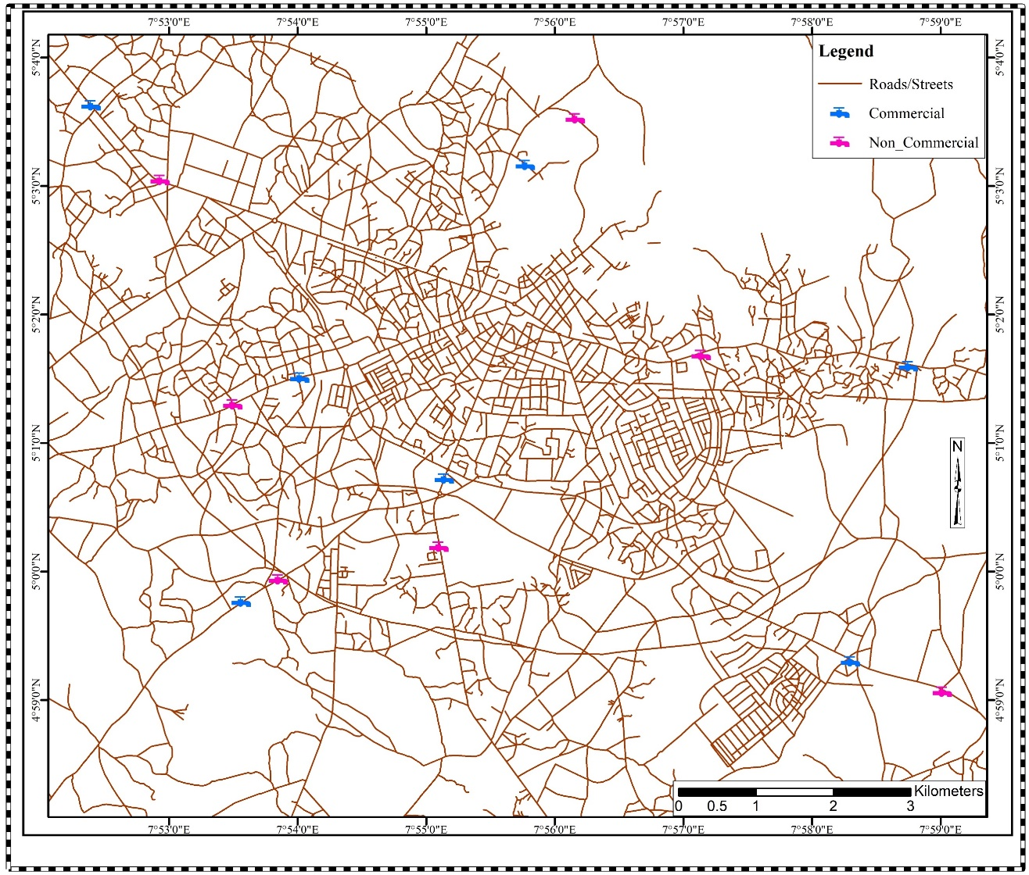

**Figure 3.1: Uyo Capital City Showing Selected Sampling Locations**

**Source: Ministry of Lands and Town Planning**

**RESULTS AND DISCUSSION**

**4.1 Non Commercial Borehole Sample Result**

The result for the samples sites of the boreholes used for the analysis is presented in tables 4.1

|  |  |  |  |  |  |  |  |
| --- | --- | --- | --- | --- | --- | --- | --- |
| **Parameters** | **BH1** | **BH2** | **BH3** | **BH4** | **BH5** | **BH6** | **BH7** |
| Water Board Itam | Water Board Oron Road | Nwaniba Road | Champion Brewery | Ikpa Road | Abak Road | Mbieriebe |
| Ph | 4.31 | 6.52 | 4.98 | 6.1 | 5.53 | 6.21 | 6.5 |
| Total Coliforms | 75 | 65 | 60 | 50 | 40 | 60 | 36 |
| Faecal Contamination | 50 | 30 | 60 | 70 | 75 | 70 | 60 |
| Conductivity (µScm-1 ) | 53.20 | 118.70 | 96.30 | 73.00 | 75.00 | 90.50 | 83.60 |
| Turbidity (NTU) | 3.75 | 4.73 | 4.16 | 5.00 | 5.14 | 3.71 | 4.77 |
| Total Suspended Solids (TSS) (mgl-1) | 10.60 | 6.27 | 13.01 | 12.75 | 4.72 | 5.89 | 5.99 |
| Total Dissolved Solids (TDS) (mgl-1) | 22.82 | 13.51 | 27.56 | 12.75 | 33.55 | 21.06 | 4.11 |
| Chloride (Cl- ) (mgl-1 ) | 23.89 | 26.71 | 14.33 | 15.74 | 19.51 | 41.31 | 25.04 |
| Bicarbonate (HCO3 - ) (mgl-1 ) | 3.00 | 0.40 | 1.60 | 0.90 | 0.80 | 0.90 | 1.94 |
| Total Hardness (mgl-1CaCO3) | 51.00 | 32.00 | 35.00 | 37.00 | 39.00 | 50.00 | 61.00 |
| Calcium (Ca2+) (mgl-1 ) | 25.00 | 23.10 | 28.31 | 26.02 | 24.10 | 23.03 | 26.40 |
| Magnesium (Mg2+) (mgl-1 ) | 7.82 | 9.33 | 9.91 | 8.88 | 8.30 | 7.91 | 8.33 |
| Sulphate (SO4 2- ) (mgl-1 ) | 0.09 | 0.03 | 0.05 | 0.06 | 0.03 | 0.07 | 0.04 |
| Total Iron (Fe) (mgl-1 ) | 0.07 | 0.11 | 1.25 | 10.00 | 0.11 | 0.56 | 0.00 |
| Nitrate (NO3 - ) (mgl-1 ) | 0.07 | 0.20 | 0.10 | 0.06 | 0.03 | 0.04 | 0.01 |
| Sodium (Na+ ) (mgl-1 ) | 100.00 | 102.00 | 111.00 | 103.00 | 93.00 | 112.00 | 96.00 |
| Lead (Pb) (mgl-1 ) | <0.001 | <0.001 | <0.001 | <0.001 | <0.001 | <0.001 | <0.001 |

**Table 4.1: Non-commercial boreholes samples results.**

**Source: Researcher’s Compilation (2024)**

Table 4.1 shows the result on commercial Borehole Quality in Uyo Capital City. Seven samples were chosen from commercial boreholes.

**4.2 Commercial Borehole Quality Result**

Table 4.2 shows the result from the sample collection in the commercial borehole sites.

|  |  |  |  |  |  |  |  |
| --- | --- | --- | --- | --- | --- | --- | --- |
| **Parameters** | **BH1** | **BH2** | **BH3** | **BH4** | **BH5** | **BH6** | **BH7** |
| Oron Road | Nwaniba Road | Aka Road by Udo Udoma | Ikpa Road By CCC | Abak Road | Mbieriebe Junction | Ikot Ambang |
| Ph | 5.3 | 6.3 | 4.5 | 5.9 | 5.1 | 6.61 | 5.7 |
| Total Coliforms | 40 | 35 | 30 | 40 | 35 | 40 | 30 |
| Faecal Contamination | 30 | 40 | 20 | 30 | 20 | 35 | 20 |
| Conductivity (µScm-1) | 53.60 | 118.20 | 95.80 | 73.50 | 74.50 | 91.00 | 83.10 |
| Turbidity (NTU) | 4.15 | 4.23 | 4.66 | 5.50 | 5.64 | 4.21 | 4.27 |
| Total Suspended Solids (TSS) | 11.00 | 6.67 | 13.41 | 13.15 | 5.12 | 6.29 | 6.39 |
| Total Dissolved Solids (TDS) | 23.22 | 13.91 | 27.16 | 13.15 | 33.95 | 21.56 | 4.51 |
| Chloride (Cl-) (mgl-1) | 24.29 | 26.21 | 13.93 | 15.34 | 19.91 | 41.71 | 25.44 |
| Bicarbonate (HCO3-) (mgl-1) | 3.40 | -0.10 | 1.20 | 0.50 | 0.40 | 0.50 | 1.54 |
| Total Hardness (mgl-1CaCO3) | 51.40 | 31.60 | 34.60 | 37.60 | 39.60 | 50.60 | 61.60 |
| Calcium (Ca2+) (mgl-1) | 25.40 | 23.50 | 28.71 | 26.52 | 24.60 | 23.53 | 26.90 |
| Magnesium (Mg2+) (mgl-1) | 8.22 | 9.83 | 10.41 | 8.38 | 8.80 | 8.41 | 8.83 |
| Sulphate (SO4 2-) (mgl-1) | 0.49 | 0.03 | 0.05 | 0.06 | 0.03 | 0.07 | 0.04 |
| Total Iron (Fe) (mgl-1) | 0.47 | 0.11 | 1.65 | 10.40 | 0.11 | 0.56 | -0.05 |
| Nitrate (NO3-) (mgl-1) | 0.07 | 0.70 | 0.50 | 0.06 | 0.03 | 0.04 | 0.51 |
| Sodium (Na+) (mgl-1) | 100.40 | 101.50 | 110.50 | 102.50 | 92.50 | 112.50 | 95.50 |
| Lead (Pb) (mgl- | <0.001 | <0.001 | <0.001 | <0.001 | <0.001 | <0.001 | <0.001 |

**Table 4.2: Commercial Borehole result (*Author’s Field work)***

**Source: Researcher’s Compilation (2024)**

Table 4.2 shows the result on non-commercial Borehole Quality in Uyo Capital City. Seven samples were chosen from non-commercial boreholes.

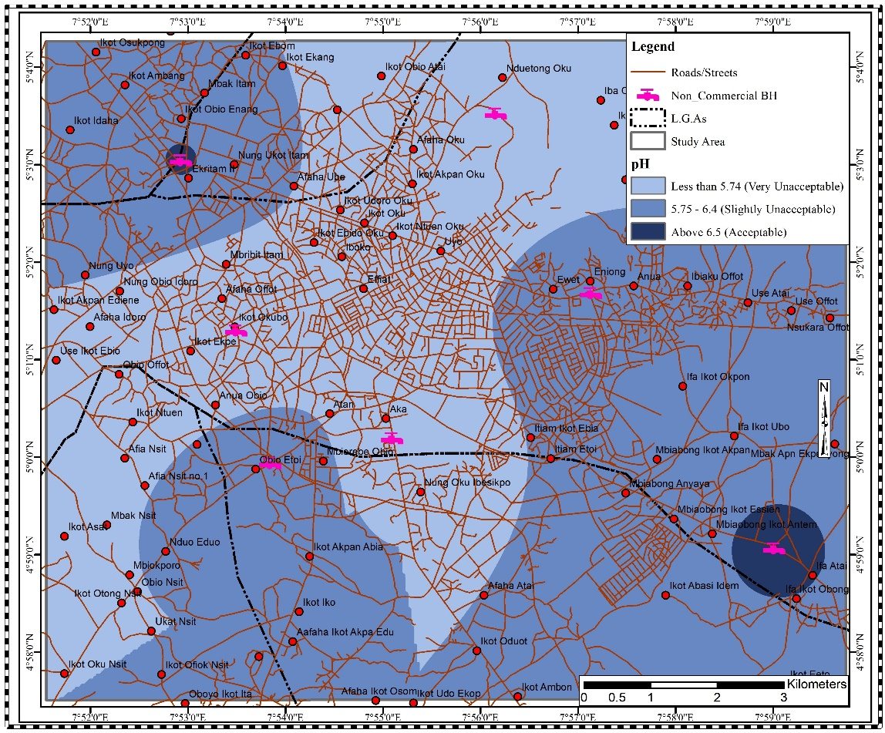

**Fig 4.1 pH distribution for Non-commercial boreholes in the study area**

**Source: Researcher’s Compilation (2024)**

From the map in Fig 4.1, it is shown that the concentration of pH in the study area happens to be beyond the accepted figure set by the WHO in some part of the study area coloured sky blue and slightly acceptable at points coloured blue and acceptable in the spot coloured navy blue.

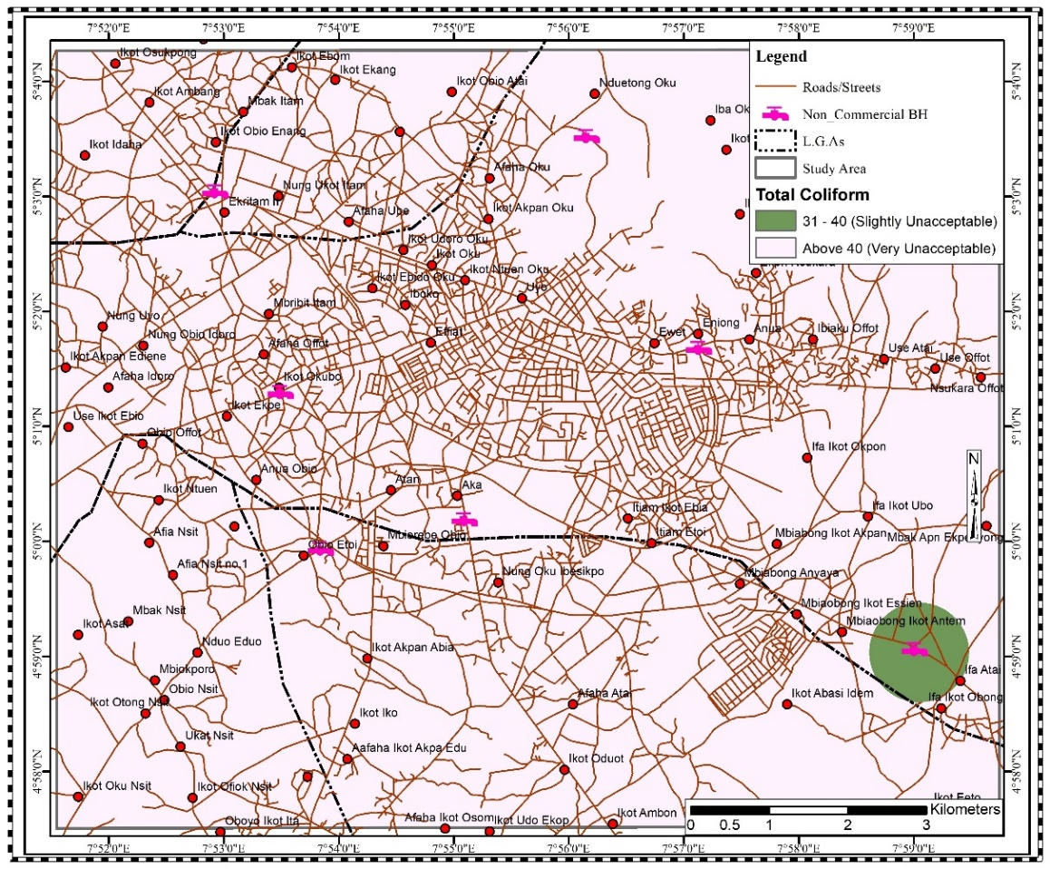

**Fig 4.2: Distribution of Total Coliform concentration in Non-Commercial Boreholes**

**Source: Researcher’s Compilation (2024)**

Figure 4.2 shows Total coliforms in groundwater of the study area as being slightly unaccepted in the area coloured green and very unacceptable in other parts of the study area. This is due to the high level of residential clusters and sewage infiltration into groundwater.

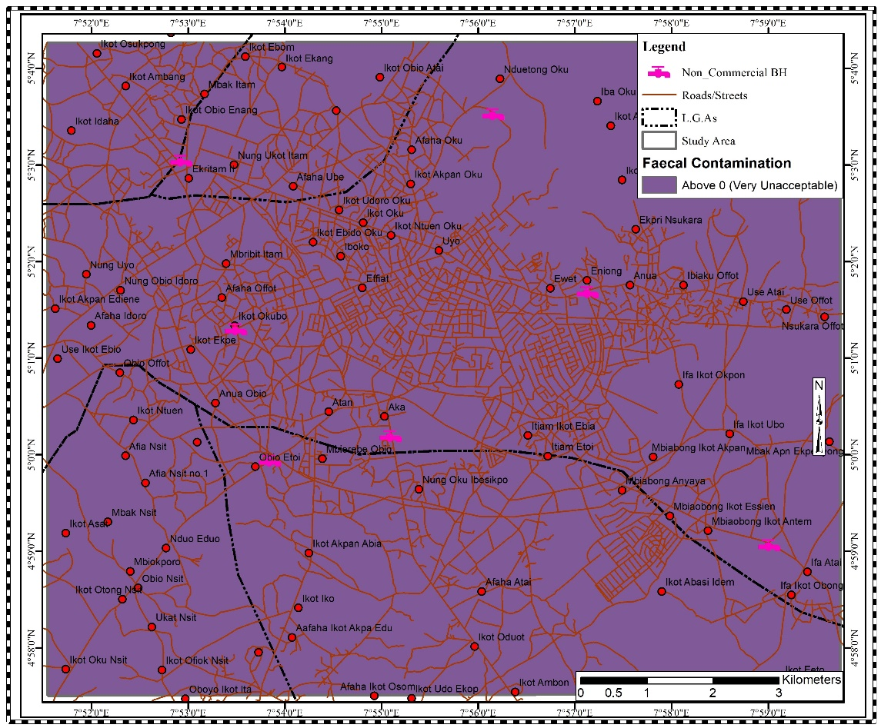

**Fig. 4.3: Feacal contamination distribution for Non-commercial boreholes in the study area**

**Source: Researcher’s Compilation (2024)**

From the Fig 4.3, it shows that the level of feacal contaminants present in the groundwater is very unsuitable. This can be attributed to the presence of septic tanks in the same environs where the borehole is being situated.

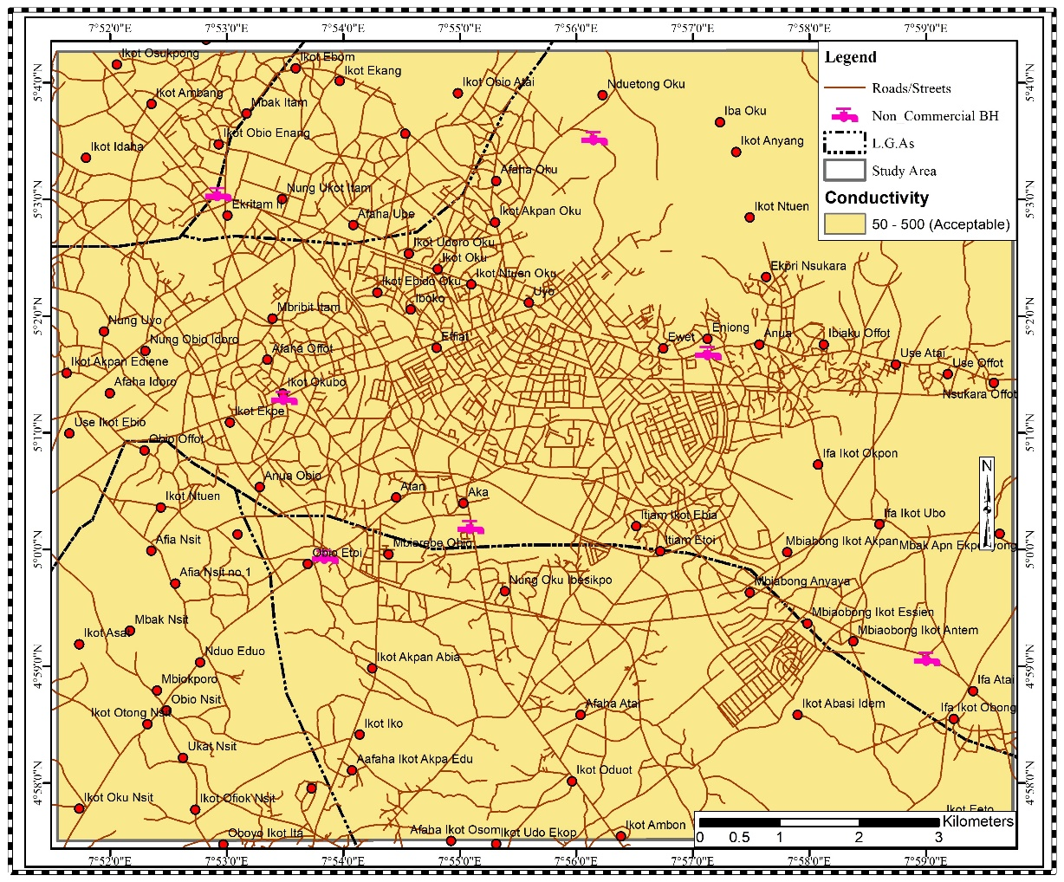

**Fig. 4.4: Conductivity distribution for Non-commercial boreholes in the study area**

**Source: Researcher’s Compilation (2024)**

Figure 4.4 shows groundwater conductivity in the non-commercial boreholes of the study area being within the acceptable standard set by the WHO.

**4.2 Discussion of Findings**

The water quality tests conducted across different locations have unveiled significant variations across various parameters, each carrying critical implications. The pH levels, spanning from 5.3 to 6.3, signal potential acidity issues in specific areas, potentially linked to industrial discharge or organic decomposition. This variance in pH suggests a need for closer monitoring and potential remediation measures to ensure water safety.

The observed variations in pH levels across different locations, serve as an initial indicator of potential groundwater contamination. These fluctuations not only impact the taste and safety of the water but also raise concerns about the underlying acidity or alkalinity, necessitating further investigation and corrective measures to identify and address pollution sources.

The presence of Conductivity hints at dissolved ions, a phenomenon often associated with industrial activities or geological sources. In this study, the amount of conductivity found in the groundwater isn’t such that should negatively impact the well-being of people. To preserve groundwater quality within acceptable limits, ongoing monitoring and targeted efforts to address the sources of increased conductivity become imperative in the quest to prevent contamination.

The slightly elevated turbidity discovered in Champion Brewery's borehole directs attention to potential suspended particles or pollutants. This underscores the necessity for regular monitoring and the implementation of improved filtration methods to ensure both water clarity and quality, mitigating the risk of groundwater contamination.

Elevated levels of TSS and TDS, point towards potential challenges in water treatment processes. The need for a focused investigation into the specific contaminants contributing to these elevated levels emerges as a critical step in guaranteeing the provision of safe drinking water and averting groundwater pollution.

The variations in chloride levels, and elevated bicarbonate levels in indicate differences in mineral content and potential sources of contamination. A deeper analysis and concerted mitigation efforts are warranted to safeguard against groundwater pollution in these specific locations.

While negligible levels of lead and nitrate meet safety standards, the importance of continued monitoring cannot be overstated. This ongoing vigilance is essential to prevent future groundwater contamination and maintain adherence to established safety standards.

The ramifications of contaminated water sources extend beyond human health, impacting agriculture, crop yields, and food security. Additionally, threats to aquatic life and ecosystems underscore the critical need for sustainable water management practices to curtail further groundwater pollution.

Non-compliance with water quality standards in both non-commercial and commercial boreholes poses serious health risks to individuals relying on these sources. Elevated levels of contaminants such as TDS, chloride, nitrate, and metals can lead to various health issues, affecting well-being and productivity. Adherence to standards is critical to prevent waterborne diseases and associated healthcare costs. The potential decline in productivity due to water-related illnesses and increased healthcare costs places a financial burden on households. Moreover, the perceived poor water quality may deter potential investors or residents, impacting local economic growth and development. Adequate water quality management is essential for sustaining economic stability and growth.

Contaminated water sources pose a threat to agriculture, affecting crop yields and food security. Additionally, they can negatively impact aquatic life and ecosystems, disrupting the natural balance and biodiversity of the region. Ensuring water quality aligns with standards is crucial for maintaining environmental sustainability and preventing long-term ecological damage.

**4.3 Conclusion and Recommendations**

This research sought to unravel the complexities surrounding groundwater quality in Uyo Capital City, delving into spatial and temporal variations, contamination sources, regulatory frameworks, private borehole management, and recommendations for sustainable groundwater quality management. The research questions guided the investigation, and the findings provide a comprehensive understanding of the groundwater landscape in the study area.

The analysis revealed spatial and temporal variations in groundwater quality, emphasizing the need for a nuanced understanding of the dynamic nature of aquifers. Both commercial and private boreholes exhibited fluctuations in water quality parameters, with deviations from standards in various locations. These variations underscore the importance of continuous monitoring to capture the temporal dynamics of groundwater quality.

Common sources of contamination in both commercial and private boreholes were identified, ranging from anthropogenic activities to natural processes. Anthropogenic contributions, including industrial discharges and agricultural runoff, were significant contributors to contaminants. This highlights the need for targeted interventions to mitigate human-induced contamination and preserve groundwater integrity.

The examination of existing regulatory frameworks governing commercial boreholes and water vendors revealed gaps in enforcement and effectiveness. Compliance rates varied, and there were challenges in ensuring the delivery of safe and clean water to consumers. Strengthening regulatory measures and enforcement mechanisms is crucial to guaranteeing the quality of water supplied by commercial entities.

The awareness and engagement of private borehole owners in water quality monitoring and maintenance varied. Challenges faced by private borehole owners, including limited awareness, resource constraints, and technological limitations, highlighted the importance of targeted education and support programs. Empowering private borehole owners is essential for enhancing their role in sustainable groundwater management. Lastly, regulatory frameworks should be strengthened by conducting a comprehensive review of existing regulations governing commercial boreholes, identifying gaps and areas for improvement.

**REFERENCES**

Adimalla, N. and Wu, J. (2019) Groundwater quality and associated health risks in a semi-arid region of south India: Implication to sustainable groundwater management. *Human and ecological risk assessment: an international journal,* 25(1-2), pp.191-216.

Akpabio, E.M. (2012) Water supply and sanitation services sector in Nigeria: The policy trend and practice constraints.

Akpabio, E.M. and Udom, E.S. (2018) ‘Borehole Race’and the Dilemma of Governing the ‘Ungoverned’: Understanding the Urban Political Ecology of Groundwater Exploitation in Nigeria. *Society & Natural Resources,* 31(9), pp.1030-1044.

Akpabio, E.M., Brown, A.S., Ansa, I.E., Udom, E.S., Abasi-ifreke, S., Eti-ido, S., Imoh, E. and Ikono, L.G.A. (2015) Nigeria’s water and sanitation: spaces of risk and the challenges of data. In Presented at the XVth World Water Congress (Vol. 25, p. 29).

Amoo AO, Gambo YH, Adeleye AO, Amoo NB. (2018) Assessment of groundwater quality in Sharada industrial area Kano, North-Western Nigeria. *FUW Trends in Science and Technology Journal*. 2018;3(2A):407-411

Ansa, I.E. and Uzoma, E.I. (2019) Assessment of Water Supply and Management in an Urban Area of Southern Nigeria. Assessment, 9(5), p.4.

Chen, L., Tian, Z. and Zou, K. (2020). Water Quality Evaluation Based on the Water Quality Index Method in Honghu Lake: One of the largest shallow lakes in the Yangtze River Economic Zone. *Water Supp 20:2145–2155. https:// doi. org/ 10. 2166/ ws.*

Chidiac, S., El-Najjar, P., Ouaini, N., El Rayess, Y. and El Azzi, D. (2023). A comprehensive review of water quality indices (WQIs): history, models, attempts and perspectives. *Rev Environ Sci Biotechnol. 22:349–395.*

Chinedu, S.N., Nwinyi, O.C., Oluwadamisi, A.Y. and Eze, V.N. (2019) Assessment of water quality in Canaanland, Ota, southwest Nigeria. *Agriculture and Biology Journal of North America*, 2(4), pp.577-583.

Choi, B. and Choi, S. S. (2021). Integrated hydraulic modeling, water quality modeling and habitat assessment for sustainable water management: A case study of the Anyang, Cheon stream. Korea Sustain *13:4330. https:// doi. org/ 10. 3390/ su130 84330.*

Elijah, E.U (2023) Bacteriological assessment of pipe borne water , and well water sources available to students in Nassarawa State University Keffi, Nassarawa State, Nigeria. *Sustinere journal of Environment and Sustainability 7(2) , 112-121*

Ezenwaji, E.E. and Ezenweani, I.D. (2019) Spatial analysis of groundwater quality in Warri Urban, Nigeria. *Sustainable Water Resources Management*, 5, pp.873-882.

Gamvroula, D. E and Alexakis, D. E. (2022). Evaluating the performance of water quality indices: Application in surface water of lake union, Washington State-USA. *Hydrology 9:116. https:// doi. org/ 10. 3390/ hydro logy9 070116.*

Li, P., Karunanidhi, D., Subramani, T. and Srinivasamoorthy, K. (2021) Sources and consequences of groundwater contamination. *Archives of environmental contamination and toxicology,* 80, pp.1-10.

Makubura, R., Meddage, D. P. P., Azamathulla, H., Pandey, M., Rathnayake, U. (2022). A simplified mathematical formulation for water quality index (WQI): A case study in the Kelani River Basin. Sri Lanka Fluids 7:147. *https:// doi. org/ 10. 3390/ fluid s7050 147.*

Mshelia, S. S. and Bulama, L. (2023). Concentration and Comparison of Groundwater Quality in Kano Metropolis, Nigeria, *British Journal of Environmental Sciences, 11(2):23- 35.*

Mshelia, S. S., Emmanuel, G. and Mbaya, Y.A. and Bulama L. (2022). Assessment of the Effects of Wastewater on Socioeconomic Activities in Gashua, Bade L.G.A., Yobe State, Nigeria. *International Journal of Advanced Academic Research. 8(1): 69-83.*

Mshelia, S. S., Emmanuel, G. and Mbaya, Y. A. (2020). Assessment of Effects of Domestic Wastewater Pollution in Tarauni Local Government Area (LGA), Kano State, Nigeria.  *International Journal of Research and Analytical Reviews, 7 (2): 881 – 889.*

Mshelia, S. S., Mbaya, Y, A. and Emmanuel G. (2020). Municipal Solid Waste Management Practices in Tarauni Local Government Area, Kano State, Nigeria. *International Journal of Geography and Environmental Management. 6(3): 1-12.*

Mshelia, S. S., Mbaya, Y. A. and Lawan, B. (2023). Evaluation of Effects of Wastewater on Socioeconomic Activities of Residents In Kano Metropolis, Kano State, Nigeria. *Science World Journal. 18(2): 176 -183. DOI: https://dx.doi.org/10.4314/swj.v18i2.2*

Mukherji, A. (2022) Sustainable groundwater management in India needs a water‐energy‐food nexus approach. *Applied Economic Perspectives and Policy,* 44(1), pp.394-410.

Mshelia. S.S and Mbaya, A.Y (2024) Suitability of Groundwater Quality for Drinking Using Water Quality Index in Kano Metropolis, Nigeria. *FJS FUDMA Journal of Sciences (FJS) Vol. 8 No. 1, February, 2024, pp 69 - 77*

Ofem, B.I., Atser, J. and Nwagbala, M.C. (2019) Household income and water consumption rate in Uyo Urban, Nigeria. *Journal of Environmental Design*, 14(2), pp.66-74.

Ofem, B.I., Jacob, A. and Dike, M. (2021) Cost Pricing and Revenue Imperatives of Uyo Urban Water Supply, Nigeria. Faculty of Environmental Studies, University of Uyo, Uyo, Nigeria, p.7.

Pérez-Lucas, G., Vela, N., El Aatik, A. and Navarro, S. (2019) Environmental risk of groundwater pollution by pesticide leaching through the soil profile. *Pesticides-use and misuse and their impact in the environment,* pp.1-28.

Raimi, M.O. and Ezugwu, S.C. (2018) An assessment of trace elements in surface and ground water quality in the Ebocha-Obrikom oil and gas producing area of Rivers State, Nigeria. In An Assessment of Trace Elements in Surface and Ground Water Quality in the Ebocha-Obrikom Oil and Gas Producing Area of Rivers State, Nigeria: Raimi, Morufu Olalekan| uEzugwu, Sabinus Chibuzor. [Sl]: SSRN.

Raimi, M.O., Funmilayo, A.A., Major, I., Odipe, O.E., Muhammadu, I.H. and Chinwendu, O. (2019) The sources of water supply, sanitation facilities and hygiene practices in an island community: Amassoma, Bayelsa state, Nigeria. Sanitation Facilities and Hygiene Practices in an Island Community: Amassoma, Bayelsa State, Nigeria (February 20, 2019).

Wilpiszeski, R.L., Aufrecht, J.A., Retterer, S.T., Sullivan, M.B., Graham, D.E., Pierce, E.M., Zablocki, O.D., Palumbo, A.V. and Elias, D.A. (2019) Soil aggregate microbial communities: towards understanding microbiome interactions at biologically relevant scales. *Applied and environmental microbiology, 85(14), pp.e00324-19.*