**CONSUMER ADOPTION AND SECURITY CONCERNS IN DIGITAL WALLETS AND MOBILE PAYMENTS**

**Author**

**Dr. Sai Ganesh,**

Professor, School of Commerce &amp; Management Studies,

Dayananda Sagar University,

Bengaluru, India, email:

saiganeshrs@gmail.com**,**

**Co-Author**

**Sahitya S Patil,**

MBA Student, School of Commerce &amp; Management Studies,

Dayananda Sagar University,

Bengaluru, India,

email: sahityapatil4@gmail.com

*Abstract*

*This study investigates the factors driving consumer adoption of digital wallets and mobile payment apps while addressing the critical issue of security concerns. Digital wallets, encompassing software and services for electronic transactions, offer convenience and efficiency in modern financial transactions. However, concerns around data security and privacy remain significant barriers to widespread adoption. This research aims to explore the factors influencing consumer decisions, including ease of use, security perceptions, and the role of trust. By analysing user behavior, preferences, and concerns, this study seeks to provide valuable insights for businesses, decision making officials, and technology developers to enhance the security, usability, and overall user experience of digital wallets, thereby fostering greater trust and widespread adoption.*

**Keywords:** *Digital Wallets, Mobile Payments, Consumer Adoption, Security Concerns, User Behavior, Fintech, Data Privacy*

**Introduction**

In recent years, the rapid advancement of digital technology has given rise to the popularity of digital wallets and mobile payments as convenient and efficient solutions for financial transactions. These methods offer users a wide array of benefits, including ease of use, quick processing times, and heightened security measures. However, despite their increasing adoption, concerns regarding the security and privacy of these payment methods have gained significant attention. Consequently, researchers have been prompted to thoroughly examine the factors influencing consumer adoption of digital wallets and mobile payments, with a particular focus on addressing security-related issues. This comprehensive study aims to delve into these factors in great detail, exploring both the driving forces behind adoption and the barriers that hinder it. Additionally, the study seeks to provide valuable insights into how digital wallets and mobile payments can be further enhanced to ensure heightened security and reliability for users.

A **Digital Wallet**, also known as an e-wallet, encompasses software, electronic devices, or online services designed to facilitate electronic transactions for individuals or businesses (Chakraborty & Das, 2020). It serves as a repository for storing various payment information across different platforms, alongside additional items like gift coupons and identification documents. Typically accessed via smartphone applications, digital wallets offer mobility and flexibility to users, though they can also be accessed through desktops or other devices. The primary function of a digital wallet is to securely store payment details, reducing reliance on physical wallets and enhancing convenience for users. By downloading specific apps provided by banks or trusted third-party providers, individuals can access and utilize digital wallet services.

From a broader perspective, digital wallets play a significant role in modern commerce, offering benefits such as

* **Enhanced Convenience:** By consolidating payment information in a single platform, digital wallets streamline transactions and reduce the need for physical cash or cards.
* **Improved Data Collection:** Companies leveraging digital wallets can gain insights into consumer spending habits, enhancing marketing strategies and product offerings. However, this may raise concerns regarding consumer privacy.
* **Financial Inclusion:** In developing countries, digital wallets facilitate participation in the global financial market and provide access to banking services in underserved areas.
* **Cross-Border Transactions:** Users can utilize digital wallets to transfer funds internationally, fostering financial connectivity between individuals and businesses worldwide.
* **Cryptocurrency Management:** Digital wallets are essential for managing balances and conducting transactions involving cryptocurrencies.

**Figure 1**

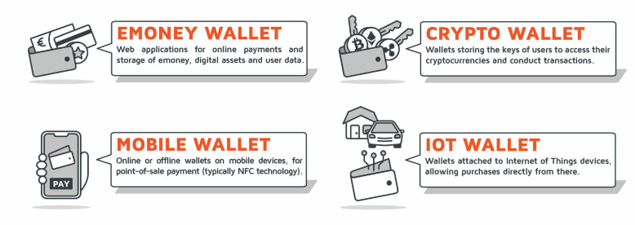**Types of E-Wallets**

**eMoney Wallet:**

The eMoney Wallet is one of the most versatile and commonly used digital wallets. This type of wallet functions as a web application that allows users to store money, digital assets, and user data securely (Chakraborty & Das, 2023). It offers significant convenience for online payments. For example, when making a purchase from an online store, users don't need to repeatedly enter card details. Instead, they can simply use their eMoney Wallet to complete the transaction quickly and securely. Furthermore, the eMoney Wallet is not solely limited to storing currency. Users can also store gift cards, loyalty points, and even travel passes. The integration of various services into one platform simplifies financial management considerably. Robust security features, such as two-factor authentication and encryption, ensure that funds and personal information remain protected.

**Crypto Wallet:**

When exploring into the world of cryptocurrencies, the necessity of a Crypto Wallet becomes evident. Unlike traditional digital wallets, a Crypto Wallet is specifically designed for storing the cryptographic keys required to access cryptocurrencies (Chakraborty & Das, 2022). This type of wallet can be either hardware-based, such as a USB drive, or software-based, residing on a computer or mobile device. Crypto Wallets are indispensable for conducting transactions on the blockchain. For instance, when acquiring Bitcoin or Ethereum, the Crypto Wallet generates a pair of cryptographic keys – a public key (used as an address to receive funds) and a private key (used to sign transactions and access the funds). The security of the private key is of utmost importance as its loss results in irreversible loss of access to the cryptocurrencies. Consequently, hardware wallets are often preferred for enhanced security against online threats.

**Mobile Wallet:**

Mobile Wallets are designed for mobile devices, enabling users to make both online and offline payments. Typically, Mobile Wallets utilize Near Field Communication (NFC) technology, allowing users to tap their phone against a payment terminal to complete a transaction. A key advantage of Mobile Wallets is their convenience and widespread acceptance (Chakraborty & Das, 2022). Whether buying groceries, paying for a cab, or dining out, users can simply use their mobile device to pay instantly. Mobile Wallets also frequently integrate with loyalty programs, providing users with rewards and discounts seamlessly (Maji P., 2024). The inclusion of added security layers, such as biometric authentication and device-specific tokens, instils confidence in using a Mobile Wallet for daily transactions.

**IoT Wallet:**

Exploring the future of digital payments, one encounters the IoT Wallet. This type of wallet is designed to integrate with Internet of Things (IoT) devices, allowing for direct purchases from these connected devices. For example, with an IoT Wallet, a smart refrigerator can automatically order and pay for groceries when it detects low stock on certain items. The IoT Wallet is an intriguing innovation that pushes the boundaries of automated and seamless transactions (Chakraborty & Das, 2019). It leverages the interconnected nature of smart devices to streamline purchases without direct user involvement. However, this also raises concerns about security and privacy, as more devices connected to financial data could potentially increase the risk of cyber-attacks. Therefore, robust encryption and stringent security measures are crucial for IoT Wallets.

In conclusion, each type of digital wallet—eMoney, Crypto, Mobile, and IoT—offers unique features and benefits tailored to specific needs and technological landscapes. Each wallet contributes to enhanced financial management and transaction experiences in different contexts by providing convenience, security, and innovation.

Mobile payments use smartphones or tablets to securely and easily handle financial transactions (Chakraborty & Das, 2019). This allows users to make purchases, transfer money, pay bills, and more using their mobile devices, often through dedicated apps or built-in features like NFC or QR codes. Early mobile payments were limited, often involving simple SMS-based transactions or charging purchases to phone bills. These methods lacked advanced features and security, hindering widespread use.

With technological advancements and the rise of smartphones, mobile payment solutions became more sophisticated. NFC technology enabled contactless payments by tapping phones on compatible terminals, simplifying transactions at stores, on public transport, and in other locations (Chakraborty & Das, 2019). Mobile payment apps also emerged, allowing users to link their bank accounts, credit/debit cards, or digital wallets to their phones. Popular apps like Apple Pay, Google Pay, and Samsung Pay let users securely store payment information and make purchases both online and in physical stores using their mobile devices.

The widespread availability of mobile internet and improved network infrastructure significantly boosted the adoption of mobile payments. Faster internet speeds and wider coverage made it easier for users to access mobile payment services and conduct transactions on the go. The proliferation of smartphones, combined with the rise of digital wallets and mobile banking apps, further fuelled the growth of mobile payments. These apps provided users with a wide range of functionalities beyond just payment processing, including bill payments, peer-to-peer transfers, and account management.

The integration of biometric authentication methods, such as fingerprint scanning and facial recognition, enhanced the security of mobile payments, reducing concerns about fraud and unauthorized access. The COVID-19 pandemic accelerated the adoption of mobile payments as consumers sought contactless payment options to minimize physical contact and reduce the risk of virus transmission. Merchants also responded by implementing contactless payment terminals and QR code-based solutions to accommodate changing consumer preferences.

The evolution of mobile payments is expected to continue, driven by ongoing technological advancements, changing consumer behavior, and regulatory developments. The convergence of mobile payments with other emerging technologies like blockchain, artificial intelligence, and the Internet of Things (IoT) has the potential to further revolutionize how financial transactions are conducted, making them even more seamless, secure, and efficient.

**Table 1**

**Pros and Cons of E-Wallets and Digital Payments**

|  |  |
| --- | --- |
| **Pros** | **Cons** |
| Convenience and Accessibility | Security Vulnerabilities |
| Cost Efficiency | Dependency on Technology |
| Enhanced Security Features | Privacy Concerns |
| Promotion of Financial Inclusion | Digital Divide |
| Stimulating Innovation | Regulatory Challenges |

Table 1 table outlines the advantages and disadvantages of using e-wallets and digital payment systems. This research aims to help us understand how people are adopting e-wallets and digital payments, and what security concerns they have. Ultimately, the goal is to provide recommendations that will help create a safe and inclusive digital financial system for everyone.

**LITERATURE REVIEW:**

Smith and Kumar (2021) investigated digital payment use in India following policy changes, finding younger consumers more receptive than older adults. Younger users valued convenience and speed, while older adults expressed concerns about security and digital literacy. Sivathanu (2020) explored factors driving digital payment adoption, emphasizing convenience, security, and promotions as key motivators. Both studies highlighted security concerns as a major barrier to wider adoption (Das & Mukherjee, 2018). The Federal Reserve Bank of Atlanta (2022) also noted the importance of perceived security in the shift towards digital payments. These findings suggest that addressing security concerns, through enhanced security measures and consumer education, is crucial for the continued growth of digital payment systems in India. Shin and Ziderman (2009) examined consumer perceptions of digital payments, finding that perceived security and trust significantly influenced acceptance. Demographic factors like age and education also played a role. Nguyen Thi Ha (2021) investigated e-wallet usage in Vietnam, identifying perceived usefulness, ease of use, security, and trust as key drivers. Both studies emphasize the critical role of security in driving adoption and highlight the need for robust security measures to build consumer trust and encourage widespread usage of digital payment systems.

Sangeeta Jerath's (2022) examined the evolution of digital payments in India since 2014. The study analyses the impact of initiatives like Digital India and the role of technology in driving this growth. It highlights the convenience and security of digital payments, analysing data from sources like the RBI Bulletin to track their exponential growth. The RBI's Digital Payment Index provides a valuable measure of this growth. The study concludes that regulatory initiatives and technological advancements are crucial for the continued growth of digital payments in India. Nidhi Singh's (2019) study investigates factors influencing user intention and satisfaction towards mobile wallet services in India. Using the TAM and UTAUT2 models, the study examines the impact of factors like ease of use, usefulness, perceived risk, and social influence. Empirical analysis, including SEM, was conducted on data collected from 206 Indian respondents. The findings provide valuable insights for enhancing the adoption and usability of mobile wallet services in the Indian market. Key factors driving online shopping decisions include secure payment gateways, product guarantees and warranties, product quality, attractive promotions, and robust privacy protection (Kirubadevi & SaiGanesh, 2016)

**Problem Statement**

The rapid growth of digital payment systems, particularly e-wallets, has revolutionized how consumers transact. However, despite their increasing popularity, significant challenges remain regarding consumer adoption and security concerns. To address these issues, the study utilizes primary research through Google Forms and secondary research from existing literature. This multifaceted approach allowed me to identify critical problems that hinder the broader adoption of digital wallets and highlight areas where improvements are necessary. From the data gathered through Google Forms, it is evident that consumer adoption of e-wallets varies widely based on several factors, including demographic variables, spending habits, and the perceived benefits of using these digital payment methods. Despite the apparent benefits of e-wallets, such as ease of use and quick transactions, there are still significant barriers to widespread adoption. One prominent issue is the varying levels of digital literacy among potential users. My research indicated that a substantial portion of respondents who do not use e-wallets feel intimidated by the technology or are unsure how to navigate the platforms effectively.

**Objectives**

1. To analyse the factors influencing consumer decisions to adopt e-wallets and digital payment methods.
2. To identify and assess the security concerns associated with e-wallets and digital payment platforms.

**Methodology**

This research aimed to explore consumer adoption and security concerns regarding digital wallets and mobile payment services. A mixed-methods approach was employed, combining both quantitative and qualitative data. Data was collected through a structured survey questionnaire and secondary sources like articles and research papers. This study utilized a mixed-methods approach, combining both quantitative and qualitative research methods. This approach provided a more comprehensive understanding of the research problem by integrating data from both survey responses and existing literature. The quantitative component involved statistical analysis of survey data to identify patterns and relationships, while the qualitative component involved a detailed review of existing literature to contextualize and enrich the quantitative findings.

Convenience sampling was used to select participants. This method involved recruiting individuals who were easily accessible and willing to participate, such as through online platforms. The goal was to gather a diverse group of participants from various backgrounds. By reaching out to a broad audience online, data were collected on their usage patterns and opinions about digital wallets and mobile payment services. A structured survey questionnaire served as the primary data collection tool. The questionnaire was developed to cover several key areas for the purpose of this research.

**Data Analysis Techniques**

* Quantitative Analysis: Quantitative data from the survey responses were analyzed using descriptive and inferential statistics.
* Descriptive Statistics: These summarized the demographic characteristics of the participants, usage patterns of digital wallets, and the prevalence of security concerns.
* Inferential Statistics: Techniques such as correlation and regression analysis were employed to examine the relationships between demographic factors, adoption drivers, and security concerns. This analysis helped identify significant predictors of digital wallet usage and the extent of security concerns among different demographic groups.

**Analysis and Discussion**

**Table 2**

**Respondents Demographic-Age**

|  |  |  |
| --- | --- | --- |
| Age | No of Respondents | Percentage |
| 18-30 | 96 | 92.3 |
| 30-40 | 2 | 1.9 |
| 40-50 | 4 | 3.8 |
| 50 above | 1 | 1 |
| 20-30 | 1 | 1 |
| Total | 104 | 100 |

The survey results highlight the age distribution among the respondents, providing insights into the demographic composition of the participants. The age distribution data from the survey shows a strong concentration of respondents in the 18-30 age group, with minimal representation from older age groups. This demographic skew highlights the need for careful consideration when interpreting the survey results, as they predominantly reflect the perspectives of younger individuals. Understanding this distribution is essential for accurately assessing digital wallet usage and security concerns, and for planning more inclusive future research efforts.

**Figure 2**

**Occupation of the Respondents**

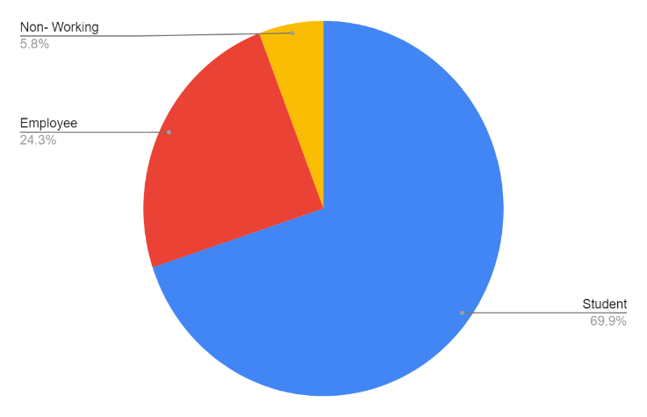

Source: Author's Compliance

**Table 3**

**Occupation of the Respondents**

|  |  |  |
| --- | --- | --- |
| Occupation | No of Respondents | Percentage |
| Student | 72 | 69.9 |
| Employee | 25 | 24.3 |
| Non- working | 6 | 5.8 |
| Total | 103 | 100 |

The occupational distribution data from the survey shows a significant skew towards students, with 69.9% of respondents being in this category, followed by employees at 24.3%, and a small fraction of non-working individuals at 5.8%. This distribution highlights the importance of tailoring digital wallet services to meet the needs of students, while also considering strategies to enhance adoption among working professionals and non-working individuals. Understanding the preferences and concerns of these different groups can help in developing more effective digital wallet solutions and expanding the user base across various demographics.

**Table 4**

**Usage Preference of Respondents**

|  |  |  |
| --- | --- | --- |
| Response | No of Respondents | Percentage |
| Yes | 98 | 95.1 |
| No | 5 | 4.9 |
| Total | 103 | 100 |

Table 4 indicates the usage of digital wallet and mobile payment apps (e.g., PayPal, Venmo, Apple Pay, Google Pay) among a sample of 103 individuals. The responses have been summarized in terms of the number of respondents and their corresponding percentages. The survey data indicates a predominant use of digital wallets and mobile payment apps among the respondents, with a striking 95.1% adoption rate. This high percentage underscores the importance of digital payment solutions in the current financial landscape and highlights the need for continued innovation and support for these technologies by financial institutions and merchants.

**Table 5**

**Respondents Awareness level on digital wallets**

|  |  |  |
| --- | --- | --- |
| **Response** | **No of Respondents** | **Percentage** |
| Yes | 80 | 77.7 |
| No | 23 | 22.3 |
| Total | 103 | 100 |

The data provided outlines respondents' awareness of digital wallets. This information is crucial for understanding the level of familiarity and potential market penetration of digital wallet technologies among the surveyed population. The data indicates that a substantial majority (77.7%) of respondents are aware of digital wallets, highlighting significant market penetration and familiarity with digital wallet technologies. However, the 22.3% of respondents who are not aware represent an opportunity for growth. Digital wallet providers should focus on converting awareness into active usage through targeted educational campaigns and addressing barriers to adoption. Additionally, continuous innovation and the introduction of new features can help maintain and expand the user base. This dual approach can ensure that digital wallets remain relevant and appealing in an increasingly competitive market.

**Table 6**

**Monthly Spending**

|  |  |  |
| --- | --- | --- |
| **Spending** | **No of Respondents** | **Percentage** |
| 500-1000 | 33 | 32.0 |
| 1000-2000 | 25 | 24.3 |
| 2000-5000 | 13 | 12.6 |
| Above 5000 | 32 | 31.1 |
| Total | 103 | 100 |

The data in Table 6 shows how respondents spend when using e-wallets. Most respondents (56.3%) fall within the moderate spending range of 500 to 2000 units. This aligns with Nguyen Thi Ha's findings, which emphasize the importance of perceived usefulness and ease of use in driving e-wallet adoption. The concern over security highlighted in the study underscores the importance of trust and confidence, especially among those who spend more. Overall, the data reflects the practical implications of factors influencing e-wallet usage.

**Figure 3**

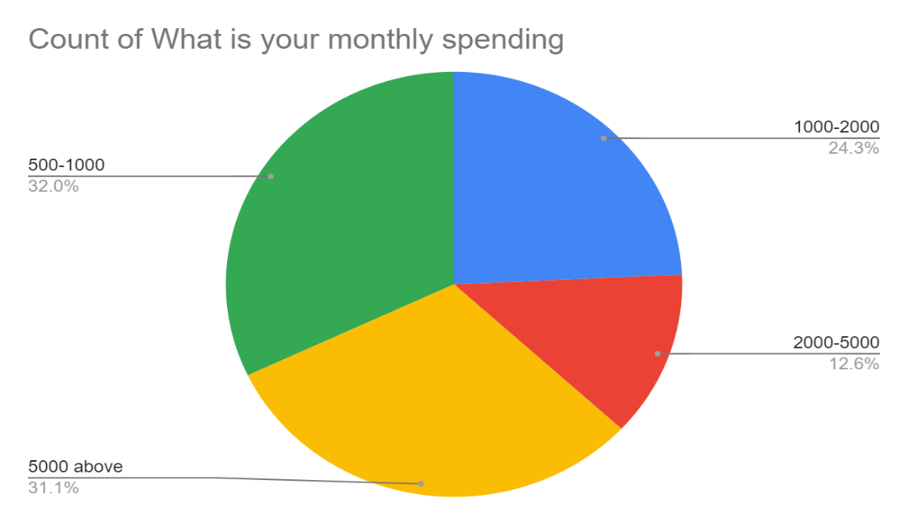**Monthly spending**

*Source: Author's compliance*

**Table 7**

**Respondents usage frequency**

|  |  |  |
| --- | --- | --- |
| **Usage** | **No of Respondents** | **Percentage** |
| Daily | 75 | 72.8 |
| Weekly | 18 | 17.5 |
| Rarely | 10 | 9.7 |
| Never | 00 | 00 |
| Total | 103 | 100 |

The data presents the frequency of digital wallet or mobile payment app usage among 103 respondents. The usage frequency is categorized into daily, weekly, rarely, and never, with the number of respondents and their corresponding percentages provided for each category. The survey data indicates a predominant use of digital wallets or mobile payment apps among the respondents, with 72.8% using them daily and 17.5% using them weekly. The absence of non-users (0%) highlights the widespread acceptance and integration of these payment methods into the respondents' lives. This data underscores the importance for financial service providers and merchants to continue supporting and enhancing digital payment options to cater to the high demand and frequency of use.

**Figure 4**

**Forms response chart. Question title: How frequently do you use digital wallet or mobile payment services?


. Number of responses: 103 responses.Respondents Usage Frequency**

Source: Author's compliance

**Table 8**

**Respondents Preference**

|  |  |  |
| --- | --- | --- |
| **Apps** | **No of Respondents** | **Percentage** |
| Google Pay | 72 | 69.9 |
| Phonepe | 82 | 79.6 |
| Paytm | 33 | 32 |
| Apple Pay | 2 | 1.9 |
| E Rupee | 7 | 6.8 |
| Amazon Pay | 1 | 1 |
| Cred | 1 | 1 |
| Total | 103 | 100 |

The survey data provides valuable insights into the current landscape of digital wallet usage among the respondents. PhonePe and Google Pay lead the market, indicating strong user preferences for these platforms. Paytm also holds a notable share, while other apps like E Rupee, Apple Pay, Amazon Pay, and Cred have smaller but potentially growing user bases. Understanding these trends can help stakeholders make informed decisions about product development, marketing strategies, and competitive positioning in the digital payments industry.

**Figure 5**

Forms response chart. Question title: Which digital wallet or mobile payment apps do you use?  🌍  (Select all that apply)
. Number of responses: 103 responses.**Respondents Preference**

*Source: Author's compliance*

**Table 6**

**Factors Influencing the use of Payment Services**

|  |  |  |
| --- | --- | --- |
| **App** | **No of Respondents** | **Percentage** |
| Convenience | 80 | 77.7 |
| Security | 17 | 16.5 |
| Promotion/Discount | 00 | 00 |
| Peer influence | 00 | 00 |
| Emergency | 2 | 1.94 |
| Transfer | 1 | 0.96 |
| Digitalization | 2 | 1.94 |
| Easy to pay | 1 | 0.96 |
| Total | 103 | 100 |

The survey data highlights that convenience is the predominant factor driving the adoption of digital wallets, followed by security. The lack of influence from promotions and peer recommendations suggests areas for potential improvement in marketing strategies. Niche motivations such as emergency use, digitalization, and ease of payment, although less common, indicate varied user needs. Digital wallet providers should focus on enhancing convenience and security features while exploring new ways to make promotions and peer influence more effective in driving adoption.

**Figure 6**

**Security Issue**

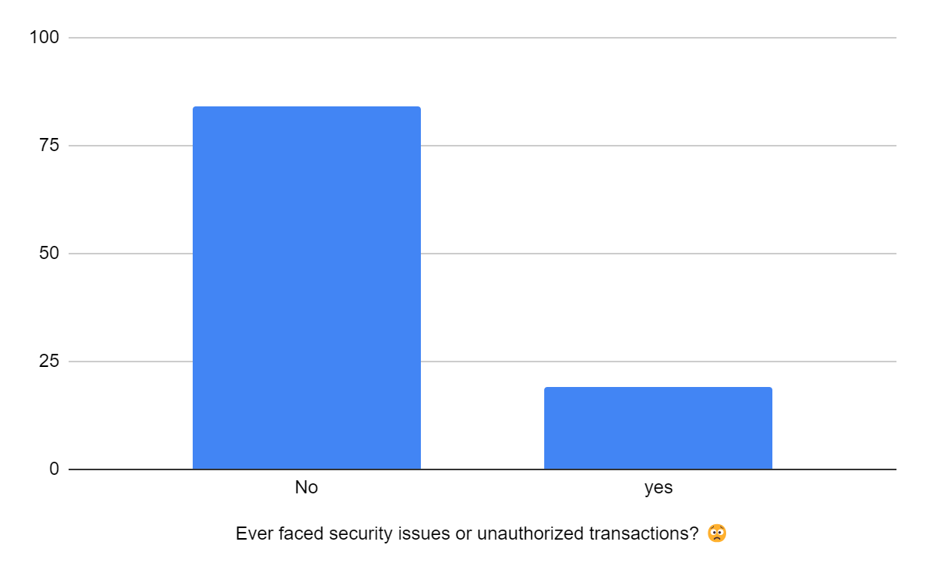

*Source: Author's compliance*

The data provided captures respondents' experiences with security issues or unauthorized transactions when using digital wallets. Understanding these experiences is crucial for assessing the reliability and trustworthiness of digital wallet platforms from the user's perspective. The data indicates that a majority of respondents (represented by various "no issue" responses) have not faced security issues or unauthorized transactions while using digital wallets, suggesting a high level of security and user trust. However, a minority has reported issues, highlighting the need for continuous improvements in security measures and user education. By addressing these concerns and enhancing security protocols, digital wallet providers can further solidify user trust and encourage wider adoption of their services.

**Table 4.9**

**Security Scale**

|  |  |  |
| --- | --- | --- |
| Concerns | No of Respondents | Percentage |
| Very much Concerned | 62 | 60.2 |
| Somewhat Concern | 27 | 26.2 |
| Natural | 10 | 9.7 |
| Not Concerned | 4 | 3.9 |
| Total | 103 | 100 |

**Figure 7**

**Security Scale**

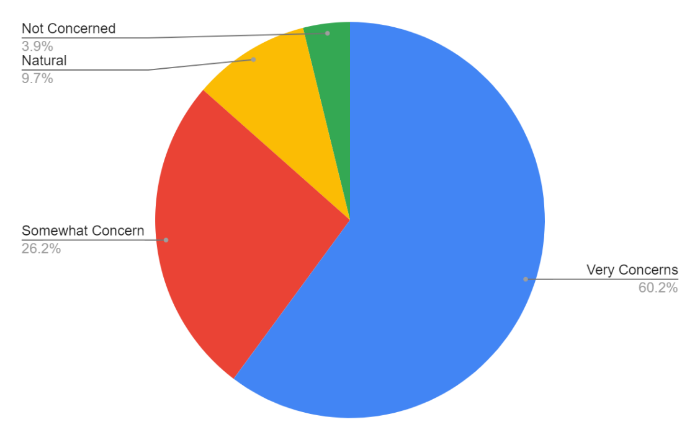

Source: Author's compliance

The data highlights significant user concerns about the security of their financial information when using digital wallets. 86.4% of users have concerns, with 60.2% being very concerned. This underscores the critical need for robust security measures, user education, and transparency to build trust and encourage wider adoption.

**Figure 8**

**Security Measures**

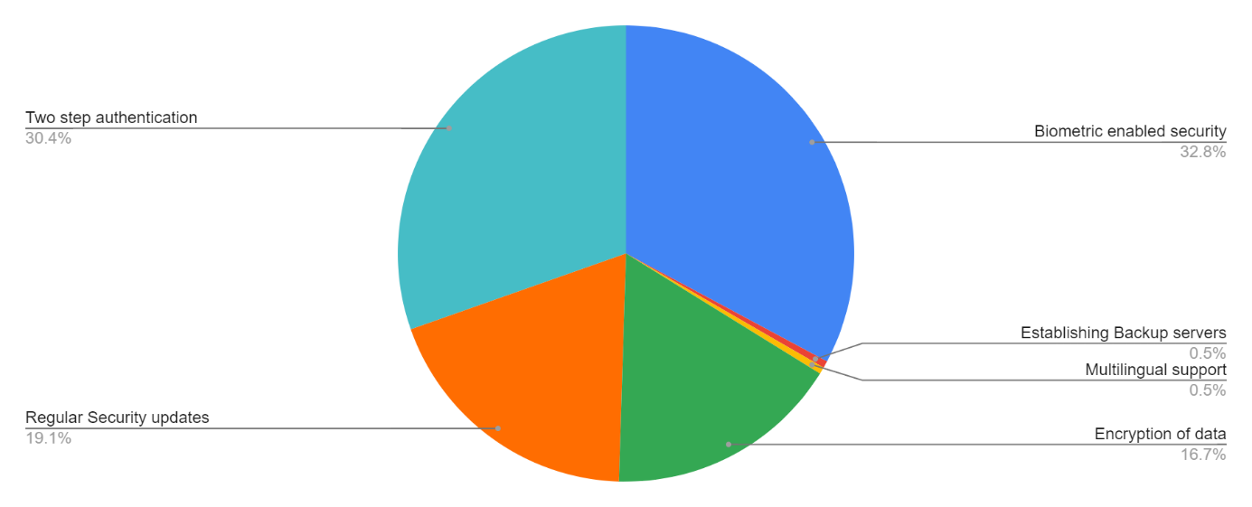

*Source: Author's compliance*

The chart shows the security measures that users expect digital wallet or mobile payment providers to implement to ensure the safety of their financial transactions. The data is collected from 103 respondents. The data reveals that users place high importance on advanced security measures such as biometric and two-factor authentication, along with regular security updates and data encryption. Digital wallet providers should focus on these areas to meet user expectations, enhance security, and build trust. By addressing these concerns proactively and transparently, providers can improve user adoption and satisfaction with their digital wallet services.

**Features or functionalities do respondents believe:**

The provided chart illustrates the diverse range of features and functionalities that users believe would enhance their experience with digital wallets and mobile payments. The data is based on 103 responses, with each response detailing a specific suggestion or concern.

Some functionalities recommended by the respondents

* Implementing biometric authentication for added security would be most beneficial.
* A feature of offline access to make payment.
* Provide More advertisements for how to use digital wallets easily.
* Tap-in feature which will not allow users to use the pin always.
* They need to stop collecting platform charges.
* More security.

The data highlights a range of user expectations and suggestions for improving the experience with digital wallets and mobile payments. Security remains a top priority, followed by offline payment capabilities and multi-currency support. Digital wallet providers should address these areas to meet user needs and enhance the overall user experience, fostering greater adoption and satisfaction.

**Consumer Adoption and Security Concerns in Digital Wallets and Payments.**

This paper investigated user trends and security concerns surrounding digital wallets and mobile payment apps. A survey of 103 respondents revealed a skewed demographic, with a significant overrepresentation of 18-30-year-olds. This necessitates future research with a broader age range for more comprehensive insights. The survey found that students constitute the largest user group (69.9%), followed by employees and non-working individuals. This highlights the need for tailored services for students and strategies to expand adoption among other demographics. The data confirmed the widespread adoption of digital wallets, with 95.1% of respondents currently using them. 72.8% use them daily, emphasizing the need for continued support and improvement of these technologies.

PhonePe leads in market share with nearly 80% user penetration, followed by Google Pay and Paytm. Understanding these trends is crucial for stakeholders to make informed decisions regarding product development and market strategies. This paper found that convenience is the top reason people use digital wallets, with 77.7% citing ease of use as a key factor. Security is also important, but surprisingly, promotions and recommendations from friends don't seem to influence people's decisions. This suggests that marketing efforts could focus more on highlighting security features and exploring new ways to reach potential users.

While most people (77.7%) are aware of digital wallets, 22.3% are not. This means there's still room to educate people about these services and encourage them to try them out. Although most users haven't experienced security breaches, 86.4% are still concerned about the security of their financial information. To build trust, digital wallet companies need to focus on strong security measures, like fingerprint recognition and two-step verification, and be transparent about how they protect user data.

**Factors that influence the users to adopt Digital Payments and E-Wallets**

several factors significantly influence the adoption of digital payments and e-wallets. Convenience stands out as the primary driver, with 77.7% of respondents highlighting the ease of use as a key motivator. Security is another crucial factor, emphasized by the high level of concern among users, with 86.4% expressing significant apprehension about potential risks. To address this, implementing biometric authentication and two-factor authentication can enhance user trust.

Additionally, users recommend features such as offline access for payments and a tap-in feature to simplify transactions without the need for a PIN. Increased advertising on how to use digital wallets effectively can also help in educating and attracting more users. Moreover, stopping the collection of platform charges would make these services more appealing. By focusing on these functionalities, digital wallet providers can improve user experience, boost adoption rates, and ensure sustained growth in the digital payments landscape.

**Findings**

Based on the comprehensive analysis of the survey data regarding digital wallet usage and preferences, several key findings emerge, providing valuable insights for stakeholders in the finance and technology sectors:

1. **Primary Users: Students and Young Professionals**: Students emerged as the primary users of digital wallets, representing a significant majority of respondents. However, there is also notable engagement from young professionals, indicating that digital wallet services are relevant across different stages of early adulthood. Understanding the specific requirements and behaviors of these user groups is essential for designing targeted marketing campaigns and product features.
2. **Widespread Adoption of Digital Wallets**: The survey reveals a remarkably high adoption rate of digital wallets, with over 95% of respondents indicating current usage. This widespread adoption underscores the growing acceptance and integration of digital payment solutions in everyday financial transactions. Financial institutions and merchants should capitalize on this trend by enhancing digital payment infrastructure and offering seamless integration with their services.
3. **Motivations for Digital Wallet Usage**: Convenience emerged as the primary motivation for using digital wallets, followed by security concerns. These findings emphasize the importance of prioritizing user convenience while simultaneously implementing robust security measures to foster trust and confidence among users. Additionally, providers should explore innovative ways to incentivize adoption, such as offering exclusive promotions or rewards programs.
4. **Security Concerns and Expectations**: While digital wallets enjoy widespread adoption, a significant proportion of users express concerns about the security of their financial information. Users expect digital wallet providers to implement advanced security measures such as biometric authentication and regular security updates to mitigate risks effectively. Addressing these concerns is crucial for maintaining user trust and ensuring long-term sustainability in the digital payment ecosystem.
5. **Desired Features for Enhanced User Experience**: Users expressed a range of suggestions for improving the digital wallet experience, including offline payment capabilities, multi-currency support, and simpler user interfaces. These insights underscore the importance of continuous innovation and customer-centric design in meeting evolving user expectations. Digital wallet providers should prioritize the development of features that enhance usability, accessibility, and functionality.
6. **Opportunities for User Education and Engagement**: The survey data highlights opportunities for digital wallet providers to educate users about the benefits and functionalities of digital wallets effectively. By providing clear guidance and support, providers can empower users to make informed decisions and maximize the value of digital payment solutions in their daily lives.
7. **Continuous Improvement and Adaptation**: In conclusion, the research findings underscore the dynamic nature of the digital payment landscape, where innovation, security, and user experience are paramount. Digital wallet providers must remain agile and responsive to evolving user needs and market trends to maintain competitiveness and drive sustainable growth in the long term.

**Interpretation and Suggestions**

Based on the insights gathered from the survey on digital wallets and mobile payment apps, the study proposes the following eight actionable suggestions to enhance the user experience, address security concerns, and drive broader adoption. These recommendations are rooted in the data and trends identified in the research, ensuring practical and real-world applicability.

1. **Expand Age Demographics**: To achieve a more balanced adoption of digital wallets, the study recommends conducting targeted marketing campaigns and educational initiatives aimed at older demographics. This could include workshops, tutorials, and partnerships with senior organizations to highlight the ease and security of digital wallets.
2. **Student-Centric Features**: Given the high usage rate among students, developing features that cater specifically to their needs, such as budget management tools, student discounts, and peer-to-peer payment functionalities, can enhance user engagement and retention within this demographic.
3. **Enhanced Security Measures**: Security remains a top concern for users. The study suggests implementing advanced security features like biometric authentication, two-factor authentication, and regular security updates. Additionally, transparent communication about these measures can build trust and reassure users about the safety of their financial information.
4. **Educational Campaigns**: With a significant portion of users still unfamiliar with digital wallets, comprehensive educational campaigns can bridge this gap. These campaigns should focus on demonstrating the convenience and security of digital wallets, using multimedia content, tutorials, and user testimonials to effectively convey the message.
5. **Promotional Strategies**: To address the apparent lack of influence from promotions, the study recommends exploring innovative promotional strategies that highlight security features and the unique benefits of digital wallets. This could include partnerships with popular brands, limited-time offers, and loyalty programs that reward frequent use.
6. **User Feedback Integration**: Continuously gathering and integrating user feedback into the development process can help in identifying pain points and areas for improvement. Regular surveys, user forums, and beta testing of new features can ensure the digital wallet evolves in line with user expectations.
7. **Cross-Platform Compatibility**: Ensuring that digital wallets are compatible with various devices and operating systems can enhance accessibility. Developing light versions of apps for older devices and ensuring smooth functionality across different platforms can widen the user base.
8. **Offline Payment Capabilities**: Introducing offline payment options can cater to users in areas with limited internet connectivity, ensuring seamless transactions even when users are not connected to the internet. This feature can significantly enhance the usability and appeal of digital wallets in diverse environments.

Implementing these suggestions can help digital wallet providers address current user concerns, enhance functionality, and drive broader adoption. By focusing on security, education, and tailored features, we can foster a more inclusive and trusted digital payments ecosystem that meets the evolving needs of a diverse user base.

**Conclusion**

The insights gathered from the survey on digital wallets and mobile payment apps underscore the critical areas that need attention to enhance user experience and drive broader adoption. By expanding age demographics through targeted marketing and educational initiatives, we can bridge the generational gap in digital wallet usage. Developing student-centric features will cater to a high-usage demographic, fostering engagement and retention. Enhanced security measures, such as biometric and two-factor authentication, are essential to alleviate user concerns. Transparent communication about these security features can build trust and reassure users of their financial information's safety. Comprehensive educational campaigns are necessary to familiarize potential users with the convenience and security of digital wallets.

Innovative promotional strategies should be explored to highlight the unique benefits of digital wallets, addressing the lack of influence from current promotions. Regularly integrating user feedback into the development process will ensure the digital wallet evolves in line with user expectations, addressing pain points and areas for improvement. Ensuring cross-platform compatibility will enhance accessibility, allowing users with various devices to benefit from digital wallets. Introducing offline payment capabilities will cater to users in areas with limited internet connectivity, ensuring seamless transactions even without an internet connection.

Implementing these actionable suggestions can help digital wallet providers address current user concerns, enhance functionality, and drive broader adoption. By focusing on security, education, and tailored features, we can foster a more inclusive and trusted digital payments ecosystem. This approach will meet the evolving needs of a diverse user base, promoting the widespread use of digital wallets and contributing to a more digital-savvy society. These strategies will pave the way for a future where digital wallets are a staple in everyday financial transactions, offering convenience, security, and versatility to all users.

**References**

1. Chakraborty, A., & Das, A. K. (2020). Ethics in Insurance Business-Evidence from India. Indian Ethos, Ethics & Management, 24.
2. Chakraborty, A., & Das, A. K. (2023). Do macro-economic factors influence the life insurance industry in India? An empirical approach. International Journal of Business Innovation and Research, 30(1), 1-17.
3. Chakraborty, A., & Kr Das, A. (2019). Role of insurance in the development of India’s micro, small and medium enterprise (MSMEs). Journal of International Business, Economics and Entrepreneurship (JIBE), 4(2), 60-66.
4. Chakraborty, A., & Das, A. K. (2019). Ethics in Insurance Selling in India-A Conceptual Approach. International Journal of Business Ethics in Developing Economies, 8(2), 44-5.
5. Chakraborty, A., & Das, A. K. (2022). Impact analysis of macro-economic factors on non-life insurance sector in India. International Journal of Financial Engineering, 9(03), 2250011.
6. Chakraborty, A., & Das, A. K. (2022). Do macro-economic factors drive life insurance growth? An empirical analysis. International Journal of Monetary Economics and Finance, 15(1), 1-18.
7. Chakraborty, A., & Das, A. K. (2019). Role of Insurance in the Development of MSMEs in India
8. Catalyze Payments. (2017). 2016 Payment Methods: How They Work. Retrieved from https://www.catalyze.org/wp-content/uploads/2017/04/2016-Payment-Methods_How-They-Work.pdf
9. Chawla, D., & Joshi, H. (2019). Consumer Attitude and Perception towards Digital Payments in India. International Journal of Bank Marketing, 37(5), 1209-1231. https://www.emerald.com/insight/content/doi/10.1108/IJBM-09-2018-0256/full/html
10. Dahlberg, T., Guo, J., & Ondrus, J. (2015). A Critical Review of Mobile Payment Research. Electronic Commerce Research and Applications, 14(5), 265-284. https://www.sciencedirect.com/science/article/pii/S0969698914000447
11. Das, A. R., & Mukherjee, S. (2018). Corporate Social Responsibility Practices in Indian Petroleum Companies: A Case Study of Selected PSUs. *International Journal of Business Ethics in Developing Economies*, *7*(2), 12-18.
12. Federal Reserve Bank of Atlanta. (2022). Diary of Consumer Payment Choice 2022 Codebook. Retrieved from https://www.atlantafed.org/-/media/documents/banking/consumer-payments/survey-diary-consumer-payment-choice/2022/dcpc2022_codebook.pdf
13. Gupta, S., & Patel, R. (2018). Digital Payments in Emerging Economies: A Consumer Perspective. Journal of Internet Banking and Commerce, 23(3), 14-27. https://doi.org/10.1080/15427528.2018.1496216
14. Jerath, Sangeeta. (2022). Digital Payments in India: An Analysis. *International Journal of Innovative Technology and Exploring Engineering*, 11(11), 47-54
15. Keel, S., & Chan, P. (2021). Trends in Digital Payments and Consumer Behaviour in Australia. Retrieved from https://search.informit.org/doi/abs/10.3316/informit.132655401604567
16. Kirubadevi, P., & SaiGanesh, S. (2016). Consumer credence towards online shopping – A study of Karnataka consumers. International Journal of Advanced Scientific Research & Development, 3(3), 73-82
17. Kumar, A., & Singh, R. (2020). Consumer Adoption of Digital Payment Systems in India: An Empirical Study. International Journal of Research and Analytical Reviews, 7(4), 147-155. Retrieved from http://ijrar.com/upload_issue/ijrar_issue_20542141.pdf
18. Liébana-Cabanillas, F., & Ramos de Luna, I. (2018). An Analysis of the Determinants of Digital Payment Systems. Information & Management, 56(4), 293-305. <https://www.sciencedirect.com/science/article/pii/S0268401218310697>
19. Maji P. (2024). Sustainable Innovations in Textiles and Fashions, Asian Textile Journal, Vol 33 (1-2), 47-51.
20. Mehra, A., & Agrawal, M. (2021). Sustainable Digital Payment Systems: An Empirical Study. Sustainability, 13(2), 831. https://www.mdpi.com/2071-1050/13/2/831
21. OMICS International. (n.d.). Journal of Internet Banking and Commerce. Retrieved from http://www.icommercecentral.com
22. Sanjay, K., &amp; Tewari, S. (2024). Determinants of Life Insurance Purchase Intention using Structured Equation Modelling with Focus on Saving Motive and Financial Literacy.International Journal of Banking Risk and Insurance, 12(2), 102
23. Shin, H., & Ziderman, A. (2009). Student loans repayment and recovery: International comparisons. Higher Education, 57, 315-333.
24. Shree, S., Pratap, B., Saroy, R. *et al.* Digital payments and consumer experience in India: a survey based empirical study. *J BANK FINANC TECHNOL* **5**, 1–20 (2021). https://doi.org/10.1007/s42786-020-00024-z
25. Singh, Nidhi., Casado-Aranda, L.-A., & Ramos de Luna, I. (2019). Assessing the antecedents of user intention to use mobile payment services in the context of emerging markets. In *Impact of Mobile Services on Business Development and E-Commerce*(pp. 123-142). IGI Global.
26. Singh, S., & Kaur, P. (2022). Digital Payments in India: An Analysis. Retrieved from https://www.researchgate.net/publication/364927310_Digital_Payments_in_India_An_Analysis
27. Tewari, S. (2015). Effect of social media on employer branding. International Journal ofScientific and Engineering Research, 6(1), 53-63.
28. Tewari, S. (2023). The Effect of Telecommuting on Productivity: A Meta-Analysis.Academy of Marketing Studies Journal, 27(4).
29. Tewari, S., Gujarathi, R., &amp; Maduletty, K. (2019). Leadership styles and productivity.Asian Social Science, 15(4), 115.
30. Tran, T. T., & Nguyen, Q. T. (2020). Factors Influencing the Adoption of E-Payment: An Empirical Study in Vietnam. Retrieved from https://repository.vnu.edu.vn/bitstream/VNU_123/137441/1/00051000631.pdf
31. Wicaksono, A. (2021). The Influence of Digital Payment Systems on Consumer Behavior. Journal of Economics and Policy, 14(1), 112-127. Retrieved from <https://journals.ums.ac.id/index.php/JEP/article/view/15469>

* Image References:

Types of wallet- <https://trimplement.com/blog/2021/02/e-wallets-definition/>