**An In-Depth Analysis of Machine Learning Models for Accurate Crop Yield Prediction**

Jampani Ravi, K. Hema Sai Lakshmi, K. Sri Bhavya, K. Keerthi Priya, M. Vara Prasad Reddy

Department of ECE, SRKR Engineering College, Bhimavaram

**Abstract:**

Machine learning is an emerging field in crop yield prediction, playing a pivotal role in modern agriculture. Accurately forecasting crop yield is essential for farmers to estimate their harvest. Traditionally, yield predictions were based on a farmer’s experience with specific crops and fields, but achieving precise predictions from available data has been a significant challenge. Machine learning offers a promising solution to this problem. Several machine learning techniques have been explored and evaluated to predict crop production for upcoming seasons. This paper proposes a system that predicts crop yield using historical data, leveraging machine learning algorithms like Support Vector Machine (SVM) and Random Forest. Additionally, it provides crop-specific fertilizer recommendations. The paper focuses on developing a predictive model that can forecast crop yield and serve as a tool for future agricultural planning. The project aims to build a machine learning-powered web application to assist farmers in making informed decisions about crop cultivation. By analyzing factors such as land type, budget, and soil characteristics, the system offers tailored recommendations on suitable crops, fertilizers, and pesticides. It also alerts farmers to potential crop diseases due to inadequate care and provides insights into soil pH, nutrient levels, and water needs. Ultimately, this project seeks to enhance agricultural productivity by accurately predicting yields and profits, helping farmers optimize their output while mitigating risks.

**Introduction**

Agriculture is vital for feeding the growing global population. To meet the increasing demand for food, farmers must maximize their productivity while minimizing losses. Accurate forecasting and analysis of crop growth are now integral to modern agriculture, with machine learning emerging as a key tool to aid these efforts. Smart farming, or precision agriculture, is an innovative approach that uses advanced technologies to enhance crop production and reduce waste. The objective of smart farming is to increase crop yields while minimizing the use of resources such as water, fertilizers, and energy.

In India, agriculture has been a central practice for centuries, with people traditionally cultivating crops on their own land to meet their needs. However, the introduction of new technologies and farming techniques is gradually replacing traditional methods. This shift has led to an emphasis on hybrid products and artificial cultivation practices, which can sometimes contribute to unhealthy lifestyles. Many people today are unaware of the importance of planting crops at the right time and under optimal conditions. This knowledge gap, combined with modern farming practices, is affecting seasonal climates and depleting vital resources like soil, water, and air, which in turn creates food security challenges.

Machine learning (ML) offers a range of algorithms, including supervised, unsupervised, and reinforcement learning, each with its own strengths and limitations. In supervised learning, algorithms build mathematical models using data that includes both input variables and corresponding outputs. Unsupervised learning, however, builds models from input data without labeled outputs. Semi-supervised learning strikes a balance by using incomplete datasets, where some samples lack labels.

ML has become an essential tool for extracting valuable insights and patterns from data, with applications spanning many fields, including agriculture. ML models are typically categorized into supervised and unsupervised learning. Supervised learning uses labeled data to make predictions or decisions, providing a structured approach to solving predictive problems. Unsupervised learning, in contrast, uncovers hidden patterns and structures within unlabeled data, often revealing new insights. Supervised learning, by utilizing historical datasets that contain labeled environmental factors and corresponding crop yields, helps capture complex relationships and make accurate predictions. By applying supervised learning, we aim to develop effective models that can predict crop yields, optimize agricultural practices, and contribute to enhancing food security.

**LITERARURE SURVEY**

Crop yield prediction is vital for farmers, policymakers, governments focused on food security, and food marketing organizations. These stakeholders rely on yield prediction models to make informed decisions and develop strategies for efficient resource allocation, food distribution, and price stabilization, ultimately contributing to a more resilient food system by forecasting changes in crop production. However, predicting crop yields is a complex task, influenced by numerous factors such as weather patterns, fertilizer application, soil type, and seed variety. As such, solving this challenge requires integrating diverse datasets and various types of attributes.

Among the many machine learning approaches, supervised learning techniques are particularly effective for crop yield prediction due to their strong predictive capabilities and ability to handle multiple attribute types. These techniques use labelled data to predict outcomes based on specific inputs, such as forecasting crop yields from weather data and soil quality.

While machine learning offers significant potential in agriculture, the quality of the predictions is highly dependent on the quality of the input data. The accuracy of crop yield prediction is greatly affected by the availability and reliability of data. A comprehensive range of data such as weather, soil conditions, historical yield records, and satellite imagery is crucial for making accurate predictions. Ensuring high-quality data through careful collection, pre-processing, and feature selection is essential for developing successful predictive models.

**PROBLEM STATEMENT**

Farmers frequently face difficulties in making informed decisions due to limited access to scientific data and personalized recommendations. Existing systems often fail to provide tailored advice that takes into account critical factors such as soil quality, land type, and available budget. Additionally, a lack of understanding about nutrient management, water requirements, and crop diseases exacerbates the issue, leading to reduced yields and financial losses. These challenges highlight the urgent need for solutions that integrate scientific knowledge with practical, customized guidance to support farmers and improve agricultural productivity.

**Machine Learning in Smart Farming**

**Support Vector Machine (SVM)**

Support Vector Machine (SVM) creates a hyperplane (or a set of hyperplanes) in a high-dimensional or even infinite-dimensional space to perform tasks like classification, regression, and more. The goal is to identify the optimal hyperplane that maximizes the margin—the distance between the hyperplane and the closest data point from each class—since a larger margin typically leads to better generalization and lower classification error. To enhance computational efficiency, SVM uses mapping techniques that transform the input space into higher dimensions, enabling it to capture non-linear relationships. The kernel function, denoted as k(x, y), is used to compute this transformation and optimize the model's performance.

**Advantages of SVM**

1. The SVM algorithm includes a regularization parameter, helping to prevent overfitting.
2. SVM uses the "kernel trick" to build a more robust model based on the available data, enabling it to handle complex problem spaces effectively.

**Support Vector Machine (SVM) Implementation Steps**

1. **Import the Required Packages:**  
   Begin by importing the necessary libraries and packages for data handling, model building, and visualization. Common libraries include numpy, pandas, matplotlib, and scikit-learn.

python

Copy code

import numpy as np

import pandas as pd

import matplotlib.pyplot as plt

from sklearn import svm

1. **Load Input Data:**  
   Load the dataset you will use for training and testing. This could be done using pandas for CSV or Excel files, or using other data loading methods.

python

Copy code

data = pd.read_csv('data.csv') # Example for CSV data

1. **Choose the Required Number of Features from the Dataset:**  
   Select the relevant features (input variables) from the dataset that will be used for training the model. This can be done by selecting columns of interest.

python

Copy code

X = data[['feature1', 'feature2']] # Select the features

y = data['target'] # Target variable (labels)

1. **Plot SVM Boundaries with the Help of Original Data:**  
   Visualize the dataset and SVM decision boundaries. This step is useful for understanding how the SVM is separating different classes.

python

Copy code

plt.scatter(X['feature1'], X['feature2'], c=y, cmap='viridis') # Plot the data points

plt.title('Data with SVM Boundaries')

plt.xlabel('Feature 1')

plt.ylabel('Feature 2')

plt.show()

1. **Define a Value for the Regularization Parameter:**  
   The regularization parameter C controls the trade-off between a smooth decision boundary and classifying training points correctly. A higher C gives more importance to classification accuracy, while a lower C creates a smoother decision boundary.

python

Copy code

C_value = 1.0 # Regularization parameter

1. **Generate the SVM Classifier Object:**  
   Create the SVM classifier using the chosen kernel (e.g., linear, polynomial, or RBF), and fit it with the training data.

python

Copy code

classifier = svm.SVC(C=C_value, kernel='linear') # You can change kernel type as needed

classifier.fit(X, y) # Train the model

This basic outline guides you through setting up an SVM model for classification. You can extend the steps by including more data preprocessing, hyperparameter tuning, and model evaluation.

**Support Vector Machine (SVM) Steps**

1. **Import the Necessary Packages:**  
   Begin by importing the essential libraries needed for data manipulation, model creation, and visualization.
2. **Load the Input Data:**  
   Load the dataset that will be used for training and testing the model.
3. **Select the Relevant Features:**  
   Choose the necessary features from the dataset that will be used to train the model.
4. **Visualize SVM Boundaries:**  
   Plot the SVM decision boundaries using the original data to understand how the model separates different classes.
5. **Set the Regularization Parameter:**  
   Define a value for the regularization parameter C, which controls the trade-off between classification accuracy and the smoothness of the decision boundary.
6. **Create the SVM Classifier Object:**  
   Generate the SVM classifier object and train it on the selected features and data.

**Architecture**

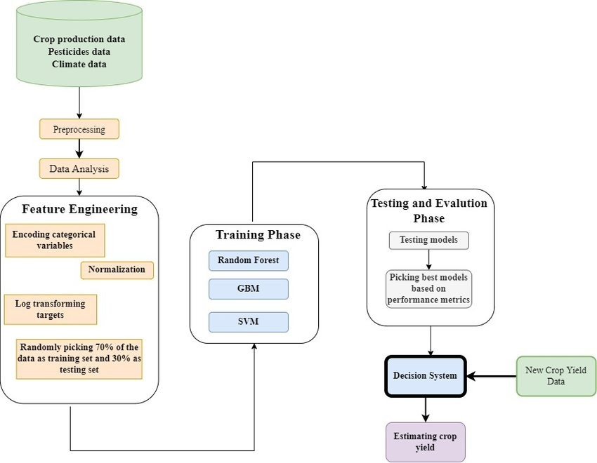

**Technologies Used:**

* Python: For model development and backend logic.
* Flask/Django: Web framework.
* MySQL/PostgreSQL: Database management.
* APIs: Weather and soil data integration.
* Visualization Tools: Matplotlib, Seaborn.
* ML Libraries: Scikit-learn, TensorFlow/Keras.

**Experimental Results**

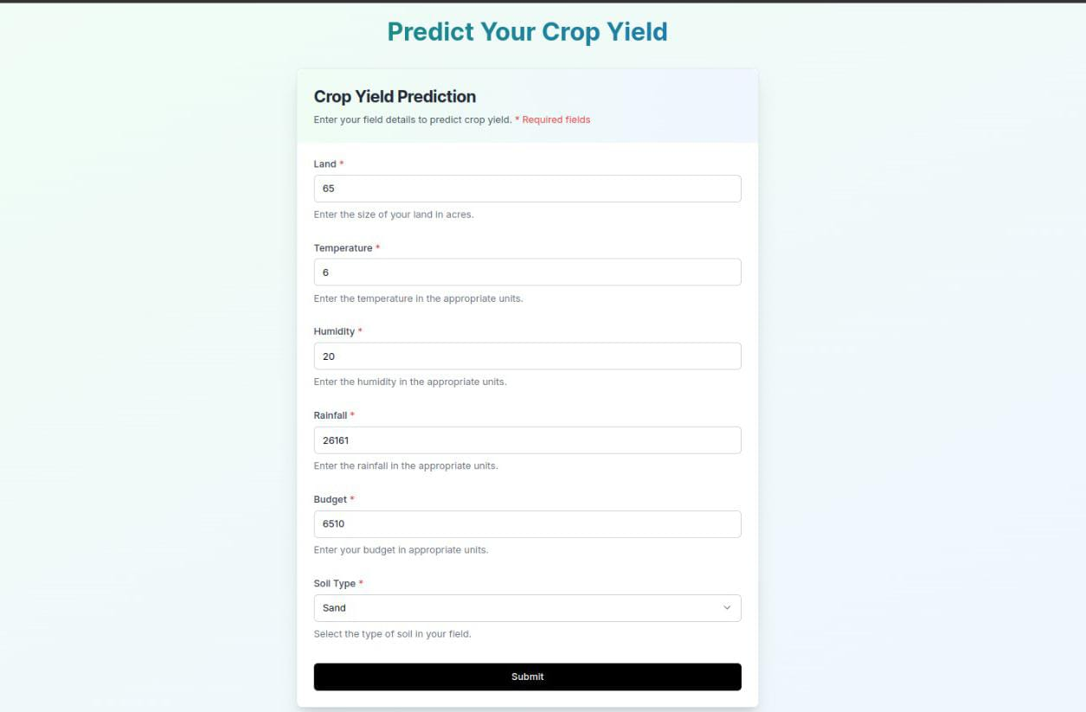

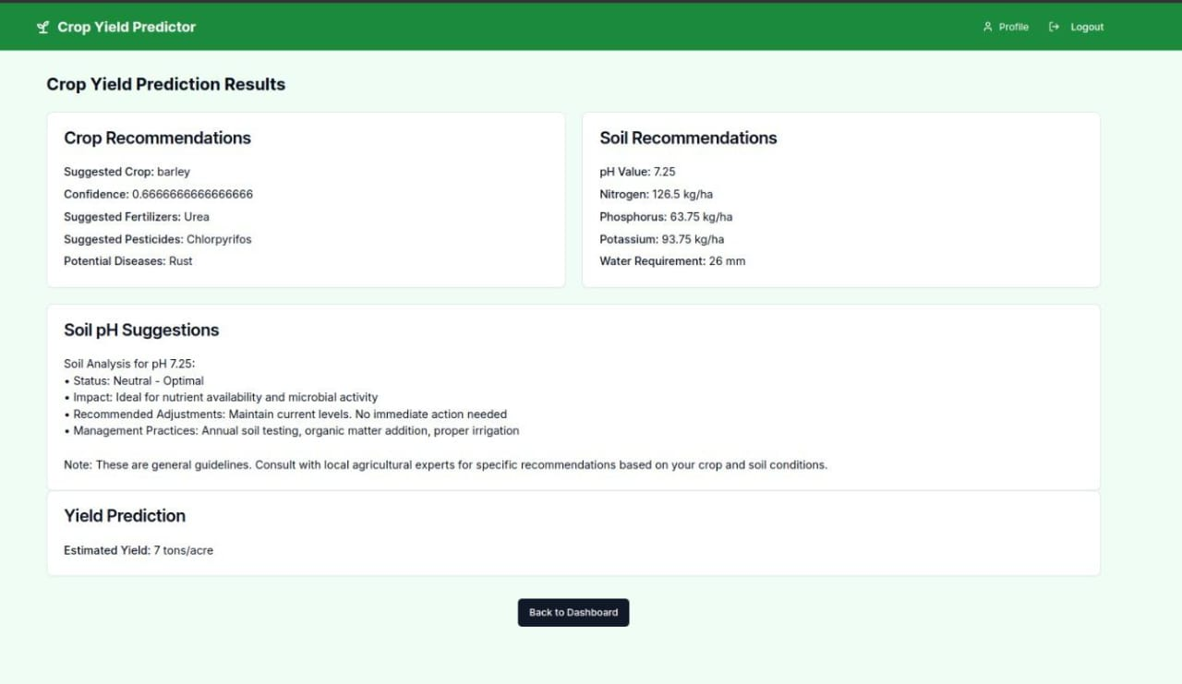

**Conclusion:**

Crop yield prediction and classification using machine learning (ML) has emerged as a transformative approach in modern agriculture. By leveraging advanced algorithms and large datasets, ML models can provide highly accurate and reliable predictions for crop yield, which is crucial for farmers, policymakers, and agricultural planners. These models analyze various factors such as weather patterns, soil quality, crop varieties, and historical data to make data-driven predictions. The use of ML for crop yield prediction offers several benefits, including improved decision-making, resource optimization, and enhanced productivity. With the ability to deliver tailored recommendations on crop selection, fertilization, irrigation, and pest management, machine learning empowers farmers to make informed choices that increase efficiency and profitability. Additionally, by predicting potential crop diseases and offering insights into nutrient management, these models help reduce risks and losses, promoting more sustainable agricultural practices. Despite these advantages, challenges remain, including the need for high-quality, diverse datasets, and the complexity of integrating various factors into a comprehensive prediction model. However, as ML technologies continue to evolve and access to data improves, the accuracy and accessibility of crop yield prediction systems will only increase, benefiting farmers and the broader agricultural community. In conclusion, machine learning holds immense potential in revolutionizing crop yield prediction and classification, leading to smarter, more efficient, and sustainable agricultural practices. As the technology matures, it will play a crucial role in addressing global food security challenges and supporting the agricultural sector's transition to more sustainable and data-driven practices.

**Future Scope**

The future of crop yield prediction and classification using machine learning is full of possibilities, from real-time decision-making tools to personalized farming advice and automated agricultural systems. As technology continues to evolve, machine learning will enable more precise, efficient, and sustainable agricultural practices. By addressing global challenges such as climate change, resource scarcity, and food security, ML will contribute significantly to the future of agriculture and the well-being of farmers worldwide.

**References**

[1] Jampani Ravi, R. Narmadha, “A Systematic Literature Multimodal Image Fusion Review on Models with Challenges and Future Research Trends”, International Journal of Image and Graphics, pp. 2550039-1- 2550039-33, November, 2023. DOI: 10.1142/S0219467825500391

[2] Jampani Ravi, R. Narmadha, “Multimodality medical image fusion analysis with multi-plane features of PET and MRI images using ONSCT”, Computer Methods in Biomechanics and Biomedical Engineering: Imaging & Visualization, September, 2023. pp. 1-19. <https://doi.org/10.1080/21681163.2023.2255684>

[3] Ravi, J., Narmadha, R. Optimized dual-tree complex wavelet transform aided multimodal image fusion with adaptive weighted average fusion strategy. *Sci Rep* **14**, 30246 (2024). <https://doi.org/10.1038/s41598-024-81594-6>

[4] Ravi, J., Subbayamma, B.V., Kumar, P.V. *et al.* Multi-image fusion: optimal decomposition strategy with heuristic-assisted non-subsampled shearlet transform for multimodal image fusion. *SIViP* **18**, 2297–2307 (2024). <https://doi.org/10.1007/s11760-023-02906-3>

[5] P. Satyanarayana , Jampani Ravi, T. Mahalakshmi, V VSatyanarayana Kona, Dr. V. Gokula Krishnan,” Performance Analysis of DSR and CACHE Customized DSR Steering Protocols in Wireless Mobile Adhoc Networks” Proceedings of the Fifth International Conference on I-SMAC (IoT in Social, Mobile, Analytics and Cloud) (I-SMAC), IEEE Xplore Part Number: CFP21OSV-ART; ISBN: 978-1-6654-2642-8, I-SMAC 2021, PP. 1348-1356. DOI: 10.1109/I-SMAC52330.2021.9641042

[6] P. Satyanarayana, T. Mahalakshmi, Dr. P. Rama Koteswara Rao, Dr. Adlin Sheeba, Jampani Ravi, J. Nageswara Rao,” Enhancement of Energy Efficiency and Network Lifetime Using Modified MPCT Algorithm in Wireless Sensor Networks” Journal of Interconnection Networks, January 18, 2022, PP. 2142019-1- 2142019-22. DOI: 10.1142/S0219265921440126

[7] Ravi, J., and G. R. Kumar. "Image fusion algorithm implementation using Laplacian pyramid." *A Peer Reviewed Open Access International Journal* 29 (2016): 103-107.

[8] Venkata syamaraju talari Jampani Ravi,Polamuri Bhanu Sree, Rayapalli Nikhila, Sesetti Sravani, sk ahamed, NV Phani sai kumar” Womens security smart system based on IOT Applications”, IJARSCT 2(2022): 305-314

[9] Jampani Ravi Y. Rama Lakshmanna , Dr. P. Shanmuga Raja , Dr. P.V. Rama Raju , Prathima Gamini,” VEHICLE ACCIDENT PREVENTION AND REPORTING SYSTEM USING GPS & GSM, ACCELEROMETER AND ALCOHOL SENSOR”, INTERNATIONAL JOURNAL FOR RESEARCH & DEVELOPMENT IN TECHNOLOGY, 16(2021) 22-27.

[10] T.V. Syamala Raju Y. Rama Lakshmanna , Dr. P. Shanmuga Raja, Dr. P.V. Rama Raju, Prathima Gamini , Jampani Ravi,” INTERNATIONAL JOURNAL FOR RESEARCH & DEVELOPMENT IN TECHNOLOGY”, 16(2021): 32-40.

[11] R. Narmadha Jampani Ravi” Image Fusion Based on Nonsubsampled Shearlet Transform”, International Journal of Engineering and Advanced Technology (IJEAT)9 (2020): 4177-4180.

[12] T. V. Syamala Raju Jampani Ravi, M. Gowri Sri Durga, Y. D. R. Ch. Kartheek, MD. Shabeena Begum, T. Raju”, Image Fusion using Nonsubsampled Contourlet Transform in Medical Field”, International Journal of Engineering and Advanced Technology (IJEAT) 9(2020): 3829-3832.

[13] T. Chakravarthi T. V. Syamala Raju, G. V. S. Padma Rao, Jampani Ravi, S. P. D. Kalyan, S. Durga Satish Kumar, N. V. Ganesh”, Attendance System using Facial Recognition, INTERNATIONAL JOURNAL FOR RESEARCH & DEVELOPMENT IN TECHNOLOGY,13(2020): 37-40.

[14] V. Yaswanth Varma J. Ravi, N.V. Phani Sai Kumar”Image Compression Implementation using Discrete Wavelet Transform”, IJSRD 5(2018): 20-23.

[15] N. Kishore Chandra Dev J. Ravi, M. Praveen Kumar”, Sementation of 3D MR Images of the Brain using a PCA Atlas”, International Journal of Engineering Science & research technology”,6(2017): 288-296.

[16] M. Praveen Kumar J. Ravi, K. Venkat rao, N. Kishore Chandra Dev, K. Yugandhar” Survey on Image Segmentation Using Thresholding methods”, International Journal for Research and Development in Technology, 2017, 8 (2017): 130-137.