DEVELOPMENT AND PROCESS STANDARDIZATION OF WHEY- COCONUT WATER BASED JELLY USING PANIKOORKA (Coleus barbatus) LEAF EXTRACT
VARUN S PRAKASH¹ and Dr. S.N. RAJAKUMAR²
¹ Department. of Dairy Technology, Verghese Kurien Institute of Dairy and Food Technology, Mannuthy, Thrissur, Kerala-680651, India
² Head and Dean, Verghese Kurien Institute of Dairy and Food Technology, Mannuthy, Thrissur, Kerala-680651, India

ABSTRACT
Commercial jellies are often criticized for their high sugar content and lack of nutritional benefits. This study focuses on developing and assessing a new type of functional jelly, designed to be low in calories and sugar. The jelly is made primarily from a blend of whey (derived from buffalo skim milk) and coconut water, with an added extract of Panikoorka (Coleus barbatus) leaves. The goal was to create a healthier jelly, particularly for individuals with diabetes, by combining the nutritional benefits of whey and coconut water with the potential health-promoting properties of panikoorka. To make the whey-coconut jelly, a standardized procedure was followed, and different formulations were tested to improve taste, texture, and nutrition. These included varying the panikoorka extract percentage (1%, 2%, and 3%), the coconut water-to-whey ratio (1:1, 1:2, and 2:1), sucralose levels (100 ppm, 200 ppm, and 300 ppm), and the amount of china grass (2.5%) used in the preparation. The best combination was achieved with equal parts coconut water and whey (1:1 ratio), 2% panikoorka extract, and 300 ppm sucralose, which resulted in a jelly with optimal taste, appearance, thickness, and texture. The use of coconut water replaced additional water, reduced the need for extra sugar, and improved the jelly's nutritional and functional qualities.
KEYWORDS: Panikoorka, Coconut, Sucralose, Dietetic, Functional, Jelly

INTRODUCTION

Jelly is a popular food with a chewy, soft texture, commonly used in desserts and drinks. According to the World Health Organization (WHO), diabetes affects approximately 422 million people globally, with the majority residing in low- and middle-income countries. Diabetes causes around 1.5 million deaths annually, and it's predicted that 300 million people will develop diabetes by 2025 (Animaw and Seyoum, 2017). A major contributor to diseases like diabetes and obesity is the excessive consumption of unhealthy foods that are high in sugar and artificial additives (such as colors and flavors). Jellies typically contain sugars like sucrose or glucose syrup, along with gelling agents, acids, flavorings, and food coloring (Cano-Lamadrid et al., 2020). The high sugar content in these products poses significant health risks and can lead to diabetes if consumed in large quantities. Therefore, there is an urgent need to reduce the sugar and calorie content of these products and make them healthier. As public awareness of health issues increases, more consumers are opting for functional foods that provide health benefits.
Coconut water is well-known for its rich electrolyte content and nutritional profile. It contains high levels of sugar (fructose), various minerals (calcium, potassium, sodium, and chloride), and vitamins (B, C, and K). Additionally, coconut water provides carbohydrates, fatty acids, and essential amino acids (like tyrosine, tryptophan, alanine, histidine, and valine), making it beneficial for replenishing minerals and carbohydrates lost during physical activity (Yong et al., 2009). It also contains organic acids such as malic and citric acids, as well as trace amounts of pyridoline, shikimic, and quinic acids (Yong et al., 2009)
Sucralose, a zero-calorie sweetener that is about 600 times sweeter than sucrose, was used to replace sugar and mitigate the bitterness of tulsi leaf extract. The use of sucralose in food and beverages has been approved by both the US Food and Drug Administration (FDA) in 1998 and the Food Safety and Standards Authority of India (FSSAI) in 2009.
China grass, also known as agar-agar, is a seaweed-derived gelatin substitute commonly used in desserts such as puddings.China grass is a good source of fiber, calcium, iron, folate, and manganese, and acts as a natural gelling agent in jelly.
Whey is the liquid by-product obtained during the cheese-making process from milk. It is considered a valuable functional food, particularly for enhancing immunity. Whey-based jelly is recommended for various population groups, especially those with conditions such as cardiovascular diseases, high blood pressure, metabolic disorders, and diabetes.
Panikoorka, also called Plectranthus amboinicus and karpooravalli, is a common treatment for coughs and colds in children in South Indian states. The plant is popular in Kerala because it is known to have many healing properties.
MATERIALS AND METHODS
MATERIALS
The ingredients used in this study include coconut water, whey (from skimmed buffalo milk), sucralose, china grass (agar-agar powder), and Panikoorka leaves. Skimmed buffalo milk was sourced from the KVASU (Kerala Veterinary and Animal Sciences University) Dairy plant in Mannuthy, Thrissur, Kerala, India. The coconuts (Cocos nucifera), aged between 8 to 12 months, were purchased from a local farm in Thrissur, Kerala, to extract the coconut water. Sucralose was obtained from Bio-oven Ingredients, Noida, India. The plain china grass powder used in the jelly production was from the BAKERS brand. Panikoorka leaves were collected from households in Mannuthy, Thrissur, Kerala, India.
PRELIMINARY FORMULATION
The product was prepared under Laboratory conditions at the LAB of Department of Dairy Technology, VKIDFT (Verghese Kurien Institute of Dairy and Food Technology) Mannuthy, Thrissur, Kerala, India.The whey-coconut jelly was developed using a standardized process and various formulations were tested to optimize the sensory attributes, texture and nutritional content. The ingredients were incorporated at different levels i.e. panikoorka leaf extract (1%, 2% and 3%), coconut water : whey ratio (1:1, 1:2 and 2:1), sucralose (100 ppm, 200 ppm and 300 ppm) and china grass (2.5%) were boiled to prepare jelly.

DEVELOPMENT OF DIETETIC JELLY

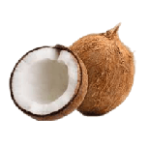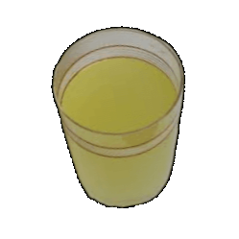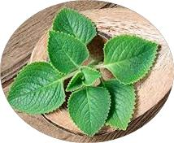

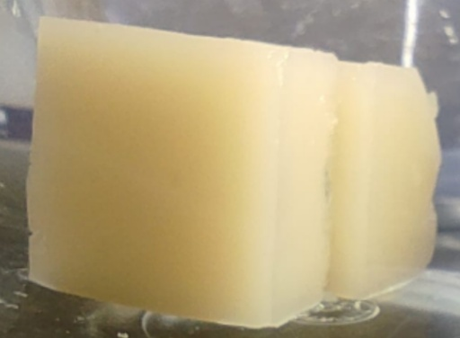

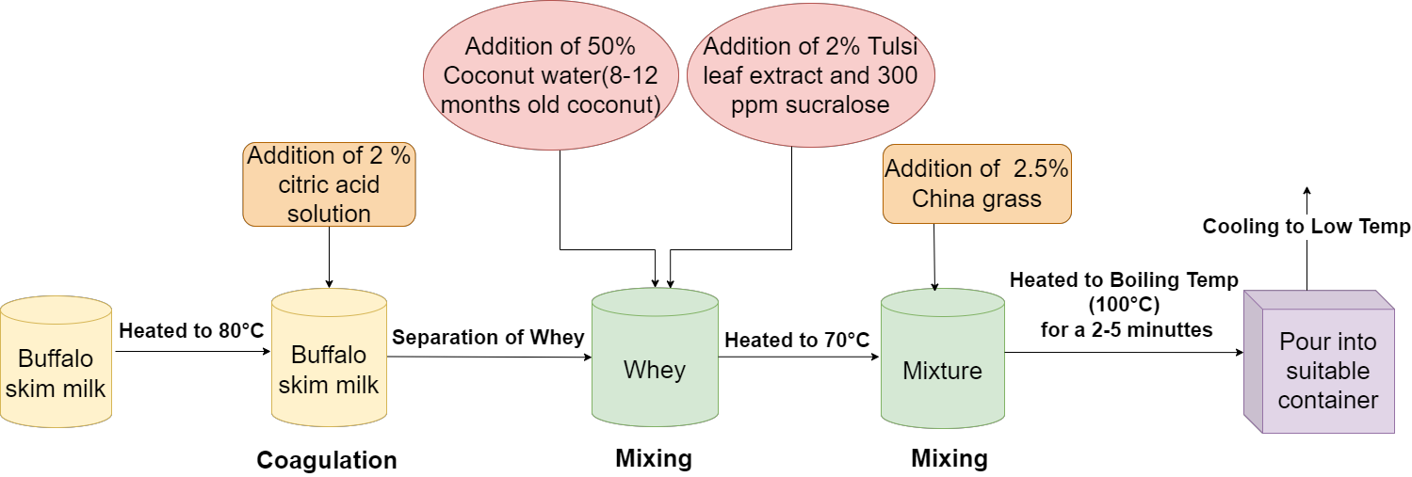
2% Panikoorka

FIG NO 1: FLOW CHART OF PRODUCTION OF DIETETIC JELLY

For the production of dietetic jelly, 500 ml of Buffalo skim milk was first heated to 90℃ for 10 minutes and was cooled to 80℃. Citric acid was added to the solution at the rate of 2 % of the milk taken. The whey obtained after the coagulation was separated out using a muslin cloth. 50 ml of coconut water, 2 per cent of panikoorka leaf extract and 300 ppm of sucralose was added to 50 ml of the whey obtained. The mixture was heated to 70℃, followed by the addition of 2.5 per cent china grass (Agar-Agar powder) to it. It was then boiled to 100℃ for 2-3 minutes. The formed product was then poured into suitable container and cooled to low temperature until the product gets set.

ORGANOLEPTIC EVALUATION OF DIETETIC JELLY
The sensory evaluation of sample jelly along with the control (Water based jelly using gelatin) was done by six semi-trained judges using the 9-point Hedonic scale. The jelly was evaluated for colour, appearance, body and texture, flavour (taste and odour), sweetness and overall acceptability.
MICROBIOLOGICAL QUALITY
The jelly samples were analyzed for their microbiological quality by taking the Aerobic plate count, Coliform count and Yeast and Mould count. The samples were plated in suitable media using appropriate dilutions as described by Speck (1984). The test was performed in triplicates and the counts obtained were noted down.

RESULTS AND DISCUSSIONS

ORGANOLEPTIC EVALUATION OF JELLY
Based on the preliminary sensory analysis of 27 samples, the levels of additions of panikoorka leaf extract, sucralose and whey:coconut water ratio was fixed at 2 per cent, 300 ppm and 1:1 ratio in the sample jelly. The level of addition of china grass powder was fixed at the rate of 2.5 per cent. The sensory scores obtained for control and optimized sample jelly are given below (Table No. 1) and it was statistically analyzed using Mann-Whitney U test.

TABLE NO 1: SENSORY ATTRIBUTES OF CONTROL AND SAMPLE JELLY
Sensory Attributes | Control | Sample | Mann- Whitney U
Flavour | 7.75±0.11 | 8.05±0.05 | 21^{ns}
Colour and Appearance | 7.70±0.09 | 8.10±0.06 | 23.5*
Body and Texture | 7.85±0.06 | 8.2±0.09 | 23*
Sweetness | 7.85±0.06 | 8.05±0.09 | 19.5^{ns}
Overall Acceptability | 7.8±0.09 | 8.25±0.08 | 24*
Figures are Mean ± Standard error of 3 replications,**-significant at five per cent level (P<0.05), ^{ns} - non-significant

It was observed that the control and optimized sample jelly were significantly (p<0.05) different in terms of colour and appearance, body and texture and overall acceptability scores whereas difference in mean scores of flavour and sweetness were not significant (p>0.05). All attributes of sensory scores obtained for optimized sample jelly were higher when compared to control jelly which indicates the feasibility of value addition of jelly without any undesirable effect on sensory properties.
MICROBIOLOGICAL ANALYSIS
The Aerobic plate count (APC) and yeast and mold count (YMC) of the sample jelly (Table No. 2) was found to be 2.74 log₁₀cfu/g and 0.94 log₁₀cfu/g respectively. The difference between the microbial count obtained for control and sample jelly is found to be non-significant (p>0.05). The APC count of sample jelly has a slightly higher value than the control jelly which may be due to the substitution of water by coconut water and whey which can act as a microbial source.
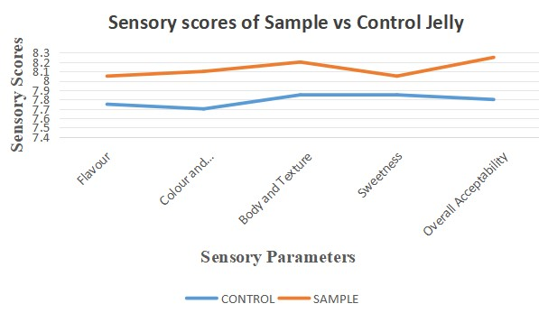
TABLE NO 2: MICROBIOLOGICAL QUALITY OF SAMPLE AND CONTROL JELLY
Microbial Parameter | Control | Sample | t-value
Aeroboic plate count(log10cfu/g) | 2.52±0.14 | 2.74±0.13 | 0.43^{ns}
Yeast and Mould count(log10cfu/g) | 0.92±0..04 | 0.94±0.08 | 0.52^{ns}
Coliform count(log10cfu/g) | ND | ND | -
Figures are Mean ± Standard error of 3 replications,**-significant at five per cent level (P<0.05), ^{ns} - non-significant
The slightly higher YMC of sample jelly may be due to the absence of sucrose which plays a major role in retarding the microbial growth. The coliform was absent in both the jellies. Plotnikova et al., (2022) also reported the absence of coliforms in jelly formulated with different carbohydrate profiles.
Treatments | Sensory scores of different treatments
Treatments | Colour and Appearance | Flavour | Body and Texture | Sweetness | Overall Acceptability
Control | 7.70±0.09 | 7.75±0.11 | 7.85±0.06 | 7.85±0.06 | 7.8±0.09*
T1 | 7.44±0.23 | 6.45±0.34 | 7.34±0.34 | 7.34±0.25 | 6.95±0.34
T2 | 7.37±0.34 | 7.84±0.23 | 7.56±0.03 | 7.45±0.26 | 7.03±0.25
T3 | 7.23±0.45 | 6.34±0.24 | 7.25±0.34 | 7.30±0.47 | 7.04±0.32
T4 | 8.14±0.24 | 8.35±0.56 | 7.45±0.07 | 7.32±0.25 | 8.02±0.04
T5 | 7.23±0.24 | 7.34±0.36 | 7.35±0.04 | 7.40±0.45 | 8.12±0.12
T6 (Sample) | 8.10±0.06 | 8.05±0.05 | 8.2±0.09 | 8.05±0.09 | 8.25±0.08**
T7 | 7.03±0.36 | 8.84±0.38 | 8.42±0.37 | 7.94±0.46 | 8.17±0.37
T8 | 7.45±0.49 | 6.45±0.57 | 8.35±0.29 | 7.67±0.76 | 7.45±0.65
T9 | 7.23±0.29 | 6.34±0.29 | 8.14±0.47 | 7.98±0.29 | 7.67±0.83
T10 | 7.36±0.04 | 6.37±0.48 | 8.17±0.29 | 7.45±0.95 | 7.45±0.67
T11 | 7.45±0.48 | 7.34±0.60 | 8.23±0.19 | 7.32±0.03 | 7.47±0.54
T12 | 7.45±0.29 | 7.37±0.08 | 8.03±0.17 | 7.23±0.27 | 7.46±0.38
T13 | 7.23±0.68 | 8.45±0.73 | 7.34±0.19 | 7.35±0.34 | 7.67±0.52
T14 | 7.45±0.26 | 8.03±0.48 | 7.65±0.27 | 7.56±0.84 | 8.04±0.34
T15 | 7.67±0.57 | 6.23±0.45 | 6.34±0.39 | 7.34±0.09 | 8.56±0.28
T16 | 7.02±0.34 | 7.48±0.74 | 7.47±0.38 | 7.87±0.67 | 7.65±0.45
T17 | 7.83±0.47 | 7.69±0.45 | 7.39±0.37 | 7.67±0.56 | 7.54±0.37
T18 | 7.38±0.39 | 7.58±0.37 | 7.04±0.48 | 7.98±0.76 | 7.85±0.47
T19 | 7.39±0.04 | 6.74±0.35 | 6.37±0.58 | 6.38±0.49 | 6.86±0.39
T20 | 7.47±0.45 | 6.90±0.48 | 6.45±0.49 | 6.39±0.37 | 6.97±0.40
T21 | 7.29±0.48 | 6.43±0.37 | 6.78±0.39 | 7.39±0.59 | 7.69±0.29
T22 | 7.83±0.05 | 6.79±0.39 | 6.45±0.38 | 7.34±0.48 | 7.69±0.51
T23 | 7.39±0.19 | 7.01±0.46 | 6.48±0.58 | 7.03±0.39 | 7.78±0.74
T24 | 7.38±0.37 | 6.83±0.37 | 6.04±0.29 | 7.21±0.49 | 7.32±0.49
T25 | 7.37±0.47 | 6.34±0.48 | 6.38±0.75 | 7.93±0.19 | 7.57±0.20
T26 | 7.49±0.27 | 6.78±0.36 | 6.94±0.07 | 7.83±0.37 | 7.48±0.04
T27 | 7.38±0.56 | 6.47±0.47 | 6.53±0.94 | 6.90±0.48 | 7.02±0.35
TABLE NO 3: PRELIMINARY SENSORY SCORES

The various treatments used in the preliminary sensory analysis are shown in Table No. 4
TABLE NO 4: PRELIMINARYTREATMENTS
Treatments | Whey:Coconut water ratio | Panikoorka(%) | Sucralose  (ppm)
T1 | 1:1 | 1 | 100
T2 | 1:1 | 1 | 200
T3 | 1:1 | 1 | 300
T4 | 1:1 | 2 | 100
T5 | 1:1 | 2 | 200
T6 | 1:1 | 2 | 300
T7 | 1:1 | 3 | 100
T8 | 1:1 | 3 | 200
T9 | 1:1 | 3 | 300
T10 | 1:2 | 1 | 100
T11 | 1:2 | 1 | 200
T12 | 1:2 | 1 | 300
T13 | 1:2 | 2 | 100
T14 | 1:2 | 2 | 200
T15 | 1:2 | 2 | 300
T16 | 1:2 | 3 | 100
T17 | 1:2 | 3 | 200
T18 | 1:2 | 3 | 300
T19 | 2:1 | 1 | 100
T20 | 2:1 | 1 | 200
T21 | 2:1 | 1 | 300
T22 | 2:1 | 2 | 100
T23 | 2:1 | 2 | 200
T24 | 2:1 | 2 | 300
T25 | 2:1 | 3 | 100
T26 | 2:1 | 3 | 200
T27 | 2:1 | 3 | 300

CONCLUSION
Commericial jellies presently available in the market have a lot of sugar (calorie) content and artifical ingredients (colour/flavour) present in it offering no functional/nutritional benefits often leading to Diabetes, obesity and other diseases. This study deals with the formulation of a Dietetic (low-calorie, low-sugar and functional) Jelly, especially for the diabetic people that combines the nutritional benefits of both whey (prepared from buffalo skim milk) and coconut water with the potential health promoting properties of panikoorka (Coleus barbatus) leaf extract. Coconut water provides electrolytes, minerals (like calcium, potassium, sodium), and vitamins (B, C, K). Sucralose replaces sugar and reduces the bitter flavour of the added panikoorka leaf extract. China grass, a natural thickening agent povides fiber, calcium, iron, folate, and manganese. Panikoorka leaf extract adds antioxidants, antimicrobial, and anti-inflammatory benefits. Whey provides whey protein, essential aminoacids and numerous bioactive compounds (peptides) that have a health benefit. It is a dietetic, functional, medicinal and more nutritious product when compared to commercial jellies. It utilises two by-products thereby reducing environmental pollution at the same time it gives a value addition. In addition, it also povides a secondary source of income for the Dairy and Kopra industries. Additionally, they are low-cost, multifunctional, and open up opportunities for diversifying the market for healthy, sustainable, and value-added products.

REFERENCES

- Adetayo, A., Oluwakemi, A. and Yinus, O . 2015. Comparative analysis of water in tender and matured coconut fruits and use as oral rehydration solution. Chem. Mater. Res. 7(2):7-10

- Anima, W., and Seyoum, Y. (2017). Increasing prevalence of diabetes mellitus in a developing country and its related factors. PloS. One, 12(11), e0187670. https://doi.org/10.1371/journal.pone.0187670

- Barbut, S. (1995). Effects of calcium level on the structure of pre-heated whey protein isolate gels. Lebensmittel - Wissenschaft Technologie, 28, 598-603.

- Cano-Lamadrid, M., Calín-Sánchez, Á., Clemente-Villalba, J., Hernández, F., Carbonell-Barrachina, Á. A., Sendra, E., and Wojdyło, A. (2020). Quality parameters and consumer acceptance of jelly candies based on pomegranate juice “Mollar de Elche.” Foods (Basel, Switzerland),9(4).https://doi.org/10.3390/foods9040516

- Collins, A. R. (2005), Assays for oxidative stress and antioxidant status: applications to research into the biological effectiveness of polyphenols. Am J Clin Nutr. 81, 261S-267S.

- DeWit, J. and Klarenbeek, G. (1984). Effects of various heat treatments on structure andsolubility of whey proteins Journal of Dairy Science, 67, 2701-2710.

- Fernando, W. M., Martins, I. J., Goozee, K. G., Brennan, C. S., Jayasena, V., & Martins,R. N. (2015). The role of dietary coconut for the prevention and treatment of Alzheimer's disease: potential mechanisms of action. British Journal of Nutrition, 114(1), 1-14. doi: 10.1017/S00071 14515001452

- Han, H., Kim, Y., Gim, M., Shin, H., Jang, H., Yoon, W.J., Lee, G.H. and Park, Y.K., 2024. Effect of sugar-free jelly on Glycemic Metabolism and Its Potential Health Benefits in non-diabetic Adults. Foods, 13(6), p.1-2

