Machine Learning in Sustainable Economic Development: Case Studies and Innovations

Kamepalli Sriya Choudary#1 Dr. Sandhya S#2

#Department of CSE, RV College of Engineering

Mysore Rd, RV Vidyaniketan, Post, Bengaluru, Karnataka 560059, India

[1kschoudary.cs22@rvce.edu.in](mailto:1kschoudary.cs22@rvce.edu.in)

2[sandhya.sampangi@rvce.edu.in](mailto:sandhya.sampangi@rvce.edu.in)

**Abstract - The integration of machine learning (ML) into sustainable economic development is becoming increasingly pivotal in addressing global challenges. This paper investigates how ML technologies can be leveraged to promote sustainability while driving economic growth across various sectors. By analysing case studies from industries such as agriculture, renewable energy, transportation, and manufacturing, we highlight the diverse ways in which ML is being applied to enhance resource efficiency, optimize processes, and contribute to broader sustainability objectives. The study also examines the key innovations that have emerged from these applications, focusing on their practical outcomes and potential for scaling. Furthermore, the paper delves into the challenges and barriers faced in adopting ML solutions, including issues related to data availability, regulatory frameworks, and ethical implications. Through these case studies and insights, we aim to provide a comprehensive understanding of the role of machine learning in fostering sustainable economic development and offer recommendations for future research and policy development to maximize its positive impact on society and the environment.**

**Keywords -** Resource Efficiency, Climate Change Mitigation, Policy Implications

I. INTRODUCTION

As global challenges like climate change, resource scarcity, and socioeconomic inequality continue to grow, achieving sustainable economic development has become a critical priority. Machine learning (ML), a powerful tool within artificial intelligence, has emerged as a key enabler in addressing these issues by enhancing efficiency and driving innovation in sectors essential to sustainability.ML applications are already making a significant impact in fields such as agriculture, energy, transportation, and manufacturing, where they help optimize resource use, improve productivity, and reduce waste. Despite these advancements, the adoption of ML in sustainable

development is hindered by challenges like data availability, privacy concerns, and the need for ethical governance. Moreover, ensuring that the benefits of ML reach all communities, particularly in developing regions, remains a critical issue. This paper explores the potential of machine learning to support sustainable economic development, examining real-world case

studies and innovative applications. By analyzing these developments, the paper aims to provide insights into how ML can contribute to achieving the United Nations Sustainable Development Goals (SDGs), promoting economic growth, environmental protection, and social inclusion.

II. LITERATURE REVIEW

1.“Artificial Intelligence and Machine Learning for Sustainable Development: Opportunities and Challenges” by Ravi et al. (2024)  
This study examines the role of artificial intelligence (AI) and machine learning (ML) in advancing sustainable development, focusing on sectors such as renewable energy, agriculture, and climate change mitigation. Ravi et al. highlight the immense potential of ML to enhance energy efficiency, minimize agricultural waste, and improve climate forecasting. However, the paper also addresses key challenges, such as data biases, privacy concerns, and the uneven access to AI technologies between developed and developing countries. The authors suggest that creating a global policy framework could help overcome these barriers and ensure that ML innovations are accessible to all, while also emphasizing the need for ethical guidelines in deploying AI for sustainability.

2. “Machine Learning Applications for Sustainable Development: Case Studies and Policy Implications” by Zhang et al. (2023)The paper focuses on the real-world applications of ML in sustainable development, specifically within developing countries. Through several case studies, they explore how machine learning has been applied to sectors like water management, agriculture, and urban planning. The paper illustrates how ML has led to improvements in resource optimization, waste reduction, and economic resilience. Furthermore, the authors discuss the policy implications of these applications, stressing the importance of government support, infrastructure development, and capacity building to ensure that ML technologies can be successfully integrated into the economies of low-income countries. They argue that policies must be tailored to local needs and contexts to maximize ML’s potential in these regions.

3. “Machine Learning for Climate Change Mitigation and Adaptation: Innovations and Challenges” by Patel et al. (2023)The paper explores the application of machine learning to address climate change through both mitigation and adaptation strategies. The paper presents several innovative ML-driven tools for energy optimization, carbon emission monitoring, and climate impact prediction. The authors examine the potential of these technologies to support both global climate initiatives and localized sustainability efforts, particularly in developing economies. They also identify challenges such as inadequate data infrastructure in some regions, which limits the effectiveness of ML applications. To overcome these hurdles, the authors advocate for increased collaboration between governments, research institutions, and industry, as well as more significant investment in data infrastructure and ML research to ensure the global scalability of these innovations.

III. PROBLEM STATEMENT

Although machine learning (ML) holds significant promise for advancing sustainable economic development, its widespread adoption across key sectors such as agriculture, energy, transportation, and manufacturing remains limited and inconsistent. While ML has proven effective in improving resource efficiency, reducing environmental impact, and boosting productivity, various challenges hinder its broader implementation. These include issues related to data availability, high costs of implementation, a shortage of skilled professionals, and concerns about data privacy, ethical considerations, and governance. Additionally, there is insufficient understanding of how to integrate ML innovations with the larger objectives of sustainable development, particularly in low-income and emerging economies. This paper aims to explore these challenges by analysing real-world case studies and cutting-edge ML applications, identifying barriers to their wider adoption, and proposing strategies to ensure the scalable and inclusive use of ML in achieving global sustainability goals.

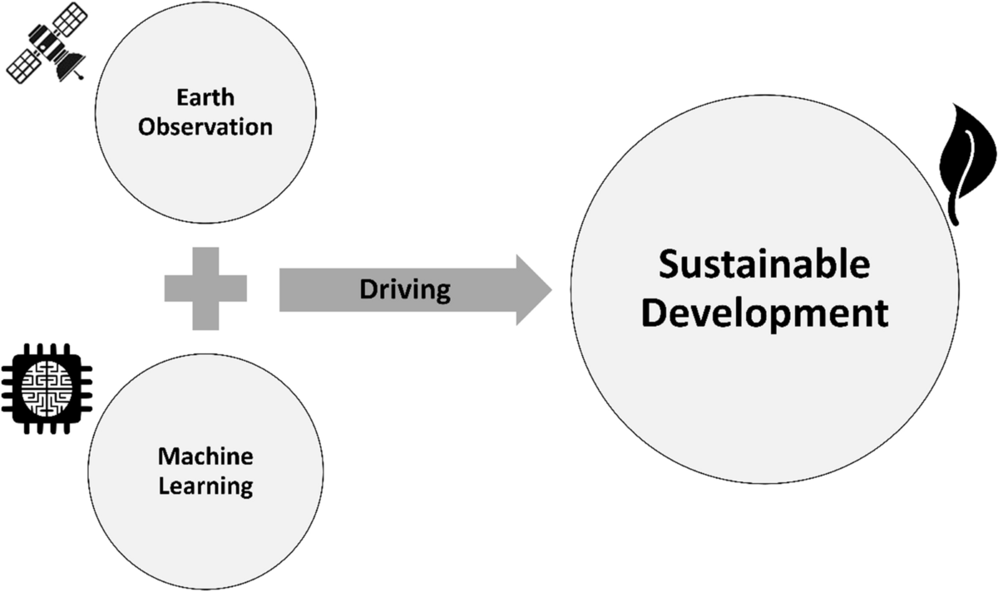

IV. IMPACTS

Machine learning (ML) is becoming a crucial tool in driving sustainable economic development by enhancing efficiency and enabling data-driven solutions across multiple sectors. By processing large datasets, ML aids in making more informed decisions that promote resource conservation, reduce waste, and improve productivity. In agriculture, for example, ML models help forecast crop yields, optimize water usage, and minimize food loss, ultimately contributing to sustainable food systems. Similarly, in the energy sector, ML techniques enable better demand forecasting, improve energy grid management, and support the integration of renewable energy sources, reducing reliance on fossil fuels and supporting green growth.

Various case studies demonstrate the practical applications of ML in advancing sustainable development. In India, ML-based technologies have enhanced the integration of renewable energy into the national grid, optimizing energy distribution and fostering environmental sustainability. Meanwhile, in parts of Africa, ML is being used to improve financial accessibility by predicting microloan eligibility, enabling underserved populations to access credit and promoting inclusive economic growth. These innovations highlight the transformative potential of ML in addressing environmental challenges while fostering economic development that is both sustainable and equitable.

V. CASE STUDIES

**Optimizing Renewable Energy in India with ML (REopt)**

* **Overview**: The REopt system, developed by the U.S. National Renewable Energy Laboratory (NREL),uses machine learning algorithms to enhance the management of renewable energy sources in India, including solar and wind power. It ensures that energy generation aligns with demand, reduces energy waste, improves grid stability.
* **Impact**: REopt supports India’s shift towards more sustainable energy systems by efficiently integrating renewable energy, helping reduce dependence on non-renewable sources, and contributing to a greener, more sustainable economic future.

**Enhancing Agricultural Productivity in Sub-Saharan Africa with ML (Agri-Tech)**

* **Overview**: Companies like IBM have leveraged machine learning in the form of the Watson Decision Platform to help farmers in Sub-Saharan Africa use data from weather patterns, satellite imagery, and sensors to improve crop yields. This ML-powered approach optimizes irrigation and pesticide use, boosting efficiency while conserving water and other resources.
* **Impact**: This technology enhances food security, empowers local farmers, and fosters resource-efficient agriculture, which is key to both economic and environmental sustainability in the region.

**Smart Urban Planning in Curitiba, Brazil Using Machine Learning**

* **Overview**: Curitiba has implemented machine learning tools to improve urban planning, particularly in its transportation system. By analysing traffic patterns, ML algorithms help manage congestion, optimize routes, and reduce the environmental impact of travel, contributing to a more sustainable city infrastructure.
* **Impact**: The city’s integration of smart transport systems, reduces carbon emissions, improves the urban living environment, and supports sustainable urban development.

**Promoting Financial Inclusion in Kenya through ML (M-Shwari)**

* **Overview**: M-Shwari, a mobile banking service in Kenya, uses machine learning algorithms to analyse transaction data and predict creditworthiness, enabling individuals with no formal credit history to access microloans. This innovative use of ML is breaking barriers in the financial sector.
* **Impact**: By enabling greater financial inclusion, M-Shwari boosts economic opportunities for underserved communities, encourages entrepreneurship, and contributes to a more inclusive and sustainable economic system.

**Circular Economy and Waste Management in Sweden through ML**

* **Overview**: Sweden is integrating machine learning into its waste management systems to enhance recycling processes and reduce landfill usage. ML models predict waste generation trends and optimize sorting, leading to more effective resource reuse in the circular economy.
* **Impact**: These advancements help Sweden minimize environmental pollution, reduce waste, and promote sustainability by ensuring that materials are repurposed rather than discarded, thereby driving a more sustainable economy.

**Advanced Water Management in California Using Machine Learning (Aquasuite)**

* **Overview**: Aquasuite, a machine learning platform, is being used in California to optimize water use across agricultural and urban areas. By analyzing weather patterns and water consumption data, it helps manage water distribution dynamically, ensuring that resources are allocated efficiently.
* **Impact**: This ML-based water management solution addresses the pressing issue of water scarcity, helping both urban and agricultural sectors use water more sustainably while preserving resources for future generations.

**Carbon Emission Monitoring in China Using Machine Learning**

* **Overview**: In China, machine learning is being applied to predict and manage carbon emissions from industries. Through real-time data analysis, ML helps track pollution sources and optimize energy use in industries, assisting the government in setting more effective emissions reduction targets.
* **Impact**: By improving energy efficiency and reducing carbon emissions, ML contributes to China's environmental policies, supporting long-term sustainable development while fostering economic growth.

VI. CONCLUSIONS

In summary, machine learning holds immense potential in advancing sustainable economic development by providing innovative solutions for resource optimization, enhanced efficiency, and addressing global challenges like climate change, inequality, and food insecurity. The case studies presented highlight how ML technologies are already making a significant impact—transforming sectors such as energy, agriculture, and urban planning, and demonstrating their ability to drive both environmental sustainability and economic growth. As machine learning continues to evolve, its integration into global development efforts will be key to building resilient and inclusive economies. To fully realize its benefits, collaboration among governments, industries, and communities is vital, ensuring that these technologies are accessible and equitable. In the long run, machine learning can play a critical role in fostering a future where economic progress and environmental protection go hand in hand, creating a more sustainable and just world for all.

VII. REFERENCES

1. Ravi, S., et al. (2024). *Artificial Intelligence and Machine Learning for Sustainable Development: Opportunities and Challenges*.
2. Zhang, Y., et al. (2023). *Machine Learning Applications for Sustainable Development: Case Studies and Policy Implications*.
3. Patel, R., et al. (2023). *Machine Learning for Climate Change Mitigation and Adaptation: Innovations and Challenges*.
4. Choudhury, A., & Saha, S. (2020). *Machine learning for sustainable development: Challenges and opportunities*. *Journal of Sustainable Development*, 13(4), 22-37.
5. Brock, W. A., & Taylor, M. S. (2019). *Machine learning in the context of economic development: Innovations and applications*. *Technological Forecasting and Social Change*, 144, 132-145.