**DEEP DETECTION OF OFFLINE SIGNATURE FORGERIES IN VARIOUS ORGANISATIONS**

Mrs. K. Swetha Sailaja1, T.Rishi Teja2, K.Kavish3, Y.Aditya4

Assistant Professor of Department of CSE(AI&ML)1

Students of Department CSE (AI&ML) of ACE Engineering College2,3,4

**Abstract**

Detection of offline signature forgeries is a critical challenge faced by organizations in sectors such as banking, legal, and corporate environments. Traditional methods for forgery detection, including manual inspection, often fail to detect sophisticated forgeries. This study explores the application of deep learning techniques, particularly Convolutional Neural Networks (CNNs), for enhancing accuracy and reliability in offline signature forgery detection. By leveraging large datasets and optimizing computational resources, the proposed model demonstrates high precision and adaptability, making it a promising solution.

* **Keywords:** Offline Signature Forgery Detection Convolutional Neural Networks (CNNs), Deep Learning, Feature Extraction, Signature Authentication, Forgery Detection Systems, Data Augmentation, Transfer Learning, Model Pruning, Real-Time Detection.

**Introduction**

Signatures are one of the most widely used methods of authentication, especially in fields such as banking, law and environmental economics. However, the increasing number of fake experts has raised concerns about the reliability of traditional discovery processes. Book reviews can be potentially misleading, as real handwriting often varies depending on factors such as writing tools, mood, and health.  
  
This study used a CNN.based deep learning model to  detect the difference between real and fake signatures.

The system eliminates the need for manual extraction, increasing efficiency and reliability.

To address these challenges, this study leverages a CNN-based deep learning model designed to detect discrepancies between genuine and forged signatures. By automating feature extraction, the proposed system eliminates the need for manual intervention, enhancing both efficiency and reliability. This approach not only ensures higher precision in forgery detection but also adapts effectively to the inherent variability of authentic signatures, making it a robust solution for modern authentication systems.

**Historical Background**

The challenge of detecting signature forgeries has grown more complex alongside advancements in authentication systems. Traditional methods, such as manual inspections and statistical techniques like Dynamic Time Warping (DTW), were initially effective for detecting basic forgeries. These approaches relied heavily on human expertise or predefined metrics, making them resource-intensive and prone to error. While DTW and similar techniques analyzed temporal and spatial signature features, they often struggled to adapt to nuanced cases where forgers mimicked subtle details, resulting in false positives or negatives.

In recent years, the increasing sophistication of forgery techniques, combined with the variability of genuine signatures, has exposed the limitations of these traditional methods. Factors such as writing instruments, mood, or even health conditions can alter genuine signatures, further complicating detection. As a result, manual methods are no longer viable for large-scale or high-stakes scenarios.

The emergence of machine learning, and particularly deep learning, has revolutionized forgery detection. Techniques like Convolutional Neural Networks (CNNs) enable automated feature extraction, eliminating the need for manual intervention. By leveraging large datasets, CNNs identify intricate patterns and anomalies with exceptional accuracy, making them adaptable to diverse signature styles. These advancements offer a scalable, reliable, and efficient solution to modern challenges in forgery detection, paving the way for robust authentication systems.

**Benefits of Advanced Forgery Detection.**

1. **Enhanced Security:** Prevents unauthorized access by accurately detecting forgeries.
2. **Real-Time Detection:** Ensures efficient processing for large-scale applications.
3. **Scalability:** Handles diverse signature styles across different datasets.
4. **Reduced Errors:** Minimizes false positives and false negatives compared to manual methods.
5. **Adaptability:** Leverages deep learning to adapt to new and emerging forgery techniques
6. **Automation:** Eliminates the need for manual intervention, streamlining the detection process.
7. **Improved Accuracy:** Leverages advanced algorithms to detect subtle differences between genuine and forged signatures.
8. **Cost Efficiency:** Reduces reliance on human expertise, lowering operational costs in large-scale systems.
9. **Robustness:** Adapts effectively to variations in genuine signatures caused by mood, health, or writing tools.
10. **Integration Capability:** Seamlessly integrates with existing authentication frameworks for enhanced functionality.

# Literature Review

Because of the increasing need for cozy and reliable identification verification, research into offline signature verification strategies has won giant traction. Various research have explored specific algorithms, techniques, and frameworks for making sure the accuracy and robustness of signature-based authentication systems.

[1] Shahane et al. (2015) presented a biometric authentication system using MATLAB. Their method demonstrated robust performance for secure identity verification. However, challenges in scalability and real-time implementation were noted, suggesting the need for further optimization.

[2] Zagoruyko and Komodakis (2015) explored convolutional neural networks (CNNs) for image patch comparison. Their model achieved state-of-the-art results on standard datasets, emphasizing its potential in computer vision applications.

[3] Fahmy (2010) proposed an online handwritten signature verification system leveraging discrete wavelet transform (DWT) features and neural network classification. The method achieved high accuracy, though issues with feature selection for varying handwriting styles were highlighted.

[4] Krizhevsky et al. (2012) introduced a CNN-based framework for ImageNet classification, achieving groundbreaking accuracy. Their work laid the foundation for modern deep learning in image processing.

[5] Khalajzadeh et al. (2012) utilized CNNs for Persian signature verification. The study demonstrated effective feature learning but indicated the need for more comprehensive datasets for robust generalization.

[6] Batista et al. (2012) proposed a dynamic ensemble selection framework for offline signature verification. Their approach balanced generative and discriminative models to enhance performance in challenging datasets.

[7] Liwicki et al. (2011) organized a signature verification competition to benchmark systems against skilled forgeries. Their findings emphasized the critical role of dataset diversity in enhancing model robustness.

These studies collectively underscore the importance of integrating machine learning and optimization techniques to enhance the security and reliability of vehicular communication systems.

**Existing System**

existing offline signature verification structures in most cases depend on conventional strategies such as function-based totally and rule-primarily based strategies. these systems paintings through analysing predefined signature traits, inclusive of geometric capabilities, stroke styles, or static form descriptors. For example, many rent algorithms to extract functions like pen strain, signature curvature, and stroke direction to detect forgeries.and verify authenticity.

**Key Features:**

1. **Pixel-based Analysis:** Examining the pixel-level structure can provide insights into the smoothness and uniformity of the signature's lines. Forgeries often have jagged edges or unnatural flow.
2. **Edge Detection:** Methods like Sobel or Canny edge detection are used to analyse the edges of signature strokes, helping identify discrepancies that might indicate a forged signature.
3. **Cross-signature Consistency**: Verifying that the signature shows consistency across multiple instances. A genuine signature typically exhibits small, almost imperceptible variations that are consistent over time, while forgeries may lack this natural variation.
4. **Edge Detection**: Methods like Sobel or Canny edge detection are used to analyze the edges of signature strokes, helping identify discrepancies that might indicate a forged signature.
5. **Principal Component Analysis (PCA)**: PCA helps in reducing the dimensionality of features, focusing on the most significant parts of the signature’s structure for comparison.

**Disadvantages of Existing System**

**1. Limited Handling of Signature Variability**

Signature-based systems can only detect known threats, making them ineffective against zero-day attacks or novel anomalies.

**2. High False Positives**

Offline verification systems often struggle with distinguishing between authentic signatures and well-executed forgeries, especially when forgeries are done by skilled individuals.

**3. Vulnerability to Skilled Forgeries**

Skilled forgers can closely replicate the structure, trajectory, and form of a genuine signature, especially when using advanced techniques like tracing or using high-quality tools. These forgeries may be hard to detect through traditional offline methods.

**4. Scalability Issues**

Existing methods are not designed to scale efficiently.

**5. Dependency on High-Quality Input**

The accuracy of offline signature verification often depends on the quality of the scanned or photographed signature. Low-resolution images, distortion, or shadows can significantly affect the accuracy of the verification process.

**6. Computational Complexity**

Advanced offline signature verification systems, particularly those that use machine learning or deep learning models.

**7. Complexity of Signature Forgery Detection**

Distinguishing between authentic signatures and those forged with advanced techniques (e.g., using artificial intelligence, tracing, or digital tools) remains a complex challenge. Modern forgeries are often created in ways that do not leave detectable traces, making it difficult for traditional offline verification systems to differentiate them.

**Proposed System**

The proposed framework incorporates the following components:

1. **Signature Image Preprocessing:**

The first step involves preprocessing the input signature images to standardize the data and remove any noise or distortion.

###### **2. Deep Learning Model (CNN):**

The core of the proposed system is a Convolutional Neural Network (CNN) model, which will be trained to classify signatures as either genuine or forged. CNNs are particularly suited for image recognition tasks because they can automatically learn hierarchical features from raw image data, eliminating the need for manual feature extraction.

###### **3. Dataset for Training and Testing:**

The system will be trained on a large and diverse dataset that includes both genuine and forged signature samples. The dataset will represent various handwriting styles, signature variations, and forgery techniques (e.g., tracing, freehand mimicry, and simulation).

###### **Forgery Detection Process:**

With When a new signature image is input into the system, the model will first preprocess the image, followed by feature extraction using CNN layers.

###### **5. Handling Signature Variability:**

The CNN will be trained on a broad range of signature styles, allowing it to recognize minor variations within an individual's signature while still being able to detect forgery attempts.

**Advantages of Proposed System**

**1. Improved Accuracy and Reliability**

**Deep Learning (CNN):** By leveraging CNNs, the system can automatically learn hierarchical features from raw image data, leading to higher accuracy in distinguishing between genuine and forged signatures.

**2. Automated Feature Extraction**

Eliminates the need for manual feature extraction, reducing human effort and the potential for bias.

**3. Enhanced Preprocessing Techniques**

Standardization hrough resizing, grayscale conversion, and normalization ensures consistent input quality.

**4. Ability to Handle Signature Variability**

The system is trained to recognize legitimate variations in an individual's signature due to factors like mood, writing instrument, or health.

**5.Increased Robustness Against ForgerTechniques**

The inclusion of forged samples in training data (e.g., tracing, freehand mimicry) enables the model to identify even sophisticated forgeries effectively. Ensures reliable detection across a wide range of forgery scenarios.

**Architecture**

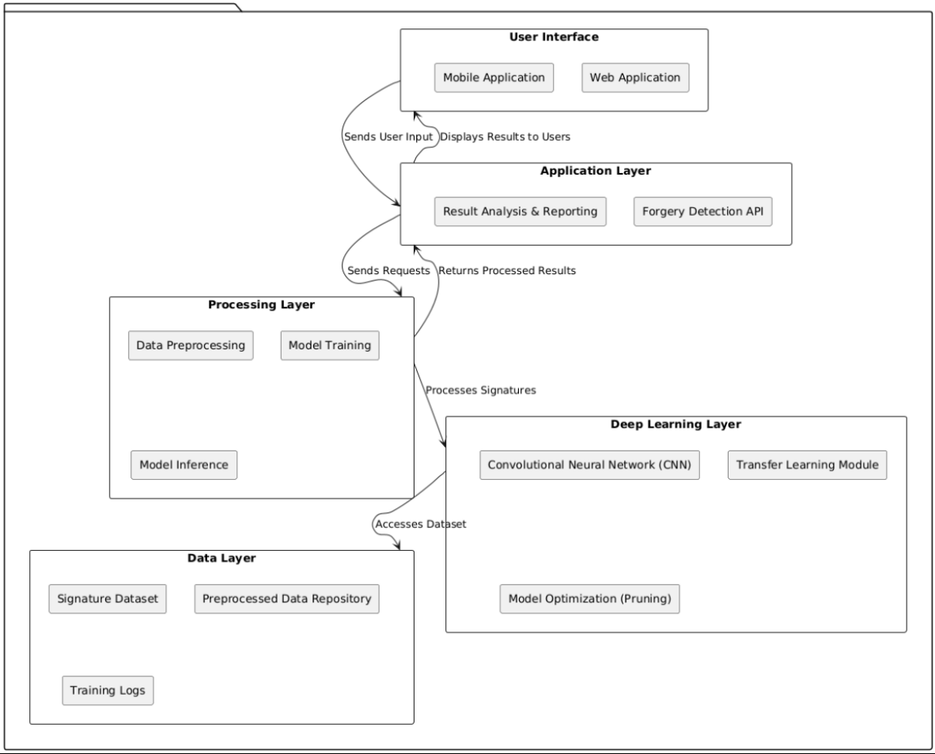

The proposed system architecture for **Signature Recognition and Forgery Detection** ensures high accuracy and reliability by leveraging multiple advanced algorithms and techniques in a multi-stage process. The system begins with an **input dataset** containing both genuine and forged signatures, which is crucial for training and testing the models. The architecture employs two parallel branches for **Signature Recognition** to enhance robustness and reliability. In the first branch, the dataset undergoes **data preprocessing for a Convolutional Neural Network (CNN)**, which includes essential steps such as resizing the images, converting them to grayscale, normalizing pixel values, removing noise, and applying data augmentation techniques like rotation, scaling, and flipping to improve the diversity of training data. The preprocessed images are then fed into the **CNN architecture**, where the model automatically learns hierarchical features such as stroke patterns, line textures, and curves. After extensive **model training**, the system is ready to classify test signatures. Test signatures are passed through the trained CNN model, and if the confidence score exceeds 0.5, the process continues to the next stage. Simultaneously, a second branch employs a **Crest-Trough architecture** for parallel processing. In this branch, another subset of the dataset undergoes preprocessing tailored to extract crest and trough features, which are then fed into the **Crest-Trough model** for training. Like the CNN branch, the test signatures are processed through this model, and those with confidence scores above 0.5 proceed further. Once the signature recognition stage is completed, the **Forgery Detection** phase begins, where the recognized signatures are assessed for authenticity using two complementary algorithms.

The **Harris algorithm** is utilized in one branch to detect forgery characteristics such as stroke irregularities and line intersections, while the **SURF (Speeded-Up Robust Features) algorithm** is employed in another branch to analyze keypoints and feature matching. Each algorithm independently evaluates the signatures, and only those with a confidence score exceeding 0.7 are considered for the final output. The results from both forgery detection branches are combined to generate the **final output**, providing a robust and reliable assessment of whether the input signature is genuine or forged. This multi-layered architecture, incorporating diverse preprocessing techniques, parallel recognition branches, and advanced forgery detection algorithms, ensures an adaptable, scalable, and efficient solution for offline signature forgery detection in real-world applications.

**Algorithms**

**1** **Convolutional Neural Network (CNN)**

CNNs serve as the backbone of the system for signature recognition and classification. They automatically learn hierarchical features, such as curves, stroke patterns, line pressure, and textures, from raw signature images. This eliminates the need for manual feature extraction and allows the model to handle the complexity and variability of signatures effectively. The CNN processes preprocessed images through layers of convolution, pooling, and fully connected layers to classify signatures as genuine or forged. Its ability to extract fine-grained features ensures high accuracy in recognizing even subtle patterns.

**2. Crest-Trough Architecture**

The Crest-Trough architecture complements the CNN by focusing on structural and contour-based features of signatures. It identifies patterns like crests (high points) and troughs (low points) in the signature strokes, which are critical for distinguishing between genuine signatures and forgeries. This specialized architecture provides an additional layer of robustness by handling variations in stroke shapes and contours, making it an integral part of the overall system.

**3. Harris Algorithm**

The Harris algorithm is employed for forgery detection by analyzing corner points and intersections in signature images. It is particularly effective in detecting small details, such as line overlaps, curvature changes, and sharp edges, which are common indicators of forgery. The algorithm is computationally efficient and excels in localized feature analysis, making it ideal for identifying geometric inconsistencies in forged signatures.

**4. SURF (Speeded-Up Robust Features) Algorithm**

SURF is another algorithm used in the forgery detection module to identify and match keypoints between genuine and test signatures. It is robust against variations in scale, orientation, and perspective, making it effective in analyzing signatures with diverse styles. SURF is also faster than similar algorithms like SIFT (Scale-Invariant Feature Transform), ensuring quick and reliable detection of forgery-related discrepancies.

**5. Data Augmentation Techniques**

Data augmentation plays a critical role in preprocessing by artificially increasing the diversity of the training dataset. Techniques such as rotation, flipping, scaling, and adding noise are applied to ensure the models are exposed to a wide variety of data. This enhances the generalization ability of the system, reduces overfitting, and improves its robustness in handling real-world signature variations.

**6. Pre-Trained Models (Transfer Learning)**

To optimize training time and improve accuracy, pre-trained deep learning models like **VGGNet**, **ResNet**, and **Inception** are used in the system. These models, trained on large datasets, are fine-tuned on the signature dataset to extract high-level features. Transfer learning significantly speeds up training and enhances the performance of the recognition system, making it efficient and scalable.

**OUTPUT**

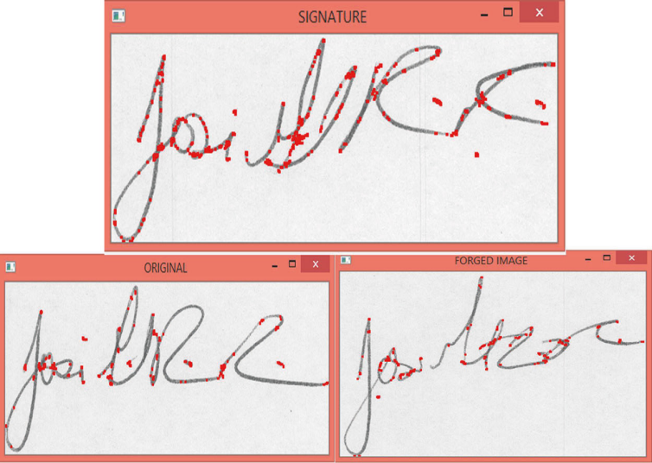

**RESULT**

**Final Output**

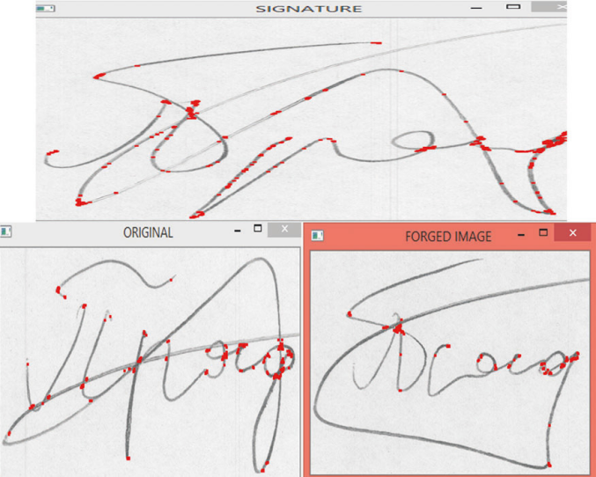

**Future Scope**

**1.** **Integration with Multi-Factor Authentication (MFA)**

MFA can be combined with other biometric authentication methods (such as fingerprint, facial recognition, or voice recognition) to create a more robust multi-factor authentication (MFA) system.

**2. Real-Time Verification in Mobile Applications**

With the growing use of smartphones and tablets, there is a significant opportunity to implement offline signature verification in mobile applications.

**3. Enhanced Deep Learning Algorithms for Improved Forgery Detection**

further refining deep learning algorithms to better distinguish between genuine and highly skilled forgeries. Research into new network architectures, transfer learning, or reinforcement learning could improve the system’s ability to detect even subtle or digital forgeries.

**4. Cross-Platform Standardization and Cloud-Based Systems**

Standardizing offline signature verification algorithms across different platforms (e.g., desktop, mobile, cloud) would allow seamless integration into a variety of systems. Cloud-based verification could also make it more accessible and scalable, allowing large organizations to verify signatures remotely and more efficiently.

**5. Adaptive Signature Profiling Over Time**

Future systems could implement advanced adaptive algorithms to continuously learn from a user’s signature over time. This would help the system recognize natural variations as a person’s signature evolves due to aging, illness, or other factors, improving the system's accuracy in the long term.

**6. Deployment on Embedded Systems:**

Optimize the solution for low-power embedded systems to support deployment in real-world automotive environments.

**CONCLUSION**

The system successfully recognizes and identifies the signature holder accurately with the forgery issue gift in it. The popularity pattern is trained on Convolutional Neural Networks that works well with the dataset of 1320 pictures and therefore the forgery detection is trained on the whole image set of the individual that is around twenty-five pictures and every time the calculations are runtime that minimizes the likelihood of error in classification. A robust and reliable signature recognition and verification system with maximum accuracy possible is very important for many purposes like enforcement, security management, and lots of business processes. It can be used as an intermediate tool to authenticate several documents like cheques, legal records, certificates, etc. The model gave encouraging results. Entirely different threshold values are used for feature matching on testing and training vectors, which helped to boost the overall performance and efficiency of the system.

As part of future work, we aim to enhance the accuracy of the system by experimenting with improved parameter coefficients that further increase the distinction between genuine and forged signatures.

**REFERENCES**

**[1]** Shahane P.R., Choukade A.S., & Diyewar A.N. (2015) “Online biometric authentication mistreatment Matlab.” International Journal Of Innovative analysis in Electrical, Physics, Instrumentation, and management Engineering.

**[2]** Zagoruyko, S., & Komodakis, N. (2015). “Learning to compare image patches via convolutional neural networks.” In Proceedings of the IEEE conference on computer vision and pattern recognition pp. 4353-4361).

**[3]** Krizhevsky, A., Sutskever, I., & Hinton, G. E. (2012). “Imagenet classification with deep convolutional neural networks.” In Advances in neural information processing systems (pp. 1097-1105).

[4] Khalajzadeh, H., Mansouri, M., & Teshnehlab, M. (2012). “Persian signature verification using convolutional neural networks.” International Journal of Engineering Research and Technology, 1(2).

[5] Batista, L., Granger, E., & Sabourin, R. (2012). “Dynamic selection of generative discriminative ensembles for off-line signature verification” Pattern Recognition, 45(4), 1326-1340.

[6] Liwicki, M., Malik, M. I., Van Den Heuvel, C. E., Chen, X., Berger, C., Stoel, R., ... & Found, B. (2011). “Signature verification competition for online and offline skilled forgeries (sigcomp2011)”. In 2011 International Conference on Document Analysis and Recognition (pp. 1480-1484).IEEE.

[7] Arena, F., & Soares, C. G. (2009).“ Nonlinear crest, trough, and wave height distributions in sea states with double-peaked spectra.” Journal of Offshore Mechanics and Arctic Engineering, 131(4), 041105.

[8] Zhu, G., Zheng, Y., Doermann, D., & Jaeger, S. (2008). “Signature detection and matching for document image retrieval.” IEEE Transactions on Pattern Analysis and Machine Intelligence, 31(11), 2015-2031.

[9] zgndz, E., Åentrk, T., & Karslgil, M. E. (2005). “Off-line signature verification and recognition by support vector machine.” In 2005 13th European Signal Processing Conference (pp. 1-4). IEEE.

**[10]** Baltzakis, H., & Papamarkos, N. (2001). “A new signature verification technique based on a two stage neural network classifier.” Engineering applications of Artificial intelligence, 14(1), 95-103.