Intellectual Property Rights : A Review

Mr. Pranav S. Bhingare*1 Mr. Shravan J. Somani*2Dr. Mahesh R. Sherkar*3 Pratibhatai Pawar College of Pharmacy, Shrirampur

Email: [pranavbhingare2312@gmail.com](mailto:pranavbhingare2312@gmail.com) Contact No. : 9130568051

# Abstract: -

This review article delves into the complex and ever-evolving field of intellectual property rights (IPR) as they relate to the pharmaceutical industry. The article begins by examining the history of IPR in pharmacy, highlighting the key developments and milestones that have shaped the landscape of pharmaceutical intellectual property law over time. From there, the article explores the different types of IPR that are relevant in the pharmaceutical industry, including patents, trademarks, and copyrights. The article then moves on to discuss the critical role that IPR plays in driving innovation and economic growth in the pharmaceutical sector.

However, the article also delves into the challenges and controversies surrounding IPR in the pharmaceutical industry. This includes discussions of issues such as access to essential medicines, high drug prices, and the tension between intellectual property rights and public health concerns. Finally, the article considers the future of IPR in

pharmacy, including emerging trends and developments that will likely shape the field in the coming years. Overall, this review article provides a comprehensive and insightful overview of intellectual property rights in the pharmaceutical industry, making it an invaluable resource for anyone interested in this important and dynamic area of the law.

# Keywords: -

Innovation, Economic growth, Drug pricing, public health, Personalized medicine, Artificial intelligence, Data assets

# Introduction: -

The concept of intellectual property (IP) has existed for centuries, with roots in ancient civilizations such as Greece and Rome. However, the modern system of intellectual property rights (IPR) that we know today has its origins in the late 19th and early 20th centuries, as a response to the increasing importance of innovation and creativity in the economy. The first major international agreement on intellectual property was the Paris Convention for the Protection of Industrial Property, signed in 1883. The convention also established rules for the protection of trademarks and industrial designs. [1]

In the following decades, other international agreements were signed to further develop the system of intellectual property rights. One of the most important of these was the Berne Convention for the Protection of Literary and Artistic Works, signed in

1886. This convention established the framework for modern copyright law, allowing authors and creators to protect their works for a fixed period and preventing others from reproducing, distributing, or performing their works without permission.

In the post-World War II era, international agreements such as the General Agreement on Tariffs and Trade (GATT) and the World Intellectual Property Organization (WIPO) were established to further develop and harmonize the system of intellectual property rights. The Agreement on Trade-Related Aspects of Intellectual Property Rights (TRIPS), signed in 1994 as part of the GATT, established a comprehensive framework for the protection of intellectual property rights in international trade. [2] Intellectual property (IP) refers to the legal rights that individuals and businesses have over the creations of their minds. These creations can include inventions, literary and artistic works, symbols, names, and images used in commerce. The term "intellectual property" is used to describe a group of legal concepts, which include patents, trademarks, copyrights, and trade secrets. These concepts are designed to protect the rights of creators and innovators and to encourage innovation and creativity. [3]

# History of Intellectual Property Rights

1. Before General Agreement on Tariffs and Trade (GATT), intellectual property rights were not subject to formal international trade negotiations.
2. Rather, intellectual properties were subject only to international

conventions like Berne and Rome conventions concerning Copyrights.

1. The agreement on TRIPS (Trade Related Intellectual Property Rights) was negotiated with other international trade agreements during the URUGUAY round trade organizations of the GATT from 1986 to 1994.
2. The TRIPS agreement sets minimum standards in the field of Intellectual Property protection that all WTO member countries have to respect.
3. To achieve this goal, WTO members have to modify their Intellectual

Property laws to make them consistent with the new WTO standards.

1. The TRIPS agreement states that all patents shall be available for at least 20 years from the filing date, whereas before the TRIPS agreement the patent term varied greatly among the countries (7, 10,17, or 20 years).
2. All WTO member countries have to incorporate this 20-year patent term

in their patent. [5]

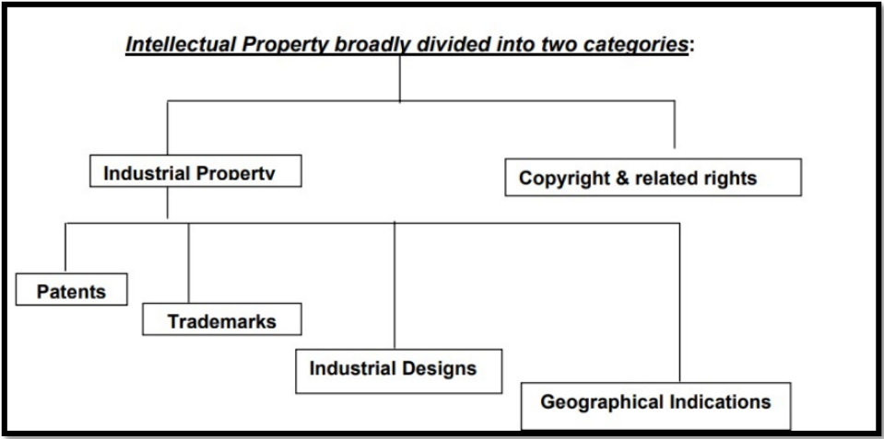

**Fig.1** Different Types of Intellectual Property Rights

# Different Types of Intellectual Property Rights (IPR):

## Patents:

Patents are a form of intellectual property that protect inventions. A patent gives the inventor the exclusive right to make, use, and sell the invention for a certain period, usually 20 years from the date of filing. In exchange for this exclusive right, the inventor must disclose the details of the invention to the public. This disclosure is intended to promote further innovation and to help others build upon the invention.

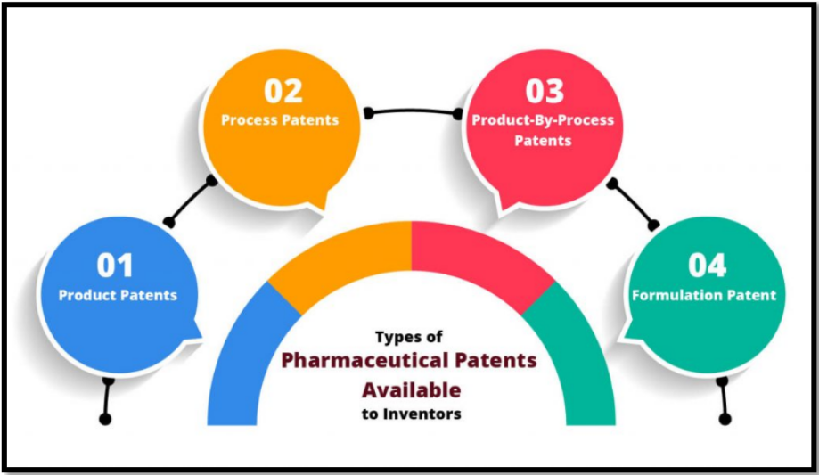

**Fig 2**. Types of Pharmaceutical Patents

## Trademarks:

Trademarks are a form of intellectual property that protect names, logos, and other symbols used to identify products and services in commerce. A trademark gives the owner the exclusive right to use the mark in connection with the goods or services for which it is registered. The purpose of a trademark is to prevent confusion among consumers and to protect the reputation of the brand.

To be eligible for trademark protection, a mark must be distinctive and not confusingly similar to existing marks. Marks that are generic or descriptive are generally not eligible for trademark protection, as they do not serve the purpose of identifying a particular brand.

## Copyrights:

Copyrights are a type of IPR that protect creative works, such as books, music, and artwork. A copyright gives the owner the exclusive right to reproduce, distribute, and display the work, and to create derivative works based on the original. Copyright protection lasts for the life of the creator plus a certain number of years after their death. [5]

## Trade Secrets:

Trade secrets are a type of IPR that protect confidential business information, such as formulas, processes, and customer lists. Trade secret protection gives the owner the right to

prevent others from using or disclosing the information without their permission. Unlike patents, trademarks, and copyrights, trade secrets do not require registration with any government agency.

## Industrial Designs:

Industrial designs are a type of IPR that protect the visual appearance of a product, such as its shape, pattern, or color. Industrial design protection gives the owner the right to prevent others from using or copying the design without their permission. [5]

**Table No.1** The table explores which types of IPR need registration.

|  |  |
| --- | --- |
| **Types of IPR** | **Registration** |
| Copyright | No |
| Patent | Yes |
| Trademark | Yes |
| Trade Secret | No |
| Industrial Design | Generally recommended, although unregistered designs are also protected. |

# Intellectual property rights (IPR) importance in the pharmaceutical industry: -

As they play a crucial role in incentivizing innovation and promoting the development of new drugs and treatments. In this section, we will discuss the various aspects of IPR that are relevant to the pharmaceutical industry and explain why they are so important.

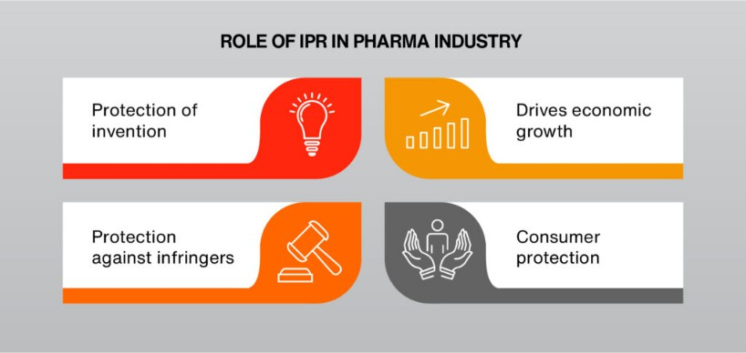

**Fig.3** Roles of IPR in the Pharma Industry

## Patents and Drug Development

One of the key forms of IPR in the pharmaceutical industry is patents. Patents provide exclusive rights to the inventor of a new drug or treatment, preventing others from manufacturing, selling, or using the invention without permission for some time. This exclusivity period is usually 20 years from the date of filing of the patent application.

Patents incentivize drug development by providing a mechanism for recovering the costs of research and development and the time spent in bringing the drug to market, and by allowing drug companies to earn profits from the sale of their products. [7]

## Data Exclusivity

Data exclusivity is another form of IPR that is important in the pharmaceutical industry. Data exclusivity protects the data generated during the clinical trials of a new drug, preventing competitors from using the data to gain regulatory approval for a generic version of the drug. Data exclusivity periods are usually shorter than patent terms and can range from five to ten years. [8] Data exclusivity is important because it allows drug companies to recover the costs of clinical trials, which can be extremely expensive. Without data exclusivity, generic drug manufacturers could simply use the data generated by the innovator company to obtain regulatory approval for their products, without incurring the high costs of clinical trials.

## Trademarks

Trademarks are another form of IPR that is important in the pharmaceutical industry. Trademarks are used to protect the brand names of drugs, as well as their packaging and other identifying features. Trademarks help to prevent confusion among consumers and ensure that the quality of the product is maintained. Trademarks are particularly important in the pharmaceutical industry because they help to build brand

loyalty and trust among patients. Patients are often more likely to choose a drug that they are familiar with and trust, and trademarks help to build that familiarity and trust.

## Trade Secrets

Trade secrets are another form of IPR that is important in the pharmaceutical industry. Trade secrets are confidential information that is used by a company to gain a competitive advantage over its competitors. In the pharmaceutical industry, trade secrets may include information about the manufacturing process for a drug, or the formulation of a drug. [9]

Trade secrets are important because they allow drug companies to maintain a competitive advantage over their competitors, without having to disclose their confidential information to the public. However, trade secrets can also be subject to abuse, and may be used to prevent the development of competing products.

## Regulatory Exclusivity

Regulatory exclusivity is another form of IPR that is important in the pharmaceutical industry. Regulatory exclusivity protects drugs that have been granted regulatory approval, preventing competitors from gaining approval for generic versions of the drug for some time. Regulatory exclusivity periods are usually shorter than patent terms and can range from six months to three years.

# Enforcement of Intellectual Property Rights: -

The enforcement of intellectual property rights is the responsibility of the owner of the intellectual property. [11] This can be done through civil litigation, such as a lawsuit for patent infringement, trademark infringement, or copyright infringement. To enforce their intellectual property rights, owners can take a variety of measures, including:

1. Registering their patents, trademarks, and copyrights with the appropriate government agencies
2. Monitoring the market for potential infringement
3. Sending cease and desist letters to potential infringers
4. Filing lawsuits against infringers
5. Seeking remedies such as damages, injunctions, or seizure of infringing products. [12]

# The Role of Intellectual Property in Innovation and Economic Growth: -

Intellectual property plays an important role in promoting innovation and economic growth. By providing legal protection for the creations of the mind, intellectual property rights encourage individuals and businesses to invest in research and development and to

bring new products and services to market. This, in turn, can lead to job creation, increased competition, and economic growth.[12]

Intellectual property rights (IPRs) are legal protections granted to individuals or companies for their original creations, such as inventions, literary or artistic works, and trademarks. These rights enable creators to have control over their work, receive compensation for its use, and prevent others from using it without permission. The protection of IPRs is critical for fostering innovation and promoting economic growth in several ways:

## Encouraging innovation:

IPRs provide an incentive for creators to invest in the development of new and useful products, technologies, and services. By granting exclusive rights to the creator for a certain period, IPRs allow them to recoup their investment and earn a return on their innovation. This incentivizes them to continue creating and investing in new ideas.

## Protecting investments:

IPRs help protect the investments made by creators in research and development, marketing, and distribution of their products or services. Without IPRs, these investments could be easily copied by competitors, who could then profit from the creator's efforts without having to incur any costs themselves.

## Promoting competition:

While IPRs grant exclusivity to the creator, they also encourage competition by preventing others from using the same ideas without permission. This creates a level playing field for competitors and ensures that the best ideas and products can succeed in the market.

## Fostering economic growth:

IPRs contribute to economic growth by promoting the creation of new goods and services, and by facilitating the transfer of technology and knowledge across different sectors and regions. They also create jobs in fields such as research and development, legal services, and manufacturing.

## Encouraging international trade:

IPRs are an important component of international trade, as they protect the interests of creators and investors in different countries. The protection of IPRs promotes trade by reducing the risks associated with cross-border transactions, and by ensuring that creators and investors can earn a fair return on their investment. [14]

However, it's important to note that the role of IPRs in innovation and economic growth is not without controversy. Some argue that IPRs can stifle innovation by creating barriers to entry for new competitors or by allowing established companies to maintain monopolies in certain industries. Others contend that IPRs may lead to the

over-pricing of products and services, particularly in areas such as healthcare, where patented drugs can be prohibitively expensive.

# Challenges and Controversies: -

The system of intellectual property rights (IPR) has been subject to several challenges and controversies since its inception. Some of the main challenges and controversies related to IPR include:

Balancing the interests of creators and users: One of the key challenges of IPR is to strike a balance between protecting the interests of creators and incentivizing innovation and creativity, while also ensuring that users have access to essential goods and services. This is particularly challenging in areas such as healthcare and education, where access to patented products or copyrighted materials can have a significant impact on people's lives.

## Enforcement and piracy:

Despite the existence of legal frameworks for protecting intellectual property, piracy and counterfeiting remain major challenges. The internet and digital technologies have made it easier than ever to copy and distribute copyrighted materials, while the high cost of patented drugs and other products has led to the growth of black markets and illegal trade. [15]

Patent trolls and frivolous litigation: In recent years, there has been growing concern about the rise of so-called "patent trolls" -

companies that acquire patents solely to sue other companies for infringement. This has led to a proliferation of frivolous lawsuits and a perception that the patent system is being abused for financial gain.

## Access to medicines:

One of the most controversial aspects of IPR is the impact on access to medicines, particularly in developing countries. Critics argue that the high cost of patented drugs and the restrictions on generic competition prevent people in low-income countries from accessing life-saving treatments, leading to unnecessary suffering and death. [16]

## Copyright and freedom of expression:

The growth of digital technologies and social media has brought new challenges to the balance between copyright protection and freedom of expression. [25] These challenges and controversies highlight the need for ongoing debate and reform of the intellectual property system, to ensure that it continues to promote innovation and creativity while also protecting the rights and interests of users and society as a whole. [17]

# The Future of Intellectual Property Rights in Pharmacy: -

As technology continues to advance, the field of intellectual property is likely to face new challenges and opportunities. For example, the rise of artificial intelligence and machine learning may raise

questions about who owns the creation of these technologies. Additionally, the increasing availability of 3D printing and other forms of digital manufacturing may make it easier for individuals to reproduce patented or copyrighted products. [19]

As a result, the laws governing intellectual property will likely continue to evolve in the coming years. This may include changes to the scope and duration of intellectual property rights, as well as new measures to address emerging technologies and forms of infringement.

The future of intellectual property rights (IPR) in pharmacy is likely to be shaped by several trends and developments, including advances in technology, changes in the regulatory environment, and the evolving nature of the pharmaceutical industry itself. In this section, we will explore some of the key trends and developments that are likely to shape the future of IPR in pharmacy. [18]

## The Rise of Personalized Medicine

One of the key trends that are likely to shape the future of IPR in pharmacy is the rise of personalized medicine. Personalized medicine involves tailoring medical treatments to the specific needs of individual patients, based on their unique genetic makeup, lifestyle, and other factors. Personalized medicine has the

potential to revolutionize the way that drugs are developed and marketed, by creating more targeted and effective treatments.

However, personalized medicine also raises several IPR issues. For example, the development of personalized treatments may require access to large amounts of patient data, which may be subject to privacy concerns. In addition, personalized medicine may require the development of new IPR frameworks, to ensure that patients receive the benefits of personalized treatments without infringing on the rights of others. [22]

## The Growing Importance of Digital Health

Another trend that is likely to shape the future of IPR in pharmacy is the growing importance of digital health. Digital health involves the use of digital technologies to improve health outcomes and provide more personalized and efficient care. Digital health technologies include everything from wearable devices that monitor health indicators to virtual reality tools that help patients manage chronic conditions. [21]

Digital health raises several IPR issues, particularly around the ownership of patient data and the development of new technologies. For example, the use of patient data to develop new treatments or technologies may require the development of new IPR frameworks, to ensure that patients are adequately compensated for their contributions.

## The Importance of Regulatory Frameworks

As the pharmaceutical industry continues to evolve, regulatory frameworks will play an increasingly important role in shaping the future of IPR in pharmacy. Regulatory frameworks are designed to ensure that drugs are safe and effective and to provide a level playing field for drug manufacturers. [24]

However, regulatory frameworks also raise several IPR issues, particularly around the balance between incentivizing innovation and promoting access to drugs. As the pharmaceutical industry continues to innovate, it will be important to develop regulatory frameworks that strike an appropriate balance between these two competing priorities.

## The Need for Collaboration

Finally, the future of IPR in pharmacy will be shaped by the need for collaboration among stakeholders in the pharmaceutical industry. The collaboration will be essential to developing new treatments, technologies, and regulatory frameworks that meet the needs of patients, drug manufacturers, and other stakeholders. [26]

However, the collaboration also raises several IPR issues, particularly around the ownership of intellectual property and the allocation of benefits. As the pharmaceutical industry continues to collaborate, it will be important to develop new IPR frameworks that promote innovation while ensuring that all stakeholders receive a fair

share of the benefits. the future of IPR in pharmacy is likely to be shaped by several trends and developments, including the rise of personalized medicine, the growing importance of digital health, the importance of regulatory frameworks, and the need for collaboration among stakeholders. [24]

## Conclusion: -

In conclusion, intellectual property rights are a critical component of modern business and innovation. Patents, trademarks, copyrights, and trade secrets provide legal protection for the creations of the mind and encourage investment in research and development. While the enforcement of intellectual property rights can be complex and expensive, it is essential for protecting the investments of creators and innovators and for promoting continued innovation and economic growth. As technology continues to evolve, the laws governing intellectual property will likely continue to evolve as well, to address new challenges and opportunities.

# References: -

1. Jajpura, L., Singh, B. and Nayak, R., 2017. An introduction to intellectual property rights and their importance in the Indian Context.
2. Dash, D.K., Vaiswade, R. and Gupta, G., 2023. A Review on the Indian Patent System and Its Implication on the Pharmaceutical Industry. Journal of Health Science and Medical Research, 41(3), p.2023926.
3. Maskus, K.E., 2000. Intellectual property rights and economic development. Case W. Res. J. Int'l L., 32, p.471.
4. Scherer, F.M., 2000. The pharmaceutical industry and world intellectual property standards. Vand. L. Rev., 53, p.2245.
5. Vankayala Phanindra. et al. / International Journal of Research in Pharmaceutical and Nano Sciences.2(4), 2013, 466 - 470. July - August

466 Review Article CODEX: IJRPJK ISSN: 2319 – 9563 A REVIEW ARTICLE ON INTELLECTUAL PROPERTY RIGHTS (IPR)

1. Rout, S.K., 2018. A Brief Review on Intellectual Property Rights with Special Attention on Patent. Journal of Applied and Advanced Research. Journal Applied and Advanced Research, 3, pp.73-77.
2. rights are reserved by Mullaicharam, A., Intellectual Property Rights in Indian Pharmaceutical Sectors-A Review.
3. Amado, R. and Gewertz, N.M., 2004. Intellectual property and the pharmaceutical industry: A moral crossroads between health and property. Journal of business ethics, 55, pp.295-308.
4. Ghai, D., 2010. Patent protection and Indian pharmaceutical industry. International Journal of Pharmaceutical Sciences Review and Research, 3(2), pp.43-48.
5. Gangil, J., Thunga, G. and Nagaich, R., 2010. Do intellectual property rights and data exclusivity encourage innovation in the pharmaceutical world? Systematic Reviews in Pharmacy, 1(2).
6. Krishna, P.D., Sujatha, D.K. and Veeranna, B., 2022. Indian Pharmaceutical Product Protection by Utilizing Intellectual Property Rights. INDIAN JOURNAL OF PHARMACEUTICAL EDUCATION AND RESEARCH, 56(4), pp.950-958.
7. Bhat, S.R., 2018. Innovation and intellectual property rights law— an overview of the Indian law. IIMB Management Review, 30(1), pp.51-61.
8. Boscheck, R., 2015. Intellectual Property Rights and the Evergreening of Pharmaceuticals. Intereconomics, 50(4), pp.221-226.
9. Saha, C.N. and Bhattacharya, S., 2011. Intellectual property rights: An overview and implications in the pharmaceutical industry. Journal of advanced pharmaceutical technology & research, 2(2), p.88.
10. Tiwari, R., Tiwari, G., Rai, A. and Srivastawa, B., 2011. Management of intellectual property rights in India: An updated review. Journal of Natural Science, Biology and Medicine, 2(1).
11. Ajeet, A., 2012. Role of intellectual property rights in the biotechnology and pharmaceutical industries. Nature Precedings, pp.1-1.
12. Rout, S.K., 2018. A Brief Review on Intellectual Property Rights with Special Attention on Patent. Journal of Applied and Advanced Research. Journal Applied and Advanced Research, 3, pp.73-77.
13. Mullaicharam et al. Ijppr.Human, 2018; Vol. 14 (1): 30-38.
14. Teixeira, A.A. and Ferreira, C., 2019. Intellectual property rights and the competitiveness of academic spin-offs. Journal of Innovation & Knowledge, 4(3), pp.154-161.
15. Chorev, N. and Shadlen, K.C., 2015. Intellectual property, access to medicines, and health: new research horizons. Studies in Comparative International Development, 50, pp.143-156.
16. Kumari, N. and Sharma, R., 2020. Intellectual property rights (IPR). Asian Journal of Pharmacy and Technology, 10(4), pp.250-254.