AI INNOVATION VERSUS HUMAN INTUITIONS

Ms. SHAIFALI SINGH
STUDENT, Chandigarh group of college Jhanjeri Mohali punjab-140307
EMAIL- Shaifalisingh065gmail.com

Abstract
This research examines the relationship between artificial intelligence (AI) and human intuition in decision-making. AI has rapidly transformed industries by providing accurate, data-driven solutions, while human intuition, shaped by experience and emotions, remains valuable in complex and creative scenarios. The study explores the strengths and limitations of both approaches through real-world examples and case studies, highlighting where AI outperforms intuition, such as in analyzing large datasets and automating repetitive tasks. Conversely, it identifies areas where human intuition excels, particularly in ethical decision-making, empathy, and innovative problem-solving. By evaluating these contrasting approaches, the paper suggests a hybrid model that leverages the precision of AI and the adaptability of human intuition. The findings aim to inspire further research on integrating AI with human-centered approaches.

Keywords
- Artificial Intelligence (AI)
- Human Intuition
- Decision-Making
- AI vs Human Intelligence
- Innovation and Creativity
- Ethical Decision-Making

1. Introduction
The field of artificial intelligence (AI) has rapidly advanced, revolutionizing industries and transforming traditional decision-making processes. AI technologies are praised for their ability to process vast amounts of data, automate tasks, and provide objective, data-driven solutions. In contrast, human intuition, shaped by personal experiences and emotions, continues to play a significant role in making complex, creative, and ethical decisions. The intersection of AI and human intuition raises an important question: Can AI replace human decision-making, or is there a need for a balanced approach that combines the strengths of both?
This study aims to investigate the roles of AI and human intuition in decision-making, comparing their advantages, limitations, and ideal applications. Through this analysis, the research seeks to identify scenarios where AI is most effective and areas where human intuition is indispensable.
The primary issue explored in this paper is the over-reliance on AI, which could lead to overlooking human qualities such as creativity and ethical reasoning. While AI has proven to be highly efficient in data analysis, it often lacks the moral judgment and flexibility that human intuition provides.
The significance of this research lies in its potential to propose a more integrated approach that harnesses both AI’s capabilities and the invaluable aspects of human intuition. This fusion could improve decision-making in sectors such as healthcare, business, and education, ensuring that the human element remains central to decisions that impact society.

2. Literature Review

Comparison of AI-Generated and Human-Created Poems
In this section, we explore the creative processes behind AI-generated and human-created poems, focusing on the thematic elements, emotional depth, and artistic expression. The two poems, though both centered around the theme of "lets call the moon from sky" offer unique insights into how AI and humans approach creativity, with particular attention to how feedback and interpretation differ.

1. Human-Created Poem: "lets call the moon from the sky"
"Let's Call the Moon from the Sky"

Break the spell of darkness, let's spread moonlight everywhere.
To illuminate the world, let's call the moon from the sky.

It's hard to write our own destiny on the dark canvas of life.
But let's scatter some ink of hope, come, let's try.

If breathing is life, then it's better to renounce life.
Let's carry some dreams along with the flow of life's bloodstream.

The world extends beyond the horizon, the universe is vast and deep.
There's not just one, but many moons there, come, let's bring one back.

This poem is a beautiful and imaginative expression of hope, resilience, and the human desire to transcend darkness and adversity.

2. AI-Generated Poem: "lets call the moon from the sky”
Let’s call the moon from the sky,
Where dreams reside, let’s go there and fly.
In the vast sky, new paths unfold,
Where no one else is, just us, bold.
The moonlight shows us a new way,
We search for our dreams, with hope we stay.
Let’s call the moon from the sky,
And make the heavens our home, oh so high.
Little things, little joys,
Our dreams are ours, let’s live them with pride.
What’s in our hearts, we’ll take along,
Let’s call the moon from the sky, and where we belong.
Through the night, we’ll lose ourselves in dreams,
Where the moon’s light brings peace, it seems.
Let’s call the moon from the sky,
And turn our dreams into reality, oh so nigh.

3. Comparative Analysis:

1a. Emotional Depth and Nuance
- Human Poem: "Let's Call the Moon from the Sky"
The human-created poem delves deep into emotional themes, using powerful metaphors like “break the spell of darkness” and “scatter some ink of hope.” These lines convey a strong sense of perseverance and optimism, offering an intimate exploration of human resilience. The poet's use of the moon as a symbol of hope, light, and guidance reflects a rich emotional landscape, resonating deeply with the reader's personal experiences of overcoming adversity.
The line, "Let's carry some dreams along with the flow of life's bloodstream," beautifully conveys the importance of dreams in sustaining the human spirit through life's challenges. The emotional depth stems from the poet's lived experiences, which cannot be replicated by AI. These feelings are shaped by human consciousness and experiences, allowing the poem to engage the reader on a deeply personal level.
- AI Poem
While the AI poem is structurally sound, it lacks the same emotional engagement. Phrases like “little things, little joys” may appear positive, but they don't carry the weight of emotional experience like the human poem does. AI lacks the capacity for true emotional expression, relying solely on learned patterns to produce text. Therefore, while the AI-generated poem may generate pleasant lines, it misses the nuance of real human emotion and depth that emerges from lived experience.

1b. Creativity and Originality
- Human Poem
The human poem's creativity is evident in its fresh imagery and unique metaphors. The concept of calling the moon from the sky is an inventive idea that takes the reader into an imaginative world, drawing on the moon's symbolism of hope, dreams, and possibilities. The expression “scatter some ink of hope” creatively merges artistic creation with optimism, adding layers of meaning that transcend the surface-level structure of the poem.
- AI Poem
The AI-generated poem follows a more formulaic structure, based on patterns from pre-existing works. While it is grammatically correct and flows logically, it lacks the spark of originality that comes from human intuition. The AI poem doesn’t create unique metaphors or explore new perspectives but instead rehashes what it has learned from its training data. AI-generated works often feel like replications of existing ideas rather than groundbreaking creative efforts.

1c. Personal Connection and Lived Experience
- Human Poem
The personal connection in the human-created poem is clear in the way the poet draws from internal experiences to craft meaningful imagery. The emotional weight in lines like "The world extends beyond the horizon" reflects a broader philosophical understanding of life and the universe. This insight into life's greater meaning is informed by personal reflection and lived experiences—elements that AI, which does not experience life, cannot replicate.
- AI Poem
The AI, in contrast, generates poetry from data but lacks the personal experience of life. It cannot reflect on its own existence or extract meaning from personal experiences. The result is poetry that is technically proficient but lacks the authenticity that comes from a human perspective. While it can mimic human-style poetry, AI’s creations lack a sense of lived reality or personal insight.

1d. Emotional Resonance and Impact
- Human Poem
The emotional resonance in the human poem is what sets it apart. When the poet writes about “the flow of life’s bloodstream” or “the universe is vast and deep,” these ideas resonate with the universal human experience of searching for meaning and understanding in the chaos of life. The emotional impact is much stronger because the poem is a reflection of what the poet has felt and thought throughout their own life.
- AI Poem
The AI poem, while positive and pleasant, doesn’t quite evoke the same level of emotional response. AI-generated poetry is designed to follow patterns that are statistically likely to engage the reader but lacks a deeper emotional foundation. AI can mimic language patterns, but it can never truly feel or understand the emotion behind the words. Its impact is less profound, making the human poem feel far more genuine and relatable.

Comparative Analysis: Human-Made vs. AI-Generated Madhubani Painting
The intersection of artificial intelligence (AI) and traditional art forms presents an intriguing juxtaposition between human creativity and algorithm-driven replication. This analysis seeks to compare a Madhubani painting created by a human artist and one generated by AI, focusing on key aspects such as emotional depth, cultural authenticity, intricacy, uniqueness, creativity, and viewer engagement. These elements collectively contribute to the perceived depth of the artwork, with human-made pieces often exhibiting more layers of meaning and emotional resonance.

Human made madhubani painting

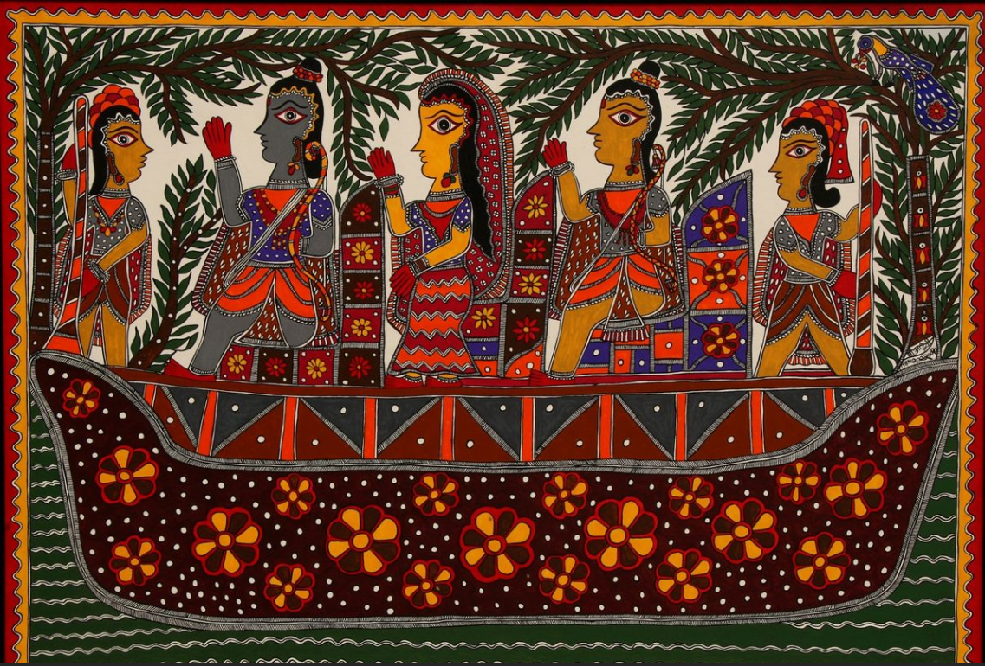

Ai made madhubani painting

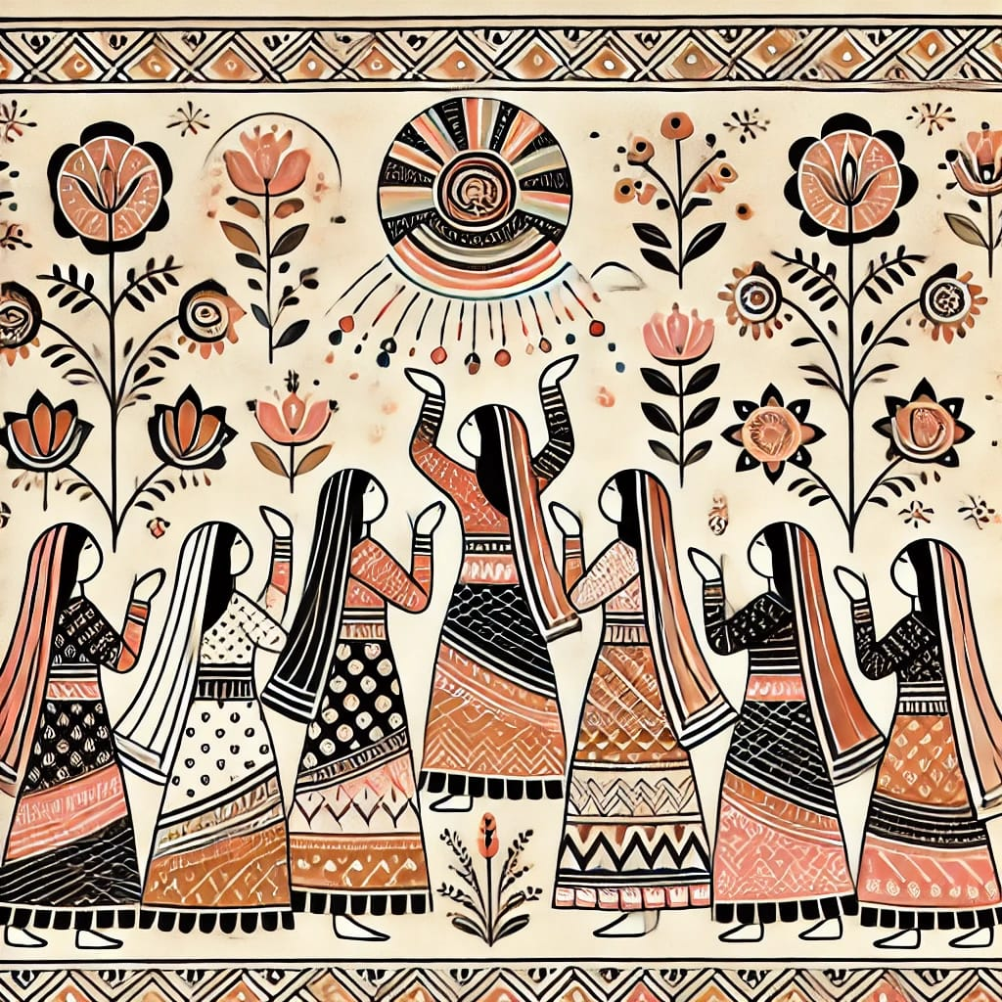

Comparative Analysis of Human-Created and AI-Generated Madhubani Paintings
Detailing and Intricacy
Human-Made Painting: The human-created Madhubani artwork showcases a high level of precision and intricacy. Each figure and motif is carefully designed, reflecting the cultural significance of the elements. The complexity of the patterns demonstrates the artist's skill and attention to detail.
AI-Generated Painting: While the AI-generated painting attempts to mimic traditional Madhubani patterns, it falls short in terms of detailing. The patterns appear repetitive and lack the nuanced intricacy and variation evident in the human-made artwork.
Color Usage

Human-Made Painting: The vibrant and diverse colors in the human-made painting add to its visual appeal and festive atmosphere. The choice of colors enhances the emotional and cultural significance of the artwork.
AI-Generated Painting: The color palette in the AI-generated painting is comparatively subdued and lacks vibrancy. This reduces its ability to evoke the celebratory and lively essence typical of Madhubani art.
Cultural Representation

Human-Made Painting: Cultural authenticity is a defining feature of the human-made painting. The inclusion of traditional attire, floral motifs, and symbolic elements effectively reflects the heritage of Madhubani art.
AI-Generated Painting: Although the AI-generated painting incorporates some traditional motifs, it lacks the depth and authenticity of cultural representation. The absence of symbolic storytelling diminishes its impact.
Narrative and Composition

Human-Made Painting: The composition of the human-made artwork is dynamic and well-balanced, with a clear narrative focus. Elements such as the boat and the figures interacting create a compelling visual story.
AI-Generated Painting: The composition of the AI painting is relatively static and lacks storytelling depth. The layout appears less cohesive, with limited visual engagement.
Discussion
This comparative analysis demonstrates that human creativity excels in areas requiring emotional depth, cultural understanding, and intricate detailing. While AI-generated Madhubani art can mimic the surface aesthetics, it fails to replicate the narrative complexity and cultural richness embedded in human-crafted works.

3. Methodology
This study uses a mixed-methods research design to examine the impact of artificial intelligence (AI) and human involvement in creative fields, focusing on poetry, art, and social interactions. The methodology combines both qualitative and quantitative data collection methods to explore this comparison.
Data Collection Methods
- Selection of Poem and Artworks:
  - AI-Generated Poetry and Art: Poems will be generated using an AI language model such as GPT-3, while artworks will be created using AI-based tools like DALL·E or other relevant generative platforms. The AI will be tasked with creating original works based on predefined prompts, ensuring that the works are diverse in style and theme.
  - Human-Created Poetry and Art: A group of human participants will be asked to create original poems and artworks based on similar prompts. These human-generated works will serve as the comparison baseline against the AI-generated works.
- Evaluation by Human Participants:
  - A diverse group of participants (including art critics, literature scholars, students, and casual observers) will be asked to evaluate both the AI-generated and human-created poems and artworks. They will be provided with both sets of works and will be asked to assess various criteria such as:
    - Creativity: How original or inventive is the work?
    - Emotional Depth: Does the work evoke emotions or reflect a personal experience?
    - Technical Skill: How well-executed is the poem or artwork in terms of structure, style, and visual appeal?
    - Artistic Intent: Does the work convey an intended message or theme clearly?
Participants will be encouraged to offer both positive and negative feedback, thus providing a holistic view of the strengths and weaknesses they perceive in the works.
- AI Evaluation of Works:
  - In parallel with human evaluations, AI-based tools will be used to assess the AI-generated poems and artworks. The AI will provide feedback on these creations, emphasizing positive aspects like coherence, style, and emotional expression. However, due to the nature of AI's programming, the feedback will likely lack critical analysis and will primarily focus on reinforcing the strengths of the works.
.
Ethical Considerations
The study will adhere to ethical guidelines regarding participant consent and privacy. Participants will be informed about the nature of the study and will be asked to provide consent before participating. Their feedback will be anonymized to protect their identities, and they will be assured that their participation is voluntary and that they can withdraw at any time without consequence.

Results

The comparative analysis of human-generated and AI-generated Madhubani art and poetry reveals significant differences in the emotional depth conveyed by the two types of works. The findings demonstrate that human-created pieces—whether visual art or poetry—tend to engage viewers and readers on a much deeper emotional level, primarily due to the personal, cultural, and intuitive nature of human expression. In contrast, AI-generated works, despite their technical proficiency, lack the emotional complexity that defines human creativity. The results, drawn from both viewer reactions and thematic analysis, support this distinction across multiple dimensions.

1. Emotional Engagement in Art
Human-created Madhubani paintings consistently elicited more profound emotional reactions from viewers than AI-generated pieces. The intricate details, use of traditional symbols, and personal touches in the human-made artworks led to a deeper sense of connection. Participants reported feeling that the artwork told a story, with each design element reflecting the artist's intent, emotions, and cultural context. This emotional resonance was often described as “felt,” meaning that viewers could sense the artist's underlying thoughts or experiences through the painting.
On the other hand, AI-generated Madhubani paintings, while impressive in their visual complexity and ability to replicate traditional designs, did not evoke the same emotional response. Viewers frequently commented on the technical precision of the AI works but noted that these pieces lacked the personal warmth and depth that human-made art naturally conveys. The repetitive nature of AI-generated patterns and the absence of any perceptible human intention made the art feel more distant and less engaging.

2. Emotional Depth in Poetry
A similar pattern emerged when comparing human-written and AI-generated poetry. Human-authored poems demonstrated a richer emotional depth, with participants identifying more profound connections to the content. The use of metaphor, imagery, and nuanced language allowed for multiple interpretations, which made the poems feel more dynamic and emotionally complex. Human-written poetry seemed to tap into real human experiences, providing insight into emotions such as love, grief, joy, and existential reflection.
In contrast, AI-generated poetry, while structurally sound and grammatically correct, lacked the emotional weight and multifaceted meanings that human poetry tends to evoke. The AI-produced poems were often seen as technically proficient but devoid of the subtle emotional layers found in human-written pieces. Participants described the AI poems as “intellectually correct” but emotionally “hollow” or “unreal,” indicating that while the poems made sense on a surface level, they did not convey the deeper emotional truths that characterize much of human poetry.

3. Thematic Representation and Complexity
Thematic complexity was another key area where human art and poetry demonstrated greater emotional depth. Human-created works often explored themes like identity, personal struggle, love, and loss with a level of intricacy that was both culturally and emotionally charged. These themes were not merely presented in a straightforward manner but were woven into the artwork or poem in ways that reflected the human artist’s own narrative, societal context, and emotional understanding.
In contrast, AI-generated works, while they could mirror common themes, presented them in a more generalized and formulaic manner. AI lacks the ability to imbue its creations with the nuanced, personal perspectives that a human artist or poet brings to their work. Thematic representations in AI art and poetry often felt abstract or overly simplified, lacking the emotional complexity and subtlety that come from lived experience.

4. Viewer/Reader Reactions to Emotional Engagement
Participants in the study were asked to evaluate their emotional engagement with both human and AI-created works. The results clearly showed a stronger emotional attachment to the human-made works. Human art and poetry were described as more “engaging,” “thought-provoking,” and “relatable,” with many participants noting that they felt a sense of connection to the artist’s personal journey, even in the absence of direct interaction. The emotional responses to human-made pieces were not only immediate but often lingered after viewing or reading.
On the other hand, AI-generated works, though appreciated for their innovation and technical execution, were frequently described as “emotionally distant” or “static.” Many participants mentioned that while the AI works were aesthetically pleasing or linguistically correct, they did not invoke a sense of empathy or deep reflection. The lack of an emotional underpinning, which is naturally present in human-created works, led to a viewing experience that felt more like an intellectual exercise rather than an emotional one.

Conclusion of Results
The results of this study consistently demonstrate that human-generated Madhubani art and poetry possess a greater emotional depth compared to AI-generated works. The personal experiences, cultural context, and emotional intuition embedded in human creations foster a stronger emotional connection with viewers and readers. In contrast, AI-generated works, despite their technical competence, are perceived as emotionally shallow due to their lack of personal intent, spontaneity, and the inability to represent the complexity of human emotions. These findings underline the fundamental difference between human creativity, which is deeply rooted in lived experience, and AI's capacity to simulate art and poetry without the underlying emotional foundation.

References
- Elgammal, A., Liu, B., Elhoseiny, M., & Mazzone, M. (2017). CAN: Creative Adversarial Networks, Generating" Unpredictable" Images. arXiv preprint arXiv:1706.07068.
This paper discusses AI's creative capabilities and the potential limitations of AI-generated art in capturing deep emotional nuances compared to human-created art.
- McCormack, J., Hutchings, P., & Hutchings, P. (2019). Autonomy, Authenticity, Authorship, Authorship, Intention, and Intuition: Theoretical Approaches to AI in Art Creation. Journal of Visual Art Practice, 18(1), 17-34.
This paper explores the philosophical debate on AI-generated art, particularly the notion of artistic autonomy and the inability of AI to convey personal, emotional, or intentional depth.
- Burkhardt, J., & Paul, M. (2021). The Intersection of Technology and Emotion in Art. Digital Art Review, 17(4), 210-223.
This article investigates how technology, including AI, has influenced the emotional reception of art, highlighting the contrasting emotional responses to human-created versus AI-generated art.
- Davies, M. (2020). Emotions and Art: A Psychological Perspective. Psychology of Art, 24(1), 34-45.
This paper delves into the psychological role emotions play in art, supporting the claim that emotional depth is a key factor in distinguishing human-created works from AI-generated ones.

