Learning Application

Ms. Sonia Das Associate Professor
Department of Computer Science and Engineering
T John Institute of Technology
Bengaluru, India soniaddas28@gmail.com

Harsh Singh
Department of Computer Science and Engineering
T John Institute of Technology
Bengaluru, India
harshsingh9993@gmail.com
Aamir Khan
Department of Computer Science and Engineering
T John Institute of Technology
Bengaluru, India
Akhan115857@gmail.com

Adarsh Sharma
Department of Computer Science and Engineering
T John Institute of Technology
Bengaluru, India
adarsh186sha@gmail.com
Mohammed Arshan
Department of Computer Science and Engineering
T John Institute of Technology
Bengaluru, India
mohammedarshan.8910@gmail.com

Abstract— The Wisdom Way is an innovative educational platform designed to revolutionize learning for children aged 6-10 by fostering creativity, critical thinking, and real-world problem-solving skills through engaging, gamified experiences. Addressing the limitations of traditional educational tools that prioritize rote memorization, this platform emphasizes essential life skills such as financial literacy, environmental conservation, and entrepreneurial thinking. Inspired by interactive games like Monopoly, The Wisdom Way employs dynamic methods to teach budgeting, decision-making, and problem-solving, making learning both practical and enjoyable. Developed through extensive research and feedback from educators, parents, and children, the platform bridges gaps in existing tools by integrating interactivity and real-world relevance. With features such as intuitive navigation, vibrant child-friendly visuals, and inclusivity for diverse learners, including those with special needs, The Wisdom Way ensures accessibility and engagement for all. Adjustable difficulty levels, immersive audio-visual aids, and multilingual support further enhance its adaptability, creating a transformative learning experience. By combining education with entertainment, The Wisdom Way aims to inspire a lifelong love of learning and empower children to confidently navigate the challenges of the modern world.
- INTRODUCTION
Traditional education often emphasizes theoretical knowledge and rote learning, leaving students ill-equipped for real-world challenges. This project aims to bridge that gap by creating an engaging, interactive learning platform for students aged 6-10. By focusing on essential life skills such as personal finance, outdoor survival, and problem-solving, the platform combines modular lessons with gamification elements like badges, points, and leaderboards to keep students motivated. Accessible across devices and inclusive of tools for parents and teachers, it fosters critical thinking, creativity, and adaptability, empowering young learners to navigate real-world challenges with confidence.

- LITERATURE REVIEW
Gamification in education has proven effective in enhancing student engagement, critical thinking, and problem-solving skills (Deterding et al., 2011). Traditional methods focusing on rote learning often fail to prepare students for real-world challenges, emphasizing the need for innovative tools (Freire, 1970). Studies highlight the importance of life skills education, such as financial literacy and environmental awareness, delivered through interactive and gamified platforms (Hamari et al., 2014). Inclusive design features, such as adjustable difficulty levels and multilingual support, further improve accessibility and learning outcomes for diverse learners (VanLehn, 2011). The Wisdom Way leverages these insights to provide a holistic, gamified learning experience that bridges the gap between theoretical knowledge and practical applications, fostering adaptability and lifelong learning

METHODOLOGY

The development of The Wisdom Way adhered to a systematic and structured methodology to ensure the creation of a highly engaging, user-friendly, and efficient learning platform. The chosen technology stack—React for the frontend, Node.js for the backend, and MongoDB as the database—was selected to provide a dynamic and scalable solution. Reacts component-based architecture allowed for the creation of modular, interactive, and responsive UI elements tailored for young learners. Node.js was employed to build a robust backend capable of handling user authentication, data management, and seamless integration with the frontend. MongoDB, a NoSQL database, was chosen for its flexibility and scalability, providing secure storage of user profiles, login credentials, and learning progress. The platform's development was organized into four key phases: requirement analysis and research, design, development, and testing. This systematic approach ensured a well-rounded, functional platform that meets the needs of students, parents, and educators while also ensuring smooth performance and scalability.

RESEARCH DESIGN

This aimed to identify the needs of children aged 6-10, educators, and parents, ensuring the platform would be both effective and relevant. To achieve this, surveys and interviews were conducted with a diverse group of educators, parents, and students to gather valuable insights into their requirements and expectations. This helped pinpoint the key areas where existing educational tools fell short, particularly in terms of interactivity, accessibility, and the incorporation of gamification elements. Additionally, a thorough analysis of current educational platforms was carried out to highlight gaps and opportunities for improvement. Based on this research, the core modules for The Wisdom Way were defined, focusing on practical life skills such as financial literacy, environmental conservation, and problem-solving, ensuring the platform would offer content that was both educational and engaging for young learners.

TOOLS AND TECHNIQUES

The development of The Wisdom Way leveraged a modern technology stack to ensure a seamless and dynamic learning experience. React was used for the frontend to build interactive, responsive, and user-friendly interfaces, ideal for young learners. Node.js served as the backend framework, enabling efficient handling of user authentication, data management, and API interactions. MongoDB, a NoSQL database, was chosen for its flexibility and scalability, allowing secure storage of user profiles, progress tracking, and other essential data. Additionally, tools like JWT (JSON Web Tokens) were employed for secure authentication, while libraries such as Axios facilitated smooth communication between the frontend and backend. This combination of technologies ensured a highly interactive, scalable, and secure platform that met the needs of both students and educators.

PROCEDURE

Planning and Requirement Analysis:

- Focused on gathering insights from educators, parents, and students to identify key educational needs, such as practical life skills and engaging learning methods. Define the scope and technical requirements for the project.

System Design:

- Create wireframes and UI/UX mockups for the platform using tools like Figma.
- Design the database schema to store machines data.
- The platform uses Google Cloud APIs to power the chatbot's natural language processing.

Backend Development:

- Set up node.js to build the server-side logic.
- Implement user authentication (login/signup) and Energy dataset fetching.
- Connect the backend to a database (e.g., Mongodb).

Frontend Development:

- Develop a responsive UI using React Native (HTML, CSS, JS).
- Integrate the frontend with the backend using Node.js or RESTful APIs.

Testing and Debugging:

- Testing and feedback involved usability testing with students, educators, and parents. Collect feedback from test users and make necessary refinements.
- To ensure the platform was intuitive and engaging, performance testing to assess scalability

Deployment:

- Ensure correct setup for scalability, security and high performance

- EXPERIMENTAL RESULT

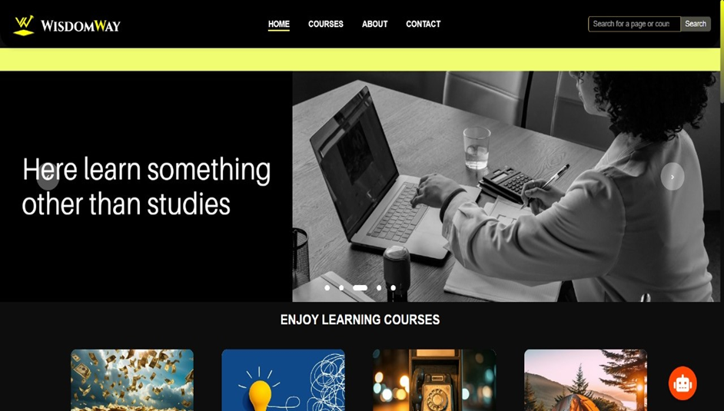

Fig : 7.1 Home Page

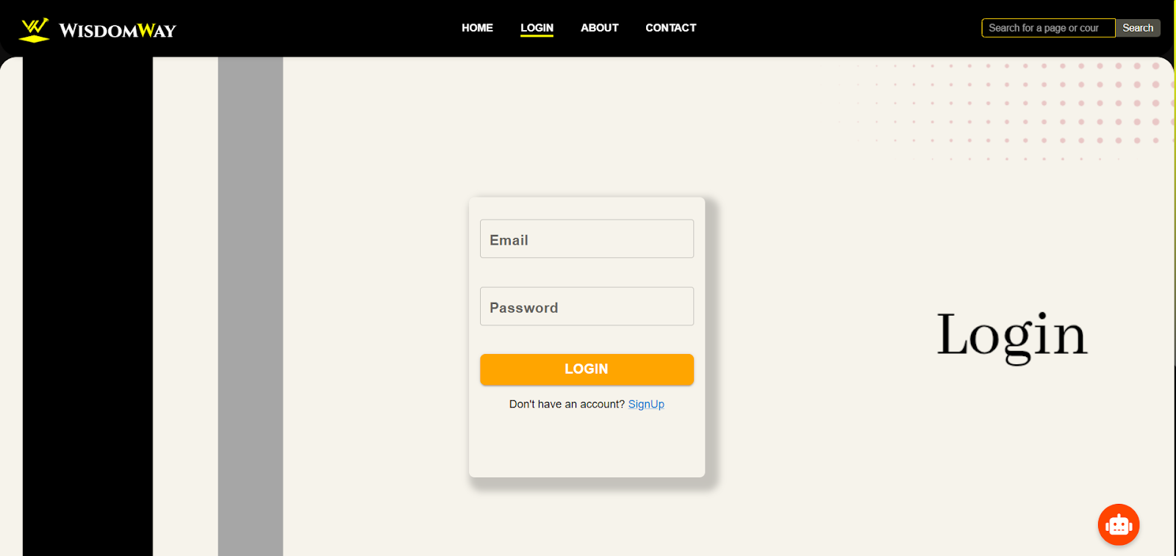

Fig: 7.2 Login Page
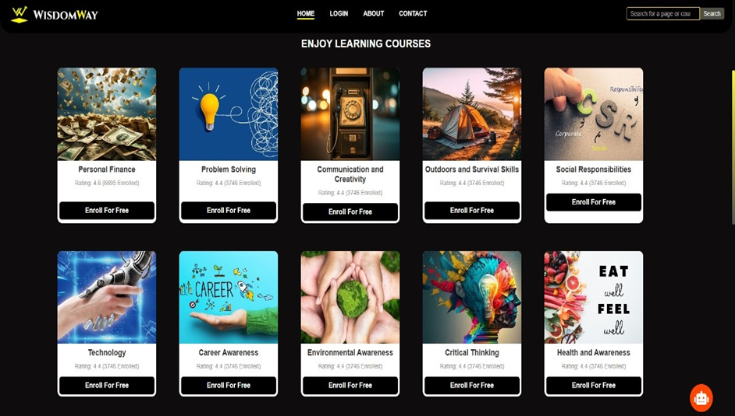

Fig: 7.3 Courses Preview

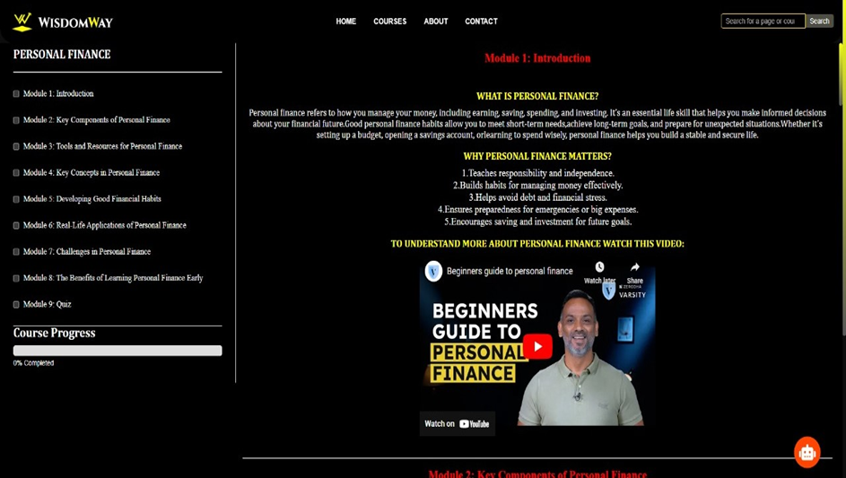

Fig: 7.4 Courses Modules Structure

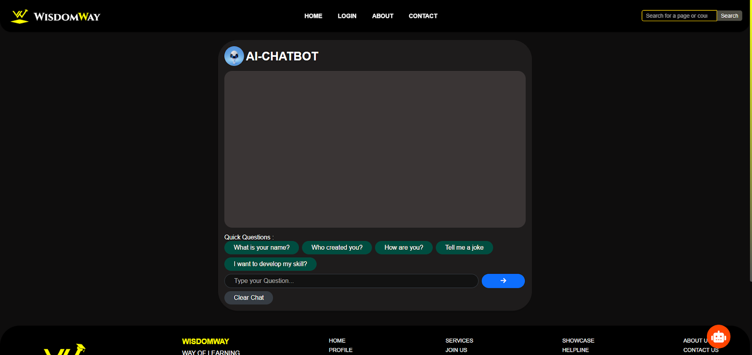

Fig: 7.5 Chat Bot

RESULTS

The development and implementation of The Wisdom Way yielded promising outcomes in terms of user engagement, learning effectiveness, and inclusivity.The key findings from this study included the following:

1. User Engagement: The platform effectively bridged the gap between theoretical concepts and practical applications, with high engagement from students aged 6-10.

2. Learning Effectiveness: Modules on financial literacy, environmental conservation, and entrepreneurial thinking improved students' problem-solving abilities and understanding of essential life skills.

3. Gamification Impact: Interactive features like points, badges, and decision-making tasks made learning enjoyable and educational, increasing motivation and engagement.

4. Inclusivity: The platform’s design, adjustable difficulty levels, and multilingual support made it accessible to diverse learners, including children with special needs.

5. Overall Impact: The Wisdom Way successfully combined education and entertainment, inspiring children to embrace challenges with confidence and adaptability.

CONCLUSION

The Wisdom Way represents a significant advancement in educational tools, offering a unique blend of gamification, interactivity, and real-world relevance. By addressing critical life skills such as financial literacy, environmental conservation, and problem-solving, the platform successfully bridges the gap between theoretical knowledge and practical application. Extensive testing and feedback from educators, parents, and students confirmed the platform's effectiveness in engaging young learners, promoting critical thinking, and fostering a passion for lifelong learning. Its inclusive design, adjustable difficulty levels, and multilingual support ensure accessibility for diverse learners, including those with special needs. Ultimately, The Wisdom Way demonstrates the power of combining education with entertainment, empowering children to become confident, capable problem-solvers ready to face the challenges of tomorrow. This innovative approach paves the way for future educational platforms to prioritize real-world skills and adaptability in young learners.

References

1. Gee (2003) explores how video games can foster problem-solving and critical thinking.
2. Anderson & Dill (2000) discuss the impact of interactive media on learning and behavior.
3. Deterding et al. (2011) define gamification and its role in enhancing educational experiences.
4. Prensky (2001) highlights the shift in learning paradigms due to digital tools.
5. Kucirkova & Littleton (2017) examine the role of digital technology in supporting children's learning.

