Alcoholic Detection with GSM module and Speed Control using Arduino

**¹T.Sudha,²V.Udayavalli,³S.Devadharshini,⁴S.Durga,⁵M.Rathika,⁶N.Sarumathy**

*¹˒²Assistant Professor,Department of Instrumentation and Control Engineering,Sri Manakula Vinayagar Engineering college,Puducherry,India*

*³˒⁴˒⁵˒⁶Student, Instrumentation and Control Engineering,Sri Manakula Vinayagar Engineering college,Puducherry,India*

*¹sudha.ice@smvec.ac.in ,²udayaishaa@gmail.com,³suguramsubbu@gmail.com,⁴durgasiva2303@gmail.com,⁵mathyrathika6@gmail.com,*

*⁶sarunagarajan02@gmail.com*

*Abstract - "***Alcoholic Detection with speed**

**control" is the project's goal. Currently, many Accidents occur as a result of drunk driving by the driver or other people operating the car. Thus, drunk driving is a significant contributing factor in the majority of collisions that occur in practically all countries from every continent. The purpose of the alcohol detector in cars is to protect the passengers.The vehicle-based alcohol detection system in our project In the event that the driver has taken alcohol, automatic control will assist in keeping the car under control. The vehicle steering should be equipped with or installed with an alcohol breath analyzer. If a driver drinks alcohol and is operating a vehicle in an emergency situation, the speed of the vehicle can be controlled, causing the speed limit to be reduced. The driver can also stop the ignition of the vehicle and send a message to the concerned party using the Global System for Mobile (GSM) module. The humans will be protected from severe accidents by it.**

# I.INTRODUCTION

Drinking alcohol is known to impair driving ability and increase the chance of an accident. Driving under the influence of alcohol has been shown to dramatically increase the chances of an accident resulting in injury or death. Driving under the influence of alcohol causes him 10,000 deaths in Europe each year. In the United States, accidents involving drunk drivers account for 31% of all traffic fatalities. According to Li et al. About 34.1% of traffic accidents in China involved alcohol. Drunk driving can lead to serious accidents. A motorist is twice as likely to be involved in a car accident as a sober driver, even if he drinks less. As a result, many countries have long worked on drunk driving remedies. This includes public awareness campaigns, education campaigns and strict drunk driving regulations. Laws against drunken driving are enacted, with severe penalties for violators.

The BAC limits range from 0.01% to 0.08%. For example, in Sweden the limit is 0.02%. 0.05% in Israel, South Korea and Australia. 0.08% in Canada, UK, Mexico and US.

Driving with a blood alcohol concentration (BAC) over 0.02% is considered drunk driving in China and offenders will be punished. Additionally, drunk driving is illegal, defined as having a blood alcohol concentration (BAC) greater than 0.08%. However, it is still difficult to eliminate drunk driving completely. As a basis for research on drunk driving prevention, it is also necessary to document the signs of alcohol poisoning in drivers. Driving ability is directly related to a driver's perception, alertness, alertness, judgment and reaction, all of which are affected by alcohol. Alcohol consumption, even in small amounts, has been shown to significantly affect driving- related skills such as vision, braking, and alertness. Alcohol also had a significant impact on drivers' attention and ability to process information.

Nash has shown that alcohol causes distraction in drivers when asked to perform certain activities. Drinking alcohol has been shown to affect a driver's perception of distance and depth.6

The effects of alcohol on visual performance are most pronounced when assessing moving objects and processing multiple pieces of information at once. Williamson et al. We found that alcohol has long-lasting effects on various traits such as reactive time, attention, visual search, and reasoning.

Although several studies have been conducted on the effects of alcohol on driving, few studies have detailed specific characteristics of impairment and driving ability at various his BAC levels. However, few studies have shown differences in drunk driving based on driving ability. Non-

contact discrimination methods based on driving performance may be more widely applicable. Drivers were recruited to participate in simulated driving experiments at various BAC levels to compile data on the effects of alcohol on driver and driving performance.

This study primarily focused on how well drivers performed on straight sections of city roads, which are the most common roads used for driving.

As a result of the experiments, participants' subjective experiences were examined to summarize their effects on driving conditions, and parameters of vehicle driving conditions were collected to characterize driving performance. Attempts were made to identify typical states of drunkenness while driving, based on key information about driving performance.

Currently alcohol detection is documented by alcohol surveysReads the alcohol content at the set limit. After sensing the alcohol content Within a set range, the vehicle's ignition is turned off via his Arduino or embedded system. A message is then sent to the area of the alcohol consumed via the GSM module. in our project Added speed control to avoid sudden accidents caused by drinking. A speed limit has been added to avoid tailgating due to unconscious driving. You can prevent big accidents. This improves safety and avoids greater risk to people accident. Therefore, in existing systems, alcohol detectors are not proposed for any vehicle. Anyone can be a drunk driver. Traffic police use alcohol detectors to prevent poisoning and drive system.

# THEORY OF OPERATION

Alcohol detection in vehicle system is continuously growing over years which could resolve drunken driving accidents worldwide. The main unit of the system is Arduino which plays a major role to transmit and receive the data collection and connected with GSM Module and to control the speed of a vehicle. With this unit process were both the speed and alcohol detection can be done to provide the safety and to avoid the human risks from major accidents.

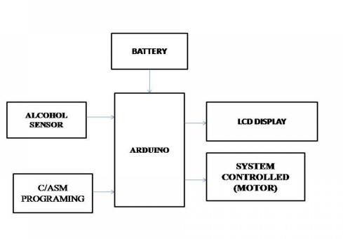

*Fig 1. Block diagram*

The System consists of hardware and software part. Figure 1, the hardware parts, shows the block diagram of alcohol detection with GSM module and speed control using Arduino project that the users can monitor the driver condition at anytime and anywhere. As for the software part, all the program located in Arduino UNO, using C language. Arduino UNO, as the main controller, connect with GSM module, and motor, gas sensor/peripherals so they can

communicate each other. And Arduino UNO can only work after we uploaded the designed program into it.

# TRANSMITTER AND RECIEVER SIDE

Each node (transmitter or receiver) is composed from microcontroller (Arduino UNO) which is discussed in previous paragraph and Arduino GSM shield which is also discussed. As mentioned before, these nodes are programmed in Arduino C++ software. To avoid the interference, two nodes one for receiving and the other for transmission are selected instead of one node. Printer is used for printing the reports of electricity bill for the custom.

# PROPOSED SYSTEM

The main objective of this proposed system is to prevent the accidents that occur due to the drunken driving by detecting the alcohol limit of the driver driving the vehicle and alerting the system

1. *Hardware Components*
   1. GSM Module

*.*

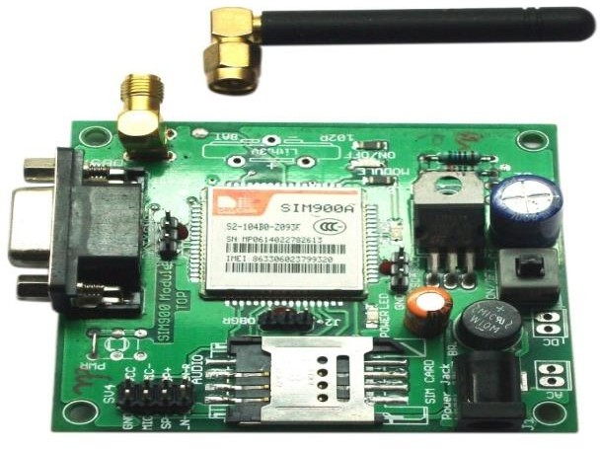

*Fig 2. GSM*

GSM is a nothing but a modem. Abbreviation for Global System for MobileCommunications (GSM). The idea of GSM was developed at Bell Labs in 1970. WidespreadA mobile communication system used around the world. GSM is an open digital cellular technology.It is used to transmit mobile voice and data services and operates at 850MHz, 900MHz and 1800MHz.and 1900 MHz frequency band.The GSM system was developed as a digital system using time division multiple access.(TDMA) A technology for communication. GSM digitizes, reduces and transmits data.Via channels with two different streams of customer data, each at its own timeslot. Digital systems can transmit data rates from 64 kbps to 120 Mbps.

* 1. Arduino UNO R3

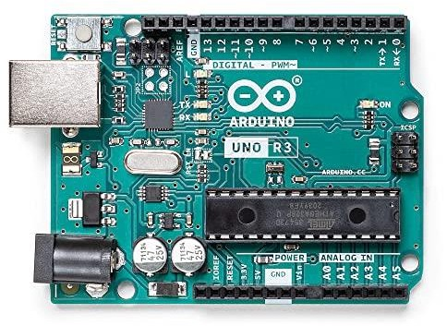

*Fig 3. Arduino UNO R3*

The Arduino Uno is a microcontroller board based on the ATmega328P. it has 14 digitalInput/output pins (6 of which can be used as PWM outputs), 6 analog inputs, 16 MHz crystal Crystal, USB connection, power jack, ICSP header, and reset button. it contains all Required to support microcontrollers. Just plug it into a universal serial compatible computer Start by using a bus (USB) cable, or power it with an AC- DC adapter or battery. can fiddle Worst case scenario using UNO without worrying too much about doing something wrong For a few bucks you can replace the chip and start over. The Arduino Uno board is an ATmega328 based microcontroller. it has 14 digital Input/output pins, 6 of which can be used as PWM outputs, 16MHz ceramic resonator, ICSP Headers, USB ports, 6 analog inputs, power jack, reset button. "Uno" means 1 in Italian and was named to commemorate the upcoming release of Arduino 1.0.

Uno and version 1.0 will be the reference version of the evolving Arduino. the United Nations Reference models for the latest USB Arduino boards and Arduino platforms. Around Comparison with previous version. Any of the Uno's 14 digital pins can be used as an input or output with the pinMode(), digitalWrite() and digitalRead() functions. They run on 5 volts. Each pin can source or receive up to 40mA and has an internal pull- up resistor. (disconnected by default) from 20-50 kOhm. For teachers, it is based on convenient processing A familiar programming environment for students learning to code in this environment How the Arduino IDE works. Arduino software is

beginner-friendly and flexible Good enough for advanced users.

* 1. Interface of GSM and Arduino

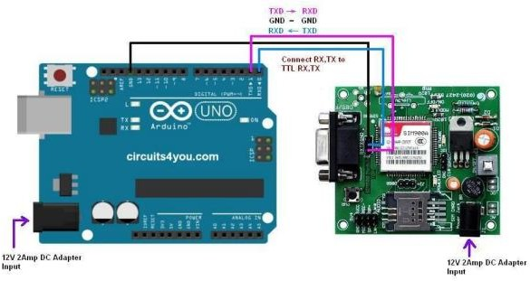

*Fig 4. GSM and Arduino UNO R3 Interface*

We are using the most popular module based on Silcom SIM900 and Arduino Uno for this tutorial. Interfacing a GSM module to Arduino is pretty simple. You only need to make 3 connections between the GSM module and Arduino. A GSM Module is basically a GSM Modem (like SIM 900) connected to a PCB with different types of output taken from the board – say TTL Output (for Arduino, 8051 and other microcontrollers) and RS232 Output to interface directly with a Personal Computer(PC). The board will also have pins or provisions to attach mic and speaker, to take out +5V or other values of 14 power and ground connections. These types of provisions vary with different modules. Lots of varieties of GSM modem and GSM Modules are available in the market to choose from. For our project of connecting a GSM Modem or module to Arduino and hence send and receive SMS using Arduino

– its always good to choose an Arduino compatible GSM Module – that is a GSM module with TTL Output provisions

* 1. LCD Interface

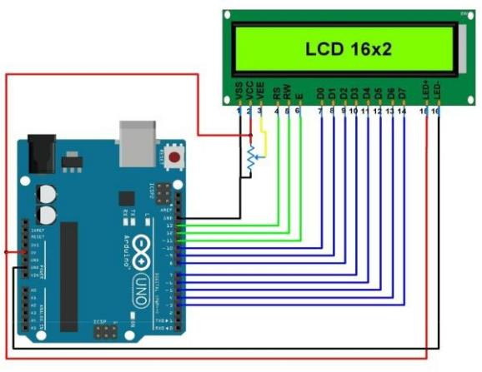

*Fig 5. LCD Interface*

LCD modules form a very important component in many Arduino-based embedded systems draft. Therefore, knowing how to connect the LCD module to the Arduino is very important for your design embedded system. This section describes how to connect the Arduino to a 16x2 LCD. JHD162A is the LCD module used here. JHD162A is a 16x2 LCD module based on HD44780. Hitachi driver. The JHD162A has 16 pins and can operate in 4- bit mode (using only 4 bits data line) or 8-bit mode (using all eight data lines).

* 1. Gas Sensor

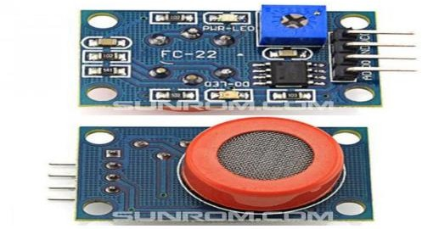

*Fig 6.Gas Sensor Module(MQ3)*

Alcohol Sensor MQ-3 Analog Gas Sensor - MQ3 is suitable for detecting alcohol. The sensor can be used with breath detectors. High sensitivity to alcohol, low sensitivity to alcohol benzene. Sensitivity can be adjusted with a potentiometer. Sensitive material of gas sensor MQ-3 is SnO2, which has low conductivity in clean air. If alcohol gas of interest is present, the sensor The higher the gas concentration, the higher the conductivity, which can be converted with a simple circuit. Change in conductivity in response to the gas concentration output signal. Alcohol Senso MQ-3 Gas The sensor is highly sensitive to alcohol, gasoline, smoke, vapor. This sensor can be used to detect different concentrations of alcohol. it is low cost and Suitable for many uses.

1. *Software Components*

Arduino IDE: Arduino IDE where IDE represents Integrated Development Environment official programming presented by Arduino.cc, which is predominantly utilized for composing, gathering, and transferring the code in the Arduino device. Practically all Arduino modules are viable with this product that is open-source and is promptly accessible to install and begin compiling the code just as transferring machine code to the microcontroller.

1. *Flow Chart*

The flow chart describes the working of the system, Initially the gas analyser will detect the consumption of alcohol and it will measure the amount of alcohol content if the consumption of alcohol is more than safe

limit then the engine wll be locked and alarm will be turned on for alerting.

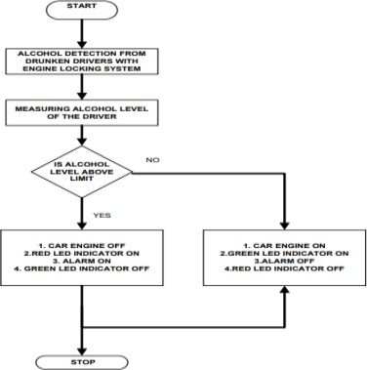

*Fig 7. Flow Chart*

# RESULT AND ANALYSIS

The project has been setup with the components on a efficient way. Initially when the driver consumed the alcohol which can be detected through the gas sensor where the air content can be measured with a range where the air content of alcohol is above the set limit the readings will be noted which can be processed by the Arduino through the implemented programmed. Then the readings and the alert message will be shown in the LCD display and also the amount of alcohol content will be displayed. After that GSM module perform to send alert message as “Alcohol detected and ignition turned off” and also the amount of alcohol consumed will be sent to the concern person. Where the speed control action takes place if a person consumed alcohol in forest area at that situation the vehicle will turn on when the GSM module signal is disabled so that the person can move the vehicle with a speed limit where the speed control limit has been implemented. At certain stage when signal is caught GSM module will be enabled and the ignition gets turned off. Finally, the alert message and consumed range of alcohol will be sent to the concern person.

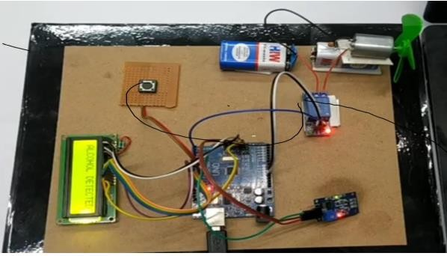

*Fig 8. Project setup*

# GSM OUTPUT

The following figures shows the messages sent from Global Service Module. Once the gas sensor detects the range of alcohol and the signal sent to Arduino and GSM will send a message to the concern person. The concern person receives an alert message “Alcohol consumed or detected and ignition turned off” and also the amount of alcohol will be seen through the message. So, with the help of GSM Module the transmitting and receiving of data communication can be done easily.

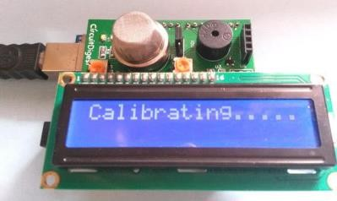

*Fig 9.System Caliberating*

When the system connected with main unit and starts to reset the old data in standard measurements. Whenever the sensor starts to detect the air from the surroundings the accuracy will be better in the readings. So that true value will be generated. After the calibration the system is ready for detecting

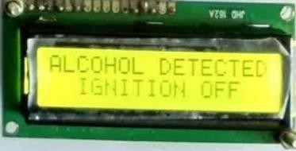

*Fig 10.* Alcohol detection and ignition off display

When the person consumed the alcohol the engine ignition will be turned off and suddenly an alert message will be display in LCD display.

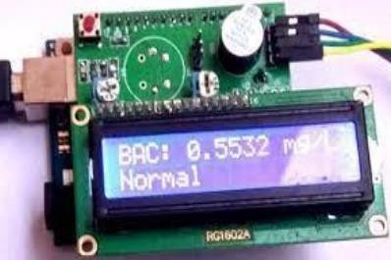

*Fig11. Alcohol range displayed in LCD*

The alcohol detection will be detected through gas sensor and reading will be generated with set limit which is implemented in the software through Arduino system and the range will be displayed in LCD, which is shown in fig 11.

# CONCLUSIONS

An effective solution is provided to develop the intelligent system for vehicles which will monitor various parameters of vehicle in- between constant time period and will send this data to the base unit as explained in this paper, by using hardware platform who’s Core is Arduino, Relay, Alcohol sensor mq3, & GSM module. The designed system would finish the function of communicating with the base station via GSM and control of various parameters. The whole Control system has the advantage of small volume and high reliability. Future scope of this system is to control the accidents and providing useful details about the accidental vehicle, thereby reducing the rate of

accidents taking place due to drunken driving. This system brings innovation to the existing technology in the vehicles and also improves the safety features, hence proving to be an effective development in the automobile industry.

# FUTURE SCOPE

In the future scope the technologies can be upgraded with IOT and embedded system in a effective way to emerge the technologies in a vehicle for detection of alcohol will leads to enhance the safety procurements and which can avoid the risks for the human life’s. We hope in a better way the safety will be improved with those technologies could withstand in upcoming vehicle manufacturing sectors which leads to avoid major accidents in all over the countries.

# REFERENCES

1. L. A. Navarro, M. A. Diño, E. Joson, R. Anacan and R. D. Cruz, "Design of Alcohol

Detection System for Car Users thru Iris Recognition Pattern Using Wavelet Transform,"

2016 7th International Conference on Intelligent Systems, Modelling and Simulation

(ISMS), Bangkok, 2016, pp. 15-19. P.

1. Cahalan,D., I. Cisin, and Crossley, American Drinking Practices: A National Study of

Driving Behaviour and Attitudes. 1969, Rutgers University Press: New Brunswick, NJ.

1. Lee, Assessing the Feasibility of Vehicle-Based Sensors to Detect Alcohol Impairment.

2010, National Highway Traffic Safety Administration: Washington, DC.

1. Nimmy James, Aparna C, Tenna P John, International Journal of Research in Computer

and Communication Technology, Vol 3, Issue 1, January- 2014 – “Alcohol Detection

System”.

1. A. ISuge, H.Takigawa, H.Osuga, H.Soma, K.Morisaki, Accident Vehicle Automatic

Detection System by Image Processing Technology, © IEEE 1994 Vehiclee Navigation

& information Systems Conference.

1. Umar, A., Hahn, Y -B. (2010), Metal Oxide Nanostructures and Their Applications,

vol. 3, American Scientific Publishers, pp. 33.

1. Watson P. E. (1989), Total body water and blood alcohol levels: updating the

fundamentals, Human Metabolism of Alcohol, vol. 1, pp. 41 -58.