**PROPER D-LUCKY LABELING ON SOME EXTENDED DUPLICATE GRAPHS**

S.Bala1,V.Suganya2, K.Thirusangu3

1,2,3 Department of Mathematics

S.I.V.E.T. College, Gowrivakkam, Chennai-73

E-mail ID:2sugan4kavi@gmail.com,1yesbala75@gmail.com

**Abstract:**

In this paper we investigate the existence of Proper D-Lucky labeling on Extended Duplicate graphs.

Keywords: Graph Labeling, D-Lucky Labeling, Path graph

**1.INTRODUCTION:**

Esakkiammal et.al., [3] introduced the concept of **Proper D-lucky Labeling**. A d-lucky labeling is called proper if $l\left(u\right)≠l\left(r\right)$ for every adjacent vertices $u$ and $r$. The proper d-lucky number of a graph is the least positive integ $k$ such that $G$ has a Proper d-lucky labeling with $\left\{1,2,….,k\right\}$ as the set of labels and is denoted by $η_{pdl}\left(G\right)$.

**Definition: 2.1.2 (Extended Duplicate Graph of Path)**

Let $DG=\left(R_{1}{,B}_{1}\right)$ be the Duplicate graph of a Path $G(R,B$). The Extended Duplicate Graph of Path $EDG \left(P_{m}\right)$ is obtained from the duplicate graph of path by joining $r_{2}r_{2}^{'},$.Clearly it has $2m+2$ vertices and $2m+1$ edges,[6].

**Definition: 2.1.3 (Extended Duplicate Graph of Star)**

Let ${DG(S}_{m})$ be the duplicate graph of Star. The Extended Duplicate Graph of Star $EDG\left(S_{m}\right)$ is obtained from the duplicate graph of Star by joining $r_{1}r_{1}^{'}.$ It has $6m$ vertices and $8m-3$ edges,[8].

**Definition: 2.1.4 (Extended Duplicate Graph of Twig)**

Let ${DG(T}_{m})$ be the duplicate graph of Twig. The Extended Duplicate Graph of Twig $EDG\left(T_{m}\right)$ is obtained from the duplicate graph of Twig by joining $r_{2}r_{2}^{'}.$ Cleary this $EDG \left(T_{m}\right)$ has $6m+4$ vertices and $6m+3$ edges,[5].

**Definition: 2.1.5 (Extended Duplicate Graph of Bistar)**

Let $DG \left({BS}_{m,m}\right)$ be the duplicate graph of Bistar. The Extended Duplicate Graph of Bistar is obtained from the duplicate graph of Bistar by joining $r_{1}r_{1}^{'}.$ Clearly $EDG \left({BS}_{m,m}\right)$ has $4m+4$ vertices and $4m+3$ edges,[7].

**2. MAIN RESULT**

In this section we investigate the existence of Proper D-Lucky Labeling on Extended Duplicate Graph of Path, Extended Duplicate Graph of Star, Extended Duplicate Graph of Twig, Extended Duplicate Graph of Bistar graph.

**THEOREM: 2.1**

Extended Duplicate Graph of Path $EDG \left(P_{m}\right)$ admits Proper d-lucky labeling with $η_{dl}\left(EDG \left(P_{m}\right) \right)=2$.

**Proof:**

From the structure of EDG $\left(P_{m}\right)$, it is clear that EDG $\left(P_{m}\right)$ has $2m+2$ vertices and $2m+1$ edges. To prove EDG is d-lucky, define the function to label the vertices as follows:

For, $1≤i≤m$

$l \left(r_{i}\right)=1$

$l (r_{i}^{'})=2$

From the structure of the EDG $\left(P_{m}\right)$, it is clear that the degrees of the vertices are as follows:

$d(r_{1}) = d(r_{i}^{'})= d(r_{m+1}) = d(r_{m+1}^{'})=1$

$d(r_{2}) = d(r_{2}^{'}) = 3$

$d(r_{i}) = d(r_{i}^{'}) = 3, for 3≤i≤m$

1. $c(r_{1}$) = $c(r_{m+1}$) = 3
2. $c(r_{1}^{'}$) = $c(r_{m+1}^{'}$) = 2
3. $c(r_{2}$) = 9
4. $c(r_{2}^{'}$) = 6
5. $c(r_{i}$) = 9, for $3≤i≤m$
6. $c(r_{i}^{'}$) = 4, for $3≤i≤m$

Clearly, $c(u)≠c(v$) for any two adjacent vertices of EDG $\left(P_{m}\right)$.Therefore EDG $\left(P_{m}\right)$ admits d-lucky labeling with $η_{dl}\left(EDG\left(P_{m}\right)\right)=2$.

**EXAMPLE: 2.1**

Proper D-lucky labeling EDG $\left(P_{5}\right)$ is shown in the figure 2.1.1 respectively.

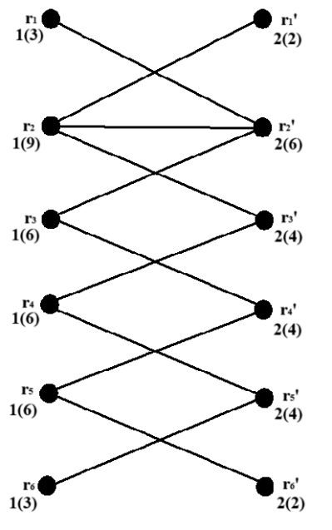

**Figure 2.1.1**

**THEOREM 2.2**

Extended duplicate Graph of Star EDG $(S_{m})$ admits Proper d-lucky labeling with $η_{dl}(ETG{(S}_{m}))=2$.

**Proof:**

From the structure of EDG $(S_{m})$, it is clear that EDG $(S_{m})$ has 6m vertices and 8m-3 edges. To prove EDG ${(S}_{m})$ is d-lucky, define the function $l:R(G)→N$ to label the vertices as follows:

For, $1≤i≤m$

$l \left(r_{i}\right)=1$

$l (r_{i}^{'})=2$

From the structure of the EDG $\left(S_{m}\right)$, it is clear that the degrees of the vertices are as follows:

1. $d(r_{1})$ $= d(r_{i}^{'})=m$,
$d(r_{i}) = d(r_{i}^{'}) =1,for 2≤i≤m$

2. $c(r_{1}$) $= 3m$,
3. $c(r_{1}$) = 3, for $2≤i≤m$
4. $c(r_{1}^{'}$) = $2m$
5. $c(r_{1}^{'}$) = $2$, for $2≤i≤m$

Clearly, $c(u)≠c(r)$ for any two adjacent vertices of EDG $\left(S_{m}\right)$. Therefore EDG $\left(S_{m}\right)$ admits d-lucky labeling with $η_{dl}\left(EDG \left(S_{m}\right)\right)=2$.

**EXAMPLE: 2.2**

Proper D-lucky labeling EDG $\left(S_{5}\right)$ is shown in the figure 2.2.1 respectively.

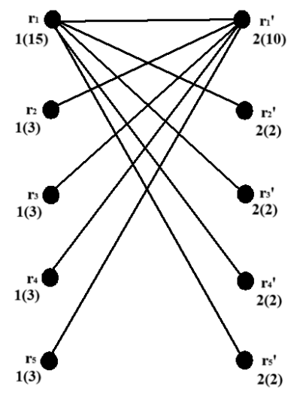

**Figure 2.2.1**

**THEOREM: 2.3**

Extended Duplicate Graph of Twig $EDG\left(T_{m}\right)$ admits Proper d-lucky labeling with $η_{dl}\left(EDG \left(T_{m}\right) \right)=2$.

**Proof:**

From the structure of EDG $\left(T_{m}\right)$, it is clear that EDG $\left(T_{m}\right)$ has $6m+4$ vertices and $6m+3$ edges. To prove EDG is d-lucky, define the function to label the vertices as follows:

For, $1≤i≤3m+2$

$l \left(r_{i}\right)=1$

$l (r_{i}^{'})=2$

From the structure of the EDG $\left(T_{m}\right)$, it is clear that the degrees of the vertices are as follows:

1. $d\left(r_{1}\right)=1$, $d\left(r_{2}\right)=5$
$d\left(r_{3i}\right)=1,for 1≤i≤m$

$d\left(r_{3i+1}\right)=1,for 1≤i≤m$

$d\left(r_{3i+2}\right)=4,for 1≤i≤m-1$

2. $d\left(r_{i}^{'}\right)=1$, $d\left(r_{2}^{'}\right)=5$
$d\left(r_{3i}^{'}\right)=1,for 1≤i≤m$

$d\left(r_{3i+1}^{'}\right)=1,for 1≤i≤m$

$d\left(r_{3i+2}^{'}\right)=4,for 1≤i≤m-1$

$d\left(r_{3m+2}\right)=d\left(r_{3m+2}^{'}\right)=1$

3. $c(r_{1}$) = 3, $c(r_{2}$) = 15
4. $c(r_{1}^{'}$) = 2, $c(r_{2}^{'}$) = 10
5. $c(r_{3i}$) = $c(r_{3i+1}$) = 3 $,for 1≤i≤m$
6. $c(r_{3i}^{'}$) = $c(r_{3i+1}^{'}$) = $2,for 1≤i≤m$
7. $c(r_{3i+2}$) = 12, $c(r_{3i+2}^{'}$) = $8, for 1≤i≤m-1$

Clearly, $c(u)≠c(r)$ for any two adjacent vertices of EDG $\left(T_{m}\right)$. Therefore EDG $\left(T_{m}\right)$ admits d-lucky labeling with $η_{dl}\left(EDG \left(T_{m}\right)\right)=2$.

**EXAMPLE: 2.3**

Proper D-lucky labeling EDG $\left(T_{3}\right)$ is shown in the figure 2.3.1 respectively.

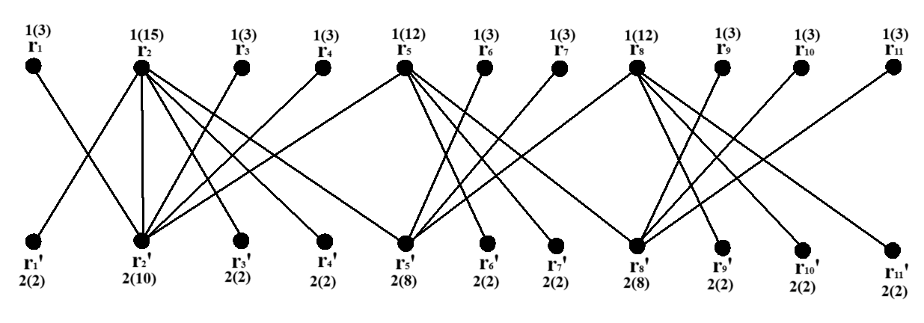

**Figure 2.3.1**

**THEOREM: 2.4**

Extended Duplicate Graph of Bistar $EDG \left({BS}_{m,m}\right)$ admits Proper d-lucky labeling with $η_{dl}\left(EDG \left({BS}_{m,m}\right) \right)=2$.

**Proof:**

From the structure of EDG $\left({BS}_{m,m}\right)$, it is clear that EDG $\left({BS}_{m,m}\right)$ has $4m+4$ vertices and $4m+3$ edges. To prove EDG is d-lucky, define the function to label the vertices as follows:

For, $1≤i≤2m+2$

$l \left(r_{i}\right)=1$

$l (r_{i}^{'})=2$

From the structure of the EDG $\left(P_{m}\right)$, it is clear that the degrees of the vertices are as follows:

1. $d\left(r_{1}\right)=d\left(r_{i}^{'}\right)=m+2$,
$d\left(r_{i}\right)=d\left(r_{i}^{'}\right)=1,for 2≤i≤m+1$

$d\left(r_{m+2}\right)=d\left(r_{m+2}^{'}\right)=m+1,for 1≤i≤m$

$d\left(r_{m+2+i}\right)=d\left(r_{m+2+i}^{'}\right)=1,for 1≤i≤m$

2. $c(r_{1}$) = $3m+6$, $c(r_{i}$) $=3,for 2≤i≤m+1$
3. $c(r_{m+2}$) = $3m+3$
4. $c(r_{m+2+i}$) $=3,for 1≤i≤m$
5. $c(r_{1}^{'}$) = $2m+4$, $c(r_{m+2}^{'}$) = $2m+2$
6. $c(r_{i}^{'}$) = $2,for 2≤i≤m+1$
7. $c(r_{m+2+i}^{'}$) = $2, for 1≤i≤m$

Clearly, $c(u)≠c(r)$ for any two adjacent vertices of EDG $\left({BS}_{m,m}\right)$.Therefore EDG $\left({BS}_{m,m}\right)$ admits d-lucky labeling with $η_{dl}\left(EDG \left({BS}_{m,m}\right)\right)=2$.

**EXAMPLE: 2.4**

Proper D-lucky labeling EDG $\left({BS}_{4,4}\right)$ is shown in the figure 2.4.1 respectively.

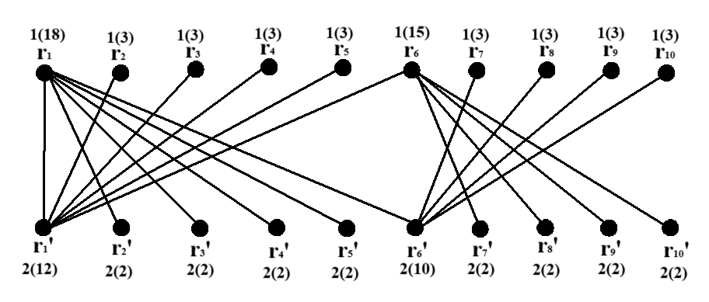

**Figure 2.4.1**

**Conclusion:**

In this paper, we have confirmed the existence of Proper D-Lucky Labeling on Extended Duplicate Graph of Path, Extended Duplicate Graph of Star, Extended Duplicate Graph of Twig, Extended Duplicate Graph of Bistar graph.

**References:**

1. Bala.S, Suganya V, Thirusangu k, D-Lucky Labeling of Some Special Graphs, Purakala, V0l 32 Issue 1, pg.no315-319,2023. ISSN :0971-2143.
2. Bala.S, Suganya.V, Thirusangu. K, D-lucky labeling for some extended triplicate graph, International journal of Research and analytical reviews, IJRAR, Volume 11, Issue 1, E-ISSN 2348-1269, P- ISSN 2349-5138, March 2024.
3. Esakkiammal E, Thirusangu K, Seethalakshmi S, Proper d-lucky labeling on arbitrary supersubdivision of some graphs, Journal of Applied Science and Computations. Vol.vi (1), (2019), pp.575-602.
4. Rosa A H and Ghodasara G V, Fibonacci cordial labeling of some special Graphs, Annais of pure and Applied Mthematices Vol, 11, No,1,2016,133-144, ISSN-2279-087X(P), 2279-0888(online),Pubished on 29 February 2016.
5. Selvam B, Thirusangu K, and Ulaganathan P.P, Odd and Even graceful labelings in extended duplicate twig graphs, International Journal of Applied Engineering Research, 6 ( 8 ) , (2011) , 1075 – 1085.
6. Thirusangu K, Ulaganathan P.P and Selvam B, Cordial labeling in duplicate graphs, Int. J. Computer Math. Sci. Appl. Vol. 4, Nos. (1-2) (2010), 179-186.
7. Ulaganathan P.P, Selvam B, Vijaya kumar P, Signed Product Cordial labeling in duplicate graphs of Bistar, Double Star and Triangular Ladder Graph, International Journal of Mathematics Trends and Technology (IJMTT), Volume 33 Number 1- May 2016. ISSN: 2231-5373, http://www.ijmttjournal.org.
8. Vijayakumar P, Ulaganathan P.P and Thirusangu K, Some Cordial Labeling in Extended Duplicate Graph of Star Graph, International Journal of Applied Engineering Research 10(80) (2015), 171-174.