LoRa and IoT Based Real-Time Refinery Monitoring
and Automated Control

W. Godfrey Daniel¹, Amrish. P ², Deepak Kumar. R³, Dhanushwar. J.P ⁴, Nepolian. A⁵

¹Assistant Professor, Department of Instrumentation and Control Engineering, Sri Manakula Vinayagar Engineering College, Puducherry
²UG Student, Department of Instrumentation and Control Engineering, Sri Manakula Vinayagar Engineering College, Puducherry
³UG Student, Department of Instrumentation and Control Engineering, Sri Manakula Vinayagar Engineering College, Puducherry
⁴UG Student, Department of Instrumentation and Control Engineering, Sri Manakula Vinayagar Engineering College, Puducherry
⁵UG Student, Department of Instrumentation and Control Engineering, Sri Manakula Vinayagar Engineering College, Puducherry
Abstract :
This project introduces an IoT-based monitoring and control system for refinery operations, utilizing AI, ML, and LoRa technology for real-time, long-range communication. The system automates temperature control to ensure optimal conditions and regulates pressure through solenoid valves for safety leakage detection with immediate buzzer alerts enhances worker safety and prevents hazards. Ph monitoring ensures chemical balance and product quality. Predictive analytics optimize operations by learning from historical data. A user-friendly interface provides real-time data visualization, streamlining operations and boosting productivity. This solution enhances safety, efficiency, and sustainability in refinery operations.
Index Terms — IoT , Industrial Automation , Refinery Monitoring , Artificial Intelligence, Machine Learning (ML ), LoRa Technology , Predictive Analytics , Temperature Control , Pressure Regulation , Liquid Level Management , Gas Leakage Detection , pH Monitoring , Real-time Data Visualization , Safety , Efficiency, Sustainability.
A visually appealing and intuitive interface simplifies monitoring by presenting real-time data, enabling quick responses to any irregularities. This comprehensive solution underscores the importance of integrating smart technologies to address modern industrial challenges, fostering a safer, more efficient, and eco-friendly refinery environment.

I.INTRODUCTION

The growing demand for safe and efficient refinery operations has underscored the importance of adopting advanced technologies to address the challenges posed by complex industrial environments. Refineries involve intricate processes that demand continuous monitoring and precise control of critical parameters such as temperature, pressure, liquid levels, gas concentrations, and chemical balances. Traditional systems often fall short in providing the level of real-time responsiveness and predictive capabilities needed to mitigate risks, enhance safety, and optimize performance. In this context, integrating IoT (Internet of Things ), Artificial Intelligence (AI ), and Machine Learning (ML ) offers a transformative solution.
This project presents a comprehensive IoT-based monitoring and control system designed to revolutionize refinery operations by combining cutting-edge technologies with industrial automation. Leveraging LoRa technology for long-range, low-power communication, the system ensures seamless connectivity across expansive refinery environments. Key parameters, including temperature, pressure, liquid levels, Ph, and gas leakage, are monitored in real-time, enabling swift and automated responses to maintain operational stability. For instance, temperature sensors automate cooling systems to prevent overheating, while pressure sensors regulate solenoid valves to avoid hazardous conditions. Additionally, the system employs gas sensors for immediate detection of leaks, triggering audible alerts via a buzzer to enhance worker safety and prevent potential disasters.
The incorporation of AI and ML further elevates the system's functionality by enabling predictive analytics and data-driven decision-making. By analyzing historical data, the system can identify patterns, predict potential failures, and optimize control strategies, significantly reducing downtime and operational inefficiencies. The integration of pH monitoring ensures the chemical balance within refinery processes is maintained, directly contributing to product quality and compliance with safety standards. The user-friendly interface provides real-time data visualization, allowing operators to monitor processes effectively and make informed decisions.
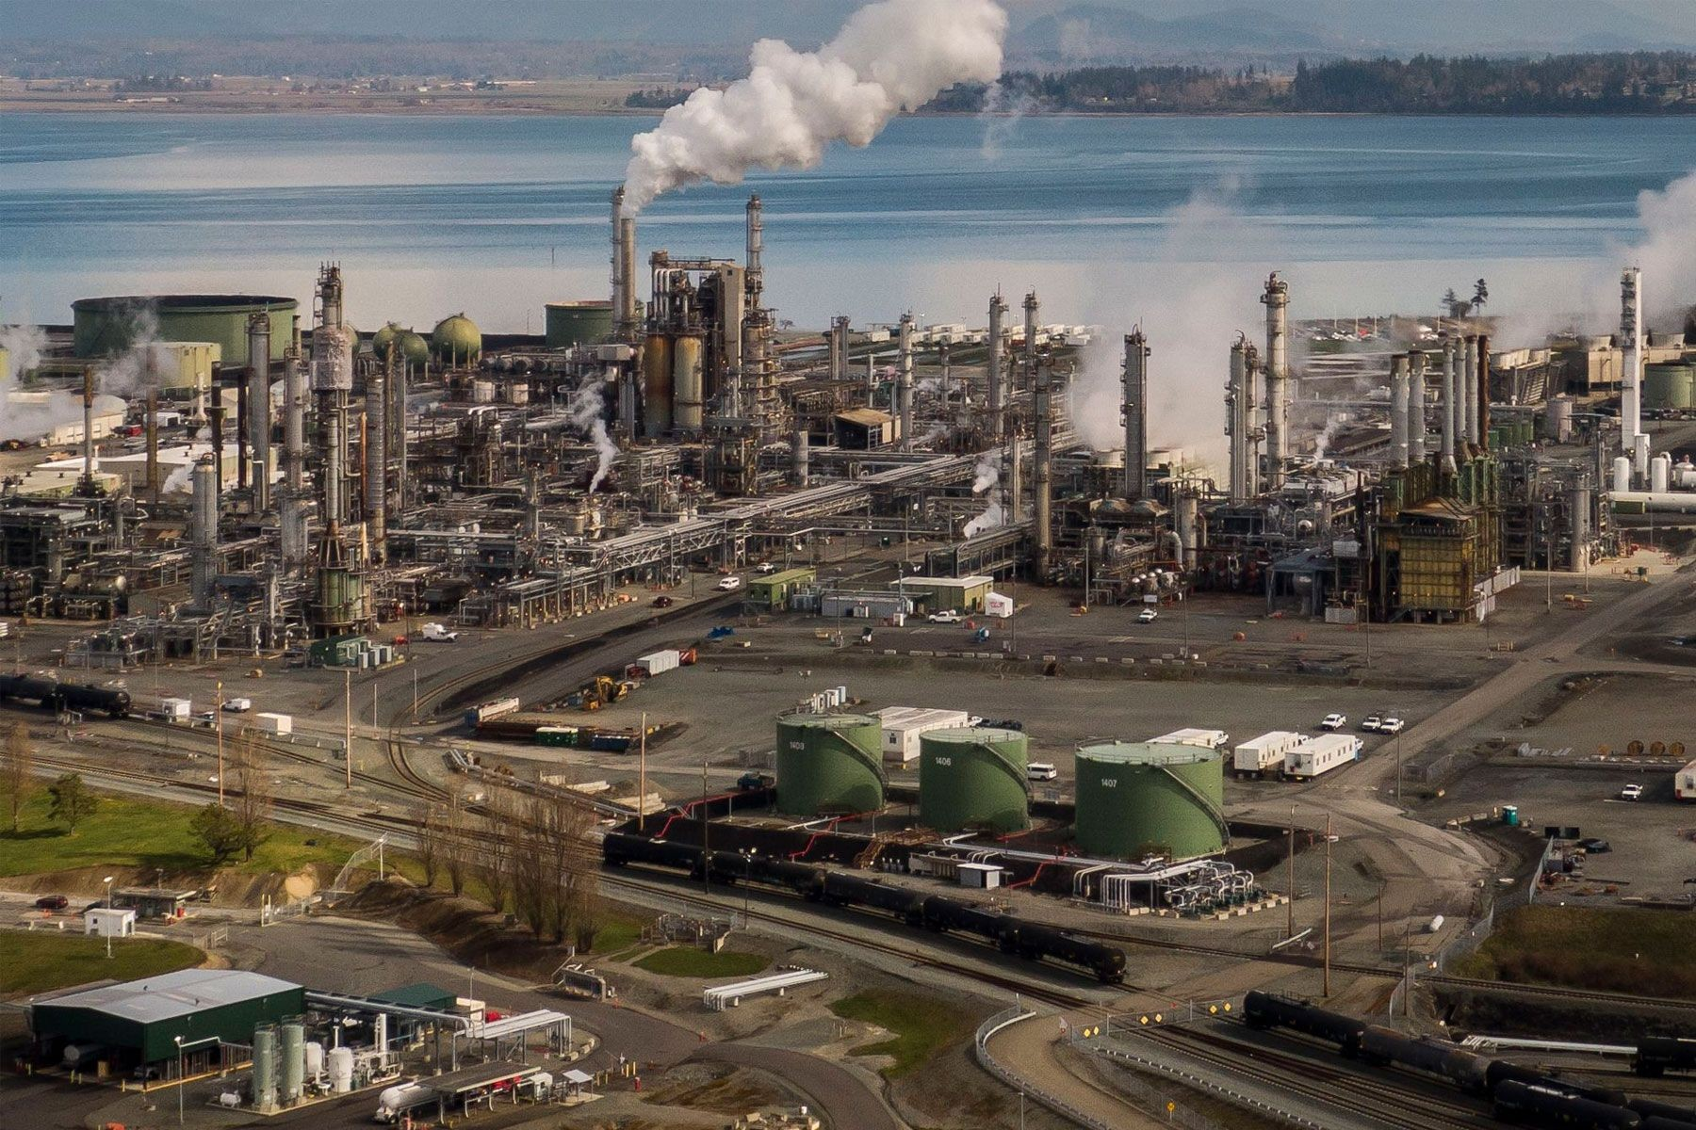
Fig .1 Refinery industry

This solution not only addresses the critical needs of safety and efficiency but also contributes to sustainable and resilient refinery operations. By reducing manual intervention, minimizing risks, and improving productivity, the system represents a significant advancement in industrial automation
. Its ability to adapt to evolving operational requirements ensures that refineries can meet the demands of modern industry while maintaining environmental and economic sustainability. This project aims to serve as a benchmark for next-generation automation in refinery operations, setting new standards for safety, efficiency, and technological integration.

II. RELATED WORKS

The development of industrial automation systems has been an active area of research, with numerous studies and projects focusing on enhancing monitoring and control in complex environments like refineries. Recent advancements in IoT, AI, and ML have significantly contributed to creating smarter and more efficient systems. Several researchers have explored IoT-based solutions for real-time monitoring of industrial processes, emphasizing the importance of wireless communication technologies like LoRa, ZigBee, and Bluetooth for long-range, low-power connectivity. LoRa, in particular, has gained attention for its ability to facilitate communication across expansive industrial areas, making it ideal for refinery applications. Studies have highlighted the use of temperature sensors for automating cooling systems, pressure sensors for maintaining operational safety, and level sensors for liquid management, demonstrating their effectiveness in reducing manual intervention and improving process reliability.
In the domain of gas leakage detection, numerous works have integrated gas sensors with IoT frameworks to provide immediate alerts in hazardous situations. These systems typically employ buzzers or alarms to ensure the safety of workers and the environment, with some approaches incorporating additional features such as SMS or email notifications for remote monitoring. Similarly, pH monitoring has been extensively studied for its critical role in maintaining chemical balance and ensuring product quality in industrial processes. Existing research often employs real-time data acquisition systems combined with IoT platforms to enable continuous monitoring and timely interventions.
Artificial Intelligence (AI ) and Machine Learning (ML ) have become indispensable in modern industrial systems, with researchers exploring their application in predictive maintenance and process optimization. AI/ML algorithms are used to analyze historical data, predict equipment failures, and optimize operational parameters, resulting in reduced downtime and enhanced efficiency. Many studies have demonstrated how predictive analytics can improve decision-making by identifying patterns and trends that may not be immediately apparent through traditional monitoring systems. Furthermore, use -friendly interfaces have been developed in various projects to provide operators with real-time insights and actionable recommendations, ensuring that decision-making is both data-driven and intuitive.
A notable gap in many previous works, however, lies in the integration of these diverse technologies into a unified system tailored specifically for refineries. While individual solutions for temperature, pressure, gas, and liquid monitoring exist, comprehensive systems that seamlessly integrate these functionalities with AI /ML capabilities remain relatively underexplored. This project seeks to address this gap by combining IoT, LoRa technology, AI/ ML, and real-time data visualization into a single, robust solution. Drawing inspiration from prior research and building upon existing methodologies, this project aims to create a state-of-the-art monitoring and control system that enhances safety, efficiency, and sustainability in refinery operations, setting a new benchmark for industrial automation.
The study of industrial automation and IoT-based systems has seen remarkable progress , with numerous related works addressing the growing need for safer and more efficient refinery operations. IoT has been widely explored for its ability to connect devices and facilitate real-time data acquisition and control. Researchers have extensively utilized IoT frameworks for monitoring critical parameters in industrial settings, such as temperature, pressure, liquid levels, gas leakage, and chemical composition. Wireless communication technologies, including LoRa, ZigBee, and Wi-Fi, have been employed in various studies, with LoRa emerging as a standout choice for long-range, low-power communication. Studies have demonstrated LoRa's suitability for large industrial sites, such as refineries, where vast areas need reliable and uninterrupted connectivity.
The monitoring of chemical properties such as pH and conductivity has also been the subject of substantial research, as these parameters are vital for maintaining product quality and process efficiency. IoT systems combined with advanced sensors have been developed to provide real-time pH data, enabling quick corrective actions when imbalances are detected. These systems are often paired with data visualization tools to give operators a clear and intuitive understanding of process conditions.

III. HARDWARE USED

The project involves integrating various sensors and components for industrial automation. It uses an LM 35 temperature sensor, an MPX5050 pressure sensor, and a ball-type level sensor to monitor environmental parameters. A MQ 02 gas sensor is incorporated for gas detection, alongside a pH sensor for measuring solution acidity or alkalinity. The system is controlled using an Arduino UNO microcontroller and displays data on an LCD screen.
Communication is achieved via LoRa transceivers, while relays manage switching operations for motors, pumps, and a solenoid valve. A reliable power supply ensures continuous operation, making the setup efficient for industrial or refinery-related processes.

A. Temperature Sensor (LM35) :

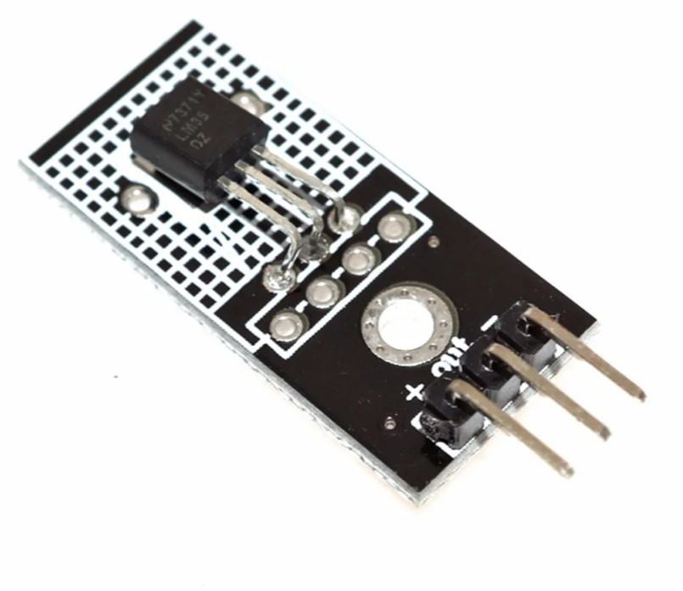
Fig .2 Temperature Sensor LM35

LM 35 is a precision temperature sensor that provides accurate readings in a linear voltage output proportional to temperature. It operates over a range of -55°C to 150 °C, making it suitable for industrial and environmental applications. The sensor's low self-heating ensures minimal interference with the surrounding temperature. It features a high degree of linearity and does not require external calibration, simplifying its use in various systems. The LM35's analog output can be directly read by microcontrollers like the Arduino UNO. It consumes minimal power, making it ideal for battery-powered applications. This sensor is reliable and widely used in automation and control systems for temperature monitoring.

B. Pressure Sensor (MPX5050) :

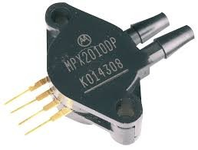
Fig .3 Pressure Sensor

The MPX5050 is a highly accurate pressure sensor capable of measuring pressures up to 50 kPa. It converts pressure variations into a proportional electrical output, suitable for analog interfacing. Its robust design and high sensitivity make it ideal for applications in fluid control systems and industrial automation. The sensor is calibrated and temperature-compensated, ensuring reliable readings across various operating conditions. With a fast response time, it is particularly effective in dynamic systems. It works seamlessly with microcontrollers for data acquisition and processing. The MPX 5050 is commonly used in applications such as HVAC systems, robotics, and refinery operations.

C. level Sensor (Ball Type):
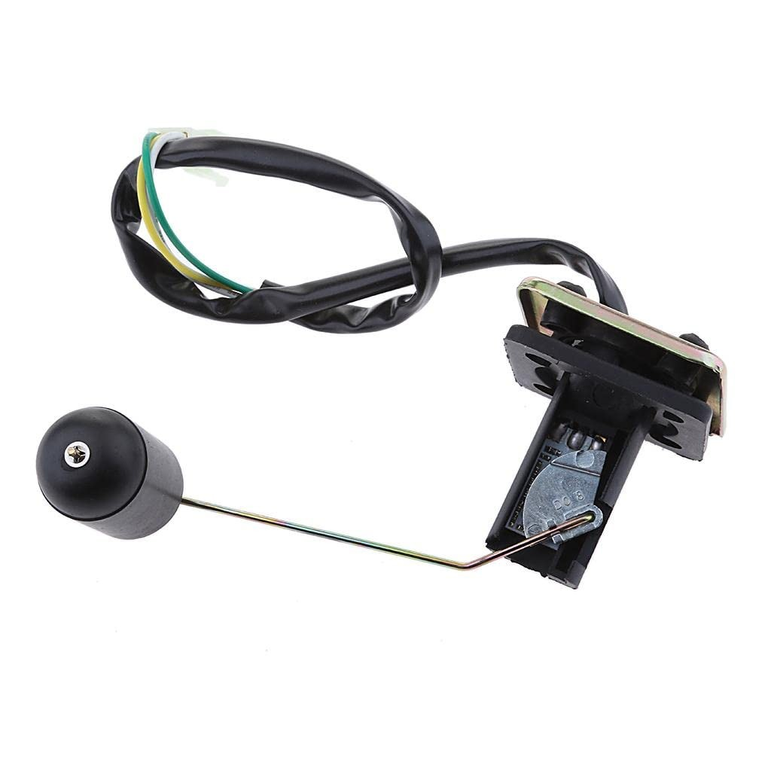
Fig .4 Level Sensor

A ball-type level sensor is a simple and efficient device for detecting liquid levels in tanks or reservoirs. It operates by floating on the liquid surface, with its position triggering a switch based on level changes. These sensors are known for their durability and ability to operate in a wide range of liquid types, including corrosive substances. Their straightforward mechanism ensures reliability and ease of maintenance. Often used in conjunction with relays, these sensors can directly control pumps or alarms. They are cost-effective and widely employed in industrial processes, including refinery and water management systems. Integration with microcontrollers enables automated level monitoring and control.

D. Gas Sensor (MQ02):

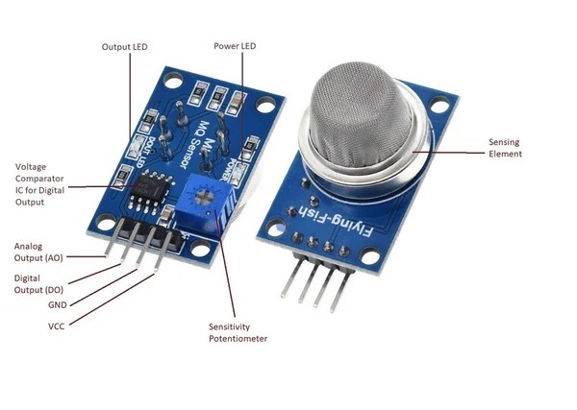
Fig 5 Gas Sensor – MQ02

The MQ02 is a gas sensor designed to detect combustible gases such as methane and propane. It operates on the principle of a sensitive material changing resistance based on gas concentration. The sensor is highly sensitive, capable of detecting low concentrations, making it suitable for safety-critical applications. It offers analog and digital output, allowing for flexible integration with control systems.

E.Ph Sensor :
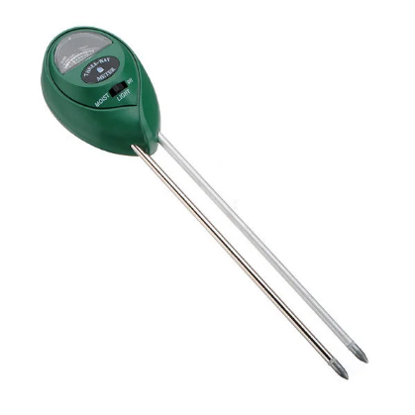
Fig 6 Ph Sensor

A pH sensor is a critical component for measuring the acidity or alkalinity of a solution . It operates by generating a voltage proportional to the hydrogen ion concentration in the liquid. These sensors are widely used in water treatment , chemical processing , and refinery applications . They provide real -time data , enabling automated control of processes requiring pH regulation. Integration with microcontrollers and display units facilitates seamless monitoring. Proper maintenance, such as regular calibration and cleaning, ensures optimal accuracy. The sensor is often combined with other sensors in multi-parameter monitoring systems. Its robustness makes it suitable for harsh industrial environments.

F. Arduino UNO :
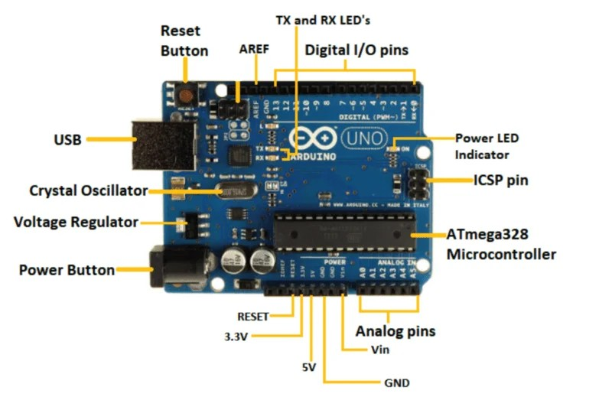
Fig 7 Arduino UNO
The Arduino UNO is a versatile microcontroller board used for developing electronic projects. It features an ATmega328P microcontroller with digital and analog I/O pins, making it ideal for sensor interfacing and automation tasks. Its ease of programming using the Arduino IDE simplifies development for beginners and professionals alike. The board supports various communication protocols, including UART, I2C, and SPI, for integrating peripherals like sensors, relays, and transceivers.
The open-source nature of the platform encourages innovation and community-driven enhancements. It can operate on a 5V power supply, making it compatible with most industrial and educational applications. Its affordability and reliability make it a go- to choice for embedded systems.

G.LCD :
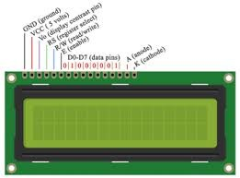
Fig 8 LCD Display
An LCD (Liquid Crystal Display ) is an essential component for visualizing data in real- time. In automation systems, it displays parameters like temperature, pressure, and pH for easy monitoring. LCDs come in various configurations, such as 16x2 or 20x4, to accommodate diverse data display needs. They are easy to interface with microcontrollers, requiring minimal wiring and programming. LCDs consume low power and provide a clear display even in varying light conditions. They are durable and capable of operating in harsh environments, making them suitable for industrial use. The ability to customize the displayed information enhances their versatility in automation projects.
h. LoRa Transceivers :
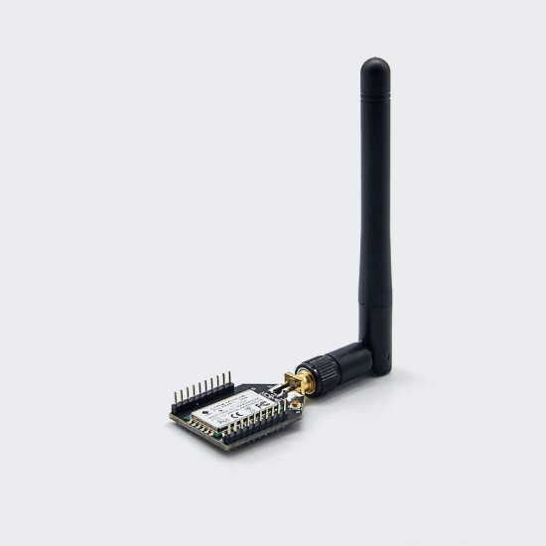
Fig 9 Lo-Ra Transceiver
LoRa ( Long Range ) transceivers are wireless communication modules designed for long-distance, low-power data transmission. They operate using spread- spectrum technology, offering robust communication even in environments with significant interference.

These transceivers are widely used in IoT and industrial applications to connect remote devices over several kilometers. Their low power consumption makes them ideal for battery-operated systems. LoRa supports bi-directional communication, enabling both monitoring and control functionalities. Integration with microcontrollers like the Arduino UNO ensures seamless data transmission in automation projects. This technology is crucial for applications requiring reliable and efficient wireless connectivity, such as industrial monitoring and smart cities.

I. Relays:
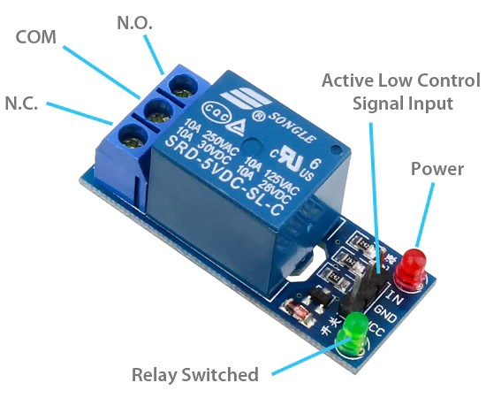
Fig 10 Relay board

Relays are electrically operated switches used to control high-power devices with low-power signals. They act as intermediaries, allowing microcontrollers to manage components like motors, pumps, and solenoid valves safely. Relays are highly reliable, and capable of isolating the control circuit from the power circuit, thus protecting sensitive electronics. They come in various types, such as electromagnetic and solid-state, catering to different requirements. With quick response times and high durability, they are widely employed in industrial and automation systems. Relays are easy to interface with microcontrollers and can be programmed for timed or conditional switching operations. Their versatility makes them a fundamental component in automated control setups.

J.Motors and Pumps:
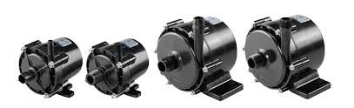
Fig 11 Motor
Motors and pumps are integral to automation systems, enabling mechanical operations such as fluid movement and mechanical control. Motors convert electrical energy into mechanical motion, driving various actuators and machinery. Pumps, powered by motors, facilitate the controlled flow of liquids or gases, which is crucial for processes like water management or chemical handling. These components are often interfaced with relays and microcontrollers for automated operation. Variable speed and direction control enhance their adaptability to diverse tasks. Proper calibration and integration ensure efficiency and longevity in demanding environments. Their reliability and precision are essential for industrial automation and refinery systems.
k.Solenoid Valve :
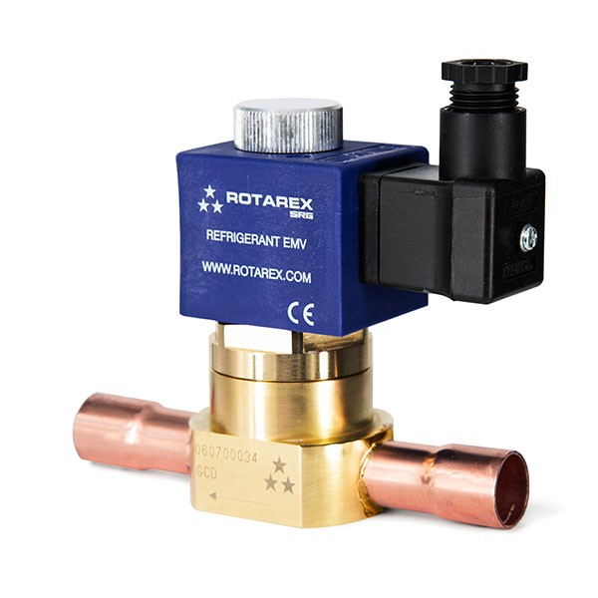
Fig 12 Solenoid valve
A solenoid valve is an electromechanical device used to control the flow of liquids or gases in automation systems. It operates by using an electromagnetic coil to actuate a valve, enabling precise on/off control. Solenoid valves are highly reliable with fast response times suitable for dynamic processes. They are commonly used in applications requiring fluid flow regulation, such as irrigation, chemical processing, and industrial automation. Integration with microcontrollers allows automated and programmable operation based on sensor inputs. These valves are compact, energy-efficient, and capable of handling a wide range of pressures and temperatures. Their robust design ensures durability in demanding industrial environments.
L. Cooling Fan :
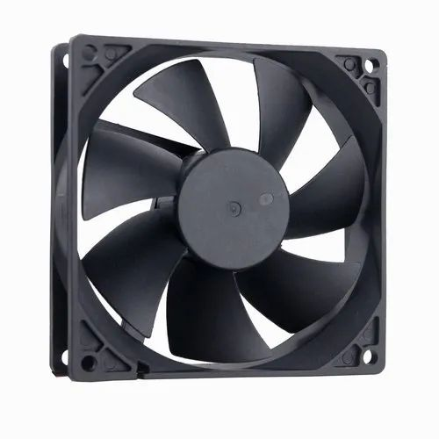
Fig 13 Cooling Fan
A cooling fan is a critical component in maintaining optimal temperature levels within industrial systems. In applications such as refineries, where temperature regulation is essential for safety, efficiency, and equipment longevity, cooling fans play a vital role. They work by dissipating excess heat generated by machinery, sensors, or control systems, thereby preventing overheating and ensuring smooth operation.

M. Buzzer:
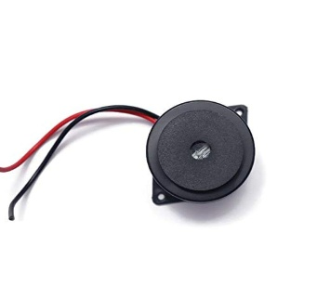
Fig 14 Buzzer
A buzzer is an essential alert mechanism in industrial automation systems, designed to provide immediate auditory feedback or warnings in critical situations. In environments such as refineries, where monitoring parameters like temperature, pressure, gas concentration, or liquid levels is crucial, the buzzer serves as a real-time alarm to draw attention to abnormal or hazardous conditions.
IV. SOFTWARE USED

A.Embedded C++ :
Embedded C++ is a programming language tailored for developing software in embedded systems. It combines the power of C with object-oriented programming features, making it ideal for managing hardware and software integration. The language allows for modular and reusable code, improving development efficiency. Embedded C + + is widely used in microcontroller programming, enabling direct manipulation of hardware registers and peripherals.
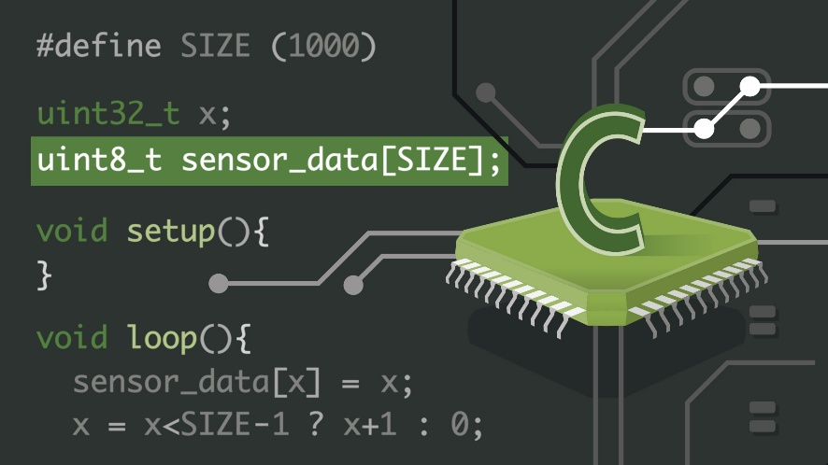
Fig 15 Embedded C++

Its low-level control and high execution speed make it suitable for real-time applications. Despite its advanced capabilities, it remains lightweight, ensuring optimal performance on resource-constrained devices. Embedded C ++ is a key tool for creating robust and scalable embedded solutions.

B.Arduino IDE :
The Arduino Integrated Development Environment (IDE) is a user-friendly platform for programming and uploading code to Arduino boards. It supports a simplified C/C++ language structure, making it accessible to beginners while powerful enough for advanced users. The IDE features a rich library ecosystem, enabling easy integration of sensors, actuators, and communication modules. Its serial monitor allows real-time debugging and interaction with connected hardware.
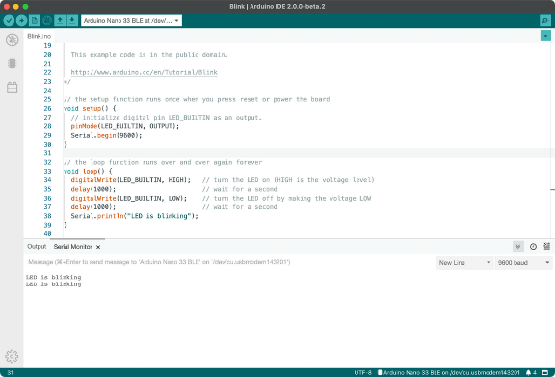
Fig 16 Arduino IDE

C.Visual Basic (GUI) :
Visual Basic is a programming language and environment developed by Microsoft that is commonly used for designing graphical user interfaces (GUIs ). It allows developers to create interactive applications with drag-and-drop components and event-driven programming. VB is ideal for automation systems where a user-friendly interface is needed to monitor and control processes. Its compatibility with hardware controllers and databases makes it suitable for industrial applications.
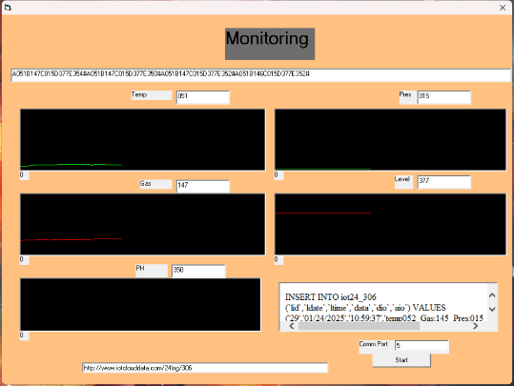
Fig 17 Visual Basic GUI
D.IoT Cloud:
IoT Cloud platforms provide a centralized solution for managing and analyzing data from Internet of Things ( IoT ) devices. These platforms enable real-time monitoring, remote control, and data storage for connected devices. With support for protocols like MQTT and HTTP, IoT Cloud facilitates seamless communication between sensors, actuators, and applications. It often includes features like dashboards, analytics, and automation workflows, enhancing system functionality.

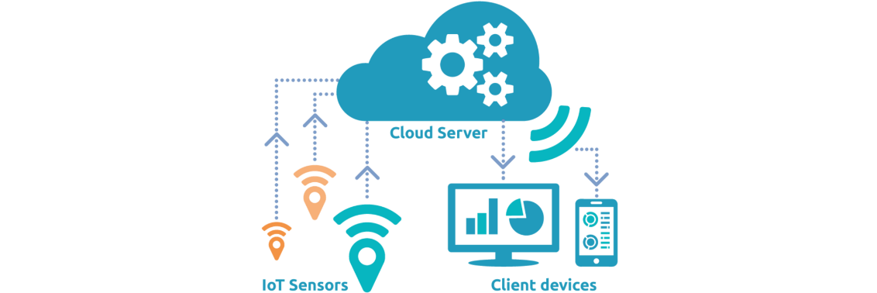

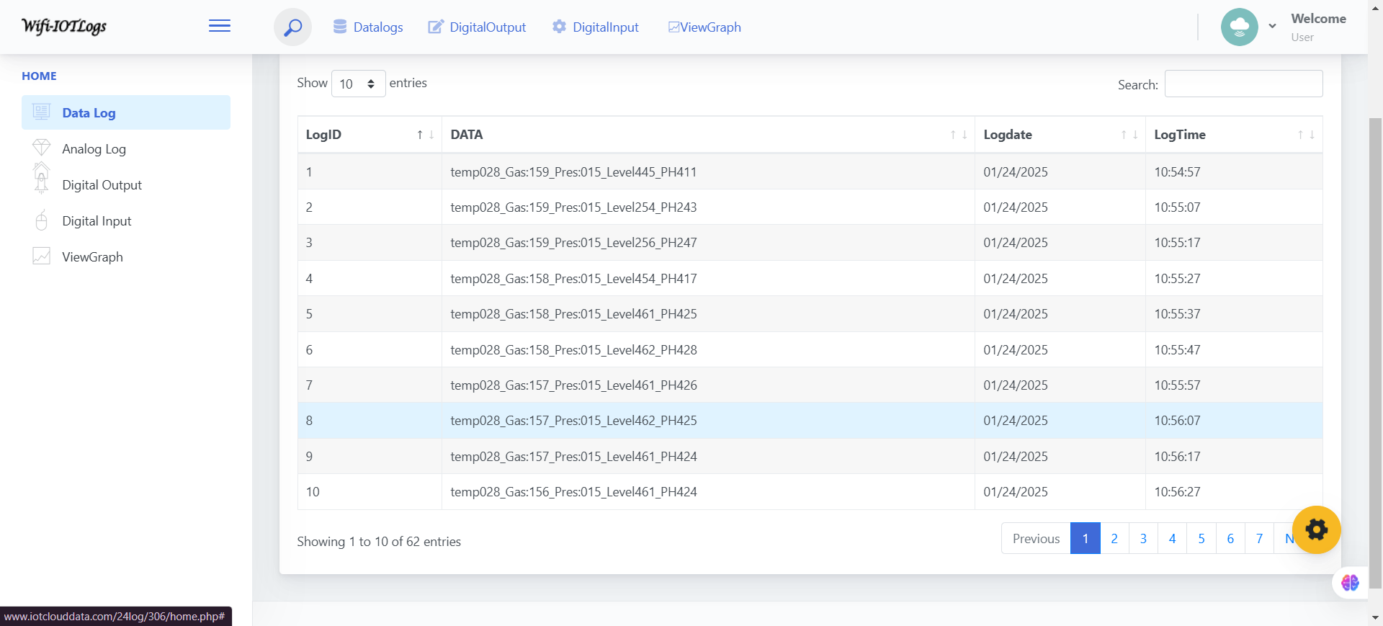
Fig 18 IOT Cloud
We can able to monitor all the data in www.iotclouddata.com and it feed all the data by separate time of interval with date and time. It secured to use and it also have login id and password for the user.

V. BLOCK DIAGRAM :
Refinery side :
LoRa Transmitter
se
LCD
se

UART
se
Temperature Sensor
se

Buzzer
se
Pressure Sensor
se
Ph Sensor
se
Level Sensor
se

Relay Driver
se

Relays
se
Gas Sensor
se

Cooling Fan
se

Pump Motor
se

Solenoid Valve
se

B.Controller side :
IoT and Cloud Storage

LORA Receiver
UART
PC with GUI
Arduino
UNO
Atmega328
VI. RESULT :

The proposed system focuses on leveraging the capabilities of LoRa (Long Range) technology and IoT (Internet of Things) to revolutionize refinery monitoring and automation processes. Refineries deal with complex operations involving multiple parameters such as temperature, pressure, gas concentration, liquid levels, and pH, all of which need precise monitoring and control for efficient and safe operation. This project integrates advanced sensors and IoT frameworks to create a real-time, cost-effective, and reliable solution for refinery management.
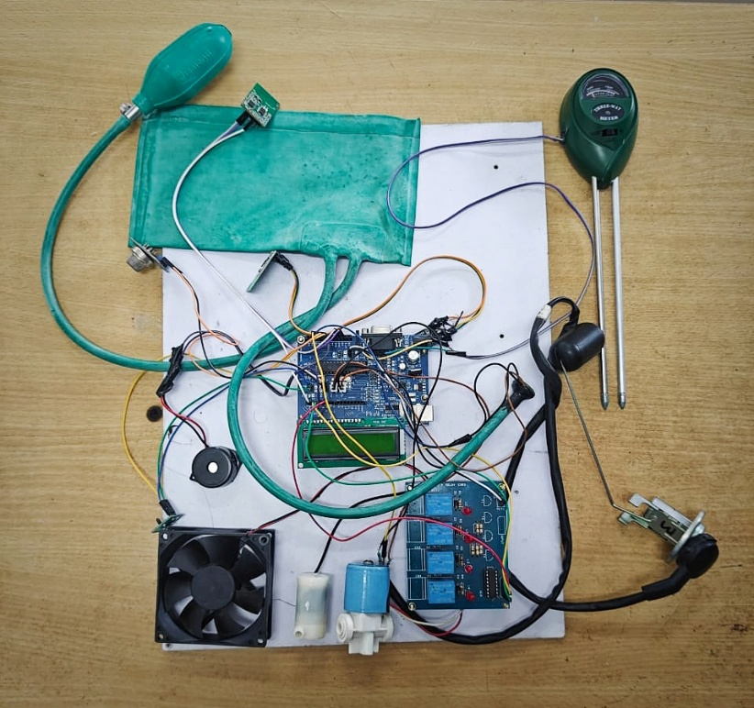
Fig 19 Project Image

Steps to initiate our project :
Step 1: Software and GUI
- In the first step we need to install the driver software for Lora Receiver connection and install the Visual basic GUI software for monitoring.
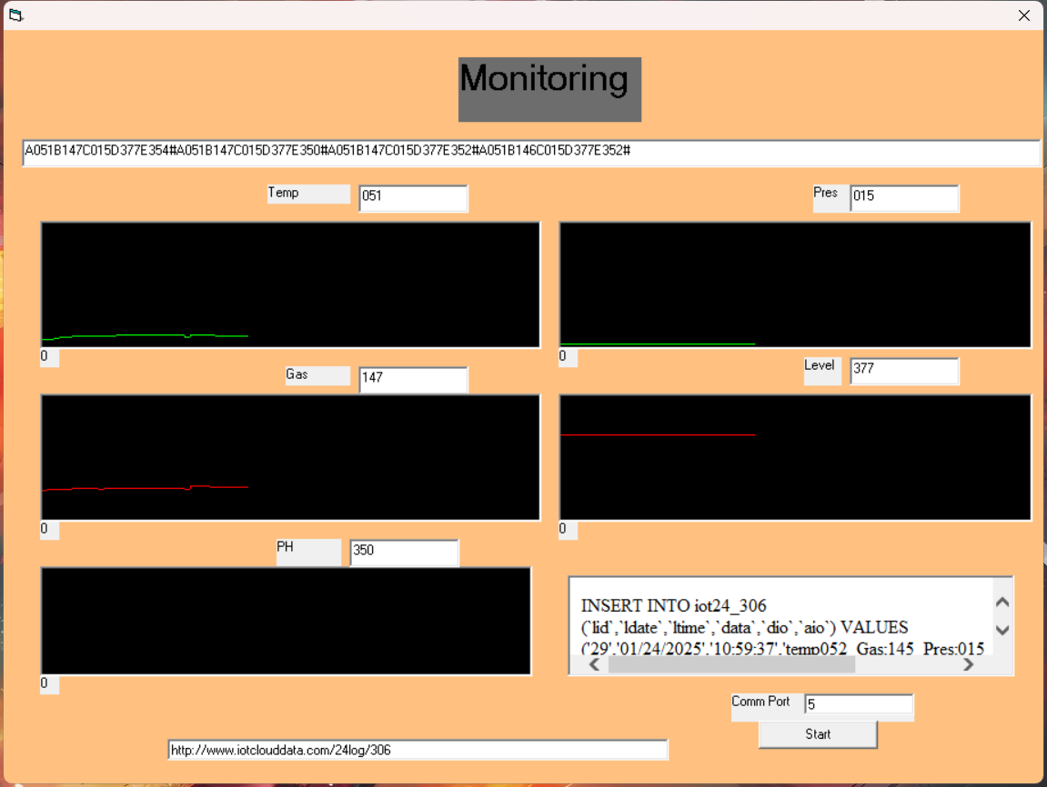
Fig 20 Visual Basic GUI
- Connect the Lora Receiver with the laptop and click the start button on the bottom of the software to start the monitoring process and it also have the IOT cloud website link for view all the data.
Step 2: Monitor the Temperature Controlling process
- In our project we use the Temperature Sensor (LM35) to measure the environmental temperature and we use the Lighter to create artificial heat for sensor. 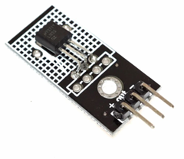
Fig 21 Temperature Sensor and Cooling Fan

- When the sensor notes the temperature is above 40°C, it turn on the Cooling fan until the temperature is less than 40°C and we can change temperature level in program.
Step 3: Monitor the Pressure Controlling process
- In this pressure controlling process, we use the Pressure Sensor MPX5050 to sense the pressure and it attached with the pressure cuff and inflation blub to increase the pressure.
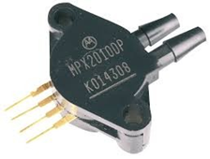
Fig 22 Pressure Sensor and Solenoid valve

- We press the inflation blub to increase pressure level and the pressure level is high and turn on the Solenoid Valve to reduce the pressure.

Step 4: Monitor the Level Controlling process

- Ball type level sensor helps to sense the level of the any liquid in tank. It floating in the liquid tank and measure the liquid level and we have a pump to increase the liquid level, when its low.
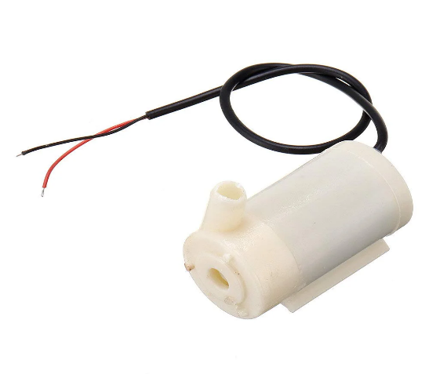
Fig 23 Level sensor and Pump
- When the level of the liquid is low it goes to turn on the pump to increase the liquid level and it turn of automatically.

Step 5: Process for hazardous gas alarm system

- We use the Gas Sensor (MQ02) in our project to sense the hazardous gas and give the alert to the plant. We have a Buzzer to give a sound alert.
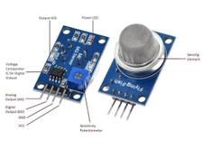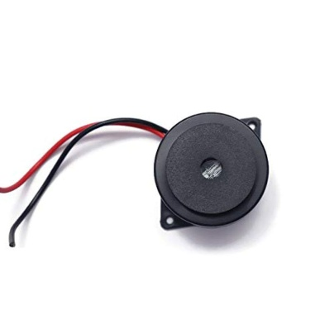
Fig 24 Gas sensor and Buzzer

- Turn on the fire lighter and off the flame and show the gas near to the gas sensor.

Step 6: Process for hazardous gas alarm system

- We use the Ph sensor to sense the Ph level of the liquid and we can also view in graphical representation.
Fig 25 Ph Sensor

Step 7: Monitor all the data in Visual basic GUI and IOT cloud

- In this project we can use graphical user Interface to monitor all the data of temperature, level, pressure, gas, Ph with the graphical representation

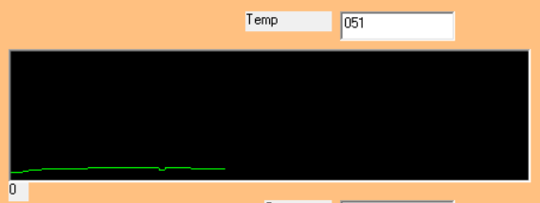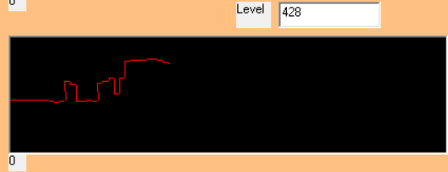
Temperature sensor output Level sensor output

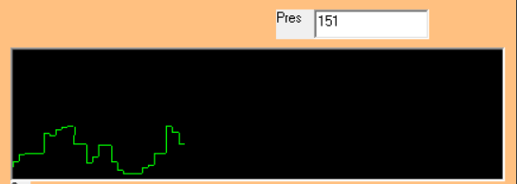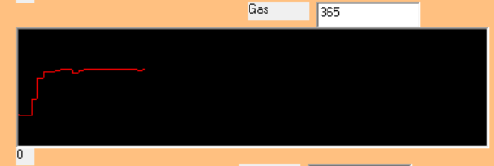
Pressure Sensor output Gas Sensor output

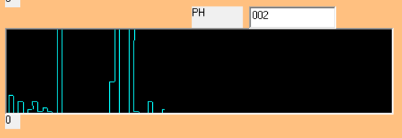
Gas Sensor output

- In GUI we can monitor the current value of the sensor and compare with the past values by the graphical representation of the past data.
- It have the different colour for different sensor values and it helps to make the GUI user friendly.
- In the bottom of the GUI have the IOT cloud website link to monitor the all the sensors output by time and date.

Fig 26 IOT cloud website

- In the IOT cloud website, we have login id and password for security purpose. Only we can login with the login id and password in the website.
- The data in the website is like tem028_Gas150_Pres020_Level460_PH07 and it have the date and time in it.
Step 8: Monitor Sensor readings in Refinery side

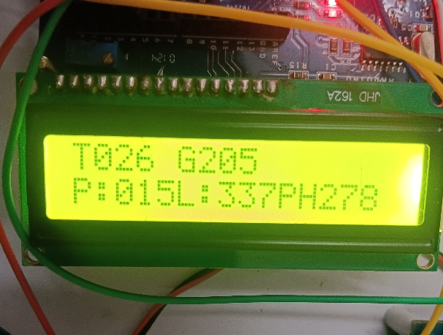
Fig 27 Digital display
- In Lora Transmitted side we have the Digital display for monitor all current sensor data and it helps for the user in refinery.

VII. ADVANTAGES

The proposed system offers a wide range of advanced features to enhance refinery operations, focusing on efficiency, safety, and sustainability. One of its primary strengths is real-time monitoring , which enables continuous tracking of critical parameters such as temperature, pressure, liquid levels, gas leakage, and pH. This feature ensures immediate detection and response to anomalies, minimizing risks and maintaining operational stability. The integration of automated control mechanisms further reduces the need for manual interventions, improving efficiency and minimizing the likelihood of human error in operational adjustments. This contributes significantly to the system's reliability in managing complex processes.
A key focus of the system is enhanced safety, achieved through immediate alerts in case of gas leakage and the implementation of automated safety controls to protect workers and equipment. The inclusion of predictive maintenance capabilities powered by AI and ML algorithms takes operational efficiency to the next level by forecasting equipment failures and scheduling maintenance proactively, thereby reducing downtime and extending the lifespan of critical machinery. To support large-scale refinery setups, LoRa technology is employed for long-range, low-power communication, enabling seamless data transmission over extended distances, making it especially suitable for expansive industrial sites.
Another highlight of the system is its data visualization capabilities, which provide operators with an intuitive graphical interface for real-time insights into system performance and alerts. This not only enhances situational awareness but also supports faster and more informed decision-making. The system is designed with scalability in mind, allowing the integration of additional sensors and functionalities to meet evolving operational demands. Its energy-efficient design, which includes automated control of cooling and pumping systems, optimizes energy use and reduces operational costs, aligning with modern sustainability goals.
The system also incorporates comprehensive data logging, capturing historical data for trend analysis and informed decision-making, enabling continuous process improvements. By streamlining monitoring and control processes, it promotes improved resource utilization, ensuring overall efficiency in refinery operations. Furthermore, remote monitoring capabilities empower operators to oversee operations from a distance, reducing the need for physical presence and associated safety risks in hazardous environments. The system’s customizable alert settings allow it to be tailored to specific operational thresholds, enhancing responsiveness to changing conditions and ensuring critical actions are taken promptly.
Overall, the proposed system combines cutting-edge technologies and thoughtful design to create a robust, flexible, and efficient solution for modern refinery operations, addressing both current challenges and future scalability requirements.

VIII. DISADVANTAGES

Traditional refinery monitoring and control systems face numerous limitations that hinder their efficiency, safety, and adaptability. A significant challenge is the reliance on manual processes for monitoring and interventions, which introduces the risk of human errors and delayed responses to critical issues. This reliance not only compromises accuracy but also reduces the speed of addressing operational anomalies. Compounding this problem is the use of outdated technology in many systems, such as legacy sensors and equipment, which often provide limited or inaccurate data. This lack of reliable information severely impacts decision-making, as operators are unable to base their actions on precise, real-time insights.
Another major limitation is the absence of real-time data in existing systems. Without continuous monitoring, it becomes difficult to detect and address problems promptly, leading to prolonged downtime and inefficiencies. The issue is further exacerbated by data silos, where fragmented systems result in disconnected data sources that hinder comprehensive analysis and holistic decision-making. This lack of integration between different components makes it challenging to gain a complete picture of operations, affecting overall performance and resource management.
Traditional systems also lack remote access capabilities, requiring operators to be physically present to monitor and control processes. This limitation not only increases safety risks in hazardous environments but also restricts operational flexibility. Furthermore, inefficient operations stemming from manual adjustments for critical tasks like cooling and pressure control result in unnecessary energy consumption, increased downtime, and higher operational costs. The inability to automate these tasks contributes to suboptimal performance and prevents refineries from meeting modern efficiency standards.
Another critical shortfall is the absence of predictive maintenance features in many traditional systems. Without predictive analytics, equipment failures can occur unexpectedly, leading to costly repairs, production losses, and extended downtime. Existing systems also often suffer from delayed safety alerts, which compromise worker safety and slow down emergency response times, increasing the risk of accidents.
Moreover, poor data visualization capabilities in conventional setups make it difficult for operators to interpret complex data effectively, limiting their ability to make timely and informed decisions. Lastly, scalability issues are a common concern, as many legacy systems are not designed for seamless upgrades or integration with emerging technologies. This restricts their adaptability to evolving industrial needs, leaving them ill-equipped to support future growth and innovation.
These limitations highlight the urgent need for modernized, integrated solutions that address the shortcomings of traditional systems, paving the way for safer, more efficient, and adaptable refinery operations.

VIII. CONCLUSION

This project demonstrates the integration of advanced sensors, actuators, and communication technologies to create a robust and scalable automation system. By utilizing components like the LM35 temperature sensor, MPX5050 pressure sensor, ball-type level sensor, MQ02 gas sensor, and pH sensor, the system ensures comprehensive environmental monitoring and control. The Arduino UNO serves as the central processing unit, effectively interfacing with sensors, relays, motors, pumps, and solenoid valves for seamless operation.
The inclusion of LoRa transceivers enables long-range wireless communication, enhancing the system's adaptability to remote and distributed setups. The user interface, developed with tools like Visual Basic and Arduino IDE, provides an intuitive platform for real-time monitoring and management. Leveraging Embedded C++ ensures efficient and reliable programming for hardware-level control, while IoT Cloud integration opens avenues for remote access, data logging, and intelligent automation.
This project not only highlights the potential of modern automation technologies in industries like refineries but also emphasizes the importance of scalability, efficiency, and user-centric design in engineering solutions. It serves as a foundation for further advancements in industrial automation, contributing to smarter, safer, and more efficient processes.

IX. REFERENCE

Y . Zhao, F . Zhang, and T . Wang, “IoT -Based Smart Refinery: Automation and Real-Time Monitoring Solutions,” IEEE Internet of Things Journal, vol. 9, no. 1, pp. 75-83, Jan. 2022. DOI: 10.1109/JIOT.2021.3095264.
R. Kumar, M. Gupta, and L. Chen, “Machine Learning Techniques for Predictive Maintenance in Refinery Operations,” IEEE Transactions on Industrial Informatics, vol. 18, no. 5, pp. 3481 -3490, May 2022. DOI: 10.1109/ TII.2021.3090293.
H. Patel and A. Mehta, “Smart Monitoring Systems in Refineries: An IoT Approach,” IEEE Access, vol. 10, pp. 12345 -12355, 2022. DOI: 10 .1109 /ACCESS .2022. 3156789.
J. Lee, S. Kim, and P. Nguyen, “Implementation of AI for Safety Monitoring in Chemical Refineries,” IEEE Transactions on Automation Science and Engineering, vol. 19, no. 3, pp. 1874 -1885, July 2022. DOI : 10.1109/ TASE.2022.3142123.
F. Tran, D . Pham, and S. Lee, “LoRa Technology for Long-Range Communication in Industrial IoT Applications,” IEEE Sensors Journal, vol. 22, no. 2, pp. 675-684, Feb. 2022. DOI: 10.1109/JSEN.2021.3105120.
K. Singh and R. Jain, “Automated Control Systems for Refineries Using IoT and Machine Learning,” IEEE Transactions on Control Systems Technology, vol. 30, no. 4, pp. 1502-1515, July 2022. DOI: 10.1109/TCST.2021. 3056149.
L. Huang, M. Zhang, and J. Liu, “Gas Leakage Detection Systems in Refineries: A Review of Current Technologies,” IEEE Transactions on Industrial Electronics, vol . 69, no . 6, pp . 6435 -6444, June 2022. DOI: 10.1109/TIE.2022.3147856.
R. Martin, A. Patel, and Y. Chen, “Data-Driven Decision Making in Smart Refineries: The Role of AI,” IEEE Transactions on Engineering Management, vol. 69, no. 3, pp . 889 -900, Sept . 2022. DOI : 10 .1109 /TEM .2021. 3089431.
M . Lopez and E . Garcia, “ Optimizing Energy Consumption in Refinery Operations Through IoT Solutions,” IEEE Transactions on Sustainable Energy, vol. 13, no. 1, pp. 123-132, Jan. 2022. DOI: 10.1109/TSTE. 2021.3057864.
A . Kumar and P . Roy , “Enhancing Refinery Safety Protocols Using IoT and Machine Learning ,” IEEE Transactions on Safety, Security, and Rescue Technology , vol . 3, no . 2, pp . 210 -220 , Apr . 2022 . DOI: 10 .1109 / TSRT.2021.3132234.

