Analysis of Image Classification using SVM and CNN

1st Aditya Pandey

*School Of Computer Application And Technology*  
*Galgotias University*Greater Noida, India

2nd Tejang  
*School Of Computer Application And Technology* *Galgotias University*Greater Noida, India

3rd Vedant Singh  
*School Of Computer Application And Technology*  
*Galgotias University*Greater Noida, India

4th Mr. Rahul Swami  
*Assistant Professor*  
*Galgotias University*Greater Noida, India

***Abstract—*** ***In today's digital age, face recognition technologies are critical in a variety of industries. Face recognition is one of the most common biometric systems, used for security, authentication, and identification, among other purposes. Although less accurate than iris and fingerprint detection, face recognition is popular due to its contactless and non-invasive nature. Additionally, facial recognition systems can help with attendance tracking in schools, colleges, and companies. This system intends to create a class attendance solution based on face recognition technology, addressing the inefficiencies of old manual attendance systems that are time-consuming and difficult to maintain, with the possibility of proxy attendance. The need for this automated system is clear. The system comprises four phases: database generation, face detection, face recognition, and attendance updating. The database is created from photographs of the pupils in the class. The Haar-Cascade classifier detects faces, while the Local Binary Pattern Histogram method recognizes them. Faces are detected and recognized from live streaming video in the classroom, and attendance records are transmitted to the appropriate faculty at the conclusion of each session.   
  
Keywords: face recognition, face detection, attendance system.***

INTRODUTION

The traditional method of marking attendance in schools and colleges is often tedious and burdensome for faculty members, as it requires them to manually call out students' names, typically taking about five minutes of the class session. In addition to taking a lot of time, there is a chance that proxy attendance will occur. To solve these concerns, many institutions have begun to use other methods of documenting attendance, such as Radio Frequency Identification (RFID), iris identification, fingerprint recognition, and so on. However, these systems frequently rely on queues, which can waste more time and be intrusive in nature.

Face recognition has evolved as a useful biometric function that is both accessible and non-intrusive. Face recognition systems are largely unaffected by various face expressions. These systems can be divided into two categories: verification and facial recognition. Face verification is a 1:1 matching process in which a face image is compared to template images, whereas face identification is a 1:N problem in which a query image is compared to a database containing many photos.

This system's goal is to create an attendance system using facial recognition technology. Each person's face will be utilized in this method to record attendance. At the moment, facial recognition is becoming more and more common. In this research, a system that recognizes students' faces from live classroom video streams is proposed. When a detected face matches a database entry, attendance is recorded. Compared to conventional techniques, this novel technology is intended to be more time-efficient.

LITERATURE SURVEY

The authors of [3] put forth a model for an automatic attendance system that combines Radio Frequency Identification (RFID) with facial recognition. In order to keep an accurate record of every registered student, this model counts authorized pupils as they enter and exit the classroom. The system also records attendance information for every student enrolled in a particular subject and supplies relevant data when required.   
The authors of a different study [4] created and put into use an iris biometric attendance system. First, attendees were requested to register their information and provide a unique iris template. The technology automatically took pictures of each person's eyes while they were there, identified their iris, and looked for a match in the database that was built. The initial version was web-based.

The authors of [5] suggested an attendance system based on facial recognition. They implemented their system using a Support Vector Machine (SVM) classifier and algorithms such as Viola-Jones and Histogram of Oriented Gradients (HOG) features. Scaling, illumination, occlusions, and stance changes were among the real-time scenarios that were taken into consideration. A MATLAB GUI was used to implement quantitative analysis based on Peak Signal-to-Noise Ratio (PSNR) measurements.   
  
The goal of the study in [6] was to compare Eigenface and Fisherface, two facial recognition algorithms offered by OpenCV 2.4.8. By using the Receiver Operating Characteristics (ROC) curve to assess their performance, the authors discovered that the Eigenface algorithm outperformed Fisherface. The accuracy rate of the system that used the Eigenface algorithm ranged from 70% to 90%.

The authors of [7] used Discrete Wavelet Transforms (DWT) and Discrete Cosine Transform (DCT) to offer a facial recognition-based approach for a classroom student attendance system. Following the extraction of facial features using these techniques, a Radial Basis Function (RBF) was employed for categorization. This system's accuracy rate was impressive.

Models:-

1. Support Vector Machine (SVM)

SVM is a supervised learning algorithm used for classification and regression tasks. It works by finding the optimal hyperplane that separates different classes in the feature space.

Characteristics:-

**Feature Engineering:-**SVM relies on manually extracted features (e.g., HOG, SIFT) from the input data. The choice of features significantly impacts the model's performance.

**Kernel Trick:-** SVM can use kernel functions (such as linear, polynomial, or RBF) to handle non- linearly separable data by mapping it to a higher- dimensional space.

**Robustness:-** SVM is effective in high- dimensional spaces and is particularly robust against overfitting, especially when the number of dimensions exceeds the number of samples.

Pros:

Good for Smaller Datasets:- SVM performs well with smaller datasets where fewer training examples are available.

Strong Theoretical Foundation:-It has a solid mathematical foundation and can provide interpretable results.

Less Memory Consumption:-SVM models can be memory-efficient, as they rely only on a subset of the training data known as support vectors.

Cons:

Feature Extraction Required:=SVM necessitates careful feature engineering, which can be time- consuming and may not generalize well.

Limited Scalability:-SVM can struggle with very large datasets due to higher computational costs during training.

1. Convolutional Neural Network (CNN)

CNNs are a class of deep learning models specifically designed for processing structured grid data, such as images. They utilize convolutional layers to automatically learn features from the data.

Characteristics:-

Automatic Feature Learning: CNNs automatically learn spatial hierarchies of features from raw images, eliminating the need for manual feature extraction.

Layered Architecture:-A typical CNN architecture consists of convolutional layers, pooling layers, and fully connected layers, which allows for deep representations.

Translation Invariance:-CNNs are designed to recognize patterns regardless of their position in the image, making them robust to translations and small distortions.

Pros:-

**High Accuracy:-**CNNs achieve state-of-the-art performance in various image recognition tasks, often surpassing traditional methods like SVM.

**Robust to Variations:-**They are more resilient to variations in lighting, pose, and occlusions, leading to better performance in real-world scenarios.

**Scalability:-**CNNs can efficiently handle large datasets and complex image data due to their architecture and the use of GPUs.

Cons:-

**Data Hungry:-**CNNs typically require large amounts of labeled data to train effectively.

**Higher Computational Resources:-**Training CNNs can be computationally intensive and requires significant memory and processing power.

**Less Interpretability:-**The deep learning nature of CNNs can make them less interpretable compared to traditional models

Summary Comparison Table:-

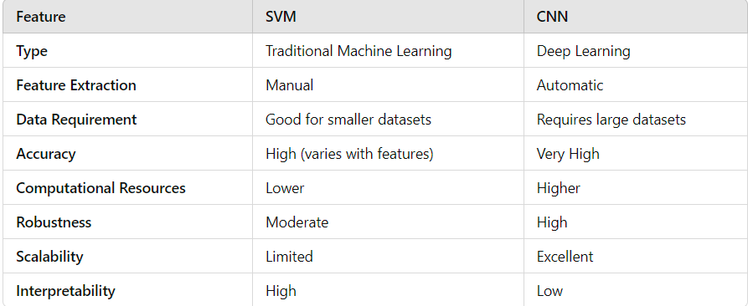

Use Cases:-

SVM (Support Vector Machine):-Ideal for smaller datasets with clearly defined features. Common applications include text classification and certain image recognition tasks in controlled environments.

CNN (Convolutional Neural Network):Best suited for large-scale image recognition tasks, video analysis, and applications that require robustness against different image conditions, such as face recognition and object detection.

Accuracy and Error Rate Comparison:-

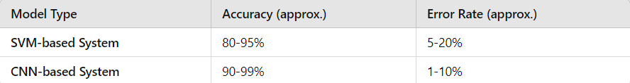

Explanation of Values

SVM-based System:-

Accuracy:-The accuracy of Support Vector Machines (SVM) can reach up to 95% in controlled environments with well-engineered features. However, it may drop to around 80% in complex scenarios with variations in lighting, pose, and background.

Error Rate:-The error rate for SVM can range from 5% to 20%, depending on the quality of the features and the variability of the dataset.

CNN-based System:-

Accuracy:-Convolutional Neural Networks (CNNs) generally achieve higher accuracy, often reaching 90% or more, and in some cases, up to 99% on challenging datasets with robust training. They are especially strong in real-world applications where variations are present.

Error Rate:-CNNs typically have a lower error rate, ranging from 1% to 10%, making them more reliable for complex and variable conditions.

Experimental Section:

All students in the class must register by entering the required details, after which their images will be captured and stored in a dataset. During each session, faces will be detected from live streaming video in the classroom. The detected faces will be compared with the images in the dataset. If a match is found, attendance will be marked for the respective student. The faculty member in charge of the session will get an email with the list of those who did not show up at the end of each session. The architecture of the system is made to guarantee accurate and efficient attendance tracking.

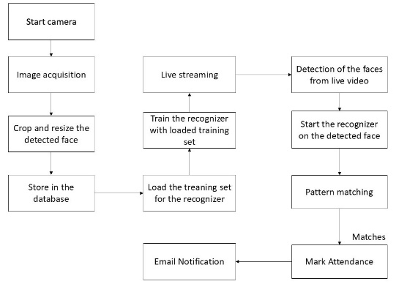

Figure 1: System Architecture   
  
Usually, there are four steps in this process:

***Creation of Datasets***

***A webcam is used to take pictures of the students. Every pupil is photographed several times, displaying a range of motions and viewpoints. The first step in pre-processing these photos is cropping them in order to determine the Region of Interest (ROI) for the recognition procedure. The clipped photos must then be resized to a particular pixel size. The pictures are then transformed from RGB to grayscale. The processed photos are then saved in a specific folder with the pupils' names written on it.***

# Identification of faces

The Haar Cascade Classifier using OpenCV is used to detect faces. To properly identify human faces, the Haar Cascade algorithm needs to be trained—a procedure called feature extraction. For Haar Cascade, the training data is an XML file called "haarcascade_frontalface_default." For feature extraction, the Haar features shown in Fig. 2 will be used

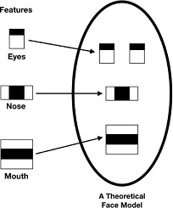

Figure 2: Haar Features

The `detectMultiScale` function from OpenCV is used in this system to draw rectangles around faces in an image. Three parameters are needed for this function: `scaleFactor`, `minNeighbors`, and `minSize`.

scaleFactor determines the factor by which the image is reduced at each scale.

minNeighbors specifies the number of neighboring rectangles each candidate rectangle must have to be considered a valid detection. Typically, higher values result in detecting fewer faces but with greater accuracy and quality.

minSize indicates the minimum size of the object to be detected, which defaults to (30, 30).

In our implementation, we have set the

`scaleFactor` to 1.3 and `minNeighbors` to 5.

# Face Recognition

The face recognition process can be divided into three main steps: preparing training data, training the face recognizer, and making predictions. The training data consists of images from the dataset, each assigned an integer label corresponding to the student it represents. These images are then used for face recognition.

The face recognizer employed in this system is the Local Binary Pattern Histogram (LBPH). Initially, a list of Local Binary Patterns (LBP) for the entire face is obtained. These LBPs are converted into decimal numbers, and histograms of all these decimal values are created. As a result, one histogram is generated for each image in the training data.

During the recognition process, the histogram of the face to be recognized is calculated and compared with the precomputed histograms. The system then returns the label that best matches the student it corresponds to.

**Attendance** Updation

After the face recognition process, recognized faces will be marked as present in the Excel sheet, while others will be marked as absent. Faculty members will receive an updated monthly attendance sheet at the end of each month.

**OUTCOMES AND CONVERSATIONS**

Users can interact with the system through a graphical user interface (GUI). The main options available are student registration, faculty registration, and marking attendance.

For student registration, students need to fill out the required details in the registration form. Once they click the register button, the webcam activates automatically, and a window will pop up (as shown in Fig. 3) to start detecting faces in the frame. The system will capture photos until it collects 60 samples. These images will then be pre-processed and stored in the training images folder.

In the faculty registration section, faculty members need to register by providing their course codes and email addresses. This information is essential, as the list of absentees will be emailed to the respective faculty members.

|  |  |  |  |
| --- | --- | --- | --- |
| Data | Model Type | Accuracy(approx.) | Error Rate(approx.) |
|  | SVM-based system | 80-95 | 5-20% |
|  | CNN-based system | 90-95 | 1-10% |

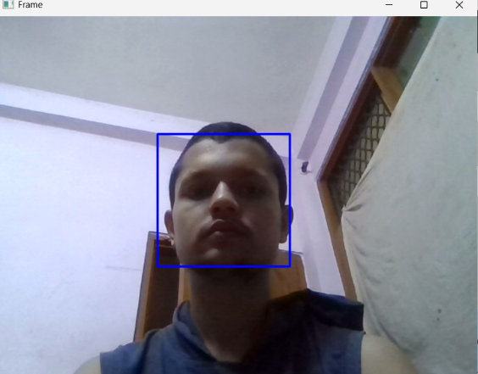

Figure 3: Face identification

Faculty members must enter their course code throughout each session. The camera will turn on automatically after the course code is entered. Two enrolled students are identified in the facial recognition window (Figure 4). To indicate that a student is not registered, the screen will read "unknown."

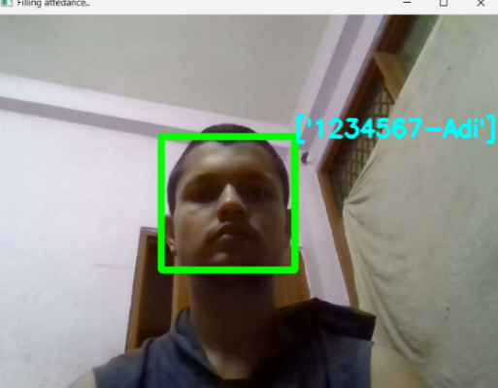

Figure 4: Identification of faces

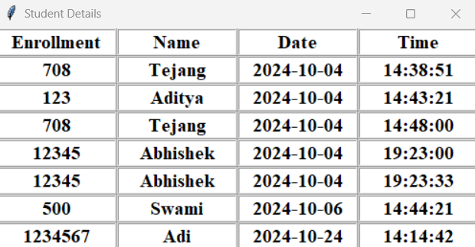

Figure 5: Attendance record

The attendance sheet is updated following the recognition process in Fig. 5.

CONCLUSION

The goal of this system is to use facial recognition technology to create an efficient class attendance system. By using a student's face traits to identify them, the suggested system will record attendance. It will use a webcam to detect faces, identify the people, and then record each identified student's attendance, updating the attendance records as necessary.

REFERENCES

1. https://www.researchgate.net/publication/326261079_Face_detection_ system_for_attendance_of_class’_stnts
2. Hapani, Smit, et al. "Automated Attendance System Using Image Processing." 2018 Fourth International Conference on Computing Communication Control and Automation (ICCUBEA). IEEE, 2018.
3. Akbar, Md Sajid, et al. "Face Recognition and RFID Verified Attendance System." 2018 International Conference on Computing, Electronics & Communications Engineering (iCCECE). IEEE, 2018.
4. Okokpujie, Kennedy O., et al. "Design and implementation of a student attendance system using iris biometric recognition." 2017 International Conference on Computational Science and Computational Intelligence (CSCI). IEEE, 2017.
5. Rathod, Hemantkumar, et al. "Automated attendance system using machine learning approach." 2017 International Conference on Nascent Technologies in Engineering (ICNTE). IEEE, 2017.
6. Siswanto, Adrian Rhesa Septian, Anto Satriyo Nugroho, and Maulahikmah Galinium. "Implementation of face recognition algorithm for biometrics based time attendance system." 2014 International Conference on ICT For Smart Society (ICISS). IEEE, 2014.
7. Lukas, Samuel, et al. "Student attendance system in classroom using face recognition technique." 2016 International Conference on Information and Communication Technology Convergence (ICTC). IEEE, 2016.
8. https://becominghuman.ai/face-detection-using-opencv-with-haar cascade-classifiers-941dbb25177
9. <https://www.superdatascience.com/blogs/opencv-face-recognition>
10. Salim, Omar Abdul Rhman, Rashidah Funke Olanrewaju, and Wasiu Adebayo Balogun. "Class attendance management system using face recognition." 2018 7th International Conference on Computer and Communication Engineering (ICCCE). IEEE, 2018.