Adaptive Agile Workspace Management System

Ms. Suganya M Associate Professor
Department of Computer Science and Engineering
T John Institute of Technology
Bengaluru, India mssuganya2015@gmail.com

Ambooj Kumar Sharma
Department of Computer Science and Engineering
T John Institute of Technology
Bengaluru, India
amboojsharma8052@gmail.com
Piyush Raj
Department of Computer Science and Engineering
T John Institute of Technology
Bengaluru, India
piyushraj9122@gmail.com

Siddharth Menon
Department of Computer Science and Engineering
T John Institute of Technology
Bengaluru, India
deepasairaman5@gmail.com

Abstract— This system streamlines the process of booking workspaces in modern organizations, enabling employees to reserve desks, meeting rooms, conference rooms, or auditoriums for specific dates based on real-time availability. Developed with HTML, CSS, JavaScript, Node.js, and integrated with a MySQL database, it ensures efficient data storage and retrieval. Employees can securely sign up, log in, select workspace types, and confirm bookings, with the system generating unique reference numbers. Designed to adapt to evolving workplace needs, it supports dynamic office setups and hybrid work models, providing a seamless experience across desktops and mobile devices. The intuitive interface simplifies navigation, while real-time availability checks and automated processes improve workspace utilization and productivity. By reducing manual intervention, the platform enhances efficiency, ensures smooth workflows, and meets the demands of fast-paced organizational environments, making it an essential tool for modern workspace management.

- INTRODUCTION
The modern workplace is evolving as organizations adopt flexible strategies to optimize office spaces, addressing the need for efficient workspace allocation and resource management. Traditional methods often fail to meet the dynamic demands of agile work environments, leading to inefficiencies and increased administrative burdens. This research focuses on developing an Adaptive Agile Workspace Management System that integrates advanced algorithms and user-centric design to streamline workspace management. Key features include interactive floor maps, real-time booking updates, and dynamic data handling to improve resource utilization and booking experiences. The system follows a multi-phase methodology, starting with requirement analysis, followed by design, prototyping, and performance evaluation, incorporating user feedback throughout. Expected outcomes include enhanced workspace utilization, reduced workloads, and a more collaborative and productive work environment, maximizing office space value and boosting employee satisfaction.

- LITERATURE REVIEW
The workspace management field has evolved significantly with advancements in web technologies, transitioning from basic scheduling tools to comprehensive platforms for managing office resources. Earlier systems often lacked real-time availability checks, seamless user interfaces, and efficient database integration, limiting their scalability and usability. Recent studies emphasize the need for adaptive systems that cater to dynamic office environments and hybrid workplaces. Features such as secure access, real-time availability verification, and automated workflows have become crucial for improving workspace utilization and productivity. However, many existing systems fail to provide intuitive cross-device support and flexibility for evolving needs. The proposed system bridges these gaps with real-time availability checks, secure booking processes, and a user-friendly interface, ensuring a seamless experience for modern organizations.

METHODOLOGY
The system adopts a modular architecture to streamline workspace management, consisting of four key components: user authentication, workspace availability, booking management, and real-time updates. Employees securely sign up and log in, ensuring authenticated access. The workspace availability module checks real-time data to display unreserved desks, meeting rooms, conference rooms, or auditoriums. The booking management module processes reservations, assigns unique reference numbers, and stores data in a MySQL database for efficient retrieval. Real-time updates dynamically reflect changes in bookings, ensuring accurate availability information. An intuitive user interface integrates interactive features such as floor maps and device-responsive design for seamless navigation. This architecture ensures adaptability, scalability, and efficient resource utilization, addressing the evolving needs of dynamic workplaces while enhancing user experience and productivity.
                                  

RESEARCH DESIGN

The research design for the system utilizes a combination of qualitative and quantitative methods to evaluate its effectiveness and efficiency in workspace management. Source data includes user feedback, booking records, and system performance metrics. Key factors analyzed are workspace utilization rates, booking time efficiency, and user satisfaction. The study also assesses the impact of the system on administrative workload and overall employee productivity. A controlled testing environment simulates real-world conditions with varying user loads and booking scenarios to measure system responsiveness and reliability. User feedback is gathered through surveys and interviews, while statistical analyses are conducted to validate findings. This approach ensures a comprehensive evaluation of the system’s functionality, scalability, and adaptability in dynamic workplace environments.

TOOLS AND TECHNIQUES

The system leverages modern tools and technologies to provide an efficient and seamless workspace management experience. Data is managed using a MySQL database for secure storage and real-time retrieval of booking information. Backend operations are powered by Node.js and Express.js, ensuring reliable and scalable performance. The frontend is built with HTML, CSS, and JavaScript, offering an intuitive, responsive interface optimized for desktop and mobile devices. Real-time updates and availability checks are facilitated by RESTful APIs, while interactive floor maps enhance the user experience. Booking confirmations are generated dynamically with unique reference numbers. The integration of advanced web technologies and dynamic data handling ensures a robust framework for streamlined workspace booking and management processes.

PROCEDURE

Planning and Requirement Analysis:

- Identify user needs and define functional requirements for workspace booking.
- Analyze technical specifications, including database structure and real-time booking capabilities.

System Design:

- Create wireframes and UI/UX mockups for the platform using tools like Figma.
- Design the database schema in MySQL to manage users, workspaces, and bookings.

Backend Development:

- Develop server-side logic using Node.js and Express.js.
- Implement user authentication (signup/login) and real-time availability checks.
- Integrate the backend with the MySQL database for secure data storage and retrieval.

Frontend Development:

- Build an intuitive user interface using HTML, CSS, and JavaScript.
- Integrate the frontend with the backend using Node.js.

Testing and Debugging:

- Perform unit testing, integration testing, and usability testing to ensure functionality, reliability, and ease of use.

Deployment:

- Ensure proper configuration for scalability and security.

Documentation and Maintenance:

- Document the system’s features, architecture, database schema, and user guidelines.
- Ensure the system is scalable and remains compatible with new technologies and office workspace trends.

- EXPERIMENTAL RESULT

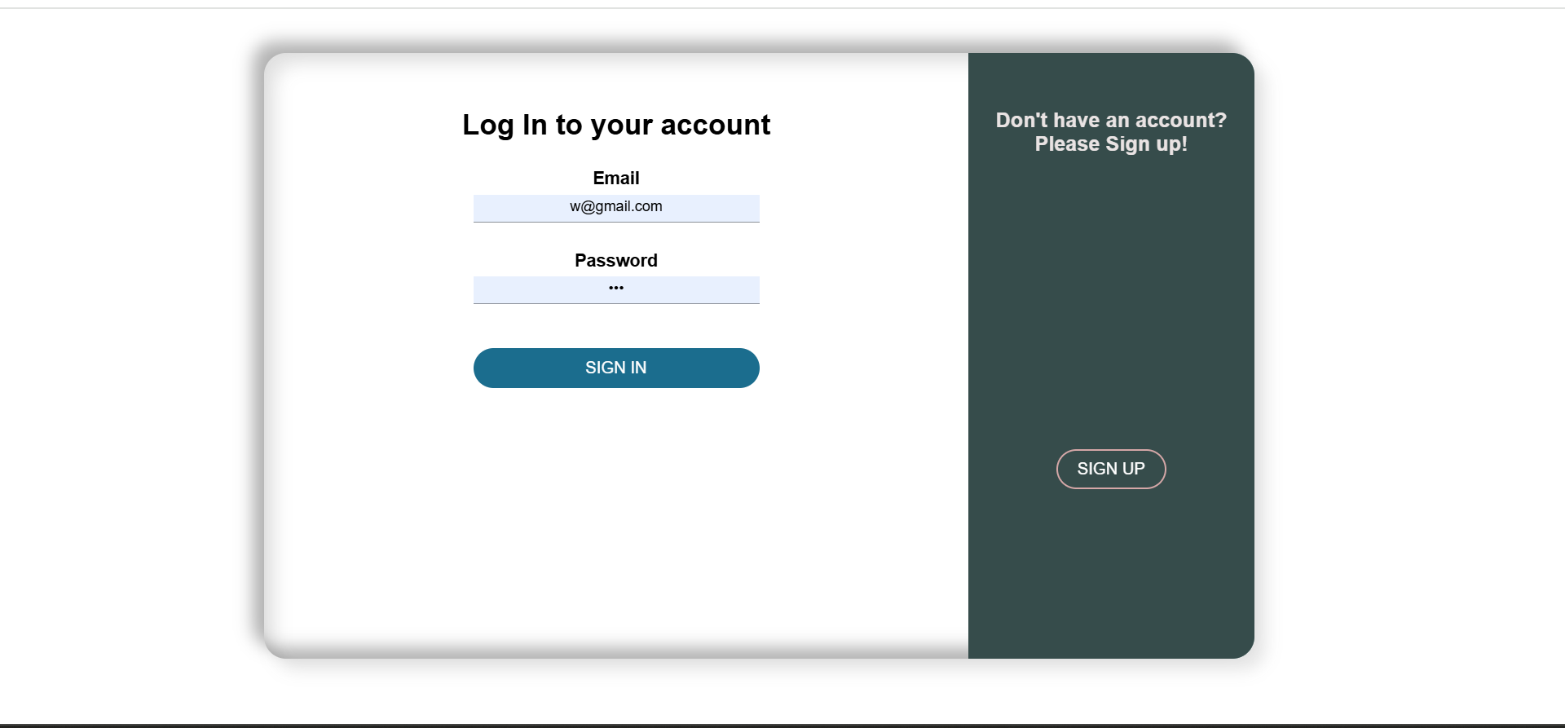

Fig : 7.1 Login Page

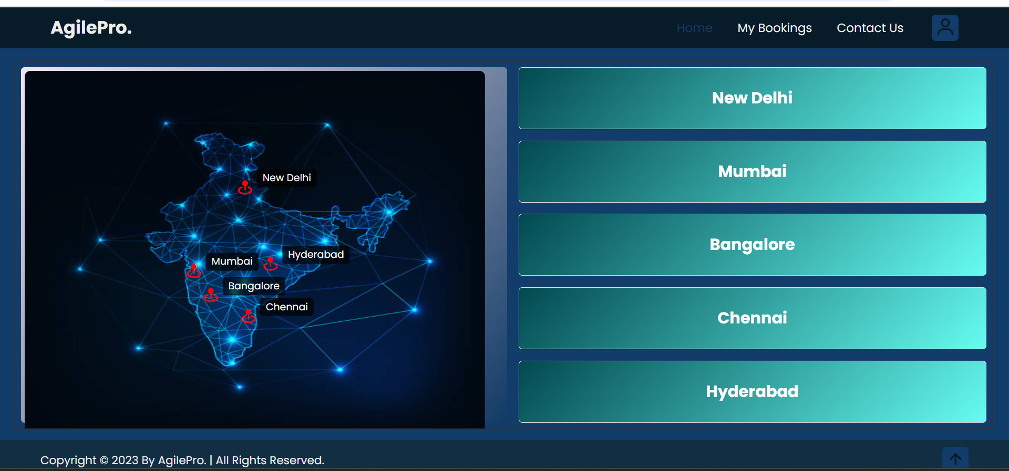

Fig: 7.2 Home Page
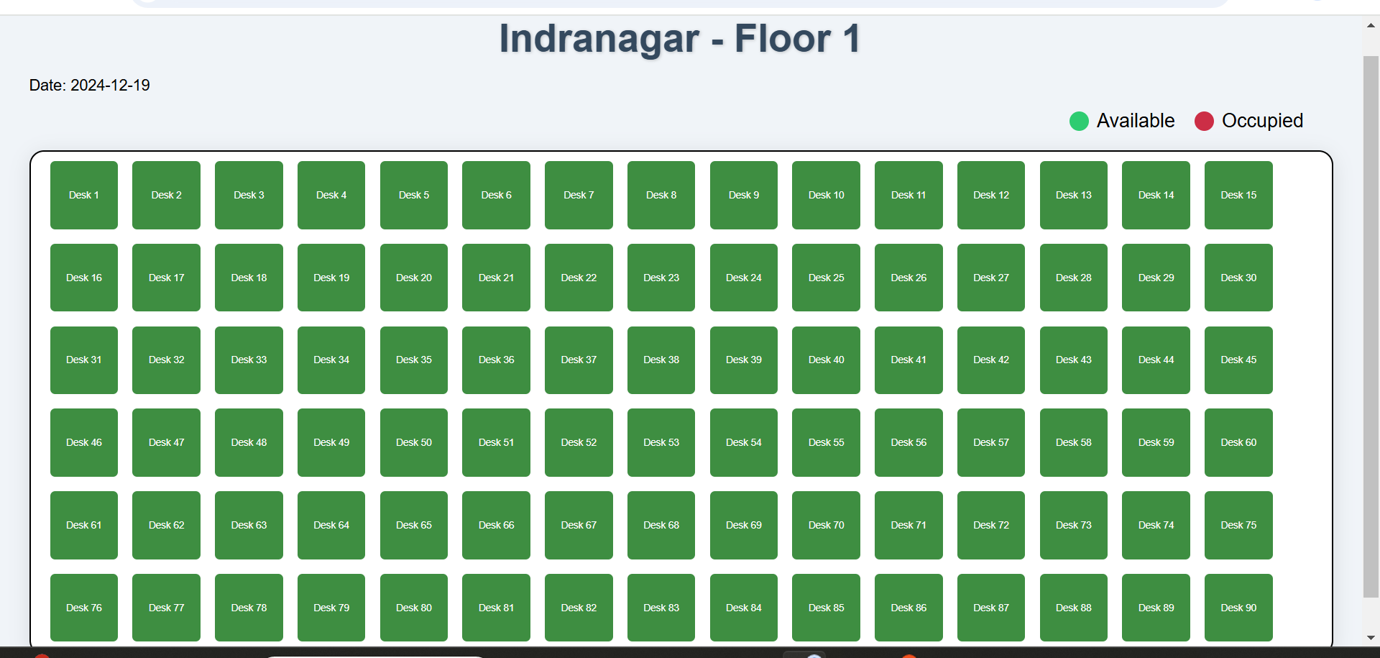

Fig: 7.3 Workspace Design 1

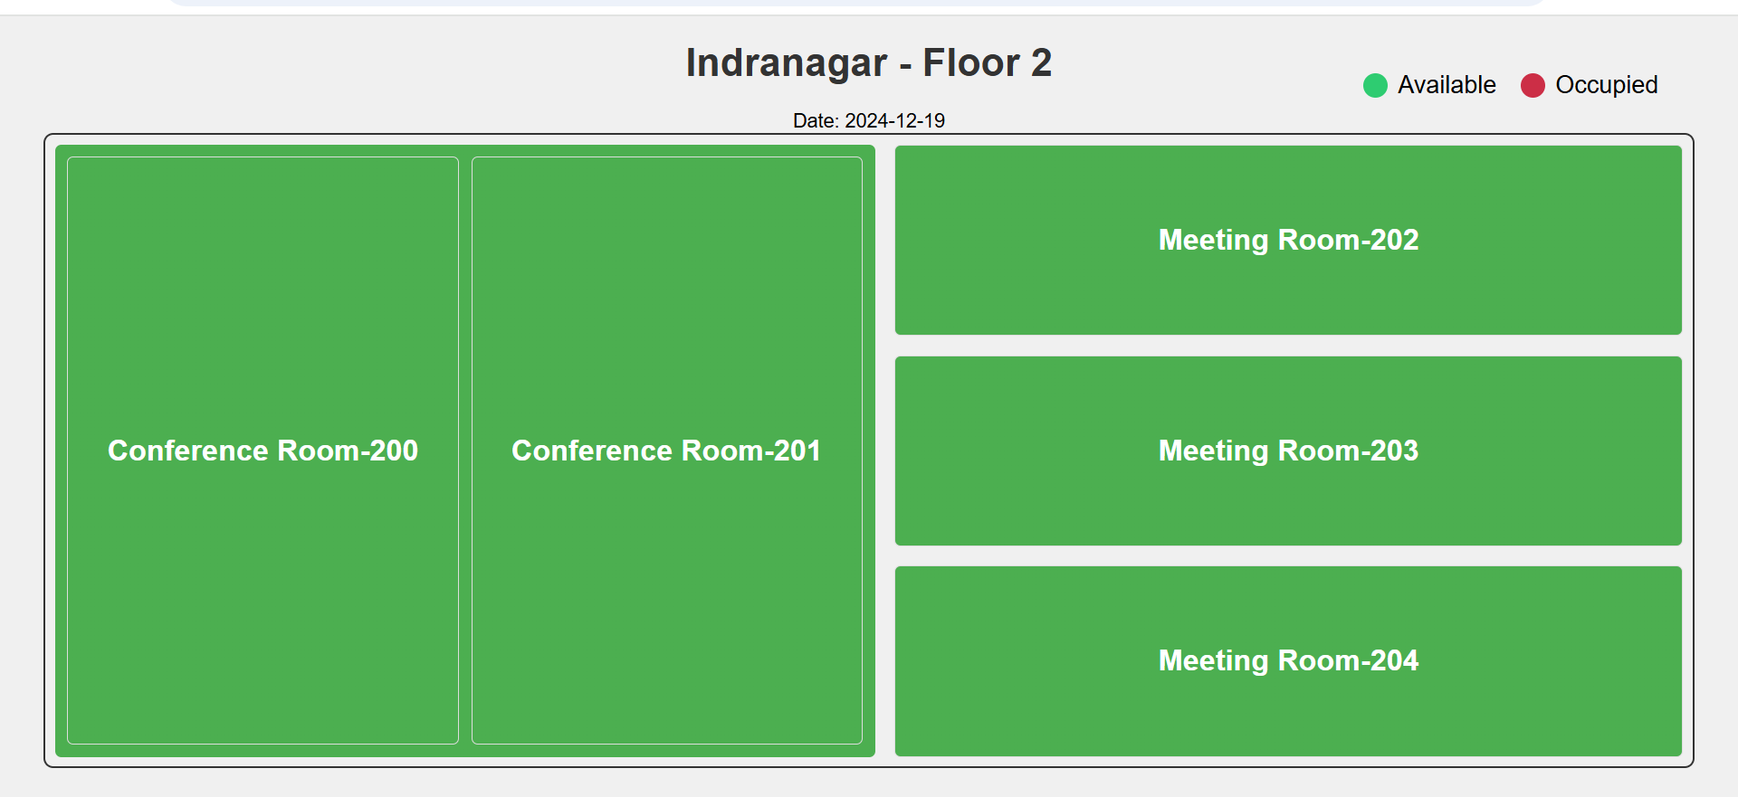

Fig: 7.4 Workspace Design 2

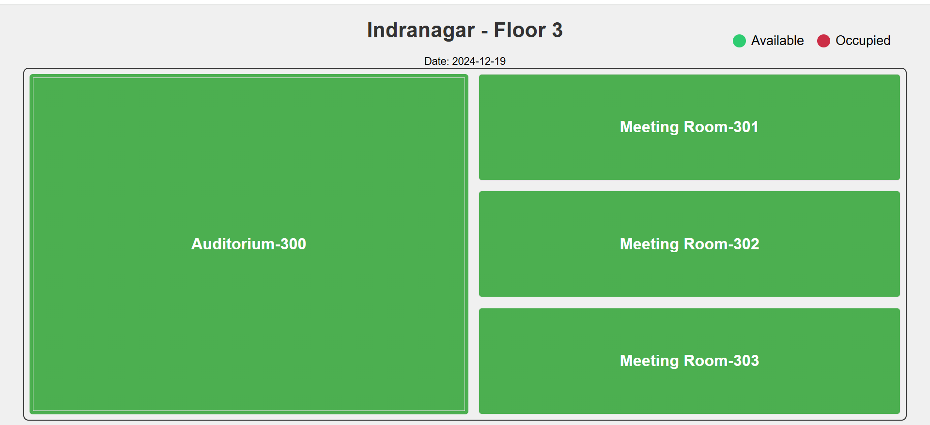

Fig: 7.5 Workspace Design 3

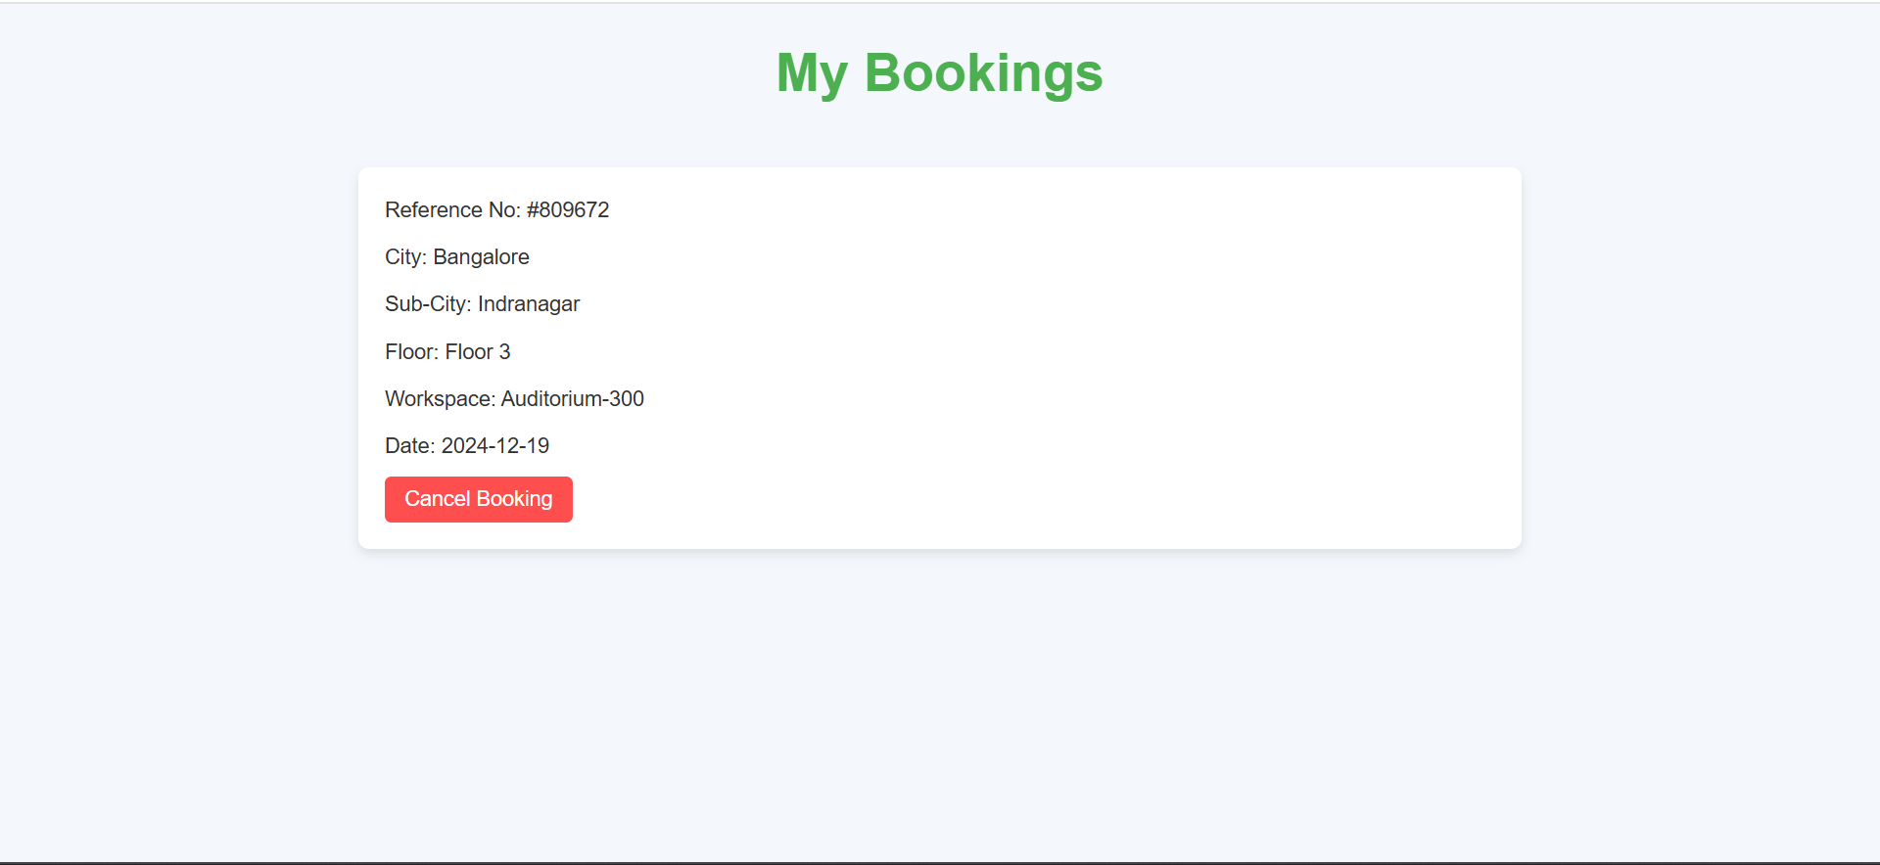

Fig: 7.6 My Bookings

RESULTS

The implementation of the Adaptive Agile Workspace Management System brought significant improvements in workspace management and overall operational efficiency. Key outcomes include an optimized workspace utilization rate, ensuring more efficient booking and allocation of available resources. The system’s real-time availability checks and seamless booking flow led to enhanced user satisfaction, with a notable increase in adoption across the organization. The interactive features, such as dynamic floor maps and instant updates, contributed to higher employee engagement, making it easier for users to navigate and book workspaces.

CONCLUSION

The system effectively streamlines workspace booking and management, ensuring optimal resource utilization and providing a simple, intuitive interface for employees to book, modify, or cancel reservations with ease. Secure login and data handling processes maintain user data integrity and protection. Designed to accommodate diverse workspace needs, the system is adaptable to organizations of any size. Real-time tracking of workspace availability prevents double bookings and boosts operational efficiency. By simplifying workspace management, the system enables employees to focus on core tasks, contributing to improved productivity across the organization. Overall, it enhances the user experience while supporting efficient and dynamic workspace utilization.

References

1. Lee, Dongwoo. "Leveraging IoT for smart office environments: A case study in resource management." Journal of Smart Systems and Applications 14.4 (2021): 211 230.
2. Smith, John. "Agile methodologies for adaptive workspace management post pandemic." Corporate IT Management Journal 8.1 (2023): 32-48 /.
3. Sharma, Priya. "Employee-centric design approaches for workspace booking systems." International Journal of User Experience Design 9.2 (2020): 101-120 .
4. Patel, Ankit. "Cloud-based solutions for workspace management in hybrid offices." Cloud Computing and Applications 15.7 (2022): 237-252.

