Machine Tool Life Management System

Dr. E Praynlin Associate Professor  
 *Department of Computer Science and Engineering* *T John Institute of Technology* Bengaluru, India [praynlin@tjohngroup.com](mailto:praynlin@tjohngroup.com)

Rishab Nair *Department of Computer Science and Engineering*   
  *T John Institute of Technology* Bengaluru, India  
 [rishabnair02@gmail.com](mailto:rishabnair02@gmail.com)

Sanika JP  
  *Department of Computer Science and Engineering*  
 *T John Institute of Technology* Bengaluru, India  
 [sanikapoornesh27@gmail.com](mailto:sanikapoornesh27@gmail.com)

**Abstract—** Machine Maintenance & Tool Life Monitoring is a System that tracks machine and tool usage and helps optimize industrial processes. To achieve stability and scalability, it was built using contemporary technologies like React, PHP, and MySQL. It includes real-time monitoring of your tools, alerts for tool replacements, and streamlined data management. This work describes the methodologies and deliverables in developing such a facility, as well as the results obtained, thus illustrating its ability to improve equipment utilization and reduce downtime in industrial environments.

INTRODUCTION

Since industries today are so reliant on machinery to get the work done, proper maintenance of these machines are vital to prevent any downtime and to have smooth operations. Manual tracking and maintenance scheduling methods are outdated and ideally require streamlining This is where Machine Maintenance & Tool Life Monitoring system comes into play as it provides automated machine usage and tool life tracking to help avoid such unwanted machine downtime with timely alerts for maintenance and replacements. This setup combines a dynamic frontend in React, a backend in PHP, and a MySQL database to provide users with a smooth experience. This is a paper about the necessity of such a system, its development process and the project impact on the industry.

1. LITERATURE REVIEW

The Previous works stress on Predictive maintenance and Tool life cycle management in industrial setups. Integrating IoT & automation significantly reduce machine downtime and operating costs, as studies show. For instance, Crespo Márquez (2016) highlights the contribution of predictive maintenance to machine reliability. In addition to that database-driven systems being applied for tool monitoring in academic and industrial projects have also been studied. Integrated systems utilizing React, PHP, and MySQL have not been well-published presenting a unique opportunity for this project.

## METHODOLOGY

System Methodological Approach: This System development has been divided into two sections i.e. agile software development and system design approaches. This is how we break down the project requirements into different phases of project and build them: requirement analysis, system design, implementation, testing, and deployment. Frontend : React and Vite for User interaction The backend was developed using PHP which was responsible for handling user authentication, data processing, and API communication. We used MySQL as the storage engine for machine, tool and alert data. The system was tested continuously in intervals to ensure functionality and reliability.                                  

# RESEARCH DESIGN

The industrial need for this project was to create a system that is both scalable and easy to use. The design prioritized a user-centric approach, ensuring a balance between functionality for administrators and an intuitive user experience for end-users. Scalability was a key focus, with the architecture designed to support future enhancements, such as IoT integration and advanced analytics. Data security was addressed by implementing role-based access control and secure password hashing to protect sensitive information. Additionally, the project also explored actual manufacturing processes, considering the materials and technologies used in the development of the prototype.

# TOOLS AND TECHNIQUES

### The development of the system involved a combination of modern tools and technologies to ensure efficiency and effectiveness. React, along with Vite, was used for building dynamic and responsive user interfaces in the frontend, while PHP handled server-side scripting and API development in the backend. MySQL was utilized for efficient data storage and retrieval. The development environment consisted of Visual Studio Code for coding and debugging, complemented by XAMPP for local server setup. Diagramming tools such as PlantUML and Lucidchart were employed for visualizing system architecture and workflows. For testing, browser developer tools were used for frontend testing, and Postman was leveraged for API testing, ensuring the robustness of the application.

# PROCEDURE

**User Requirement Analysis**: Analysis of needs from a user perspective with respect to managing a machine and a tool, alerts that get created, reporting and other needed features.

**System Design**: Architecting of system designs, including component diagrams, database schema and interactions.

**Application**: Code Stubbing of frontend and backend and integration of layers

**Testing:**To make sure everything is working, unit tests and integration tests and user acceptance tests are performed.

**Deployment:** The application was initially installed locally using XAMPP for testing and development.

1. EXPERIMENTAL RESULT

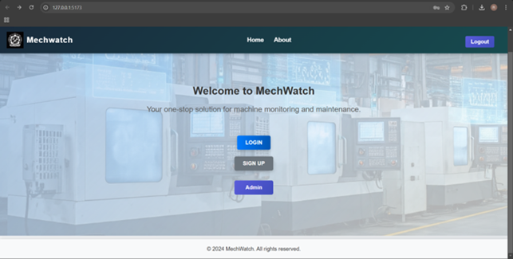

Fig: 7.1 landing page

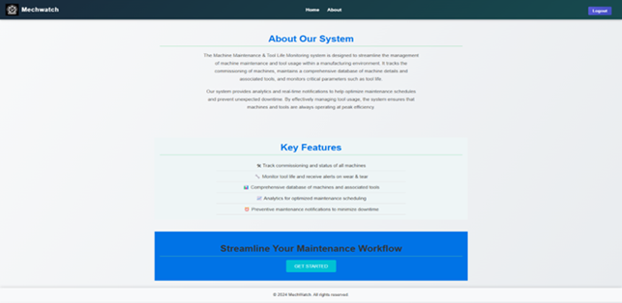

Fig: 7.2 about page

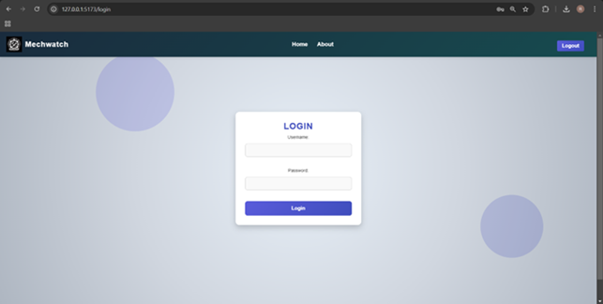

Fig: 7.3 login page

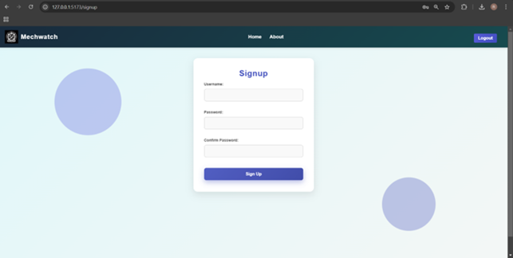

Fig: 7.4sign up page

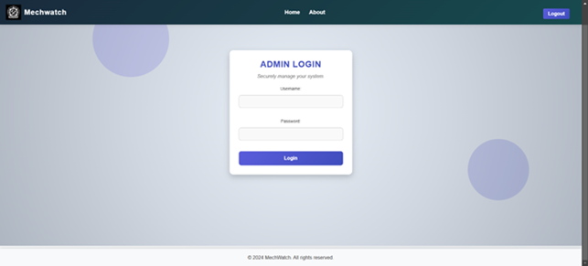

Fig: 7.5Admin login page

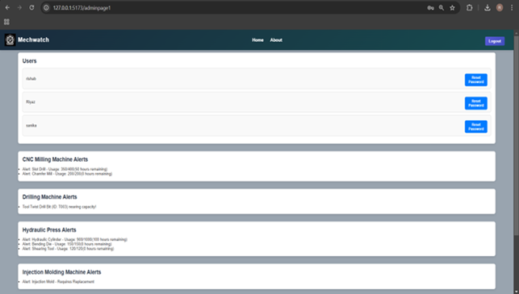

Fig:7.6 Admin page

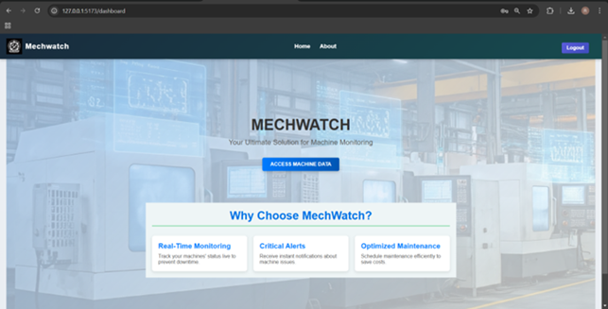

Fig:7.7 Home page

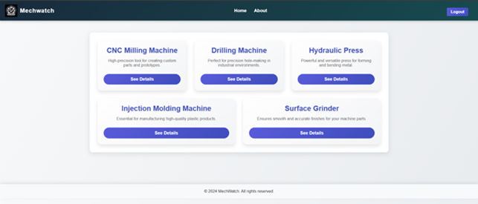

Fig:7.8 dashboard

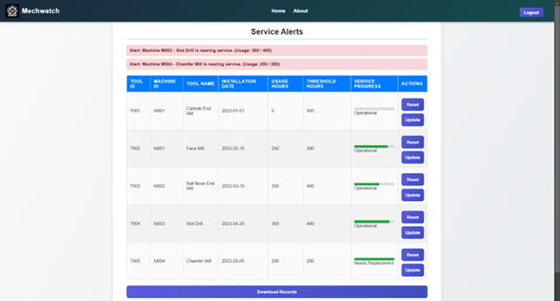

Fig:7.9 machine page

# RESULTS

1. The Machine Maintenance & Tool Life Monitoring system successfully met its objectives by providing the following outcomes.

2. Reduced Downtime: Alerts for tool replacements helped minimize machine downtime.

3. Improved Efficiency: Automated tracking reduced manual intervention and errors.

#### 4. Scalability: The system's modular design supports future enhancements and integrations.

##### 5 User Satisfaction: Feedback from test users highlighted the system's intuitive interface and reliability.

##### CONCLUSION

With an increasing number of players in the industrial maintenance and management sector, the development of automated solutions using machine learning and waterproof integrated VoIP solutions, like the Machine Maintenance & Tool Life Monitoring system promises to automate and throw critical processes like tool lifecycle management and machine maintenance. It uses the latest technologies such as React, PHP, and MySQL for a scalable and reliable solution. It can also lead to IoT integration, predictive maintenance, and advanced analytical processes to take system capabilities to the next level. It also provides the foundation for evolving an ever-evolving approach to all aspects of its industrial processes.

##### References

1. **Maintenance Engineering and Management** by R.C. Mishra & K. Pathak.
2. **Predictive Maintenance of Industrial Machines** by Adolfo Crespo Márquez.
3. IEEE Paper: "Predictive Maintenance System Design Using IoT and Machine Learning."
4. React,PHP,MySQL Documentation.
5. FreeCodeCamp: React, PHP, and MySQL.
6. W3Schools: HTML, CSS, JavaScript, PHP, SQL.