**DEVELOPMENT AND QUALITY EVALUATION OF A PROBIOTIC SWEETENED YOGHURT BY INCORPORATING CARROT (Daucus carota subsp sativus)**

**VARUN S PRAKASH, DR LIGIMOL JAMES AND FRANJO THOMAS DEPARTMENT OF DAIRY SCIENCE AND TECHNOLOGY, VKIDFT, MANNUTHY, THRISSUR**

**Abstract**

Yoghurt is one of the most popular fermented milk product gaining worldwide importance in current scenario due to its ability to reduce lifestyle diseases. Being itself a highly nutritious product, an effort was made to fortify yoghurt prepared from homogenized toned cow milk with carrot to further improve its nutrients and health promoting effects. Initially, the preliminary trials were conducted to standardize sugar at 15% from 5, 10,15and 20% sugar added samples at a constant inoculation(1%) and inoculum was standarised at 1% from 1,2,3and 5% yoghurt culture added samples at constant sugar(15%) by one-factor-at-a time method. The processing steps included boiling of toned homogenized cow milk (3% Fat,8.5% Snf) followed by keeping it simmered for 5 mins after addition of 15% sugar. Then,carrots (14%) and nuts (2%) were added, grinded thoroughly by a mixer and filtered, followed by addition of 1% yoghurt culture and incubation. The quality (78.76% people liked) evaluated on the basis of composition, organoleptic and physiochemical properties revealed the proximate composition of the optimized product: Ash:0.695%, Acidity:0.74%LA, pH@25.6°c:4.23, Fat:4.6%, Protein:3.4%, Microbial count:10 6 dilution:3×10 6 cfu/ml,Total solids:24.56%, Moisture:75.44% and Total sucrose:18%, shelf life:15days. Thus, the most acceptable carrot based yoghurt is made by using “toned and homogenised cow milk,15% sugar and inoculums (yoghurt culture) @1% and incubated at 37°C for 14 hrs”giving a yield of 126.6% at a cost of Rs 200/litre of milk used.

Keywords: Yoghurt, Carrot, Cow milk, Inoculum

**Introduction**

The production of fermented dairy products has seen a significant rise in developing countries. In India, yogurt stands out as a flavorful and nutritious product with increasing production and consumption due to its therapeutic benefits and high nutritional value. The live lactic acid bacteria present in the yoghurt offer several health benefits, such as alleviating digestive issues, improving lactose digestion in those

with intolerance, reducing cancer risks, lowering cholesterol levels, strengthening immunity, and aiding the body's absorption of nutrients like protein, calcium, and iron (Perdigón *et al.,* 1998; Marona and Pedrigón, 2004).To diversify and enhance market competitiveness, some researchers explores incorporating carrot juice into yogurt production (Schieber *et al.,* 2002; Simova *et al.,* 2004). Carrot (*Daucus carota L*.), a commonly consumed vegetable, is rich in beta-carotene, ascorbic acid, and tocopherol, classifying it as a vitamin-packed food. Combining carrot juice with yogurt creates a nutritionally balanced product. While carrots are an excellent source of carbohydrates, vitamins (A, B1, B2, C, E), minerals (calcium, phosphorus, iron, potassium, etc.), and antioxidants, they lack protein and fat. On the other hand, yogurt is high in protein and fat but lacks vitamin C and iron. Blending the two enhances their nutritional value (Ikken *et al*., 1998; Raum, 2003). Carrots are potent sources of antioxidants and play a crucial role in promoting better health. They not only prevent vitamin A deficiency but also help combat cancer and other diet-related diseases. Additionally, carrots exhibit cytotoxic effects on cancer cells, reduce the activity of enzymes that convert precarcinogens into carcinogens, enhance immunity, and provide protection against stroke, high blood pressure, osteoporosis, cataracts, arthritis, heart disease, bronchial asthma, and urinary tract infections. In recent years, the addition of dietary fiber to milk products has made it possible to improve the texture and stability of yogurt and create functional foods that are beneficial to health (Wang, Kristo, & Lapointe, 2019).Yogurt is the most consumed fermented milk drink and the most investigated as a vehicle for microorganisms and bioactive compound. Pop *et al.* (2015) reported that incorporating 24% carrot juice into bio-yogurt significantly enhanced its microbial stability, maintaining microbial counts of 10⁷ CFU/mL at the end of a 21-day shelf life. Similarly, Kailasapathy *et al.* (2008) observed in a comparable study that the acidification process and interaction with vegetable components altered the casein structure, resulting in a denser and more uniform texture in yogurt.

**Materials and Methods**

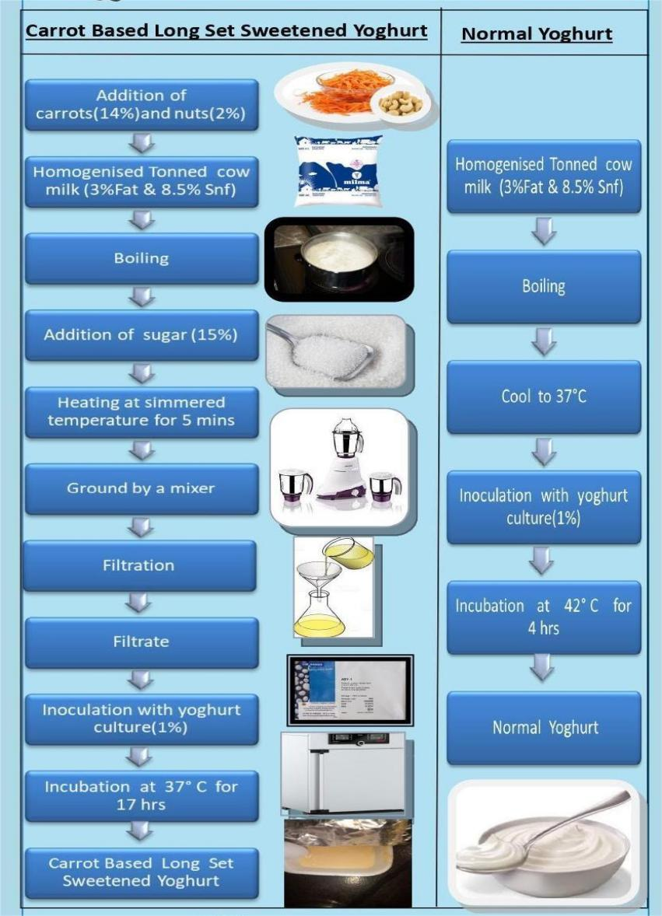

The Sensory evaluation of both normal and carrot based long set sweetened yoghurt was done with the help of 13 trained judging panel members. The microbial counts of Yeast and mould, Coliforms and Lactic acid bacteria count were carried out using standard procedures with the help of theie selective medias. The physico chemical analysis of the yoghurts were also carried out at lab of VKIDFT Mannuthy, Thrissur..

**Results and discussion**

The results obtained from the present investigation have been summarized in the following tables:

**Table 1**: Physiochemical analysis of normal and long set sweetened carrot based yoghurt 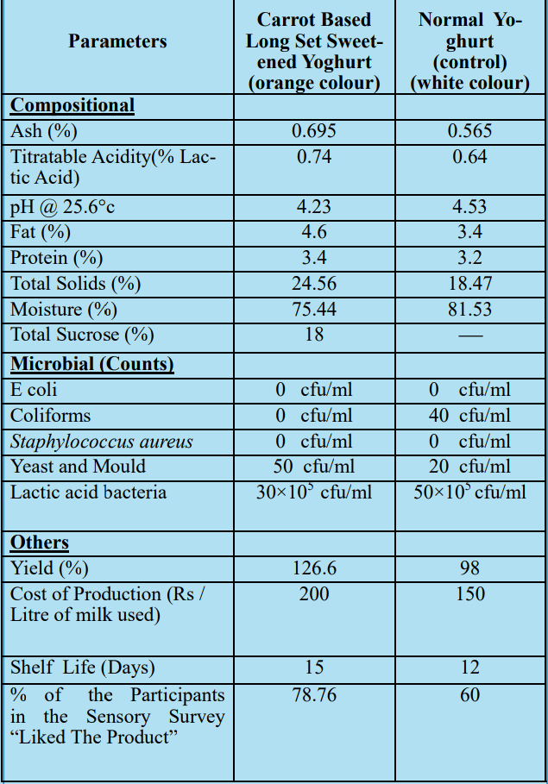

**Sensory evaluation**

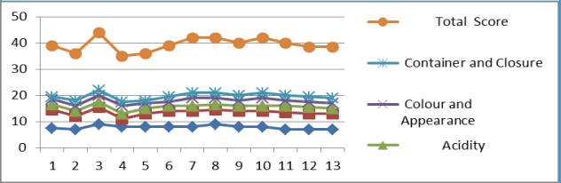

**Sensory evaluation of long set sweetened carrot based yoghurt**

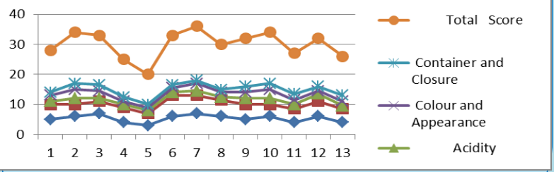

**Sensory evaluation of Normal yoghurt**

Higher amounts of ash content, protein content and total solids were found in carrot based long set sweetened yoghurt. The proximate composition of the optimized product: Ash:0.695%,Acidity:0.74%LA,pH@25.6°c:4.23, Fat:4.6%, Protein:3.4%, Microbial count:10 6 dilution:3×106 cfu/ml,Total solids:24.56%, Moisture:75.44% and Total sucrose:18%, shelf life:15days. Thus, the most acceptable carrot based yoghurt is made by the

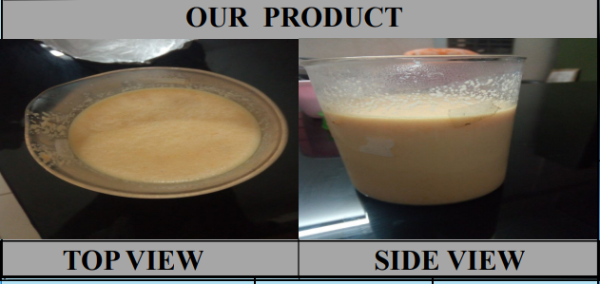

using “toned and homogenised cow milk,15% sugar and inoculums (yoghurt culture) @1% and incubated at 37°C for 14 hrs”giving a yield of 126.6% at a cost of Rs 200/l.. The sensory scores obtained were higher for the carrot based sweetened yoghurt than the normal yoghurt. The lactic acid bacteria count of the carrot yoghurt exceeded the minimum probiotic count of 106  making the product a probiotic product. The resulting product had a orange colour thus increasing its consumer appeal, which is evident from the sensory scores. The Yeast and mould count of the yoghurt were within the standard limit. The cost of production of carrot based yoghurt was a little higher than the normal yoghurt owing to additional ingredients added to it. The shelf life of the carrot based yoghurt (15 days) was higher than that of normal yoghurt which may be due to the sugar addition.

**Conclusion**

The most acceptable carrot based long set sweetened yoghurt is made by using “toned and homogenised cow milk, 15% sugar,14% carrots and inoculum (yoghurt culture) @1% and incubated at 37°C for 17 hrs Though the cost is a little higher, it is of higher nutritive value ,better colour& flavour and overall acceptability than the normal yoghurt..Higher amounts of ash content, protein content and total solids were found in carrot based long set sweetened yoghurt. The carrot based yoghurt has an orange colour thereby increasing the products consumer acceptability.

**References**

1 .Karagul, Y., C. Wilson and H. White, 2004. Formulation and processing of yoghurt. J. Dairy Sci., 87: 543-550.

1. Marona, D. and G. Pedrigon, 2004. Yoghurt feeding inhibits promotion and progression of cancer. Med.Sci. Monit., 10: 96-104.
2. Allgeyer, L.C., Miller, M.J. and Lee, S.Y. (2010). Sensory and microbiological quality of yoghurt drinks with prebiotics and probiotics. Journal of Dairy Science, 93(10), 4471-4479. https:// doi.org/10.3168/jds.2009-2582
3. Roy, D.K.D., Saha, T., Akter, M., Hosain, M., Khatun, H. and Roy, M.C. (2015). Quality Evaluation of Yoghurt Supplemented with Fruit Pulp (Banana, Papaya, and Water Melon). International Journal of Nutrition and Food Sciences 4(6), 695-699.
4. AOAC (Association of Official Analytical Chemists). (2000). Official methods of analysis of AOAC International. Arlington, Virginia, USA: AOAC

6.Cliff, M.A., Fan, L., Sanford, K., Stanich, K., Doucette, C. and Raymond, N. (2013). Descriptive analysis and early-stage consumer acceptance of yoghurts fermented with carrot juice. Journal of Dairy Science, 96(7), 4160–4172.