**AN EXPERIMENT STUDY ON PARTIAL REPLACEMENT OF FINE AGGREGATE BY GLASS POWDER IN CONCRETE**

**LAKSHMIKANTHANAIK N T 1, AJAY T 2, YASHAVANTHA KUMARA L 3, THIPPESWAMY T 4, PRUTHVI RANI K M 5 ,**

1 UG Student, Department of Civil, SJM Institute of Technology, Chitradurga, Karnataka, India

2 UG Student, Department of Civil, SJM Institute of Technology, Chitradurga, Karnataka, India

3 UG Student, Department of Civil, SJM Institute of Technology, Chitradurga, Karnataka, India

4 UG Student, Department of Civil, SJM Institute of Technology, Chitradurga, Karnataka, India

5 Assistant Professor, Department of Civil, SJM Institute of Technology, Chitradurga, Karnataka, India

**ABSTRACT**

Coarse and fine aggregates, together with cement and water, are the main ingredients of concrete, which is combined to a desired consistency and strength. The manufacture of concrete relies on cement more than any other substance. There has to be a solution for cheaper building materials because of the high prices. You may use broken glass as both a coarse and fine aggregate. At 28 days three, the effects of adding 20% glass powder by weight to an M40 mortar concrete mix are discussed in this study. Various doses of these glass particles will be used.

**Keywords:** Glass powder, Natural Resources, Compressive Strength, Split Tensile Strength Test

1. **INTRODUCTION**

As a result of the substantial amount of trash that is generated on a daily basis by factories and businesses, concrete, which is the second most extensively used material in the world, is confronted with environmental challenges. The management of solid waste is a major worldwide issue, and recycling and reusing garbage have presented themselves as potential answers to this problem. In comparison to the production of new materials, the recycling of recyclable materials has a less negative impact on the environment and is more cost-effective. Concerns have been raised over the preservation of natural aggregate sources as a result of the growing usage of natural aggregate solutions.

Making concrete more sustainable and friendly to the environment may be accomplished by the use of alternative resources in its manufacturing. It is possible to utilise coconut shells as a replacement for sand by crushing them to the size of sand. Coconut shells are a material that is both durable and slow to degrade. They are also used in the production of charcoal and activated carbon, which are utilised in the filtration of mineral water, carbonated beverages, and food.

In terms of worldwide production, concrete is second only to water, and a significant quantity of trash is produced all over the world. Glass garbage accounts for 0.7% of the total urban waste generated in India since it is created on a yearly basis. Concrete, which is an artificial building material, is utilised extensively, and the need for it is growing continually. River sand, which is the most essential component in the manufacture of concrete, is both costly and difficult to come by. The disposal of discarded glass does not disintegrate in soil, which leads to negative effects on the environment.

1. **LITERATURE REVIEW**

This sections gives the information on work carried out by the previous research scholars to find robustness of concrete when glass powder is mixed with concrete.

|  |  |  |  |  |
| --- | --- | --- | --- | --- |
| Author | Employed method | Results | Tests | Application |
| Minahil Asad  2024 [1] | Compressive strength tests on cylindrical concrete samples.  Varying proportions of glass powder and fly ash used. | Rough glass powder peaked at 23.26 MPa at 15% replacement.  Mixed glass powder achieved 21.57 MPa at 30% replacement | Compressive strength tests were conducted to evaluate the structural performance of each concrete mix. | Potential applications in construction.  Promotes sustainability through waste material reuse |
| Alemu Mosisa Legese  2024 [2] | Tests on cement setting time and workability.  Evaluation of compressive, tensile, and flexural strength. | Optimal 10% replacement increased compressive strength by 12.55% at 7 days.  Flexural strength improved by 19.7% with waste materials. | Compressive strength test  Splitting tensile strength test  Flexural strength test | Waste plastics and glass as fine aggregate replacements.  Enhancing concrete properties like compressive and flexural strength. |
| Minjae  2024 [3] | Evaluated mass-produced glass fine aggregate (GFA) properties.  Analyzed effects on mortar properties and ASR expansion behavior. | Mass-produced GFA increases strength reduction and ASR expansion.  Recommended GFA content is within 20% of NFA. | The tests conducted on concrete to find strength include evaluations of compressive strength and flexural strength. | Utilization of waste glass as sustainable fine aggregate.  Evaluation of mass-produced GFA effects on mortar. |
| Hakim  2024 [4] | Assess workability, durability, strength of concrete with glass powder.  Provide comprehensive summary of current knowledge on the topic. | Lower carbon footprint, reduced reliance on virgin materials, waste minimization.  Cost savings, readily available waste glass at low cost. | The tests conducted on concrete to find strength include compressive strength tests, flexural strength tests, and tensile strength tests. | Waste glass powder as fine aggregate substitute in concrete.  Enhancing sustainability and reducing environmental impact in construction. |
| Yusuf  2024 [5] | Evaluated workability of concrete with waste glass.  Determined compressive and tensile strength of concrete. | Max compressive strength: 32.9 N/mm² at 30% glass replacement  Max tensile strength: 3.9 N/mm² at 20% glass replacement | The tests conducted on concrete to find strength included compressive strength tests and tensile strength tests. | Performance of steel fibre reinforced concrete.  Use of waste glass as fine aggregate replacement. |
| Mohammad Esam Shareef 2023 [6] | The research found that Waste Glass Powder decreased workability and compressive strengths in all concrete mixes, but enhanced splitting tensile strength by 12%. | Decrease in compressive strength with WGP addition  Splitting tensile strength enhanced by about 12% | The tests conducted on concrete to find strength included compressive strength tests and splitting tensile strength tests.  Compressive strength was evaluated for curing ages of 7, 14, 21, 28, 56, and 90 days.  Splitting tensile strength was tested for curing ages of 7, 14, 21, and 28 days. | Waste Glass Powder as sand replacement in concrete.  Potential use in Iraqi construction field |

1. **MATERIALS AND METHODOLOGY**

Specimens are prepared by concentrate by using the following material are stated below,

**3.1 Materials employed**

Materials employed to prepare the concrete are discussed in this sub-section.

**3.1.1 Cement**

For this study, Ordinary Portland Cement (OPC) 43 Grade was utilized. This type of cement is known for its versatility and is commonly used in structural applications. It is preferred for its ability to achieve good strength, quick setting, and durability. OPC 43 grade is particularly suitable for residential and commercial buildings, pavements, and reinforced concrete structures due to its reliable performance. Physical properties of cement is provided in Tab.1

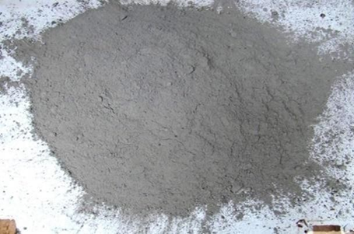

Figure Cement

Table Physical properties of cement

|  |  |  |  |
| --- | --- | --- | --- |
| S.No | Description of Test | Results | Limit as per  IS 269 / IS 456 |
| 1 | Standard consistency (%) | 29 | - |
| 2 | Initial setting time(minutes) | 180 | 30 (Min) |
| 3 | Final setting time(minutes) | 290 | 600 (Max) |
| 4 | Specific gravity | 3.14 | 3.15 |
| 5 | Compressive strength (N/mm2) | 51.43 | 43 (Min) |
| 6 | Fineness of cement in 90mic sieve Retained ( %) | 1.88 | 10 (Max) |

**Tests conducted on cement**

To ensure the quality and performance of the cement, several standard tests were conducted following the guidelines specified by the Bureau of Indian Standards (BIS), such as IS 4031 and IS 12269. The key tests performed include

Table Tests conducted

|  |  |
| --- | --- |
| **Test name** | **Value** |
| Specific Gravity | 3.14 |
| Initial setting time | 180 minutes |
| Final setting time | 290 minutes |
| Consistency test | 30% M30 grade |
| Finess Test | 225 m2/kg |

**3.1.2 Coarse aggregate (CA)**

Coarse aggregates are made from crushed SS crusher stones that meet the standards of IS 383 -2016, as seen in figure 4.3. The coarse aggregate used in concrete is mostly gravel, with crushed stone making up the bulk of the remaining portion. There are a number of construction applications for coarse aggregates. Included in concrete is the most common and noticeable use. They are also used in the preparation of the moisture break under the slab and vapor barrier. Driveways and highways rely on them as part of their foundational preparation. The bigger stones that are mixed into the concrete are known as coarse aggregate. It is as shown in Fig. 2 and physical properties is tabulated in Tab.3

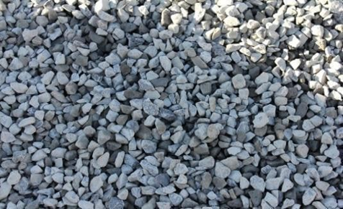

Figure Course aggregate

Table : Physical properties of Coarse aggregate

|  |  |  |  |  |  |
| --- | --- | --- | --- | --- | --- |
|  | S.No | Description of Test | Results | | Limit as per  IS 383 : 2386 |
| 12.5mm | 20mm |
|  | 1 | Specific gravity | 2.780 | 2.750 | - |
|  | 2 | Water Absorption (%) | 0.42 | 0.61 | - |
|  | 3 | Flakiness (%) | 3.21 | 5.8 | 25 (Max) |
|  | 4 | Elongation (%) | 6.08 | 8.15 | 25 (Max) |
|  | 5 | Crushing Value (%) | 14.97 | 14.97 | 30 (Max) |
|  | 6 | Impact Value (%) | 13.43 | 13.43 | 30 (Max) |
|  | 7 | Abrasion Value (%) | 13.2 | 13.2 | 30 (Max) |

* + 1. **Fine aggregate**

Used in the making of concrete and asphalt as well as road bases and other structures, fine aggregates are pieces of crushed stone or natural sand with a diameter of less than 4.75 millimetres and no more than 75 microns. They are an essential building component because of the strength, stability, and longevity they give. It is as shown in Fig. 3 and physical properties is tabulated in Tab.4

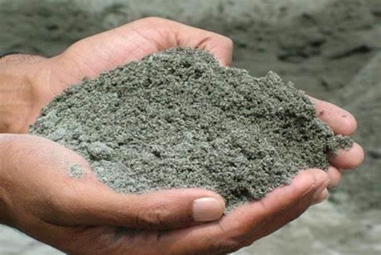

Figure Fine aggregate

Table Physical properties of fine aggregate

|  |  |  |  |
| --- | --- | --- | --- |
| S.No | Description of Test | Results | Limit as per IS383 : 2386 |
| 1 | Material passing 75 micron by mass (%) | 3.80 | 10.0 Max |
| 2 | Specific gravity | 2.652 | - |
| 3 | Water Absorption (%) | 1.62 | - |

3. 1.4 **Glasspowder**

Silica, soda ash, and CaCO3 are melted together at high temperatures and then cooled to solidify without crystallisation, creating the translucent substance known as glass. Sheet glass, bottles, glasses, vacuum tubing, and many other produced glass objects are ubiquitous in our daily lives. The ever-increasing demand for glass items has led to a steady rise in the quantity of waste glass in recent years. Landfills have been the primary destination for discarded glasses. Due to their lack of biodegradability, used glasses are not eco-friendly and should not be dumped in landfills. Thus, we become both environmentally conscious and cost-effective in the building industry by using discarded toughened glass in concrete. This research makes use of glass powder that is sourced from the Bharuch market. This substance is used in lieu of cement in the mixture. Physical property of glass powder is given in Tab.6.

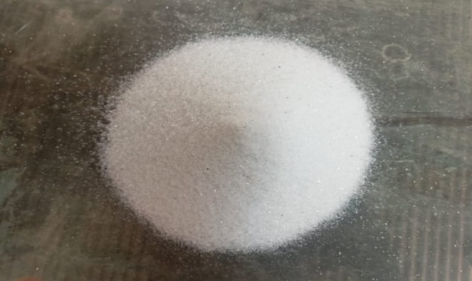

Figure Sample of Glass powder

Table Physical properties of glass powder

|  |  |  |
| --- | --- | --- |
| SL. NO | PROPERTIES | RESULT |
| 1 | Specific Gravity | 2.5 |
| 2 | Fineness modulus | 70 MICRON |

3.1.5 **Water**

Tests on the water have shown that it meets the standards set forth by IS:456–2000 and IS: 3025–1964. Water taken is as shown in Fig.5 and Tab.7

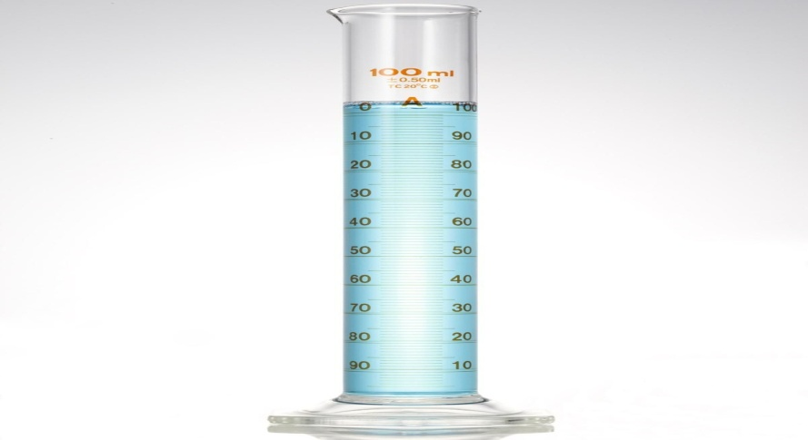

Figure Water

Table Properties of water

|  |  |  |  |
| --- | --- | --- | --- |
| S.  No | Description of  Test | Results | Limit as per  IS 456 |
| 1 | Ph Value | 8.68 | 6.0 (Min) |
| 2 | Organic solids (mg/l) | 46 | 200 (Max) |
| 3 | Inorganic Solids (mg/l) | 284 | 3000 (Max) |
| 4 | Suspended Matter (mg/l) | 1.0 | 2000 (Max) |
| 5 | Chloride Content (mg/l) | 193 | 2000 (Max) for PCC |
| 500 (Max) for RCC |
| 6 | Sulphate Content (mg/l) | 1.0 | 1. max) |

* 1. **METHODOLOGY**

A trial mix of concrete grade M30 was created as part of the experimental effort that followed the standards of IS10262-2019. Using these proportions, we were able to create glass powder concrete, which substitutes industrial and demolition glass for fine aggregate. Multiple experiments employing standardised codes formed the basis of the unique blend design. The procedure includes a literature review, the collection of glass waste from demolition sites and glass cutting shops, physical property testing of raw materials, and the development of concrete according to the specifications of the Indian Standard code using a mixture of cement, coarse aggregate, or glass waste, and fine aggregate. Following this, the concrete blocks undergo the usual battery of quality control tests, including flexural, split tensile, and compression tests. Summary of methodology is as shown in Fig.6.



Figure Methodology employed

**3.2.1 Process of converting glass to glass powder**

The pozzolanic characteristics and eco-friendliness of glass powder make it a popular building material. To get the right particle size and quality, the procedure has many phases. Gathering shattered glass from places like bottles, windows, and factories is the first step. Impurities such as plastics, metals, or labels must be removed via proper segregation. Because the chemical makeup and reactivity of the end product are affected by these characteristics, glass is usually categorised according to kind and colour.

To clean the separated glass, we first remove any impurities including grime, oil, and glue. In order to make the next steps with the glass simpler, it is first crushed into tiny pieces called cullets. Afterwards, specialised machinery is used to mill the cullet into a fine powder. Coarse grinding reduces the cullet to granular form, while fine grinding usually results in particles smaller than 90 µm.

The material is sieved after grinding to make sure the particles are of the same size. Glass powder that is fine and homogeneous in size and fits specified specifications for use in building or industry is produced by recycling too-large particles back into the grinder.

To make sure the powdered glass is up to snuff for its designated usage, it undergoes quality testing. Some important factors to consider are the particle size (minimum of 90% passing through a 90 µm filter) and chemical make-up (tested for pozzolanic activity and free of hazardous substances).

To avoid clumping, the glass powder is kept in a dry place after passing quality tests and before being packed in moisture-proof containers. Batch numbers and specifications may be easily identified with proper labelling. Contributing to waste reduction and sustainable development, glass powder finds extensive usage in building, industrial applications, and eco-friendly goods.

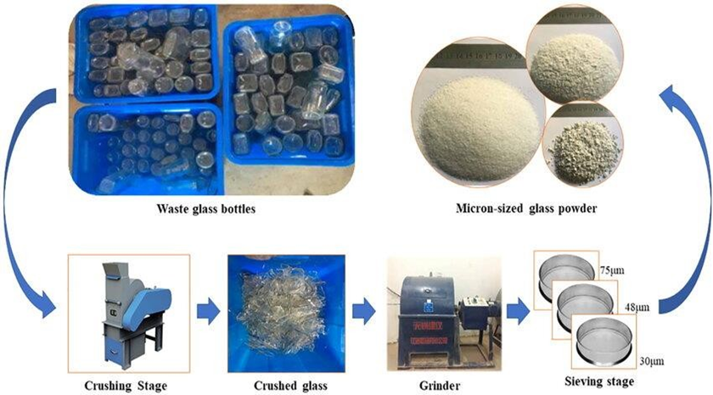

Figure Process involved in converting glass to glass powder

1. **Results and Discussion**

This section discusses about the testing performed on the robustness of concrete prepared by mixing glass powder.

**4.1 Compression strength test**

The compression strength test is a fundamental method used to determine the ability of materials, such as concrete, bricks, and other structural elements, to withstand compressive forces. This test is crucial in construction to ensure that materials meet the required strength specifications for safety and durability. It measures the maximum load a material can bear before failure under axial compression. Placing of concrete to test the compression strength is as shown in Fig 8.

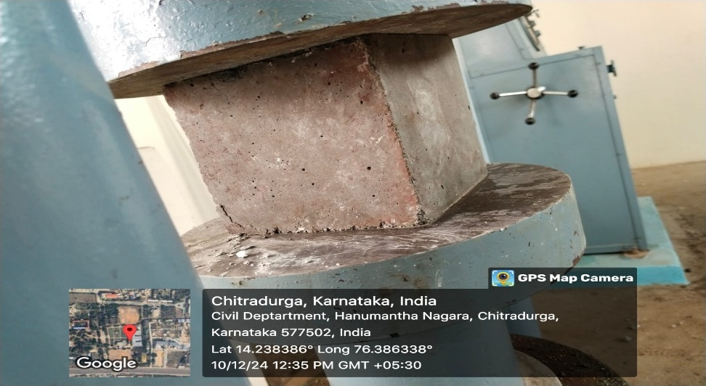

Figure Compressive strength test

Compressive strength, split tensile test and Flexure strength test results on testing on concrete cubes are shown in the Tab.7, Tab. 8 and Tab. 9 respectively.

Table Compressive strength on cubes

|  |  |  |  |  |
| --- | --- | --- | --- | --- |
| Mixed % | Water cement ratio | Compressive strength (7days) N/mm2 | Compressive strength  (14days) N/mm2 | Compressive strength (28days) N/mm2 |
| 10% | 0.36 | 35.55 | 48.89 | 55.56 |
| 10% | 0.36 | 34.78 | 48.34 | 56.20 |
| 10% | 0.36 | 36.00 | 47.90 | 55.80 |
| 20% | 0.36 | 33.33 | 40.45 | 48.89 |
| 20% | 0.36 | 32.90 | 41.1 | 48.20 |
| 20% | 0.36 | 33.40 | 40.9 | 48.63 |
| 30% | 0.36 | 26.67 | 28.00 | 33.33 |
| 30% | 0.36 | 26.20 | 27.80 | 33.52 |
| 30% | 0.36 | 26.90 | 28.32 | 33.86 |

**4.2 Split tensile strength test**

The split tensile strength test is a widely used method to evaluate the tensile strength of concrete, which is critical for understanding how the material performs under tensile forces. Concrete is inherently strong in compression but weak in tension, making this test important for assessing its ability to resist cracking and failure due to tensile stresses. Results are as tabulated in Tab.8.

Table Split tensile strength test

|  |  |  |  |  |
| --- | --- | --- | --- | --- |
| **Mixed %** | **Water cement ratio** | **Split tensile strength (7days) N/mm2** | **Split tensile strength**  **(14days) N/mm2** | **Split tensile strength (28days) N/mm2** |
| 10% | 0.36 | 0.477 | 0.541 | 0.580 |
| 10% | 0.36 | 0.460 | 0.510 | 0.522 |
| 10% | 0.36 | 0.455 | 0.516 | 0.526 |
| 20% | 0.36 | 0.413 | 0.477 | 0.509 |
| 20% | 0.36 | 0.409 | 0.462 | 0.512 |
| 20% | 0.36 | 0.411 | 0.472 | 0.515 |
| 30% | 0.36 | 0.366 | 0.420 | 0.413 |
| 30% | 0.36 | 0.369 | 0.422 | 0.409 |
| 30% | 0.36 | 0.360 | 0.415 | 0.415 |

**4.3 Flexural strength test**

The flexural strength test evaluates the ability of concrete or other structural materials to resist bending or flexural forces. Often referred to as the "modulus of rupture," this test is crucial for assessing the tensile strength of concrete, especially in applications where the material is subjected to bending stresses, such as in beams, slabs, and pavements.

Table Flexural strength test

|  |  |  |  |  |
| --- | --- | --- | --- | --- |
| Mixed % | Water cement ratio | Flexural strength (7days) N/mm2 | Flexural strength  (14days) N/mm2 | Flexural strength (28days) N/mm2 |
| 10% | 0.36 | 0.310 | 0.270 | 0.230 |
| 10% | 0.36 | 0.305 | 0.265 | 0.250 |
| 10% | 0.36 | 0.311 | 0.260 | 0.245 |
| 20% | 0.36 | 0.270 | 0.300 | 0.330 |
| 20% | 0.36 | 0.290 | 0.305 | 0.325 |
| 20% | 0.36 | 0.285 | 0.298 | 0.338 |
| 30% | 0.36 | 0.230 | 0.260 | 0.280 |
| 30% | 0.36 | 0.255 | 0.245 | 0.265 |
| 30% | 0.36 | 0.222 | 0.253 | 0.283 |

1. **CONCLUSION**

Present at the testing location is a bag containing waste glass powder and cement, both of which are material in concrete. Furthermore, because of its use in the building sector, it serves as a source for the disposal of Waste Glass Powder. Further, by reducing the burden on existing landfills and incinerators, trash Glass Powder mix will lessen the requirement for new trash disposal infrastructure.

1. **REFERENCE**
2. Asad, Manan. "Enhancing Concrete Composition: Glass Powder and Fly Ash as Combined Additives in Sand-Reduced Concrete Mixture." European Journal of Applied Science, Engineering and Technology 2.6 (2024): 104-112.
3. Legese, A. M., Mitiku, D., Feyessa, F. F., Urgessa, G., & Boru, Y. T. (2024). Experimental Study on the Suitability of Waste Plastics and Glass as Partial Replacement of Fine Aggregate in Concrete Production. Construction Materials, 4(3), 581-596.
4. Son, M., Kim, G., Lee, S., Kim, H., Eu, H., Lee, Y., ... & Nam, J. (2024). Investigation of Conditions for Using Mass-Produced Waste Glass as Sustainable Fine Aggregate for Mortar. International Journal of Concrete Structures and Materials, 18(1), 55.
5. Hakim, S. J. S., Mhaya, A. M., Mokhatar, S. N., Kamarudin, A. F., Tong, Y. G., & Chik, T. N. T. (2024, June). Towards greener concrete: a comprehensive review of waste glass powder as a partial fine aggregate substitute. In IOP Conference Series: Earth and Environmental Science (Vol. 1347, No. 1, p. 012072). IOP Publishing.
6. Yusuf, A. M., and N. Ali. "The performance of steel fibre reinforced concrete with waste glass as partial replacement of fine aggregate." IOP Conference Series: Earth and Environmental Science. Vol. 1347. No. 1. IOP Publishing, 2024.
7. Shareef, Mohammad Esam, Dheyaa Ghanim Abdulrazzaq, and Murtatha Alshijlawi. "Investigation of Using Waste Glass Powder (WGP) as a Partial Natural Sand Replacement in Concrete for a Potential Use in Iraqi Construction Field." Civil and Environmental Engineering 19.2 (2023): 700-713.