**AN ANALYSIS OF AI-POWERED FINANCIAL DECISION-MAKING**

**Authors**

**Dr. K. Baranidharan,1 Kishore M,2 Rajeshkumar T,3 Nithish Kumar.K,4**

**S. Anbarasan5**

**Professor, in MBA, Sri Sai Ram Institute of Technology1**

**First Year, Master of Business Administration2,3,4,5**

**Sri Sai Ram Institute of Technology, Chennai – 44, India**

# Abstract

The revolutionary effect of AI on the decision-making procedures in the financial sector is investigated in this paper. Integrating AI technology into the financial sector is outlined along with its goals, requirements, scope, limitations, and ramifications. Enhanced efficiency, accuracy, and personalized services are highlighted by studying various AI applications, such as algorithmic trading, risk management, and fraud detection. In addition, it covers all the bases when it comes to understanding how AI may influence financial decision-making in the future, including the ethical concerns and difficulties that come with using it.

**Key Words** : Artificial Intelligence, Financial Decision-Making, Algorithmic Trading, Risk Management, Ethical Considerations

**Introduction**

Data has always been vital in the financial industry, which uses massive datasets to guide decision-making. Traditional analytical tools can be overwhelmed by the sheer number and complexity of financial data. Here is where artificial intelligence (AI) comes in, providing sophisticated algorithms and machine learning methods for the efficient and accurate analysis of massive datasets. Artificial intelligence (AI) allows financial institutions to better understand consumer habits, market tendencies, and risk management, allowing them to make better, faster judgments. Algorithmic trading, credit scoring, fraud detection, and tailored financial advising are just a few examples of the many financial decision-making applications enabled by AI. As an example, algorithmic trading makes use of AI systems that analyze real-time market data in order to execute deals at the best possible times, maximizing rewards while minimizing risks. In a similar vein, credit scoring algorithms powered by AI can evaluate a wider range of factors to determine a person's creditworthiness than older, more conventional approaches.

Artificial intelligence (AI) has several uses beyond improving efficiency in financial decision-making. Organizations can reallocate human resources to strategic objectives and client engagement by automating regular processes. Businesses can also take advantage of AI's improved predictive analytics to foresee changes in the market and make proactive strategy adjustments. Ethical considerations and potential obstacles must be given careful consideration as the finance sector continues to use AI technologies. To guarantee the responsible and successful use of these technologies, concerns including data privacy, algorithmic bias, and the necessity for transparency in AI decision-making processes must be addressed.

A game-changer in many sectors and an improvement to people's daily lives, artificial intelligence (AI) is now an integral part of the technology landscape. The document begins with a description and definition of AI, then moves on to describe the numerous kinds of AI, explain why they are important, list their main characteristics, and talk about the many ways AI is used in different industries.

**Purpose of the Research**

* To examine how AI can improve financial decision-making.
* To catalog the many uses of AI in the banking and insurance industries.
* To assess the pros and cons of using AI in the financial sector.
* Investigating the moral weight of AI in monetary policymaking.

**Study Requirements**

To comprehend how AI can handle the intricacies and difficulties encountered by financial institutions while handling massive volumes of data, the research is crucial. Insights into the ways AI might enhance efficiency, accuracy, and customer engagement in decision-making are sought after, along with a spotlight on the possible hazards and ethical considerations that come with its utilization.

**Research Area**

Algorithmic trading, risk management, fraud detection, customer service, credit scoring, and individualized financial advise are some of the financial industry applications of artificial intelligence that are the subject of this study. It covers the examination of artificial intelligence technologies, including their pros and downsides as well as the ethical issues that need to be resolved in light of the growing adoption of these breakthroughs in the financial sector.

**Study Restrictions**

The ever-changing landscape of AI technology and their applications poses challenges to this study's attempt to offer a thorough review of AI in financial decision-making. Furthermore, not all possible financial AI applications or ethical considerations may have been addressed in the study.

**ARTIFICIAL INTELLIGENCE**

The term "artificial intelligence" (AI) describes computer systems that have been designed to mimic human intelligence through training and observation. It covers a wide range of technologies that enable computers to interpret natural language, recognize patterns, solve problems, and make decisions, all of which are generally associated with human intelligence.

There are essentially three main kinds of AI:

1. **Narrow AI, also known as weak AI,** is trained to do a single task, such face recognition, search the internet, or operate a self-driving car. Because of the restrictions under which it functions, it is unable to go beyond its intended purpose.

2. **General AI, also known as Strong AI**, is a theoretical type of AI that can mimic human intellect in many ways, including understanding, learning, and applying intelligence to new situations. This AI type is still in its infancy and has not come to fruition just yet.

3. Artificial intelligence that is superior to human intelligence and capabilities is known as **super intelligent AI**. Since it prompts fundamental concerns regarding the nature and destiny of our species, it has become a contentious and speculative topic.

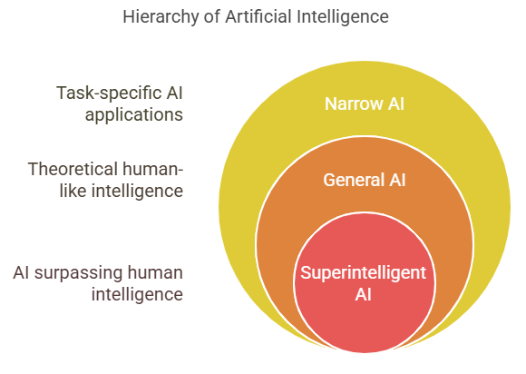

# The significance A key feature of AI is its capacity to improve accuracy, productivity, and efficiency in a wide range of fields.Automating monotonous chores, analyzing massive volumes of data, and making informed judgments are all made possible by it.The use of AI has also been essential in propelling innovation, which in turn has improved sectors including healthcare, banking, and transportation. Features Learning: AI systems can gradually enhance their performance by absorbing data and analyzing it, all without the need for explicit programming. Reasoning: AI has the ability to reason its way through data and make decisions. Artificial intelligence (AI) has the ability to detect issues and come up with solutions using algorithms and computational approaches. NLP, or Natural Language Processing, allows AI to comprehend and produce human language, opening the door to machine-to-human communication. AI has the ability to perceive its surroundings by analyzing sensory input like sights and sounds.

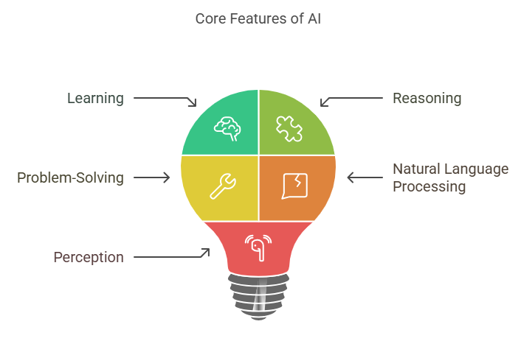

**Practical Uses Of AI**

Among the many fields that can benefit from AI are: • Healthcare, where the technology is already seeing widespread usage in areas such as diagnosis, personalized treatment, and predictive analytics with the goal of bettering patient outcomes.

In the financial sector, algorithmic trading, risk assessment, and the detection of fraud all make use of AI algorithms.

In the transportation sector, AI enables driverless cars to optimize their routes while simultaneously increasing safety.

• Retail: AI improves customer service by managing inventory and making personalized recommendations.

AI's predictive maintenance and quality control features make manufacturing a more efficient industry.

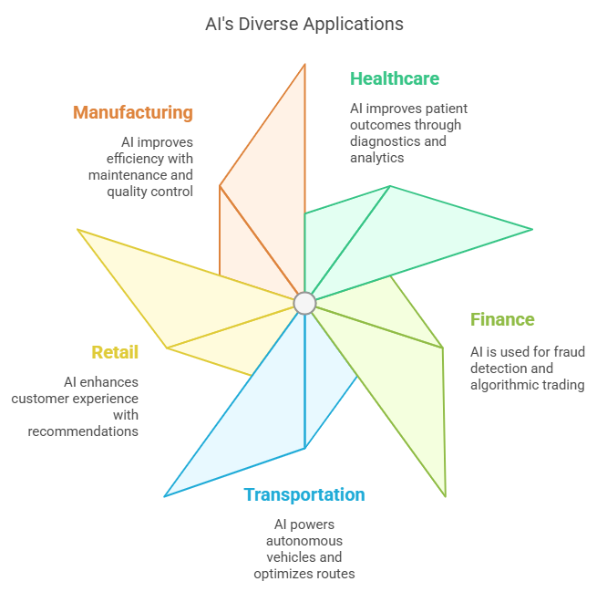

**Financial Solutions Driven by AI**

Financial institutions' operations, decision-making, and client interactions are being revolutionized by artificial intelligence (AI) in the ever-changing world of finance. This paper delves into the history of artificial intelligence (AI) in the financial sector, its salient characteristics, its numerous uses, and the ways it has altered analytics and decision-making. Financial firms may improve client experiences, increase efficiency, and decrease risks by utilizing AI technologies.

**Use of AI in the Financial Sector**

The financial sector is experiencing a paradigm shift as a result of AI's ability to customize services, increase efficiency, and improve decision-making. The paper delves into the several uses of AI in the financial sector, outlining both the advantages and the disadvantages of this technology.

**A Financial Perspective on AI's Use**

1. **Algorithmic Trading:** This trading method uses artificial intelligence algorithms to sift through mountains of market data, find promising possibilities, and then execute deals at the best possible times—often far quicker than human traders.

2. **Risk Management:** Artificial intelligence systems help financial firms make smart investment and loan decisions by studying past data and forecasting future trends.

3. **Detection of Fraud:** By using machine learning models, suspicious trends in transactions can be identified and prevented in real-time.

4. **Service to Customers:** Chatbots and virtual assistants powered by AI offer round-the-clock customer support, answering questions and helping with transactions, ultimately improving the entire customer experience.

5.**Credit Scoring**: AI improves upon conventional credit scoring models by integrating other data sources, leading to more precise evaluations of a person's creditworthiness.

Robo-advisors use artificial intelligence to assess customers' financial conditions and objectives, then they provide personalized investing strategies and financial planning recommendations.

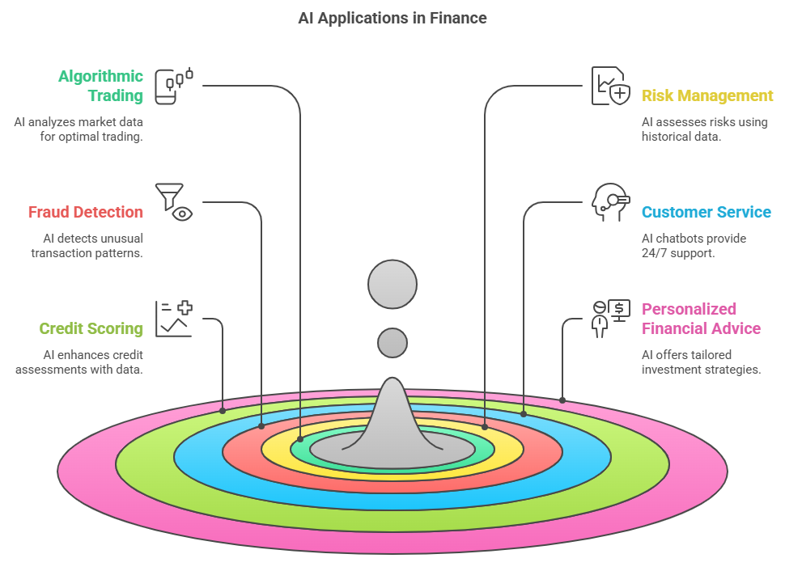

# The Financial Advantages of AI

# • Enhanced Productivity: By automating mundane processes, operating costs can be reduced and time can be spent on more strategic endeavors by financial experts.

# AI systems can process and analyze data more precisely, reducing the room for human mistake in financial reporting and analysis. This leads to improved accuracy.

# Investment and risk management decisions can be made more wisely and quickly with the help of AI's insights gained from data analytics.

# Pros and Cons of AI in the Financial Sector

## Pros

* **Increased Efficiency**: AI can automate repetitive tasks, freeing up human resources for more complex decision-making.
* **Enhanced Accuracy**: AI algorithms can reduce human error in data analysis and decision-making processes.
* **Better Customer Insights**: AI can analyze customer behavior and preferences, allowing for personalized financial products and services.

## Cons

* **Job Displacement**: The automation of tasks may lead to job losses in certain areas of the financial sector.
* **Bias in Algorithms**: If not properly managed, AI systems can perpetuate existing biases in data, leading to unfair treatment of certain groups.
* **Security Risks**: The reliance on AI systems can expose financial institutions to new cybersecurity threats.

# Automated Financial Tasks

# 1. Automation: Robots can take over mundane but necessary financial operations like data input, processing transactions, and compliance checks so that humans can concentrate on higher-level, more strategic endeavors.

# 2.Business strategy can be informed by the patterns and trends discovered through the rapid and accurate analysis of huge information by AI systems.

# 3.Personalization : Thanks to AI, banks can cater to each customer's unique tastes and habits by providing tailored services and products.

# Fourthly, in risk management, AI improves risk assessment through the analysis of past data and the prediction of future risks, allowing firms to reduce losses.

# 5. Fraud Detection: Artificial intelligence systems can identify suspicious trends in transactions and alert about possible fraudulent activities immediately.

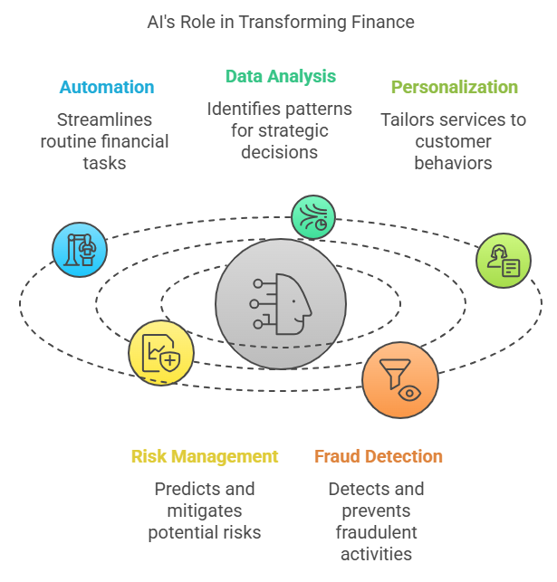

# Financial Analytics Driven by AI

# Artificial intelligence (AI) improves analytics by shedding light on financial data at a deeper level. Machine learning-driven predictive analytics help businesses foresee future market trends, consumer actions, and threats. Financial institutions can enhance their overall performance, optimize their operations, and make proactive decisions using this data-driven strategy.

# Using AI for Decision Making

# By offering insights and recommendations based on data, AI has a major influence on financial decision-making processes. Using AI tools, financial professionals can examine the outcomes of different strategies, evaluate risks, and run scenarios. This improves the efficiency of financial operations as a whole and leads to better decisions by lowering uncertainty.

# Financial AI Obstacles

# Data privacy is an issue since AI uses massive databases, which could compromise the security of customers' personal and financial details.

# • Regulatory Compliance: Innovating while staying in compliance with the myriad of rules governing artificial intelligence is a major challenge for the financial sector.

# Unfair treatment of some groups in credit scoring or loan approvals might result from AI systems unintentionally perpetuating biases found in training data.

# Ethical Considerations in Monetary Policymaking

The integration of AI into monetary policymaking raises important ethical questions. Policymakers must consider the implications of relying on algorithms to make decisions that affect the economy and society at large. Issues such as transparency, accountability, and the potential for bias must be addressed to ensure that AI-driven policies serve the public good and do not exacerbate existing inequalities.

In conclusion, while AI presents numerous opportunities for improving financial decision-making and operational efficiency in the banking and insurance sectors, it also poses significant challenges that must be carefully navigated. As the financial landscape continues to evolve, ongoing assessment of AI's impact will be essential to harness its benefits while mitigating its risks.

**Ai In The Indian Financial Industry**

The pandemic has accelerated the adoption of a few technologies like chatbots, computer vision and assisted video KYC to enable efficient servicing and onboarding of customers where corresponding offline functionalities were no longer accessible. Using this multidimensional view tailored to the Indian FS industry, organisations can plan their timelines, estimate effort and prioritise the implementation of AI technologies. For example, the graph shows that customer journey personalisation is an emerging technology whose adoption is relatively low and driven by autonomous intelligence, while chatbots are being widely used by most FS players. That said, the opportunity for AI to contribute substantial gains in productivity and consumption across the value chain is high, even in the case of seemingly mature technologies. For instance, though chatbots are widely used, few financial institutions are using the data collected by them to redefine up- and down-stream processes. Further, with the rise of AI, there are concerns about trust and accountability. Organisations globally are considering how they can fully realise AI’s potential while addressing the potential risks. Governments are following suit, with emerging regulation on data privacy, accountability and explainability

# 

* The curve above categorises the AI landscape based on the level of AI adoption and the time required to achieve that adoption level in the Indian context.
* A noticeable feature of the above use cases is the positive correlation between level of adoption and timeframe. This is due to the adoption of highly effective and proven use cases globally by Indian FS organisations.

# AI Applications in the Top Indian Banks

## State Bank of India (SBI)

SBI, which is India’s largest public-sector bank with 420 million customers, is embarking on its AI journey from the point of view of both employees and customers. To fuel its AI mission, this year, SBI launched a national hackathon, [“Code For Bank”](https://www.hackerearth.com/sprints/sbi-code-for-bank-2017/), for developers, startups and students to come up with innovative ideas and solutions for the banking sector, focusing on technologies such as predictive analytics, fintech/blockchain, digital payments, IoT, AI, machine learning, BOTS and robotic process automation.

### ****SIA Chatbot****

From a customer chatbot perspective, SBI has [launched SIA](http://trak.in/tags/business/2017/09/05/sbi-chatbot-sia/), an AI-powered chat assistant that addresses customer enquiries instantly and helps them with everyday banking tasks just like a bank representative told Emerj (the company’s own press release for said SIA launch appears to be unavailable due to a website issue, as of Dec 27, 2017). AI-based conversational interfaces can facilitate customer service and numerous consumer banking actions. Our readers can [download the Executive Brief](https://emerj.com/report/ai-in-banking-vendor-scorecard/) for our AI in Banking Vendor Scorecard and Capability Map report to learn more.

SIA was developed by [Payjo](https://www.payjo.co/), a startup based in Silicon Valley and Bengaluru. According to Payjo, since its launch, the chatbot has responded to millions of queries from thousands of customers. “SIA is setup to handle nearly 10,000 enquiries per second or 864 million in a day. That is nearly 25% of the queries processed by Google every day,” Payjo said in a [statement](https://tech.economictimes.indiatimes.com/news/internet/sbi-launches-chatbot-to-help-customers-in-banking-activities/60834602). Deployment of this size is arguably the ﬁrst of its kind in India and even across the world. SBI claims that SIA continuously learns with each interaction and gets better over time (this alone isn’t unique, it’s the premise of more or less any machine learning-based product). Currently, SAI can address enquiries on banking products and services. It is trained with a large set of past customer questions and is said to aptly handle frequently asked questions.

[We spoke](https://soundcloud.com/aiinbanking/banks-vs-fintechs-the-battle) with [Lee Smallwood](https://www.linkedin.com/in/lee-smallwood/), COO of Markets and Securities, North America at Citi about how banks, fintech companies, and AI firms factor into the competitive landscape they all share. When asked about how AI startups usually create their products, Smallwood said: Payjo likely developed SIA after studying how other banks were changing their customer service business models and basing their ideas on what they thought would succeed the most in the future. Then they would have “unbundled” the offerings of other banks and decided on which topicss they could start building the chatbot to handle.

## HDFC Bank

HDFC Bank has developed an AI-based chatbot, [“Eva”](https://www.hdfcbank.com/htdocs/aboutus/News_Room/pdf/Press-Release-HDFC-Bank-launches-chatbot-Eva-for-customer-service.pdf), built by Bengaluru-based [Senseforth AI Research](http://www.senseforth.com/). Since its launch in March this year, Eva (which stands Electronic Virtual Assistant) has addressed over 2.7 million customer queries, interacted with over 530,000 unique users, and held 1.2 million conversations. Eva can assimilate knowledge from thousands of sources and provide simple answers in less than 0.4 seconds, the bank said. Within the first few days of its launch, Eva has answered more than 100,000 queries from thousands of customers from 17 countries across the globe.

“With the launch of Eva, the bank’s customers can get information on its products and services instantaneously. It removes the need to search, browse or call. Eva also becomes smarter as it learns through its customer interactions. Going forward, Eva would be able to handle real banking transactions as well, which would enable HDFC Bank to offer the true power of conversational banking to its customers,” the bank [stated](https://www.hdfcbank.com/htdocs/aboutus/News_Room/pdf/Press-Release-HDFC-Bank-launches-chatbot-Eva-for-customer-service.pdf) in a company news release.    “Eva will complement our existing digital platforms in enhancing experience for our customers,” said Nitin Chugh, Country Head – Digital Banking, HDFC Bank.

HDFC is also experimenting with in-store robotic applications. The video below highlights HDFC’s IRA (stands for “Intelligent Robotic Assistant”) robot: As with most [current retail robotics use-cases](https://emerj.com/ai-sector-overviews/robots-in-retail-examples/), IRA appears to be in research and development, not in widespread use. Other banks have experimented with in-store robots to help guide customers or visitors (we found [an example of customer-facing robots at Santander bank from 2010](https://www.youtube.com/watch?v=bzDIJ6TTc6w)), but it seems unclear when this technology will be legitimately viable.

## ICICI Bank

ICICI Bank, India’s second-largest private sector bank has deployed [software robotics](https://www.icicibank.com/aboutus/article.page?identifier=news-icici-bank-introduces-software-robotics-to-power-banking-operations-20160809103646464) in over 200 business processes across various functions of the company. ICIC seems to be referring to what is often referred to as “[robotic software](https://en.wikipedia.org/wiki/Robot_software)” – a kind of software generally focused on automating office work (a topic which we’ve covered in great depth in [a past interview on “white collar automation”](https://emerj.com/ai-podcast-interviews/automating-white-collar-work-two-examples-and-a-look-forward/)). The bank said it is the first in the country and among a few globally to deploy this technology, which emulates human actions to automate and perform repetitive, high-volume and time-consuming business tasks.

Software robots now perform more than 1 million banking transactions per working day, an ICICI spokesperson said. The software robots at ICICI Bank are configured to capture and interpret information from systems, recognize patterns and run business processes across multiple applications to execute activities, including data entry and validation, automated formatting, multi-format message creation, text mining, workflow acceleration, reconciliations and currency exchange rate processing among others.

The bank has created the software robotics platform mostly in-house, leveraging AI features such as facial and voice recognition, natural language processing, machine learning and bots among others. “I believe that the implementation of software robotics will herald a transformational change in the Indian banking industry. We plan to more than double the software robots to over 500 by end of this fiscal,” said Chanda Kochhar, chief executive, ICICI.

It should be noted that robotic software is by no means new, and is a staple in large white collar work environments – including many [US banks](https://emerj.com/ai-sector-overviews/ai-in-banking-analysis/). That being said, we’re unable to judge ICIC’s applications one way or another from the outside. We suspect that if ICIC will see improved margins (and ethical concerns around job loss) if they succeed in truly pushing the boundary on robotic software. In February this year, ICICI Bank [launched its AI-based chatbot, named iPal](https://cio.economictimes.indiatimes.com/news/enterprise-services-and-applications/icici-banks-ai-chatbot-ipal-empowers-customers-with-information-and-financial-services/61118452). Since its launch, the chatbot has interacted with 3.1 million customers, answering about 6 million queries, with a 90 percent accuracy rate, the bank said. Madhivanan said the services offered by iPal are divided into three broad categories, most of which are mapped to the iMobile app.

**Category 1**: It involves FAQs, which are simple questions that you may want to ask your bank executive for which there are simple, structured answers. You ask the queries and the bot will give you the correct response, and it learns along the way.

**Category 2**: It involves financial transactions, wherein you can make fund transfers from person-to-person, pay your bills or recharge your mobile phone bills using queries.

**Category 3**: It involves helping people discover new features. These are simple how-to tasks such as how to reset your ATM pin, which is a bit more evolved and is like interacting with your bank executive.

The bank is currently in the process of integrating iPal with existing voice assistants such as Cortana, Siri and Assistant. “Yes, it is a natural progression. We want to explore our ability to interface with multiple voice assistants and that certainly presents different challenges,” Madhivanan added in a statement to [FirstPost](http://www.firstpost.com/tech/news-analysis/icici-banks-ai-powered-chatbot-ipal-completes-6-million-responses-interacts-with-3-1-million-customers-in-eight-months-4151269.html).

## Axis Bank

Axis Bank, India’s third-largest private sector bank, launched an innovation lab called “[Thought Factory](https://www.axisbank.com/thoughtfactory/index.html)” last year to accelerate the development of innovative AI technology solutions for the banking sector. The innovation hub located in Bengaluru, has an in-house innovation team and an accelerator program through which the bank engages with startups in a 3-month program. Shortlisted startups are then put in a structured mentorship program for fine-tuning, validating and scaling their business.

Recently, Axis Bank [launched](https://tech.economictimes.indiatimes.com/news/mobile/active-ai-brings-chat-bots-to-axis-bank/55427666) an AI & NLP (Natural Language Processing) enabled app, Conversational Banking, to help consumers with financial and non-financial transactions, answer FAQs and get in touch with the bank for loan other products. Currently available on Facebook and the Axis Bank website, it will soon be extended to mobile banking channels

# Conclusion

With its cutting-edge data analysis and decision-making tools, AI is causing a revolution in the financial sector. By utilizing its applications, financial institutions can improve efficiency, accuracy, and customer service, enabling them to effectively traverse complicated market dynamics. Data privacy issues and algorithmic bias are two of the problems that might arise from integrating AI. It is critical to tackle these difficulties to guarantee responsible and successful usage of AI as the finance industry keeps embracing emerging technologies. Understanding AI's function in financial decision-making and maintaining a conversation about its ethical ramifications are both highlighted by this study.

REFERENCE

*1.Artificial Intelligence in Finance, Yves Hilpisch, O'Reilly Media, Inc., 1005 Gravenstein Highway North, Sebastopol, CA 95472, USA, 2020,* ***ISBN-13:*** *978-1098101364.*

*2. Machine Learning for Asset Managers, Marcos López de Prado, Cambridge University Press. Cambridge University Press, The Edinburgh Building, Cambridge, CB2 8RU, UK, 2020,* ***ISBN-13:*** *978-1108487118.*

*3. The Role of AI and Machine Learning in Financial Decision Making, Journal of Financial Data Science, Bernhard Rieder, Achim B. Czischke, Gábor Cséfalvay, Financial Data Science, 2020.*

*4. Baranidharan, K., P. Ranjith, T. Suganya, N. Selvakumar, T. Sujathabaranidharan, M. A. Priya, and S. Narenderan. "An investigation of artificial intelligence in business." International Journal of Research Publication and Reviews 4, no. 4 (2023).*

*5. C. Saravanabhavan, S. Ranjithkumar, M. Subashini, K. Baranidharan, P. Preethi and P. Ashok, "Blockchain-Based Secure Menger's Authentication for Industrial IOT,"*2022 2nd International Conference on Advance Computing and Innovative Technologies in Engineering (ICACITE)*, Greater Noida, India, 2022, pp. 1302-1308, doi: 10.1109/ICACITE53722.2022.9823904.*

# *6. Optimizing task scheduling in fog computing: Adaptive algorithms for enhanced security and efficiency in IoT environments, M Anita, B Usha Rani, JK Periasamy, TK Sethuramalingam, E Uma Maheswari, K Baranidharan, R Srinivasan, V Vijayan, M Anita, B Usha Rani, JK Periasamy, TK Sethuramalingam, E Uma Maheswari, K Baranidharan, R Srinivasan, V Vijayan, 2024. AIP Publishing.*

# *7. An Exploration Of Block Chain Technology In Decentralized Finance (Defi), K. Pavithra Dr. K. Baranidharan, T. Anushya, INTERNATIONAL JOURNAL OF PROGRESSIVE RESEARCH IN ENGINEERING MANAGEMENT AND SCIENCE (IJPREMS, 2024.*

# *8.****Artificial Intelligence in Finance: A Review,*** *Journal of Financial Markets, Christian L. Dunis, Peter W. Middleton, Andreas Karathanasopolous, Konstantinos Theofilatos, Elsevier, 2019.*

### *9.A Study on the Application of Financial Analytics in the Field of Blockchain Technology, Dr.K.Baranidharan, K.Sabitha, V.Deepika, International Journal of Science Engineering and Technology, 2024.*

### *10.****Artificial Intelligence for Financial Decision Making: A Survey",*** *Journal of Computational Finance, J. Zhang, J. Zhang, X. Li, Risk Management Institute, National University of Singapore, 2021.*

*11.Blockchain Technology for Enhancing Supply Chain Transparency: Opportunities and Challenges, Dr.K.Baranidharan, Mahalakshmi.R, Anagha.S, International Journal of Advanced Research in Schence, Communication and Technology (IJARSCT) ISSN 2581 9429, 2025.*

*12.*[*https://www.pwc.in/assets/pdfs/research-insights/2022/ai-adoption-in-indian-financial-services-and-related-challenges.pdf*](https://www.pwc.in/assets/pdfs/research-insights/2022/ai-adoption-in-indian-financial-services-and-related-challenges.pdf)

*13.*[*https://emerj.com/ai-applications-in-the-top-4-indian-banks/*](https://emerj.com/ai-applications-in-the-top-4-indian-banks/)

*14.*[*https://www.ai-finance.org*](https://www.ai-finance.org)

*15.*[*https://jfds.pm-research.com*](https://jfds.pm-research.com)

*16.*[*https://towardsdatascience.com*](https://towardsdatascience.com)